**PHYSICS PROJECT**

**TELESCOPES**

**Anjana Pradeep**

**XII A**

**ISC Roll No: B/8296/013**

**INDEX**

Page No.

Introduction 1

Parts Of A Telescope 2

Reflecting Telescope 3

Refracting Telescope 6

Catadioptric Telescope 9

**INTRODUCTION**

A telescope is an instrument that aids in the observation of remote objects by collecting [electromagnetic radiation](http://en.wikipedia.org/wiki/Electromagnetic_radiation) (such as [visible light](http://en.wikipedia.org/wiki/Visible_light)). The first known practical telescopes were invented in the [Netherlands](http://en.wikipedia.org/wiki/Netherlands) at the beginning of the 17th century. The word telescope can refer to a wide range of instruments detecting different regions of the [electromagnetic spectrum](http://en.wikipedia.org/wiki/Electromagnetic_spectrum).

The word "telescope" (from the [Greek](http://en.wikipedia.org/wiki/Greek_language) [τῆλε](http://en.wiktionary.org/wiki/%CF%84%E1%BF%86%CE%BB%CE%B5), tele "far" and [σκοπεῖν](http://en.wiktionary.org/wiki/%CF%83%CE%BA%CE%BF%CF%80%CE%AD%CF%89), skopein "to look or see"; τηλεσκόπος, teleskopos "far-seeing") was coined in 1611 by the Greek mathematician [Giovanni Demisiani](http://en.wikipedia.org/wiki/Giovanni_Demisiani) .

The earliest known working [telescopes](http://en.wikipedia.org/wiki/Telescope) appeared in 1608 and are credited to [Hans Lippershey](http://en.wikipedia.org/wiki/Hans_Lippershey).The design of these early [refracting telescopes](http://en.wikipedia.org/wiki/Refracting_telescope) consisted of a convex [objective](http://en.wikipedia.org/wiki/Objective_(optics)) lens and a concave [eyepiece](http://en.wikipedia.org/wiki/Eyepiece). [Galileo](http://en.wikipedia.org/wiki/Galileo_Galilei) used this design the following year. In 1611, [Johannes Kepler](http://en.wikipedia.org/wiki/Johannes_Kepler) described how a telescope could be made with a convex objective and eyepiece lens and by 1655 astronomers such as [Christiaan Huygens](http://en.wikipedia.org/wiki/Christiaan_Huygens) were building powerful but unwieldy Keplerian telescopes with compound eyepieces.[Laurent Cassegrain](http://en.wikipedia.org/wiki/Laurent_Cassegrain) in 1672 described the design of a reflector with a small convex secondary mirror to reflect light through a central hole in the main mirror.

Types of telescopes

The name "telescope" covers a wide range of instruments. One important classification is the type of radiation the telescope is detecting. Most telescopes detect [electromagnetic radiation](http://en.wikipedia.org/wiki/Electromagnetic_radiation), but there are major differences in how astronomers must go about collecting light (electromagnetic radiation) in different frequency bands.

Another classification is by location: ground telescope, [space telescope](http://en.wikipedia.org/wiki/Space_telescope), or [flying telescope](http://en.wikipedia.org/wiki/Flying_telescope). Telescopes may also be classified as to whether they are operated by [professional astronomers](http://en.wikipedia.org/wiki/Astronomer) or [amateur astronomers](http://en.wikipedia.org/wiki/Amateur_astronomer). A vehicle or permanent campus containing one or more telescopes or other instruments is called an [observatory](http://en.wikipedia.org/wiki/Observatory).

Three main types of telescopes are:

* Reflector telescopes
* Refractor telescopes

## Catadioptric telescopes

## PARTS OF A TELESCOPE

[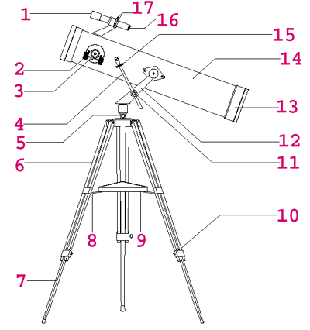](http://www.universetoday.com/wp-content/uploads/2008/08/parts_of_a_telescope.gif)

1. Finderscope  
2. Focuser  
3. Eyepiece  
4. Release Control For Mount  
5. Mount Base or Mounting Plate  
6. Outer Tripod Leg  
7. Tripod Leg Extension  
8. Tripod Support Brace  
9. Accessory Tray  
10. Tripod Leg Clamp  
11. Mount Axis  
12. Mount  
13. Mirror Cell – Primary  
14. Telescope Tube  
15. Slow Motion Control Lock  
16. Finderscope Eyepiece  
17. Finderscope Bracket

**REFLECTING TELESCOPE**

A reflecting telescope (also called a reflector) is an [optical telescope](http://en.wikipedia.org/wiki/Optical_telescope) which uses a single or combination of [curved mirrors](http://en.wikipedia.org/wiki/Curved_mirror) that reflect [light](http://en.wikipedia.org/wiki/Light) and form an [image](http://en.wikipedia.org/wiki/Image). The reflecting telescope was invented in the 17th century as an alternative to the [refracting telescope](http://en.wikipedia.org/wiki/Refracting_telescope) which, at that time, was a design that suffered from severe [chromatic aberration](http://en.wikipedia.org/wiki/Chromatic_aberration). Although reflecting telescopes produce other types of optical aberrations, it is a design that allows for very large diameter [objectives](http://en.wikipedia.org/wiki/Objective_(optics)). Almost all of the major telescopes used in [astronomy](http://en.wikipedia.org/wiki/Astronomy) research are reflectors. Reflecting telescopes come in many design variations and may employ extra optical elements to improve image quality or place the image in a mechanically advantageous position.

A telescope that used a single or more than one curved mirror that reflects the light from an image to form and image is a reflecting telescope.  The reflecting telescope was invented to try and make the images much more clearer than a refracting telescope.Although the reflecting telescope did succeed in this quest, the reflecting telescope does create its own distortions.One of the advantages of this type of telescope is that the viewing diameter is very large.This large viewing diameter is helpful in research telescopes.  
Some of the considerations that need to be taken into account when looking at a reflecting telescope are as follows. If the telescope is using more than one mirror, the two mirrors may not focus in tandem. If the telescope uses mirrors that are in the shape of a sphere, they can cause this distortion.  In order to get rid of this type of distortion in a reflecting telescope, get one that does not use spherical mirrors. You may also encounter another common problem with this type of telescope. A variation in the reflecting telescopes magnifying ability will most likely cause distortions in the field of view with it being the worst at the outer edges. This will lessen the definition of the object you are looking at. In general terms, the best way to view an image in a telescope like this despite its problems is by the use of curved mirrors.

Just about all telescopes used for research are reflecting telescopes.  This is due to the realization that the mirror or mirrors in this type do not need to be defect free.  They just need to be polished.  Light coming off of different objects travel at different wavelengths and at different speeds. The reflector telescope allows more wavelengths of light to bounce off of them as opposed to refracting telescopes that use lenses which absorb some wavelengths of light.

### Types of Reflecting Telescopes

* [Cassegrain telescope](http://en.wikipedia.org/wiki/Cassegrain_telescope)
* [Gregorian telescope](http://en.wikipedia.org/wiki/Gregorian_telescope)
* [Herrig telescope](http://en.wikipedia.org/w/index.php?title=Herrig_telescope&action=edit&redlink=1)
* [Herschelian telescope](http://en.wikipedia.org/wiki/Reflecting_telescope#Herschelian_telescope)
* [Newtonian telescope](http://en.wikipedia.org/wiki/Newtonian_telescope)
* [Schiefspiegler telescope](http://en.wikipedia.org/wiki/Schiefspiegler_telescope)
* [Stevick–Paul telescope](http://en.wikipedia.org/w/index.php?title=Stevick%E2%80%93Paul_telescope&action=edit&redlink=1)

### The Cassegrain Reflecting Telescope

The Cassegrain telescope (sometimes called the "Classic Cassegrain") was first published in an 1672 design attributed to [Laurent Cassegrain](http://en.wikipedia.org/wiki/Laurent_Cassegrain). It has a parabolic primary mirror, and a hyperbolic secondary mirror that reflects the light back down through a hole in the primary. Folding and diverging effect of the secondary creates a telescope with a long focal length while having a short tube length. The "Classic" Cassegrain has a parabolic primary mirror, and a hyperbolic secondary mirror that reflects the light back down through a hole in the primary. Folding the optics makes this a compact design. On smaller telescopes, and camera lenses, the secondary is often mounted on an optically flat, optically clear glass plate that closes the telescope tube. This support eliminates the "star-shaped" diffraction effects caused by a straight-vaned support spider. The closed tube stays clean, and the primary is protected, at the cost of some loss of light-gathering power.

It makes use of the special properties of parabolic and hyperbolic reflectors. A concave [parabolic reflector](http://en.wikipedia.org/wiki/Parabolic_reflector) will reflect all incoming light rays parallel to its axis of symmetry to a single point, the focus. A convex hyperbolic reflector has two foci and will reflect all light rays directed at one of its two foci towards its other focus. The mirrors in this type of telescope are designed and positioned so that they share one focus and so that the second focus of the hyperbolic mirror will be at the same point at which the image is to be observed, usually just outside the eyepiece. The parabolic mirror reflects parallel light rays entering the telescope to its focus, which is also the focus of the hyperbolic mirror. The hyperbolic mirror then reflects those light rays to its other focus, where the image is observed.

This is one of the most popular designs in reflecting telescopes. It works along the same method as the Gregorian Reflector but the difference between the two is that the secondary mirror in the Cassegrain is also curved rather than flat like in the Gregorian. This gives the telescope a much wider field of view. For this reason, professionals who choose reflecting telescopes choose those made with the Cassegrain design.  
  
The Cassegrain reflector is a combination of a primary [concave mirror](http://en.wikipedia.org/wiki/Concave_mirror) and a secondary [convex mirror](http://en.wikipedia.org/wiki/Convex_mirror), often used in [optical telescopes](http://en.wikipedia.org/wiki/Optical_telescope) and [radio antennas](http://en.wikipedia.org/wiki/Antenna_(radio)).

In a symmetrical Cassegrain both mirrors are aligned about the [optical axis](http://en.wikipedia.org/wiki/Optical_axis), and the primary mirror usually contains a hole in the centre thus permitting the light to reach an [eyepiece](http://en.wikipedia.org/wiki/Eyepiece), a [camera](http://en.wikipedia.org/wiki/Camera), or a [light detector](http://en.wikipedia.org/w/index.php?title=Light_detector&action=edit&redlink=1). Alternatively, as in many radio telescopes, the final focus may be in front of the primary. In an asymmetrical Cassegrain, the mirror(s) may be tilted to avoid obscuration of the primary or the need for a hole in the primary mirror (or both).

The classic Cassegrain configuration uses a [parabolic reflector](http://en.wikipedia.org/wiki/Parabolic_reflector) as the primary while the secondary mirror is [hyperbolic](http://en.wikipedia.org/wiki/Hyperboloid).However, variations exist where the primary is hyperbolic for increased performance, and where the primary and/or secondary are spherical or elliptical for ease of manufacturing.

**REFRACTING TELESCOPE**

In a simple refractor, or refracting telescope, the light-collecting part of the instrument is a large curved lens called an objective. As parallel rays of light from an object deep in space pass through this lens, they are refracted, or bent, along the telescope tube towards a point where they converge, forming an image. The distance of this point from the lens determines the focal length that you may see mentioned in its description.

The second vital element of the refractor is the eyepiece, which is simply a magnifying lens, or set of lenses, that is used to enlarge the image produced by the main lens. Astronomers normally use a range of eyepieces so that they can magnify their observing targets by different amounts to suit different situations.

The reflecting telescopes generally use both concave and convex lens and focus the light. There is another category of optical telescopes called refracting telescopes.

Refracting telescopes make use of the lenses. They usually focus the light waves with the help of these lenses. They find a wide range of applications in astronomy, though the applications include non-astronomical uses as in binoculars and cameras.

These are the first formed ones that fall under the category of optical telescopes.

The telescope consists of lenses and an eyepiece. This combination can get a better collection of the light waves. This amount will be more than that can be collected with the naked human eyes.

This can absorb the light and can give a better view of the image with a magnified and bright image. The working is with the help of the refraction of light.

The parallel light can converge on points and those that are not parallel can converge to a plane.  The refracting telescopes are also called by the name refractors.

There are different classes of refracting telescopes. They are Galilean telescope, Keplerian Telescope, Achromatic refractors and Apo chromatic refractors. The objective lens of the Galilean telescope is convex where as the eyepiece is a concave lens. These telescopes where earlier used for the viewing of sky.

### Types of Refracting Telescopes

* [Achromatic telescope](http://en.wikipedia.org/wiki/Achromatic_telescope)
* [Apochromatic](http://en.wikipedia.org/wiki/Apochromat)
* [Binoculars](http://en.wikipedia.org/wiki/Binoculars)
* [Monocular](http://en.wikipedia.org/wiki/Monocular)
* [Galilean telescope](http://en.wikipedia.org/wiki/Galilean_telescope)
* [Keplerian Telescope](http://en.wikipedia.org/wiki/Keplerian_Telescope)
* [Aerial telescope](http://en.wikipedia.org/wiki/Aerial_telescope)
* [Superachromat](http://en.wikipedia.org/wiki/Superachromat)
* [Varifocal gas-lens telescope](http://en.wikipedia.org/w/index.php?title=Varifocal_gas-lens_telescope&action=edit&redlink=1)

### Galileo's telescope

The original design [Galileo Galilei](http://en.wikipedia.org/wiki/Galileo_Galilei) came up with in 1609 is commonly called a Galilean telescope. It uses a convergent (plano-convex or bi-convex) objective lens and a divergent (plano-concave or bi-concave) eyepiece lens. Galilean telescopes produce upright images.

Galileo’s best telescope [magnified](http://en.wikipedia.org/wiki/Magnification) objects about 30 times. Because of flaws in its design, such as the shape of the lens and the narrow field of view, the images were blurry and distorted. Despite these flaws, the telescope was still good enough for Galileo to explore the sky. The Galilean telescope could view the [phases of Venus](http://en.wikipedia.org/wiki/Phases_of_Venus), and was able to see [craters](http://en.wikipedia.org/wiki/Impact_crater) on the [Moon](http://en.wikipedia.org/wiki/Moon) and four [moons](http://en.wikipedia.org/wiki/Galilean_moons) orbiting Jupiter.

The Galilean telescope consists of a converging lens (plano-convex or biconvex) serving as objective, and a diverging lens (plano-concave or biconcave) serving as eyepiece. The eyepiece is situated in front of the focal point of the objective, at a distance from the focal point equal to the focal length of the eyepiece. Since converging lenses are conventionally positive (or of positive optical power) and diverging ones negative (or of negative optical power), we can also say that the distance between the objective and the eyepiece is equal to the algebraic sum of their focal lengths. The negative eyepiece intercepts the converging rays coming from the objective, rendering them parallel and thus forming, to the infinite (afocal position), a virtual image, magnified and erect. The magnification of the system is determined by the ratio between the focal length of the objective and that of the eyepiece. The Galilean telescope, although it furnishes erect images with the aid of erector devices, has the severe drawback of an extremely narrow field of view (which makes it, in practice, usable only for magnifications up to around thirty).

### Keplerian Telescope

The Keplerian Telescope, invented by [Johannes Kepler](http://en.wikipedia.org/wiki/Johannes_Kepler) in 1611, is an improvement on Galileo's design . It uses a convex lens as the eyepiece instead of Galileo's concave one. The advantage of this arrangement is the rays of light emerging from the eyepiece are converging. This allows for a much wider field of view and greater eye relief but the image for the viewer is inverted. Considerably higher magnifications can be reached with this design but to overcome aberrations the simple objective lens needs to have a very high [f-ratio](http://en.wikipedia.org/wiki/Focal_ratio) ([Johannes Hevelius](http://en.wikipedia.org/wiki/Johannes_Hevelius) built one with a 45 m (150 ft) [focal length](http://en.wikipedia.org/wiki/Focal_length) and even longer tubeless "[aerial telescopes](http://en.wikipedia.org/wiki/Aerial_telescope)" were constructed). The design also allows for use of a [micrometer](http://en.wikipedia.org/wiki/Filar_micrometer#Prior_devices) at the focal plane (used to determining the angular size and/or distance between objects observed).

|  |
| --- |
| Catadioptric telescopes Catadioptric telescopes are [optical telescopes](http://en.wikipedia.org/wiki/Optical_telescope) that combine specifically shaped mirrors and lenses in designs that have all spherical surfaces that are easier to manufacture, have an overall greater degree of error correction than their all lens or mirror counterparts, have a wide [field of view](http://en.wikipedia.org/wiki/Field_of_view), take advantage of a folded optical path, or a combination of any or all of these attributes. Many types employ “correctors”, a lens or curved mirror in a combined [image-forming optical system](http://en.wikipedia.org/wiki/Image-forming_optical_system) so that the reflective or refractive element can correct the aberrations produced by its counterpart. The Cassegrain reflector is a combination of a primary [concave mirror](http://en.wikipedia.org/wiki/Concave_mirror) and a secondary [convex mirror](http://en.wikipedia.org/wiki/Convex_mirror), often used in [optical telescopes](http://en.wikipedia.org/wiki/Optical_telescope) and [radio antennas](http://en.wikipedia.org/wiki/Antenna_(radio)).  Catadioptric [dialytes](http://en.wikipedia.org/wiki/Dialyte_lens#Dialyte_telescopes) are the earliest type of catadioptric telescope. They consist of a single element [refractor](http://en.wikipedia.org/wiki/Refracting_telescope) [objective](http://en.wikipedia.org/wiki/Objective_(optics)) combined with a silver backed negative lens (similar to a Mangin mirror). The first of these was the Hamiltonian telescope patented by W. F. Hamilton in 1814. The Schupmann medial telescope designed by German optician [Ludwig Schupmann](http://en.wikipedia.org/wiki/Ludwig_Schupmann) near the end of the 19th century placed the catadioptric mirror beyond the focus of the refractor primary and added a 3rd correcting/focusing lens to the system.  In a symmetrical Cassegrain both mirrors are aligned about the [optical axis](http://en.wikipedia.org/wiki/Optical_axis), and the primary mirror usually contains a hole in the centre thus permitting the light to reach an [eyepiece](http://en.wikipedia.org/wiki/Eyepiece), a [camera](http://en.wikipedia.org/wiki/Camera), or a [light detector](http://en.wikipedia.org/w/index.php?title=Light_detector&action=edit&redlink=1). Alternatively, as in many radio telescopes, the final focus may be in front of the primary. In an asymmetrical Cassegrain, the mirror(s) may be tilted to avoid obscuration of the primary or the need for a hole in the primary mirror (or both).  The classic Cassegrain configuration uses a [parabolic reflector](http://en.wikipedia.org/wiki/Parabolic_reflector) as the primary while the secondary mirror is [hyperbolic](http://en.wikipedia.org/wiki/Hyperboloid).However, variations exist where the primary is hyperbolic for increased performance, and where the primary and/or secondary are spherical or elliptical for ease of manufacturing. Types of Catadioptric Telescopes  * [Argunov–Cassegrain telescope](http://en.wikipedia.org/wiki/Argunov%E2%80%93Cassegrain_telescope) * [Catadioptric dialytes](http://en.wikipedia.org/wiki/Catadioptric_system#Catadioptric_telescopes) * [Klevtsov–Cassegrain telescope](http://en.wikipedia.org/wiki/Klevtsov%E2%80%93Cassegrain_telescope) * [Lurie–Houghton telescope](http://en.wikipedia.org/wiki/Lurie%E2%80%93Houghton_telescope) * [Maksutov telescope](http://en.wikipedia.org/wiki/Maksutov_telescope) * [Modified Dall–Kirkham telescope](http://en.wikipedia.org/wiki/Modified_Dall%E2%80%93Kirkham_telescope) * [Schmidt–Cassegrain telescope](http://en.wikipedia.org/wiki/Schmidt%E2%80%93Cassegrain_telescope) * [Schmidt–Newton telescope](http://en.wikipedia.org/wiki/Schmidt%E2%80%93Newton_telescope)  The Schmidt-Cassegrain Telescope The Schmidt–Cassegrain is a [catadioptric telescope](http://en.wikipedia.org/wiki/Catadioptric_telescope) that combines a [cassegrain reflector's](http://en.wikipedia.org/wiki/Cassegrain_reflector) optical path with a [Schmidt corrector plate](http://en.wikipedia.org/wiki/Schmidt_corrector_plate) to make a compact astronomical instrument that uses simple [spherical surfaces](http://en.wikipedia.org/wiki/Spherical_reflector).The Schmidt-Cassegrain is a telescope that uses a combination of mirrors and lenses (catadioptric optics) to fold the optics and form an image. The light enters through a thin aspheric Schmidt correcting lens, then strikes the spherical primary mirror and is reflected back up the tube and intercepted by a small convex spherical secondary mirror which reflects the light out an opening in the rear of the instrument where the image is formed at the eyepiece. These catadioptrics are the most popular type of instrument, with the most modern design, marketed throughout the world in 3-1/2" and larger apertures.  The Schmidt–Cassegrain design is very popular with consumer telescope manufacturers because it combines easy to manufacture [spherical](http://en.wikipedia.org/wiki/Spherical) optical surfaces to create an instrument with the long focal length of a [refracting telescope](http://en.wikipedia.org/wiki/Refracting_telescope) with the lower cost per [aperture](http://en.wikipedia.org/wiki/Aperture) of a [reflecting telescope](http://en.wikipedia.org/wiki/Reflecting_telescope). The compact design makes it very portable for its given aperture, which adds to its marketability. Their high [f-ratio](http://en.wikipedia.org/wiki/Optical_telescope#Focal_length_and_f-ratio) means they are not a wide field telescope like their Schmidt camera predecessor but they are good for more narrow field [deep sky](http://en.wikipedia.org/wiki/Deep_sky) and planetary viewing.  While there are many variations, (both mirrors spherical, both mirrors aspherical, or one of each) they can be divided into two principal design forms: compact and non-compact. In the compact form, the corrector plate is located at or near the focus of the primary mirror. In the non-compact, the corrector plate remains at or near the center of curvature (twice the [focal length](http://en.wikipedia.org/wiki/Focal_length)) of the primary mirror. Typical examples of the compact design are [Celestron](http://en.wikipedia.org/wiki/Celestron) and [Meade Instruments](http://en.wikipedia.org/wiki/Meade_Instruments) commercial instruments, combining a fast primary mirror and a small, strongly curved secondary. This yields a very short tube length, at the expense of field curvature. Most compact designs from Meade and Celestron have a primary mirror with a [focal ratio](http://en.wikipedia.org/wiki/Focal_ratio) of f/2 and a secondary with a negative focal ratio of f/5 yielding a system focal ratio of f/10. One notable exception is the Celestron C-9.25, which has a primary focal ratio of f/2.3 and a secondary focal ratio of f/4.3, the result being a slightly flatter field and a slightly longer tube aspect ratio than most other compact designs.  Non-compact designs keep the corrector at the center of curvature of the primary mirror. One very well-corrected design example would be the concentric (or monocentric) Schmidt–Cassegrain, where all the mirror surfaces and the focal surface are concentric to a single point: the center of curvature of the primary. Optically, non-compact designs often yield better aberration correction and a flatter field than a compact design, but at the expense of longer tube length.  Schmidt-Cassegrain (SCT) Advantages   * Best all-around, all-purpose telescope design. Combines the optical advantages of both lenses and mirrors while canceling their disadvantages. * Excellent optics with razor sharp images over a wide field. * Excellent for deep sky observing or astrophotography with fast films or CCDs. * Very good for lunar, planetary and binary star observing or photography. * Excellent for terrestrial viewing or photography. * Closed tube design reduces image degrading air currents. * Most are extremely compact and portable. * Large apertures at reasonable prices and less expensive than equivalent aperture refractors. * Most versatile type of telescope. * More accessories available than with other types of telescopes. * Superior near focus capability compared to other types of telescope (approximately 20 feet or 6 meters).   http://www.uk-telescopes.co.uk/REFLECTOR%20diagram.jpg |
| http://www.celestron.com/c3/support3/themes/client_default/space.gif | |

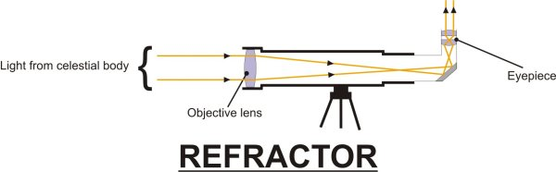

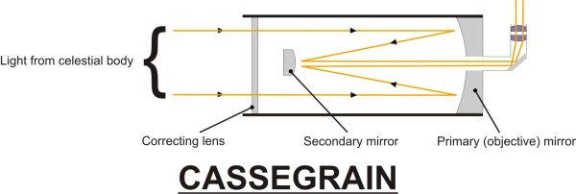

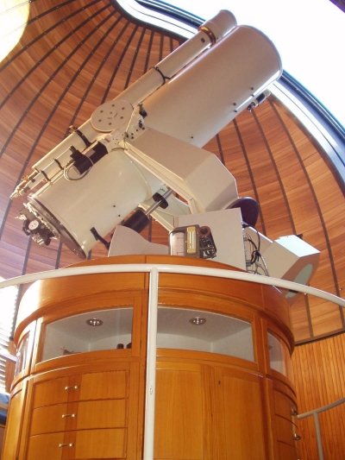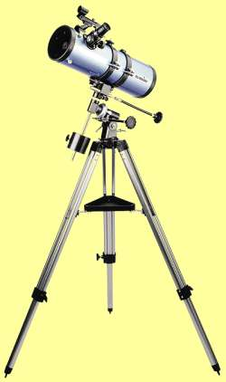

[Newtonian Telescope](http://en.wikipedia.org/wiki/Newtonian_telescope) Cassegrain Telescope

**[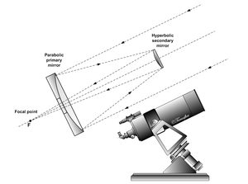](http://en.wikipedia.org/wiki/File:Cassegrain.en.png)**

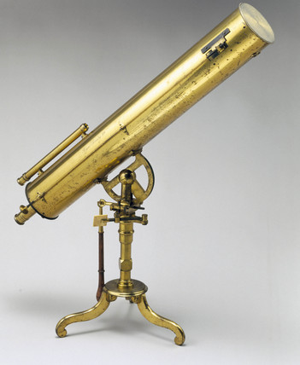

Light path in a Cassegrain Reflecting Telescope

[Gregorian Telescope](http://en.wikipedia.org/wiki/Gregorian_telescope)

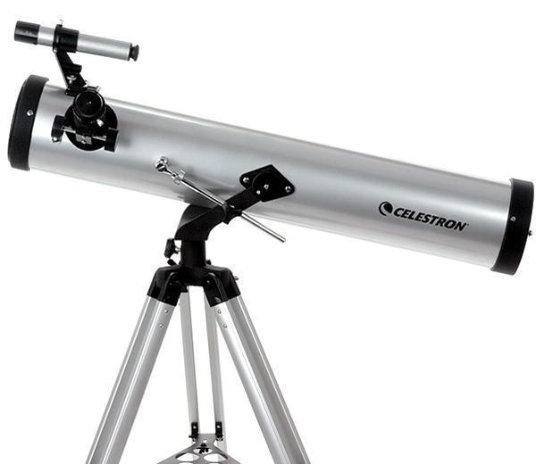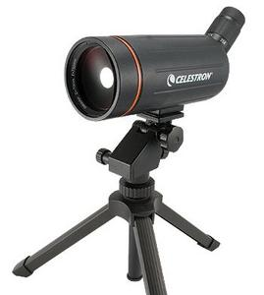

Schmidt-Cassegrain Telescope

[Maksutov Telescope](http://en.wikipedia.org/wiki/Maksutov_telescope)

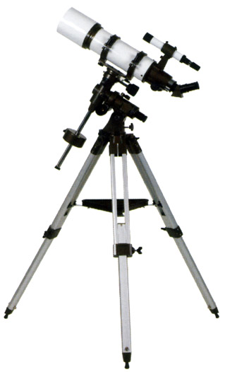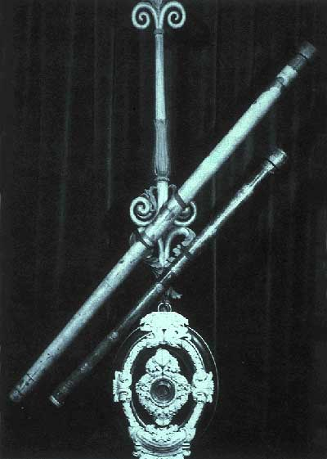

### 

[Achromatic Telescope](http://en.wikipedia.org/wiki/Achromatic_telescope)

### Galileo's Telescope

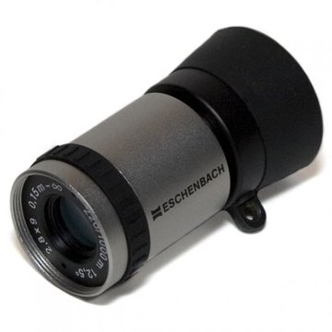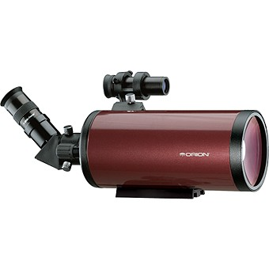

[Argunov–Cassegrain Telescope](http://en.wikipedia.org/wiki/Argunov%E2%80%93Cassegrain_telescope)

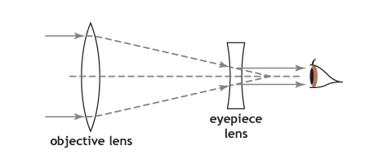 [Keplerian Telescope](http://en.wikipedia.org/wiki/Keplerian_Telescope)

Light path in a Galileo's Refracting Telescope

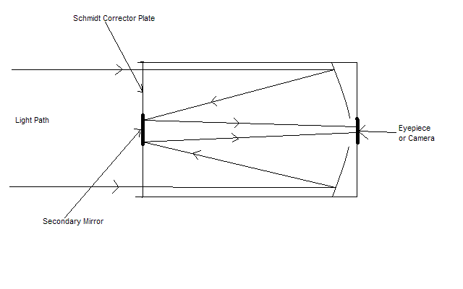

Light path in a Schmidt-Cassegrain Catadioptric Telescope