**PID CONTROLLER**

Control is how we use steering, brakes and throttle to move a car. And **controllers** are the control algorithms. With the help of controllers, we get a car move along a trajectory, automatically.

One of the most fundamental controllers is **PID Controller**. It consists of three components, the Proportional (P) component, the Integral (I) component, & the D (Derivative component).

CROSS TRACK ERROR

Cross track error is the lateral distance between the position of the car and the reference trajectory. The goal of the PID controller is to minimize the error so that the car stays on the trajectory.

**P – CONTROLLER**

P-controller steers the car in proportion to the CTE. However, when the car turns it oscillates around the reference trajectory. When the car turns, it overshoots the reference trajectory, but then it again turns towards the trajectory, again overshoots, and so on. This causes the oscillating behaviour. The coefficient Kp determines how fast it oscillates.

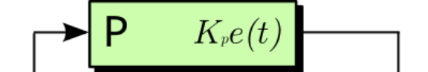

**D – CONTROLLER**

In order to reduce the oscillatory behaviour of the P-controller, D- controller is introduced. It’s the rate of change of cross track error. The derivative reduces the CTE, turning the steering slightly upwards when the car tends to overshoot the trajectory, hence turning the car gracefully along the trajectory. The coefficient Kd to optimize/reduce how far the car overshoots (also known as oscillation amplitude) from the reference trajectory.

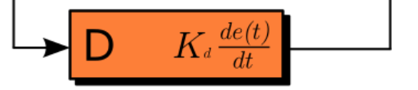

**I – CONTROLLER**

Sometimes there could be a bias which might prevent the PD controller to reach the trajectory line.

For example if the car’s wheels are aligned towards left and the trajectory is towards right. But the CTE remains the same and the car does not steer enough to reach the trajectory line. For larger steering angle, we need larger CTE. For this we bring in one more controller called integration controller which is the sum of cross track errors of all time. This brings in larger error causing the car to steer more, hence reach the trajectory line. The coefficient Ki determines how much error to bring in for sufficient steering.

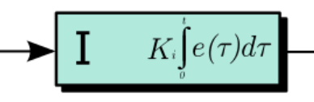

**PID – CONTROLLER**

Therefore the total error in PID looks as below:

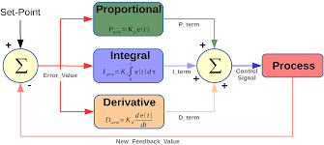

**PARAMETER OPTIMIZATION**

We need appropriate values of Kp, Kd and Ki for the car to run smoothly along the trajectory line. For this, we need to tune the parameters. The tuning can be done either manually or using an algorithm called Twiddle algorithm. I chose Twiddle algorithm where parameters are tuned automatically, than manual, which could have been time consuming.

The proper way of tuning is to initially set all the coefficient values to 0. Then set the value of Kp, so that car starts oscillating. Now, adjust the values of Kd and Ki to smoothen the car’s trajectory.

I finally set the Kp as 0.27, Kd as 3.0 and Ki as 0.001 for the car to run on the track without any oscillations.

**VIDEO OUTPUT**

Here is the video of the car with and without oscillations:

[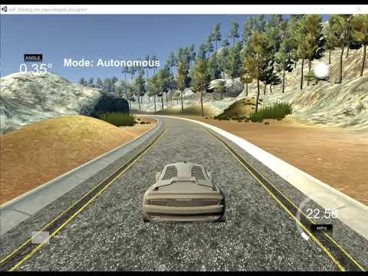](https://www.youtube.com/embed/hOAxBwIWw3s?feature=oembed)[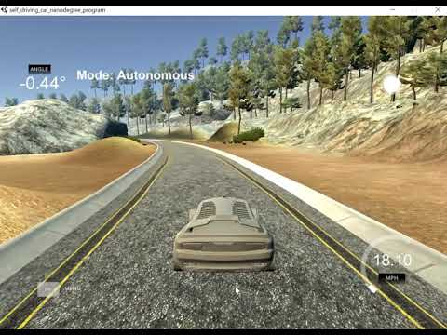](https://www.youtube.com/embed/Yp0Bq2OEP3A?feature=oembed)

Figure 1: Oscillatory behaviour of car Figure 2: Smooth movement of car