TASK 02
PRODUCT DESCRIPTION /
TECHNICAL WRITING

USER GUIDE
How to Create a GitHub Repository

A step-by-step guide for beginners
Student Name | Bezawada Anjana
Course / Department | B-TECH ARTIFICIAL INTELLIGENCE AND DATA SCIENCE
Organization / College | TAKSHASHILA UNIVERSITY
Date | 17 SEPTEMBER 2026

1. Introduction
- GitHub is a web-based platform used to store, manage, and collaborate on software projects. A GitHub repository is a project space where files, documentation, and version history can be maintained.
- This user guide explains how a beginner can create a new GitHub repository through the GitHub website. The instructions focus on one specific feature: creating a repository.

2. Objective
- The objective of this guide is to provide a clear, beginner-friendly procedure for creating a GitHub repository and choosing the basic settings required for the repository.

3. What You Will Learn
- What a GitHub repository is.
- What is required before creating a repository.
- How to start the repository creation process.
- How to enter a repository name and description.
- How to select repository visibility.
- How to initialize a repository with a README file.
- How to create and verify the repository.

4. About the Selected Feature
- The selected feature is GitHub's repository creation function. A repository provides a central location for a project's files and related documentation. Once created, it can be used to organize project work and share the project with others, depending on its visibility setting.

5. Requirements
- Before starting, make sure the following are available:
Requirement | Purpose
GitHub account | A registered GitHub account that you can sign in to.
Internet connection | A stable connection for accessing the GitHub website.
Web browser | A current browser such as Chrome, Edge, Firefox, or another supported browser.
Project name | A clear name for the repository.
Optional project description | A short sentence explaining what the project is about.

6. Important Terms
Term | Meaning
Repository | A project space on GitHub used to store project files and related information.
README | A document, usually written in Markdown, that introduces and explains a project.
Public repository | A repository that can be viewed by other people on GitHub.
Private repository | A repository whose contents are restricted to authorized users.
Git | A version-control system commonly used to track changes to files.

7. Before You Begin
- Sign in to your GitHub account before starting the procedure. Decide on the repository name and whether the repository should be public or private. Avoid including passwords, API keys, or other secrets in project files.

8. Step-by-Step Procedure

Step 1: Open GitHub

- Open a web browser and go to GitHub. Sign in to your account if you are not already signed in.
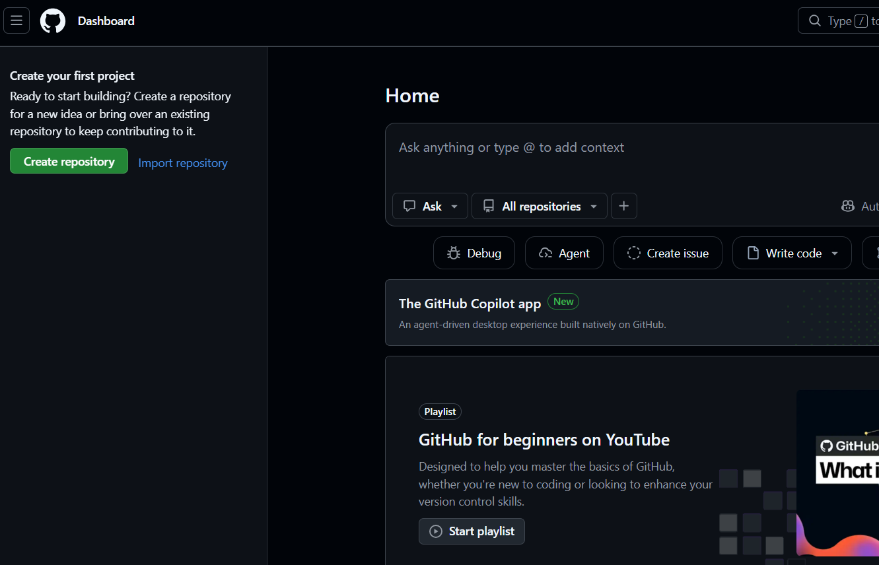

Step 2: Start a New Repository

- Use the + menu in the GitHub interface and select the option for creating a new repository. This opens the repository creation form.
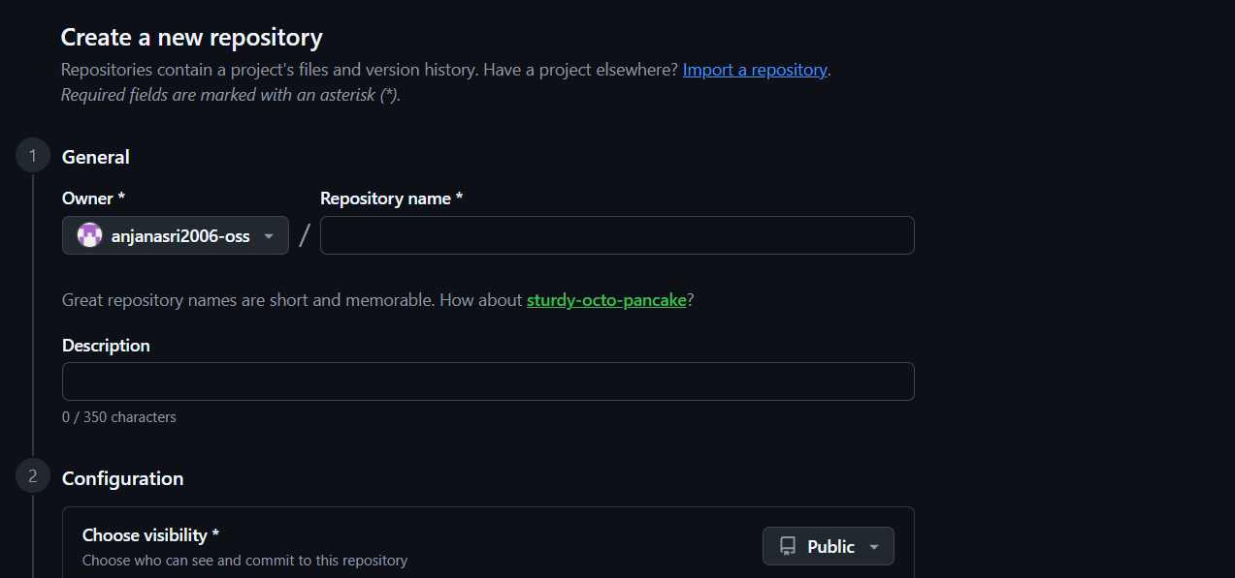

Step 3: Enter the Repository Name

- Type a clear and meaningful name in the Repository name field. Choose a name that helps other users understand the purpose of the project. Avoid unnecessary spaces or confusing names. 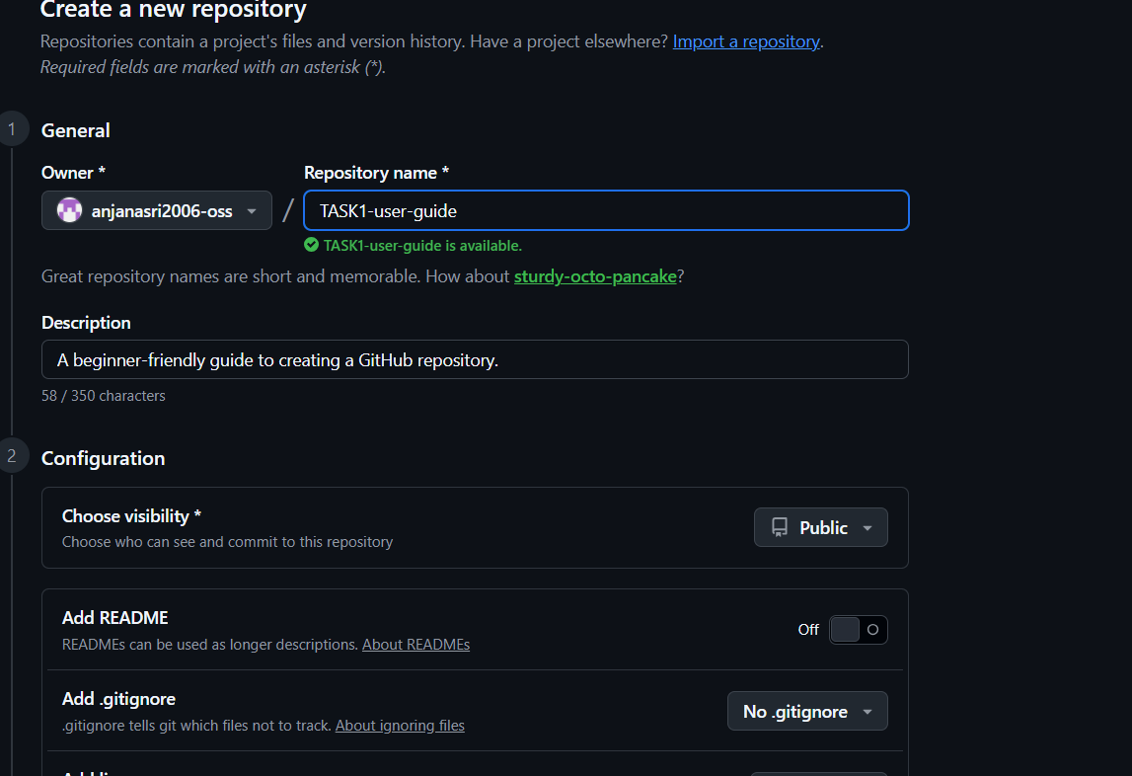

Step 4: Add a Description

- Enter a short description of the project if desired. A good description briefly tells visitors what the repository contains or what the project does.

Step 5: Choose Visibility

- Choose Public if the repository is intended to be visible to everyone. Choose Private if access should be restricted. Select the option that matches the purpose of the project.
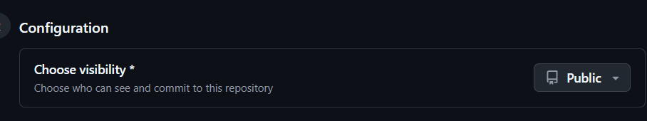

Step 6: Add a README

- Enable the option to add a README file if you want GitHub to create an initial project description file. A README can later be edited to document the project.
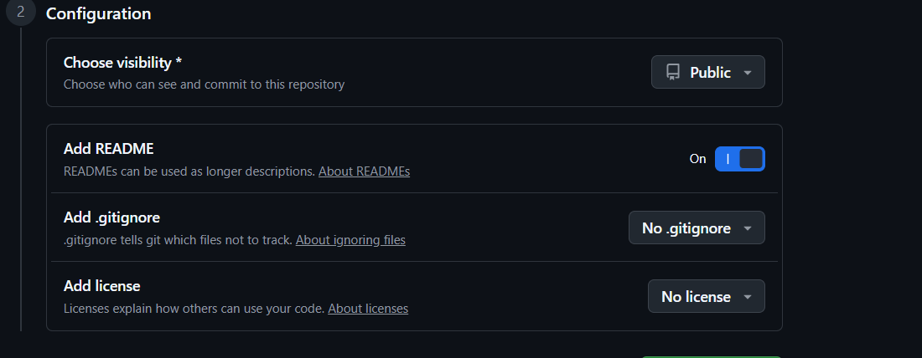

Step 7: Create the Repository

- Review the information entered in the form. When everything is correct, select the button to create the repository. GitHub will open the newly created repository page. 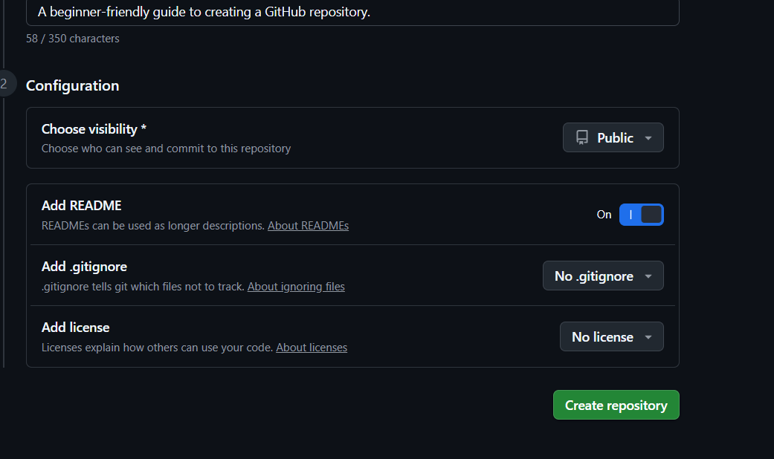

9. Verify the Repository
After creation, check the repository page. The repository name should appear at the top, and the file list should contain the files that were created during setup. If a README was selected, the README should also be visible in the repository.
- Check that the repository name is correct.
- Check that the selected visibility is correct.
- Confirm that the README file appears if you selected the README option.
- Open the repository page once more to make sure it is accessible as intended.
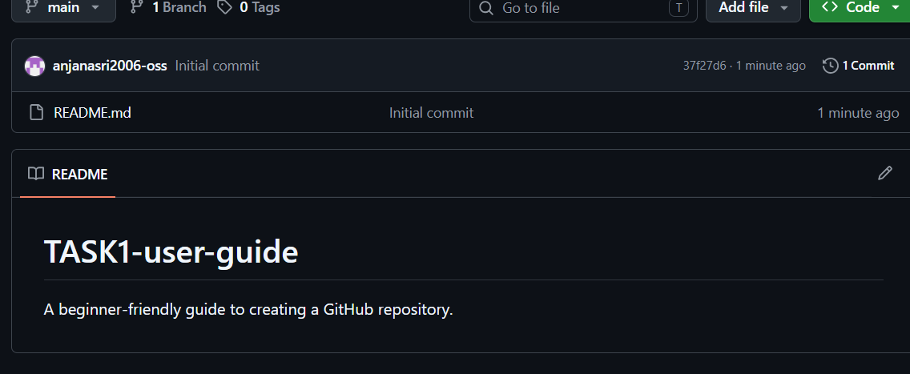

10. Best Practices
- Use a short, descriptive repository name.
- Write a useful README so visitors understand the project.
- Keep project files organized into logical folders.
- Do not upload passwords, private keys, API keys, or other sensitive information.
- Use meaningful commit messages when making changes.
- Review repository visibility before sharing the project.

11. Common Problems and Solutions
Problem | Possible solution
Cannot sign in | Check your username/email and password, and complete any required account verification.
Repository name is unavailable | Try a different repository name; repository names must follow GitHub's naming rules and may already be in use.
Wrong visibility selected | Open the repository settings and review the visibility options carefully before sharing the project.
README is missing | If you did not initialize the repository with a README, you can create one later from the repository interface.

12. Conclusion
Creating a GitHub repository is a useful first step for organizing and sharing a software project. The process involves signing in, opening the repository creation form, entering the project details, choosing visibility, optionally initializing a README, and creating the repository.
By following this guide, a beginner can create a repository with the basic settings needed to begin managing a project on GitHub.

13. Quick Reference Checklist
☐ Sign in to GitHub
☐ Open the New Repository option
☐ Enter a repository name
☐ Add a short description
☐ Select Public or Private
☐ Decide whether to add a README
☐ Review the settings
☐ Create the repository
☐ Verify the repository page

14. Screenshot Checklist
For the final submission, replace each screenshot placeholder with your own screenshots. Suggested screenshots:
- GitHub home/sign-in page
- New repository form
- Repository name and description
- Visibility selection
- README selection
- Create repository button
- Completed repository page

15. References
GitHub Documentation — use the official GitHub documentation for current interface details and repository guidance.
GitHub — official website and repository interface.

