Dimension | Strategy One | Microsoft Power BI
Primary target | Large enterprises, regulated industries, complex deployments | Broad market — SMBs to enterprise, especially Microsoft shops
Architecture | Semantic Graph (central metadata repository). Cloud-native, containerized, multi-hyperscaler (AWS, Azure, GCP, STACKIT) | Cloud-first on Azure / Microsoft Fabric. Strong in Microsoft ecosystem
Semantic layer | Mature, centralised Semantic Graph. Single source of truth; changes propagate everywhere automatically | DAX measures + Power Query. Governance possible but decentralized by default
AI capabilities | "Auto" NLQ assistant (Azure OpenAI); AI agents; auto-dashboards from sketches; BYO LLM support (Llama, GPT, offline models); MCP integration (Jan 2026) | Copilot (natural language Q&A); Azure ML integration; Q&A visuals. Tighter Microsoft 365 AI integration
Reporting | Pixel-perfect enterprise reports; report bursting; free-form subscriptions (PDF/Excel without login); high-volume scheduled delivery | Strong interactive reports and dashboards; less suited to pixel-perfect, paginated print-quality output
Data scale | No data volume or refresh limits; multi-pass SQL; intelligent cache/cube routing. Built for very large datasets | Premium required for full scale; dataset size limits exist in Pro; refresh limits apply
Mobile analytics | First-class mobile apps; offline access; mobile-first design philosophy | Power BI Mobile app available; strong but secondary to desktop experience
Embedded analytics | Low-code / no-code embedding into web apps, mobile, enterprise apps. Hyper Intelligence for in-app overlays | Power BI Embedded (Azure); requires developer effort; licensing can be complex
Microsoft 365 integration | Connectors for Teams, Excel, PowerPoint (100+ integrations); not native | Deep native integration with Teams, Excel, SharePoint, Azure, Dynamics 365
On-premises support | End-of-support for legacy on-premises announced Jan 2025 (cloud-first strategy) | Power BI Report Server available for on-premises deployments
Governance & security | Enterprise-grade RBAC + AI anomaly detection; ISO 27001, SOC 2 Type II, PCI DSS, HIPAA, FedRAMP | Microsoft Purview for governance; strong compliance in Azure; enterprise security available in Premium
Pricing | Seat-based from ~$13/user/month (standard); enterprise quotes for large deployments. Predictable — AI included, no surprise add-ons | Pro: $9.99/user/mo · PPU: $20/user/mo · Premium: $4,995/mo (capacity). Free tier available but limited
Learning curve | Steeper; fewer skilled developers available in market; powerful but complex to configure | Gentler; large community; huge ecosystem of tutorials; widely taught in training programs
Visualizations | Functional but fewer built-in chart types; custom apps possible but design can lag behind newer tools | Wide visual library; custom visuals marketplace; polished and visually appealing out of the box
Analyst ratings (2025) | SelectHub: 90 · Gartner Peer Insights: 4.6★ (902 reviews) | SelectHub: 87 · Gartner Peer Insights: 4.4★ (3,202 reviews)
Head-to-head: Strategy One vs Power BI
Capability radar (community & analyst consensus)
Enterprise scale & governance
Strategy One95
Power BI75
Ease of use & learning curve
Strategy One55
Power BI88
AI & NLQ capabilities
Strategy One82
Power BI78
Microsoft ecosystem fit
Strategy One52
Power BI97
Mobile & embedded analytics
Strategy One90
Power BI68
Visualisation variety
Strategy One64
Power BI85
Pricing transparency
Strategy One72
Power BI68
Semantic layer maturity
Strategy One95
Power BI62
Choose based on your situation
Pick Strategy One when…
You need enterprise-scale governance, pixel-perfect regulated reporting, no data volume ceilings, strong mobile + embedded analytics, or you want a vendor-neutral semantic layer (Mosaic) that can serve multiple BI tools. Also preferred for organisations leaving legacy platforms (Cognos, BOBJ).
Complex enterpriseRegulated industryMulti-BI stackLarge data volumesMobile-first
Pick Power BI when…
You're already in the Microsoft ecosystem (Azure, Teams, Excel, Dynamics), need fast self-service dashboards with a gentle learning curve, or are a smaller team with budget constraints. Also ideal if you want polished visualisations quickly and a massive support community.
Microsoft stackSMB to mid-marketSelf-service BIBudget-conscious
Here's the full deep-dive. Let me walk you through the key story:
The rebrand explained
MicroStrategy — the veteran software company known for betting billions on Bitcoin — rebranded to Strategy in February 2025 CNBC, and formally changed its legal name to Strategy Inc. effective August 11, 2025. Strategy The company now operates as two things simultaneously: the first and largest Bitcoin treasury company, and the leading provider of universal semantic layer and AI+BI software for enterprises. LeadIQ
What is Strategy One specifically?
Strategy One combines a governed semantic layer, self-service tools, and AI-powered intelligence to drive deeper insights — so teams spend less time wrangling data and more time driving outcomes. Strategy Software It connects to over 100 data sources including legacy systems, cloud platforms (AWS, Azure, Google Cloud), and third-party tools — into one governed semantic layer. Strategy
On the AI front, you can now connect your own AI models directly into the platform — whether Llama, GPT, another approved model, or even offline models for organisations with stricter data handling and privacy requirements. Strategy Software Their "Auto" AI assistant uses NLQ (natural language queries) and as of January 2026, connecting any MCP client to Agent workflows is now effortless, with OAuth 2.0 and PKCE authentication support. Strategy
The biggest differences vs Power BI
The core split comes down to philosophy:
- Strategy One is built for enterprises that need a single, governed semantic layer where business logic is defined once and propagates everywhere. Its pixel-perfect reporting, no data volume ceilings, and strong mobile/embedded analytics make it the choice for regulated industries and complex deployments. The trade-off is cost and a steeper learning curve.
- Power BI wins on ease of use, the Microsoft 365 ecosystem, visual polish, pricing accessibility, and a massive community. Power BI often suits small teams and individual analysts well, but creates challenges as an enterprise solution — technology leaders often need to bolster Power BI with Fabric and other Microsoft tools to support their enterprise data analytics strategy. Strategy
Strategy One has an analyst rating of 90 vs Power BI's 87 according to SelectHub analysis. SelectHub On Gartner, Strategy One has a rating of 4.6 stars (902 reviews) compared to Power BI's 4.4 stars (3,202 reviews). Gartner
The irony is that the two tools are increasingly complementary — Strategy's Mosaic semantic layer can actually serve data into Power BI, so some enterprises use both.
not able to understand
00:31
Let me break this down in a much simpler way!
V
visualize
V
visualize show_widget
Here's the simple version! Let me summarize it in plain words:
The name change story in one sentence: MicroStrategy (old name) → renamed to Strategy in 2025 → their BI software is now called Strategy One.
Both tools do the same basic job — they take your company's data and turn it into charts, dashboards, and reports so people can make better decisions. Think of them like advanced versions of Excel charts.
The key difference in plain English:
- Strategy One is like a heavy-duty industrial truck — powerful, handles anything, but expensive and needs a trained driver
- Power BI is like a modern car — gets you where you need to go, easy to drive, affordable, and most people already know how
For most companies in India (especially startups, mid-size firms), Power BI is the more practical choice because it's cheaper, easier, and fits well if you already use Microsoft Office. Strategy One makes sense if you're at a bank, large hospital chain, or a Fortune 500 company with a dedicated data team.
Want me to go deeper on any specific part — like pricing, the AI features, or how the semantic layer works?
how microstrategy is different from power bi deep drive into architecture
00:33
Good question! Let me build a full architectural deep-dive visually.
Great — let me walk you through the architecture of both tools, one diagram at a time, starting from the very foundation of how each is built differently.
Diagram 1 — The core architectural philosophy. The most important difference is WHERE the "brain" of each tool lives. MicroStrategy puts everything in one central place (the Semantic Graph). Power BI keeps logic spread across individual files and users.
V
visualize
V
visualize show_widget
Think of it this way: in MicroStrategy, you define "Revenue" once in the Semantic Graph and every single report uses that same definition. In Power BI, each report file (.pbix) carries its own copy of the data model — so "Revenue" could be defined differently in 5 different reports by 5 different people, causing inconsistency.
Now let's go deeper. Diagram 2 — The full internal architecture of MicroStrategy, layer by layer.
V
visualize
V
visualize show_widget
The most powerful layer is Layer 3 — the Semantic Graph. It's like the company's "dictionary" for data. When a CFO says "Revenue" and a Sales manager says "Revenue", both get the exact same number because both pull from this one shared definition. Now let's see how Power BI is built differently.
Diagram 3 — Power BI's full architecture, which is tightly woven into the Microsoft ecosystem.
V
visualize
V
visualize show_widget
Notice Layer 3 — each .pbix file is a self-contained package. The data model and logic live inside the file itself, not in a central server. This makes it easy to start, but creates problems at scale (duplicated logic, inconsistent numbers across teams).
Diagram 4 — The biggest architectural difference: how a query travels from user click to result in each system.
V
visualize
V
visualize show_widget
This is the key engineering difference. MicroStrategy processes everything on the server — your browser just shows the result. Power BI uses the VertiPaq engine, which compresses data into your computer's memory — super fast for smaller datasets, but hits a wall when data gets very large.
Finally, Diagram 5 — where data is stored in each system (Import vs Live vs Cache).
V
visualize
V
visualize show_widget
Here's a clean summary of what all 5 diagrams are telling you:
The 5 core architectural differences — explained simply:
1. Where logic lives. MicroStrategy stores all business logic in one central Semantic Graph on a server. Power BI stores logic inside each .pbix report file — meaning logic is scattered and can drift.
2. How queries are processed. MicroStrategy runs everything on the server — your laptop does almost nothing. Power BI loads data into your computer's memory using the VertiPaq engine and calculates locally — fast for small data, struggles at massive scale.
3. How data is stored. MicroStrategy reads directly from your database (data never leaves). Power BI in Import Mode actually copies your data into the report file and compresses it — so you need scheduled refreshes to keep data current.
4. How it scales. Because MicroStrategy is server-side, 10,000 users all share the same server cache — very efficient. In Power BI, each user's session runs its own memory calculations — scaling means buying more Premium capacity.
5. Governance. In MicroStrategy, if you change the definition of "Profit Margin" in the Semantic Graph, all 500 reports update instantly. In Power BI, you'd need to open and fix each .pbix file manually — or use Fabric's shared datasets, which partially solves this but adds complexity.
Want me to go even deeper into any specific layer — like how the VertiPaq engine compresses data, or how the Semantic Graph handles security?
hands on step by step on microstrategy . let consider I have a simple sales Excel file where sales data is present
00:42
Great! Let's do a complete hands-on walkthrough. I'll take you from zero to your first MicroStrategy report using a sales Excel file, step by step.
V
visualize
V
visualize show_widget
Click through all 8 steps using the Next/Previous buttons! Here's a quick summary of what each step covers:
The entire journey follows this path: your raw Excel file → MicroStrategy reads the columns → you label them as Attributes (Region, Product) or Facts (Revenue, Quantity) → you build Metrics (Total Revenue = Sum of Revenue) in the Semantic Graph → drag those onto a Grid Report → turn that report into a visual Dossier (dashboard) → share via link or email subscription.
The most important thing to understand hands-on is Step 5 — creating Metrics. In Power BI you'd write a DAX formula inside a .pbix file. In MicroStrategy you write it once in the Semantic Graph, and it becomes a shared object. Every report in your entire company that uses "Total Revenue" points to that one definition — so numbers are always consistent.
A few things that trip beginners up:
The word "Dossier" means Dashboard. The word "Document" means a pixel-perfect printable report. "Report" means a plain data grid. MicroStrategy has its own vocabulary which feels strange at first.
Also, when you first upload an Excel file, MicroStrategy creates something called a "Freeform SQL dataset" or an "Import dataset." This is a beginner-friendly shortcut, but the proper enterprise way is to connect to a database and define proper Schema Objects (Attributes, Facts) through the Architect tool.
Want me to go deep on any specific step — like how to write advanced Metric formulas, how to set up drill-downs from Region to Product, or how to add security so each salesperson only sees their own region's data?
as of now I came to understand that in microstategy all the calculations which you called matric---at first we have to calculated those matric first then build dashboard and this matric defination for all other report right ? and this matric are stored is server and and when we interact with dashboard data come from server
00:54
Yes! You understood it perfectly. Let me confirm and sharpen that mental model visually.
100% correct! Your understanding is spot on. Let me draw exactly what you described — so the mental model is locked in forever.
V
visualize
V
visualize show_widget
You got it exactly right. Let me confirm your 3 statements one by one:
"First we have to calculate those metrics" — YES, correct. You define metrics in the Semantic Graph before building any dashboard. The metric Sum(Revenue) lives on the server as a saved object. The dashboard just says "hey, give me Total Revenue" — it doesn't contain the formula itself.
"This metric definition is for all other reports" — YES, 100% correct. This is the most important thing about MicroStrategy. If you have 50 reports all showing "Total Revenue" and your finance team decides the formula should change (say, exclude returns), you change it in ONE place on the server — and all 50 reports automatically show the new number the next time they run. No one has to touch any report.
"Data comes from the server when we interact with the dashboard" — YES, exactly right. Your browser is just a display screen. When you click a filter, apply a date range, or open a chart — your browser sends a request to the MicroStrategy server, the server looks up the metric definitions, generates SQL, sends that SQL to your database, gets the numbers back, calculates the result, and sends only the final number back to your browser. Your laptop does zero calculation — it only renders what the server sends.
Compare this to Power BI — in Power BI, the data and formulas are downloaded into your browser's memory. Your laptop's RAM does all the work. That's why Power BI feels faster for small data but struggles with millions of rows.
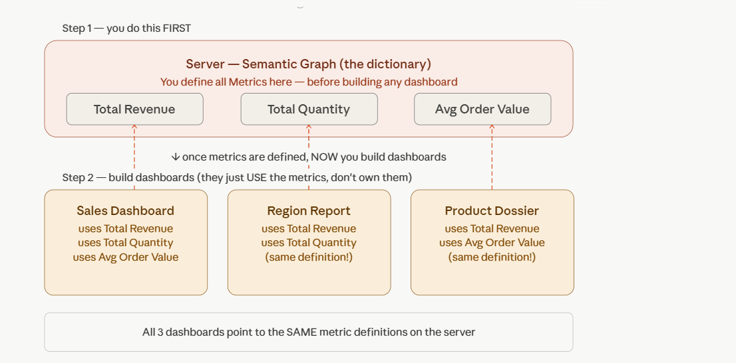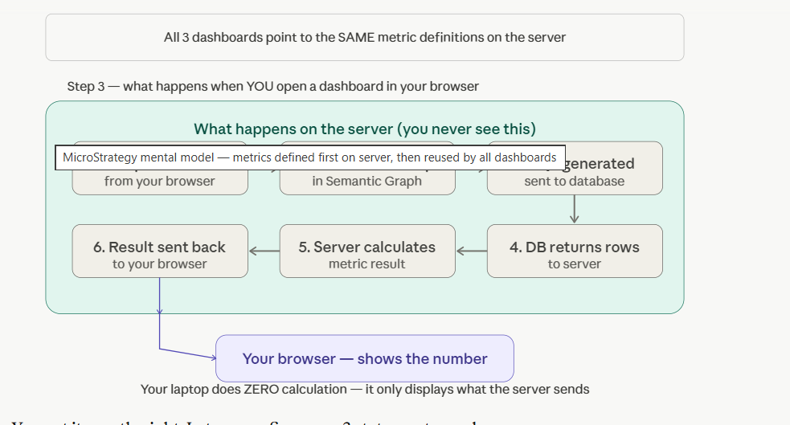

MicroStrategy (Strategy One) — Quick Revision Notes
🧠 What is MicroStrategy?
MicroStrategy (Strategy One) is a BI tool where:
👉 Data logic is defined once (centrally)
👉 Stored in server (semantic layer)
👉 Used by all reports and dashboards

🔑 Core Concept (MOST IMPORTANT)
👉 Semantic Layer (Brain)
- Central place where:
  - Metrics (calculations)
  - Attributes (dimensions)
  - Facts (numbers)
are defined

💡 Example:
Revenue = SUM(Sales)
👉 Defined once
👉 Used everywhere
👉 Change once → reflects everywhere

🧩 3 Core Objects
1️⃣ Attributes (Dimensions)
- Customer
- Product
- Region

2️⃣ Facts (Numbers)
- Sales
- Profit
- Quantity

3️⃣ Metrics (Calculations)
- Revenue = SUM(Sales)
- Profit %

⚙️ Architecture (3 Boxes)
Client → Server → Database
Flow:
- User clicks dashboard
- Request goes to server
- Server calculates
- Result sent to screen
👉 Server does all work

🔥 Key Understanding
👉 Dashboard has NO logic
👉 It only uses predefined metrics

⚡ MicroStrategy vs Power BI
🧠 Logic Storage
- MicroStrategy → Server (central)
- Microsoft Power BI → PBIX file

⚙️ Calculation
- MicroStrategy → Server calculates
- Power BI → Your system calculates

📊 Data Storage
- MicroStrategy → Data stays in DB
- Power BI → Data copied into PBIX

🔐 Governance
- MicroStrategy → One version of truth
- Power BI → Possible duplication

🎯 Ease of Use
- MicroStrategy → Complex
- Power BI → Easy

🔄 Development Approach
❌ Wrong thinking:
👉 “Define all metrics first”

✅ Correct approach:
👉 Define basic metrics first
👉 Build dashboard
👉 Add more metrics later

🧩 Simple Analogy
- MicroStrategy = Restaurant 🍽️
  - Fixed recipes
  - Same output
- Power BI = Home cooking 🍳
  - Flexible
  - Different results possible

🎯 Final Mental Model (VERY IMPORTANT)
👉 MicroStrategy
- Metric = central
- Stored in server
- Used everywhere
- Server does calculation

👉 Power BI
- Metric = inside report
- Stored in PBIX
- Your system calculates

🏁 One-Line Summary
👉 MicroStrategy is a centralized, server-driven BI tool with a single source of truth, while Power BI is a flexible, self-service BI tool.

👍 You’ve learned the hardest part
You now understand:
- Semantic Layer ✅
- Metrics concept ✅
- Architecture ✅
- Difference vs Power BI ✅

Attribute
A column that answers WHO, WHAT, WHERE, WHEN
It is a label. You group by it, filter by it, slice by it.
You can never add or subtract an attribute. "North + South" means nothing.
Fact
A column that answers HOW MUCH, HOW MANY
It is a raw number stored in the database row.
You can add, sum, average a fact. Facts become Metrics.
What MicroStrategy does with each type
What MicroStrategy does with Attributes
Places them on rows or columns of a report
Uses them as filter / slicer options
Builds hierarchies from them (Year → Quarter → Month)
Each attribute has an ID form (Region_ID) and a Description form (Region_Name)
Controls drill-down — click North → see products inside North
What MicroStrategy does with Facts
Stores the raw number from the DB row — no aggregation yet
Facts are the ingredients — Metrics are the recipe
A Metric is built ON TOP of a Fact: Sum(Revenue)
Same Fact can power many Metrics: Revenue → Total Revenue, Avg Revenue, Max Revenue
Facts are never shown directly in reports — always wrapped in a Metric
The tricky ones — columns that confuse everyone
Order_ID — Attribute, NOT Fact
Even though it's a number (1001, 1002), you never Sum Order IDs. It's an identifier — a label for each row. → Attribute with ID form.
Unit_Price — Fact, be careful
It's a number you can average (Avg Unit Price), but summing it across rows is usually meaningless. Define it as a Fact but only use it in a "Avg" or "Max" Metric.
Date — Attribute, NOT Fact
Even though dates are numbers underneath, you never Sum dates. You group by dates. → Attribute. MicroStrategy auto-creates Year/Month/Quarter child attributes from a Date attribute.
Revenue — Fact, becomes Metrics
This is the classic Fact. One raw number per row. From it you build: Total Revenue (Sum), Avg Revenue, Max Revenue, Revenue Growth % — all separate Metrics.
Fact → Metric — how the chain works
Fact: Revenue→ wrap in aggregation →Metric: Total Revenue = Sum(Revenue)
Fact: Revenue→ different aggregation →Metric: Max Revenue = Max(Revenue)
Fact: Revenue+Fact: Quantity→ formula →Metric: Avg Price = Sum(Revenue)/Sum(Quantity)
Attribute: Region+Metric: Total Revenue→ MicroStrategy generates SQL
SELECT region, SUM(revenue) FROM sales GROUP BY region

MicroStrategy | Power BI
Dossier | Dashboard
Report | Table
Document | Paginated Report
Attribute | Dimension
Fact | Column (numeric)
Metric | Measure (DAX)
c1 | Slicer
Mosaic Model | Data Model
Report = Table (raw data view)
Simple meaning:
- Grid format (rows & columns)
- Less visual
- Used for detailed data
Document = Pixel-perfect report (print format)

💡 Example:
- Invoice
- Bank statement
- PDF report

Intelligent Cube
👉 What is it?
👉 Pre-loaded data in memory
💡 Why used?
- Faster performance
⚡ Power BI Mapping:
- Import mode
Mosaic Model
👉 What is it?
👉 Data model + semantic layer

💡 Simple:
- Where you define:
  - Attributes
  - Facts
  - Relationships

Prompted Reporting: Reports that ask users to answer one or more prompts (questions) before the report runs. Prompts control what data is retrieved or how it is displayed — reducing data volume and personalising output.
01 — Value Prompt | Most common User types in a specific value — number, date, or text — to filter the report

WHAT IT DOES
Asks the user to enter a single scalar value. That value is injected directly into the report's SQL filter — e.g. WHERE Year = {user_input}. Filters happen at query time, so only matching data is fetched from the database.
SUB-TYPES BY DATA TYPE Number | Text / String | Date | Date & Time | Big Decimal | Long

REAL EXAMPLES
Date prompt: | "Enter the start date" → user picks 01/01/2024
Number prompt: | "Enter min revenue threshold" → user types 50000
Text prompt: | "Enter customer name" → user types "Acme Corp"
Date range: | Two prompts — "From date" + "To date" used together

Mandatory / Optional — Can be set as required or skippable
Default value — Can pre-fill a default so user just clicks OK
Operator — Equal, Greater than, Between, Contains, etc.
Used in — Reports, Documents, Dossier filters
SQL impact — Injected into WHERE clause at query time
Restriction — Single value per prompt (use 2 for ranges)

POWER BI EQUIVALENTS
- Date Value Prompt → Date Range Slicer or Date Picker visual
- Number Value Prompt → What-if Parameter (Modeling → New Parameter)
- Text Value Prompt → Text Filter custom visual or Search slicer
- For query-time filtering → Dynamic M Query Parameters (Power Query)
- DAX reads value using SELECTEDVALUE() or VALUES() function

02 — Element List Prompt | Pick from a list User selects one or more members from an attribute's element list — e.g., pick regions, products, or years

WHAT IT DOES
Presents a list of actual data values (elements) from a chosen attribute. User picks one or many. Report only fetches data matching selected elements. The list can be pre-filtered or limited by another prompt (cascading prompts).
SELECTION MODES Single select | Multi-select | Select all | Min / Max limit | Cascading

REAL EXAMPLES
Single select: | "Select a Region" → user picks North America
Multi-select: | "Select Products" → user picks 3 items from a list of 100
Cascading: | Prompt 1: "Select Country" → Prompt 2 list auto-filters to only show cities in that country
Limited: | "Select max 5 customers" — enforces selection limit

Attribute source — Tied to a specific attribute in the schema
Cascading — List filters based on a prior prompt answer
Max selections — Can limit how many items user can pick
Search in list — Large lists support search/filter box
Default selection — Pre-select elements as default answer
SQL impact — Becomes IN ( ) clause in SQL WHERE

POWER BI EQUIVALENTS
- Single select → Slicer (Single select mode)
- Multi-select → Slicer (Multi-select mode, default in Power BI)
- Cascading prompts → Slicer sync + cross-filter between slicers
- Large list with search → Slicer with search enabled (dropdown mode)
- Query-time filtering → Dynamic M Query Parameters for IN list

03 — Object Prompt | Swap objects at runtime User swaps which MicroStrategy objects — attributes, metrics, hierarchies — appear in the report template

WHAT IT DOES
Instead of filtering data, this prompt lets users change the structure of the report itself. A placeholder slot in the template is filled at runtime with whatever object the user picks. One report can serve many different analytical views.
OBJECT TYPES THAT CAN BE SWAPPED Attribute | Metric | Hierarchy | Custom Group | Consolidation | Fact | Filter

REAL EXAMPLES
Metric swap: | "Select a metric" → user picks Revenue, Profit, or Units. Report recalculates with chosen metric.
Attribute swap: | "Group by" → user picks Region, Category, or Channel. Report rows change.
Row + Column: | Report has a blank row slot and blank column slot — user fills both at runtime.
Multiple objects: | User selects 3 metrics at once — all 3 appear as columns in the grid.

Object types — Can restrict to specific types (metrics only, attributes only)
Object list source — From a folder, project, or curated list
Min / Max objects — Control how many objects user must pick
Template slot — Objects slot into Rows, Columns, or Page-by axis
No filter — Does not filter data — changes report structure
SQL impact — Changes SELECT and GROUP BY, not WHERE

POWER BI EQUIVALENTS
- Metric Object Prompt → Field Parameters (Modeling → New Parameter → Fields)
- Attribute Object Prompt → Field Parameters for dimension swapping
- SWITCH() DAX measure pattern for dynamic metric selection
- Calculation Groups (Tabular Editor) for time-intelligence metric swapping
- Bookmark Navigator for switching between pre-built layouts

04 — Level Prompt | Change aggregation User chooses the granularity (level) at which a metric is calculated — Year, Quarter, Month, Day

WHAT IT DOES
Controls at which level of a hierarchy a metric aggregates, independently of what attributes are displayed. A single report can show Revenue at Year level or Month level — the user picks the aggregation granularity at runtime without changing the template rows.
TYPICAL USE CASES Time hierarchy levels | Geography rollup | Product hierarchy | Org hierarchy

REAL EXAMPLES
Time level: | "Select time period" → user picks Year → Revenue shows annual totals. User picks Month → Revenue shows monthly totals.
Geo level: | "Select geography level" → user picks Country vs State vs City — metric aggregates at chosen level.
Advanced: | Display rows at Product Category but calculate Revenue at Product Item level — level prompt controls this split.

Hierarchy source — Uses a defined attribute hierarchy
Affects metrics — Changes metric calculation level only
Not a filter — Does not remove rows — changes aggregation
SQL impact — Changes GROUP BY level in metric SQL
Least common — Less frequently used than Value/Element prompts
Combined — Often paired with Element prompt for full control

POWER BI EQUIVALENTS
- No direct 1:1 equivalent — this is a MicroStrategy-specific concept
- Time hierarchy → USERELATIONSHIP() or TREATAS() in DAX
- Dynamic granularity → Calculation Groups with time intelligence
- User-controlled level → Field Parameters selecting Year/Quarter/Month
- Matrix drill-down hierarchy partially replicates the visual output

05 — Expression Prompt | Most flexible / complex User builds or selects a complete filter expression — like a custom WHERE condition — at runtime

WHAT IT DOES
The most powerful and flexible prompt. Instead of filtering on a single value or list, the user builds a complete filter condition — choosing the attribute, operator, and value(s). An empty filter qualifier in the report template is filled at runtime with the user's custom expression.
ALSO CALLED Filter Prompt | Attribute Qualification Prompt | Metric Qualification Prompt | Set Qualification Prompt

REAL EXAMPLES
Attr qualification: | User selects: Customer Age is greater than 30 — defines the attribute, operator, and value all at runtime.
Metric qualification: | User selects: Revenue is greater than 100,000 — filters report to high-value rows.
Set qualification: | Show customers where Revenue rank is in top 10% — dynamic set-based filtering.
Combined: | Multiple expression prompts ANDed together for complex ad-hoc filtering.

Attribute qualification — Filter on attribute form values
Metric qualification — Filter on calculated metric values (HAVING)
Set qualification — Filter using rank, top/bottom N, percentile
SQL impact — WHERE clause (attr) or HAVING clause (metric)
Complexity — Hardest to build and maintain
Used in — Analyst-facing self-service reports

POWER BI EQUIVALENTS
- Attribute Qualification → Slicer + Relative date / range filter in Filter pane
- Metric Qualification → Visual-level filter on a measure (basic) or What-if + FILTER() DAX
- Top N / Rank filtering → Top N filter in visual Filter pane
- Complex ad-hoc → Q&A visual or AI-assisted filtering
- No true 1:1 — Power BI is not designed for full ad-hoc expression building by end users

