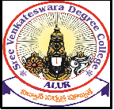
SREE VENKATESWARA DEGREE COLLEGE
(Affilated to Rayalaseema University, Kurnool)
Alur(M)Kurnool(Dist)-518395

Date:21-07-2019.

TO WHOMW SO EVER IT MAY CONCERN

This is to certify that Mr. Kathriki Ramanjaneyulu S/o K. Thayappa has worked in our institution from 17 July 2017 To 20 Aug 2019.His designation at the time of reliving was Lecturer in Computer Science.
We thank appreciate Mr. Kathriki Ramanjaneyulu for his contribution towards institution and wish him good luck for feature and endeavor.

Principal

