MWAA Downgrade Impact Analysis
Here is the data gathered regarding the performance issues currently observed. Looking closely at the metrics, it's clear the recent MWAA compute downgrade directly caused the slowdown. Everything else—data volume, pipeline complexity—stayed essentially the same.

1. Overall Batch Runtimes Increased
Starting March 27th, our batch jobs are taking about 44% longer to finish.
Timeframe | Runs Analyzed | Average (Mins) | Median (Mins)
Before Downgrade | 34 | 38.73 | 36.57
After Downgrade | 13 | 52.09 | 52.57
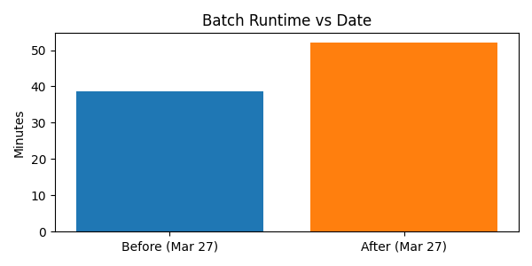

SQL Query:
SELECT
CASE
WHEN JOB_START_TIME < '2026-03-27' THEN 'BEFORE'
ELSE 'AFTER'
END AS PERIOD,
COUNT(*) AS RUNS,
ROUND(AVG(DATEDIFF(SECOND, JOB_START_TIME, JOB_END_TIME))/60, 2) AS AVG_MINS,
ROUND(MEDIAN(DATEDIFF(SECOND, JOB_START_TIME, JOB_END_TIME))/60, 2) AS MEDIAN_MINS
FROM ENT_IR_PROD.GW_INTG.JOB_STATUS
WHERE JOB_TYPE = 'sf_integration_orchestrator'
AND JOB_START_TIME >= '2026-02-16'
AND JOB_START_TIME::TIME < '12:00:00'
AND JOB_END_TIME IS NOT NULL
GROUP BY PERIOD;

2. Data Volume is Flat
A check on whether more data was being processed showed that the volume has remained completely stable.
Timeframe | Avg Records | Median Records
Before Downgrade | 6,843 | 6,500
After Downgrade | 6,738 | 6,700
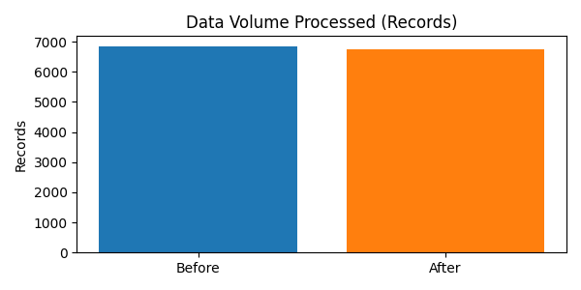

SQL Query:
SELECT
CASE
WHEN JOB_START_TIME < '2026-03-27' THEN 'BEFORE'
ELSE 'AFTER'
END AS PERIOD,
ROUND(AVG(TOTAL_RECORDS),0) AS AVG_RECORDS,
ROUND(MEDIAN(TOTAL_RECORDS),0) AS MEDIAN_RECORDS
FROM ENT_IR_PROD.GW_INTG.JOB_STATUS
WHERE JOB_TYPE = 'sc_to_sf_contact_dag'
AND JOB_START_TIME >= '2026-02-16'
GROUP BY PERIOD;

3. Slower Per-Record Processing
Because data volume is flat but time is up, the actual time it takes to process a single record is noticeably worse—about 31% slower on average.
Timeframe | Avg Seconds per Record
Before Downgrade | 0.0328
After Downgrade | 0.0431
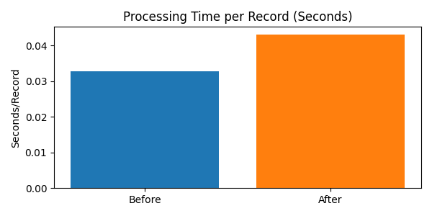

SQL Query:
SELECT
CASE
WHEN JOB_START_TIME < '2026-03-27' THEN 'BEFORE'
ELSE 'AFTER'
END AS PERIOD,
ROUND(AVG(
DATEDIFF(SECOND, JOB_START_TIME, JOB_END_TIME)
/ NULLIF(TOTAL_RECORDS,0)
), 4) AS AVG_SEC_PER_RECORD
FROM ENT_IR_PROD.GW_INTG.JOB_STATUS
WHERE JOB_TYPE = 'sc_to_sf_contact_dag'
AND TOTAL_RECORDS < 50000
GROUP BY PERIOD;

4. System-Wide Impact Across All DAGs
This isn't an isolated problem with one specific job. An analysis of different DAGs shows they all experience the exact same performance hit.
DAG | Median Mins BEFORE | Median Mins AFTER | Change
sc_to_sf_contact_dag | 3.01 | 3.75 | +25%
sc_to_sf_transaction_dag | 2.57 | 3.57 | +39%
fintrx_to_sf_account_dag | 2.04 | 2.97 | +46%

SQL Query:
SELECT
JOB_TYPE,
CASE
WHEN JOB_START_TIME < '2026-03-27' THEN 'BEFORE'
ELSE 'AFTER'
END AS PERIOD,
ROUND(MEDIAN(DATEDIFF(SECOND, JOB_START_TIME, JOB_END_TIME))/60,2) AS MEDIAN_MINS
FROM ENT_IR_PROD.GW_INTG.JOB_STATUS
WHERE JOB_START_TIME >= '2026-02-16'
AND JOB_START_TIME::TIME < '12:00:00'
AND JOB_TYPE NOT LIKE '%orchestrator%'
GROUP BY JOB_TYPE, PERIOD
ORDER BY JOB_TYPE;

5. Instant Jump on the Downgrade Date
Performance did not slowly degrade over time. It was an immediate step-change right when the infrastructure change went in.
Date | Runtime (Mins)
Mar 25 | 35.8
Mar 26 | 37.1
Mar 27 | 51.9
Mar 28 | 53.2
Mar 29 | 52.6
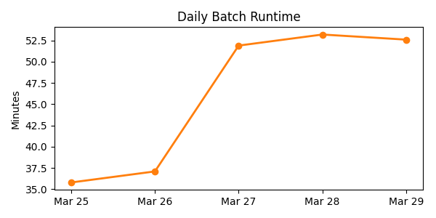

SQL Query:
SELECT
JOB_START_TIME::DATE AS RUN_DATE,
ROUND(DATEDIFF(SECOND, JOB_START_TIME, JOB_END_TIME)/60,2) AS MINS
FROM ENT_IR_PROD.GW_INTG.JOB_STATUS
WHERE JOB_TYPE = 'sf_integration_orchestrator'
ORDER BY RUN_DATE;

6. Real-World Example (April 10)
Just to ground this with a concrete run: if we take a baseline run and compare it to a recent one on April 10, the pipeline is processing fewer records but taking almost twice as long.
Comparison | Records Processed | Total Time | Speed (Sec/Record)
Typical Old Run | ~6,500 | ~3.6 mins | ~0.033
Recent April 10 Run | 5,586 | 6.8 mins | 0.073
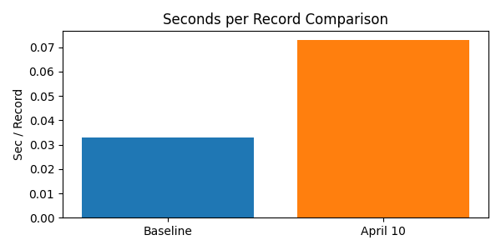
Takeaway:
The runtime regressions currently observed are tied directly to the reduced compute footprint on MWAA. Since job complexity and data volumes haven't shifted, the smaller resource pool is simply being maxed out. A discussion is needed to determine if this should be reverted or if the longer runtimes are acceptable for the business.

