Business plan for startup IT company “Home Food”

Anjan Khatri

Marymount University

IT 489 Capstone Project: Project Plan and Literature Review

Faculty Advisor: Dr Natalia Ermicioi

Date: 03/21/2021

“On my honor, I have neither given nor received aid on this assignment.”

Abstract

Building a startup company requires an idea and the plan to execute. It is difficult to start a company without the proper business model. There are several competitors in the market for this product, so it is very efficient to research about those products as well. In addition, a company starting as a small business have to go through series of rule and regulation of the country and states. The finding gives the proper information about the starting an IT business in the US which has explanation of market need and market research.

Key word: Marketing, product, delivery apps, budget, advertisement, self-employed, technology, entrepreneurs.

**Table of Contents**

**1.** **Introduction** 3

**2.** **Faculty Advisor and Mentor** 4

**3.** **Project Schedule** 4

Table 1: distribution of task. 5

Figure 1: Gantt chart for project timeline 6

**4.** **Resources, Expected Outcome and Possible Challenges** 7

**5.** **Literature Review** 7

5.1 Key terms and literature sources 7

Table 2: Direction and resources 8

5.2 Summary of the Resources 8

5.2.1 How to Startup a Company? 8

5.2.2 Marketing tools and Competitors 9

Figure 2: Marketing tools 11

5.2.3 Target Audience 12

5.3 Findings 13

Table 3: Literature review findings table 13

**6.** **Methodology** 16

6.1 Requirement 16

6.1.1 Functional requirement: 16

6.1.2 Nonfunctional Requirements: 18

6.2 Case Diagram 20

Figure 3 Case diagram of interaction 21

6.3 Basic Entity Relation Diagram of Database 21

Figure 4: Basic ER diagram 22

6.4 Activity Label diagram 22

Figure 5: Activity diagram 23

**7.** **Conclusion** 23

**8.** **Work Cited** 25

# **Introduction**

Home Food is a food delivery service that I am planning to launch in the future as a start-up company. This business plan is estimated to work after graduation. Home food is the idea of providing the food delivery service in the local community. This project is based on the home food app's business plan, which will be launched and deployed soon. In this project, I will be drafting the business plan to implement the knowledge that I learned and launched the product in the market. This project will solely be focused on the business plan only. This research-based project will be concentrated on the scope and starting the company, analyzing the need for this application, and researching its competitors. The idea of building up a business plan for the app development company show the way to become an entrepreneur in the future. All the of the giant IT company as well as the popular delivery app in the market are well planned and are built with the strong foundation with market research, user needs and financial involvement in the company. A company can be succeeded with the proper vision and research about the need and market condition. Sometimes the idea might work despite lack of market research but most of the time the idea fails. (Spaeder, 2019). In this project, market research and targeted audience are the important part to launch and achieved the success. This project is a business model plan to develop and deploy a food delivery app which will be deployed in the market by a fresh graduate student. Since this development involves a setting up a company based on US small business rules and regulation, analysis of competitors in the market, and technical requirement for this company. This literature review opens with the overview of requirement to establish a small business in the US, market need of this company, and targeted audiences. It also focusses on the advertisement and analysis of the current competitors. It will conclude with the structured and sufficient information to work forward in this business plan.

# **Faculty Advisor and Mentor**

This project will not be perfect without the help of the mentor and advisor. Dr. Natalia Ermicioi and Professor Micheline Al Harrack will be assisting in completing this project. Dr. Natalia has the expertise of more than ten years in training and non-formal education, and she had a diverse skillset around the world. She holds multiple bachelor's degrees, including economics, which is essential for this project. She also has a better understanding of the Information technology market around the world. Most importantly, she holds a doctorate degree in cybersecurity and has a better understanding of the Information technology world as she taught IT global ages at Marymount University. Professor Micheline Al Harrack is a visiting professor at Marymount University who is passionate about project management. She taught Project management in my junior year. She holds a master's degree in Business Administration in Management and a Master of science in project management concentration. She has a better understanding of the IT business model in the United States. Professor Al Harrack's areas of interest include machine learning application, statical analysis, function point, linguistics, and cybersecurity. She has served as a session moderator at regional and national conferences. The advice and help from qualified professors like Dr. Natalia and Professor Al Harrack will help me make this business plan doable.

# **Project Schedule**

The project plan indicates the project schedule, which includes the date to make sure that the task has been completed and we are not behind schedule. The timeline for this project includes:

* 02/17/2021: Proposal draft includes the proper planning of schedule of research topics based on the course syllabus.
* 02/24/2021: The research and find the literature source to support the project's core idea and draft of literature review.
* 03/14/2021: The final report of the project proposal following the feedback from the professor.
* 03/24/2021: Progress reporting, which includes research sources between 10-15 sources. By this time, a draft of the project report should be prepared.
* 04/07/2021: The preparation of prototype and project presentation begins based on the drafted project report.
* 04/21/2021: Meet with the professor and mentor for presentation.
* 04/28/2021: Submit final report and Retrospective of the project.

The schedule mentioned above is based on the syllabus, which is subject to change, but the submission of the report and draft will not change. The distribution of the tasks for this project is listed below.

## Table 1: distribution of task.

|  |  |
| --- | --- |
| Week | Task |
| Feb 15 - 17 | * Research on pitch and motivation of this project, present market condition, target audience. * Research on Competitors and platform for this company * Need of Operational and management role in this company. |
| Feb 18- 19 | * Research on feature description of the project. * Functional and non-function specification including Prototyping of the application. * Research on Design Strategy and plan for marketing and sales plan of this application. |
| Feb 20 – 24 | * Research on financial plan and budgeting involving business cost, revenue, and funding figure for app development project. * Draft a literature review based on the above findings. |
| Feb 25 – March 14 | * Final project proposal based on professor and mentor feedback. |
| March 11-24 | * Finalizing the literature review for the final paper * Drafting the overall findings as a project report draft |
| March 25-April 7 | * Prepare for the presentation |
| April 8- 21 | * Meet with professor to finalize the project report and schedule the project presentation |
| April 28 | * Project Retrospective and final report |

## Figure 1: Gantt chart for project timeline

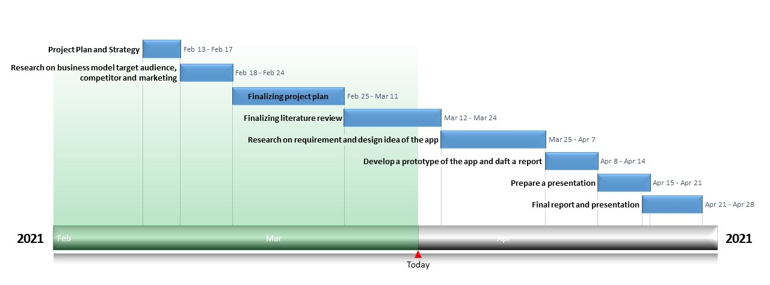

# **Resources, Expected Outcome and Possible Challenges**

Most of the resources for this research project will be from the Marymount library and other open-source libraries. Some of the resources will be from similar existing companies in the market and their websites. The project ends up with the idea of designing the application. For the prototyping of the application, I will be using online tools or adobe tools that are also open source. The expected outcome of this project is to enrich knowledge to the start-up of an IT company after graduation. This research will prepare a full business plan that will be used as a blueprint to start a company. The report will be prepared in a professional manner such that it can be presented in TechExpo and in front of the interested investors. There are a lot of challenges that lie ahead to complete this research project. Preparing a business plan is a huge step, and it takes time to find the actual articles over the internet since the different business has different business model, so it is challenging to figure out which business model work perfect to succeed in implementing this project in future.

# **Literature Review**

## 5.1 Key terms and literature sources

The important terms and the direction of the sources are used in this section of the paper. The research project is based on the business plan so it will focus more on the demand of the app and the market analysis. It will research on the practical aspect of the app that will be the product of this business plan. The literature sources are widely collected from the different websites and library. It used the academic searches and some articles published in the journal and some information from the government websites. In addition to that the key terms used to search the articles are small business, mobile App development, food delivery, startup, self-employment, marketing tools and entrepreneur. Table 2 contains the direction of the resource and the types of sources used.

## Table 2: Direction and resources

|  |  |  |  |  |  |
| --- | --- | --- | --- | --- | --- |
| SN | Direction of Research | Academic articles | Journal | Government websites | total |
| 1. | How to Startup a company? | 0 | 1 | 1 | 2 |
| 2. | Marketing tools and competitors | 3 | 1 | 1 | 5 |
| 3. | Target Audiences | 2 | 1 | 0 | 3 |
|  | Total | 4 | 3 | 2 | 10 |

## 5.2 Summary of the Resources

The academic literature and professional review were collected to help building the structure of the startup company. The literature review focus on overall problem and clarify the findings to encourage a fresh graduate for startups.

### 5.2.1 How to Startup a Company?

It is difficult for the newly graduates to start an IT company. There are several rules and regulation to follow in starting a new business. According to U.S. Small business Administration, “Starting a business involves planning, making key financial decision, and completing a series of legal activities” (SBA). Starting a business, only a product is not enough to make a successful business. It is found that at least nine out of ten companies fail even after the large sum of money is spent. (Fletcher, A. C., & Bourne, P. E. 2012). Success of the business comes from the extensive market research, realistic business model and application of good all-around business skills to all aspects of the business. Most of the business in the united states are small business and SBA is helping to grow the business which has strong business model. Starting up the company requires legal, ethical and regulatory environment. A business establishment requires manpower to proceed which includes Lawyers, Accountant, insurers and many other professionals (Fletcher, A. C., & Bourne, P. E. 2012). The business requires a location and business structure that determines the need of registration. Registration is important step in starting up as thye help in personal liability protection, legal benefit and tax benefit. Business are registrated in Federal, States, and Local agencies. According to SBA, most businesses are not required to register with federal government to become a legal entity other than simply filing to get federal tax id. They register with federal agency for trademark protection. The company like LLC, corporation, nonprofit are required to register in state where the business is conducted, in our case Virginia. The business requires a license and permit from the county or city if required but company must have tax id which is also known as employer identification number (EIN). EIN is like a social security number, but they are for business which let small business pay state and federal taxes (US Small Business Administration)

### 5.2.2 Marketing tools and Competitors

Marketing is essential step for mobile app development entrepreneurs. To develop the delivery app requires technical knowledge but to make it popular and success, it need marketing strategies. Marketing research techniques tends to be essential for IT business owners when analyzing the customer need and competitors lack to provide that need to the customer. Business owners seek a way to sell their product with advance marketing strategies and it is opportunity for the entrepreneurs to connect and establish relation with the customer and fulfil the gap that current competitors fail to provide (Mojica et al., 2014). Online market has experienced the strong growth over the past decade as customer increasingly move online which has increase the potential of technology developer to enter in the IT business environment. Online food providers are growing in the small restaurant business. Food delivery service requires highly efficient and scalable real time delivery services and which ever company fulfil the efficiency move ahead in marketing. (Li, C., Mirosa and et al. 2020). It is very important to focus on the an insight of the delivery need of the customer – what they want and what is valued. In the food delivery service it is essential to view on how the market is responding to these need and opportunity that the need of the customer creates. The other marketing strategies is to look for the data and statistics about the customer perceptions, attitude and behaviors. Customer wants flexibility and this project will work for the customer not for the competitors. According to Andrew Starkey data set, around 43% of people from the sample size of 450 household are the online consumers and 43% of them agree that delivery experience and delivery offer from the retailer can influence their choice (Andrew Starkey, 2010). The marketing must consider the main reason for customer satisfaction for delivery lies within the customer service and also it should meet the customer’s expectation and is communicated and promoted effectively.

The other important marketing strategies for this project is social media marketing. Social media marketing is getting very powerful channel which is budget friendly and mainly focus on the targeted audience. Effective use of the social media marketing helps the startups to create a company brand, generate interest, awareness and continuing customer engagement. “Entrepreneurs running small businesses and startups have limited resources and budgets; therefore, social media networks are used to promote their brand at very little financial cost. Moreover, social media has also proved to be a strong word-of-mouth advertising tool to market products and brand awareness” (Basri, Wael & Siam, 2017). This shows that social media marketing is one of the easiest and effect ways to of marketing in this digital world. The summary of the marketing cycle is represented by figure 2 below.

## Figure 2: Marketing tools

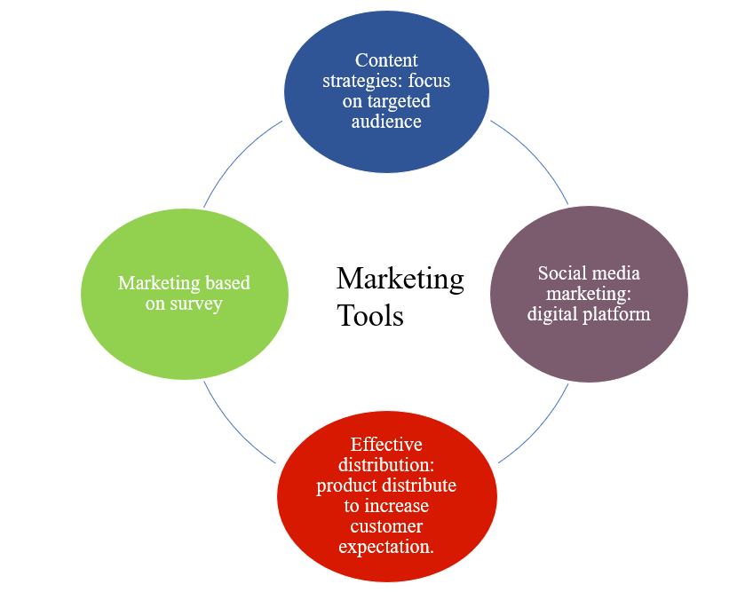

There are many apps that are launched and running successfully in the market. Some of the most popular competitors are UberEATS, Door Dash, Grub Hub, and Post Mate. All of these food delivery service works from restaurant to customer. When facing with the competitors we must know how often your business would compete with them and how you would tailor your messages when competing with each of these group? (Spaeder, 2019) these app charge restaurants for their services and since there are many services competing in the market, they are not making a huge margin of profit. Focusing on competitors in the market, this business model use different approach in the food delivery services. The app which is the main proposal of this research will focus on the same customer, but the food provider will be the different vendors. The existing app use the food vendor as local restaurant of specific area and they deliver the food of the restaurant to the users, but this project app will focus on household as a food vendor. People staying home can cook and sell their food without obligation and without the need of fancy kitchen like restaurant. This app will provide the platform to the people who are interested in cooking at home. In doing so, customer can get the home-made food based on their preference. Since the food market is huge in the United States but this company will not be competing with the exiting complete that are already in the market because it has different approach and different platform.

### 5.2.3 Target Audience

This app will specifically target college students, young adults, parents, and working professional. It is often challenging for the startup company to find the targeted audience. This product focus on two aspect of the audience one to provide delivery service and other aspect is making some earning in free time. The product of this company will not only provide the delivery service to the people but also help them to generate the income and encourage to be self-employed. In the food delivery business, most popular demographic are college students and young adults (Baldwin, 2018). They are mostly engaged in the classes, active social lives and new careers, there are little to no time to think about what they are planning to eat and it is easier for them to order food rather then make by themselves. However, they are also conscious about what they are eating to maintain their body. Most often food from the restaurant do not provide the sufficient nutrient as they needed. According to the research form University of Illinois kinesiology and community health by Ruopeng An, (Diana Yates, 2015) consuming the food at restaurant and fast food increase the risk of obesity, and heart disease and also the food that are consumed in the full services restaurant is not necessarily healthier. He recommends that it is healthier to consume diet that are prepared at home. So it would be better if they get the food which are prepared at home and be able to deliver to them. The targeted customer are included as professional worker who spent 9-5 schedule in the office. They do not have time to prepare their food which force them to eat at the fast food or restaurant meal. These targeted audience are the people who use their app to make an order, but this app also focus on generating income when people are staying home. The other aspect of this product will help people who enjoy cooking at home. This platform will help to sell their food in the market. For example: Anyone can cook food and post about their menu in our platform which will be viewed by the targeted audience. These audience will order food directly from them and we will fulfil the order with the help of delivery drivers. This will help people to be self-employed and they do not need a well-furnished restaurant or license regulation to open a restaurant. They can run their business from home. According to the US bureau of statistics, the unemployment rate during the global pandemic in the US was 13.2% in the month of May 2020 where many people lose their jobs and many businesses closed. During that time, where people were staying at home, they could have utilized that time to generate some extra money using this platform. There are many people who can be self employed by selling the food that they prepare at home. “Self-employment is often perceived to be a desperate effort of workers who have been laid off and unable to find work again” (Goetz and et al. 2012).

## 5.3 Findings

From this literature we find the following evidence:

## Table 3: Literature review findings table

|  |  |
| --- | --- |
| How to startup a company? | * There are several steps involved in starting a company in the United states (SBA). * The Startup company must be register with the federal agency or the state agency depending on the benefit and resource of the company. (SBA) * There are the higher changes of failing with out a business plan and model (Fletcher, A. C., & Bourne, P. E. 2012). * A business establishment requires manpower to proceed which includes Lawyers, Accountant, insurers and many other professionals (Fletcher, A. C., & Bourne, P. E. 2012). * Starting a business requires a Tax ID (SBA). |
| Marketing tools and competitors | * Advance marketing strategies the is opportunity for the entrepreneurs to connect and establish relation with the customer and fulfil the gap that current competitors fail to provide (Mojica et al., 2014). * Food delivery service requires highly efficient and scalable real time delivery services and whichever company fulfil the efficiency move ahead in marketing. (Li, C., Mirosa and et al. 2020) * Delivery experience and delivery offer can influence the choice of the customer (Andrew Starkey, 2010). * Social media has also proved to be a strong word-of-mouth advertising tool to market products and brand awareness” (Basri, Wael & Siam, 2017) * When facing with the competitors we must know the impact on competition with them and ways to tailor our messages when competing with each of these group (Spaeder, 2019) |
| Target Audience | * In the food delivery business, most popular demographic are college students and young adults (Baldwin, 2018). * Self-employment is often perceived to be a desperate effort of workers who have been laid off and unable to find work again” (Goetz and et al. 2012). |

From the above finding, we can conclude that starting a company is not a easy task. It requires us to follow certain guidelines provided by the states and federal government. However, we can get help from these agencies to establish the company. The decision whether to use the federal agency or state agency depends on motive of the company. They have different level of benefit in each agency level. Startup must be concern and hire lawyer, accountant, and other human resource for the effective business plan. In the current situation, social media marketing is the best way to reach to every targeted customer. Marketing strategy is the important for the growth of the company. We must look after the competitor, but we must focus more on the customer satisfaction and experience to establish the online business. It is very important to look for the demographics of the area and for this specific project, our main targeted audience are the college students. Young adults and working professionals whereas our targeted vendors are parents and people who are laid off and unemployed.

# **Methodology**

## 6.1 Requirement

The purpose of “Home food” delivery system is to make user convenient to order the food that are prepared at home and help people who are interested in preparing food at their home to be self-employed. This platform is a bridge between user who want to get healthy home prepared food and user who want to earn extra income by selling their food from home. The whole application consists of front-end design for user interaction and back-end structure to store the information and connect to the delivery drivers. The features of the system consist of functional and nonfunctional requirement.

### Functional requirement:

**Table 4:** Functional Requirements

|  |  |  |
| --- | --- | --- |
| SN | Functions | Description |
| 6.1.1.1 | Registration | User can register account with personal details, so they have username and password for logging in. |
| 6.1.1.2 | Login | User can enter their username and password so that they can login to the system |
| 6.1.1.3 | Username or Password retrieve | User can retrieve their information in case they forget |
| 6.1.1.4 | Profile | Application shall allow user to update their profile and information, so they are up to date |
| 6.1.1.5 | Area selection | User can select the area so that they are ordering or post the food available within the specific miles. |
| 6.1.1.6 | Search | User can search for specific food posted by the other user to find what they are looking for |
| 6.1.1.7 | Post area as customer | As a user, I can post about what kind of food I am looking for in the form of text or media attachment so that vendor can contact customer. |
| Customer post have reply section so vendor can provide the details about their food service |
| 6.1.1.8 | Post area as vendor | Vendor can post with the description of type of food they are serving and price so that customer can easily find their match. (post can be text or media). |
| Vendor’s post will have order function and more information function |
| 6.1.1.9 | Order | As a customer, I can click order function from vendor post so that I can order the food from them |
| 6.1.1.10 | Menu and quantity | Customer will select the desire quantity and select from the menu posted by the vendor to order their requirement |
| 6.1.1.11 | Special Request | Customer can request for special accommodation in food for example spice level or allergic. |
| 6.1.1.12 | Payment | Customer input the payment information so that they can order food from that vendor |
| 6.1.1.13 | Confirmation | Application shall send the confirmation to vendor about the order so that they can prepare the food and make it ready for delivery. |
| Application shall send the confirmation to the user about their order history and estimated time of food arrival. |
| 6.1.1.14 | Cancel | Customer can cancel their order for any unusual event |
| Vendor can cancel the placed order for any unusual event. |

### Nonfunctional Requirements:

**Table 5**: Nonfunctional Requirement

|  |  |  |
| --- | --- | --- |
| SN | Non-Functional requirements | Description |
| 6.1.2.1 | Data requirement | 1. User must enter the correct data like mobile number, credit card information and time. |
| 6.1.2.2 | Compatibility | 1. The application shall be compatible with iOS, Android, windows, MacOS, and iPadOS |
| 6.1.2.3 | User interface | 1. Application interface should be familiar as possible to user who have used other application following the interaction style. 2. User interface must follow the universal design rule. |
| 6.1.2.4 | Security | 1. Access will be controlled with username and password. It must use SSL (Secured Socket Layer) in all the transaction that has confidential information of user like card information. 2. Application should log out the user after certain period of inactivity. 3. Application should not leave any cookies on user device containing password. 4. Sensitive data must be encrypted before sending over insecure connection like internet. |
| 6.1.2.5 | Reliable | 1. Backing up the data in secure database. 2. Maintain and update application to reflect the recent changes. 3. Stability of system and its underling operating system. |
| 6.1.2.6 | Availability | 1. Application should have high availability and low downtime. 2. User can access it all the time and incase of failure it should backup data and should be able to retrieve it. 3. System should handle the increased load without problem of failure |
| 6.1.2.7 | Latency | 1. Ordering food should be very fast |
| 6.1.2.8 | Testability | 1. Frequency testing of the application to find the issue and resolve it. |

These are the general functional and nonfunctional requirement of the application.

## 6.2 Case Diagram

The purpose of use case diagram is to demonstrate the different ways that user might interact with the system. It helps to discuss and represent the scenario in which the application interacts with customer and vendor. The case diagram does not go into a lot of details, but it gives a proper high-level overview of relationship between user and system. In this application, case diagram is simple representation of interaction between user and application.

## **Figure 3** Case diagram of interaction

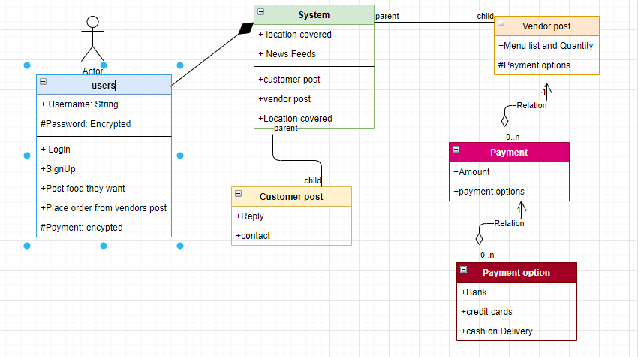

In this case diagram, primary actor or user can be customer as well as vendor who has username and password attribute which function are logging in, posting information in the app and payment. When user login, then it has a system which consist of location and new feed attribute. The function of this system class is to make user post their preference specifying whether they are food provider or customer. The system is a parent class of two child class customer post and vendor post. Vendor post has menu list of food and payment options. It has multiple payment option the relation is one to many. Customer post has replay and contact so that food provider can contact them about their needs.

## 6.3 Basic Entity Relation Diagram of Database

The entity relation diagram is the basic structure of database that represent the entities and their relationship in a database. This application consists of the database which store the information of users.

## Figure 4: Basic ER diagram

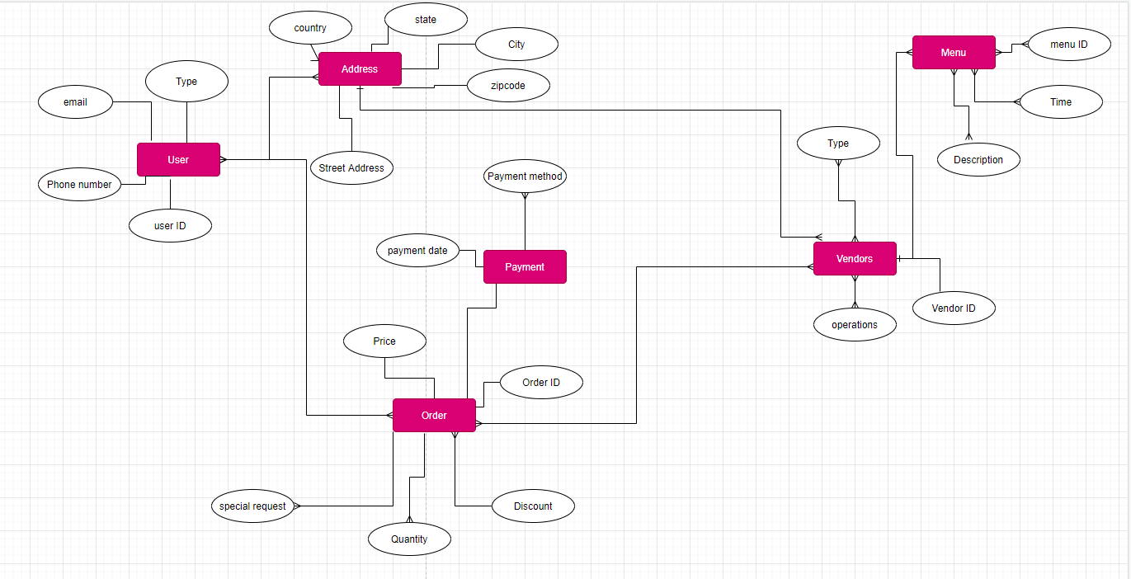

The entities which represented in rectangle boxes are concept about information that are to be stored and oval boxes are the attribute of the given entities. Fork’s symbol are representing one to many or many to many relation between these entities.

## Activity Label diagram

Activity label diagram is the visual representation of series of action or flow of control in the application similar to the flow chart. Activity label diagram is commonly used in business modeling process and in manager label. This is the important aspect of creating the model on how the system should behave in the business label. In activity diagram below, represents decision node with questions,

## Figure 5: Activity diagram

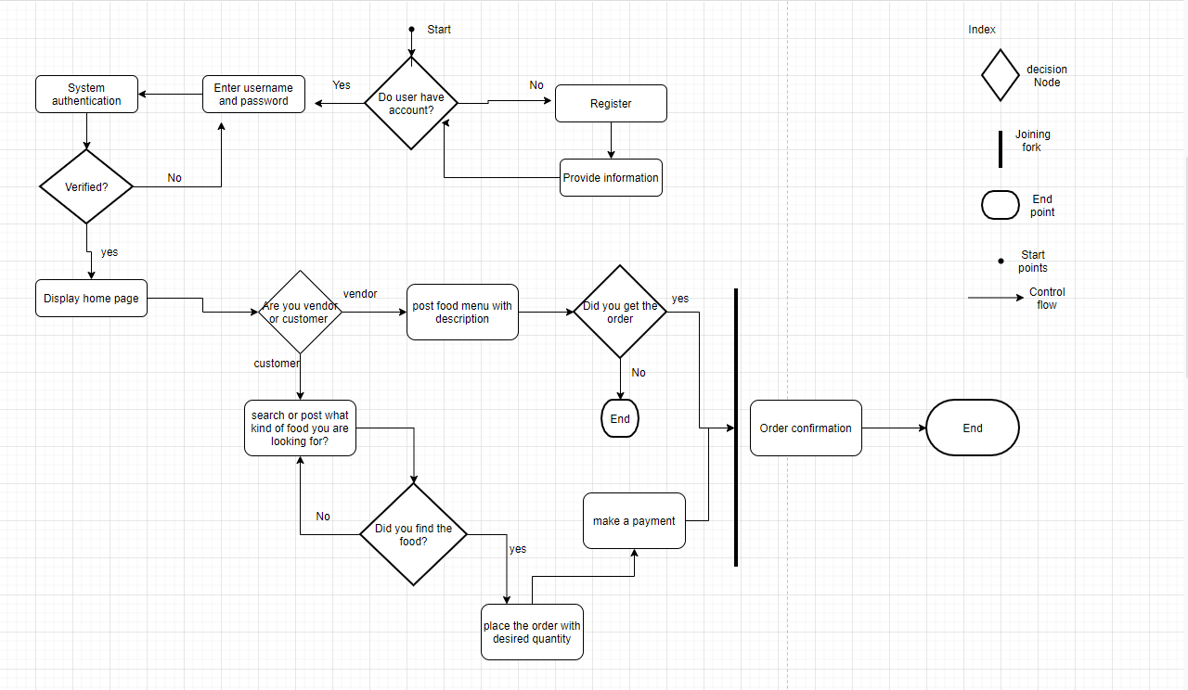

# **Conclusion**

Business model and design of home food app was an interesting project to work on. This project starts out as a business plan for a startup and end with the simple design and requirement for basic application. It was the combination of research as well as practical side. Research side of this project gives the proper understanding of establishing a business in the United States and researching on the need and targeted audience. With out the proper research on market analysis, it would be difficult to deploy an application. While researching about the market, it was found that there are many competitors in the market with the huge investment. Although they have similar business model, they are completely different in terms of their platform. The established company like UberEATS, door dash, grub hub are online delivery services that select restaurant as a food provider. Our platform select user who are at home are the food provider which mean food provider do not need restaurant to sell their food, they can sell their food from their home which is the basic scope of this project. Researching about the targeted audience, we found that the possible target audience are college students, busy professionals, health concerned people and people who are passionate about cooking. Any startup company requires creative way of marketing, so we found that digital marketing is best option for starting a company. Based on the market research we implement the requirement methodology to create an option for creative design and prototype. This project gives the foundation to many possibilities to improve this project for future work. The requirement analysis and class diagram open door for other improvement and implementation in the future which was the main scope of this project.

# **Work Cited**

Baldwin, Daniela (Mar 13, 2018). 3 Target Audience to Market Your Meal Service To. Anthem Branding. [https://medium.com/@anthembranding_boulder/3-target-audiences-to-market -your-meal-delivery-service-to-a4f18e353527](https://medium.com/@anthembranding_boulder/3-target-audiences-to-market%09-your-meal-delivery-service-to-a4f18e353527)

Basri, Wael & Siam, Mohammed. (2017). Maximizing the Social Media Potential for Small Businesses and Startups: A Conceptual Study. International Journal of Economic Perspectives. 11. 241-245.

Fletcher, A. C., & Bourne, P. E. (2012). Ten simple rules for starting a company. PLoS computational biology, 8(3), e1002439. <https://doi.org/10.1371/journal.pcbi.1002439>

Goetz, Stephan & Fleming-Muñoz, David & Rupasingha, Anil. (2012). The Economic Impacts of self-Employment. Journal of Agricultural and Applied Economics. 44. 10.1017/S1074070800000432.

Li, C., Mirosa, M., & Bremer, P. (2020). Review of Online Food Delivery Platforms and their Impacts on Sustainability. Sustainability, 12(14), 5528. MDPI AG. Retrieved from <http://dx.doi.org/10.3390/su12145528>

Mojica, I., Adams, B., Nagappan, M., Dienst, S., Berger, T., & Hassan, A. (2014). A Large-Scale Empirical Study on Software Reuse in Mobile Apps. IEEE Software, 31(2), 78–86. <https://doi.org/10.1109/MS.2013.142>

Spaeder, K. E. (2019). Retrieved from How to Research Your Business Idea: <https://www.entrepreneur.com/article/70518>

Starkey, A. (2010). e-Retail — Using home delivery as a service differentiator and strategic marketing tool. Journal of Direct, Data and Digital Marketing Practice, 12, 165-173.

U.S. Small Business Administration: [https://www.sba.gov/business-guide/launch-your business/register-your-business](https://www.sba.gov/business-guide/launch-your%09%09%09%09business/register-your-business)

YATES, D. (2015, July 1). Study: Restaurant meals can be as bad for your waistline as fast food is. Illinois News Bureau. <https://news.illinois.edu/view/6367/236713>