**Marymount eConcierge**

*Anjan Khatri*

*IT 355A-Software Testing & Quality Assurance*

*Dr. Alex V Mbaziira*

*Date: 10/16/2020*

Table of Contents

Introduction 2

Overview 3

Navigation and Conclusion 5

# Introduction

Marymount University eConcierge is the internal search engine tool for the Marymount student and faculty that provides the answers and guides a new user to give the defining features in university policy and procedure. This web application provides information about the university policies and prompts users to the link they are looking for. For example: if we look for the fitness center hours, we may get different results that confuse the student. However, when we search from Marymount University's eConcierge, it will prompt the user to the link that will directly send users to the athletics and recreational center. The search on the eConcierge will provide the instant user answer to what they are looking for. Marymount eConcierge is a part of Marymount commons, and it has many different features that will help the student find the resources. It has a search bar that directly navigates the users to their search. This web application has a heading of the features, and each heading contains the articles and the link which will send the user to their result.

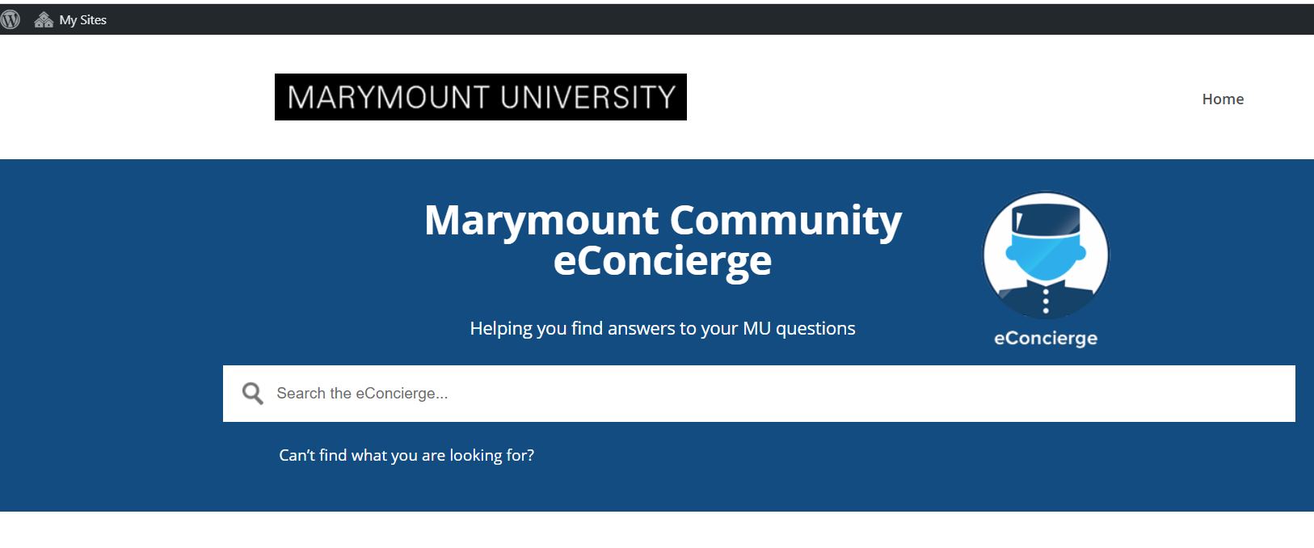

# Overview

Since all of the headings are listed in alphabetical order, it will be easy for them to navigate it. "Academic matters" features have listed 90 articles in it, and each of the articles is posted at a different time and frequently updated by the University. It has articles that explain most of the commonly used tools and current affairs. It has a Zoom description, which is the most important tool for video conferencing and taking classes these days, article on coronavirus, which will take the user to the link of student health and wellness that provide the COVID19 information as well as hotline number and email. Most of the article in this section is related to the academic's sector of the University. It has listed the articles about the operation hours, departments information, off-campus work opportunities, applying for scholars program, library service for adjunct faculty, admission information for international students, undergraduates and graduate students, academic advising centers, and other tools like starfish appointment, bookstore information and most importantly Marymount portal. The next feature, "Athletics," has around six articles that have information about participating in athletics and intramural sports at the University. It directly prompts users to the student athletics handbook, which has all the policies and procedures about Marymount athletics, and athletics articles will directly take the athletics website of Marymount University.

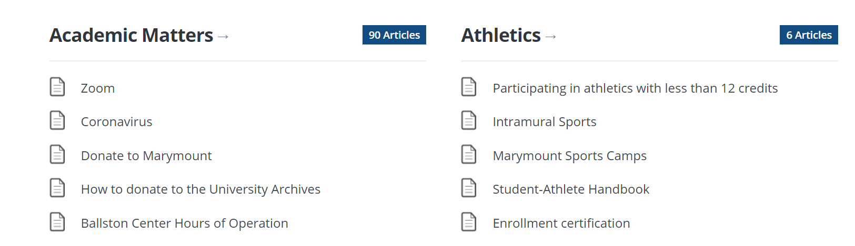

In addition to that, it has Business function features that have an article that refers to the business conduct of the University, which provides the information about the refund process, account payment and reimbursement form, support services, and operating expense object codes of every year. It has all the article that deals with the business aspect of the University. The other features are campus services, which have around 48 articles that provide information about the University's operation like hours, location, MU alerts, parking, residency hall information, MU ID, and everything related to campus services. eConcierge feature provides information about the policies and helps guide. The employee resource feature has information about everything related to the on-campus job or Marymount employers. It prompts users to understand Handshake (job search platform), W2, background Investigator request, and all other resources. Events features in this web application provide information about different events at the University, including reserving for the event, the bark, planning event on campus, and so on. Faculty resources are for the university faculty member, which helps locate the specific thing as a faculty like becoming faculty mentors, connecting with the University, and answering all other faculty-related questions. HR forms service are the human resource information of the University, and Information technology services are IT related information; however, Information Technology services is different from IT faculty or academic. This feature is mostly related to technology used in the University and tech support of the University. News features provide information about recent news and announcement broadcasted in the University, and policy and planning features provide information about strategic plans and policies within the campus like academic integrity and rules. The essential features that we will be navigating in this paper are student resources. It has all the information necessary for the student to understand the university policies and navigate the different tools that students will be using throughout their university journey. It has almost 281 articles where all the information answers the question and helps navigate the Marymount website. It also has the option to post the question if we do not find the answer that we are looking for, and that feature is at the end of the web application.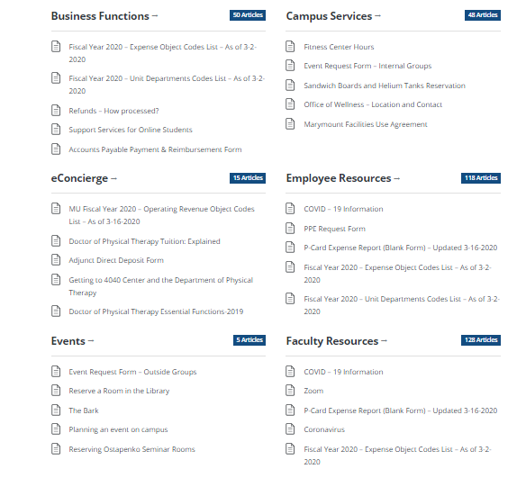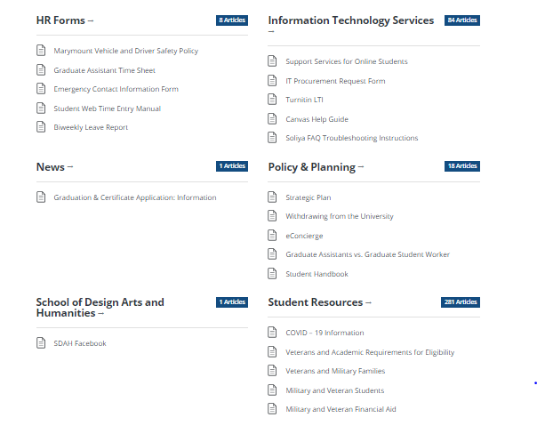

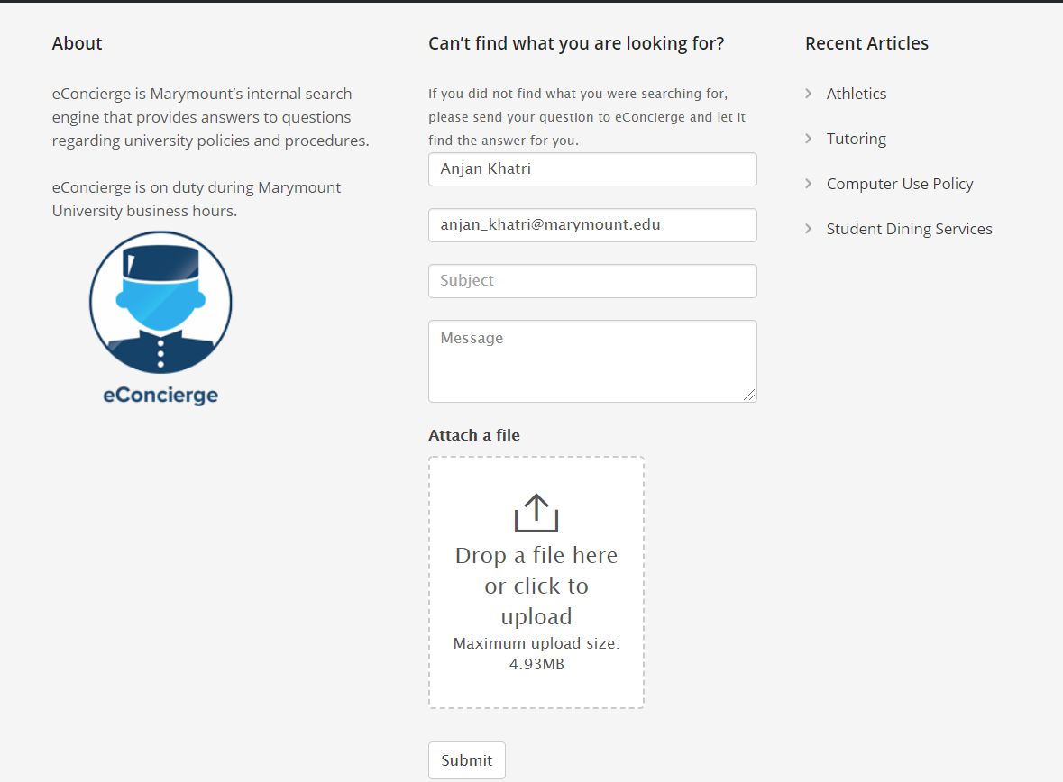

# Navigation and Conclusion

In this paper, we will be navigating the users to use eConcierge's student resource features. Users can get access to eConcierge in multiple ways. The easiest way to get access to Marymount eConcierge is from the university website. The step for the navigating through Marymount Website is listed below:

1. When the user gets into the Marymount website (Marymount.edu), on the heading of the website, there is a drop-down link known as "Quick Link."
2. Hovering the mouse over Quick Link will drop the list of options, and at the end of the list, users can find eConcierge.
3. Clicking on it will open a new window with Marymount Community eConcierge subheading. 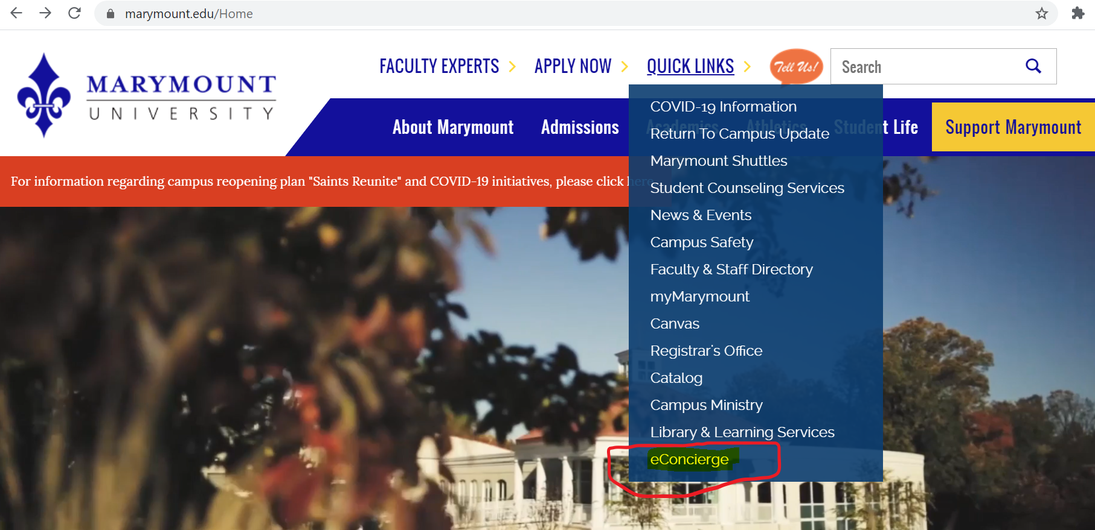

The other way to get access to the eConcierge is through the Marymount portal. Google searching "marymount portal" will find a link to my.marymount.edu and at the end of the portal, there is econcierge tab that will prompt to the eConcierge home page. 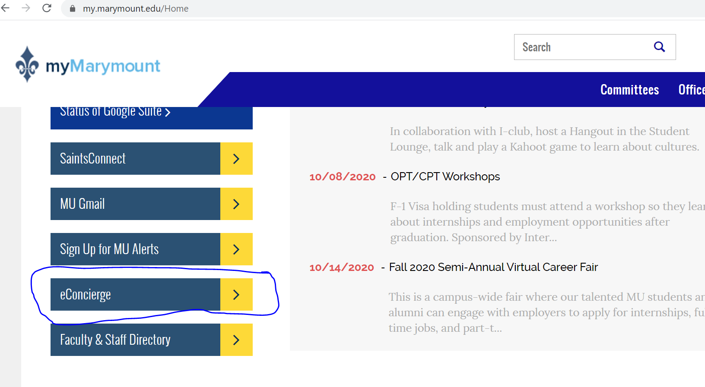

On the home page of eConcierge, the user can find the search bar, log in on the left side, and dashboard symbol. Users can find the answer without login into the eConcierge. This eConcierge help student to find a resource that is needed throughout college life to support their learning experience. We will be focusing on Student resource features of eConcierge.

The steps to navigating through student resource where we look for library resource for the new student are:

1. Most of the questions that we are looking for can be easily found when we search on the search bar with the keyword. For example: If we have to look for the Ballston library, then we can search for the Ballston library extension, and It will show the result. Clicking on the result Ballston Coakley Library extension, it will show a small button "library" on it. When we click on it, it will take us to the library website.

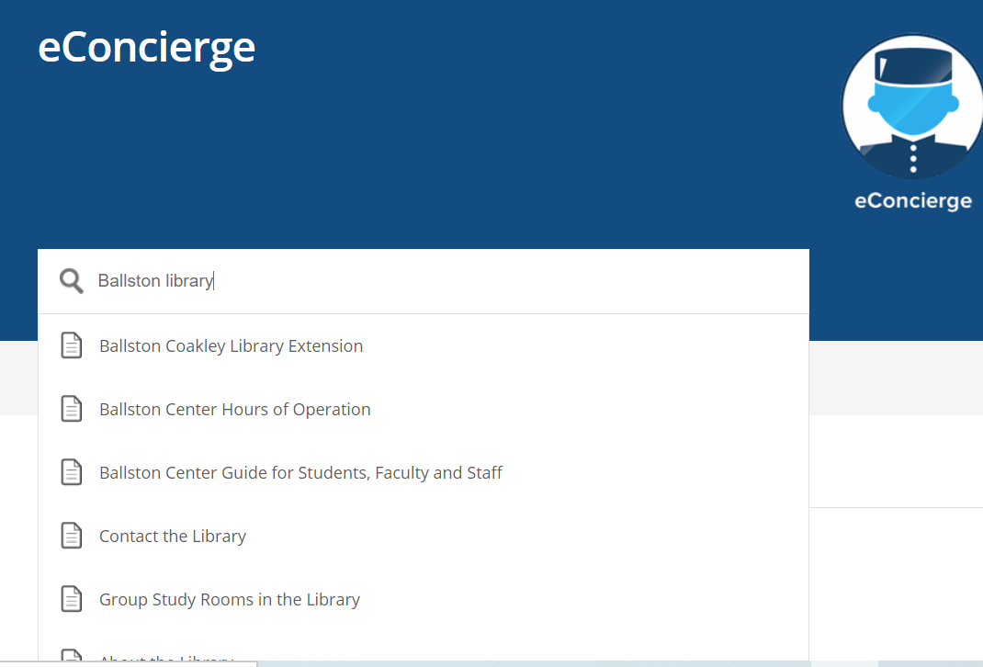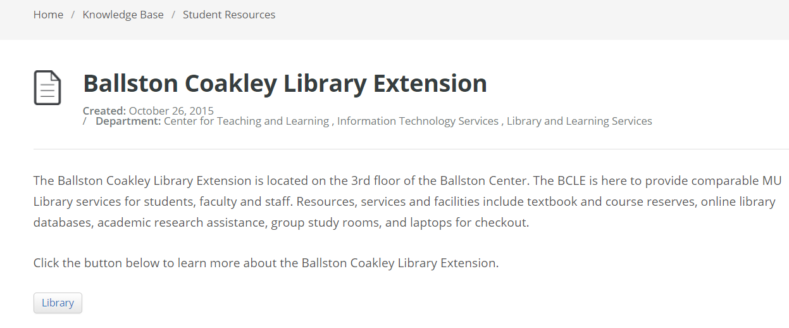

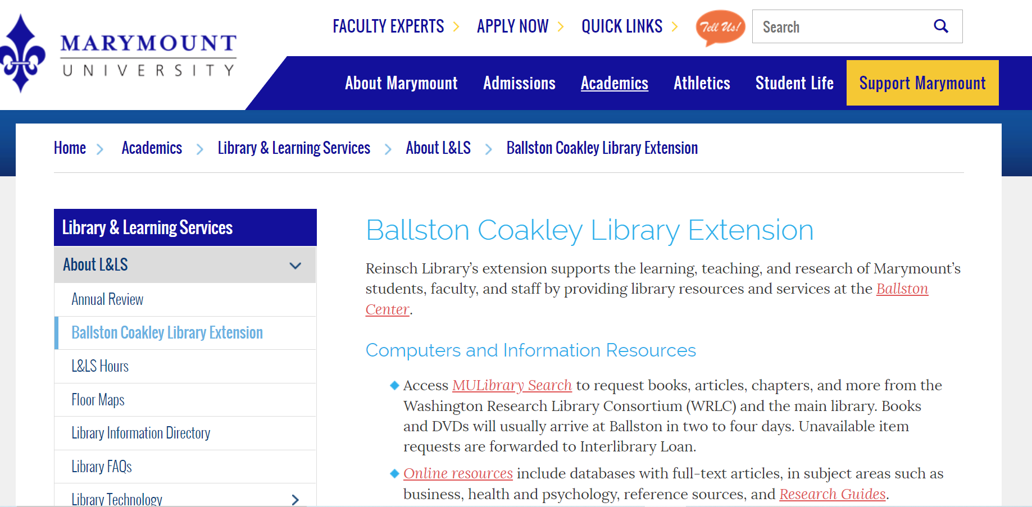

1. The search bar is helpful in finding the answers using the relatable keywords. If we scroll down and go into the student resource features, we can see around 281 articles posted there. We can click on the student resource features, which will prompt to the list, and then we can scroll down and find what we are looking for.

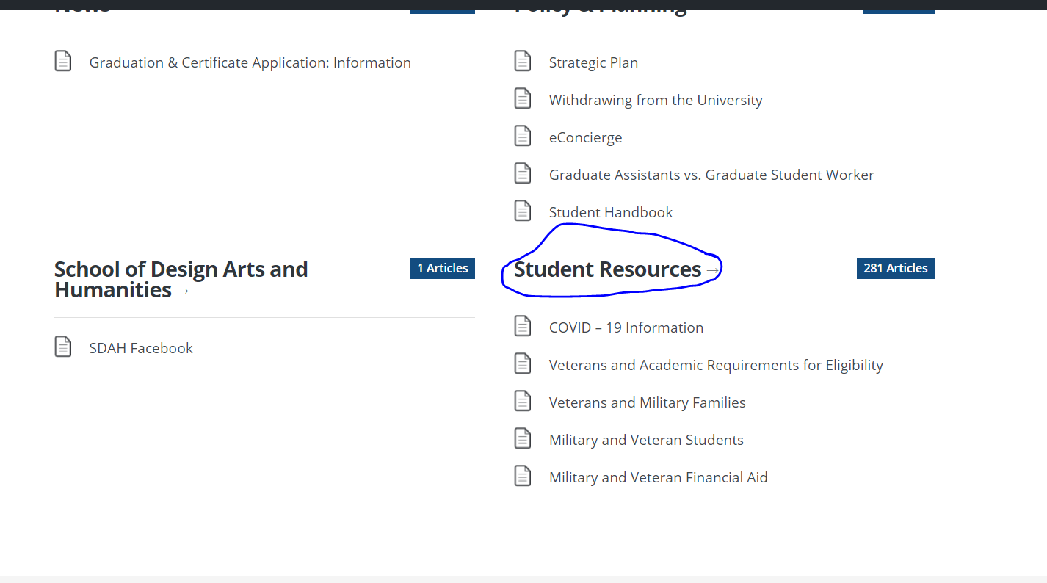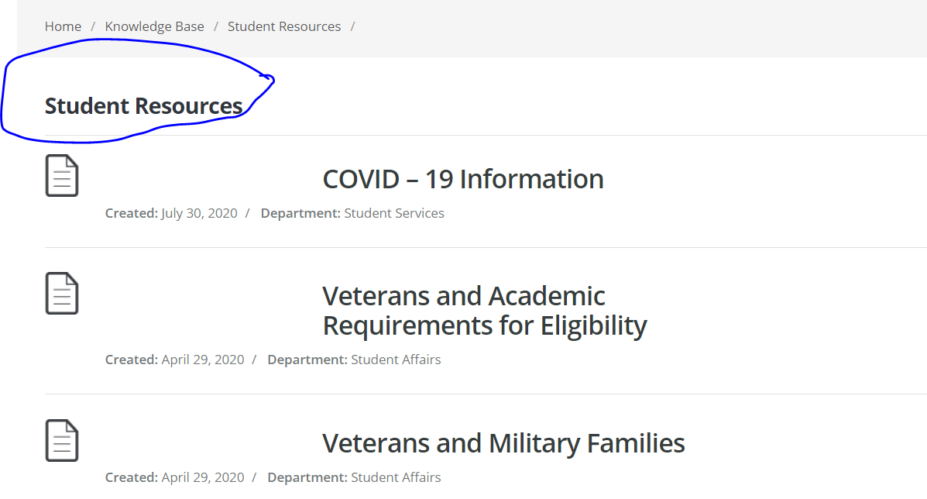

There are many articles posted in the student resource tab; it is easy for the user to type the keywords in the search. The search bar will not only look for a specific file, but it will give the different results, which will help to get a broad idea of the search. For example, if we search for keyword library, we will get the wide varieties of suggestion which helps student to select their choice. The library keyword alone gives 11 results, so we can look for the most appropriate one. And if the user does not find what they were looking for, then, user can click on "Can't find what you are looking for?" which will take the user to fill out the form.

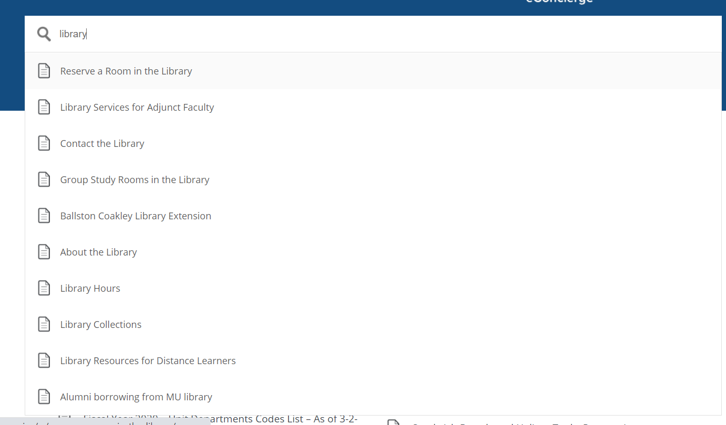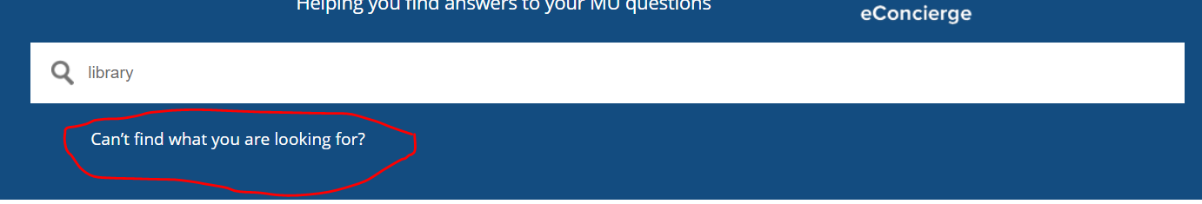

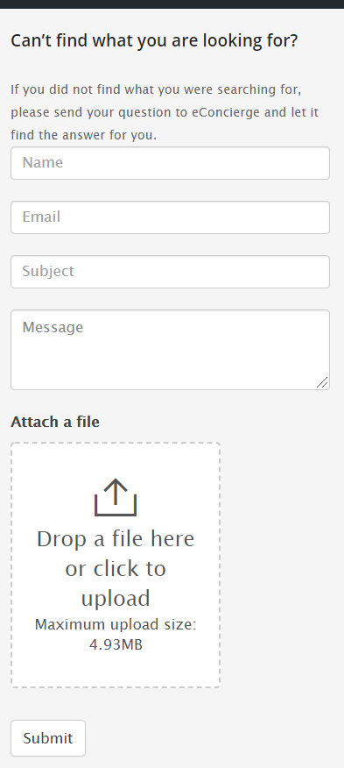

Submitting this form will send the question to eConcierge, which will be online during university business hours, and they will let it find the answer.

The purpose of this paper is to show the new student about the available resource at Marymount University. It is difficult to find specific things on the university website alone, so that this web application tool is helpful to understand the resource information for the new students.