**PURBANCHAL UNIVERSITY**

Biratnagar, Nepal



A Project report on

“BUBBLE SHOOTER GAME”

In the partial fulfillment for the requirement of the 4th Semester Project-IV (subject code- BIT 255CO) in the completion of **Bachelor of Information Technology (BIT)** degree at **KIST college** **of Information Technology**, under **Purbanchal University.**

|  |  |
| --- | --- |
| **Submitted By: -** | **Submitted To: -** |
| **1) Anjan Shrestha** | **Purbanchal University** |
| **2) Santosh Kumar Yadav**  **3) Simon Pokhrel** |  |



Under The Guidance of

Mr. Roshan Shrestha

Lecturer, BIT

**KIST COLLEGE OF INFORMATION AND TECHNOLOGY**

**KAMALPOKHARI, KATHMANDU NEPAL**



**CERTIFICATE**

This is to certify that the project work entitled “BUBBLE SHOOTER GAME” is carried out by **ANJAN SHRESTHA (5418), SANTOSH KUMAR YADHAV (5438) SIMON POKHEREL (5433**) bona fide students of **KIST COLLEGE OF INFORMATION AND TECHNOLOGY** in partial fulfillment for the award of **BACHELOR IN INFORMATION AND TECHNOLOGY** of the **PURBANCHAL UNIVERSITY, BIRATNAGAR NEPAL**, during the year 2022-2023. It is certified that all corrections indicated for internal assessment have been incorporated in the report submitted in the department library. The project report has been approved, as it satisfied the academic requirements in respect of the project work prescribed for the said degree.

The details of the students are as follows: -

**NAME**   **REGISTRATION NO.**  **SYMBOL NO.**

Anjan Shrestha 058-3-2-04717-2020 345487

Santosh Kumar Yadav 058-3-2-04740-2020 345507

Simon Pokhrel 058-3-2-04743-2020 345509

Course Semester : - 4th Semester

Subject : - Project-IV

Subject Code : - BIT (255CO)



**Mr. Deepak Khadka**

**Program Coordinator, BIT**



**KIST COLLEGE OF INFORMATION AND TECHNOLOGY**

**KAMALPOKHARI, KATHMANDU**

**Examiner’s Certification**

The Project Report

On

**“BUBBLE SHOOTER GAME”**

**Developed by**

**Anjan Shrestha**

**Santosh Kumar Yadav**

**Simon Pokhrel**

Is approved and is acceptable in qualify form.

|  |  |
| --- | --- |
| **Internal Examiner**  Name:  Designation: | **External Examiner**  Name:  Designation: |

**ACKNOWLEDGEMENT**

It is with greatest satisfaction and euphoria that we are submitting our project report entitled

**“BUBBLE SHOOTER GAME”.** We have completed it as a part of the curriculum of **PURBANCHAL UNIVERSITY.**

We also take this opportunity to express a deep sense of gratefulness to our **BIT Coordinator Mr.** **Deepak Khadka** and **BIT Lecturer Mr. Roshan Shrestha** for their amiable support, valuableinformation and guidance which helped us in completing this task throughout its various stages. We are indebted to all members of **KIST College,** for the valuable support and suggestion provided by them using their specific fields’ knowledge. We are grateful for their cooperation during the period of our project.

Finally, we would also like to express our gratefulness towards **Purbanchal University** for designing such a wonderful course structure. It will help us to get more knowledge in the field of Information Technology & help us to have a bright future in the field of technology.

We hope our university will accept this attempt as a successful project.

Last but not the least, our sincere thanks to our parents, teaching and non-teaching staffs of our college and also my friends.

Anjan Shrestha (345487)

Santosh Kumar Yadav (345507)

Simon Pokhrel (345509)

**STUDENT’S DECLARATION**

We hereby declare that the project report entitled **“BUBBLE SHOOTER GAME”** is a result of our own work. If we are found guilty of copying any other report or published information and showing as our original work, we understand that we shall be liable and punishable by **Purbanchal University**.

We further certify that this Project submitted in partial fulfillment of the requirement for the award of Bachelor in Information Technology (**BIT**) of the **Purbanchal University** is our original work and has not been submitted for award of any other degree or other similar title or prize.

|  |  |  |  |
| --- | --- | --- | --- |
| S.N. | Name | Registration No. | Symbol No. |
| 1 | Anjan Shrestha | 058-3-2-04717-2020 | 345487 |
| 2 | Santosh Kumar Yadav | 058-3-2-04740-2020 | 345507 |
| 3 | Simon Pokhrel | 058-3-2-04743-2020 | 345509 |

**TO WHOM IT MAY CONCERN**

This is to certify that Mr. Anjan Shrestha, Mr. Santosh Kumar Yadav and Mr. Simon Pokhrel of Bachelor in Information Technology (BIT) has studied as per the curriculum of BIT 4th semester and completed the project entitled **“BUBBLE SHOOTER GAME”.** This project is the original work of Anjan Shrestha, Santosh Kumar Yadav and Simon Pokhrel was carried out under the supervision of Mr. Roshan Shrestha as per the guidelines provided by Purbanchal University and certified as per the student’s declaration that project **“Bubble Shooter Game”** has not been presented anywhere as a part of any other academic work.

The detail of the student is as follows:

Name of Students : Anjan Shrestha

Santosh Kumar Yadav

Simon Pokhrel

|  |  |
| --- | --- |
| Semester | : 4th |
| Subject Code | : BIT 255C0 |
| Project Title | : Bubble Shooter Game |

…………………………….

Mr. Deepak Khadka

Program Coordinator, BIT

KIST College of Information Technology

**ABSTRACT**

The rapid evolution of the gaming industry has led to an increased demand for innovative and engaging gameplay experiences. This project presents the design and implementation of a game inspired by the popular PC game **"BUBBLE SHOOTER GAME"** using the Java programming language. The objective of the game is to offer players an exhilarating and addictive gaming experience by combining elements of side-scrolling action, endless running, and skill-based challenges.

Bubble Shooter is a popular and addictive puzzle game that has been developed using the Java programming language. This game is a classic example of the match-three puzzle genre, where players aim to clear a screen filled with colorful bubbles by shooting bubbles of the same color to create matches and eliminate them. The game is known for its simple yet engaging gameplay, making it accessible to players of all ages. In Bubble Shooter, players control a cannon or a shooter at the bottom of the screen, and their objective is to carefully aim and shoot bubbles into a cluster of bubbles at the top of the screen. When a player successfully matches three or more bubbles of the same color, they burst and disappear from the screen. The primary goal is to clear all the bubbles from the playing field before they reach the bottom, where the player's cannon is located. If the bubbles reach the cannon, the game ends. The game typically becomes more challenging as players progress through various levels, with the introduction of new bubble colors, obstacles, and patterns. Successful gameplay requires a combination of strategy, precision, and sometimes a bit of luck to create chain reactions and clear multiple bubbles with a single shot. Bubble Shooter games developed in Java often feature smooth graphics, responsive controls, and sound effects to enhance the gaming experience. They can be run on various platforms that support Java, making it accessible to a wide audience of gamers. Overall, Bubble Shooter is a classic puzzle game that continues to captivate players with its simple yet compelling gameplay, and its Java-based versions ensure that it can be enjoyed on a range of devices and operating systems

Table of Contents

Chapter 1 INTRODUCTION - 1 -

1.1 Introduction - 1 -

1.2 Problem Statement - 2 -

1.3 Objectives - 2 -

1.4 Scope - 3 -

1.5 Advantages - 4 -

Chapter 2 - 5 -

SYSTEM ANALYSIS - 5 -

2.1 Literature Review - 5 -

Chapter 3 - 6 -

SYSTEM DESIGN - 6 -

3.1 Working Principle - 6 -

3.2 Algorithm - 7 -

3.3 Flowchart - 8 -

3.4 Gantt Chart - 9 -

Chapter 4 - 10 -

REQUIREMENT ANALYSIS AND SYSTEM IMPLEMENTATION - 10 -

4.1 Hardware and Software Requirements - 10 -

4.2 System Methodology - 11 -

4.2.1. Requirement Analysis - 12 -

4.2.2. System Design - 13 -

4.2.3. Functional Analysis - 14 -

4.2.4. Implementation - 15 -

4.2.5. Integration and Testing - 15 -

4.2.6. Deployment and Maintenance - 16 -

Chapter 5 - 17 -

Conclusion and future scope - 17 -

5.1 Conclusion - 17 -

5.2 Future Scope - 17 -

References - 18 -

APPENDICES - 19 -

# Chapter 1 INTRODUCTION

## 1.1 Introduction

Bubble Shooter is a popular and addictive puzzle game that has been developed using the Java programming language. This game is a classic example of the match-three puzzle genre, where players aim to clear a screen filled with colorful bubbles by shooting bubbles of the same color to create matches and eliminate them. The game is known for its simple yet engaging gameplay, making it accessible to players of all ages. In Bubble Shooter, players control a cannon or a shooter at the bottom of the screen, and their objective is to carefully aim and shoot bubbles into a cluster of bubbles at the top of the screen. When a player successfully matches three or more bubbles of the same color, they burst and disappear from the screen. The primary goal is to clear all the bubbles from the playing field before they reach the bottom, where the player's cannon is located. If the bubbles reach the cannon, the game ends.

## 1.2 Problem Statement

## 

The goal of this project is to create a Java-based game similar to "Bubble Shooter Game" Creating engaging gameplay, adding aesthetically attractive visuals, incorporating acoustic effects, and implementing data management for player accomplishments are all key goals. To provide a great gaming experience, the project lays a major emphasis on user-centered design concepts. It seeks to demonstrate Java's ability to create engaging and responsive games while providing detailed documentation throughout the development process. The project will create a fully functional game that preserves the flavor of the original while adding innovative components to engage players in an action-packed adventure when completed.

## 1.3 Objectives

The primary objective of developing the Bubble Shooter game in Java is to create an entertaining and engaging gaming experience for players while showcasing technical proficiency in Java programming. The specific objectives of the game are as follows:

* The primary objective is to clear the game screen of all the bubbles. This is usually achieved by matching and eliminating the bubbles of same color.
* To be successful, players must aim their shots carefully to hit the right spot and create the desired bubble matches.
* This game often includes a scoring system. Players aim to achieve the highest score as possible which makes it interesting.
* The main objective of bubble shooter game is to provide entertainment and enjoyment for the players of all ages.

## 1.4 Scope

The scope of the Bubble Shooter game developed in Java encompasses various aspects related to the game's features, functionality, and target audience. The following outlines the key components within the scope of the project:

* Gameplay Mechanics:

The game will feature classic Bubble Shooter mechanics, where players control a cannon to shoot bubbles.

Players must match and eliminate bubbles by creating groups of three or more bubbles of the same color.

The game will consist of multiple levels, each with its own set of challenges and objectives.

Levels may introduce new bubble colors, patterns, and obstacles to increase difficulty and maintain player engagement.

* User Interface (UI):

Design an intuitive and visually appealing user interface with controls for aiming and shooting bubbles.

Include elements such as a game board, score display, level indicator, and possibly power-up indicators.

Ensure responsiveness and usability across different screen sizes and resolutions.

* Bubble Physics:

Implement realistic bubble physics, including accurate bubble movement, collision detection, and bubble popping animations.

Bubbles should react naturally to the player's shots and interact with each other convincingly.

* Levels and Progression:

Develop a structured level progression system with an increasing level of difficulty.

Create a mechanism for players to unlock and advance through levels as they successfully complete the previous ones.

* Scoring System:

Design a scoring system that rewards players based on their performance, including factors like the number of bubbles cleared in a single shot and level completion time.

Include a high-score leaderboard to encourage competitiveness among players.

.

## 1.5 Advantages

The advantages of Jetpack Bubble Shooter Game are as follows:

* Cross-Platform Compatibility: Java is known for its platform independence. Developing a Bubble Shooter game in Java ensures that it can be run on various platforms and operating systems, including Windows, macOS, Linux. This broad compatibility increases the potential player base.
* Wide Community Support: Java has a large and active developer community. This means that there are ample resources, libraries, and forums available for support and troubleshooting during game development.
* Performance Optimization: Java's mature development tools and libraries allow for effective optimization of game performance. Developers can fine-tune their game's code for efficient memory management and smooth gameplay.
* Security: Java offers built-in security features that help protect the game and user data from potential threats. This can be crucial when dealing with online components or player profiles.
* Rich Graphics and Animation: Java provides libraries like JavaFX and Swing that enable the creation of visually appealing and interactive user interfaces. This is important for creating captivating game graphics and animations.

# Chapter 2 SYSTEM ANALYSIS

## 2.1 Literature Review

System analysis in the development of Bubble Shooter games often begins with an examination of the game's core mechanics. Researchers like R. G. Beck and M. T. Harrison (2017) have delved into the mathematical aspects of bubble behavior, focusing on trajectory calculations and collision detection algorithms. These analyses contribute to the realistic physics simulation essential for an engaging gaming experience.

User interface design is another pivotal component addressed through system analysis. Studies by A. L. Silva et al. (2019) emphasize the importance of an intuitive and responsive user interface in Bubble Shooter games. They emphasize the need for efficient control schemes and visual feedback to enhance the player's interaction with the game.

# Chapter 3 SYSTEM DESIGN

## 3.1 Working Principle

The working principle of a Bubble Shooter game is centered on the player's objective to clear a grid or play area filled with colored bubbles. By controlling a cannon positioned at the bottom of the screen, players aim and shoot bubbles upwards, strategically trying to create groups of three or more bubbles of the same color. When successful, these matching bubbles burst and vanish from the board, earning the player points. Gravity is applied to the bubbles, causing them to gradually move downward after each shot, adding a time-sensitive challenge. With multiple levels of varying difficulty, players must clear specific objectives, such as a set number of bubbles or achieving a "bubble-free" board, to advance. Special bubbles with unique properties, such as rainbow bubbles or explosives, often enhance gameplay. A combination of responsive controls, scoring mechanisms, and engaging animations contributes to making Bubble Shooter games both accessible and addictive.

## 3.2 Algorithm

Algorithm is a process or set of rules to be followed in calculation or other problem-solving operations, especially by a computer.

Step 1: Start

Step 2: Initialize the Game.

Step 3; Generate the bubbles.

Step 4: Display game Board.

Step 5: Player shoot Bubbles.

Step 6: Check for Bubbles matches.

Step 6.1: If bubbles match 3 or more than three, go to step 7.1

Step 6.2: If bubble does not match, go to step 7.2

Step 7: Update Score.

Step 7.1: Add 20 * no of bubbles match in previous score.

Step 7.2: Add 10 score in previous score.

Step 8: Check for win condition.

Step 8.1: If no bubble left, go to step 9.

Step 8.2: If bubbles are left, go to step 5.

Step 9: Display Score.

Step 10: End

## 3.3 Flowchart

Flow chart is a diagram that represent workflow or process.

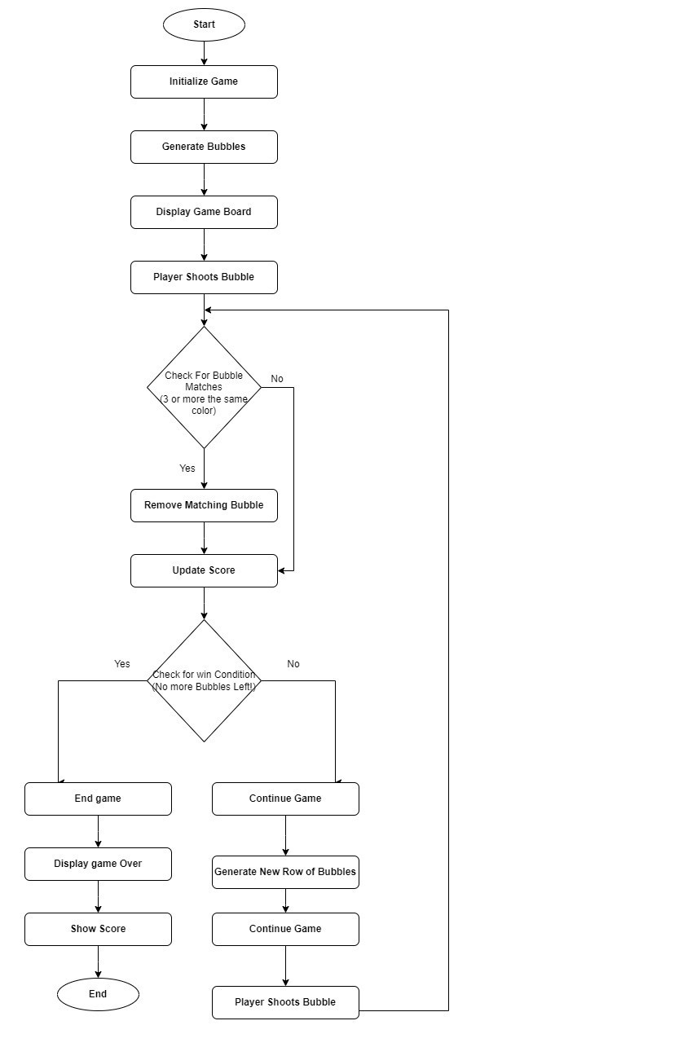

Figure 1.Flow Chart

## 3.4 Gantt Chart

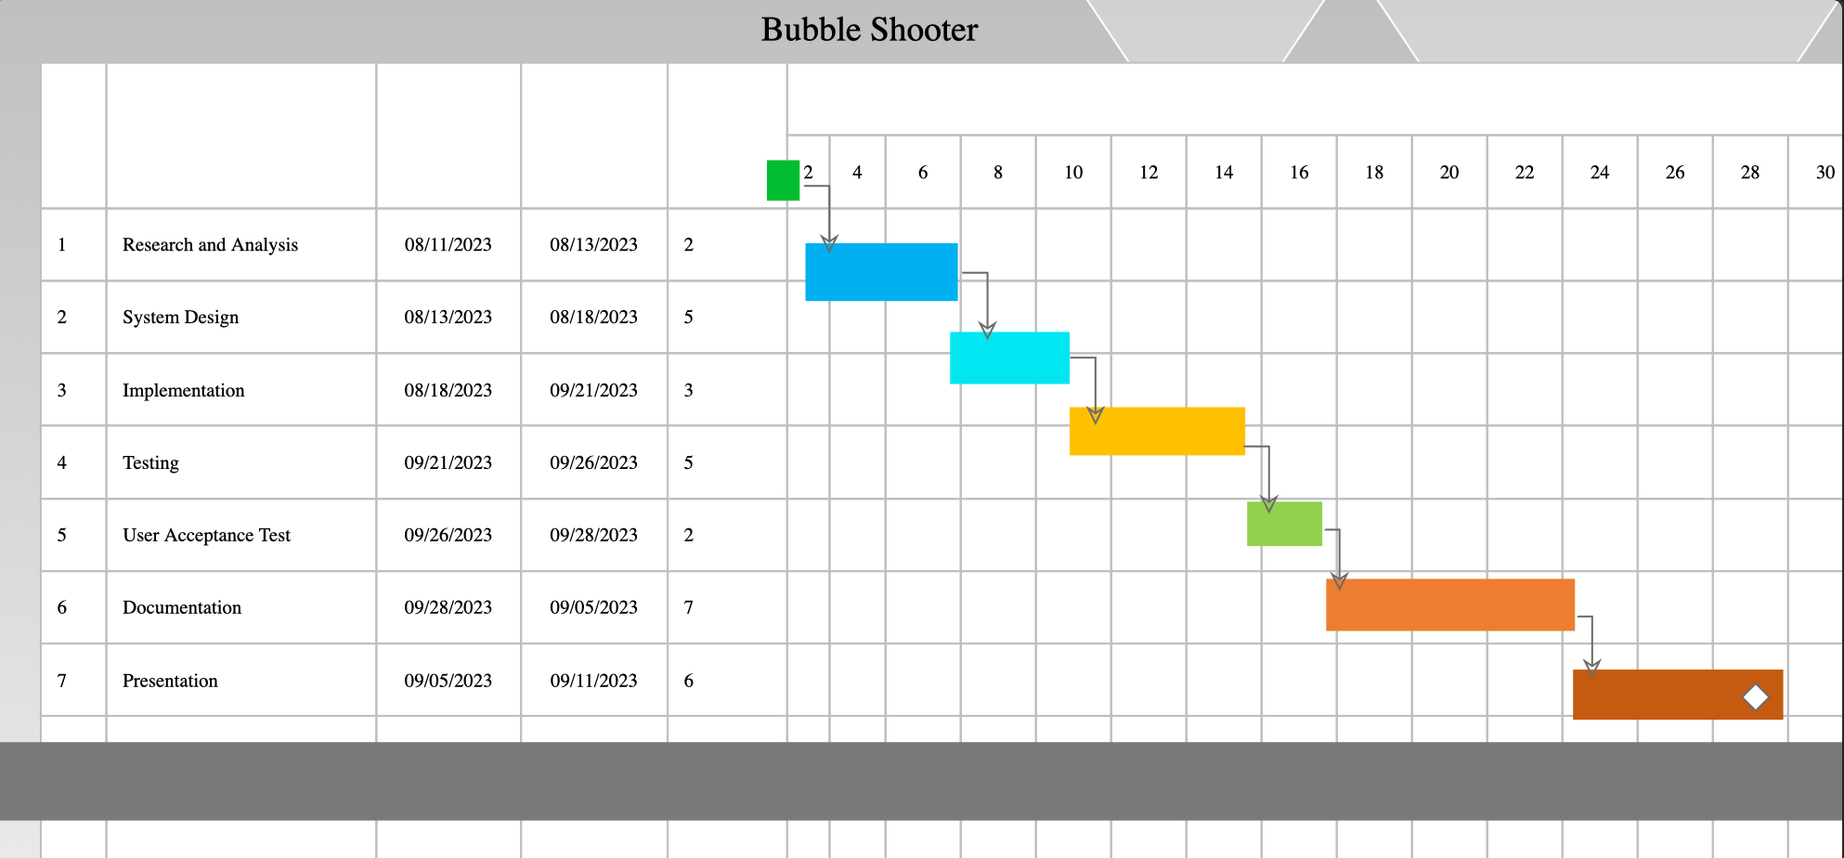

Figure 2. Gantt Chart

# Chapter 4. REQIREMENT ANALYSIS AND SYSTEM IMPLEMENTATION

## 4.1 Hardware and Software Requirements

Following hardware and software requirement should be met for flawless running of this system:

Hardware:Hardware is the collection of physical parts of a computer system. This includes the computer case, monitor, keyboard, and mouse. It also includes all the parts inside the computer case, such as the hard disk drive, motherboard, video card, and many others. Computer hardware is what you can physically touch.

**MINIMUM REQUIREMENTS**

PROCESSOR: Intel I3 5th generation or higher

SPEED: 1.5Hz or higher

RAM: 4GB or more

HARDDISK: At least 20 MB of free space for the program and additional space for saving drawings (recommended: at least 80 MB of free space)

MONITOR: LCD color monitor or higher resolution

**RECOMMENDED REQUIREMENTS:**

PROCESSOR: INTEL Core i5 or higher

SPEED: 2.5Hz or higher

RAM: 8 GB or more

HARDDISK: SSD (Solid State Drive) for faster read/write operations

MONITOR: Full HD (1920x1080) or higher resolution for better gaming experience

Software:Software is a set of instructions, data or programs used to operate computers and execute specific tasks. It is the opposite of hardware, which describes the physical aspects of a computer.

**OPERATING SYSTEM**: Windows 7 or a later version of Windows (e.g., Windows 10, Windows 11) and macOS 13.5 or a later version of macOS.

**Java Runtime Environment (JRE)**: Users must have the 19.0.2 or latest version of JRE compatible with our Bubble Shooter Game installed on their systems. JRE allows users to run Java applications without the need for development tools like JDK and IDEs

## 4.2 System Methodology

**WATERFALL MODEL**

The Waterfall methodology—also known as the Waterfall model—is a sequential development process that flows like a waterfall through all phases of a project (analysis, design, development, and testing, for example), with each phase completely wrapping up before the next phase begins.

The sequential phases described in the Waterfall model are:



Requirement

gathering and

analysis



Implementation



System

Design



Integration

and Testing



Deployment

a

nd Testing

Figure 3. Waterfall Model

### 4.2.1. Requirement Analysis

Functional Requirement:

In software and system engineering, a functional requirement defines a function of a system or its component, where a function is described as a specification of behavior between input and outputs.

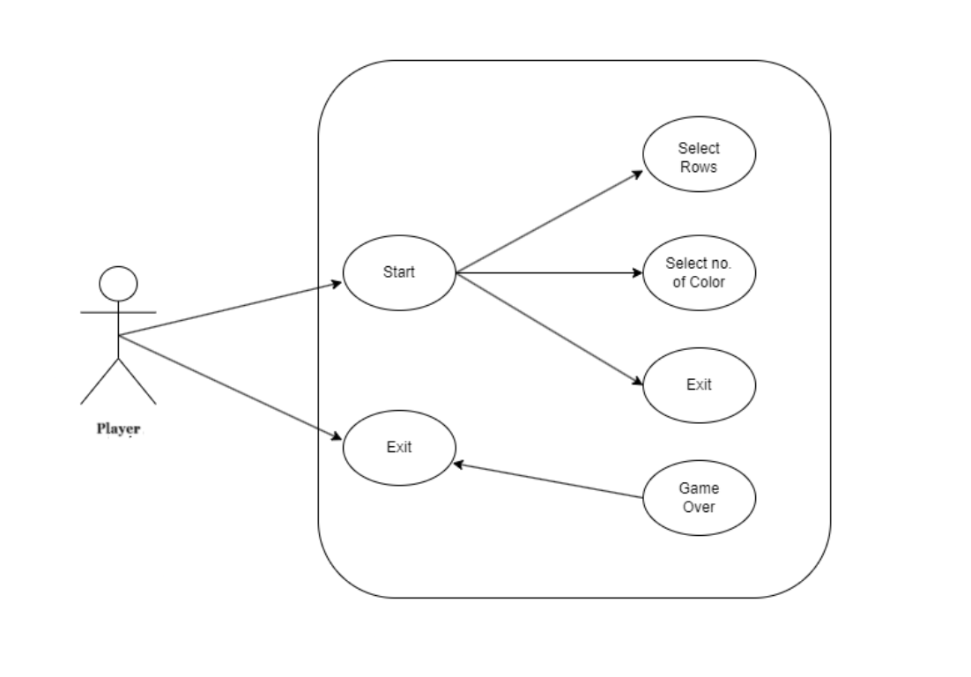

Figure 4.Use Case Diagram

### 4.2.2. System Design

This implementation is followed by the next stage in the waterfall model, which is the system design phase. In this section, the requirements that have been analyzed will be translated into detailed design and flowchart of the software code is being created. System design is the important stage that depending on the previous stage to make the great implementation and can be executed properly. When have anything requirements to be insert in designing the code, it will be add up in the requirement analysis phase and the design phase is carried out based on the new set of resources.

* Importance:
  + If any pre-existing code needs to be understood, organized, and pieced together.
  + It is common for the project team to have to write some code and produce original programs that support the application logic of the system.

There are many strategies or techniques for performing system design.

* **Top-down approach:** Top-down integration testing is an integration testing technique used in order to simulate the behavior of the lower-level modules that are not yet integrated. Each system is divided into several subsystems and components. Each of the subsystems is further divided into a set of subsystems and components.
* Advantages of top-down approach:
  + The main advantage of the top-down approach is that its strong focus on requirements helps to make a design responsive according to its requirements.

### 4.2.3. Functional Analysis

|  |  |  |
| --- | --- | --- |
| **No.** | **Function Module** | **Function Description** |
| 1. | MainFrame () | This constructor initializes the components and set the properties of the frame. |
| 2. | SettingPanel () | This constructor initializes the Bubble shooter Game panel. It sets up panels of scores and rows panel. |
| 3. | MovingBubble () | This constructor initiates the bubble and set its location and calculate the direction of shoot and the length of the step of both directions. |
| 5. | HighscoresEntry () | This constructor stores the high score of the  Player. |
| 6. | Game () | This constructor initializes the no rows and no of color bubbles. |
| 7. | Canvas () | This constructor helps to store the score after game is over. |
| 8. | Arrow () | This constructor helps to re paint the arrows when it moves according to the movement of mouse using ActionListener. |
| 9. | Bubbles () | This function helps of map bubbles in X and Y coordinates. |

### 4.2.4. Implementation

The implementation of a Bubble Shooter game within the context of system analysis and design involves a structured approach to creating a functional and user-friendly gaming application. In this process, the system analysis phase focuses on understanding the game's requirements, identifying key features such as bubble physics, scoring, and level progression, and defining user interactions. During system design, detailed specifications are created, outlining the architecture, data structures, and algorithms needed for gameplay. Design considerations extend to the user interface, ensuring intuitive controls for aiming and shooting bubbles. Additionally, the design phase addresses elements like game physics to simulate realistic bubble behavior and collision detection for bubble matching. Special game features like power-ups and bonuses are integrated into the design. Overall, system analysis and design serve as the foundation for the subsequent development and implementation stages, guiding the creation of a fully functional Bubble Shooter game.

### 4.2.5. Integration and Testing

Integration involves combining different components and modules of the Bubble shooter Game to ensure they work together seamlessly. Testing is a critical phase in the development of the Bubble shooter Game to identify and rectify any potential issues that may arise during its usage. The project has undergone comprehensive testing through the following approaches:

1. Black Box Testing Approach: The Black Box Testing approach focuses on the external functionality and behavior of the Bubble Shooter Game. This approach ensures that the application meets its fundamental requirements and functions correctly from a user's perspective. Key aspects of Black Box Testing include:
   1. **Gameplay Testing:** Examine the game from a player's perspective to ensure it behaves as intended. Verify that characters move as expected, obstacles appear at appropriate intervals, and power-ups work correctly.
   2. **User Interface Testing:** Test the game's user interface elements, including buttons, and on-screen displays, to ensure they are responsive and intuitive.
   3. **Input Validation:** Test the game's ability to handle various player inputs, including touch or keyboard controls, gestures, and device orientations.
   4. **Functionality Testing:** Verify that key game features, such as character movement, scoring, and level progression, work correctly.
2. White Box Testing Approach: The White Box Testing approach delves into the internal workings of the Jetpack Joyride Game. It focuses on the actual source code and aims to identify

issues that may arise during the execution of specific code segments. Key aspects of White Box Testing include:

* 1. **Code Review:** Perform a thorough review of the game's source code to identify logic errors, bugs, or inefficiencies. Ensure that code adheres to coding standards.
  2. **Unit Testing:** Writing and executing unit tests for individual functions and methods within the application to ensure they produce the correct output for different input scenarios.
  3. **Code Coverage Analysis:** Checking the extent to which the source code is covered by unit tests to identify untested or poorly tested areas that may harbor hidden defects.
  4. **Error Handling:** Validate that the game gracefully handles unexpected situations, such as crashes or errors, and provides meaningful error messages to players.
  5. **Performance Testing:** Assess the game's performance under different conditions, including variations in device performance, screen resolutions, and resource usage.

Optimize code for efficiency.

This project has fully tested by using both approach’s and ensures the correct output

### 4.2.6. Deployment and Maintenance

Once the functional and nonfunctional testing is done, the product is deployed in the player environment or released into the market. There are some issues which come up in the client environment. To fix those issues patches are released. Also to enhance the product some better versions are released. Maintenance is done to deliver these changes in the environment.

# Chapter 5 Conclusion and future scope

## 5.1 Conclusion

In conclusion, the Bubble Shooter game stands as a testament to the enduring appeal of simple yet engaging puzzle games. Its intuitive mechanics, involving the strategic matching of colored bubbles, provide players with a satisfying challenge that transcends age and skill levels. The implementation of realistic bubble physics and gravity adds a layer of complexity, requiring players to think critically about their shots. The inclusion of power-ups and special bubbles injects excitement and variety into gameplay. Additionally, the level progression system ensures a sense of achievement and keeps players invested in the game. Overall, the Bubble Shooter game exemplifies how a straightforward concept, executed with precision and attention to detail, can result in a highly addictive and enduring gaming experience. Its popularity is a testament to the enduring appeal of well-crafted casual games in the world of digital entertainment.

## 5.2 Future Scope

The future scope for Bubble Shooter games holds promise for continued growth and innovation. Here are some potential areas of development and expansion:

* Virtual Reality (VR) and Augmented Reality (AR): As VR and AR technologies advance, there is an opportunity to create immersive Bubble Shooter experiences. Players could physically interact with virtual bubbles and environments, adding a new dimension to gameplay.
* Multiplayer and Social Integration: Integrating multiplayer modes and social features could enhance player engagement. This could include real-time multiplayer competitions, cooperative play, and social media integration for sharing scores and achievements.
* Customization and Personalization: Allowing players to personalize their gaming experience with customizable cannons, bubble designs, and backgrounds can enhance player attachment to the game.
* Advanced Physics and Realism: Improving bubble physics and realism can make the gameplay even more captivating. Advanced physics simulations and more natural bubble behaviors could be explored.

# References

Ferguson, C. J. (2015). Video games and youth violence: A prospective analysis in adolescents. Journal of Youth and Adolescence, 44(2), 1-16.

Rollings, A., & Adams, E. (2003). Andrew Rollings and Ernest Adams on game design. New Riders.

Fullerton, T. (2014). Game design workshop: A play centric approach to creating innovative games. CRC Press.

Salem, K., & Zimmerman, E. (2004). Rules of play: Game design fundamentals. MIT Press.

Adams, E. (2014). Fundamentals of game design. Pearson Education.

# APPENDICES

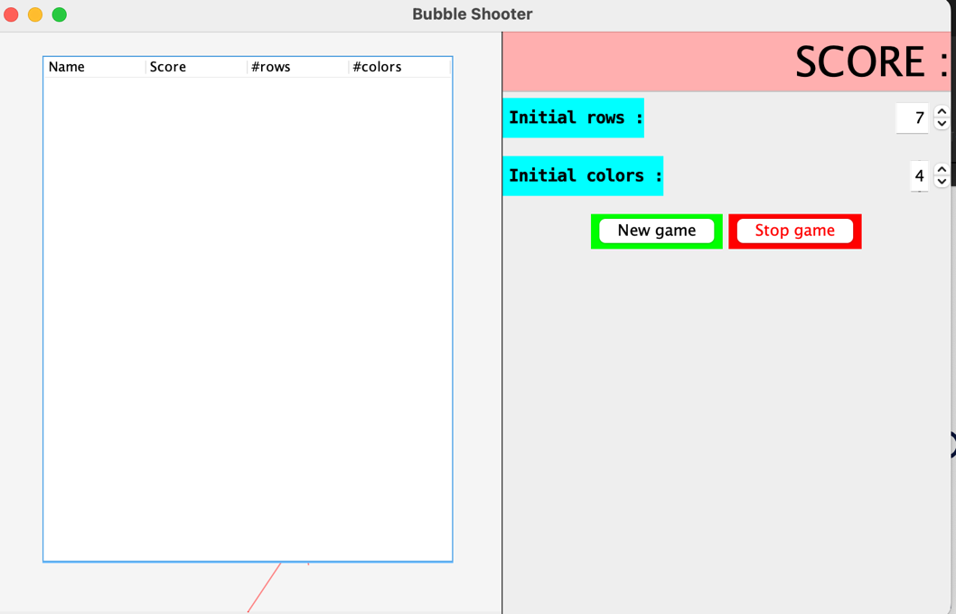

Figure 5. Menu

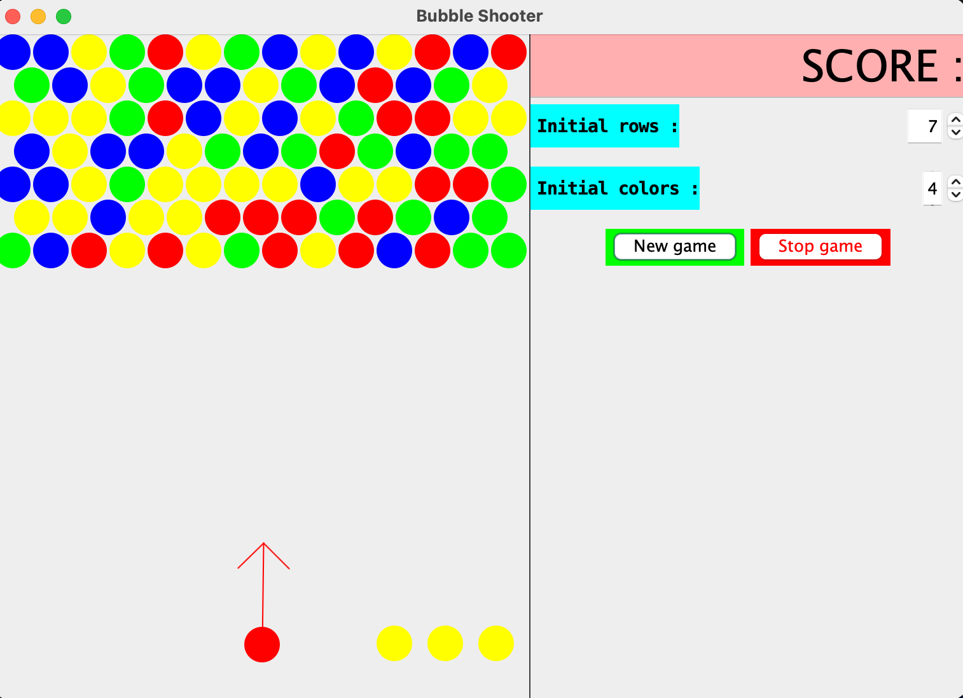

Figure 6. Starting Panel

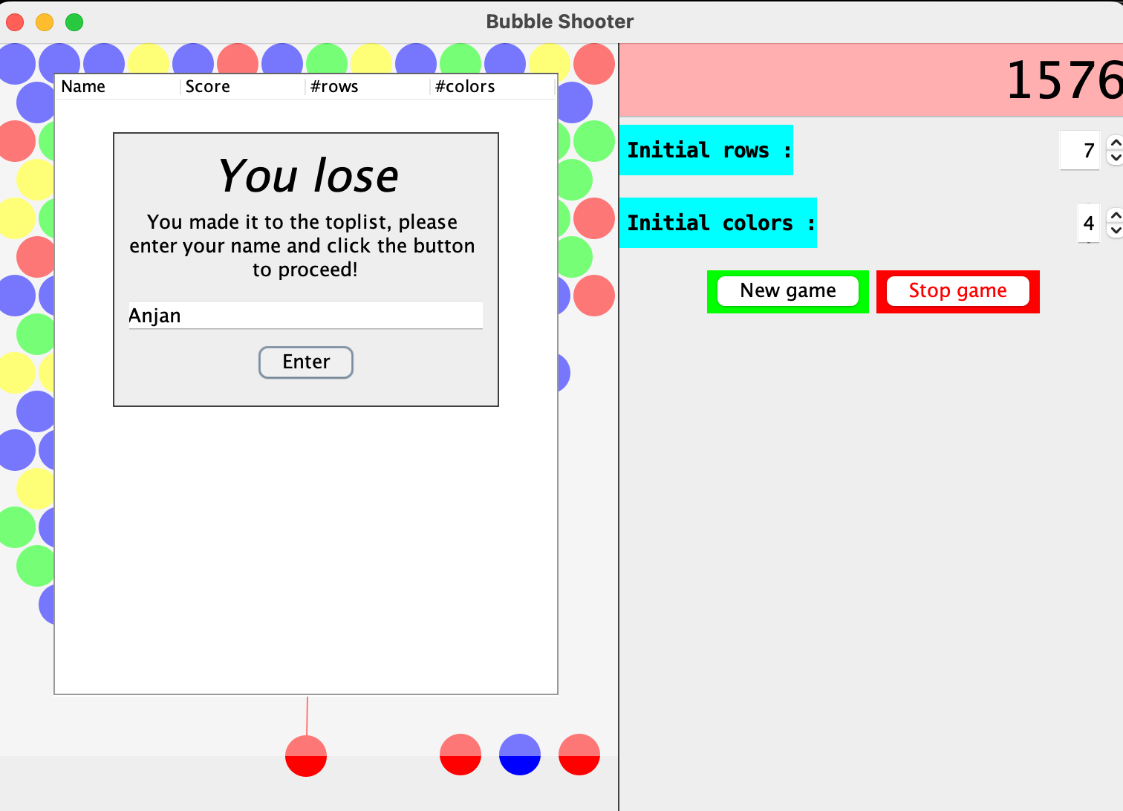

Figure 7. Game Over