System Methodology

Of

LIBRARY BOOKS MANAGEMENT SYSTEM

(LBMS)

Submitted to:

Mr. Prawesh Dhungana

(Project Teacher)

Submitted to:

Anjan Shrestha (5418)

Pukar Tiwari (5429)

Sandip Shrestha (5437)

Saurav Magar (5432)

WATERFALL MODEL

The waterfall model is a classical model used in system development life cycle to create a system with linear and sequential approach. It is termed as waterfall because the model develops systematically from one phase to another in a downward fashion. This model is divided into different phase and the output of one phase is used as the input of the next phase starts and there is no overlapping of the phase.

The sequential phases described in the Waterfall model are:

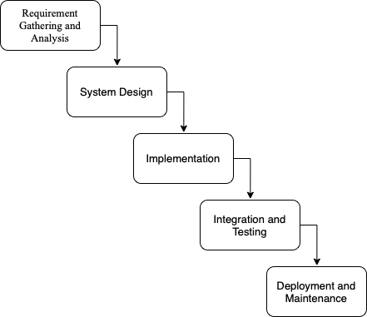

# Requirement and Gathering Analysis

It indicates hardware and software requirements of the project at the time of project development as well as project implementation.

Minimum hardware requirements for efficient operation of this project are as follows:

1. Processor : Pentium and above
2. Speed : 1.5Hz
3. Hard disk : 5MB or above free space
4. RAM : 128MB or above
5. Output Unit : Monitor
6. Input Unit : Keyboard

Minimum software requirements for efficient operation of this project are as follows:

1. Operating System : Windows XP or above Versions

Maximum hardware requirements for efficient operation of this project are as follows:

1. Processor : i3 Processor
2. Speed : 1.7Hz
3. Hard disk : 80GB (At least 200MB of free space)
4. RAM : 1GB

Maximum software requirements for efficient operation of this project are as follows:

1. Operating System : Windows 7, Windows 10

# System Design

In this phase we designed the algorithm and flowchart required for the development of the system.

# IMPLEMENTATION

It is the process of using the project in client’s computer. After the executive file has been created, this project can be copied from saved source to any secondary storage device and pasted to the required system. The project can be operated by opening it, completely replacing the existing manual system.

# INTEGRATION AND TESTING

Testing in a project development is a very important task to find out the possible mistakes made by the developers. The system cannot give the correct output until the project contains no errors at all. This project has checked the possible errors by using the following approaches:

1. Black Box Testing Approach: This approach concentrates on the basic requirements of the project. It simply checks direct matching of records of particular book, after we select a book no of a particular student.
2. White Box Testing Approach: This approach concentrates on the actual codes written during the development of the project. It checks every line of codes in all the functions of the program.

This project has fully tested by using both approach’s and ensures the correct output

# DEPELOYMNET AND MAINTANANCE

When time changes, the requirements of the organization also changes and this project can no longer fulfill its requirements. The changes are necessary to keep the project running and useful to college. Maintenance may be required when the college changes its requirements.