Food court distribution index of Mysore and outskirts

Introduction

The study mainly attributes towards exploring the neighborhood of Mysore which helps entrepreneurs to find out their area of interest to invest for new restaurants.

Once the dataset is formed basing on a category of venue, for further clarity they are distributed in various clusters depending on their similarity against a particular type. This clusters are later plotted on a map to have a better insight about the distribution of their desired venues across the neighborhood.

The same code can be used for any variable apart from food for its detail synopsis in the same way as presented below.

Data acquisition and cleaning

The neighborhood dataset has to be classified by its postal code for its further synthesis along with its latitude and longitude values which is obtained from Indian government website (<https://data.gov.in/resources/all-india-pincode-directory-contact-details-along-latitude-and-longitude>) .

the intersection of this dataset can be done with data collected from FourSquare API on the basis of available latitude and longitude to explore food category venues within a radius of 50 m.

Post obtaining the intersected dataset, a filtering of the data has been done by selecting the category as “food”. The filtered dataset is then plotted on a bar graph to further squeeze it by selecting only top 9 food categories to obtain the basic dataframe for this study. The postal codes with either or both latitude and longitude missing are dropped from analysis.

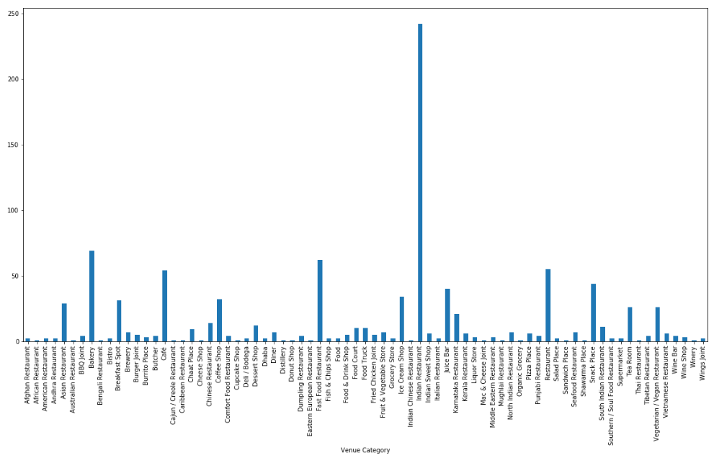

Venue distribution across neighborhood