DEVRAJ PATEL
PRINCIPAL DATA ARCHITECT | ML ENGINEERING LEADER | 14+ YEARS
devraj.patel@datacraft.io | +1 (214) 555-0391 | Dallas, TX | linkedin.com/in/devrajpatel | github.com/devrajpatel

14+ Years Exp $35M TCO Savings  100+ Engineers Led 5 Industries | Career Growth Timeline  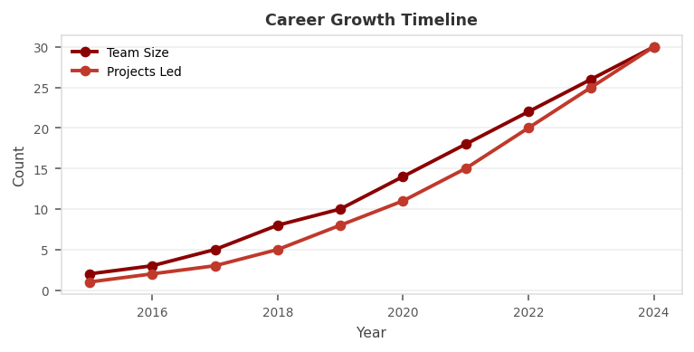

EXECUTIVE SUMMARY
Principal Data Architect and ML Engineering Leader with 14 years delivering enterprise data transformation programs for financial services, healthcare, and logistics companies. Expert designing scalable cloud-native data architectures on Snowflake, AWS, and Azure that support AI/ML at scale. Track record leading 100+ engineer data platform teams, managing $30M+ budgets, and achieving $50M+ in annual cost savings. Recognized speaker at Strata, DataCouncil, and Snowflake Summit. Open-source contributor with popular dbt and Kafka tools.
PROFESSIONAL EXPERIENCE
PRINCIPAL DATA ARCHITECT | Wells Fargo | Charlotte, NC Feb 2021 - Present
Client: Wells Fargo | Domain: Financial Services, Regulatory Compliance | $1.9T Asset Bank
- Defined 5-year enterprise data strategy for $1.9T asset bank migrating 3,000+ analytical workloads from legacy Teradata to Snowflake Data Cloud; projected $35M TCO savings over 5 years.
- Established enterprise DataOps platform using dbt, GitHub Actions, Airflow enabling 200 engineers to deploy pipeline changes in minutes vs. weeks with 99.9% reliability.
- Designed real-time regulatory reporting pipeline using Kafka and PySpark processing 100M+ daily transactions for FR Y-9C, DFAST, and CCAR stress testing requirements.
- Built enterprise ML platform integrating Snowflake Cortex AI, MLflow, SageMaker enabling 40 model deployments annually with automated retraining and drift detection.
- Led enterprise data governance implementing Collibra Data Intelligence Cloud achieving 95% critical data element coverage and ISO 27001 certification across all data domains.
- Managed team of 35 architects and engineers; implemented competency framework resulting in 90% retention rate and 8 internal promotions in 24 months.
- Reduced Snowflake spend $4.2M annually through warehouse optimization, query profiling, and materialized view strategies across 50 virtual warehouses.
- Implemented column-level security and dynamic data masking meeting PCI-DSS, GLBA, and CCPA across 15 data domains serving 5,000+ users in 20 business units.
- Designed federated identity using Okta SSO with Snowflake SCIM provisioning for 5,000+ users; implemented network policies restricting access to approved IP ranges.
Env: Snowflake, dbt, Kafka, PySpark, MLflow, SageMaker, AWS, Collibra, Alation, Airflow, GitHub Actions, Terraform, Databricks, Monte Carlo, DataBricks
SENIOR DATA ENGINEER - LEAD | CVS Health | Woonsocket, RI Apr 2018 - Jan 2021
Client: CVS Health | Domain: Healthcare, Pharmacy Analytics, HIPAA
- Led clinical data platform ingesting 2B+ patient records from 10,000+ pharmacy locations into HIPAA-compliant Snowflake data lake for population health analytics.
- Built real-time prescription monitoring using AWS Kinesis and Lambda detecting drug interaction risks within 500ms of dispensing event for 9,000+ pharmacies.
- Developed NLP pipeline using spaCy and BERT models extracting structured data from 500M+ clinical notes reducing manual abstraction costs $8M annually.
- Designed Snowflake Data Sharing architecture enabling secure analytics collaboration with 30+ insurance and PBM partners without data movement.
- Implemented 800+ dbt Core transformation models supporting 150+ downstream BI reports for pharmacy analytics and clinical operations teams.
- Built patient 360 data product consolidating pharmacy, medical, and behavioral health data enabling personalized care interventions for 20M+ members.
Env: Snowflake, AWS Kinesis, Lambda, spaCy, BERT, dbt, Airflow, Python, PySpark, HIPAA compliance, Azure ADF, Tableau, Kafka
DATA ENGINEER | FedEx | Memphis, TN Jul 2015 - Mar 2018
Client: FedEx | Domain: Logistics, IoT, Supply Chain
- Engineered package tracking analytics platform processing 15M+ daily shipment events from IoT sensors, barcode scanners, and GPS devices into GCP BigQuery.
- Built route optimization ML pipeline using Google Dataflow and TensorFlow reducing average delivery distance 12% saving $25M annually in fuel costs.
- Developed GCP Pub/Sub event streaming architecture consuming 50,000+ events/second from 300,000 delivery vehicles and facilities worldwide.
- Created logistics data warehouse with dimensional models for 20 Data Marts covering package, customer, revenue, and operational analytics domains.
Env: GCP BigQuery, Dataflow, Pub/Sub, TensorFlow, Python, PySpark, dbt, Looker, Terraform, Cloud Run, Cloud Functions
DATA ANALYST / ETL DEVELOPER | Deloitte Consulting | Chicago, IL Sep 2013 - Jun 2015
Client: Deloitte | Domain: Consulting, Banking, Insurance
- Delivered 12 data engineering engagements for Fortune 500 clients across banking, insurance, and manufacturing verticals.
- Developed Informatica PowerCenter ETL integrating SAP, Oracle EBS, Salesforce data into enterprise data warehouses for risk reporting.
- Built Tableau executive dashboards with KPI scorecards, trend analysis, and variance reporting for quarterly business reviews.
Env: Informatica PowerCenter, SAP, Oracle EBS, Salesforce, Tableau, SQL Server, SSIS, Teradata
JUNIOR ETL DEVELOPER | Wipro Technologies | Hyderabad, India Jun 2011 - Aug 2013
Client: Wipro | Domain: Banking, Insurance
- Developed SSIS and ODI ETL packages for banking clients processing 10M+ daily mainframe records into analytical data warehouses.
- Created T-SQL stored procedures for data transformation and loading into dimensional data mart structures for reporting.
- Supported production ETL with on-call monitoring, incident resolution, and performance tuning for mission-critical batch jobs.
KEY ACHIEVEMENTS
$35M TCO Savings  Wells Fargo Teradata to Snowflake migration  $25M Fuel Savings  FedEx ML-driven route optimization  $8M Cost Reduction  CVS NLP clinical notes automation | 100M+ Events/Day  Real-time regulatory reporting at Wells Fargo  95% Data Coverage  Enterprise data governance critical element coverage  90% Team Retention  Engineering team retention under direct leadership
TECHNICAL EXPERTISE
Architecture | Data Mesh, Medallion Architecture, Lambda/Kappa, CQRS, Event Sourcing, Data Lake House, Zero-Copy Sharing
Data Warehouse | Snowflake, Redshift, BigQuery, Azure Synapse, Teradata, Oracle, SQL Server, Hive, Presto, Trino
Streaming | Kafka, Kinesis, Pub/Sub, Event Hubs, Flink, Spark Streaming, Kafka Streams, NiFi, Samza
ML/AI | MLflow, Kubeflow, SageMaker, Snowflake Cortex, Vertex AI, AzureML, TensorFlow, PyTorch, spaCy, BERT
Governance | Collibra, Alation, Monte Carlo, DataHub, Apache Atlas, Great Expectations, dbt Tests, Soda Core
DevOps | GitHub Actions, GitLab CI/CD, Jenkins, Terraform, Pulumi, Docker, Kubernetes, Helm, ArgoCD, Vault
CERTIFICATIONS & EDUCATION
EDUCATION  M.S. Computer Science - UT Dallas, 2013  B.Tech. IT - Gujarat Technological University, 2011  CERTIFICATIONS  - AWS Solutions Architect Professional  - Snowflake SnowPro Advanced Data Engineer  - GCP Professional Data Engineer  - Azure Data Engineer Associate (DP-203) | SPEAKING & PUBLICATIONS  - Strata Data 2023 - Keynote: Data Mesh at Scale  - Snowflake Summit 2022 - Cortex AI for Enterprises  - DataCouncil Austin 2021 - Real-Time Compliance Pipelines  LINKS  linkedin.com/in/devrajpatel  github.com/devrajpatel - dbt & Kafka tools  devrajpatel.com - Portfolio & Case Studies

