 | SANJAY KUMAR  Sr. FinTech Data Engineer | 13+ Years  New York, NY | sanjay.kumar@fintechdata.io | +1 (917) 555-0562  linkedin.com/in/sanjaykumar-de | github.com/skumar

13+  Years FinTech | $400B  Trading Book | 5M/min  Events Processed | FRM  Certified

PROFESSIONAL SUMMARY
Senior FinTech Data Engineer with 13 years delivering mission-critical data platforms for investment banks, hedge funds, and payment processors. Deep expertise in high-frequency trading data pipelines, risk management analytics, regulatory reporting (CCAR, DFAST, MiFID II, Basel III), and real-time market data processing. Proficient in Snowflake, AWS, Apache Kafka, and Python quantitative analytics. Proven track record at Goldman Sachs, Morgan Stanley, and Two Sigma with $1T+ AUM clients.
SKILLS & EXPERTISE OVERVIEW
- FinTech:FIX Protocol, Bloomberg B-PIPE, Refinitiv, MiFID II, CCAR, DFAST, Basel III, VaR, CVA, FpML  - Languages:Python, C++, Java, Scala, SQL, SnowSQL, T-SQL, R, MATLAB, Bash, JavaScript  - Data Warehouse:Snowflake, AWS Redshift, GCP BigQuery, Sybase IQ, Oracle DW, Teradata  - Streaming:Apache Kafka, Kafka Streams, Apache Flink, Spark Streaming, AWS Kinesis, Redis Streams  - Quant:NumPy, pandas, SciPy, statsmodels, QuantLib, Monte Carlo, Black-Scholes, Options pricing  - Cloud:AWS (EMR, Kinesis, SageMaker, S3, Redshift), GCP (BigQuery, Dataflow), Azure (Synapse)  - ETL/ELT:dbt, AWS Glue, Informatica, Talend, Fivetran, SSIS, Matillion, custom Python frameworks  - DevOps:Git, GitHub Actions, Jenkins, Terraform, Docker, Kubernetes, Helm | 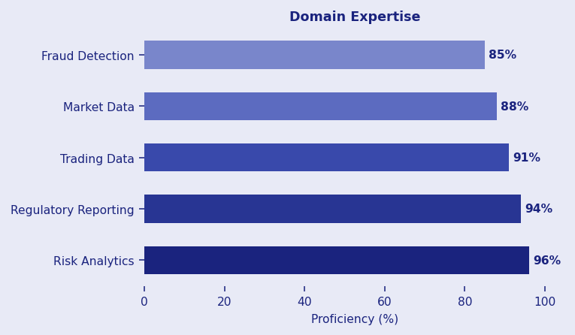

PROFESSIONAL EXPERIENCE
LEAD DATA ENGINEER - MARKET RISK | Goldman Sachs Nov 2021 - Present
Client: Goldman Sachs | Investment Banking, Market Risk, Equities Trading
- Built intraday market risk aggregation pipeline processing 500M+ position updates daily using Kafka, PySpark, and Snowflake enabling real-time VaR for $400B trading book.
- Engineered low-latency market data ingestion consuming Bloomberg B-PIPE and Reuters Refinitiv feeds achieving sub-50ms end-to-end latency for real-time pricing of 100,000+ instruments.
- Designed CCAR/DFAST regulatory reporting platform on Snowflake processing 200+ stress scenarios quarterly reducing reporting cycle from 2 weeks to 3 days.
- Built quantitative factor analytics pipeline using Python/pandas processing historical price data for 50,000+ securities to compute alpha signals for systematic trading.
- Implemented real-time P&L attribution pipeline decomposing daily P&L across 15 risk factors for 300+ trading desks using Kafka Streams and custom aggregation framework.
- Led migration from legacy Sybase to Snowflake reducing query latency 80% enabling self-service analytics for 400+ quantitative analysts.
- Implemented FIX protocol message processing parsing 10M+ daily trade messages from 50+ execution venues for regulatory trade reporting.
- Designed Terraform-based infrastructure automation for Snowflake, Kafka, and AWS reducing environment setup from weeks to 2 hours.
Env: Snowflake, Kafka, PySpark, Python, AWS, Bloomberg B-PIPE, Refinitiv, Terraform, FIX Protocol, Redis, Apache Flink, NumPy, pandas
SENIOR DATA ENGINEER | Morgan Stanley May 2018 - Oct 2021
Client: Morgan Stanley | Investment Banking, Risk Analytics, Derivatives
- Engineered enterprise risk data lake on AWS S3 + Redshift consolidating 40+ source systems including trades, positions, reference data, and market data.
- Built MiFID II transaction reporting pipeline processing 2M+ trades daily with real-time ESMA validation and automated submission to ARM.
- Developed Monte Carlo simulation framework using Python and NumPy for option pricing processing 10,000 scenarios per security in 500ms.
- Created counterparty credit risk analytics calculating CVA/DVA/FVA adjustments for 5,000+ OTC derivative contracts daily.
- Built automated reconciliation platform comparing internal vs. prime broker positions reducing breaks 85% through automated matching logic.
Env: AWS S3, Redshift, Python, NumPy, pandas, Kafka, Airflow, MiFID II, ESMA reporting, dbt, Jenkins, Tableau
DATA ENGINEER - ALGO TRADING | Two Sigma Investments Jan 2015 - Apr 2018
Client: Two Sigma | Quantitative Hedge Fund, Systematic Trading
- Built market microstructure analytics pipeline processing tick-level order book data for 5,000+ equities at nanosecond granularity using C++ and Python.
- Developed distributed backtesting framework on AWS EMR enabling quant researchers to test strategies on 20+ years historical tick data in under 30 minutes.
- Created alternative data processing pipeline ingesting satellite imagery, credit card transactions, and web signals for systematic alpha research.
Env: Python, C++, AWS EMR, Kafka, Spark Streaming, HBase, Redis, NumPy, pandas, Airflow, Hadoop
ETL / DATA ANALYST | Citibank Technology Jun 2012 - Dec 2014
Client: Citibank | Consumer & Investment Banking
- Developed Informatica ETL consolidating trade/settlement data from 20+ systems for Basel III regulatory capital calculations.
- Built T+2 settlement reconciliation processing 500K+ daily transactions achieving 99.95% straight-through processing rate.
- Created SQL Server/SSRS reports for back-office operations covering trade lifecycle and fails management.
Env: Informatica, SQL Server, SSRS, Oracle, ETL, Basel III, FpML, Sybase
TECHNICAL SKILLS MATRIX
FinTech | FIX Protocol, Bloomberg B-PIPE, Refinitiv, MiFID II, CCAR, DFAST, Basel III, VaR, CVA, FpML
Languages | Python, C++, Java, Scala, SQL, SnowSQL, T-SQL, R, MATLAB, Bash, JavaScript
Data Warehouse | Snowflake, AWS Redshift, GCP BigQuery, Sybase IQ, Oracle DW, Teradata
Streaming | Apache Kafka, Kafka Streams, Apache Flink, Spark Streaming, AWS Kinesis, Redis Streams
Quant | NumPy, pandas, SciPy, statsmodels, QuantLib, Monte Carlo, Black-Scholes, Options pricing
Cloud | AWS (EMR, Kinesis, SageMaker, S3, Redshift), GCP (BigQuery, Dataflow), Azure (Synapse)
ETL/ELT | dbt, AWS Glue, Informatica, Talend, Fivetran, SSIS, Matillion, custom Python frameworks
DevOps | Git, GitHub Actions, Jenkins, Terraform, Docker, Kubernetes, Helm
CERTIFICATIONS
- CFA Level II Candidate  - FRM Part I Certified (GARP)  - AWS Solutions Architect Professional  - Snowflake SnowPro Core | - GCP Professional Data Engineer  - Databricks Certified Developer  - Series 63 License  - Bloomberg Market Concepts (BMC)
EDUCATION
M.S. Financial Engineering - Columbia University, New York | 2012
B.Tech. Computer Science - IIT Bombay, India | 2010
PROFESSIONAL LINKS
>> LinkedIn: linkedin.com/in/sanjaykumar-de
>> GitHub: github.com/skumar - Quantitative data tools
>> SSRN Papers: papers.ssrn.com/author=sanjay-kumar
>> Bloomberg Terminal Certification Verify

