 | MEENAKSHI RAJAN  Supply Chain Data Engineer | 11+ Years  Dallas, TX | meenakshi.rajan@logdata.io | +1 (469) 555-0733  linkedin.com/in/meenakshirajan | github.com/mrajan

11+  Years Supply Chain | $100M  Cost Savings | 50M+  Daily Events | CSCP  Certified

PROFESSIONAL SUMMARY
Supply Chain Data Engineer with 11 years building end-to-end logistics analytics platforms, IoT data pipelines, and real-time shipment tracking for global 3PL, retail, and manufacturing companies. Expert in GCP BigQuery, Snowflake, Kafka, and PySpark. Track record delivering $100M+ supply chain cost savings through data-driven insights. Experienced with SAP ECC/S4HANA integration, ERP data modeling, and building global supply chain visibility platforms for complex multi-tier networks.
SKILLS & EXPERTISE OVERVIEW
- Supply Chain:SAP ECC/S4HANA, TMS/WMS integration, GS1, EDI 204/214/990, SCAC codes, CBP ACE  - Cloud/DW:GCP BigQuery (Expert), Snowflake, AWS Redshift, Azure Synapse, GCP Dataflow, Databricks  - IoT/Streaming:GCP Pub/Sub, AWS Kinesis, Kafka, MQTT, Apache Flink, AWS IoT Core, Azure IoT Hub  - ETL/ELT:dbt, GCP Dataflow, AWS Glue, ADF, Informatica, Talend, Fivetran, Airbyte, Matillion  - Languages:Python, PySpark, SQL, BigQuery SQL, SnowSQL, Scala, R, Bash, dbt, Terraform  - ML/Analytics:XGBoost, scikit-learn, Vertex AI, SageMaker, BigQuery ML, MLflow, Prophet, PyTorch  - BI/Reporting:Looker, Tableau, Power BI, GDS, Metabase, D3.js, Plotly  - Compliance:APICS CSCP, Six Sigma Green Belt, ISO 9001, GDPR supply chain | 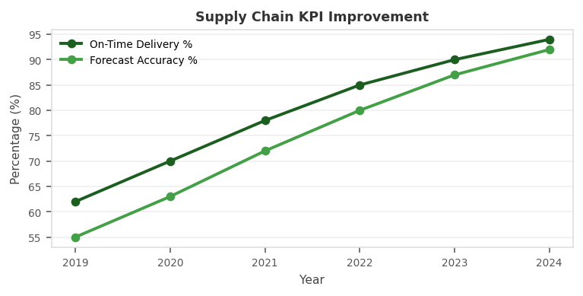

PROFESSIONAL EXPERIENCE
LEAD DATA ENGINEER - SUPPLY CHAIN | DHL Supply Chain Aug 2021 - Present
Client: DHL Supply Chain | 3PL Logistics, Global Supply Chain Visibility
- Architected global logistics data platform on GCP BigQuery processing 50M+ shipment events daily from 60 countries enabling supply chain visibility for Fortune 100 clients.
- Built IoT telemetry pipeline ingesting real-time location, temperature, and condition data from 200,000 GPS-tracked vehicles using Pub/Sub and Dataflow.
- Developed ML-powered ETA prediction model using XGBoost improving delivery time accuracy 35% and customer NPS by 22 points across 500+ lanes.
- Designed automated carrier performance analytics tracking 2,000+ lanes, 500+ carriers, $2B+ freight spend with real-time exception alerting.
- Built customs compliance pipeline integrating with CBP ACE, EU Customs, and 15 national customs authorities automating tariff classification.
- Created demand sensing model using Vertex AI combining POS data, weather, and social signals improving 30-day demand forecast accuracy 28%.
- Implemented BigQuery ML for carrier rate prediction enabling automated spot rate benchmarking saving $15M annually in freight procurement.
- Led GCP cost optimization achieving 40% reduction through BigQuery slot reservation, table partitioning, and query optimization.
Env: GCP BigQuery, Dataflow, Pub/Sub, Vertex AI, Python, PySpark, dbt, Airflow, Terraform, Looker, BigQuery ML, Cloud Run, MQTT
SENIOR DATA ENGINEER | Amazon - Supply Chain Mar 2018 - Jul 2021
Client: Amazon | E-Commerce Fulfillment & Logistics
- Built fulfillment center analytics platform on AWS processing 10M+ daily events across 200+ FCs enabling real-time labor and inventory optimization.
- Engineered demand forecasting pipeline integrating 500+ demand signals for ML models predicting inventory 90 days out at 92% accuracy.
- Developed last-mile delivery analytics using AWS Kinesis and Lambda processing 2M+ daily delivery events for route optimization.
- Built returns analytics platform processing 1M+ daily returns identifying fraud patterns and operational bottlenecks saving $30M annually.
Env: AWS S3, Kinesis, Lambda, EMR, Redshift, SageMaker, Python, PySpark, Airflow, dbt, Spark, Kafka, Tableau
DATA ENGINEER - LOGISTICS | UPS Technology Jul 2015 - Feb 2018
Client: UPS | Parcel Delivery, Package Analytics
- Designed package tracking platform processing 25M+ daily scans from barcode readers, GPS, and RFID sensors into Snowflake analytical warehouse.
- Built network optimization ML model using scikit-learn reducing average sort time 15% across 5 major hub facilities.
- Developed fuel cost analytics processing 50M+ truck telematics records enabling fuel efficiency scoring and driver coaching.
Env: Snowflake, PySpark, Python, scikit-learn, dbt, GCP BigQuery, Tableau, AWS Glue, Kafka, Airflow
ETL DEVELOPER | Accenture - Logistics May 2013 - Jun 2015
Client: Accenture | Logistics Technology Consulting
- Delivered 6 SAP integration data engineering projects for retail and manufacturing clients processing master data from SAP ECC into analytical warehouses.
- Developed Informatica PowerCenter workflows for inventory reconciliation processing 5M+ daily inventory movements across 1,000+ store locations.
Env: SAP ECC, Informatica PowerCenter, SQL Server, SSRS, Talend, Oracle, ETL, Tableau
TECHNICAL SKILLS MATRIX
Supply Chain | SAP ECC/S4HANA, TMS/WMS integration, GS1, EDI 204/214/990, SCAC codes, CBP ACE
Cloud/DW | GCP BigQuery (Expert), Snowflake, AWS Redshift, Azure Synapse, GCP Dataflow, Databricks
IoT/Streaming | GCP Pub/Sub, AWS Kinesis, Kafka, MQTT, Apache Flink, AWS IoT Core, Azure IoT Hub
ETL/ELT | dbt, GCP Dataflow, AWS Glue, ADF, Informatica, Talend, Fivetran, Airbyte, Matillion
Languages | Python, PySpark, SQL, BigQuery SQL, SnowSQL, Scala, R, Bash, dbt, Terraform
ML/Analytics | XGBoost, scikit-learn, Vertex AI, SageMaker, BigQuery ML, MLflow, Prophet, PyTorch
BI/Reporting | Looker, Tableau, Power BI, GDS, Metabase, D3.js, Plotly
Compliance | APICS CSCP, Six Sigma Green Belt, ISO 9001, GDPR supply chain
CERTIFICATIONS
- GCP Professional Data Engineer  - GCP Professional Cloud Architect  - AWS Certified Solutions Architect Professional  - APICS CSCP (Certified Supply Chain Professional) | - Six Sigma Green Belt (ASQ)  - dbt Certified Developer  - Snowflake SnowPro Core  - Databricks Certified Developer
EDUCATION
M.S. Supply Chain Management & Analytics - MIT, Cambridge, MA | 2013
B.E. Industrial Engineering - Anna University, Chennai | 2011
PROFESSIONAL LINKS
>> LinkedIn: linkedin.com/in/meenakshirajan
>> GitHub: github.com/mrajan - Supply chain data tools & GCP utilities
>> Portfolio: meenakshirajan.io - Case studies
>> GCP Certification: cloud.google.com/certification

