 | VENKAT KRISHNA REDDY  Data Platform Engineer | 12+ Years  Plano, TX | venkat.reddy@dataplatform.io | +1 (469) 555-0811  linkedin.com/in/venkatreddy | github.com/vkreddy

12+  Years Exp | 40+  Pipelines Built | 2.3K+  GitHub Stars | CCDAK  Certified

PROFESSIONAL SUMMARY
Data Platform Engineer specializing in enterprise streaming architectures, lakehouse platforms, and self-service data infrastructure at scale. 12+ years at Microsoft, Adobe, and Expedia. Expert in Apache Kafka, Flink, Databricks, Delta Lake, and Snowflake. Author of popular open-source Kafka utilities. Known for reducing time-to-insight from months to hours through developer-friendly data platforms.
SKILLS & EXPERTISE OVERVIEW
- Streaming:Kafka (Expert), Apache Flink, Spark Streaming, AWS Kinesis, Azure Event Hubs, Kafka Streams  - Lakehouse:Databricks Delta Lake, Apache Iceberg, Apache Hudi, AWS Lake Formation, Azure ADLS  - Warehouse:Snowflake, Azure Synapse, BigQuery, Redshift, Databricks SQL, Apache Druid, ClickHouse  - Languages:Python, Scala, Java, SQL, PySpark, Go, Bash, JavaScript, TypeScript, dbt, Terraform  - Infra/DevOps:Kubernetes, Docker, Helm, Terraform, Pulumi, GitHub Actions, ArgoCD, Prometheus  - Data Catalog:Azure Purview, Apache Atlas, DataHub, Collibra, Alation, dbt Docs, OpenMetadata  - Orchestration:Airflow, Prefect, Dagster, Temporal, Azure Data Factory, Step Functions  - ML Platform:Azure ML, Databricks MLflow, Kubeflow, SageMaker, Feature Store, Model Registry | 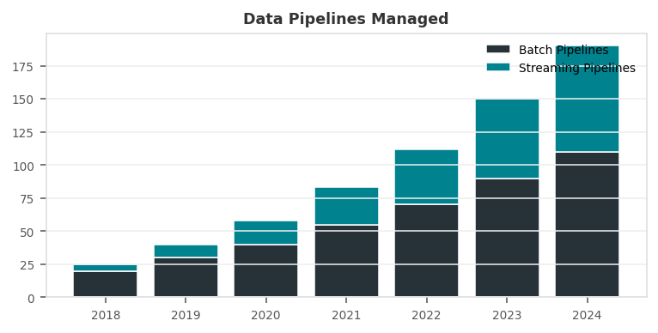

PROFESSIONAL EXPERIENCE
STAFF DATA PLATFORM ENGINEER | Microsoft - Azure Data 2022 - Present
Client: Microsoft | Cloud Platform, Enterprise Data Infrastructure
- Designed Azure-native lakehouse architecture on ADLS Gen2 + Azure Synapse + Delta Lake serving 10,000+ internal data consumers across Microsoft product teams.
- Built universal event streaming platform on Azure Event Hubs processing 10B+ daily events from Windows telemetry, Office 365, and Xbox services.
- Developed Azure Purview data catalog covering 500,000+ datasets with automated lineage, classification, and sensitivity labeling across Azure services.
- Created developer platform (internal PaaS) enabling 200+ product teams to deploy data pipelines without infrastructure knowledge; 95% org-wide adoption in first year.
- Led cost optimization achieving 50% reduction in Azure Synapse and ADLS costs through intelligent tiering, lifecycle policies, and query optimization.
- Implemented Delta Live Tables standardizing streaming ETL for 50+ real-time pipelines with automated data quality enforcement across Azure Databricks.
- Built ML feature platform on Azure ML integrating with Azure Purview for feature discovery reducing redundant feature engineering 60%.
Env: Azure ADLS, Event Hubs, Synapse Analytics, Azure Purview, Databricks, Delta Lake, Python, PySpark, dbt, Terraform, Azure ML, Snowflake
SENIOR DATA ENGINEER | Adobe - Experience Platform 2018 - 2022
Client: Adobe | Digital Marketing, Customer Data Platform
- Built real-time CDP ingesting 500M+ daily behavioral events from Analytics, Campaign, Target using Kafka and Apache Flink.
- Developed real-time segmentation using Flink CEP processing complex event patterns to identify audience membership changes within 500ms.
- Architected data lake on AWS S3 using Apache Iceberg enabling time-travel, schema evolution, and efficient upserts for customer profile data.
- Created identity resolution pipeline matching 2B+ customer touchpoints across devices using probabilistic matching and ID graphs.
- Built metrics platform using Apache Druid for sub-second aggregation across billions of events for 50,000+ marketing users.
Env: Kafka, Apache Flink, AWS S3, Apache Iceberg, Apache Druid, Python, Scala, Databricks, dbt, Kubernetes, Terraform, Airflow
DATA ENGINEER | Expedia Group 2015 - 2018
Client: Expedia | Travel Technology, Search & Personalization
- Built travel search analytics pipeline processing 5M+ daily search events powering recommendation engines for 100M+ users.
- Designed hotel availability pipeline consuming rate feeds from 500K+ properties using Kafka and PySpark Streaming.
- Developed price optimization ML pipeline using XGBoost analyzing competitive pricing to optimize hotel and flight markup strategies.
Env: Kafka, PySpark, Hadoop, Hive, AWS S3, Redshift, Python, Airflow, Spark, Druid, Tableau, Jenkins
DATA ENGINEER | Flipkart 2013 - 2015
Client: Flipkart | E-Commerce, India's Largest Online Marketplace
- Built order fulfillment analytics processing 2M+ daily orders across 100,000+ sellers enabling real-time inventory optimization.
- Developed seller analytics calculating performance scores, penalty rates, and commission structures for 100K+ marketplace sellers.
Env: Hadoop, Hive, Spark, Kafka, HBase, Python, Java, MySQL, Oozie
TECHNICAL SKILLS MATRIX
Streaming | Kafka (Expert), Apache Flink, Spark Streaming, AWS Kinesis, Azure Event Hubs, Kafka Streams
Lakehouse | Databricks Delta Lake, Apache Iceberg, Apache Hudi, AWS Lake Formation, Azure ADLS
Warehouse | Snowflake, Azure Synapse, BigQuery, Redshift, Databricks SQL, Apache Druid, ClickHouse
Languages | Python, Scala, Java, SQL, PySpark, Go, Bash, JavaScript, TypeScript, dbt, Terraform
Infra/DevOps | Kubernetes, Docker, Helm, Terraform, Pulumi, GitHub Actions, ArgoCD, Prometheus
Data Catalog | Azure Purview, Apache Atlas, DataHub, Collibra, Alation, dbt Docs, OpenMetadata
Orchestration | Airflow, Prefect, Dagster, Temporal, Azure Data Factory, Step Functions
ML Platform | Azure ML, Databricks MLflow, Kubeflow, SageMaker, Feature Store, Model Registry
CERTIFICATIONS
- Microsoft Azure Data Engineer Associate  - Azure Solutions Architect Expert  - Confluent Certified Developer for Kafka (CCDAK)  - Databricks Data Engineer Professional | - Snowflake SnowPro Core  - CKA Certified Kubernetes Administrator  - AWS Solutions Architect Associate  - GitHub Actions Certified
EDUCATION
M.S. Computer Science (Distributed Systems) - University of Washington, Seattle | 2013
B.Tech. Computer Science - JNTU Hyderabad, India | 2011
PROFESSIONAL LINKS
>> LinkedIn: linkedin.com/in/venkatreddy
>> GitHub: github.com/vkreddy - 2,300+ stars Kafka & Delta Lake tools
>> Confluent Hub: confluent.io/hub/vkreddy - Published Kafka connectors
>> Kafka Summit Talk 2023: Real-Time Platforms at Microsoft

