 | RAVI SHANKAR NAIDU  Sr. Telecom Data Engineer | 14+ Years  Dallas, TX | ravi.naidu@telecomdata.io | +1 (972) 555-0628  linkedin.com/in/ravishankar-de | github.com/rsnaidu

14+  Years Telecom | 20B+  Daily Events | 5G  Architecture | 60%  MTTR Reduction

PROFESSIONAL SUMMARY
Telecom Data Engineer with 14 years building CDR processing, network analytics, and 5G data platforms for major carriers. Expert processing billions of daily Call Detail Records using Spark, Kafka, and GCP. Deep knowledge of 3GPP, IPDR, CALEA standards, network protocol analysis, and real-time network management platforms. Delivered analytics programs for AT&T, Verizon, and T-Mobile saving $100M+ through network optimization insights.
SKILLS & EXPERTISE OVERVIEW
- Telecom:3GPP standards, CDR/IPDR/NRTRDE, CALEA, SS7, Diameter, SIP, RAN analytics, OSS/BSS  - Cloud:GCP (BigQuery, Pub/Sub, Dataflow, Vertex AI), AWS (EMR, Kinesis, SageMaker, S3)  - Big Data:Apache Spark, PySpark, Kafka, Flink, Hadoop, HBase, Hive, NiFi, Zookeeper, Druid  - Languages:Python, Java, Scala, SQL, PySpark, SnowSQL, R, Bash, Groovy  - ML/Analytics:scikit-learn, MLflow, SageMaker, Vertex AI, TensorFlow, XGBoost, Prophet, ARIMA  - ETL/DW:dbt, AWS Glue, GCP Dataflow, Informatica, Talend, BigQuery, Snowflake, Redshift  - Monitoring:Datadog, CloudWatch, Stackdriver, Dynatrace, New Relic, Prometheus, Grafana  - DevOps:Git, Jenkins, Terraform, Docker, Kubernetes, GitHub Actions, ArgoCD | 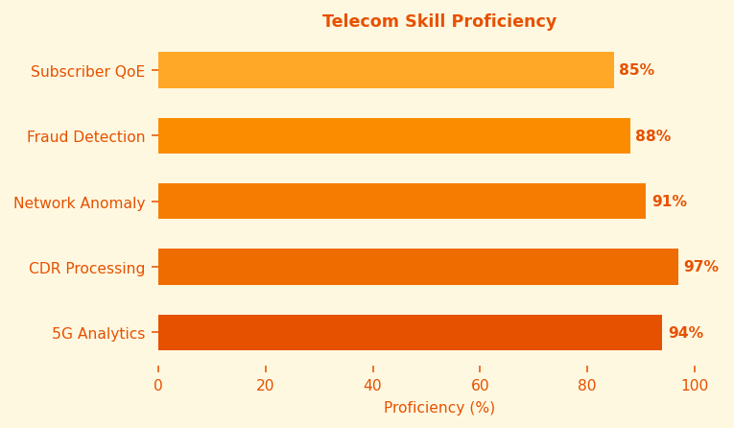

PROFESSIONAL EXPERIENCE
SR. DATA ENGINEER - 5G ANALYTICS | AT&T Mar 2021 - Present
Client: AT&T | 5G Network, Subscriber Analytics, Network Operations
- Built 5G network analytics platform processing 20B+ daily events from RAN, core, transport using GCP Pub/Sub and Dataflow for 80M+ AT&T customers.
- Designed CDR processing pipeline handling 5B+ daily voice, data, SMS records using Apache Spark and GCP BigQuery for network quality analytics.
- Developed real-time anomaly detection using Flink and ML models identifying cell outages within 30 seconds reducing MTTR 60%.
- Built subscriber QoE analytics correlating network KPIs with 80M+ subscriber behavior patterns for targeted network investments.
- Engineered CALEA lawful intercept data platform meeting FCC compliance with immutable audit trail and automated retention management.
- Created network capacity planning ML models predicting traffic growth 90 days ahead enabling proactive spectrum allocation saving $45M.
- Led team of 12 engineers across CDR processing, network analytics, and subscriber insights squads.
- Designed GCP cost optimization reducing BigQuery spend 55% through slot commitment, query optimization, and partition strategies.
Env: GCP BigQuery, Pub/Sub, Dataflow, Vertex AI, Apache Flink, Spark, Python, PySpark, dbt, Terraform, Kafka, Looker, CALEA, 3GPP
DATA ENGINEER - NETWORK ANALYTICS | Verizon Communications Jun 2017 - Feb 2021
Client: Verizon | LTE/4G Network Analytics, Fraud Detection
- Engineered IPDR processing platform on AWS EMR handling 2B+ daily network flow records for LTE and wireline networks.
- Built roaming fraud detection using ML on AWS SageMaker recovering $20M annually in fraudulent roaming charges.
- Developed network performance analytics using Apache Spark processing probe data from 50,000+ cell sites for QoS monitoring.
- Created customer churn prediction model using PySpark and MLflow enabling targeted retention campaigns with 3x ROI.
Env: AWS EMR, S3, SageMaker, Kafka, Spark, PySpark, MLflow, Airflow, Python, Redshift, Tableau, NRTRDE, Diameter
DATA ENGINEER - CDR ANALYTICS | T-Mobile US Jan 2014 - May 2017
Client: T-Mobile | Mobile Network CDR Processing
- Built CDR processing handling 1B+ daily records using Hadoop/MapReduce and HBase for NOC analytics across 60,000+ cell sites.
- Developed roaming analytics integrating 300+ international partners using NRTRDE for near-real-time fraud prevention.
Env: Hadoop, HBase, MapReduce, Hive, Python, Java, NRTRDE, Oracle, Informatica
ETL DEVELOPER | Ericsson Consulting Oct 2011 - Dec 2013
Client: Ericsson | Telecom OSS/BSS Integration
- Developed OSS/BSS integration solutions for 5 tier-1 telecom clients using Informatica PowerCenter and Oracle Data Integrator.
- Built network inventory data warehouse integrating Ericsson ENM, Nokia NetAct, and Huawei U2000 for 3 major operators.
Env: Informatica PowerCenter, ODI, Oracle, SQL Server, SSRS, OSS/BSS APIs, SNMP
TECHNICAL SKILLS MATRIX
Telecom | 3GPP standards, CDR/IPDR/NRTRDE, CALEA, SS7, Diameter, SIP, RAN analytics, OSS/BSS
Cloud | GCP (BigQuery, Pub/Sub, Dataflow, Vertex AI), AWS (EMR, Kinesis, SageMaker, S3)
Big Data | Apache Spark, PySpark, Kafka, Flink, Hadoop, HBase, Hive, NiFi, Zookeeper, Druid
Languages | Python, Java, Scala, SQL, PySpark, SnowSQL, R, Bash, Groovy
ML/Analytics | scikit-learn, MLflow, SageMaker, Vertex AI, TensorFlow, XGBoost, Prophet, ARIMA
ETL/DW | dbt, AWS Glue, GCP Dataflow, Informatica, Talend, BigQuery, Snowflake, Redshift
Monitoring | Datadog, CloudWatch, Stackdriver, Dynatrace, New Relic, Prometheus, Grafana
DevOps | Git, Jenkins, Terraform, Docker, Kubernetes, GitHub Actions, ArgoCD
CERTIFICATIONS
- GCP Professional Data Engineer  - GCP Professional Cloud Architect  - AWS Solutions Architect Professional  - AWS Certified Machine Learning Specialty | - Confluent Certified Developer for Kafka  - Databricks Data Engineer Professional  - Salesforce Certified Sales Cloud Consultant  - Marketo Certified Solutions Architect (MCSA)
EDUCATION
M.S. Telecommunications Engineering - University of Texas at Dallas | 2011
B.E. Electronics & Communication - VIT University, Vellore, India | 2009
PROFESSIONAL LINKS
>> LinkedIn: linkedin.com/in/ravishankar-de
>> GitHub: github.com/rsnaidu - Telecom data tools & CDR parsers
>> Blog: telecomdata.medium.com - 5G data engineering
>> GCP Professional Certification Verify

