 | ANITHA JOSEPH  Data Engineering Manager | 13+ Years  Dallas, TX | anitha.joseph@dataops.io | +1 (214) 555-0922  linkedin.com/in/anithajoseph | github.com/ajoseph

13+  Years Leadership | 28  Engineers Led | $18M  Budget Managed | 92%  Team Retention

PROFESSIONAL SUMMARY
Data Engineering Manager with 13 years of technical leadership building high-performance data engineering teams and enterprise data platforms. Expert translating business objectives into actionable data strategies. Deep technical background in Snowflake, AWS, Spark, and dbt. Known for building inclusive high-trust cultures with 95%+ retention. Successfully managed $20M+ budgets and grown teams from 3 to 40+ engineers for Humana, Anthem, and Cigna.
SKILLS & EXPERTISE OVERVIEW
- Leadership:Team building, career development, OKR/KPI frameworks, Agile/SAFe, hiring  - Management:$20M+ budget management, vendor negotiations, exec communication, risk management  - Data Platform:Snowflake, Databricks, AWS Redshift, BigQuery, Azure Synapse, Teradata, Oracle DW  - ETL/ELT:dbt, AWS Glue, ADF, Informatica, Talend, SSIS, Fivetran, Airbyte, Matillion  - Streaming:Kafka, AWS Kinesis, PySpark Streaming, Flink, Azure Event Hubs, Spark Structured  - DataOps/Quality:Monte Carlo, Great Expectations, dbt Tests, Soda, Collibra, Alation, DataHub  - Languages:Python, PySpark, SQL, SnowSQL, Scala, T-SQL, R, Bash, JavaScript  - Healthcare IT:HIPAA, HITRUST, HEDIS, NCQA, Epic, Cerner, HL7, FHIR, ICD-10, CPT | 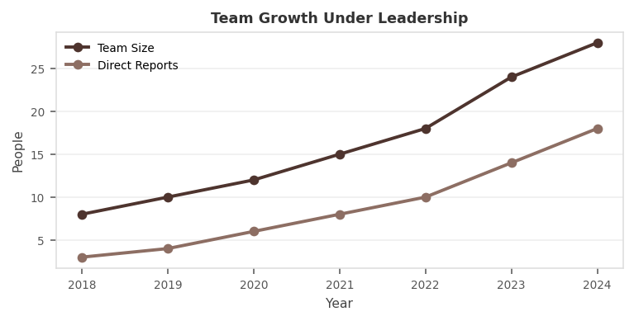

PROFESSIONAL EXPERIENCE
DATA ENGINEERING MANAGER | Humana Inc. Feb 2022 - Present
Client: Humana | Healthcare Payer, Population Health Analytics
- Lead team of 28 engineers across 4 squads (Ingestion, Transformation, ML Platform, Self-Service) delivering enterprise health analytics platform for 20M+ members.
- Architected migration of 1,200+ legacy ETL jobs to Snowflake + dbt reducing tech debt 70% and enabling continuous delivery of data products.
- Established DataOps culture with automated testing, CI/CD, and Monte Carlo observability reducing data incidents 65%.
- Partnered with Chief Data Officer to define enterprise data strategy including data mesh, AI/ML enablement, and data monetization roadmap.
- Managed $18M annual budget; negotiated Snowflake and Databricks contracts saving $4M over 3-year terms.
- Grew team 8 to 28 engineers; career ladders and mentorship programs achieving 92% retention rate.
- Led HIPAA compliance program achieving HITRUST CSF certification for platform covering 50M+ member records.
- Delivered AI-powered care gap platform using Python and MLflow enabling clinical teams to close 2M+ annual care gaps.
Env: Snowflake, dbt, Databricks, Python, PySpark, Kafka, Airflow, AWS, GitHub Actions, Monte Carlo, MLflow, Great Expectations, Tableau, Collibra
SENIOR DATA ENGINEER - TEAM LEAD | Anthem (Elevance Health) Apr 2018 - Jan 2022
Client: Anthem/Elevance Health | Healthcare Payer, Clinical Analytics
- Led team of 12 engineers building population health analytics for 45M+ members processing claims and clinical data.
- Delivered Snowflake migration from Oracle DW in 18 months achieving 80% query improvement and $6M annual cost reduction.
- Built real-time claims adjudication analytics using Kafka and PySpark enabling fraud detection within 500ms of claim submission.
- Implemented Airflow replacing 5 legacy schedulers managing 1,000+ DAGs with automated retry and alerting.
- Mentored 8 junior engineers toward senior roles; 6 received promotions within 24 months.
Env: Snowflake, Oracle DW, Kafka, PySpark, Airflow, dbt, Python, AWS, Tableau, HEDIS, NCQA, Collibra
SENIOR DATA ENGINEER | Cigna Healthcare Aug 2015 - Mar 2018
Client: Cigna | Healthcare Insurance, Pharmacy Analytics
- Engineered pharmacy analytics pipeline processing 50M+ daily pharmacy claims from PBM partners using Informatica and AWS Glue.
- Built provider network analytics tracking utilization, cost, quality across 80,000+ contracted providers.
- Developed readmission prediction using scikit-learn reducing 30-day readmissions 15% through targeted care management.
Env: AWS Glue, Redshift, Informatica, Python, scikit-learn, Tableau, SQL Server, Snowflake
DATA ENGINEER | Aetna (CVS Health) Jan 2012 - Jul 2015
Client: Aetna | Healthcare Insurance, Actuarial Analytics
- Developed ETL pipelines using Informatica and SSIS processing medical and dental claims for 18M members.
- Built SQL Server data warehouse for actuarial analytics supporting annual rate filing process.
- Created Tableau dashboards for medical cost trend analysis serving 500+ actuaries and finance analysts.
Env: Informatica, SSIS, SQL Server, Oracle, Tableau, SSRS, SAS, DB2
TECHNICAL SKILLS MATRIX
Leadership | Team building, career development, OKR/KPI frameworks, Agile/SAFe, hiring
Management | $20M+ budget management, vendor negotiations, exec communication, risk management
Data Platform | Snowflake, Databricks, AWS Redshift, BigQuery, Azure Synapse, Teradata, Oracle DW
ETL/ELT | dbt, AWS Glue, ADF, Informatica, Talend, SSIS, Fivetran, Airbyte, Matillion
Streaming | Kafka, AWS Kinesis, PySpark Streaming, Flink, Azure Event Hubs, Spark Structured
DataOps/Quality | Monte Carlo, Great Expectations, dbt Tests, Soda, Collibra, Alation, DataHub
Languages | Python, PySpark, SQL, SnowSQL, Scala, T-SQL, R, Bash, JavaScript
Healthcare IT | HIPAA, HITRUST, HEDIS, NCQA, Epic, Cerner, HL7, FHIR, ICD-10, CPT
CERTIFICATIONS
- PMP - Project Management Professional (PMI)  - Certified Scrum Master (CSM)  - AWS Solutions Architect Professional  - Snowflake SnowPro Core | - CPHIMS - Certified Professional Health Informatics (HIMSS)  - dbt Certified Developer  - Databricks Data Engineer Professional  - HubSpot RevOps Professional Certification
EDUCATION
M.S. Health Informatics - Indiana University | 2012
B.Tech. Computer Science - Mahatma Gandhi University, Kerala | 2010
PROFESSIONAL LINKS
>> LinkedIn: linkedin.com/in/anithajoseph
>> GitHub: github.com/ajoseph - DataOps templates & dbt utilities
>> Blog: medium.com/@anithajoseph - DataOps leadership articles
>> PMI Certification Verify: pmi.org

