DNA Extraction with kit

Quick Overview
Parameter | Information
Protocol ID | MOL-001
Version | 1
Method Owner | Lieke Lipsch
Estimated Hands-on Time | 4 hours
Total Duration | 4 hours
Difficulty Level | ☐ Basic ☐ Intermediate ☐ Advanced
Training Required | ☐ Yes ☐ No
Biosafety Level | /
Typical Throughput | 16
Sample types | Soil samples
Output | Extracted DNA, nanodrop values for DNA quality
Related Protocols | /

Method Information
Method Title: DNA extraction with kit
Author(s): Lieke Lipsch
Date Created: 22-01-2025
Last Updated: 22-01-2025
Reviewed By:
Approved By:

Purpose
What is this method used for? Extracting DNA

Scope
When should this protocol be used and when should it not be used?

Suitable for
- Soil samples

Not suitable for
- ?

Safety Considerations

Hazards
- Biological: /
- Chemical: /
- Physical: Make sure to use the right lid for the beads beater

Required PPE
- Lab coat
- Gloves

Waste Disposal
- Biological waste: tubes/filters/leftover samples - bag for autoclaving
- Chemical waste: washing buffer – add to non-halogenated waste bottles in fume hoods.
- Sharps: /

Materials and Reagents
Reagent/Material | Specification | Supplier | Storage
Nucleo Spin® | Soil | Machery- Nagel  740780.10 / .50 / .250  https://www.mn-net.com/de/nucleospin-soil-mini-kit-fuer-dna-aus-bodenproben-740780.50 | Room temperature

Equipment
Equipment | Model | Location
Centrifuge with 30*2ml tube rotor  Beads beater  Nanodrop |  | DNA extraction lab 105  DNA extraction lab 105  DNA extraction lab 105

Procedure

Before Starting

Checklist
☐ Required lab training completed
☐ Required eplas training completed
☐ Kit ordered/ available
☐ Equipment and bench available/ reserved
☐ Sample IDs assigned

Step-by-Step Procedure
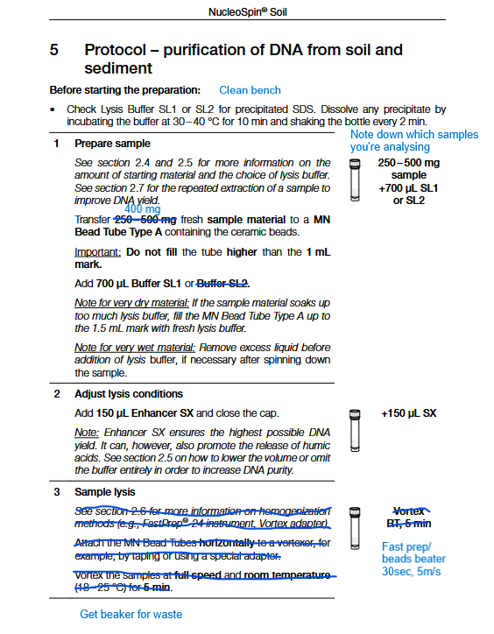
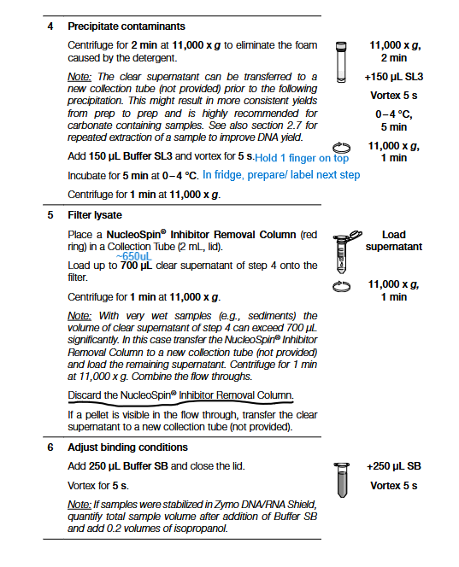
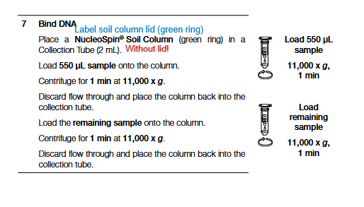
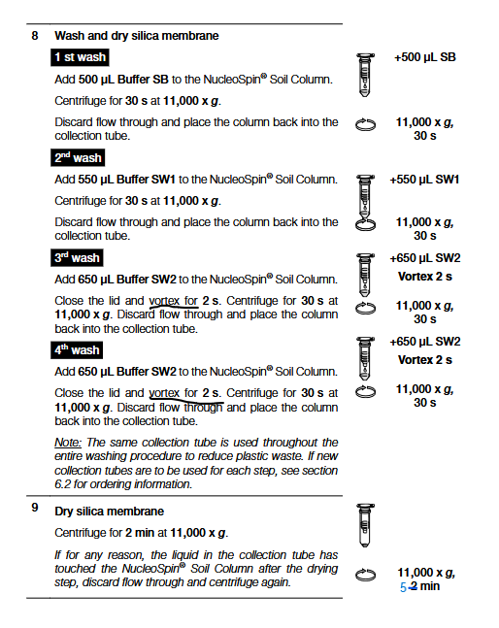
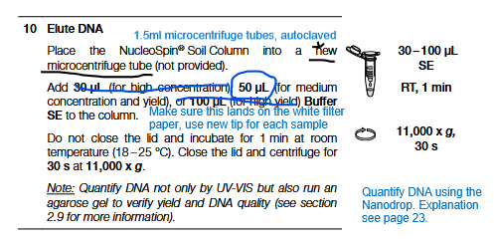
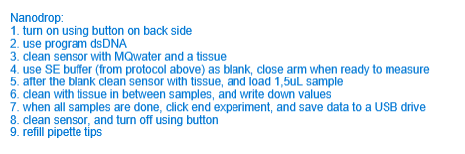

Critical Control Points
⚠ Step: /
Why it is critical:/
How to avoid mistakes:/

Quality Control
QC Parameter | Acceptance Criterion
Nanodrop | DNA can be measured

Troubleshooting
Problem | Possible Cause | Solution
No/low DNA concentration | Not ideal lysis conditions for your samples.  Too low DNA concentration in your sample | Try the other lysis buffer (SL2) and try if you get better results without the enhancer SX.  Try to concentrate your sample.

Expected Outcome
You should expect to have a measurable amount of DNA after the extraction.

Data Recording in Lab Books
Record the following information:
- Operator
- Date
- Sample IDs
- Batch numbers
- Deviations from protocol
- Raw data location

Storage and Stability
Item | Storage Condition | Stability
Extracted DNA | -20 degrees | Months

References
- SOPs: https://www.mn-net.com/media/4d/42/06/1793581373/Instruction-NucleoSpin-Soil_pa.pdf?ts=1793581373
- Publications
- Instrument manuals

Revision History
Version | Date | Changes | Author
1.0 |  | Initial version

