Bacterial Extracellular Vesicles (EVs) Extraction

Quick Overview
Parameter | Information
Protocol ID | EV-Extraction-001
Version | 1.0
Method Owner | Haining Huang
Estimated Hands-on Time | ~4–6 h (excluding the unattended centrifugation and the 2 h ultracentrifugation run)
Total Duration | ~6.5–9 h of bench time; usually spread over 1–3 days with optional overnight 4°C holds
Difficulty Level | ☐ Basic ☐ Intermediate ☑ Advanced
Training Required | ☑ Yes ☐ No
Biosafety Level | Depends on the strain used; in all cases, work must comply with the applicable institutional laboratory safety regulations
Typical Throughput | Max ~5 L of culture processed each time
Sample types | Bacterial culture supernatant (e.g., E. coli or P. putida liquid culture)
Output | Purified bacterial extracellular vesicles (EVs), resuspended in ~1 mL PBS
Related Protocols | EV-Purification-001 (Density Gradient Purification — see Optional Step)

Method Information
Method Title | SOP for Bacterial Extracellular Vesicles (EVs) Extraction
Author(s) | Haining Huang
Date Created | 2026-08-28
Last Updated | 2026-10-21
Reviewed By | Chika Ejikeugwu
Approved By

Purpose
To isolate and enrich extracellular vesicles (EVs) from bacterial culture supernatant through sequential centrifugation, filtration, concentration, and ultracentrifugation, yielding an EV preparation suitable for downstream functional validation assays. If proteomic analysis is required, further purification by density gradient can be performed (Optional Step).

Typical Starting Material
Typically, E. coli MG1655 carrying plasmid pKJK5 or P. putida KT2440 carrying plasmid RSF1010 is cultured in LB medium at 37°C for 16 h at 150 rpm until it reaches an OD600 of approximately 1.5. Approximately 2 L of culture is processed per batch.

Scope

Suitable for
- EV isolation from bacterial liquid culture supernatant (broth culture)
- Sample volumes from <1 L (dead-end filtration can be used) up to ~5 L (using the TFF system)
- EV preparations intended for downstream functional validation assays

Not suitable for
- Non-liquid/solid samples

Safety Considerations

Hazards
Biological: Bacterial culture supernatant may contain live bacterial cells or residual pathogens prior to filtration; handle at the appropriate biosafety level
Chemical: 0.01 M NaOH (mildly alkaline, used for TFF system storage) — avoid contact with skin and eyes; wear safety goggles
Flammable: Ethanol (70–75%, lab-grade; used to clean ultracentrifuge tubes and filter inserts) — keep away from open flames and other ignition sources
Physical: Ultracentrifugation at 100,000 × g — if a tube is underfilled, the vacuum drawn during the run may crush the thin-wall tube (see Critical Control Points below); observe standard mechanical safety when operating the centrifuge/ultracentrifuge

Required PPE
- ☑ Lab coat
- ☑ Gloves
- ☑ Safety goggles (when handling NaOH or ethanol)

Waste Disposal
Biological waste: Centrifuge bottles and ultracentrifuge tubes, filter membranes and TFF cassettes that have been in contact with bacterial culture are decontaminated before reuse or disposal (see “Decontamination of Reusable Bottles, Tubes and Glassware” above). Single-use items — filter membranes, syringe filters and pipette tips — are discarded as biological waste; reusable items are collected centrally for decontamination and washing.
Chemical waste: 0.01 M NaOH solution — dispose of per institutional chemical waste guidelines

Decontamination of Reusable Bottles, Tubes and Glassware
Bottles, tubes and glassware that have been in contact with bacterial culture are decontaminated by one of the two routes below before washing. Use one route only: do not autoclave items that have already been chemically disinfected, and avoid autoclaving the same item repeatedly — the plastic degrades with every cycle.
Route A — Autoclaving. Separate the bottles from their caps, bag them and autoclave, then wash. This is the most thorough option, but polypropylene bottles and thin-wall ultracentrifuge tubes tolerate only a limited number of cycles; keep a record of the cycles for items that are reused often.
Route B — Chemical disinfection. Immerse the items in 2% (v/v) Wofasteril (peracetic acid) for 1–2 h, then rinse thoroughly with water and wash as usual. Use this route for items that would otherwise have to be autoclaved repeatedly.

Materials and Reagents

Equipment
Equipment | Model | Location
1 L centrifuge bottles | Thermo Scientific | E27/K21 in building 4.1 (UFZ)
SORVALL LYNX 6000 Centrifuge | Thermo Scientific Inc., Waltham, MA, USA | K21 in building 4.1 (UFZ)
Vacuum pump | Laboratory diaphragm vacuum pump (any model suitable for filtration) | E29 in building 4.1 (UFZ)
Vacuum filtration flask | e.g., Büchner/side-arm filter flask, used with the vacuum pump | E29 in building 4.1 (UFZ)
Concentrator tubes | Amicon® Ultra-15, 100 kDa MWCO | E29 in building 4.1 (UFZ)
Tangential Flow Filtration (TFF) system | Interchangeable cassettes: Sartorius 0.2 µm cassette (Step 2, filtration) and Millipore 100 kDa cassette (Step 3, Method B) | One in K29 in building 4.1 (UFZ), one in BTU
Analytical balance | precision 0.01 g | E29 in building 4.1 (UFZ)
Ultracentrifuge + rotor | Beckman Coulter Optima XP-80 ultracentrifuge with SW 32 Ti swinging-bucket rotor and buckets (#1–#6) | Lab 221 in building 4.1 (UFZ)
Ultracentrifuge tubes | Open-Top Thinwall PP, 38.5 mL, 25×89 mm, Cat. No. 326823 | E29 in building 4.1 (UFZ)

Materials and Reagents
Reagent/Material | Specification | Supplier | Storage
1× PBS (stock) | Not filtered; general-purpose stock solution | Prepared in-house | Room temperature (RT)
1× PBS (filtered, cold) | Sterile, 0.2 µm filtered, pre-chilled — used for resuspension steps (e.g., Step 4.7) | Prepared in-house | 4°C
0.01 M NaOH (working solution) | 0.01 M (in DI water) | Prepared in-house | RT
PBS salts | NaCl, KCl, Na₂HPO₄ (anhydrous), KH₂PO₄ — analytical grade; used to prepare the 1× PBS stock (Table 2) | Any supplier | RT
NaOH (solid) | Pellets, analytical grade; used to prepare the 0.01 M NaOH solution | Any supplier | RT
Ethanol | 70–75% (v/v), lab-grade; used to clean ultracentrifuge tubes and concentrator filter inserts | Any supplier | RT — flammable; store per institutional rules
Deionized (DI) water | Large volume consumable; used for rinsing the TFF system, concentrator tubes, and ultracentrifuge tubes | Available in the lab | RT
Media bottle | 5 L, glass | Any supplier | RT
Erlenmeyer flask | 1 L, 2 L or 3 L | Any supplier | RT
Centrifuge tubes | 50 mL | Any supplier | RT
Filter membranes (dead-end filtration) | PES, 0.8 / 0.45 / 0.2 µm, 47 mm diameter — see Ordering Information | Cytiva (Pall) Supor or GVS  (or any supplier) | RT
Syringe filters | 0.2 µm, sterile | https://www.sigmaaldrich.com/DE/de/product/mm/slgpr33rs  https://www.fishersci.de/shop/products/sterile-pes-syringe-filter/15206869 | RT
Syringes | 20 mL / 50 mL | Any supplier | RT
EP tubes | 1.5 mL/2 mL | Thermo Fisher | RT
General labware | Pipettes, motorized pipette filler, tube racks, micropipettes (various volumes), sterile syringes | Any supplier | RT

Reagent Preparation

Solution/Buffer 1 — 1× PBS (RT stock)
Table 1. Solution/Buffer 1 — 1× PBS (RT stock)
Composition | 1× PBS, autoclaved (filtration optional)
Preparation | See Table 2
Storage | Room temperature (RT)
Stability | Stable for ≥1 year at RT
Table 2. Composition of 1× PBS (0.01 M, pH 7.2)
Component | Amount per 1 L
NaCl | 8 g
KCl | 0.2 g
Na₂HPO₄ | 1.44 g
KH₂PO₄ | 0.24 g
Solvent | Double-distilled water (ddH₂O), make up to 1 L
pH | Adjust to 7.2

Solution/Buffer 2 — 1× PBS (filtered, cold)
Table 3. Solution/Buffer 2 — 1× PBS (filtered, cold)
Composition | 1× PBS, sterile, 0.2 µm filtered
Preparation | Filter the PBS stock through a 0.2 µm filter
Storage | 4°C
Stability | Stable

Solution/Buffer 3 — 0.01 M NaOH
Table 4. Solution/Buffer 3 — 0.01 M NaOH
Composition | 0.01 M NaOH in DI water
Preparation | Dissolve 0.4 g of NaOH in 1 L of DI water.
Storage | Room temperature (RT)
Stability | Used to flush/store the TFF system between runs to inhibit bacterial growth; very stable

Procedure
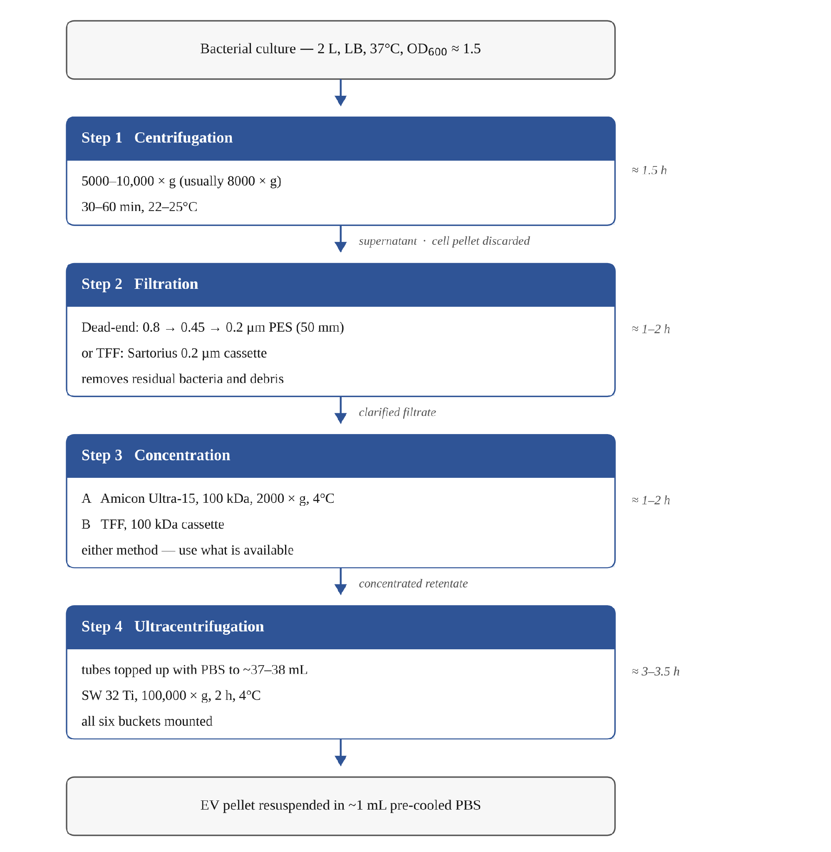
Figure 1. Workflow overview of the bacterial EV extraction procedure
Approximate time for each step is shown on the right. Steps 1–2 remove bacteria and debris; Steps 3–4 enrich the vesicles.

Before Starting — Checklist
- ☐ Required training completed
- ☐ Reagents prepared (1× PBS, 0.01 M NaOH)
- ☐ Equipment available (TFF system, ultracentrifuge and rotor booked/confirmed)
- ☐ Calibration verified (analytical balance)
- ☐ Sample IDs assigned

Step 1: Centrifugation (Bacterial Removal)
Note: Because this is a bacterial culture (unlike, e.g., soil or environmental samples), the starting density of the culture is relatively uniform, so balancing between bottles is straightforward. Bottles must still be balanced carefully before every run (see Critical Control Points).
- Pour the bacterial culture into 1 L centrifuge bottles.
- Strictly balance the bottles using a scale or by matching the liquid volume meniscus.
- Centrifuge at 5000–10,000 × g (usually 8000 × g), 30–60 min, 22–25°C (room temperature).
- After centrifugation, slowly transfer the supernatant into a clean 2/3/5 L media bottle.
- Separate the centrifuge bottles and caps and decontaminate them by Route A or Route B (see “Decontamination of Reusable Bottles, Tubes and Glassware”), then wash.
Expected result: Clear supernatant free of bacterial pellet, ready for filtration.
⏱ This step will take approximately 1.5 h (including loading, balancing, centrifugation, and supernatant transfer). If you cannot finish on the same day, the supernatant can be kept at 4°C and the protocol continued the next day.

Step 2: Filtration (Removal of Residual Bacteria and Debris)
Note: Traditional dead-end filtration (sequentially using 0.8, 0.45, and 0.2 µm filters) can be used; for larger volumes, a tangential flow filtration (TFF) system is recommended to accelerate processing. However, not all labs have the 0.2 µm cassette.
Sequential Dead-End Filtration
- Assemble the vacuum filtration unit: fit a 47 mm 0.8 µm PES membrane into the filter holder and connect the filtration flask to the vacuum pump. The membranes do not need to be pre-wetted.
- Pour the supernatant from Step 1 into the funnel and filter it under vacuum. Replace the membrane whenever the flow rate drops noticeably.
- Repeat the filtration with a fresh 47 mm 0.45 µm PES membrane, then with a fresh 47 mm 0.2 µm PES membrane, collecting the filtrate each time. Use a new membrane at every stage.
- Discard the used membranes as biological waste and send the filtration glassware for sterilization and washing.

Tangential Flow Filtration (TFF) — Sartorius 0.2 µm cassette
- Rinse the internal system of the TFF equipment with 2 L of DI water to remove residual liquid.
- Insert the feed tube into the sample bottle. Collect the permeate; route the retentate back into the feed tube to circulate until all liquid is collected as permeate.
- Flush the lines with 2 L of DI water, then circulate 1 L of 0.01 M NaOH to inhibit bacterial growth for storage.
- Decontaminate the original sample bottles by Route A or Route B (see “Decontamination of Reusable Bottles, Tubes and Glassware”), then wash.
Expected result: Filtrate free of residual bacteria and debris (clarified through 0.2 µm).
⏱ This step will take approximately 1–2 h, depending on sample volume and filter flux. If you cannot finish on the same day, the filtrate can be kept at 4°C and the protocol continued the next day.
Purpose of Steps 1–2: to remove bacteria and large particles/debris from the sample.

Step 3: Concentration (Volume Reduction)
Two methods can be used for this step. Both give an equivalent result — use whichever system is available:
Method A — Tube-based centrifugal concentration (Amicon® Ultra-15, 100 kDa MWCO)
Performed in E29 (building 4.1, UFZ) using an Eppendorf centrifuge and 100 kDa Millipore (Amicon® Ultra-15) concentrator tubes.
- Rinse the 15 mL concentrator tubes with DI water and place the filter insert into the plastic tube.
- Use a pipette to transfer the filtered sample into the concentrator tubes (max capacity per run: 16 tubes × 15 mL = 240 mL).
- Centrifuge at 4°C, 2000 × g, 3–5 min (adjust the time based on the residual volume in individual tubes).
- When the retentate volume is <1 mL, transfer it to a 50 mL centrifuge tube for pooling. Repeat this process until all samples are concentrated (est. time: ~2 hours for 2 L).
- After the last collection, rinse the concentrator tubes with 1–20 mL of PBS to recover vesicles attached to the membrane and add the rinse to the pooled sample. The pooled volume does not have to fill the ultracentrifuge tubes — they are topped up with PBS in Step 4.2.
- Store the concentrated samples at 4°C.
- Rinse the filter inserts multiple times with DI water and store them in 0.01 M NaOH or 75% ethanol; wash and dry the plastic outer tubes.
Expected result: Retentate volume suitable for loading into the ultracentrifuge tubes in the next step.
⏱ Method A will take approximately 2 h for 2 L of sample. If you cannot finish on the same day, the concentrated sample can be kept at 4°C and the protocol continued the next day.
Method B — Tangential Flow Filtration (TFF) concentration (Millipore 100 kDa TFF system)
Use this method when a dedicated 100 kDa TFF concentrator system is available; it is faster than Method A for large volumes.
- Rinse the TFF concentration system with DI water.
- Load the filtered sample (from Step 2) into the TFF system reservoir.
- Circulate the sample through the 100 kDa cassette, discarding the permeate, until ~150 mL of concentrated retentate remains.
- Rinse the remaining sample out of the system with PBS and collect a further ~80 mL, giving ~230 mL of pooled retentate in total.
- Flush the system with DI water, then circulate 0.01 M NaOH for storage between uses (as in Step 2).
- Store the pooled retentate at 4°C until ultracentrifugation.
Expected result: Same as Method A, achieved more quickly.
⏱ Method B will take approximately 1 h for 2 L of sample (faster than Method A). If you cannot finish on the same day, the concentrated sample can be kept at 4°C and the protocol continued the next day.
Typical final volume prior to ultracentrifugation (either method): up to 6 × 38.5 mL (38.5 mL = capacity of each ultracentrifuge tube; up to 6 tubes/samples can be processed per ultracentrifugation run).

Step 4: Ultracentrifugation (EV Enrichment)
- Filter the concentrated sample using a 0.2 µm syringe filter and transfer it into the 38.5 mL ultracentrifuge tubes.
- Top up each tube with pre-cooled PBS to ~37–38 mL, close to the 38.5 mL capacity. Underfilled tubes collapse under vacuum — see Critical Control Points.
- Balance the ultracentrifuge tubes precisely to 0.01 g using an analytical balance.
- Place the tubes symmetrically into the SW 32 Ti rotor buckets (e.g., #1 opposite #4, #2 opposite #5). All six buckets must be attached to the rotor for every run, even when fewer tubes are loaded.
- Set parameters: Rotor/Tube: SW 32 Ti / 38.5 mL; Speed: 100,000 × g; Time: 2 h; Temperature: 4°C; Accel: Max; Decel: 7/8 (or set to no coast).
- Operation monitoring and run: click “Start vacuum” to evacuate the chamber; the run begins after 2–3 min and the rotor reaches the set speed in ~5 min. After the run, the vacuum is released once the speed drops below 2000 rpm; then click “Open vacuum” before removing the tubes.
- Remove the tubes and pour off the supernatant completely in one smooth motion. Add 100–200 µL of pre-cooled PBS to the tube and resuspend the pellet by pipetting up and down repeatedly aimed at the bottom (final total volume should be ~1 mL). If more than one tube was run, pool the resuspended pellets from all tubes into a single collection tube and adjust the combined volume to ~1 mL with pre-cooled PBS.
- Clean the ultracentrifuge tubes for reuse: decontaminate them by Route A or Route B (see “Decontamination of Reusable Bottles, Tubes and Glassware”), then rinse with DI water, dry and store at room temperature. Thin-wall polypropylene tubes tolerate only a limited number of autoclave cycles, so Route B is preferred for tubes that are reused often.
Expected result: EV pellet resuspended in ~1 mL PBS, ready for downstream storage or assays.
⏱ This step will take approximately 3–3.5 h (including tube loading, balancing, the 2 h run, and pellet resuspension). If you cannot start the ultracentrifugation run on the same day, the pre-filtered concentrated sample can be kept at 4°C and the run continued the next day.
Purpose of Steps 3–4: to enrich the vesicles.
In theory, EVs are obtained once the steps above are complete. Depending on your experimental design, however, consider whether further purification is needed (see Optional Step below).

Optional Step: Density Gradient Purification (Further Purification)
If downstream analysis involves proteomics, separate and purify using a sucrose solution or iodixanol. This step is generally not required for functional validation assays. This procedure is documented separately as Protocol EV-Purification-001 (Density Gradient Purification).

Critical Control Points
⚠ Step | Why it is critical | How to avoid mistakes
Step 4.1–4.2 — Loading and filling the ultracentrifuge tube | Tubes are thin-wall plastic with low resistance to compression; if the liquid volume is not nearly full, the vacuum drawn during the run will collapse/destroy the tube (see Figure 2) | Fill the tube close to its capacity (e.g., top up to 37–38 mL with PBS for a ~30 mL sample); verify the volume before loading
Step 1.2 / Step 4.3 — Balancing bottles/tubes | Imbalance can damage the rotor and compromise run safety | Use a scale or match liquid meniscus for centrifuge bottles; balance ultracentrifuge tubes precisely to 0.01 g with an analytical balance; load rotor positions symmetrically

Troubleshooting
Problem | Possible Cause | Solution
Ultracentrifuge tube collapsed/deformed after the run (Step 4) | Combined sample + PBS volume in the tube was insufficient; the resulting air gap allows the vacuum drawn during the run to crush the thin-wall tube | Before the run, top up the liquid volume close to the tube's capacity (e.g., to ~37–38 mL for a 38.5 mL tube); double-check the volume before loading; ensure precise balancing
No visible pellet after ultracentrifugation | Normal in most runs — bacterial EV pellets are small and translucent and are often not visible by eye | Do not discard the tube. Resuspend the bottom of the tube as described in Step 4.7 and confirm recovery by NTA before concluding that the run failed
TFF flux drops sharply during filtration or concentration | Membrane fouling by residual cells and debris | Pause and rinse or backflush the cassette with DI water; confirm that the Step 1 centrifugation removed the cell pellet completely; replace the cassette if the flux does not recover
Filtrate still turbid after 0.2 µm filtration | Membrane damaged or bypassed through a poor seal; incomplete bacterial removal in Step 1 | Re-filter through a fresh 0.2 µm membrane; check the seal of the filter holder; check the Step 1 supernatant for carry-over of the pellet

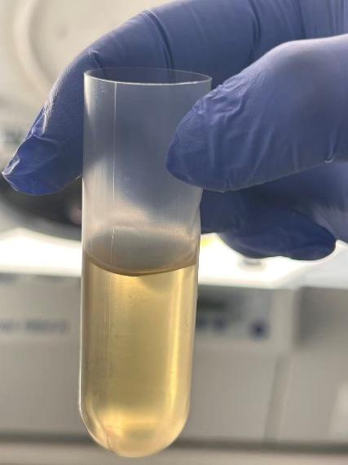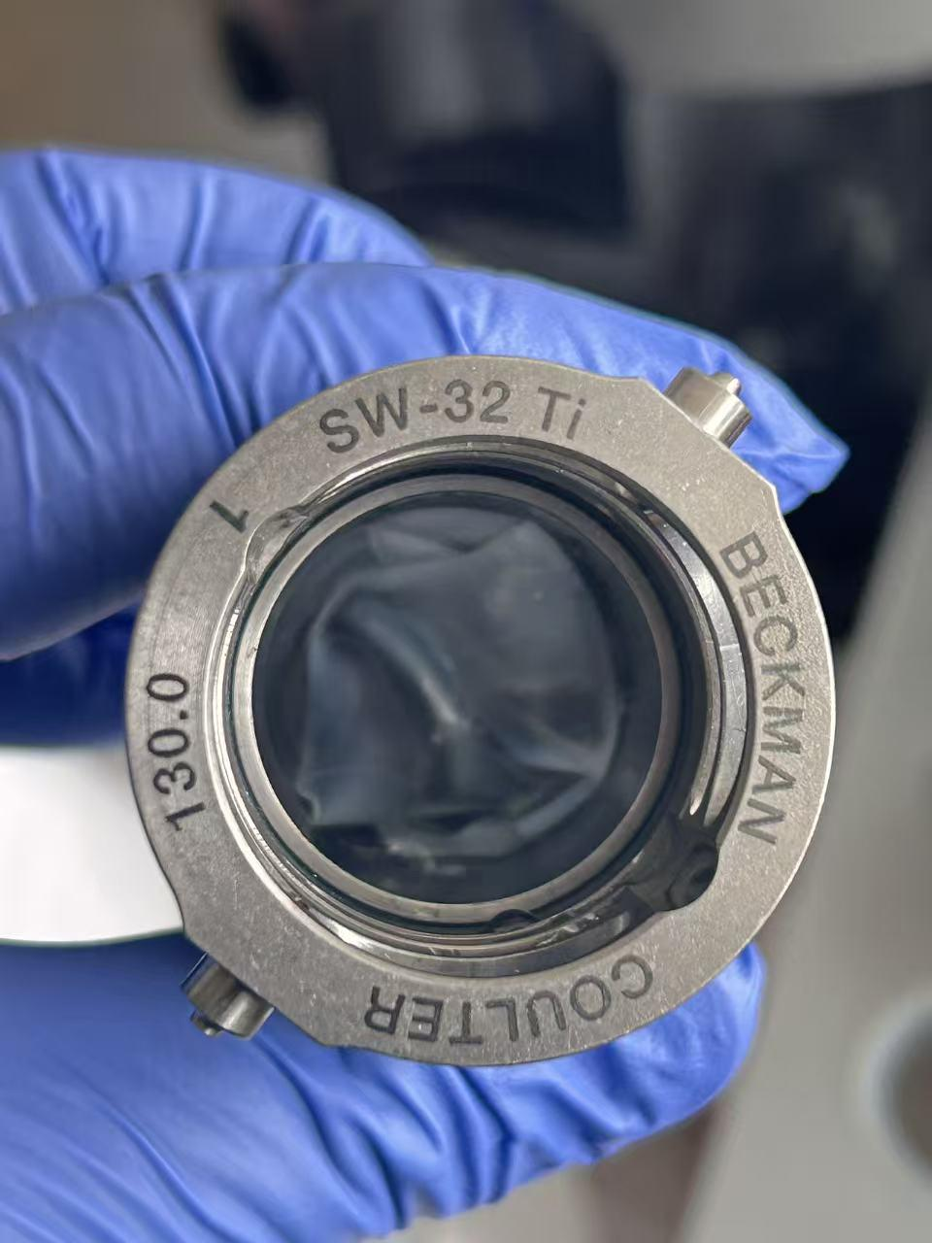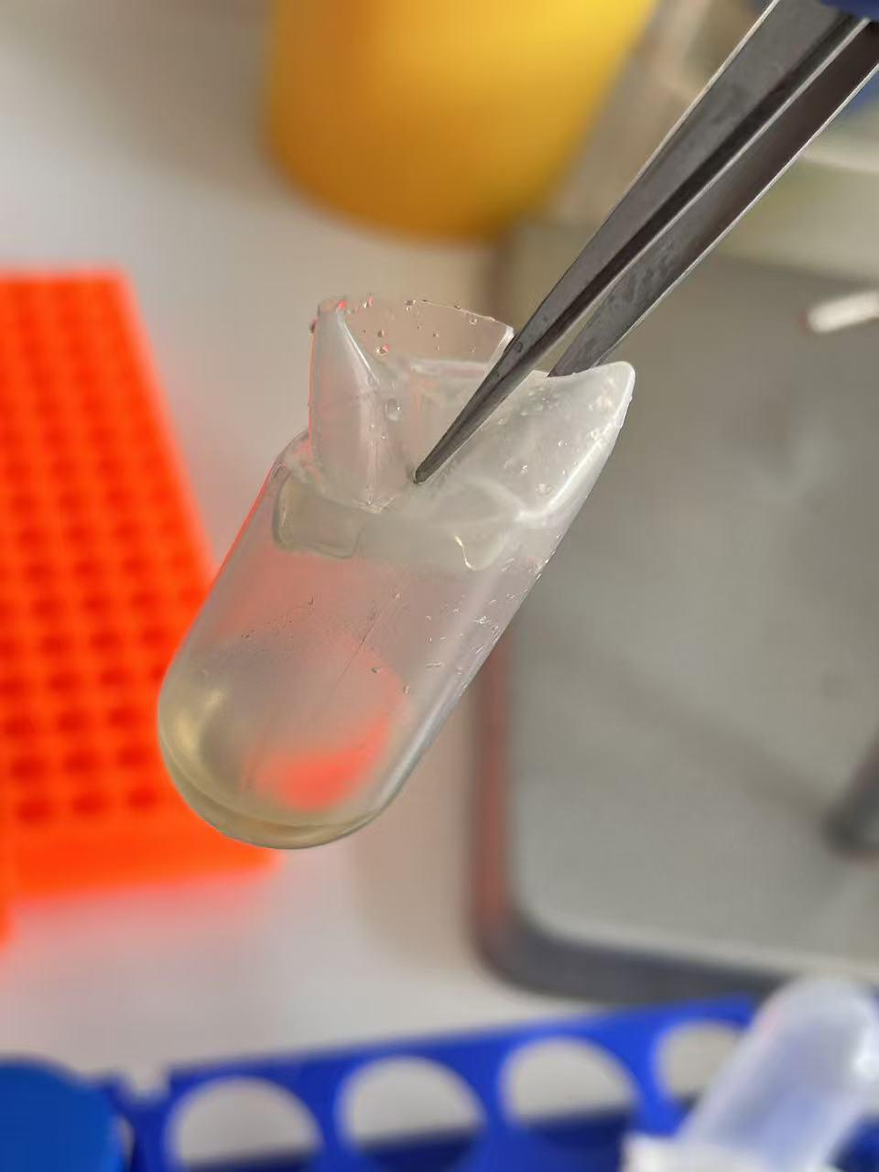
Figure 2. Vacuum-induced collapse/deformation of the ultracentrifuge tube
Left to right: (1) insufficient liquid volume in the tube ("the volume is not enough"); (2) a visibly deformed tube inside the rotor bucket; (3) close-up of the crushed tube.

Expected Outcome
A successful preparation yields a translucent to pale-yellow EV pellet resuspended in ~1 mL of pre-cooled PBS, with no visible bacterial contamination, suitable for downstream functional validation assays. Further purification by density gradient can be performed if proteomic analysis is needed.

Storage and Stability
Item | Storage Condition | Stability
Concentrated sample (pre-ultracentrifugation) | 4°C | 1–2 days
Final EV pellet/resuspension | 4°C (short term) or −20°C/−80°C (long term) | 4°C — short-term storage (~1 week). −20°C or −80°C — long-term storage; aliquot before freezing and avoid repeated freeze–thaw cycles. Choose the temperature based on the intended downstream experiment
TFF system (idle/storage) | Internally circulated with 1 L of 0.01 M NaOH | Inhibits bacterial growth
Concentrator filter inserts | Stored in 0.01 M NaOH or 75% ethanol | —

References

SOPs
- EV-Purification-001 — Density Gradient Purification (Optional Step)

Publications
Su, Z. Z., Hou, Y., Lin, J. J., et al. (2026). Extracellular vesicles from biofilm and planktonic Pseudomonas aeruginosa: proteomic profiles, iron chelation and functional implications. Archives of Microbiology, 208, 239. https://doi.org/10.1007/s00203-026-04794-w — detailed methods are described in this publication.
Zhu, L.-T., Huang, H.-N., Avellán-Llaguno, R. D., Qin, Y., An, X.-L., Su, J.-Q., Huang, Q., & Zhu, Y.-G. (2022). Diverse functional genes harboured in extracellular vesicles from environmental and human microbiota. Journal of Extracellular Vesicles, 11, e12292. https://doi.org/10.1002/jev2.12292

Instrument manuals
- Beckman Coulter SW 32 Ti rotor manual
- TFF system manual
- Amicon® Ultra-15 concentrator tube instructions

Ordering Information
Consumables used in this protocol and where they are ordered.

Table 5. Consumables and ordering information
Item | Specification | Supplier / Cat. No. | Price
Ultracentrifuge tubes | Open-Top Thinwall PP, 38.5 mL, 25 × 89 mm | Beckman Coulter, Cat. No. 326823 (50/pack, non-sterile)  Sterile version: Beckman C14301 = Fisher NC2259182 (48/pack) | 326823: on request  C14301: US$ 567.12 / 48
Concentrator tubes | Amicon® Ultra-15 centrifugal filter, 100 kDa MWCO | Merck Millipore, UFC9100 — pack sizes 8 / 24 / 96  24-pack = UFC910024 | On request (sign-in)
Syringe filters | Millex®-GP, 0.22 µm PES, sterile, 33 mm | Merck/Sigma-Aldrich, Cat. No. SLGPR33RS | € 239.00 / 50
Filter membrane — 0.8 µm (pre-filter) | PES, 47 mm | Cytiva (Pall) Supor®-800, Cat. No. 60110 — Fisher 17184481 (100/pack) | On request
Filter membrane — 0.45 µm | PES, 47 mm | Cytiva (Pall) Supor®-450, Cat. No. 60173 — Fisher 17134491 (100/pack)  Alternative: Sartorius type 15406, 15406--47------N | ≈ SEK 3,125 / 100 (Fisher SE list; DE price on request)
Filter membrane — 0.2 µm | PES, 47 mm | Cytiva (Pall) Supor®-200, Cat. No. 60301 — Fisher 17164501 (100/pack)  Alternative: Sartorius type 15407, 15407--47----MIN | On request
Syringes | 20 mL / 50 mL, sterile | Any supplier | —
1 L centrifuge bottles | for SORVALL LYNX 6000 | Thermo Scientific | —
Centrifuge tubes | 50 mL | Any supplier | —
EP tubes | 1.5 mL / 2 mL | Eppendorf Safe-Lock Tubes | —
TFF cassette (Step 2 — 0.2 µm filtration) | Hydrosart®, 0.2 µm, 0.1 m² | Sartorius Sartocon® Slice, Order No. 3051860701W | On request  Around 1,500 Euro
TFF cassette (Step 3, Method B — 100 kDa) | Pellicon® 2 Mini ultrafiltration module, 0.1 m², 100 kDa NMWCO, with Pellicon® Mini cassette holder | Merck: holder XX42PMINI, module P2C100C01  Sartorius alternative: Sartocon® Hydrosart® 100 kDa, 0.1 m², E-Screen, 3051446801E | Merck: on request  Sartorius: US$ 1,610
Pump (Step 3, Method B) | Pump head YZ15; takes #16 and #17 tubing | Golander BT100S variable-speed peristaltic pump, 1–4 channels, 0.0001–720 mL/min | —
Wofasteril | peracetic acid; used as a 2% (v/v) working solution | Any supplier | —
PBS salts | NaCl, KCl, Na₂HPO₄ (anhydrous), KH₂PO₄ — analytical grade | Any supplier | —
NaOH | pellets, analytical grade | Any supplier | —
Ethanol | 70–75% (v/v), lab-grade | Any supplier | —
List prices checked on 2026-10-22, excluding VAT. Prices depend on the framework contract and on the pack size ordered — confirm them before ordering.

Revision History
Version | Date | Changes | Author
1.0 | 2026-10-21 | Initial version | Haining Huang

