Soil moisture analysis via soil moisture analyser

Quick Overview
Parameter | Information
Protocol ID | PHYS-003
Version | 1
Method Owner | Lieke Lipsch
Estimated Hands-on Time | 2 minutes per sample
Total Duration | 10 – 20 minutes for a sample of 2 grams of soil
Difficulty Level | ☐ Basic ☐ Intermediate ☐ Advanced
Training Required | ☐ Yes ☐ No
Biosafety Level | /
Typical Throughput | 1
Sample types | Soil samples, plant samples, and liquids
Output | Moisture content of your sample (%)
Related Protocols | PHYS-002

Method Information
Method Title: Soil moisture analysis via soil moisture analyser
Author(s): Lieke Lipsch
Date Created: 05-06-2025
Last Updated: 07-09-2026
Reviewed By:
Approved By:

Purpose
This method is used to determine the moisture in (soil) samples.

Scope

Suitable for
- Most types of samples including soils, plants, and liquids, as long as no corrosive and/ or toxic chemicals are present.
- The weight range of samples that can be measured is: 0.5 g – 71 g (see notes about the standard deviation at point 4 below).

Not suitable for
- Old/ dried out samples
- Any toxic or corrosive chemicals, as this can lead to toxic fumes.

Safety Considerations

Hazards
- Biological: /
- Chemical: Do not put in any toxic or corrosive chemicals, as this can lead to toxic fumes.
- Physical:
- During and after use, parts of the instrument will be hot.
- Do not touch the areas marked with warning symbols.
- Do not open the device before it has cooled down.

Required PPE
- Lab coat
- Gloves

Waste Disposal
- Biological waste: Contaminated soils should be disposed of appropriatly
- Chemical waste: /
- Sharps:/

Materials and Reagents
Reagent/Material | Specification | Supplier | Storage
Sample pans | Aluminum sample pan, HA-D90, set of 80 pcs 00013865 | https://www.mt.com/shop/gb/en/product/13865/aluminium-sample-pans | In drawer underneath the moisture analyser in the soil lab 205

Equipment
Equipment | Model | Location
Moisture analyser | HE73- METTLER TOLEDO | 205

Procedure

Before Starting

Checklist
☐ Required training completed
☐ Equipment available
☐ Sample IDs assigned

Step-by-Step Procedure
General information
- The standard program will heat your sample to 105 degrees Celsius and will stop the measurement when your sample is completely dry i.e. there is no weight loss measured anymore. There are other options, see tips at the bottom for this.
- When using the standard program described above, it takes approximately 10-15 minutes for a sample of 2 grams of soil.
- One sample can be measured at a time. After a short cooling period and removing the previous sample the next sample measurement can be started.
- You will get the most accurate reading if the device has been plugged in for at least one hour.

How to use the moisture analyser:
- You can turn on the device by pressing the ‘on’ button. Check if the device is leveled correctly, by making sure that the air bubble is in the center of the circle.
- Blinking icons on the display will show which step you need to take at that moment, as shown below (blinking parts indicated in gray):
- Place the sample pan in the holder and make sure that it is level. It is important that the sample pan is not bend, use a new one if this is the case. New sample pans are stored in a blue box in the top drawer below the device. Close the lid to tare (no need to press any buttons, it will tare automatically).
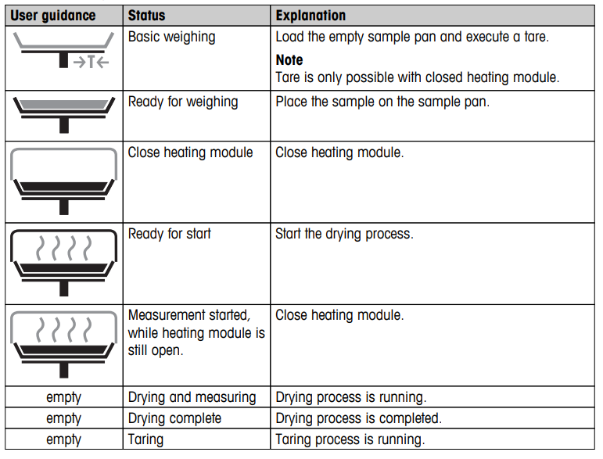
- You can now place your sample in the sample pan. Make sure that your sample is spread out evenly over the bottom of the sample pan. The standard deviation from larger samples is smaller compared to small samples (max. 0.05% for 2g samples, max. 0.01% for 10g samples). So it is likely best to use at least 2 g of each sample. The required minimum weight of a sample is 0.5g (maximum 71 g).

- Close the lid.

- Drying will start automatically.

- The device will beep as soon as the drying is finished. ‘END’ will be showing in the progress indicator diagram. The display will indicate the moisture content (MC) of your sample in %.

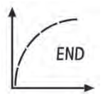
- After cooling you can open the lid by using the sides (indicated here by the black arrows). Do not use the gray handle of the sample tray holder; you will spill your sample.
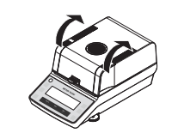
- Take out the sample pan by lifting the sample pan holder. You can take the pan out of the holder by lifting it up slightly. Clean the sample tray with a tissue. If any sample spilled onto the device make sure to clean this too, but be careful some parts might still be hot.
- You can now measure another sample by repeating the previous steps.
Tips:
- Your sample will dry quicker if it has a larger surface. You can use glass fiber filters to do this for liquids.
- If you do need to measure samples that could produce toxic gases, use the device in a fume hood.
- There are other options such as programming a second type of program. This can include stopping the drying process after a certain amount of time. The device will calculate the moisture using the weight lost within this time. This can be useful to make the analyses shorter. Please confer the handbook, that can be found here:
https://www.hogentogler.com/images/Mettler_HE73_manual.pdf?srsltid=AfmBOopjCxtCQHZcgqIXAZFmqFY_fN1nG0YPj9t_6cjIsb26p7YJp48s
Calculation:
Calculation used by device for the calculation of the moisture content:
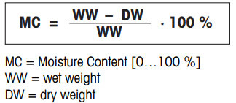

Critical Control Points
⚠ Step: Balancing the sample pan
Why it is critical: If the pan is not level no accurate measurements can be taken.
How to avoid mistakes: Make sure that the pan sit horizontally in the holder and is touching all three arms of the holder.

Quality Control
QC Parameter | Acceptance Criterion

Troubleshooting
Problem | Possible Cause | Solution

Expected Outcome
The moisture content of your sample can range between 0-100%.

Data Recording in Lab Books
Record the following information:
- Operator
- Date
- Sample IDs
- Batch numbers
- Deviations from protocol
- Raw data location

Storage and Stability
Item | Storage Condition | Stability
Soil samples | Samples should be stored in closed vials or bags to prevent excessive drying. | Soil samples should not be stored long before measurement

References
- SOPs
- Publications
- Instrument manuals

Revision History
Version | Date | Changes | Author
1.0 | 07-09-2026 | Initial version | Lieke Lipsch

