**Question 1:**

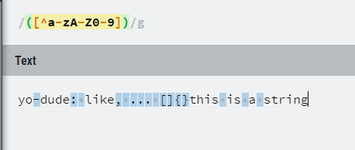

**Question 2:**

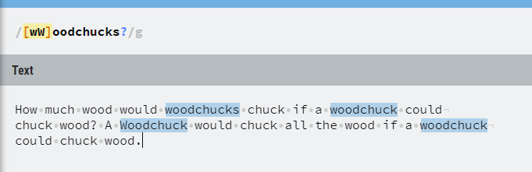

**Question 3:**

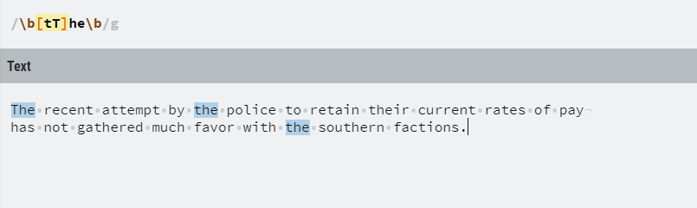

**Question 4:**

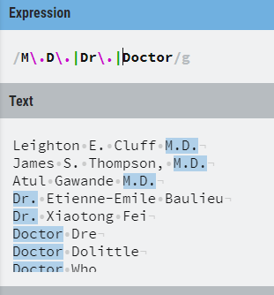

**Question 5:**

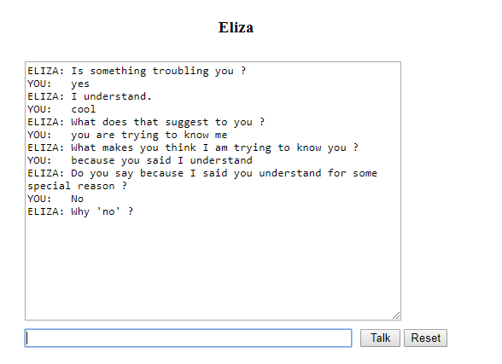

**I think the chatbot tries to understand or learn from the user responses and generates the question based on previous responses.**