1. The 10 turn dialog

Me: What you think of importance of Natural language processing for data science career?

Chatbot : A lot of importance.

Me : How was your assignment 3?

Chatbot: I had hard time completing the assignment.

Me: Hey, How are you?

Chatbot: I am doing good.

Me: Are we going to see fall colors this season in charlotte.

Chatbot: I don’t think so.

Me: How likely is to get a job in Data science after doing Masters?

Chatbot: Depends on your grades and skills.

1. The stanford parse of the 10 sentences

(ROOT

(SBARQ

(WHNP (WP What))

(SQ

(NP (PRP you))

(VP (VB think)

(PP (IN of)

(NP

(NP (NN importance))

(PP (IN of)

(NP

(NP (JJ Natural) (NN language) (NN processing))

(PP (IN for)

(NP (NN data) (NN science) (NN career)))))))))

(. ?)))

(ROOT

(NP

(NP (DT A) (NN lot))

(PP (IN of)

(NP (NN importance)))

(. .)))

(ROOT

(SBARQ

(WHADVP (WRB How))

(SQ (VBD was)

(NP

(NP (PRP$ your) (NN assignment))

(NP (CD 3))))

(. ?)))

(ROOT

(S

(NP (PRP I))

(VP (VBD had)

(NP

(NP (JJ hard) (NN time))

(VP (VBG completing)

(NP (DT the) (NN assignment)))))

(. .)))

(ROOT

(SBARQ

(WHADVP (WRB How))

(SQ (VBP are)

(NP (PRP you)))

(. ?)))

(ROOT

(S

(NP (PRP I))

(VP (VBP am)

(VP (VBG doing)

(ADJP (JJ good))))

(. .)))

4.

(ROOT

(S

(VP (VB Are)

(S

(NP (PRP we))

(VP (VBG going)

(S

(VP (TO to)

(VP (VB see)

(NP (NN fall) (NNS colors))

(NP (DT this) (NN season))

(PP (IN in)

(NP (NN charlotte)))))))))))

(ROOT

(S

(NP (PRP I))

(VP (VBP do) (RB n't)

(VP (VB think)

(ADVP (RB so))))

(. .)))

5.

(ROOT

(SBARQ

(WHADJP (WRB How)

(ADJP (JJ likely)))

(SQ (VBZ is)

(S

(VP (TO to)

(VP (VB get)

(NP

(NP (DT a) (NN job))

(PP (IN in)

(NP (NNP Data) (NN science))))

(PP (IN after)

(S

(VP (VBG doing)

(NP (NN Masters)))))))))

(. ?)))

(ROOT

(NP

(NP (NNS Depends))

(PP (IN on)

(NP (PRP$ your) (NNS grades)

(CC and)

(NNS skills)))

(. .)))

1. The Spacy parse of the 10 sentences

1.

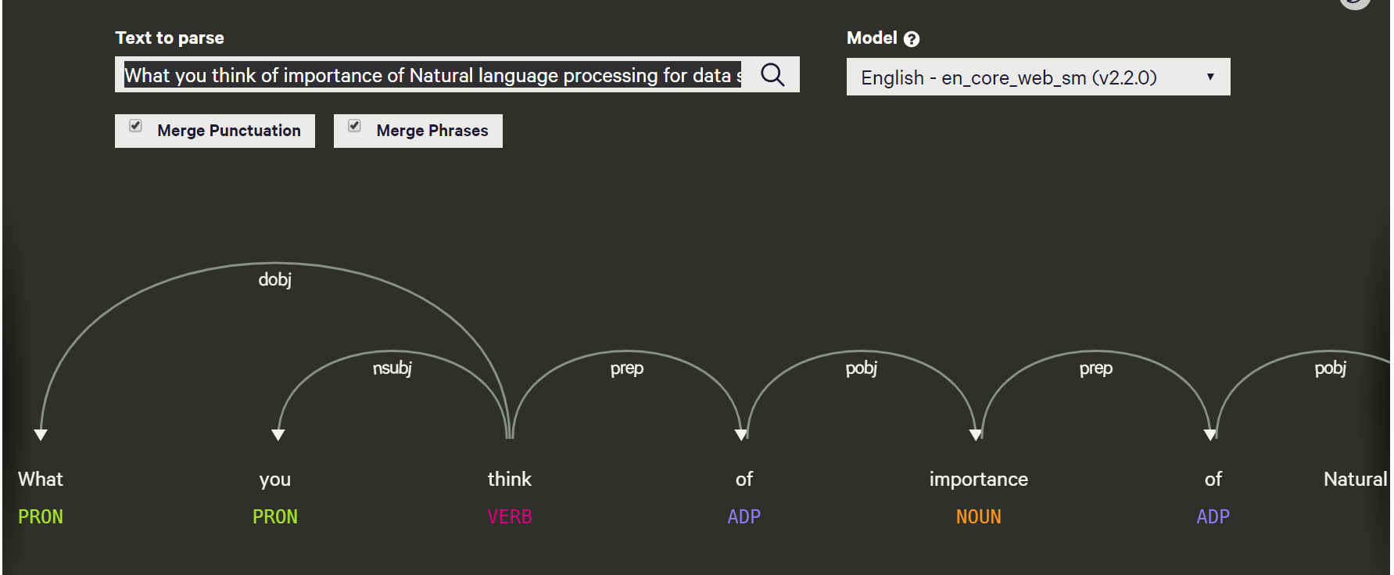

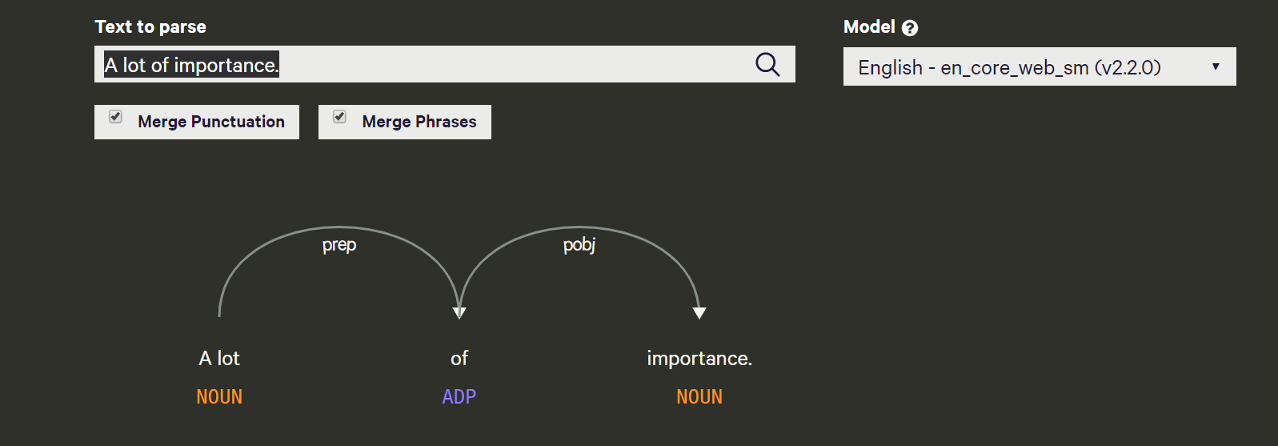

2.

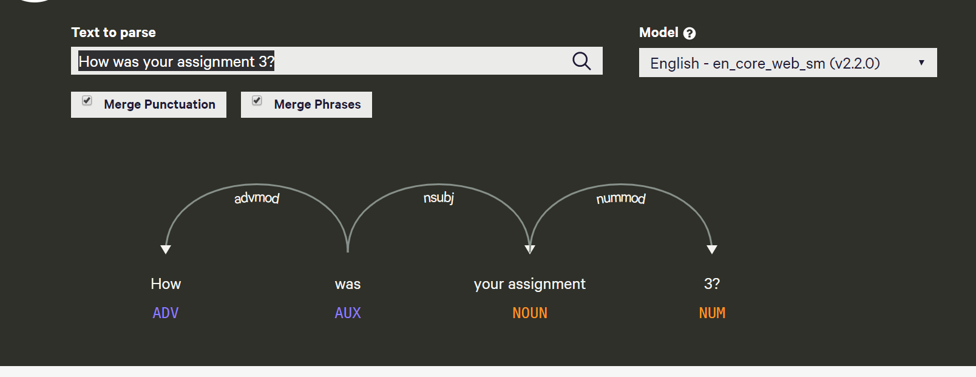

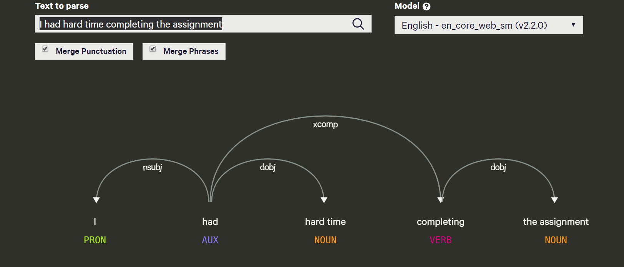

3.

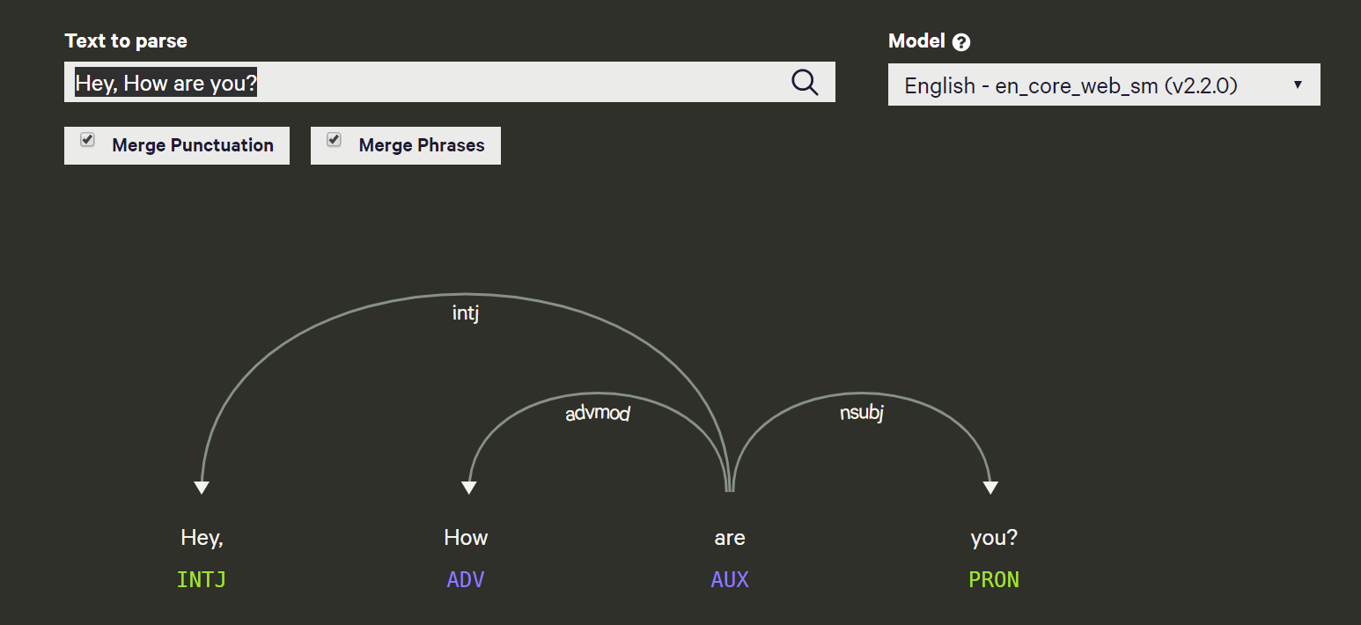

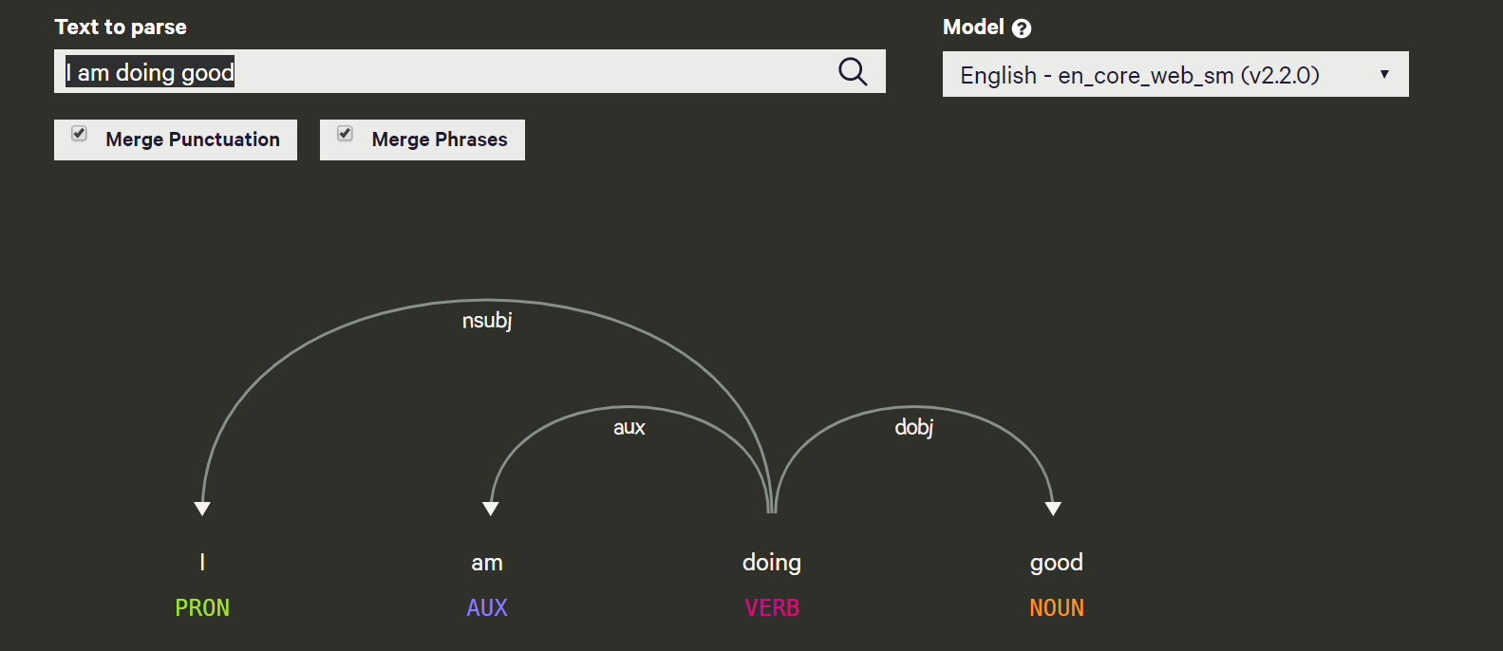

4.

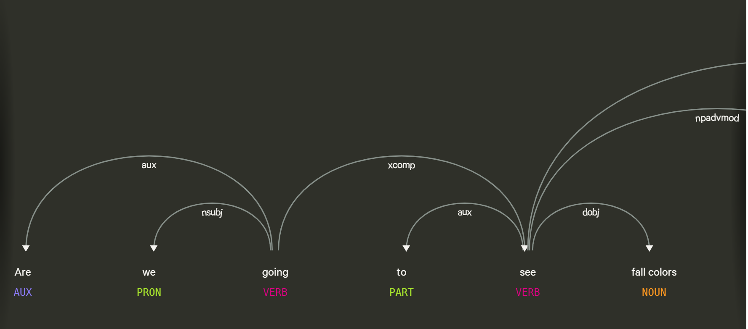

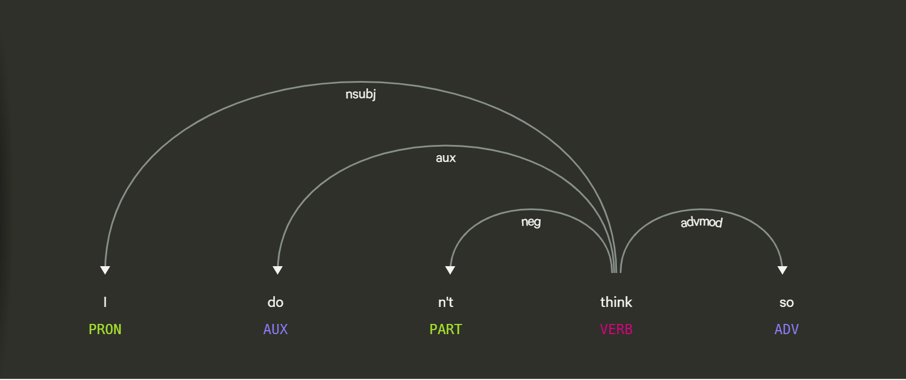

5.

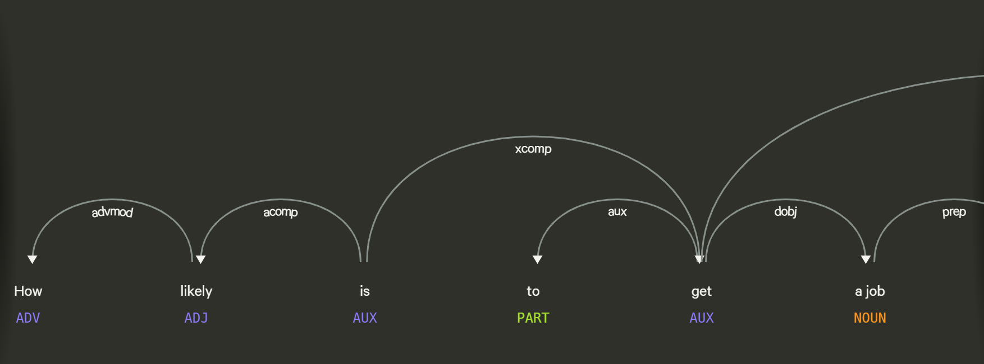

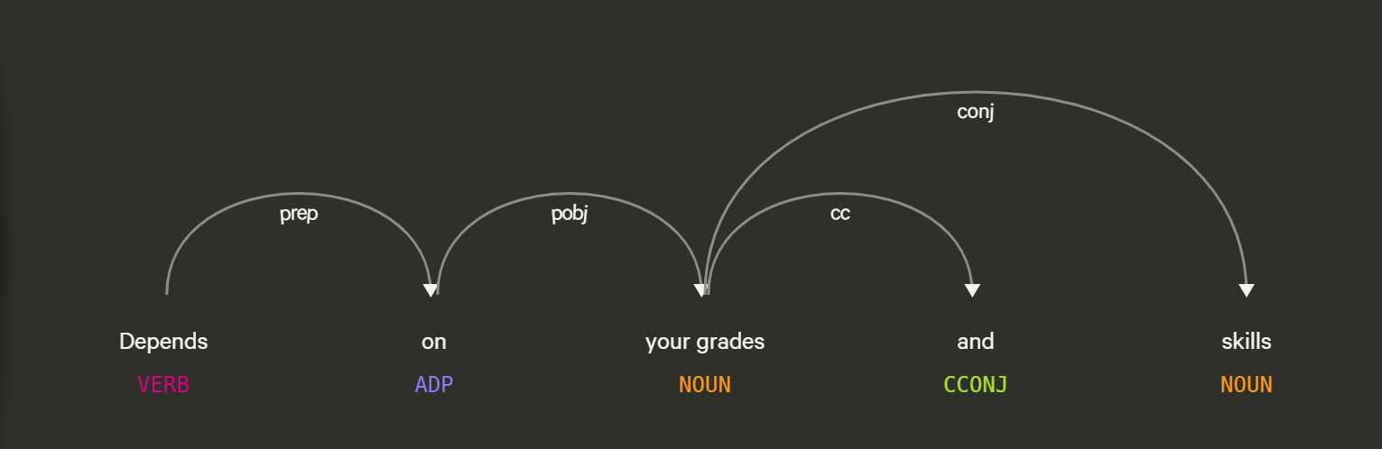

1. Paragraph summary as outlined in 4 above.

Stanford Parser is much better in terms of dividing the themes and grouping it into themes. It is more detailed which will be useful to train a chatbot accurately.

However Spacy has a graphical representation which is easy to see the actual parsing and to decide what can be pruned.