NextRole-AI
Project Documentation
Stateful AI Job Application and Interview Copilot

1. Project Intention
NextRole-AI helps job seekers make evidence-based application decisions and prepare stronger, truthful application materials. A user uploads a resume and pastes a job description. The system extracts structured information, maps every job requirement to resume evidence, calculates an explainable fit score, recommends APPLY, REVIEW, or SKIP, prepares an application package, pauses for human approval, and generates interview preparation based on the candidate's gaps.
The project is intentionally designed as an AI-engineering portfolio project rather than a general job board. Its purpose is to demonstrate structured model outputs, stateful orchestration, deterministic decision logic, human-in-the-loop control, persistence, safeguards, failure handling, and evaluation in one understandable vertical workflow.

Primary objectives
- Help candidates identify roles that are genuinely aligned with their evidence.
- Explain each recommendation instead of presenting an unsupported model-generated percentage.
- Tailor wording without inventing employers, technologies, metrics, responsibilities, or certifications.
- Keep the candidate in control before any application is considered ready.
- Connect missing requirements directly to interview questions and study actions.
- Persist the journey so applications can be reviewed and continued later.

2. User Journey
- Upload a text-based PDF resume.
- Paste the complete job description.
- Extract resume facts and job requirements into validated schemas.
- Map required and preferred skills to resume evidence.
- Calculate a deterministic weighted fit score.
- Route the role to APPLY, REVIEW, or SKIP.
- For APPLY or REVIEW roles, create an editable application package.
- Pause the LangGraph workflow for explicit human approval or rejection.
- After approval, generate interview questions, knowledge gaps, and a study plan.
- Save the application stage and LangGraph checkpoint in SQLite.

3. System Architecture
NextRole-AI uses one LangGraph workflow with specialized nodes. It does not create a collection of autonomous agents. This keeps behavior observable and easier to test while still demonstrating agentic state, routing, interruption, and recovery.
Streamlit UI -> LangGraph workflow -> structured LLM calls + deterministic tools -> SQLite persistence
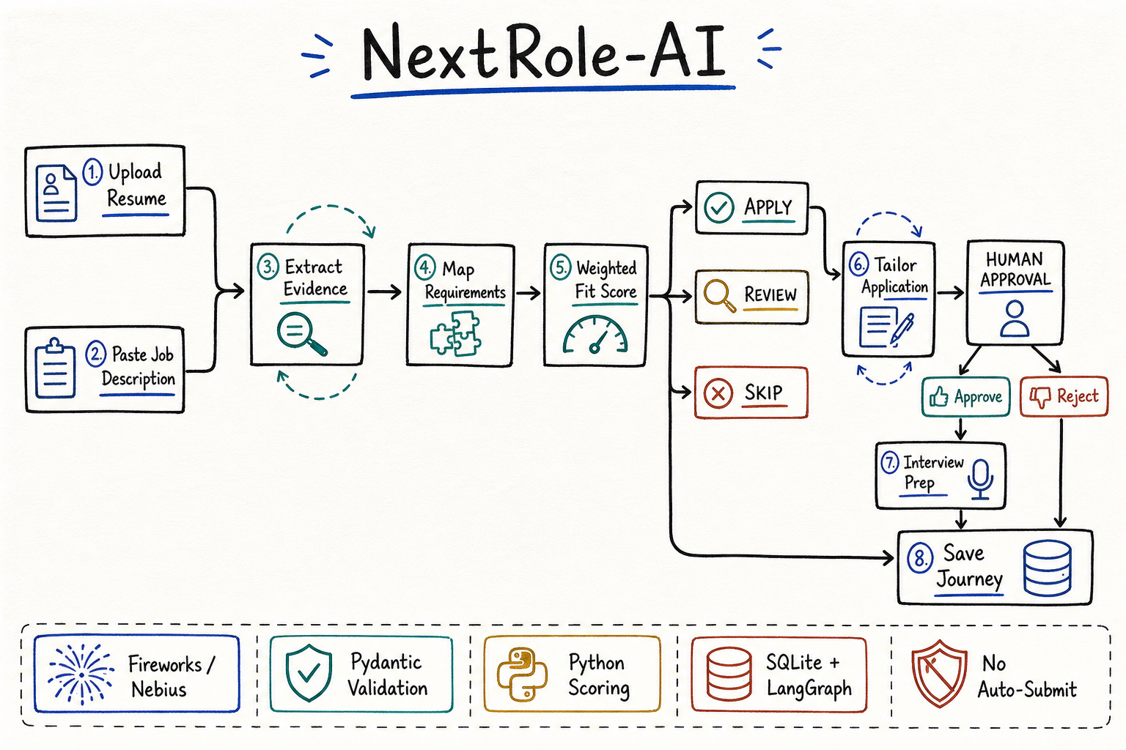
Figure 1. Hand-drawn overview of the complete NextRole-AI workflow.

Responsibility boundary
Large language model | Deterministic Python
Resume and job information extraction | Weighted fit-score calculation
Semantic evidence comparison | APPLY / REVIEW / SKIP thresholds
Truthful wording suggestions | Skill normalization and deduplication
Recruiter message generation | Evidence-table reconciliation
Interview question generation | Conditional graph routing
Study-plan generation | Approval enforcement and persistence

4. Models and Providers
Model / mode | Role | Status
Fireworks AI: accounts/fireworks/models/deepseek-v4-flash-0731 | Default hosted model for all structured extraction and generation tasks. | Active default; verified with long-resume ResumeProfile output. Reasoning is disabled to reserve tokens for complete JSON.
Nebius: Qwen/Qwen3-235B-A22B | Optional OpenAI-compatible alternative configured through environment variables. | Supported alternative; requires NEBIUS_API_KEY.
Local demo mode | Deterministic lexical comparison used to exercise the UI and graph without an API key. | Testing/demo only; not a semantic assessment.
The application uses the OpenAI-compatible Python client for both hosted providers. Provider responses are constrained with JSON Schema and then validated with Pydantic. Empty, invalid, or truncated structured responses are retried once. The second attempt receives a larger output budget.

Environment configuration
Variable | Purpose
LLM_PROVIDER | Selects fireworks or nebius.
FIREWORKS_API_KEY | Fireworks authentication key.
FIREWORKS_MODEL | Configurable Fireworks model ID.
FIREWORKS_BASE_URL | Fireworks OpenAI-compatible endpoint.
NEBIUS_API_KEY | Optional Nebius authentication key.
NEBIUS_MODEL | Configurable Nebius model ID.
NEBIUS_BASE_URL | Nebius OpenAI-compatible endpoint.

5. Agents in the Pipeline
The following names describe logical agent responsibilities. In code, they are specialized nodes within a single stateful graph, not separate autonomous processes.
Logical agent / graph node | Purpose | Output
Resume Analysis Agent / parse_resume | Extracts supported candidate facts from the uploaded resume. | ResumeProfile: name, summary, skills, highlights, domains, education.
Job Analysis Agent / analyze_job | Extracts exhaustive and normalized job requirements. | JobAnalysis: company, title, required/preferred skills, responsibilities, domains, education.
Job Fit Agent / calculate_fit | Compares requirements with evidence. Python recalculates the final score and recommendation. | FitAnalysis and requirement-to-evidence map.
Application Agent / tailor_application | Reframes only existing experience for the target role. | Resume suggestions, recruiter message, fit narrative, keywords, cover-letter summary.
Human Approval Gate / human_approval | Interrupts execution until the user approves or rejects the editable package. | Explicit approval decision.
Interview Agent / interview_prep | Builds questions and preparation actions from role requirements and gaps. | Categorized questions, gap priorities, preparation hints, study plan.
Persistence nodes / save_* | Records skipped, rejected, or ready-to-submit outcomes. | SQLite application record and durable graph checkpoint.

6. Deterministic Tools and Capabilities
Tool / capability | Responsibility
PDF text extraction | Reads selectable text from uploaded PDF resumes with PyPDF.
StructuredLLM.structured | Calls Fireworks or Nebius, requests JSON Schema output, validates it, detects truncation, retries with a larger budget, and normalizes provider errors.
Skill normalization | Deduplicates skill names and removes generic orphan tokens such as 'big' or 'analysis' while preserving phrases such as 'Big Data'.
Evidence reconciliation | Forces one evidence row per actual required/preferred job skill and removes unrelated model-generated gaps.
Hybrid scoring engine | Calculates the final score from five components using fixed weights.
Fit router | Routes scores to APPLY, REVIEW, or SKIP.
Approval router | Sends approved packages to interview preparation and rejected packages to persistence.
SQLite application store | Stores application summaries, status, stage, and timestamps.
SQLite LangGraph checkpointer | Persists thread state and interrupts so a saved journey can be reopened.
Streamlit tracker | Lists saved applications and changes the active thread when Continue is selected.

7. Fit-Scoring Method
The language model extracts evidence and supplies bounded component assessments. Deterministic Python calculates the overall score:
Component | Weight
Skills match | 40%
Experience match | 30%
Domain match | 15%
Education match | 5%
Preference match | 10%
Score range | Recommendation
75-100 | APPLY
55-74 | REVIEW
0-54 | SKIP
This design keeps routing reproducible. The model cannot change the thresholds or directly control the final decision.

8. Human-in-the-Loop and Safety
- The application package is editable before approval.
- The graph visibly pauses at a LangGraph interrupt.
- The system cannot submit an application, fill an external form, send an email, or contact a recruiter.
- Approval means READY_TO_SUBMIT; the user still submits externally.
- Unsupported job requirements remain gaps.
- Tailoring instructions explicitly prohibit invented employers, skills, technologies, metrics, responsibilities, and certifications.
- Raw resume text is excluded from the application tracker record. It remains in the LangGraph checkpoint only so interrupted work can resume.

9. Current Version
- Streamlit interface with Job Analysis, Application, Interview Prep, and Applications tabs.
- PDF resume upload and pasted job-description input.
- Fireworks DeepSeek V4 Flash default provider with reasoning disabled, plus optional Nebius.
- Local fallbacks across resume, job, fit, and interview stages.
- Pydantic schemas for every major model response.
- Complete required/preferred skill extraction with deterministic cleanup.
- Requirement-to-resume evidence table.
- Deterministic hybrid scoring and conditional graph routing.
- Truthful, editable application package.
- Visible approve/reject interrupt.
- Gap-connected interview questions with category, difficulty, rationale, and preparation hints.
- Gap-to-action study plan.
- SQLite application tracker and durable LangGraph checkpoints.
- No-key demo mode.
- Automated tests for scoring, routing, persistence, approval, rejection, skill filtering, and evidence completeness.

10. Current Limitations
- Only text-based PDFs are supported; scanned PDFs require OCR before upload.
- Preference scoring currently defaults to a neutral/full value because the UI does not yet collect detailed candidate preferences.
- Component assessments are model-assisted even though the final weighted calculation is deterministic.
- Demo mode uses lexical matching and should not be treated as a reliable semantic evaluation.
- There is no job-search API, company research, or multi-job comparison.
- There is no external application submission or communication automation.
- SQLite is appropriate for a local portfolio MVP but not a multi-user hosted deployment without additional design.

11. Next Version Roadmap

Version 2 - Better matching and tracking
- Collect candidate preferences: location, remote/hybrid/onsite, salary range, sponsorship, industry, and role level.
- Calculate preference score from explicit rules instead of a default value.
- Add OCR support for scanned resumes.
- Allow DOCX and plain-text resumes.
- Compare multiple jobs side by side.
- Add a mocked sample-job search abstraction, followed later by an authorized job API.
- Add application-stage editing: APPLIED, INTERVIEWING, REJECTED, OFFER.
- Add downloadable tailored package and interview-prep exports.
- Add evaluation cases measuring extraction completeness, evidence correctness, hallucination rate, and routing stability.

Version 3 - Integrations and memory
- Authorized Gmail integration for draft-only recruiter follow-ups.
- Calendar integration for interview preparation and reminders.
- Optional Mem0-based long-term preference memory with user controls.
- Optional Pinecone semantic retrieval for multiple resume versions, portfolio projects, and supporting evidence.
- Company research with cited sources.
- Notifications for follow-up dates and interview milestones.

Version 4 - Production evolution
- Multi-user authentication, access controls, encryption, retention controls, and audit logging.
- PostgreSQL-backed persistence and hosted checkpointing.
- Observability and model-quality monitoring.
- Human feedback loops that recalibrate scoring without allowing opaque automatic decisions.
- Carefully scoped multi-agent decomposition only where independent parallel work provides measurable value.
- Authorized browser or application integrations subject to platform rules and explicit confirmation.

12. Technology Stack
Layer | Technology
User interface | Streamlit
Workflow orchestration | LangGraph
Schemas and validation | Pydantic
Hosted inference | Fireworks AI; optional Nebius
Provider client | OpenAI-compatible Python SDK
PDF parsing | PyPDF
State and tracker persistence | SQLite and LangGraph SQLite checkpointer
Configuration | python-dotenv
Testing and quality | pytest and Ruff
Dependency management | uv

13. Portfolio Summary
NextRole-AI demonstrates where an LLM adds value and where deterministic software should remain in control. Models perform semantic extraction, evidence comparison, rewriting, and question generation. Python owns validation, normalization, scoring, routing, permissions, approval, and persistence. The centerpiece is the traceable connection: job requirement -> resume evidence -> identified gap -> interview question -> study action.

Appendix: Workflow State
- journey_id and job description
- structured resume profile and job analysis
- component scores, overall score, and recommendation
- requirement-to-evidence mapping
- application package and approval status
- interview questions, knowledge gaps, and study plan
- current workflow step, status, and error collection
End of document.

