About Olympics

## Warning: package 'knitr' was built under R version 3.5.3

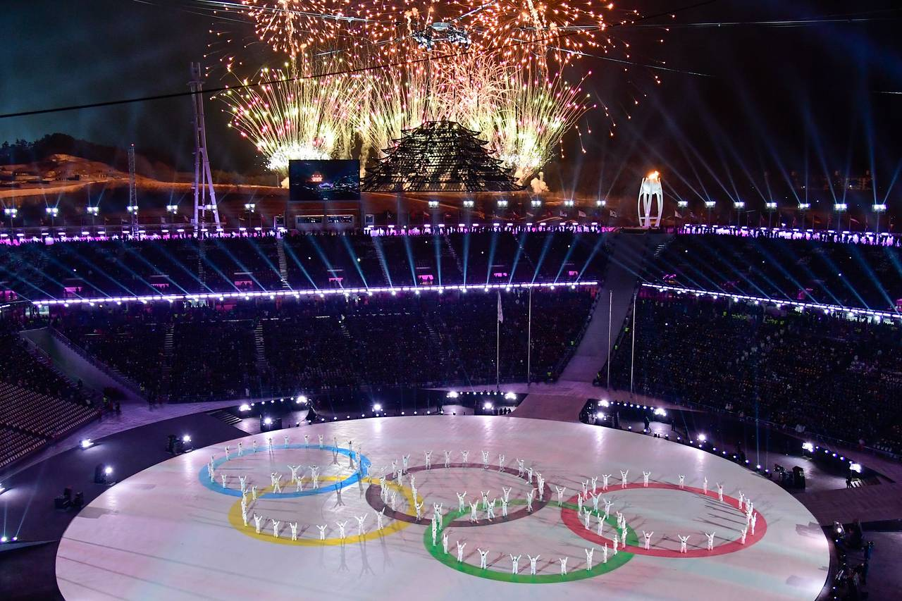

This Shiny App visualizes and analyzes data on the Olympic Games from 1896 to 2016.

Data is from: <https://www.kaggle.com/heesoo37/120-years-of-olympic-history-athletes-and-results>.

Data includes athlete name, gender, age, height, weight, team, NOC (country), games, year, season, city, sport, and medal. Data is missing in 1916, 1940 and 1944 because of World War I and World War II. GoogleVis was used to visualize a world map with total medals by country and historical host cities.

Instructions for navigating this app: - World map shows the distribution of Gold, silver and bronze medals. you need to hover over the country. - Host city map shows the points where Olympics was hosted. - Top countries give you the information of medals for top countries in each sport. - You are able to choose which country data you would like to look at in the country drop down. Additionally, you can look at the top athletes in the chosen country and the top countries by sport in the sport dropdown. - All code was written in R.