1.Python Program to Print Hello world!

Description:

Print():The print() function prints the specified message to the screen, or other standard output device.

Code:

a="Hello world"

print(a)

output:

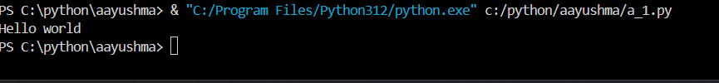

2. Python Program to Add Two Number

Description:

Input():The python input function is used to derive input from the user.

Int:The int() python is used to convert the specified string or number into an integer value.

Code:

n1=int(input("enter first number:"))

n2=int(input("enter second number"))

Sum=n1+n2

print(Sum)

output:

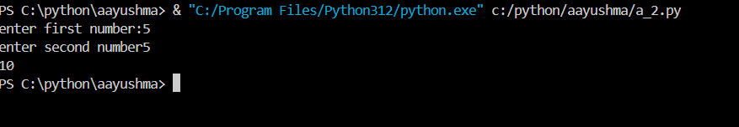

3. Python Program to Find the Square Root

Description:

Import math:Python has also a built-in module called math , which extends the list of mathematical functions.

math.sqrt():The math.sqrt() method returns the square root of a number

code:

import math

def square(n):

    print(math.sqrt(n))

n=int(input("enter a number:"))

square(n)

output:

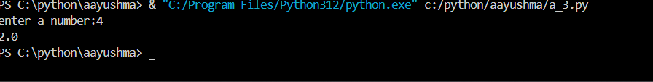

4. Python Program to Calculate the Area of a Triangle.

Description:

float:float function in Python is to convert real numbers or integers into floating point numbers.

Code:

breadth=float(input("enter breadth:"))

height=float(input("enter height:"))

area_of_triangle=(breadth*height)/2

print(area_of_triangle)

output:

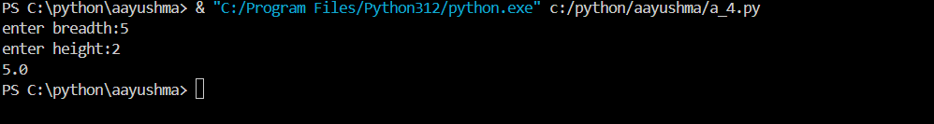

5. Python Program to Solve Quadratic Equation

Description:

if condition:An if statement is a condition statement used to check a condition, and execute it if the condition holds true

code:

a = float(input("Enter coefficient a: "))

b = float(input("Enter coefficient b: "))

c = float(input("Enter coefficient c: "))

difference = b**2 - 4*a*c

if difference > 0:

    root1 = (-b + (difference)**0.5) / (2*a)

    root2 = (-b - (difference)**0.5) / (2*a)

    print(f"The roots of the quadratic equation are {root1} and {root2}")

elif difference == 0:

    root = -b / (2*a)

    print(f"The root of the quadratic equation is {root}")

else:

    real_part = -b / (2*a)

    imaginary_part = ((-difference)**0.5) / (2*a)

    print(f"The roots of the quadratic equation are {real_part}+{imaginary_part}i and {real_part}-{imaginary_part}i")

output:

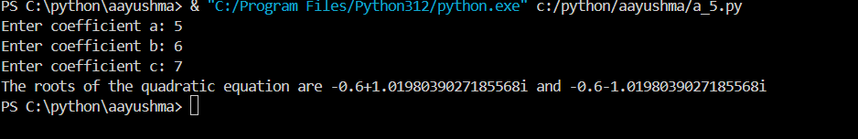

6. Python Program to Swap Two Variables

x = input("Enter value for x: ")

y = input("Enter value for y: ")

print(f"Before swapping: x = {x}, y = {y}")

temp = x

x = y

y = temp

print(f"After swapping: x = {x}, y = {y}")

output:

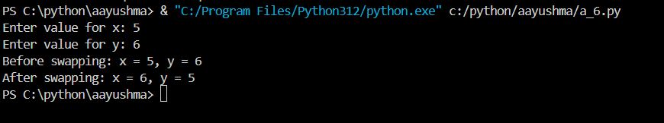

7. Python Program to Generate a Random Number

Description:

Import random:The Python import random module is used to generate random values.

Code:

import random

random_number=random.randint(1,100)

print(random_number)

output:



8. Python Program to Convert Kilometers to Miles.

Code:

kilometers = float(input("Enter value in kilometers: "))

conversion_factor = 0.621371

miles = kilometers * conversion_factor

print(f"{kilometers} kilometers is equal to {miles} miles")

output:

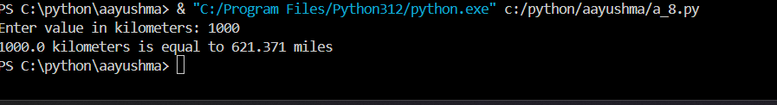

9. Python Program to Convert Celsius To Fahrenheit.

Code:

celsius = float(input("Enter temperature in Celsius: "))

fahrenheit = (celsius * 9/5) + 32

print(f"{celsius} degrees Celsius is equal to {fahrenheit} degrees Fahrenheit")

output:

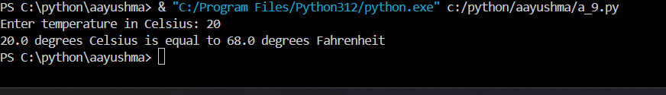

10. Python Program to Print Output Without a Newline

Description:

list:Lists are used to store multiple items in a single variable

code:

elements = [1, 2, 3, 4, 5]

for element in elements:

    print(element, end=' ')

output:

