WAFA STUDIOS:
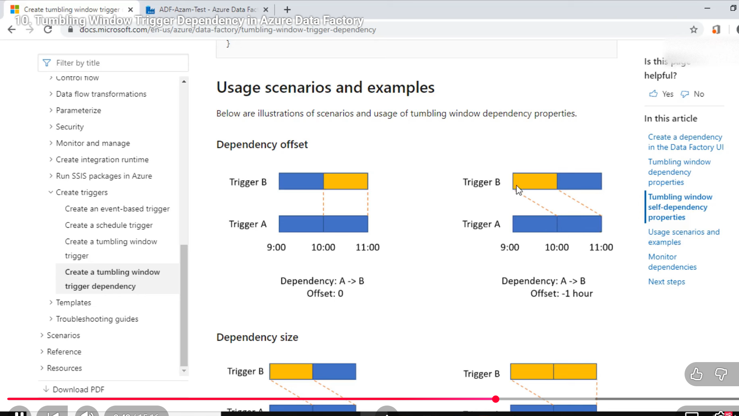
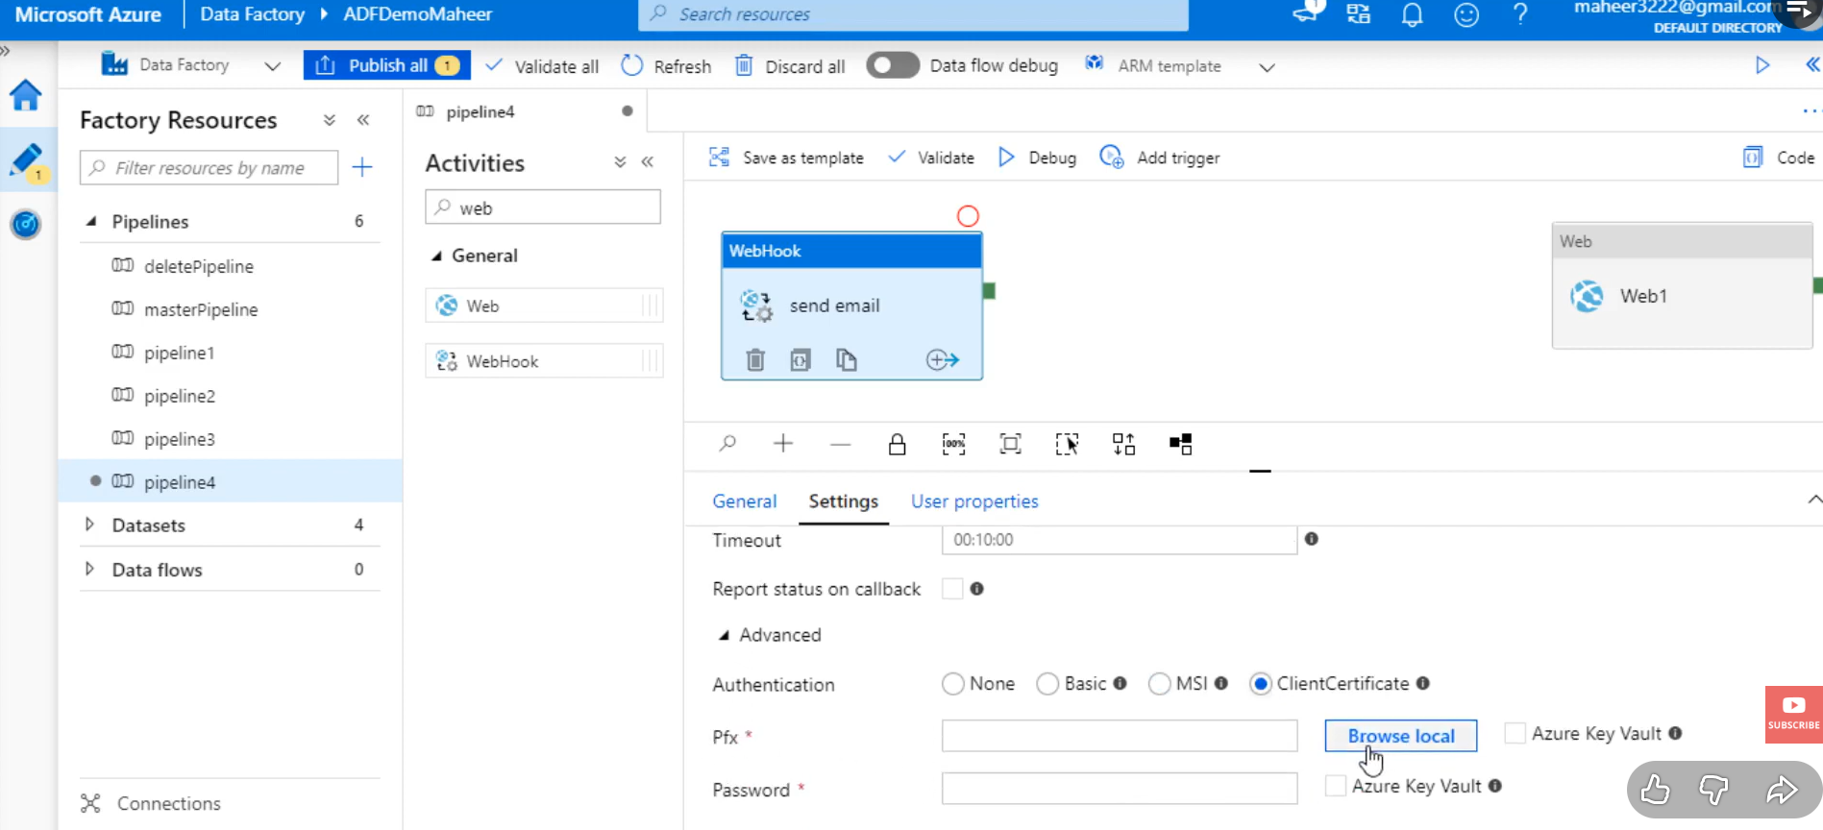
its asynchronous activity which will wait for pipeline and wait for call back URI:
we need to pass this call back URI in logic app dynamically
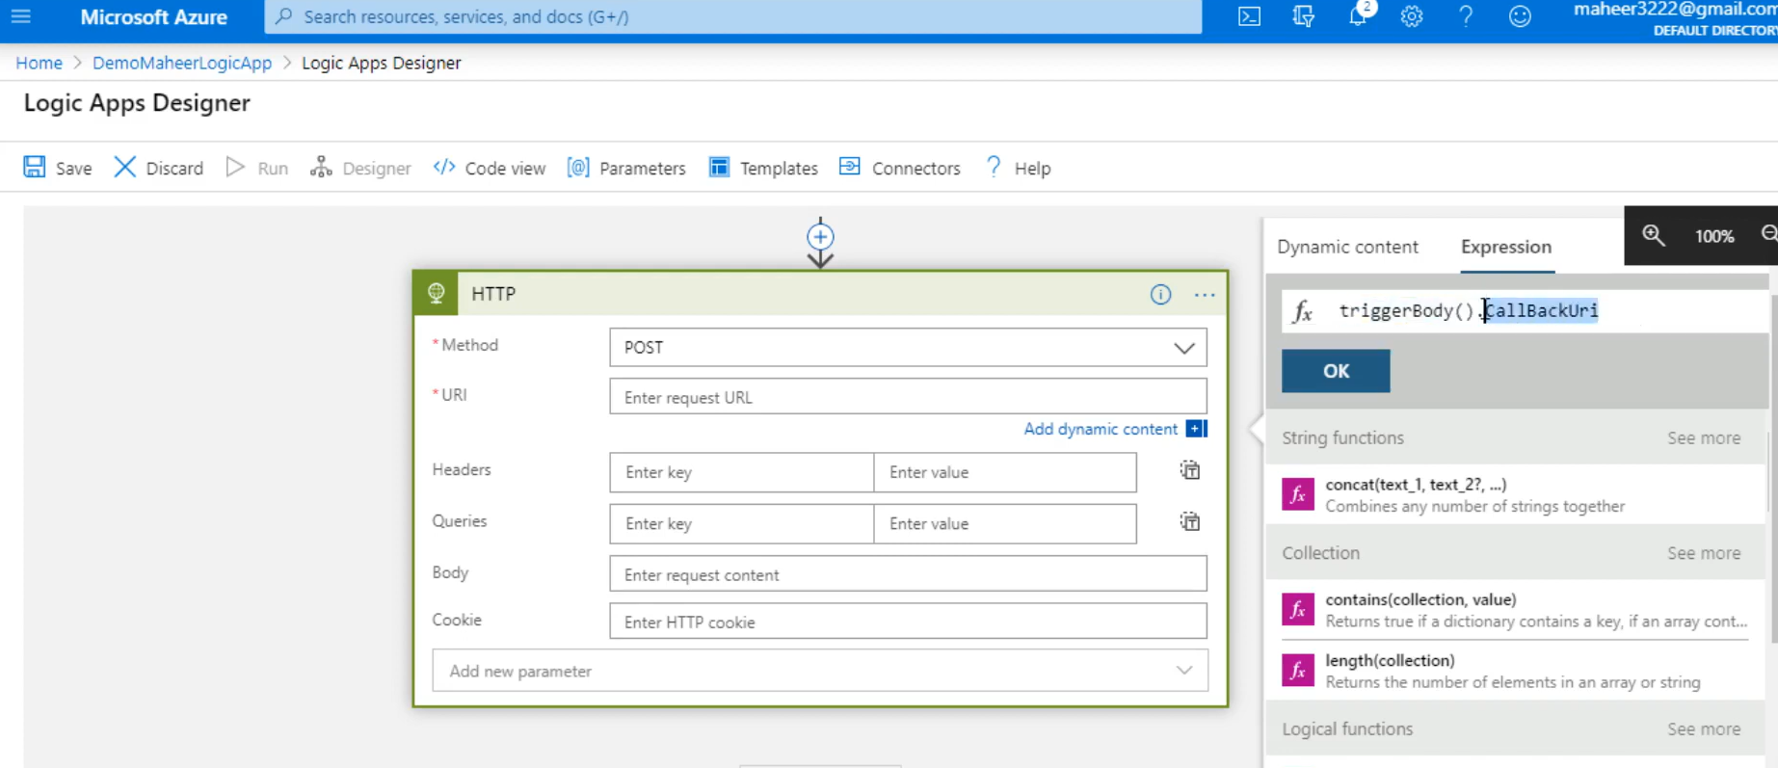
Azure key vault:
Instead of hardcoding our values we use azure key vault to store info
we use managed identity of ADF and give access to key vault
now we use access key>connection string of storage account and give it in azure key vault to generate secret name (value of secret name is connection string)
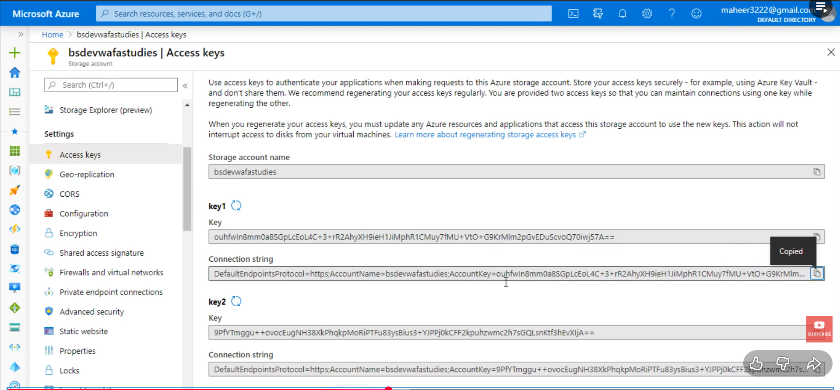
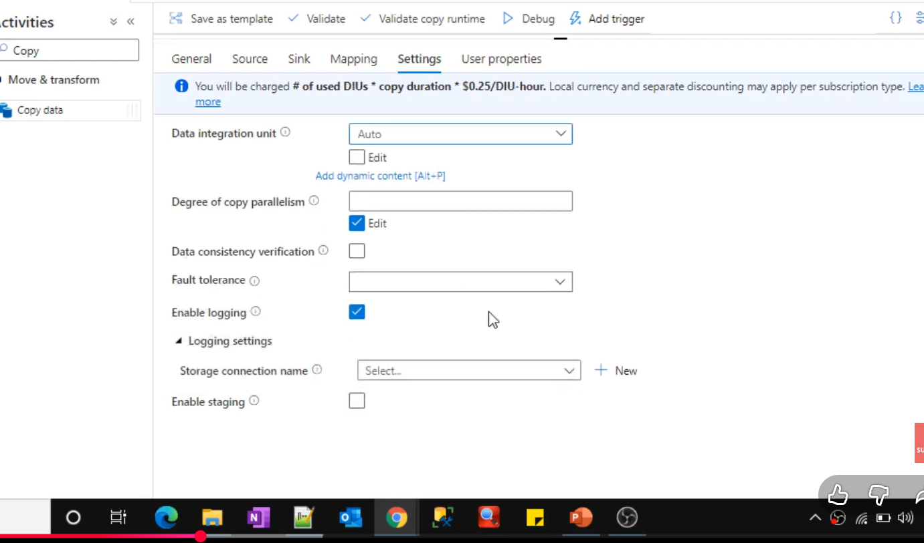
use fail activity after logic app web based mail we use fail activity to show our pipeline as failed
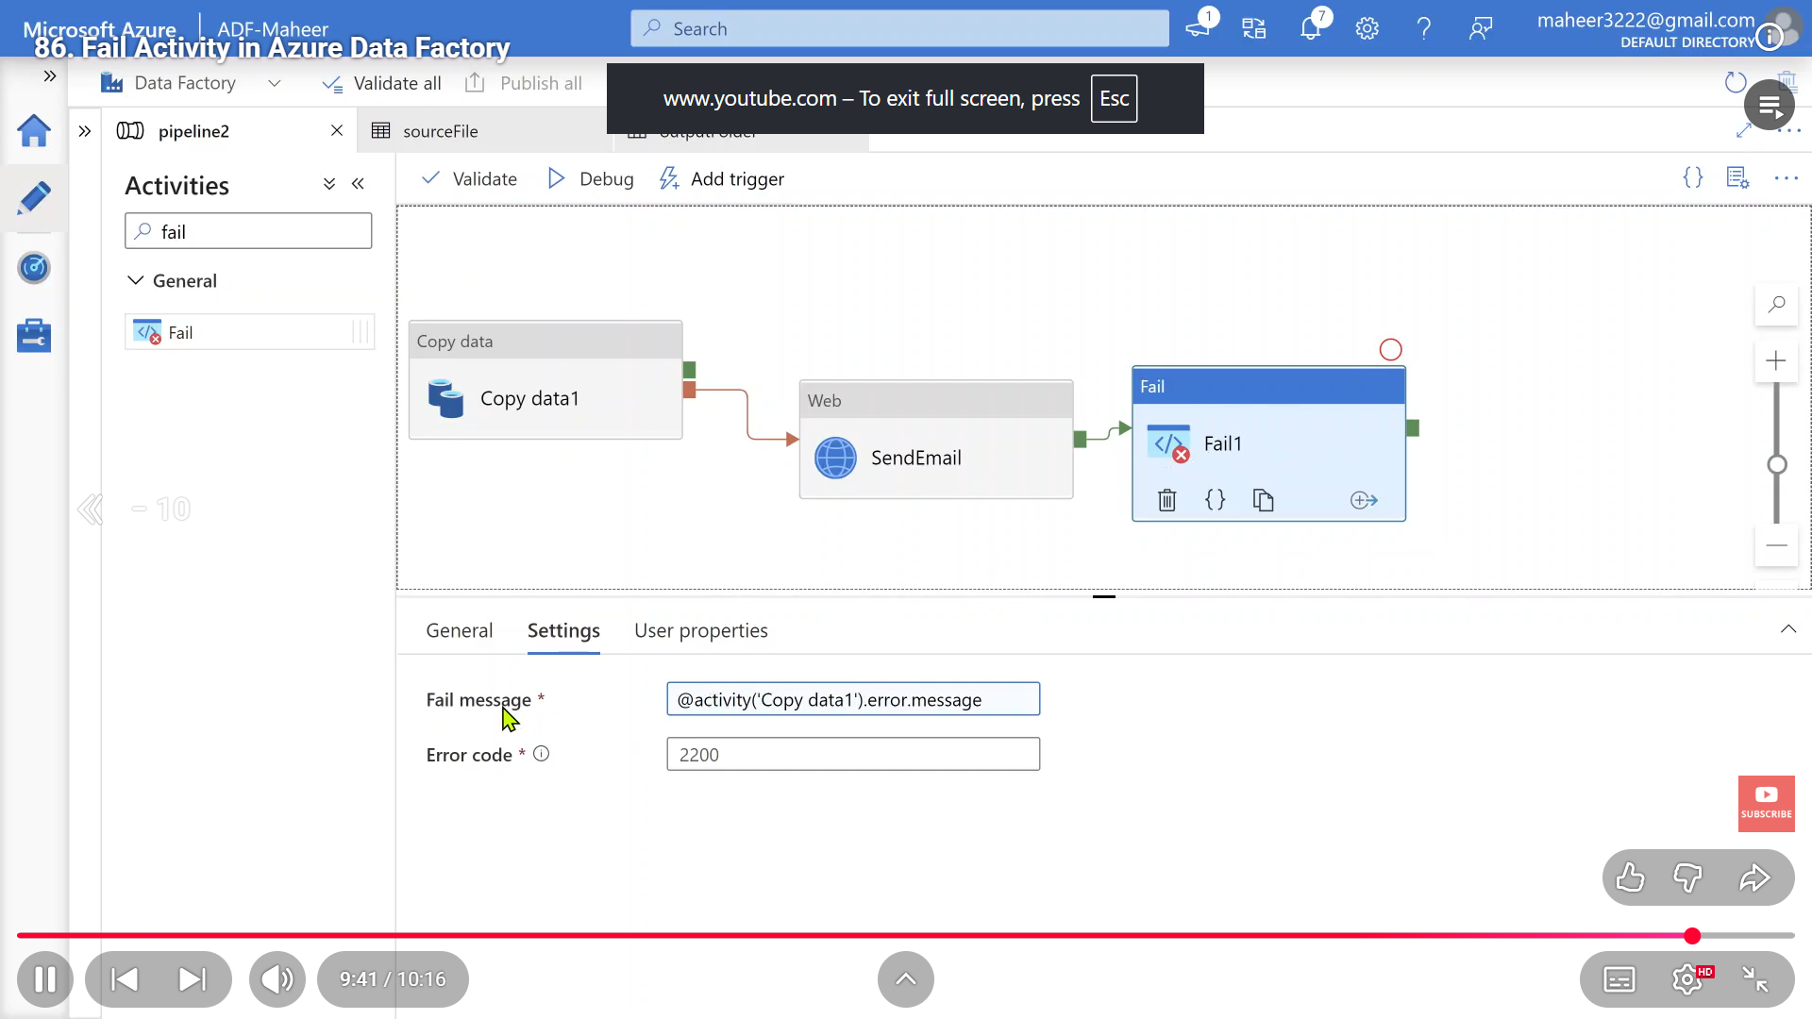
when we use any dataset sommany times and u don’t need schema for it and u can use inline dataset for timebeing
ALERTS AND METRICS
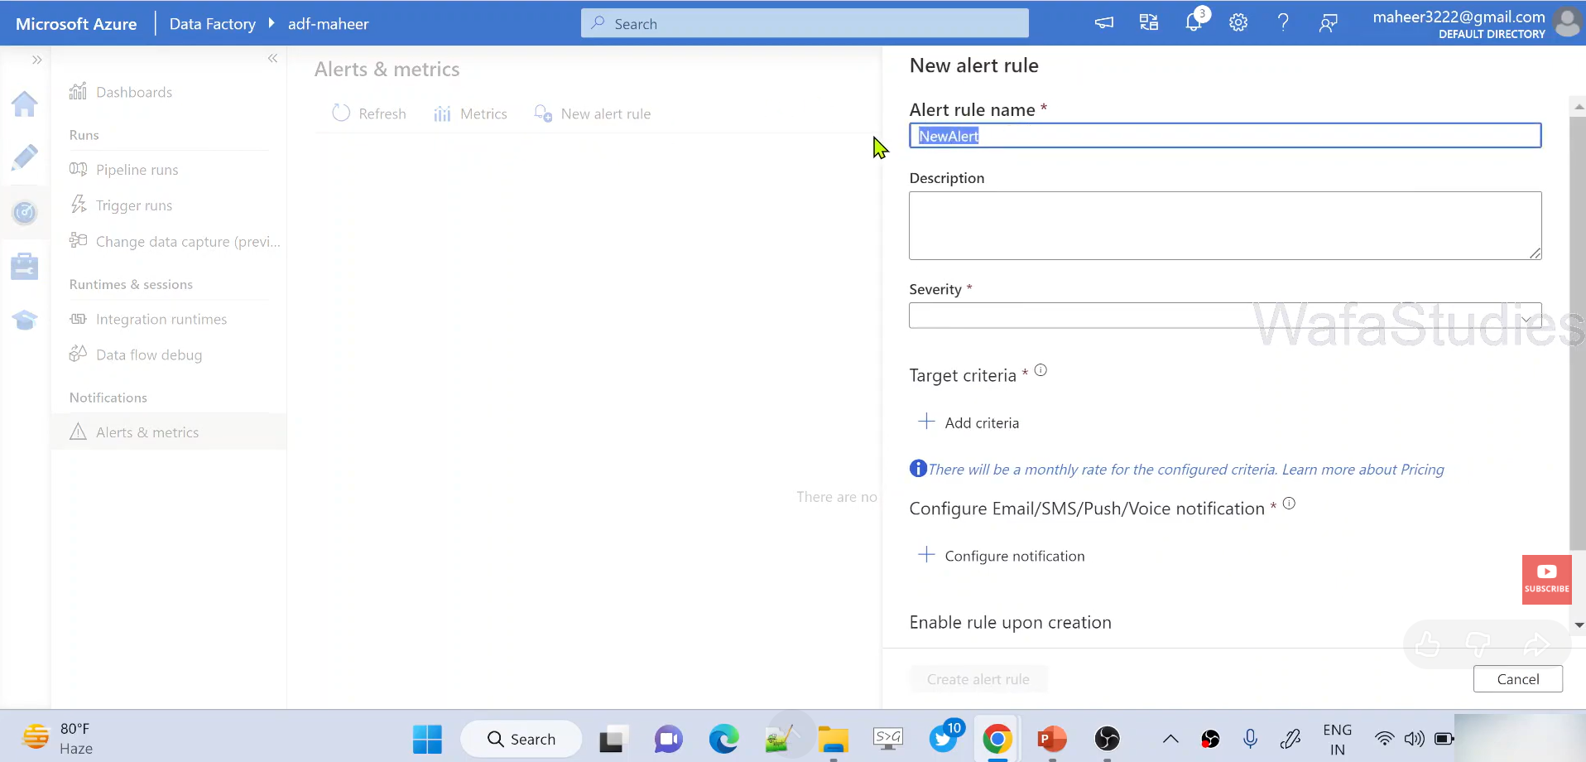
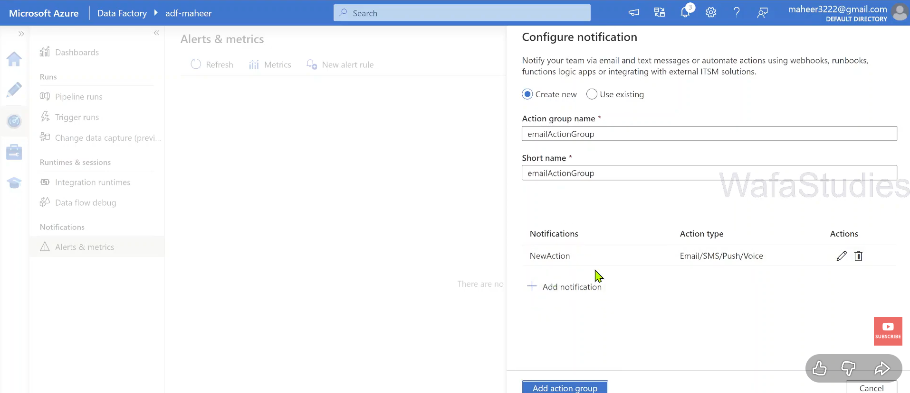
CDC CAPTURE
WE NEED TO ENABLE IT IN SQL SERVER AND THEN USE DATAFLOW
Cdc CAPTURE AND SQL SERVER
-----
Integration run time
we have azure
which is self hosted
Azure auto resolve
azure ssis
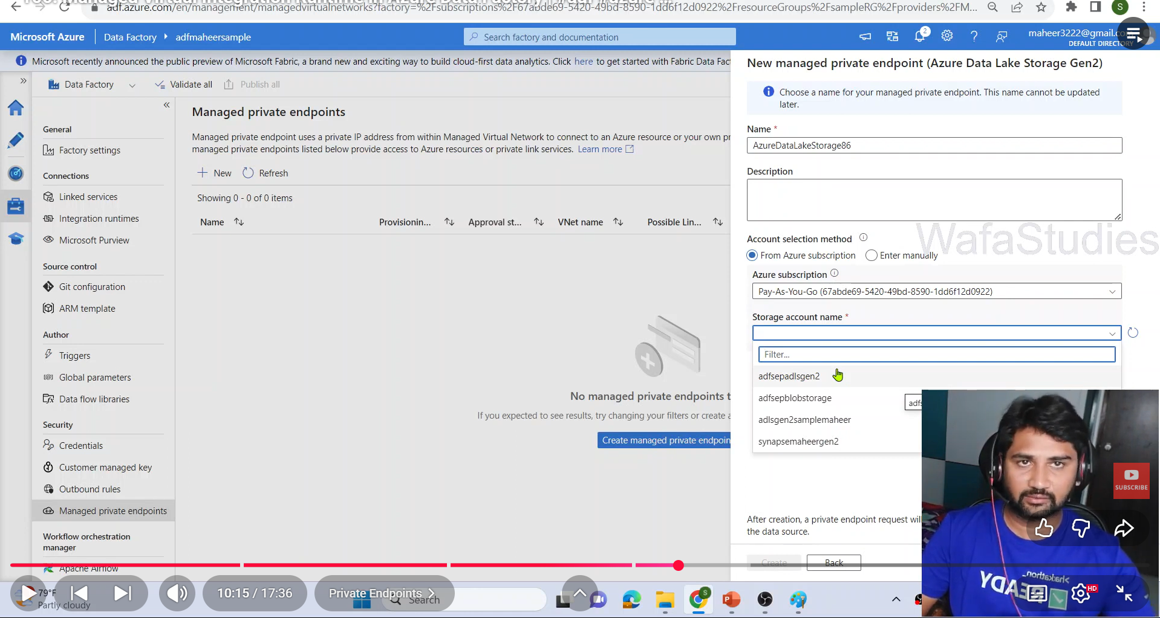
we need to create azure managed IR which will create a managed vm in backend and then create a private end point to ADLS where it needs approval from ADLS >networking
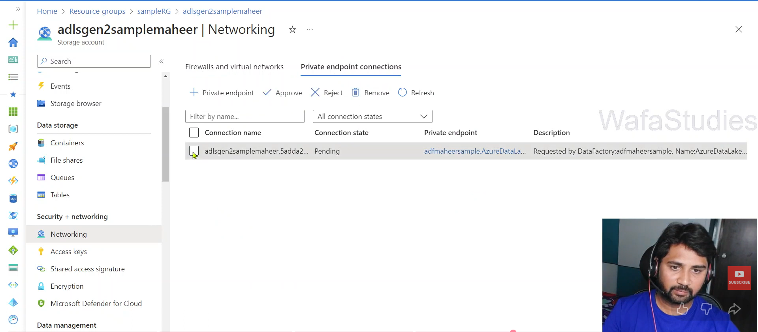
1. What is Power BI?
Answer: Power BI is Microsoft’s business intelligence tool that allows you to connect to multiple data sources, transform data, and create interactive dashboards and reports. Example: You can connect Power BI to SQL Server, clean the data using Power Query, and then build a dashboard showing monthly sales trends.
What are the main components of Power BI? Power Query, Power Pivot, Power View, Power Map, and Power Q&A.

- Power Query → Data prep.
- Power Pivot → Modeling + DAX.
- Power View → Visuals. – drill down
- Power Map → Geo-visuals. Say “Power Map helps visualize geographic trends, like sales distribution across India.”

- Power Q&A → Natural language queries.
Show total sales by product category in 2025.”
- Power Q&A instantly generates a bar chart with categories and sales values.

2. Difference between Import Mode and DirectQuery
Answer:
- Import Mode: Data is loaded into Power BI’s internal storage. Faster performance, but dataset size is limited.
- DirectQuery: Queries data live from the source. Useful for very large datasets, but performance depends on the source system. Example: For a 10 GB sales database, you’d use DirectQuery to avoid loading all data into Power BI. For a 100 MB Excel file, Import Mode is faster.
3. Difference between Calculated Column and Measure
Answer:
- Calculated Column: Stored in the table, evaluated row by row.
- Measure: Calculated at query time, more efficient. Example:
- Column: Profit = Sales[Revenue] - Sales[Cost] (stored per row).
- Measure: Total Profit = SUM(Sales[Revenue]) - SUM(Sales[Cost]) (calculated dynamically).
4. Explain CALCULATE function in DAX
Answer: CALCULATE() changes the filter context of a calculation. Example: Sales LY = CALCULATE(SUM(Sales[Amount]), SAMEPERIODLASTYEAR(Date[Date])) This calculates last year’s sales by modifying the filter context to the previous year.
5. What is Row-Level Security (RLS)?
Answer: RLS restricts data access for users based on filters. Example: If you set RLS so that Region = "South", a user assigned to that role will only see South region data in reports.
6. Difference between Dashboard and Report
Answer:
- Report: Multi-page, detailed visuals.
- Dashboard: Single page, summary view, can combine visuals from multiple reports. Example: A report might have pages for Sales, Inventory, and Finance. A dashboard shows key KPIs from all three on one page.
7. What is Drill-down vs Drill-through?
Answer:
- Drill-down: Navigate hierarchy within a visual (e.g., Year → Month → Day).
- Drill-through: Jump to a detailed page filtered for a specific item. Example: Clicking on “2025” in a bar chart to see monthly breakdown = Drill-down. Right-clicking “Region = South” to open a detailed page = Drill-through.
8. What is a Star Schema and why is it preferred?
Answer: Star Schema has a central fact table linked to dimension tables. It’s simple, efficient, and works best with Power BI’s columnar storage. Example: Fact table = Sales (Revenue, Quantity). Dimensions = Date, Product, Customer. This structure makes DAX calculations faster.
9. Difference between SUM and SUMX
Answer:
- SUM() → Adds values in a column directly.
- SUMX() → Iterates row by row, applies an expression, then sums. Example:
- SUM(Sales[Revenue]) → Adds all revenue values.
- SUMX(Sales, Sales[Revenue] - Sales[Cost]) → Calculates profit per row, then sums.
10. How do you optimize a slow Power BI report?
Answer:
- Use Import mode for small datasets.
- Reduce visuals per page.
- Use aggregations.
- Optimize DAX (avoid row-by-row calculations).
- Use Star Schema instead of Snowflake. Example: If a dashboard with 20 visuals is slow, split it into multiple pages and use measures instead of calculated columns.
11. What is a Data Model in Power BI?
- Answer: A Data Model is the logical structure of tables, relationships, and calculations used to build reports. Example: Sales fact table linked to Product, Customer, and Date dimension tables forms a model that supports KPIs like revenue by product.
- 12. Difference between Star Schema and Snowflake Schema
- Answer:
- Star Schema: Fact table directly linked to dimension tables.
- Snowflake Schema: Dimensions are normalized into multiple related tables. Example: Star → Sales fact linked directly to Customer dimension. Snowflake → Customer dimension split into Customer → Region → Country tables.
- 13. Why is Star Schema preferred in Power BI?
- Answer: Star Schema is simpler, reduces joins, and performs better with columnar storage. Example: A Sales fact with Date, Product, Customer dimensions allows fast aggregation. Snowflake adds complexity and slows queries.
- 14. What are Relationships in Power BI?
- Answer: Relationships define how tables connect (one-to-many, many-to-one). Example: Customer table (CustomerID) linked to Sales table (CustomerID) → one customer can have many sales.
- 15. What is Cardinality in Relationships?
- Answer: Cardinality describes the nature of the relationship (one-to-one, one-to-many, many-to-many). Example:
- One-to-many: Customer → Sales.
- Many-to-many: Students ↔ Courses.
- 16. What is a Surrogate Key?
- Answer: A surrogate key is an artificial key (like an integer ID) used to uniquely identify rows when natural keys are complex. Example: CustomerID (auto-generated) instead of using Email + Phone as a composite key.
- 17. Difference between Fact and Dimension Tables
- Answer:
- Fact Table: Contains measurable data (sales, revenue, quantity).
- Dimension Table: Contains descriptive attributes (customer, product, date). Example: Fact = Sales (Revenue, Quantity). Dimension = Product (Name, Category).
- 18. What is Normalization vs Denormalization?
- Answer:
- Normalization: Splitting data into multiple tables to reduce redundancy.
- Denormalization: Combining tables for faster querying. Example: Normalized → Customer split into Customer, Address tables. Denormalized → Customer table includes address fields directly.
- 19. How do you handle Many-to-Many Relationships in Power BI?
- Answer: Use a bridge table or DAX functions to resolve ambiguity. Example: Students ↔ Courses → Create an Enrollment bridge table linking StudentID and CourseID.
- 20. What is a Composite Model in Power BI?
- Answer: Composite models allow combining Import and DirectQuery in the same dataset. Example: Import small reference tables (Product, Date) but use DirectQuery for a large Sales fact table.

How to connect to spark notebook from ADF to trigger automatically:
We need to create a linked service between spark and ADF and connect to
choose workspace and access token from below and we need to choose job cluster and inter
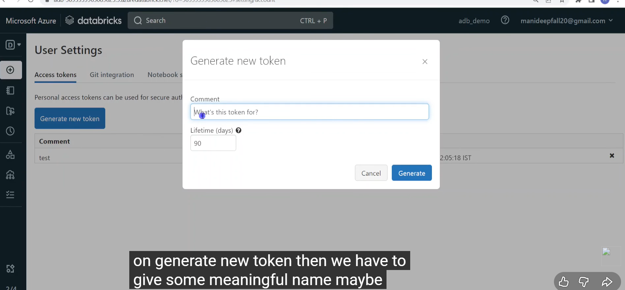
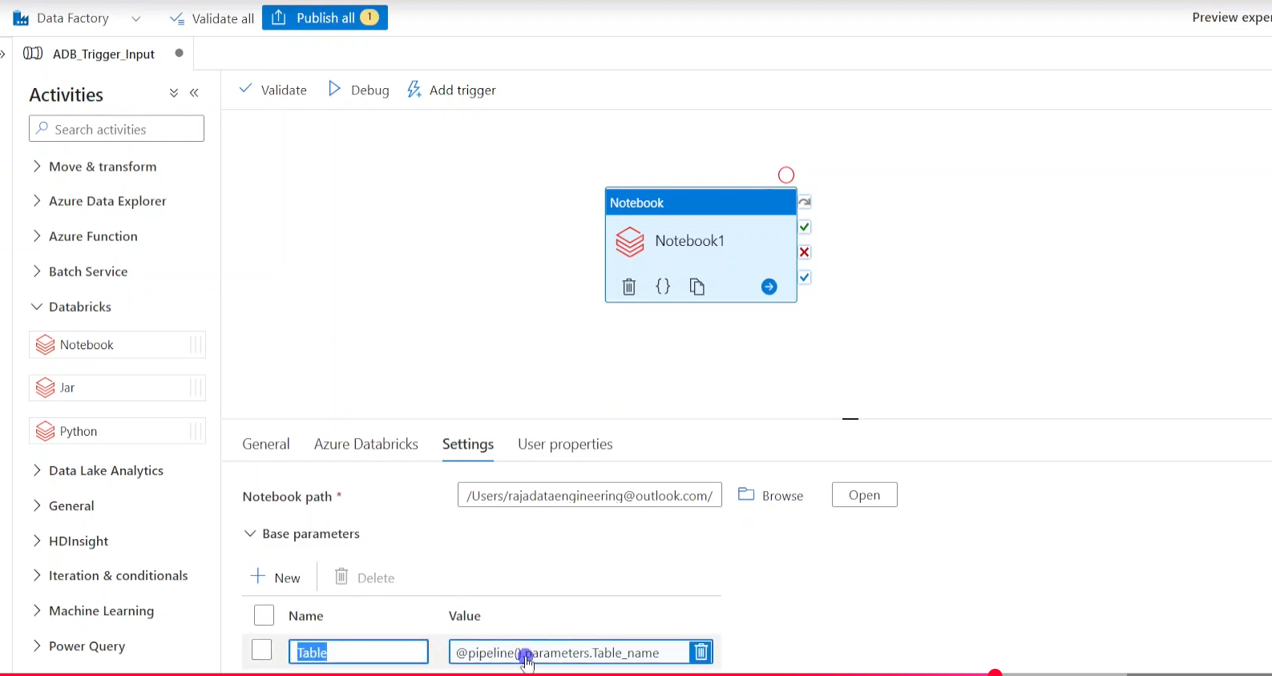
we can pass pipeline parameters or pipeline name from ADF to notebook like above
we choose workspace in linked service
then if we are having output parameters we can do like below:
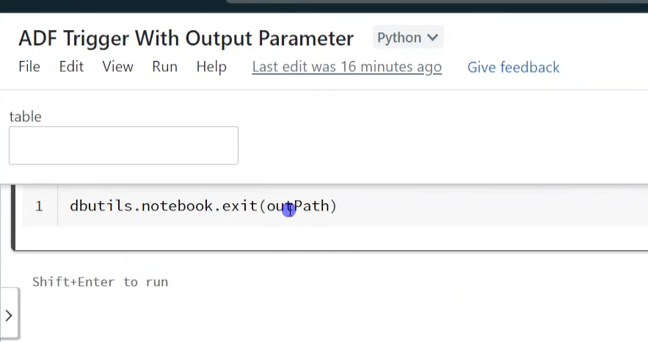
And use set variable activity to hold these values
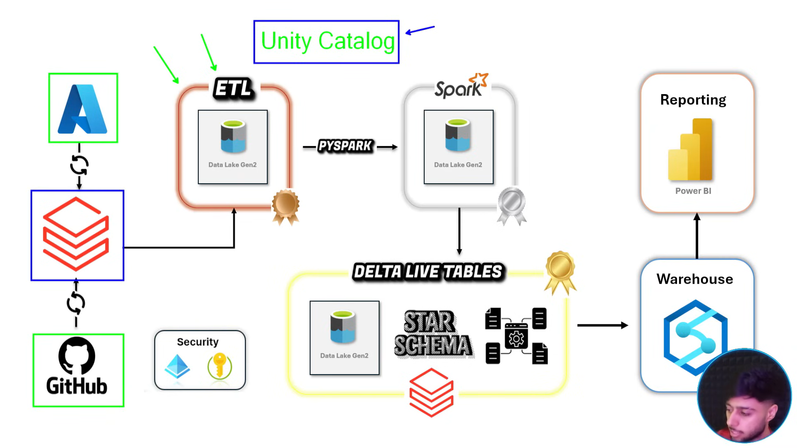
how to set up databricks unity catalog:
go to settings>manage account>
in azure search Microsoft entra id and copy mail and login ti databricks using that mail
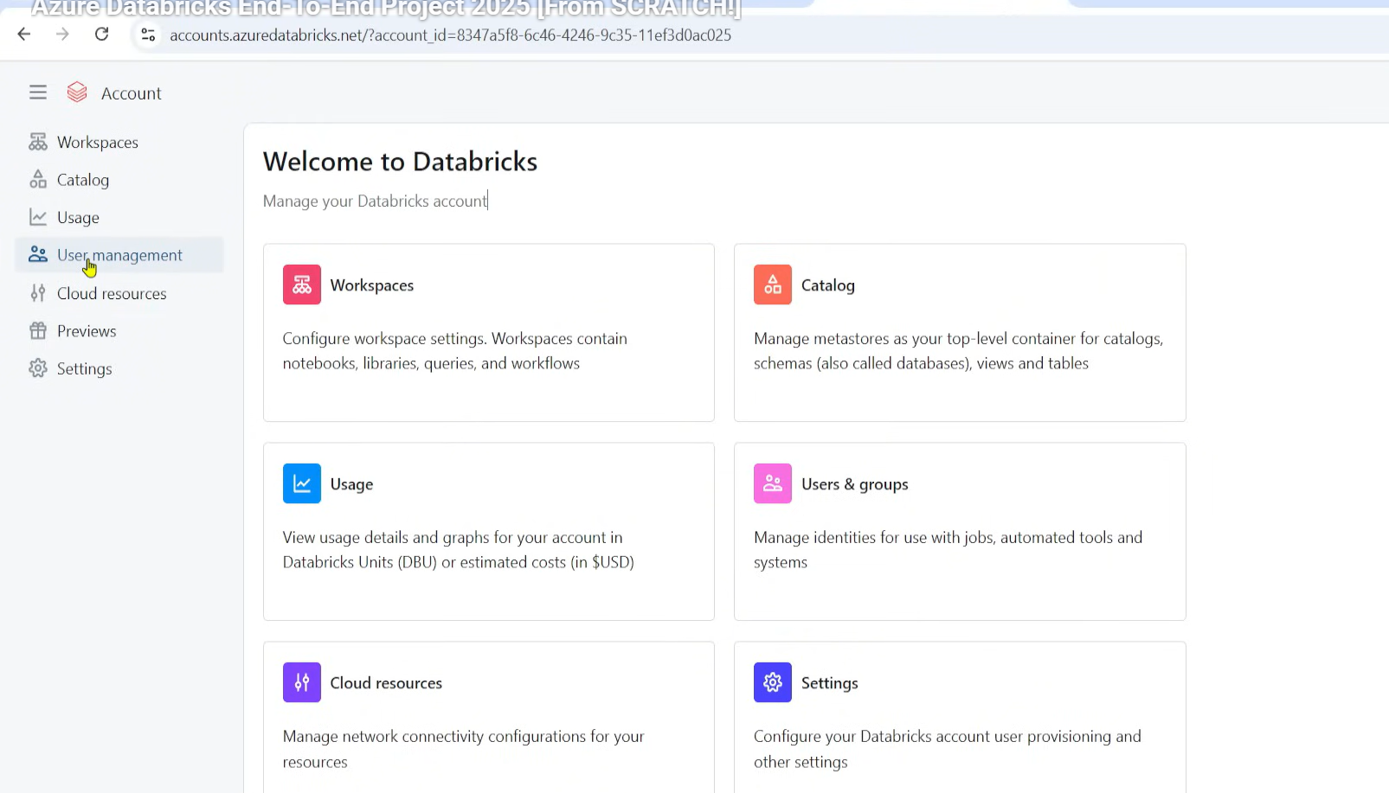
user management >
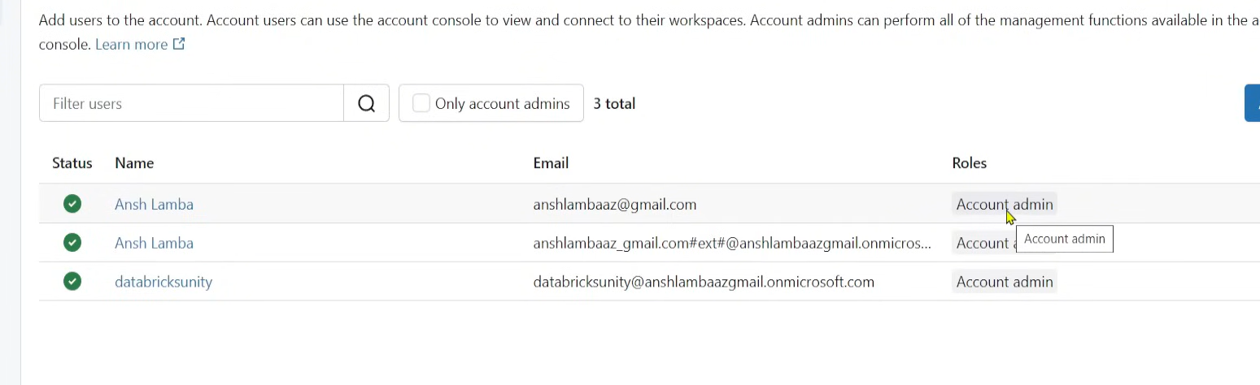
catalog>create metastore( only one metastore in one location accepted)>
create an access connector for databricks and in ADLS give blob contributor access to that managed identity of access connector (databricks)
create a container named metastore in ADLS and path is given to databricks as per below ss
now in
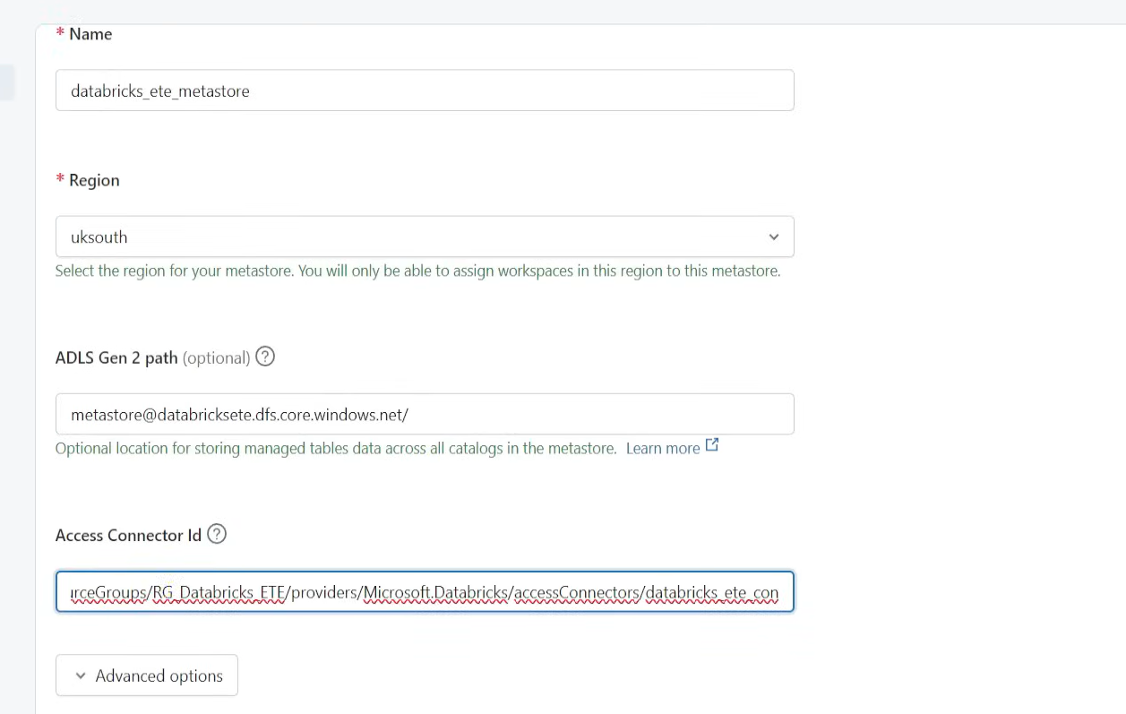
once metastore is done then create a catalog in databricks
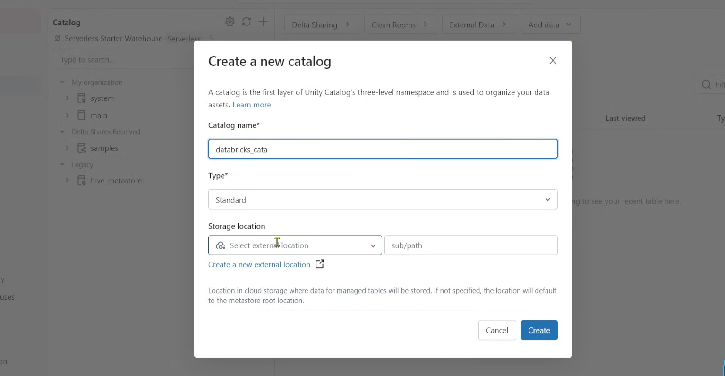
now we had access to metastore container but we need access to other containers in ADLS also right
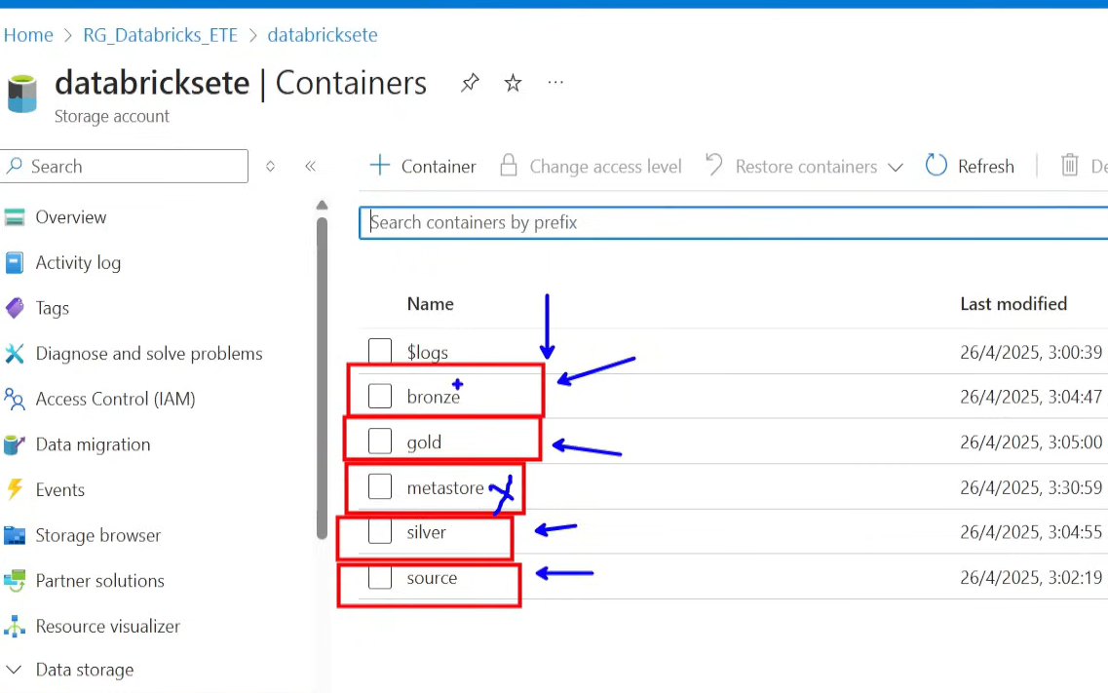
for that we need to create external data and add credentials(resource id ) for our access connector and this is called credential ( which holds access connector of databricks)
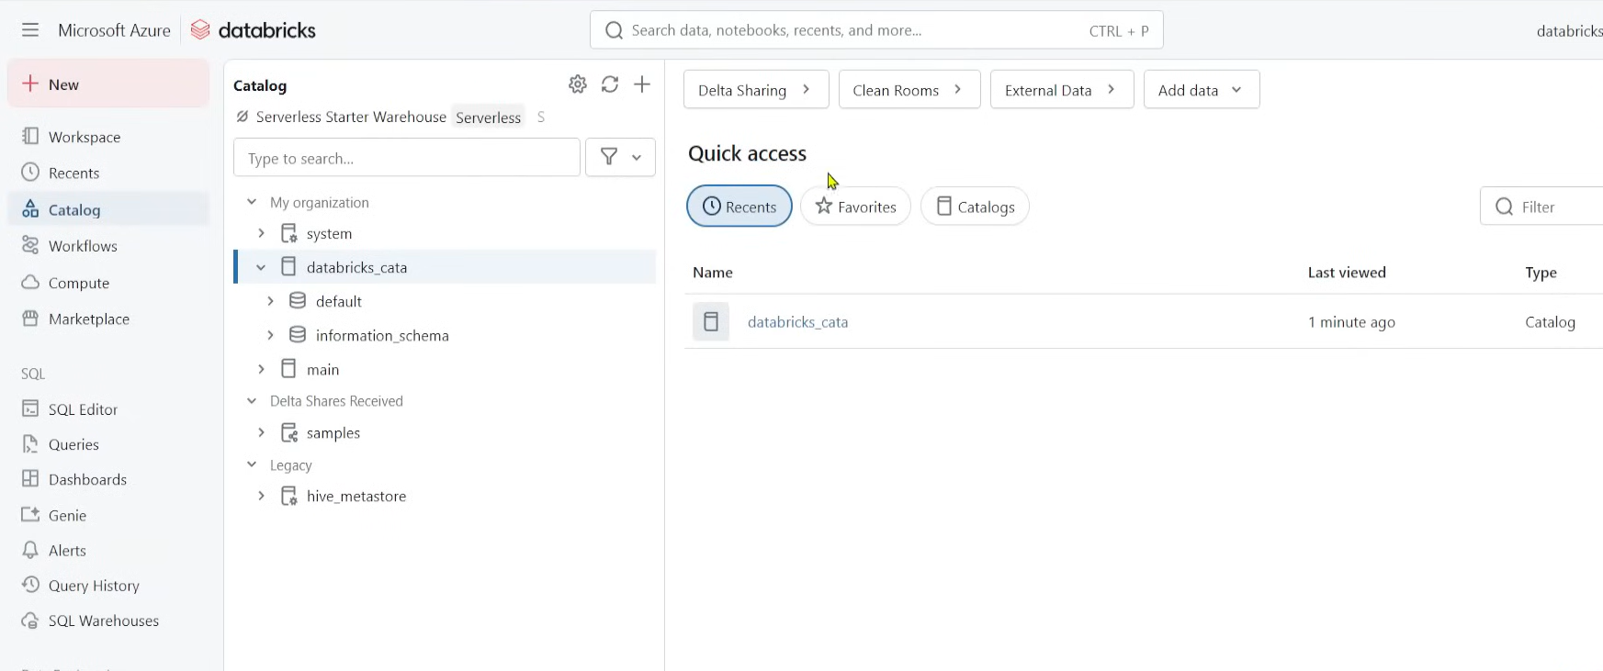
now that we need to create external location
we need a metastore(centralized) then we need to create a catalog which stores workspaces and points to our ADLS ( external location)
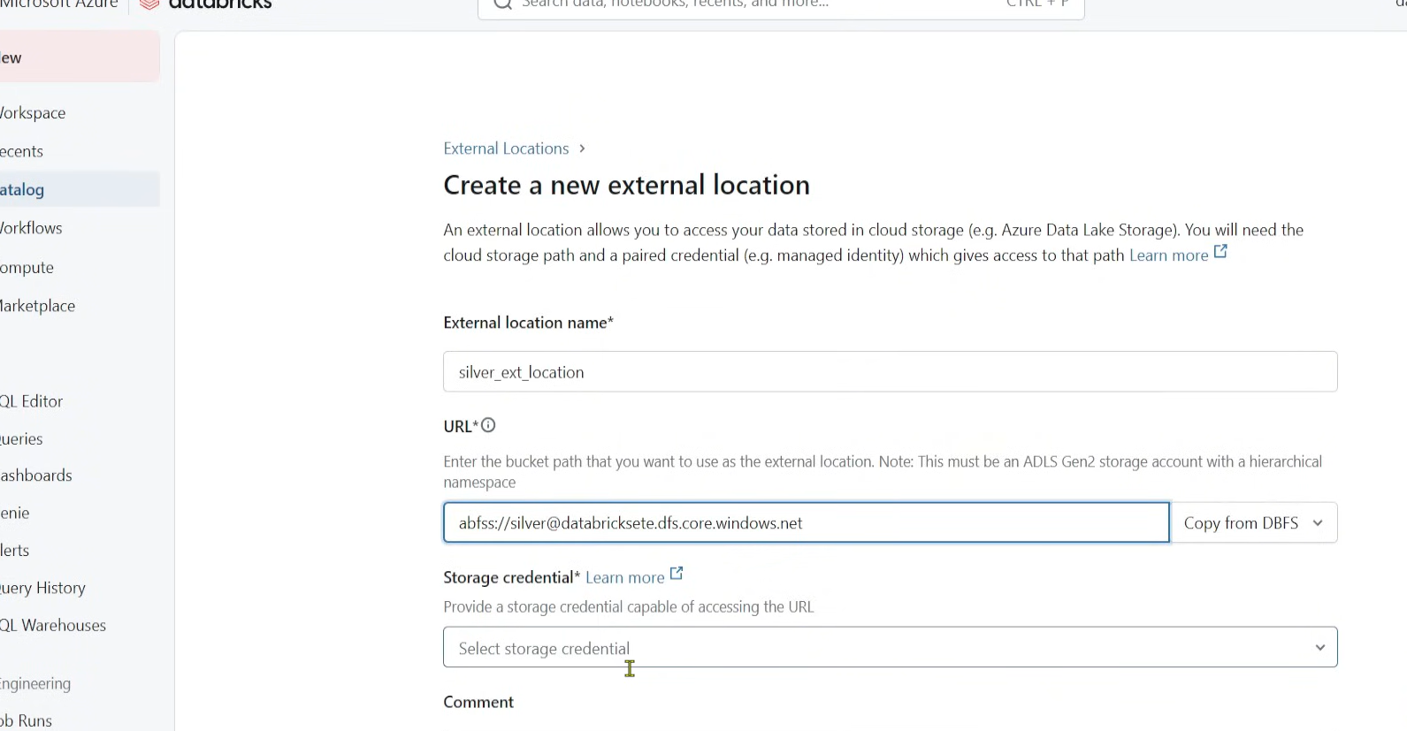
here storage credentials will be the one we created creds above ( data bricks access connector) which has access to our storage containers in ADLS
----
x
----
we can pass parameters dynamically like below
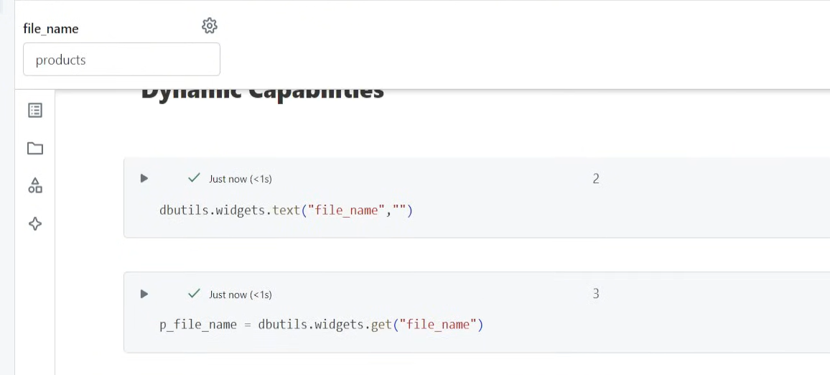
now we need to pass parameters dynamically using a for loop right so we create
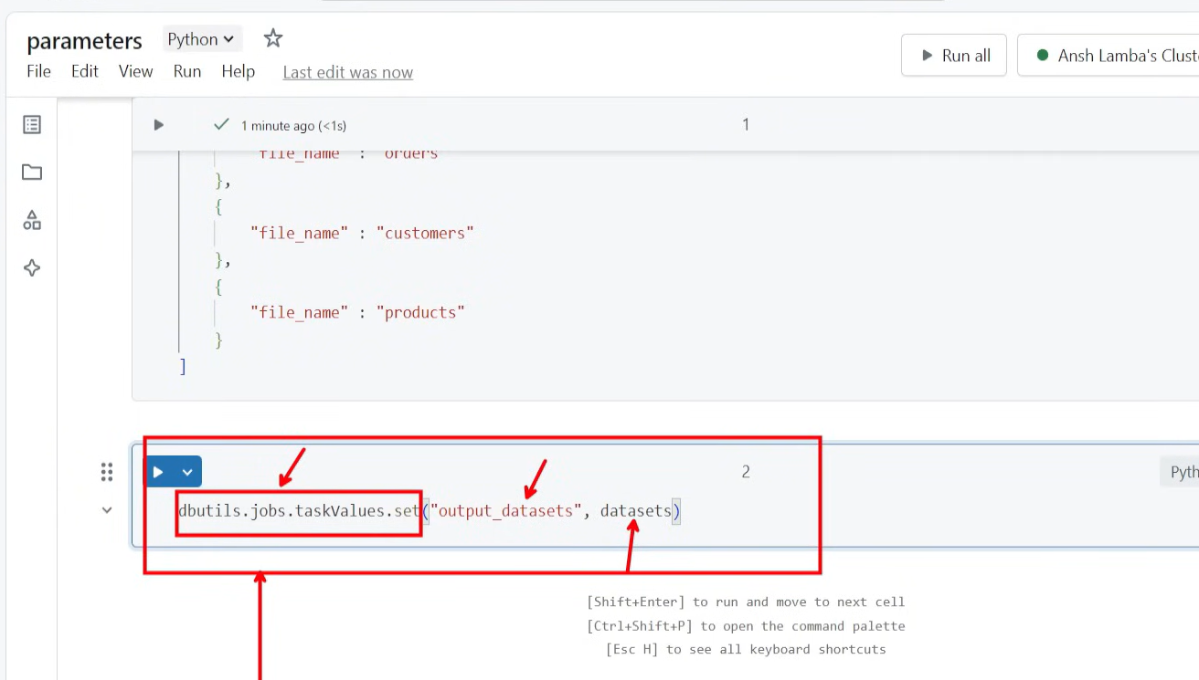
we create a parameters where values are stored and now we need to create a job
in workflows> jobs > and create jobs as like in ADF
-------------------------------------
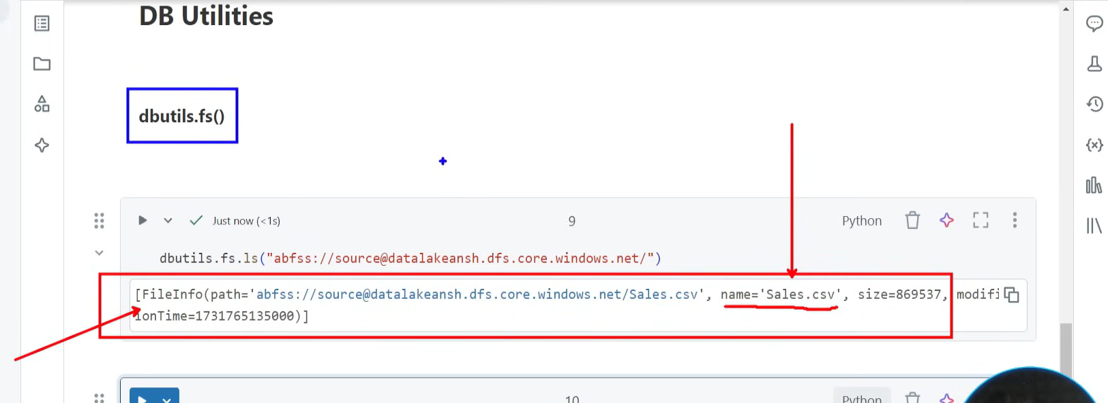
to read files in a path
-----------------------
we are not hardcoding our secret value taken from Microsoft entra id and we pass it as per below steps
we need to pass secret into data bricks notebook using keyvault
we need to create a key vault and inside keyvault we need to create a secret
to create secrets we need to be part of keyvault admin and then create secrets
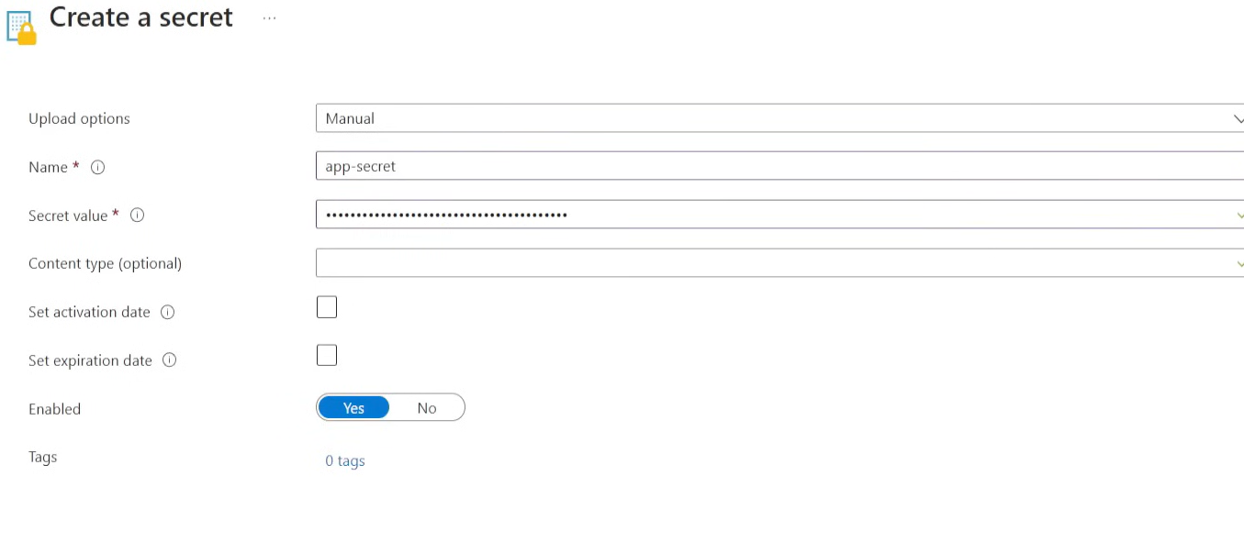

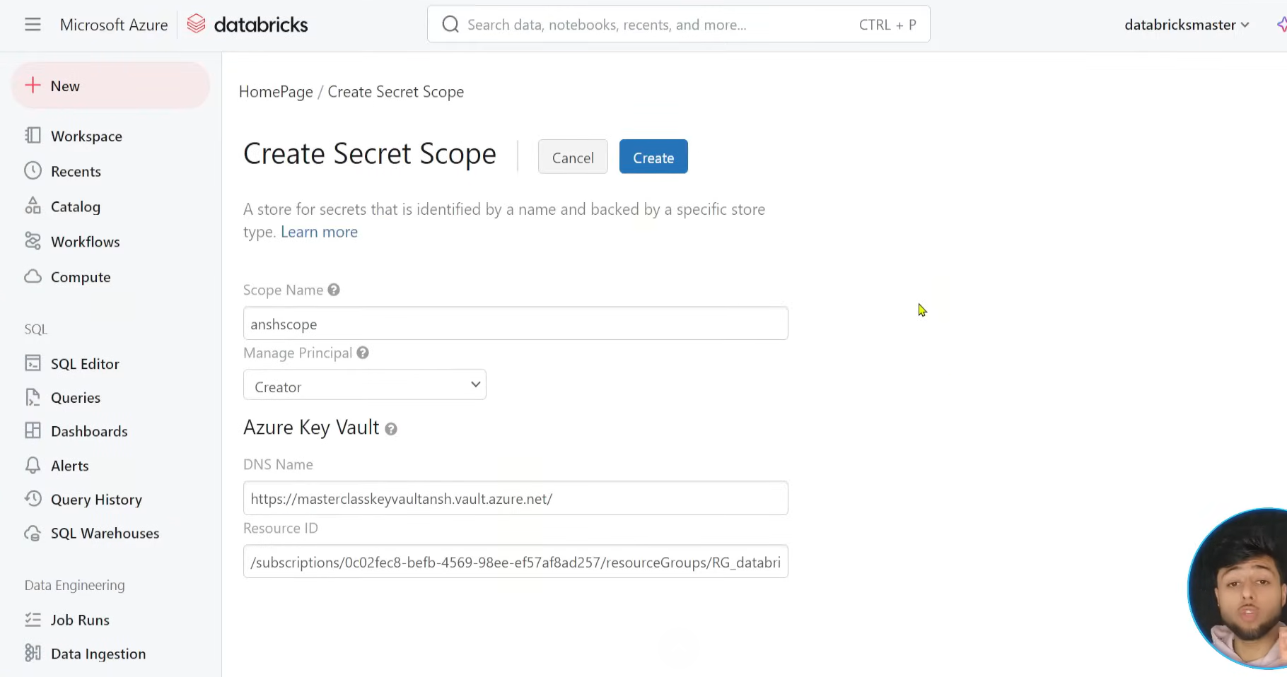
pick those values from Azurekeyvault
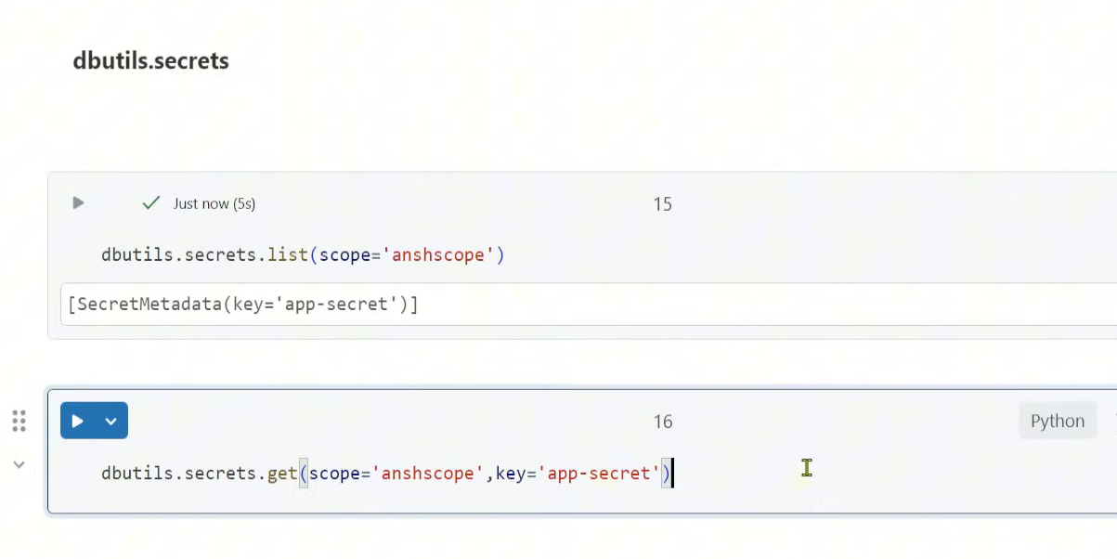
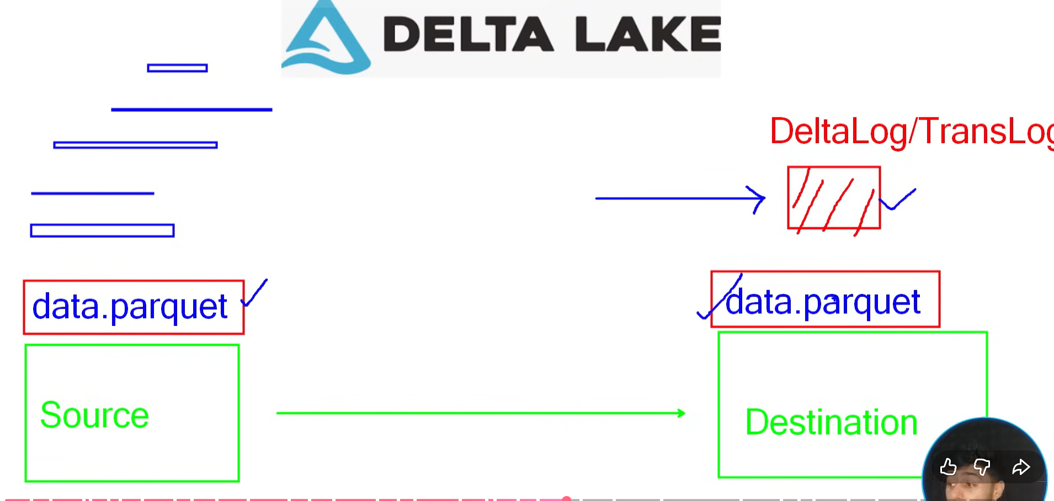
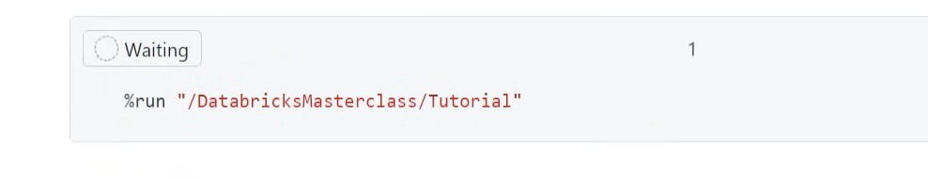
This command is used to copy and run everything that is there in another notebook
-----
inside delta logs we will have these
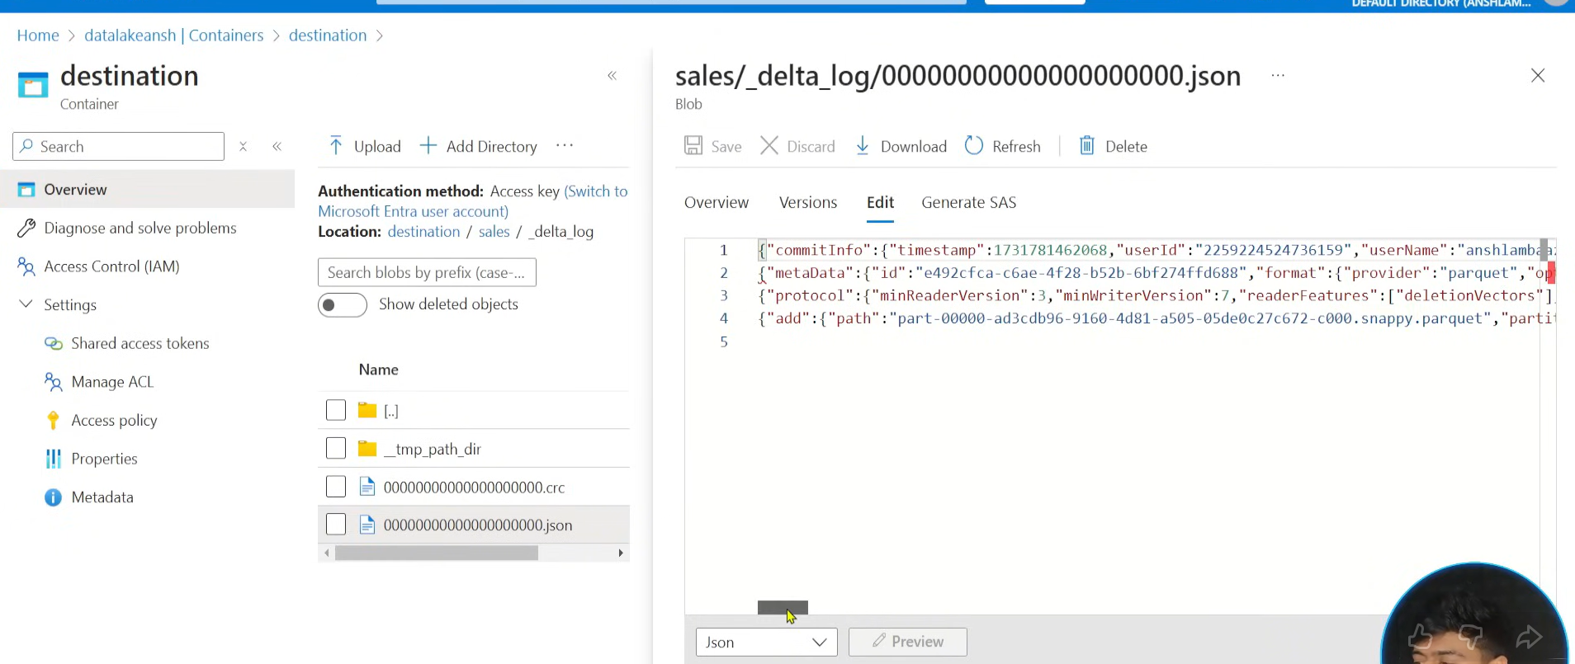
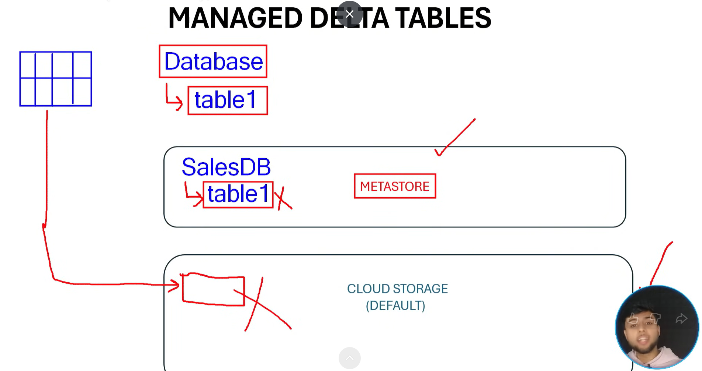
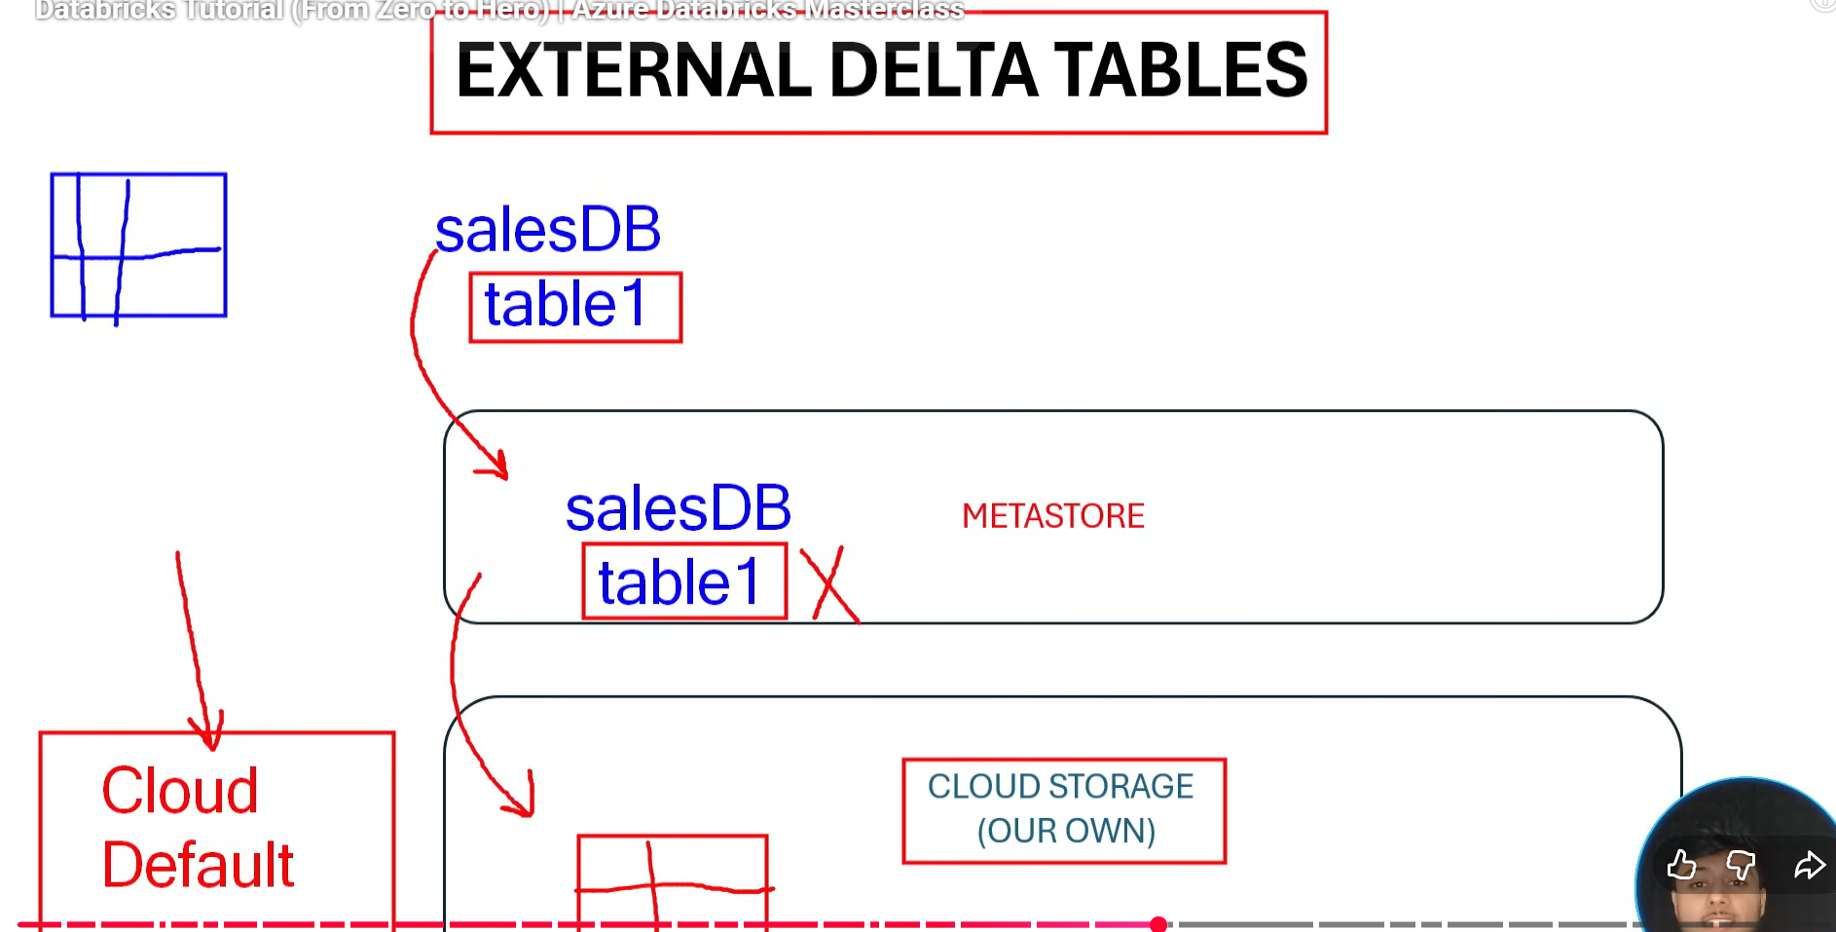
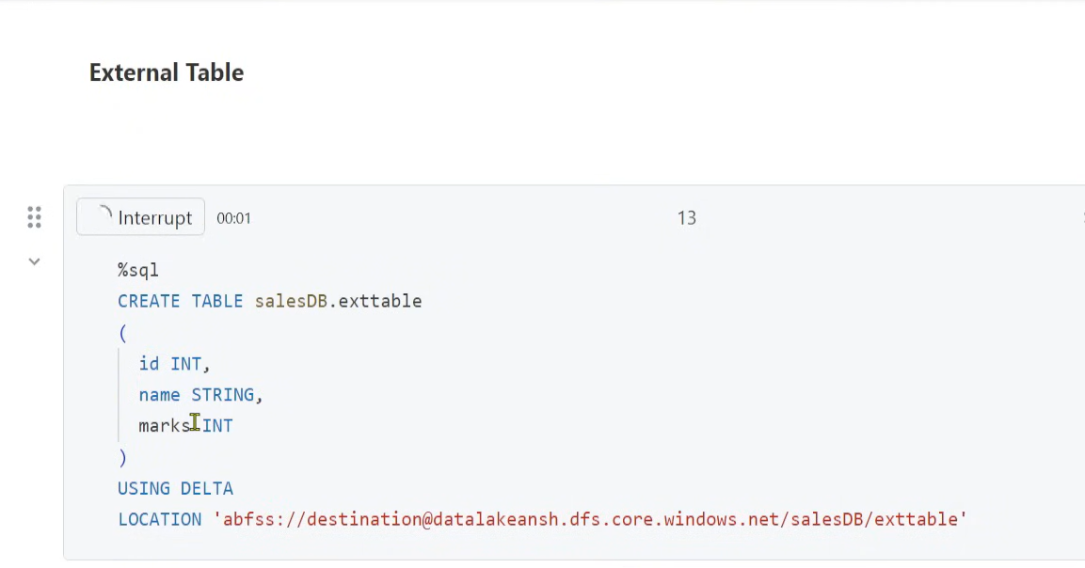
if we write location where our data needs to be stored then it will be external table and metadata is stored in hive metastore of databricks
For internal table we don’t give any location and both data and metadata is stored in databricks only – schema will be in hive metastore and data will be in default storage account
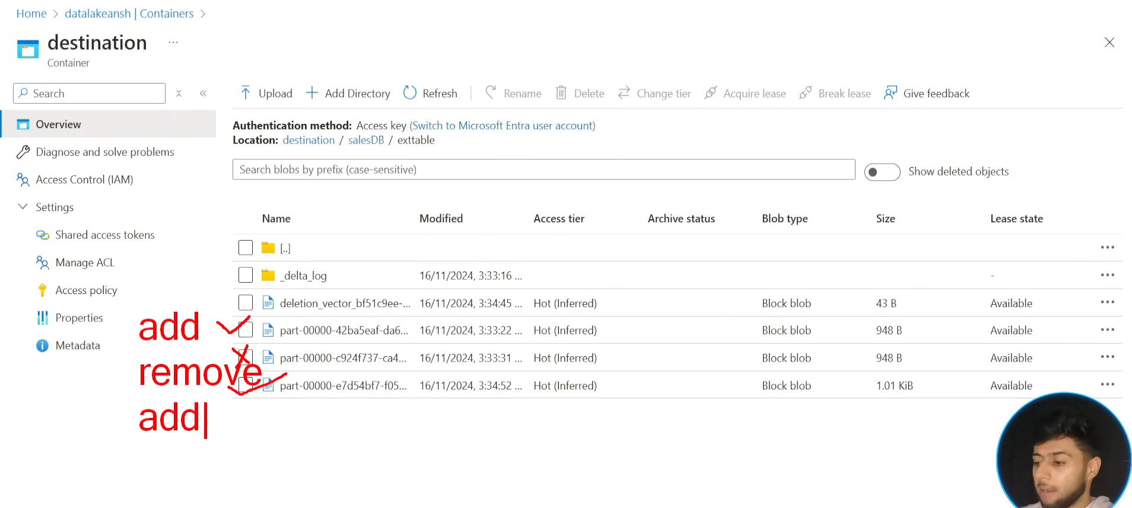
we first created a table and inserted 1 2 3 4 values into it
we then inserted 5 6 7 8 into same table
these are two parquet files like part 0 part 1 and then we deleted a record where id = 8 which is in the part 1 as per our knowledge
now everything is written in delta logs like created table inserted values and again inserted values then delete the records
now what delta table does is it will not update the part 1 file (5 6 7 8) by removing the 8 from it, instead it will create a new parquet file part 2 which holds ( 5 6 7) records and 8 is not added into it and in delta log it will say to consider only part 2 will contains all 7 records
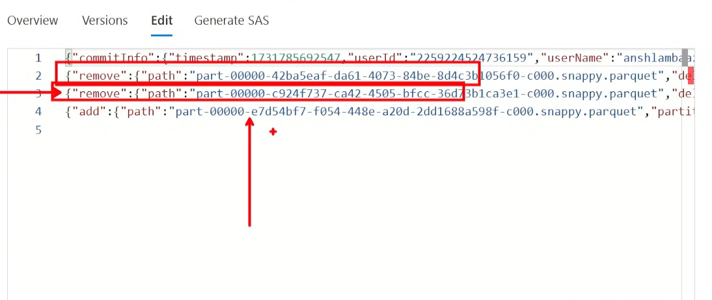
remove part 0 remove part 1 and add part 2 like that ( here soft deletion is happened for remaining parts ) and this is called tombstoning
-----------
versioning
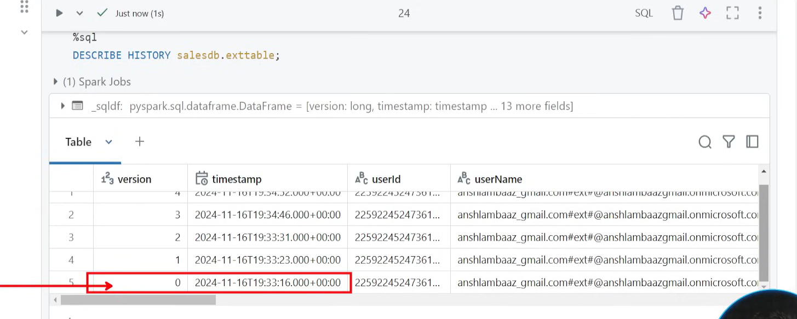
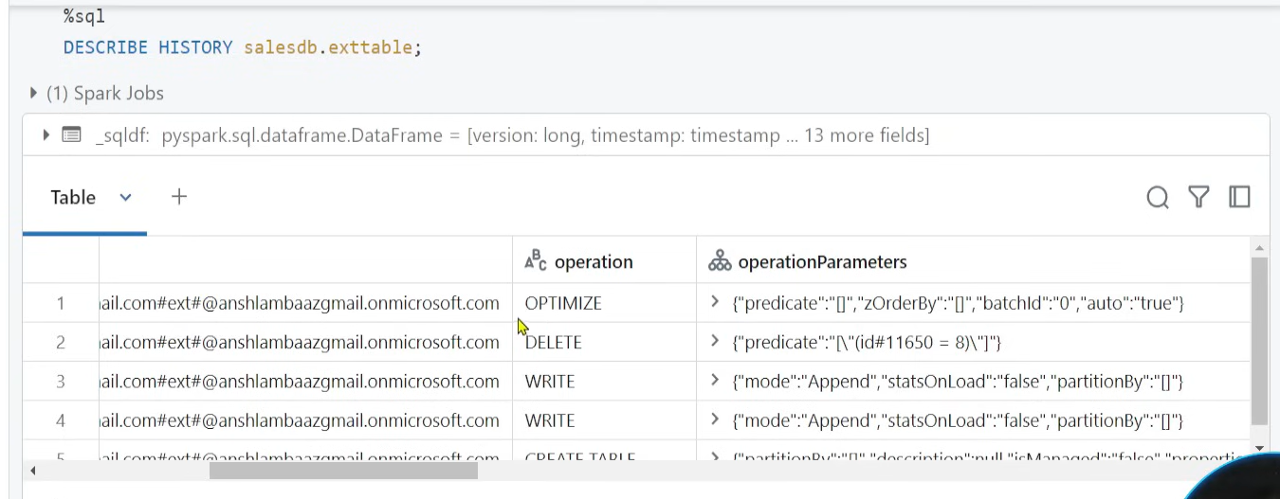
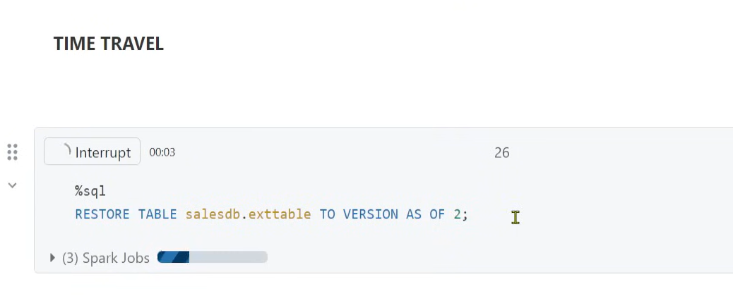
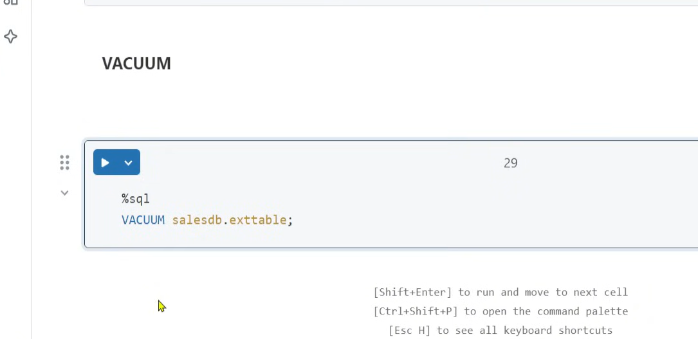
we use vacuum when the part 0 part 1 files needs to be physically deleted from the storage not just soft delete
in our case we don’t need part 0 and 1 we just need part 2 only In that case we use vacuum
---
even when vacuum is used if the file is less than 7days then we cant delete
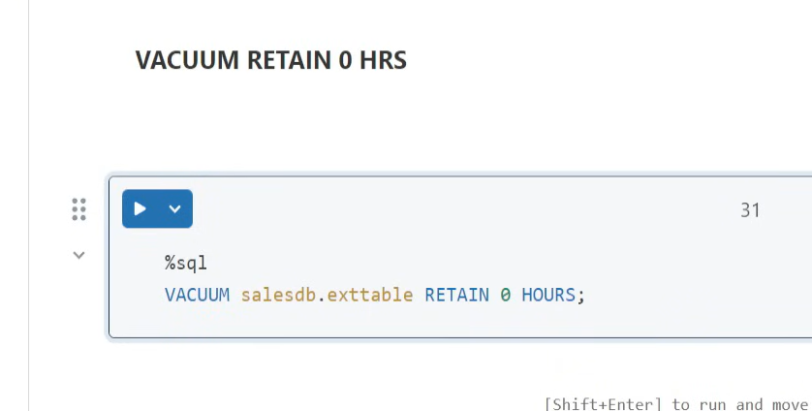
this is force delete with 0hours
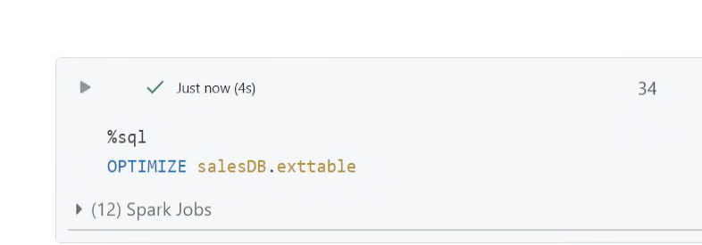
with out optimize it took 0.99 secs but with this it took 0.93s
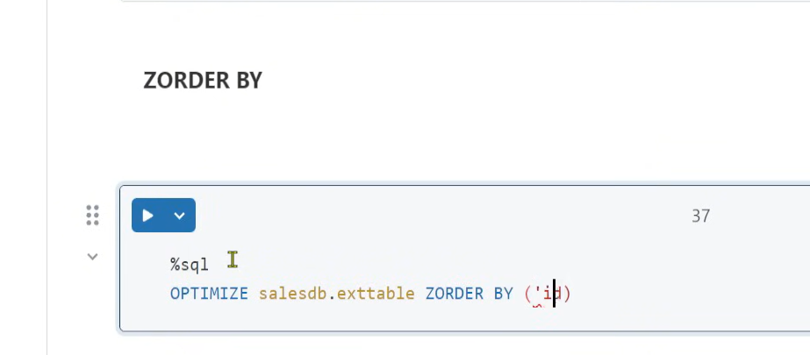
zorder is used with optimize and now it took 0.37s
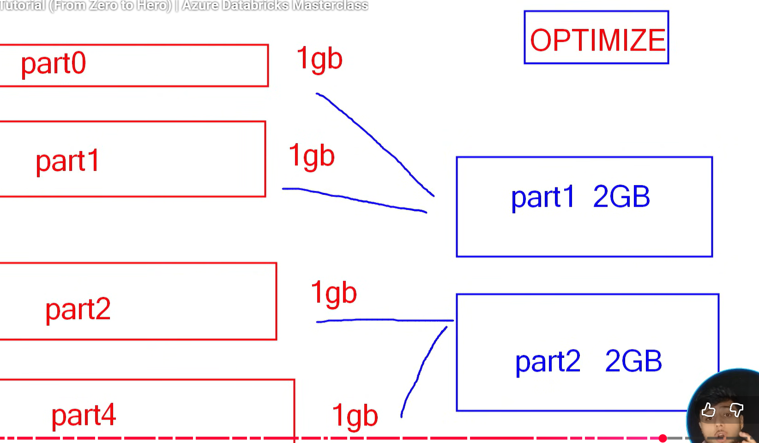
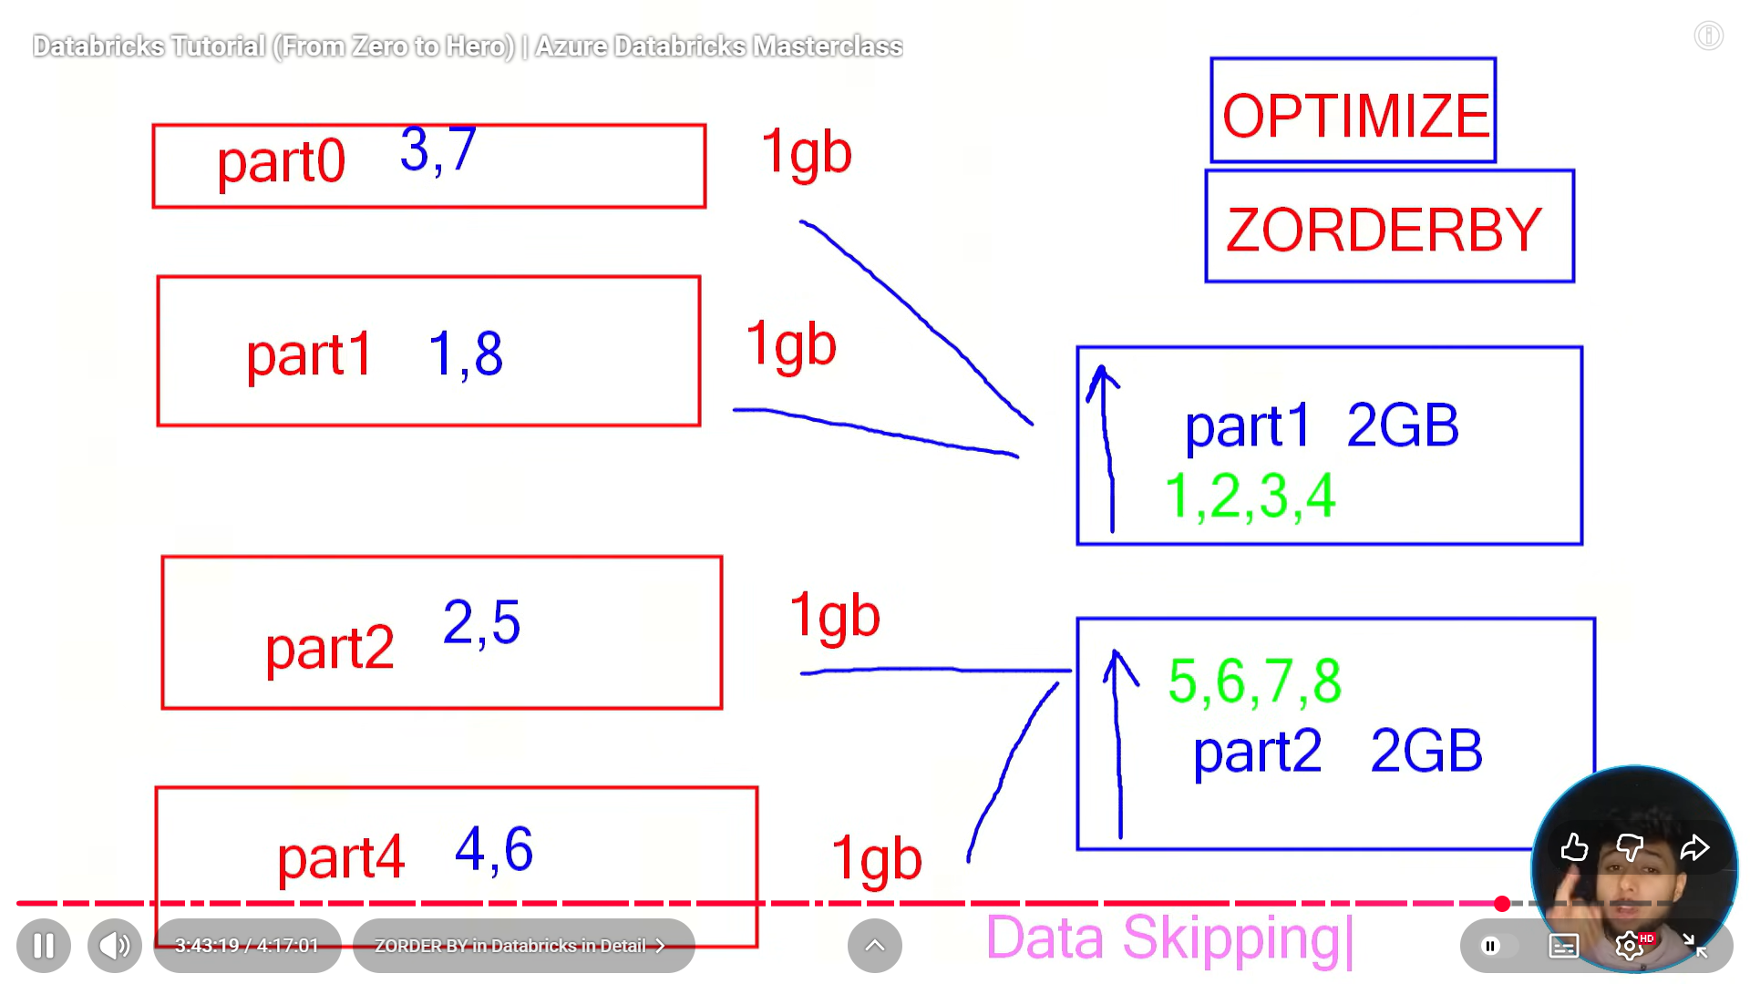
------------------
Streaming:
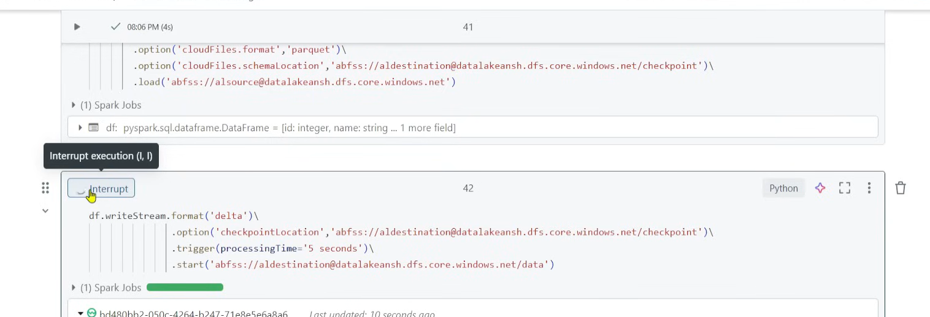
---------------
Workflows are used for orchestration
inside workflow we need to create job
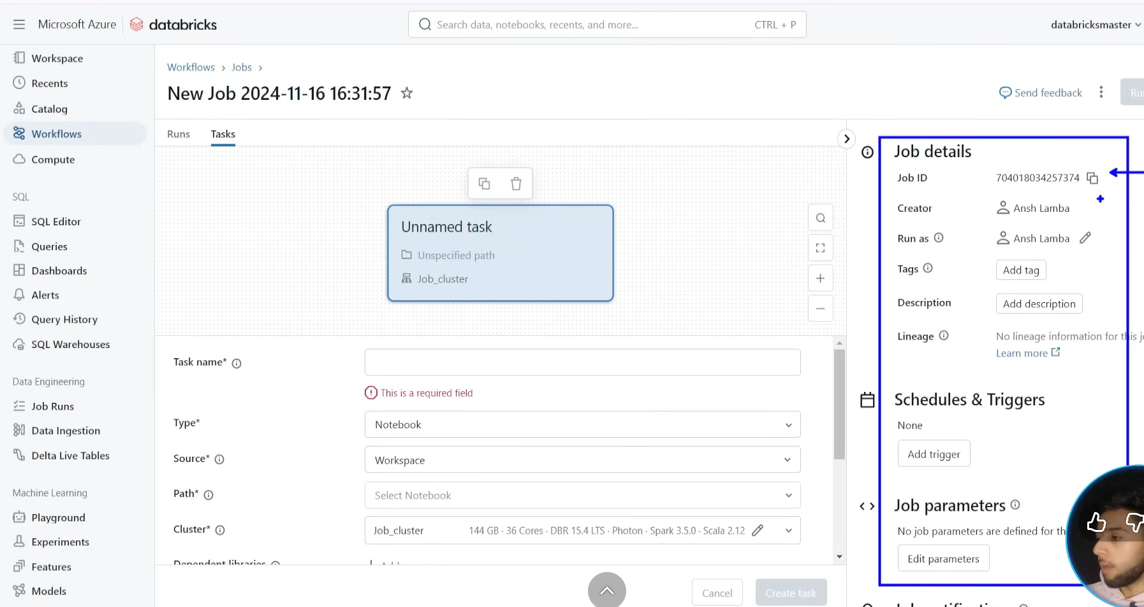
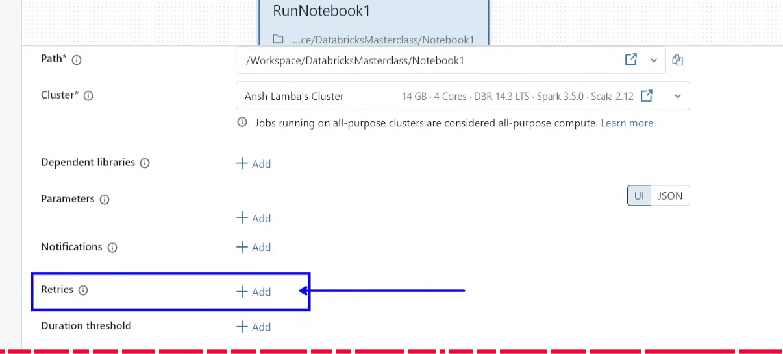
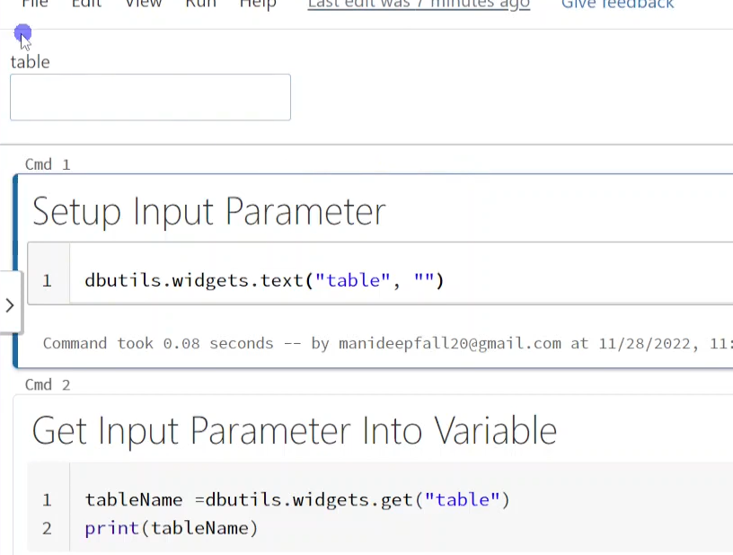
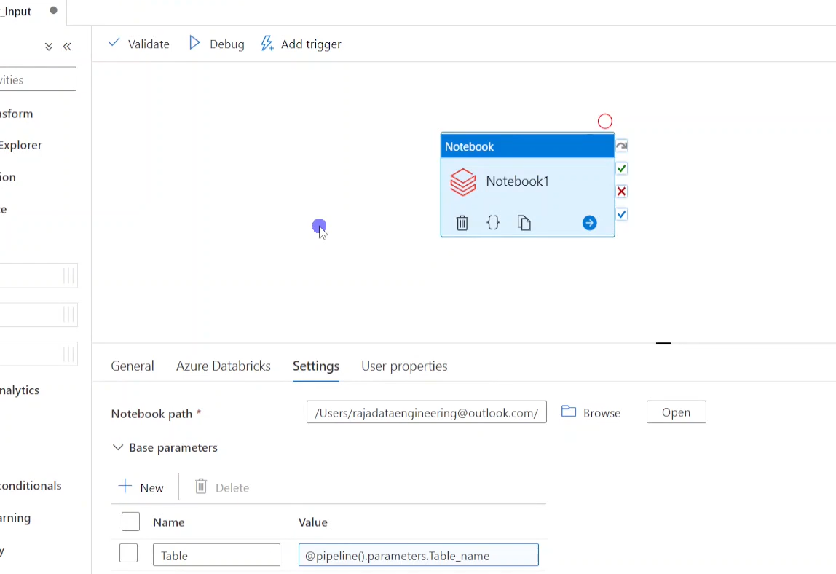
we create parameters dynamically and pass to notebook in databricks and now this table parameter should pick some value from foreach or something as an input
We collect notebook output like this below ss
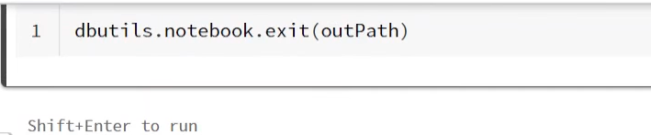
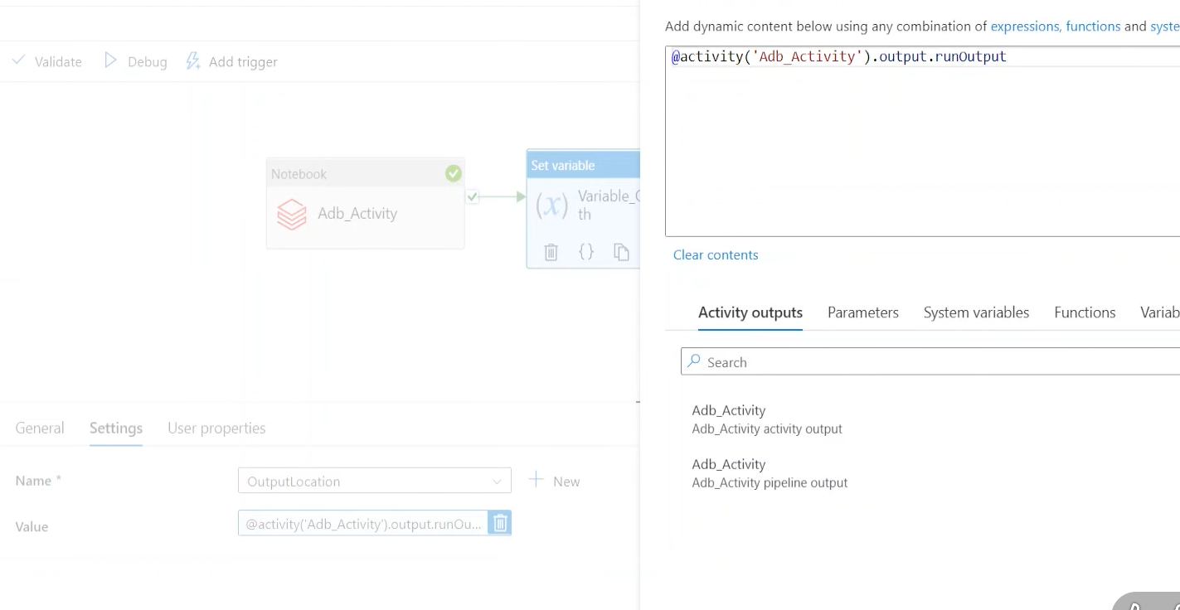
we get databricks output as runOutPut key name (item().name for foreach like that )

