Course:Devops NAME:S.ANJANEYULU

Module:cloud [EMAILID:ANJISINGAM@103GMAIL.COM](mailto:EMAILID:ANJISINGAM@103GMAIL.COM) Topic:s3,ebs,storagegateway Assignment no.7

Trainer name:Mr.Madhukar date of submission:26/02/2024

BATCH NUMBER –116

S3 bucket with cross region replication

Cross region replication means create two buckets in same region or different regions after creating cross region replication in between two s3 buckets if you upload one file or floder in one s3 bucket automatically same file or folder uploaded in another s3 bucket

* Create s3 bucket in US East (N. Virginia) us-east-1

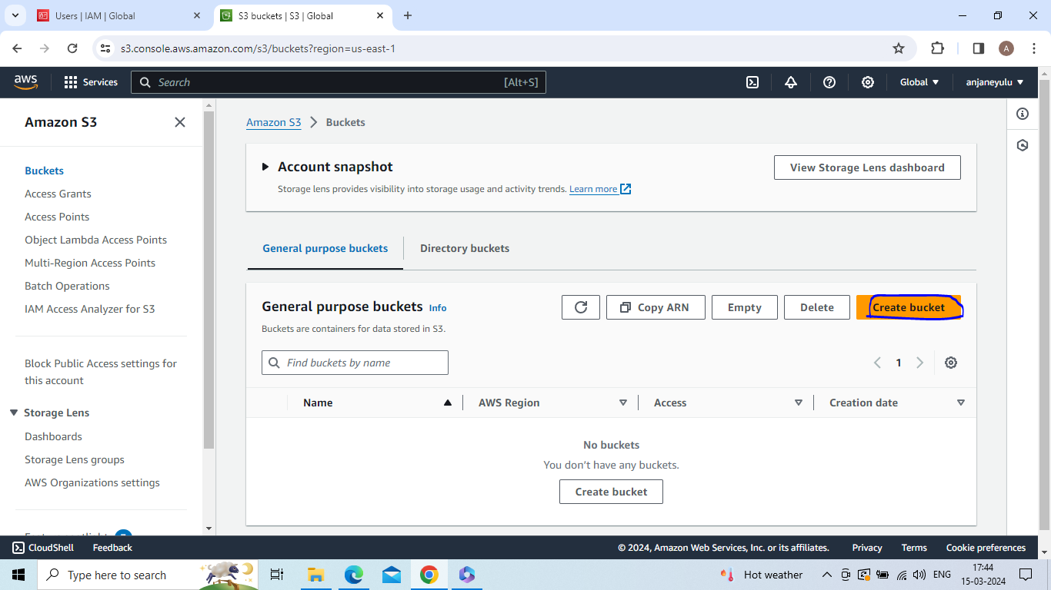

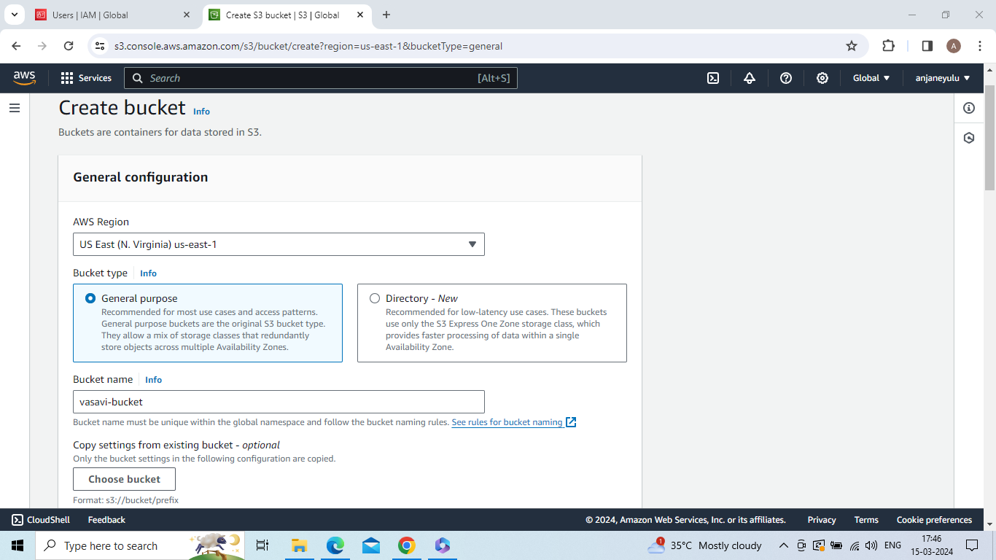

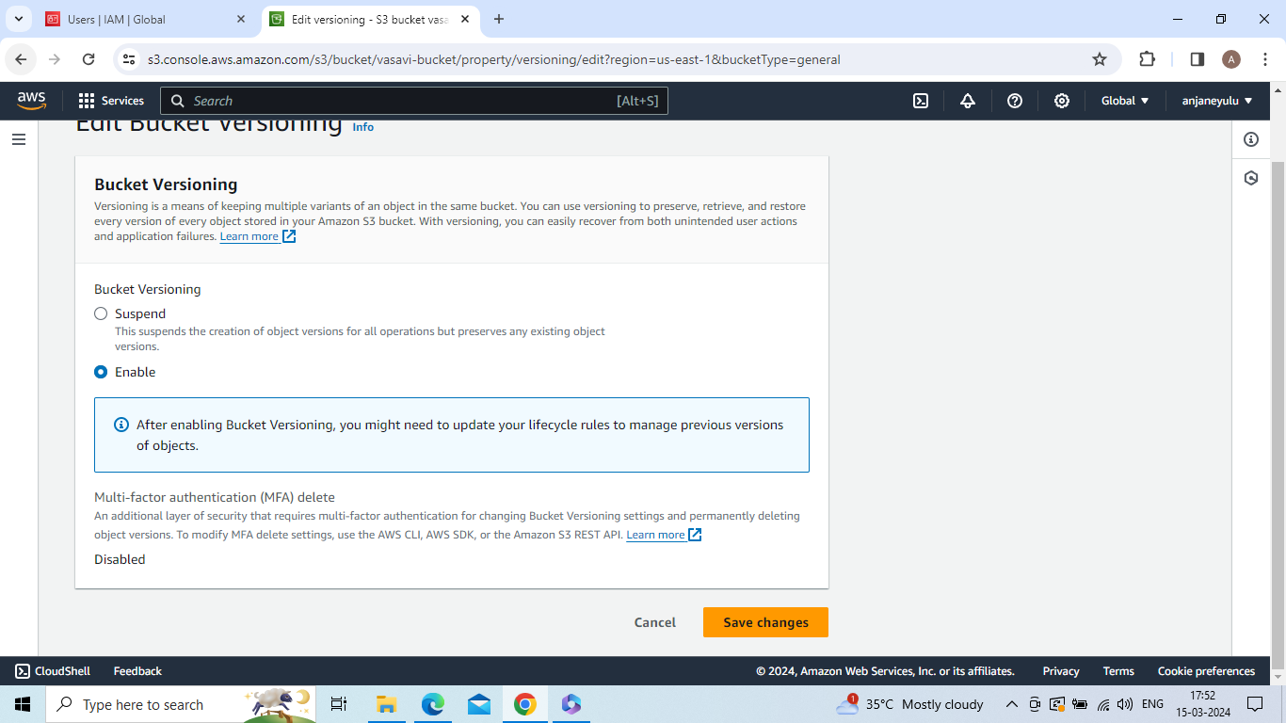

Create s3 bucket in US East (Ohio) us-east-2

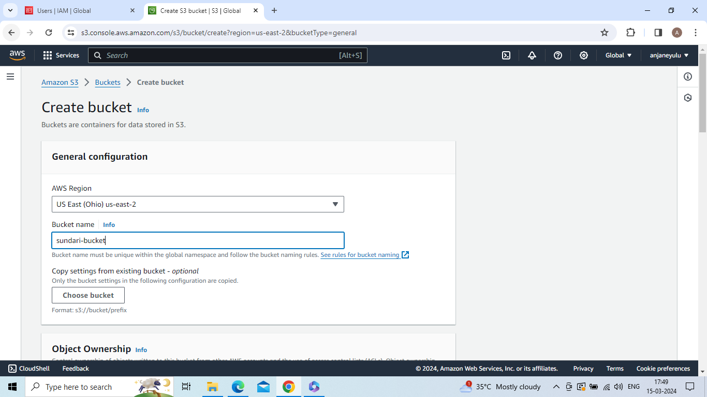

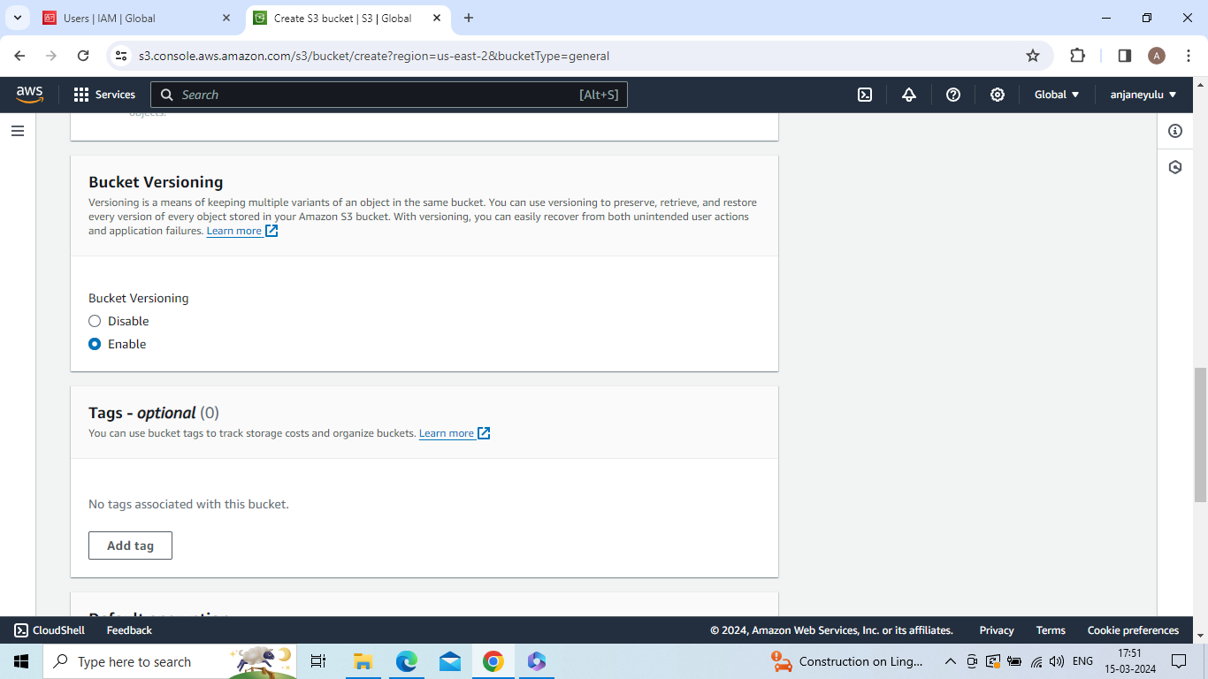

Create cross region replication

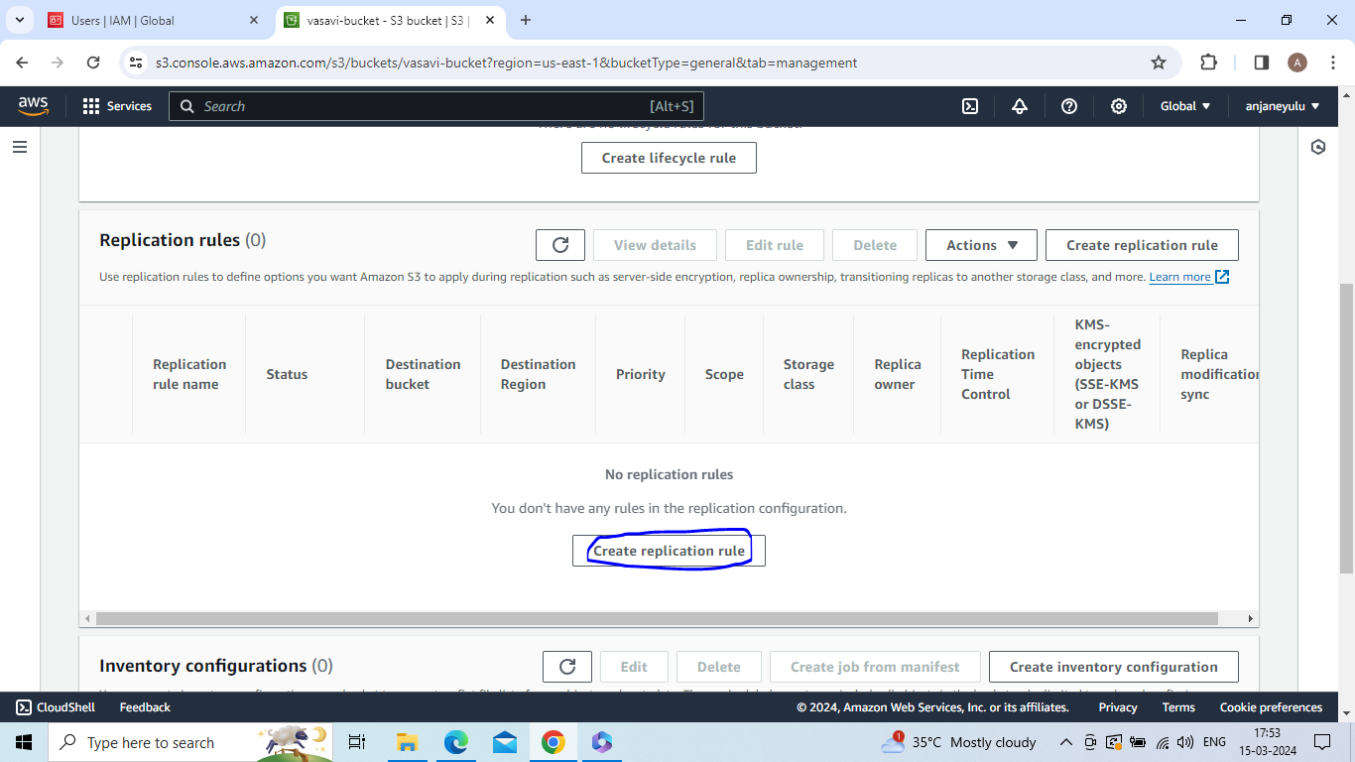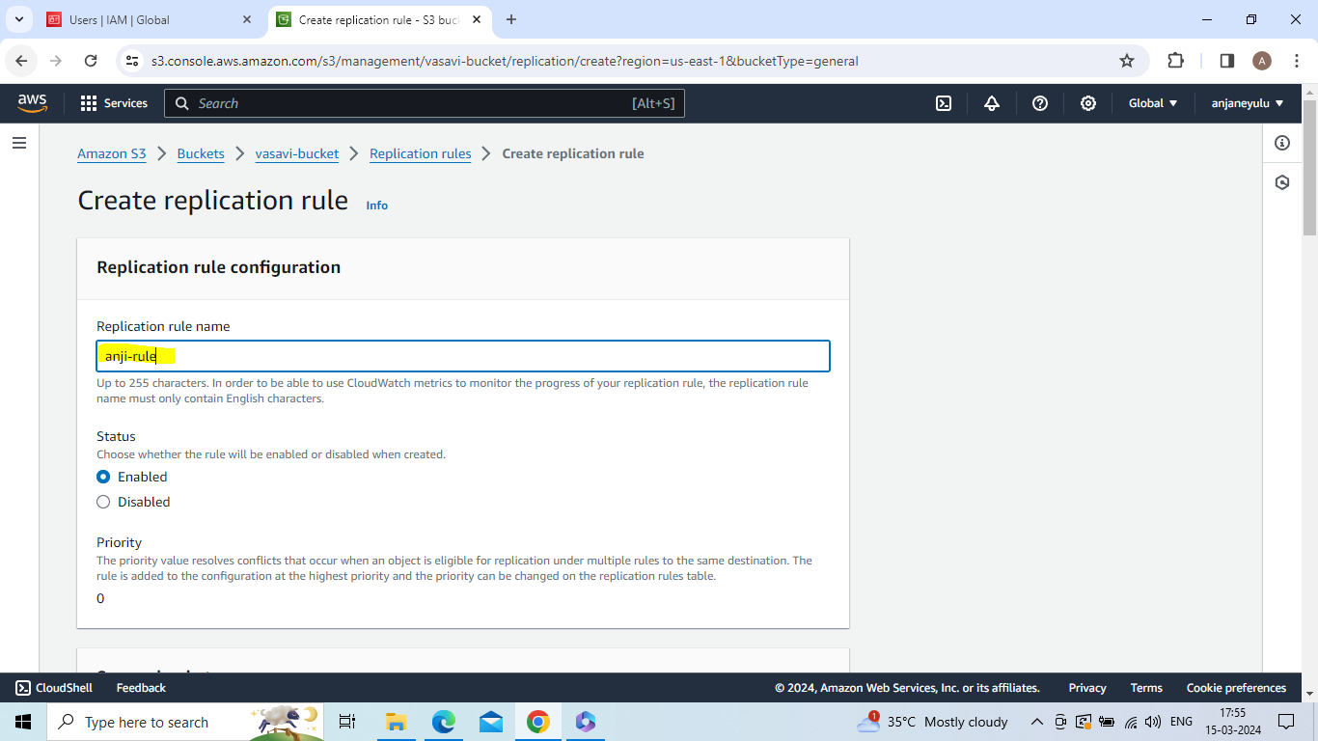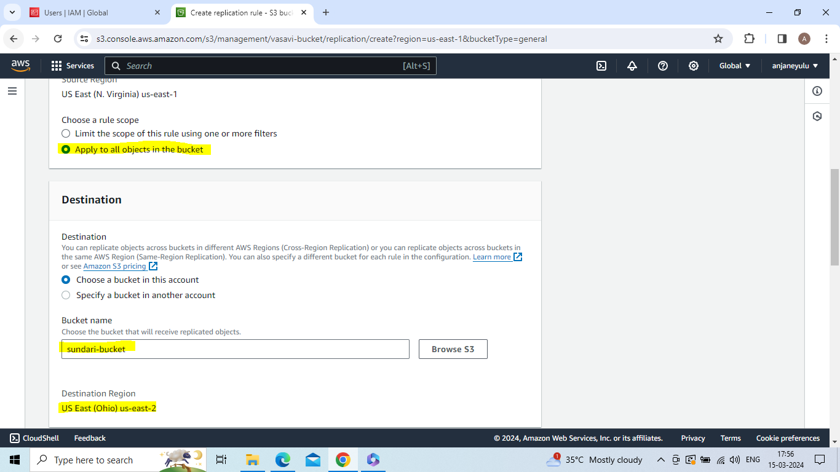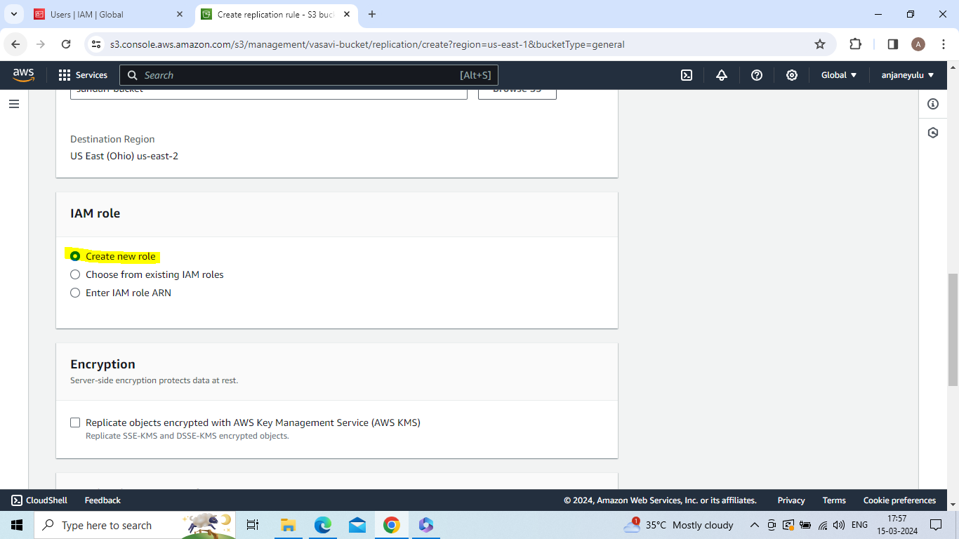

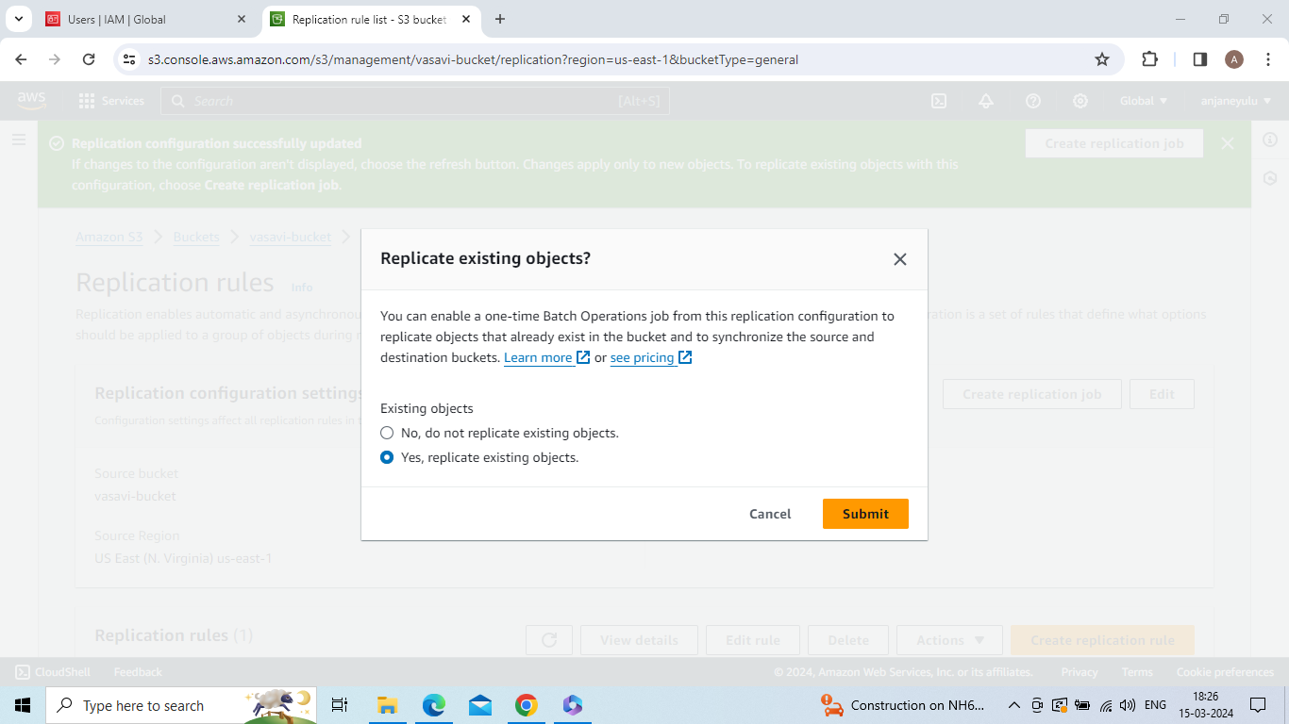

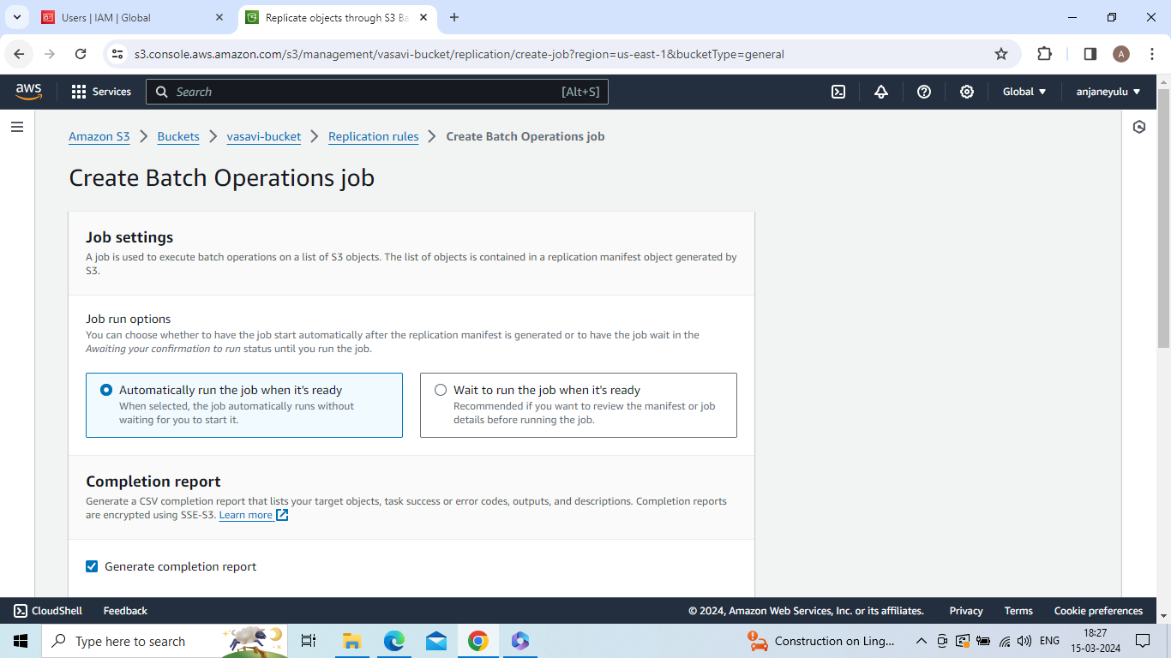

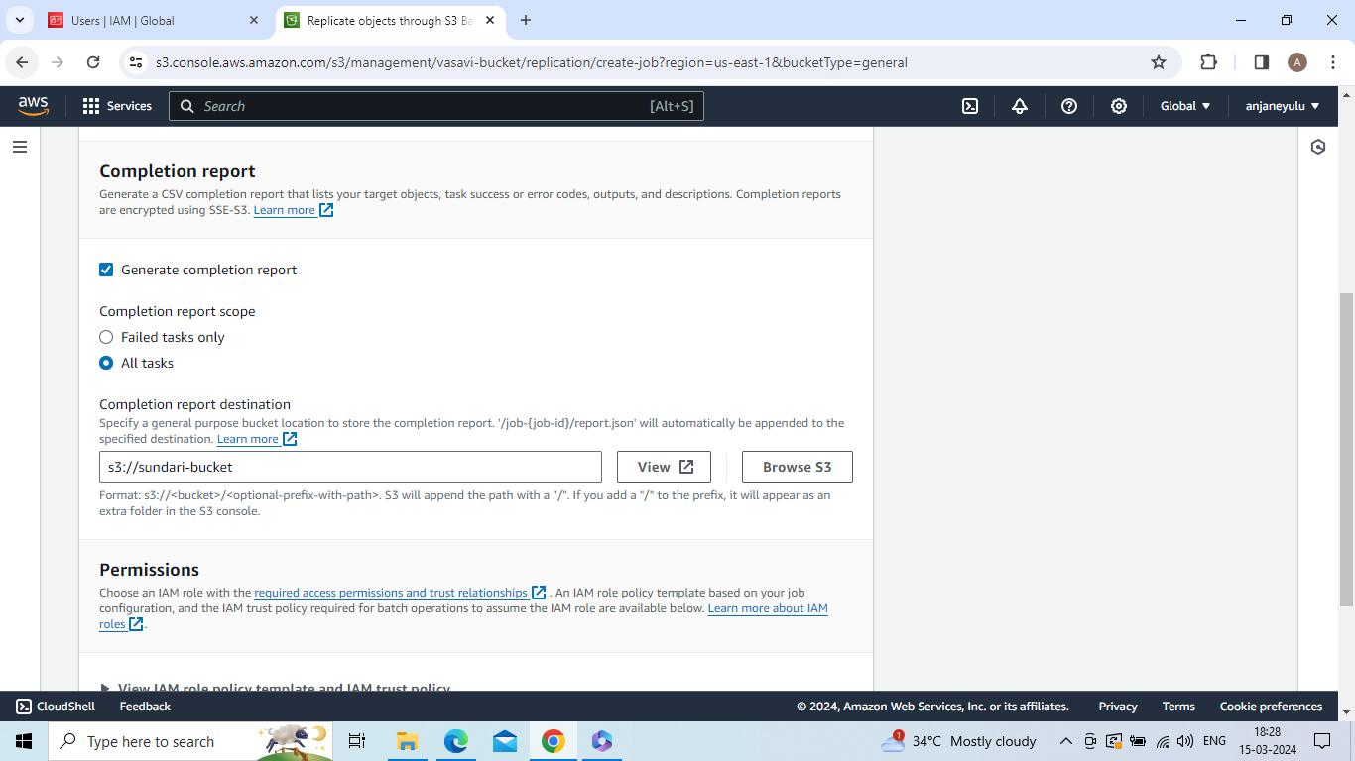

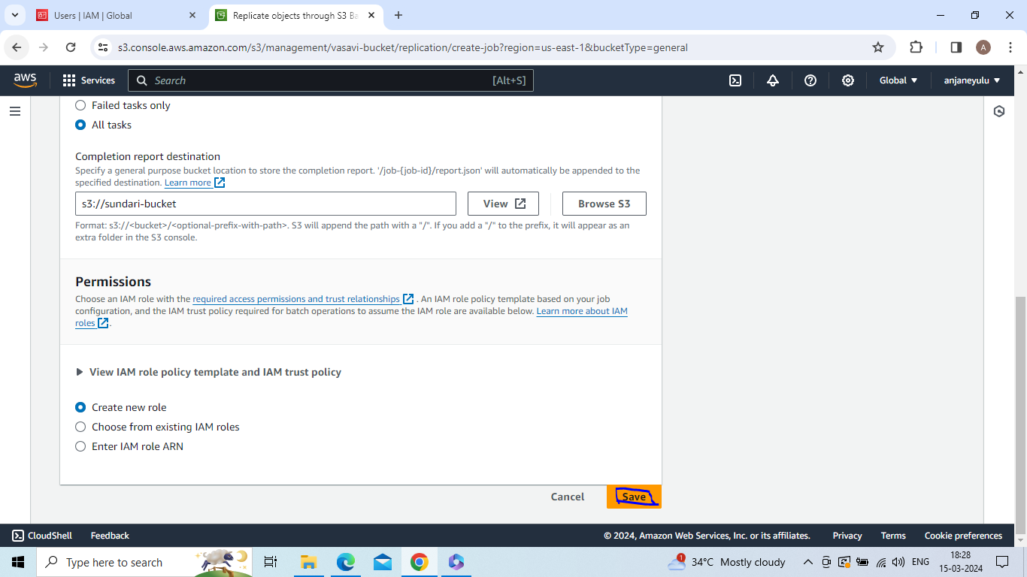

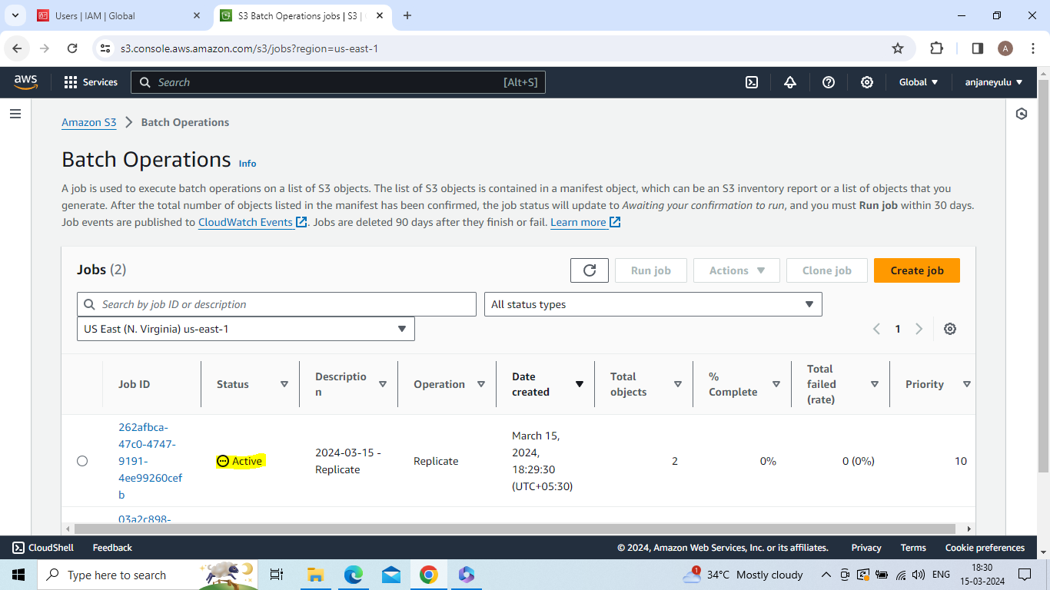

source region in replication

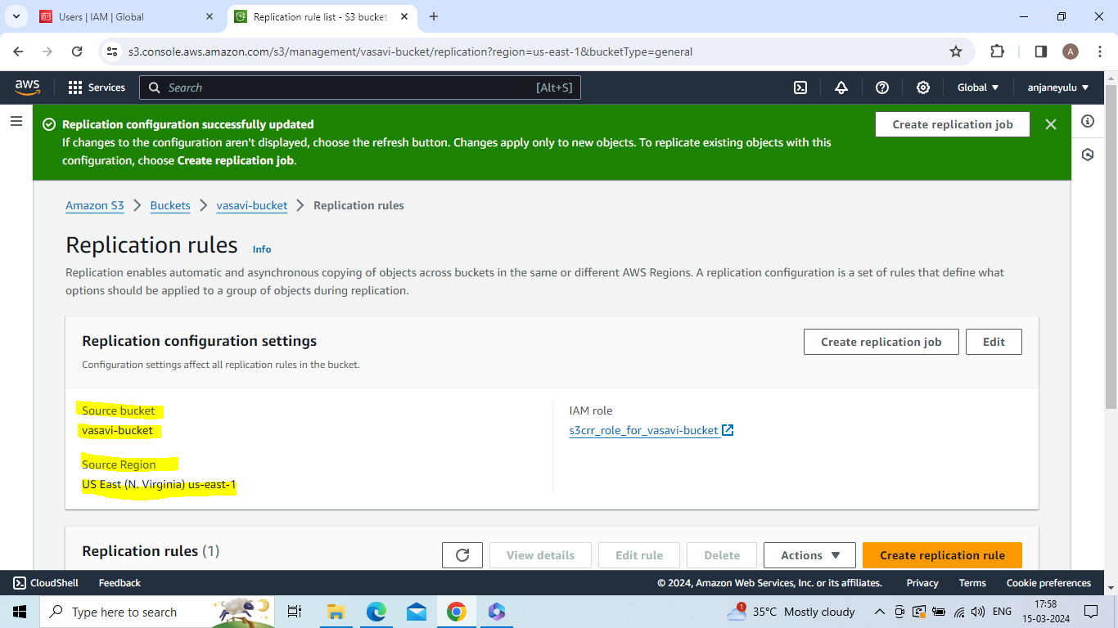

Destination in replication

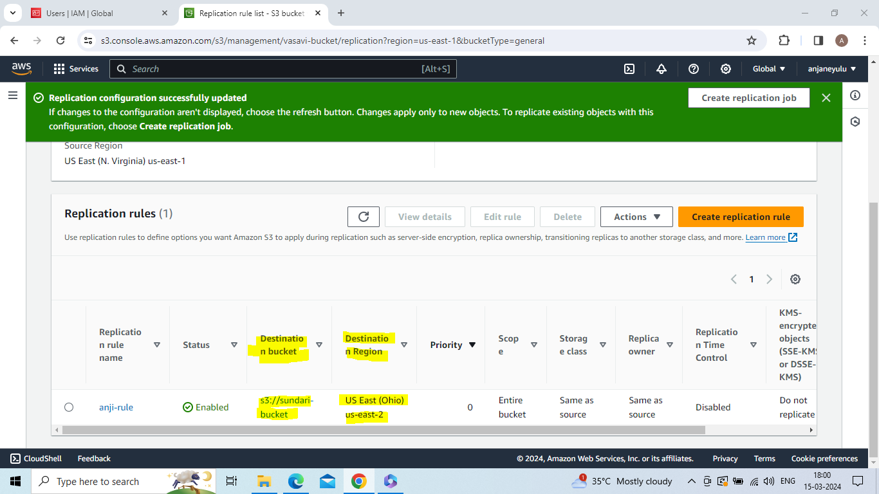

Select one bucket-->click on upload

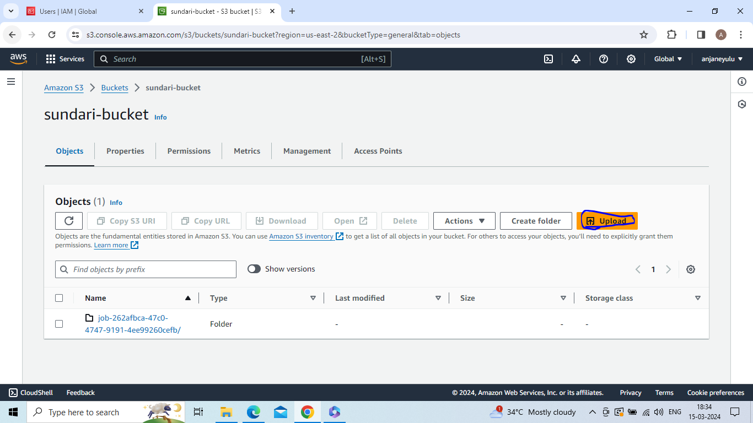

Click on add files or add floder -->select file or folder

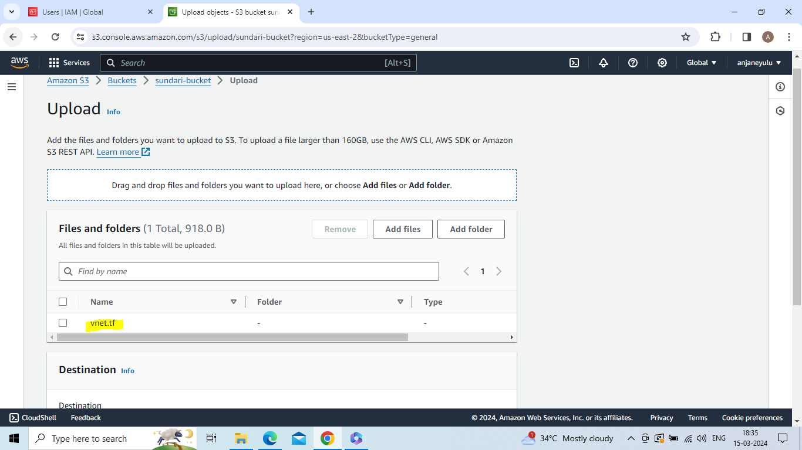

Click on upload

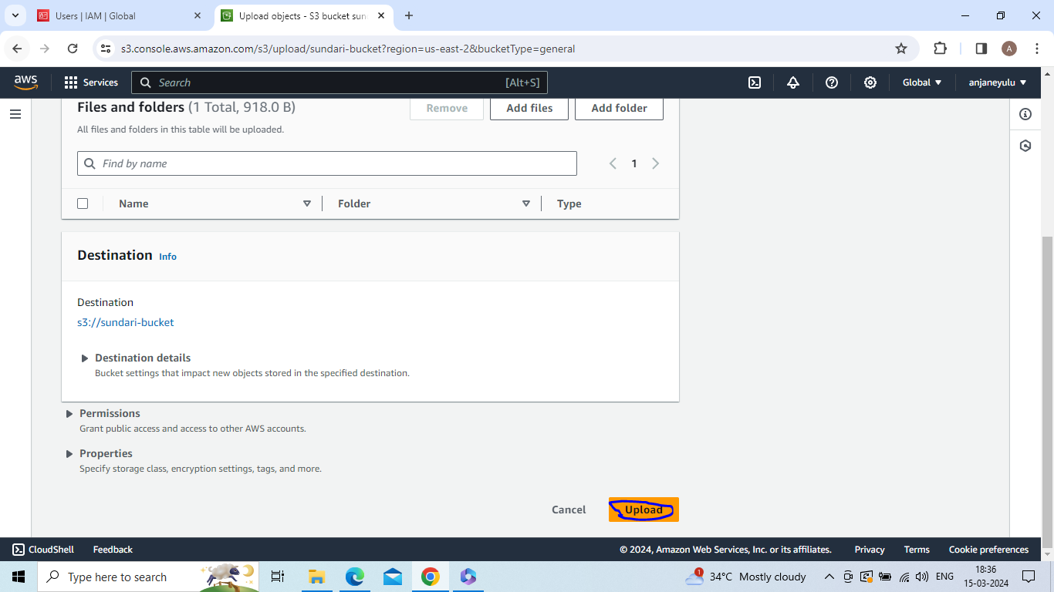

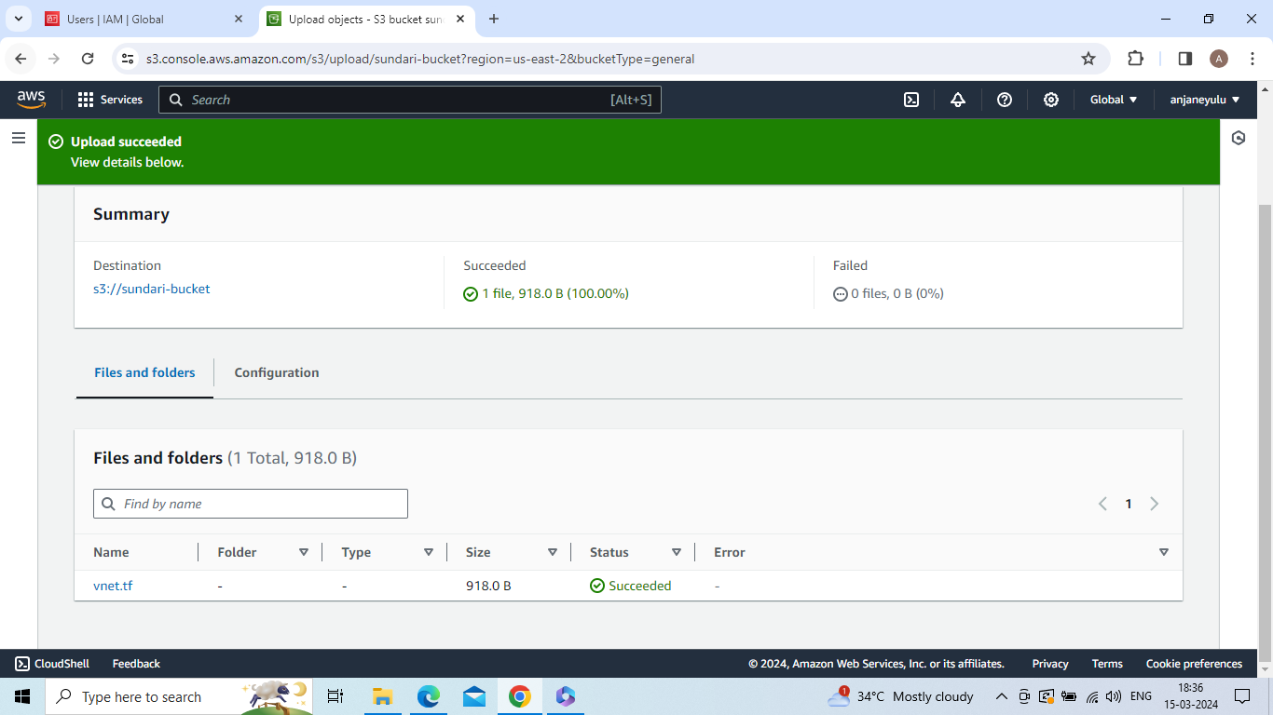

Go to vasavi-bucket (US East (N. Virginia) us-east-1) and check same file (what you upload in US East (Ohio) us-east-2) is uploaded or not if upload cross region replication is done

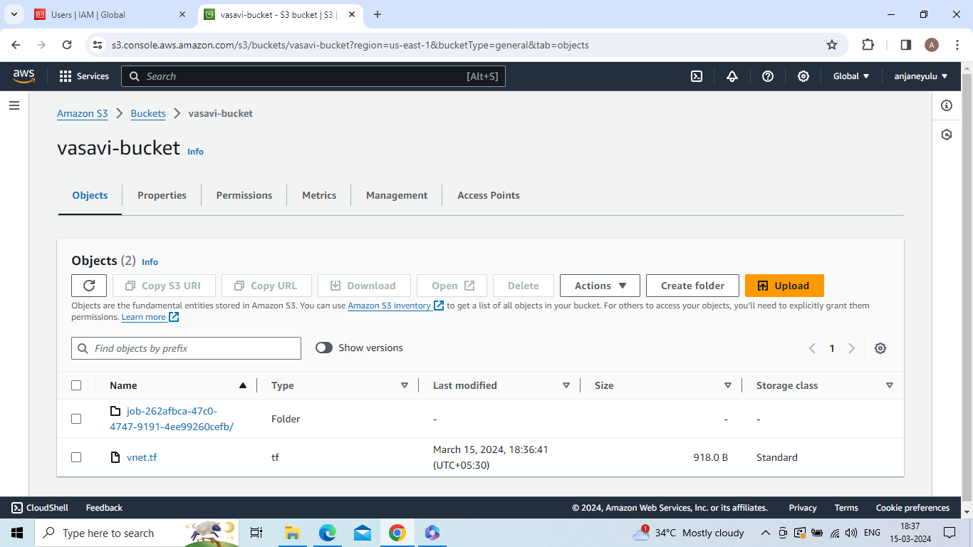

EBS(elastic block store)

Create volume(availability zone : us-east-2a)

Click on create volume

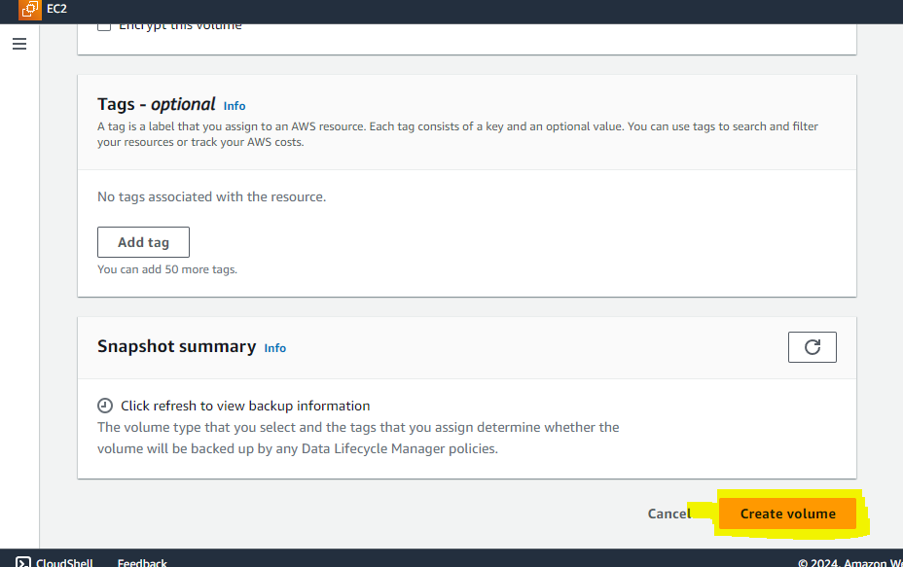

Create and launch instance 1 with availability zone: us-east-2a

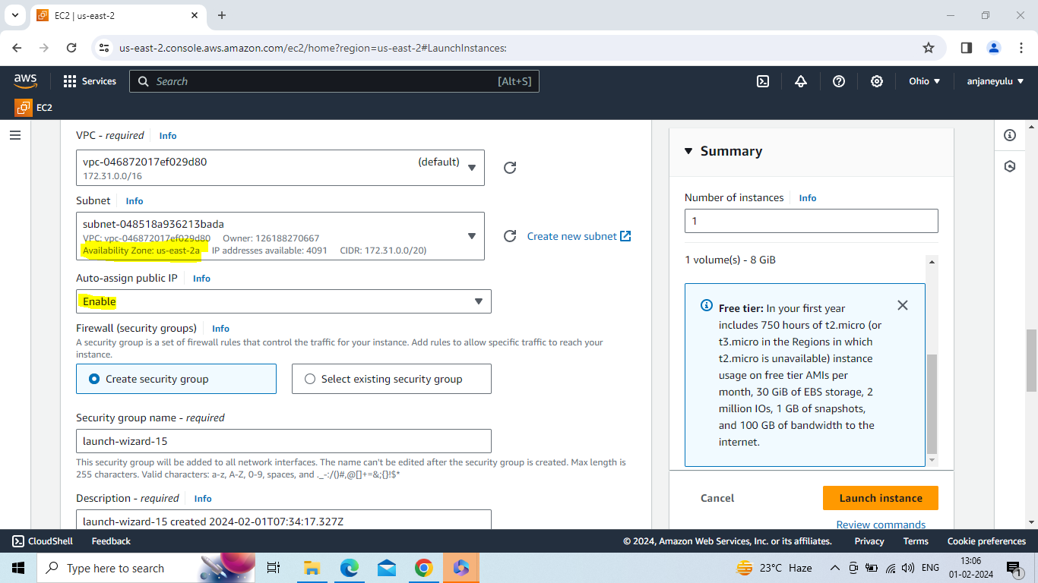

Attach volume to instance 1

Click on attach volume

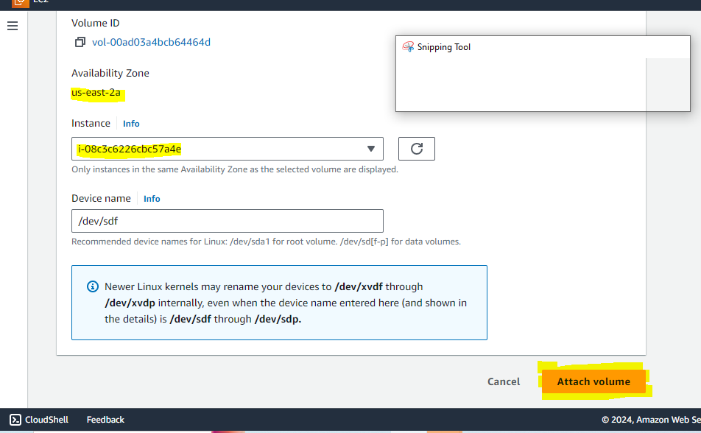

Connect to ubuntu server with instance

Sudo –i (convert to root user)

Df –h

Lsbl (list all block devices in linux machine)

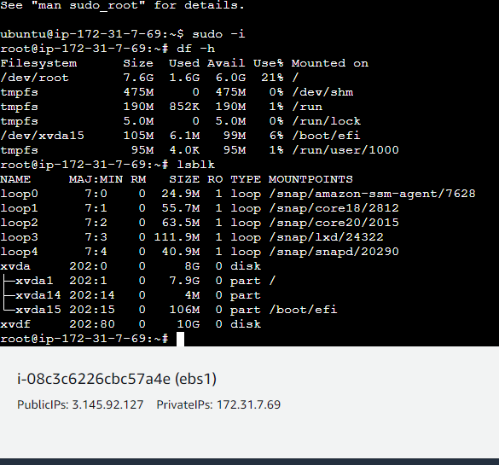

File –s /dev/xvdf (check is there any file system on this device)

Mkfs –t xfs /dev/xvdf (create a file system)

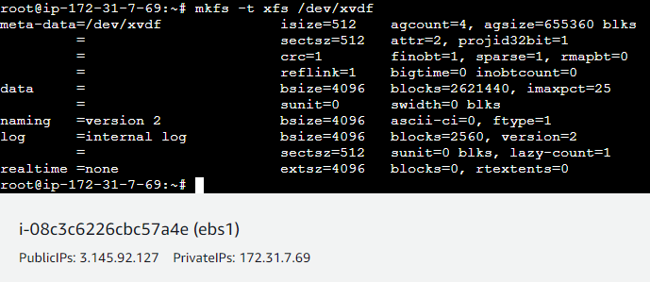

File –s /dev/xvdf (now we have a file system - check is there any file system on this device)

Mkdir d1 (create one directory)

Mount /dev/xvdf d1

Cd d1(go to d1 directory)

Vi file1 -->insert data in file1 (creation of file)

Vi file2 -->insert data in file2 (creation of file)

Mkdir file3

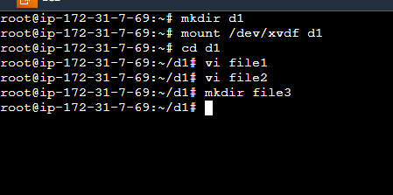

Detach the volume from instance

Create and launch instance 2 with availability zone : us-east-2a

Attach the volume with instance 2

Connect to ubuntu server with instance 2

Sudo –i (convert to root user)

Mkdir d2 (create one directory)

Mount /dev/xvdf d2

Cd d2 (go to d2 directory)

Ls

Automatically files and directories come from instance 1 to instance 2

Create volume

Create and launch instance 1

Attach the volume to instance 1

Connect to ubuntu server

Df –h

Lsblk (list all block devices in linux machine)

File –s /dev/xvdf (check is there any file system on this device)

Mkfs –t xfs /dev/xvdf (create a file system)

File –s /dev/xvdf (now we have a file system - check is there any file system on this device)

Mkdir d1 (create directory)

Mount /dev/xvdf d1

Cd d1(change to d1 directory)

Create files and directories whatever you want

Detach volume from instance 1

Create and launch instance 2

Connect to server

Attach volume to instance 2

Sudo –i (convert to root user)

Mkdir d2 (create a directory)

Mount /dev/xvdf d2

Cd d2 (change to d2 directory)

Ls

After ls command using we will see whatever you create files in instance 1

Note:

1. you must be create instances(1,2) and volume in same region and same availibility zone

2.first we create one directory and mount that directory and after mount we have change into that directory and create files and directories what ever we want

Storage gateway

Storage gateway

A storage gateway is a hybrid cloud storage solution that connects an organization's on-premises infrastructure with cloud-based storage services. It acts as a bridge between on-premises environments and cloud storage, enabling seamless integration and data transfer between the two.

Steps to create a storage gateway

Creating a storage gateway typically involves several steps, which may vary depending on the specific cloud provider and type of storage gateway you're deploying. Below are general steps to create a storage gateway:

* **Choose a Cloud Provider**: Determine which cloud provider you want to use for your storage gateway. Major cloud providers like Amazon Web Services (AWS), Microsoft Azure, and Google Cloud Platform (GCP) offer storage gateway services.
* **Select the Type of Storage Gateway**: There are different types of storage gateways available, such as file gateway, volume gateway, and tape gateway. Choose the type that best suits your requirements. For example, if you need file storage, you might opt for a file gateway.
* **Set Up Cloud Storage**: Create the cloud storage repository where your data will be stored. This typically involves creating a bucket or container in your chosen cloud provider's storage service.
* **Deploy the Storage Gateway Software or Appliance**: Install and configure the storage gateway software or appliance on-premises. This may involve downloading software from the cloud provider's website and installing it on your servers or deploying a physical appliance if provided by the cloud provider.
* **Configure the Storage Gateway**: Follow the instructions provided by the cloud provider to configure the storage gateway. This includes specifying settings such as network configuration, caching options, security settings, and connecting the gateway to your cloud storage repository.
* **Connect On-Premises Storage**: If you're using a volume or tape gateway, you'll need to connect your existing on-premises storage devices to the gateway. This may involve attaching external storage arrays, SAN volumes, or tape libraries to the gateway appliance.
* **Set Up Access Permissions**: Define access permissions and policies for users and applications that will be accessing data through the storage gateway. This includes setting up authentication and authorization mechanisms to control who can read, write, and manage data.
* **Test and Verify**: Once the storage gateway is configured, perform thorough testing to ensure that data can be seamlessly transferred between your on-premises environment and the cloud storage repository. Verify that access permissions are correctly enforced and that data integrity is maintained.
* **Monitor and Manage**: Implement monitoring and management tools to keep track of the storage gateway's performance, health, and usage. Set up alerts for any potential issues or failures and regularly review logs and metrics to ensure smooth operation.

By following these steps, you can successfully create and deploy a storage gateway to integrate your on-premises infrastructure with cloud storage services.