EBS(elastic block store)

Create volume(availability zone : us-east-2a)

Click on create volume

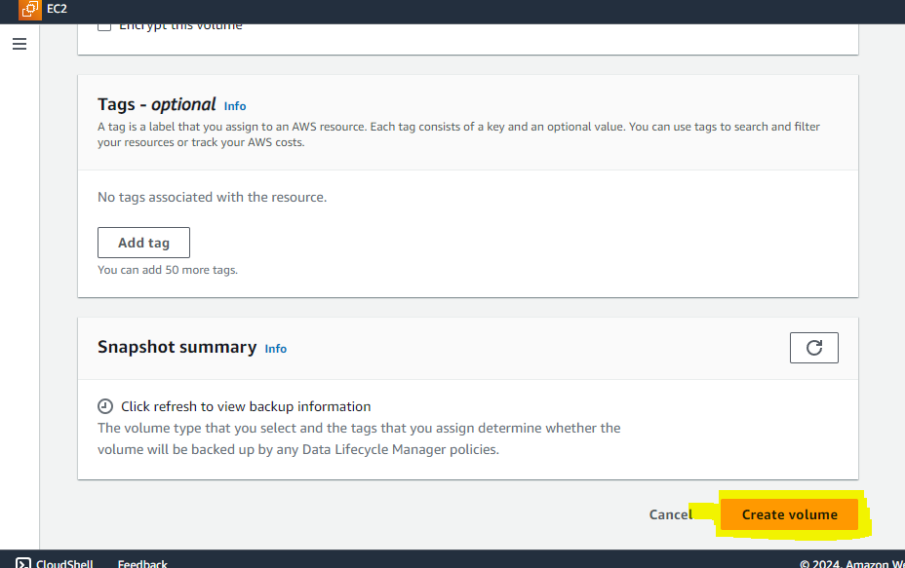

Create and launch instance 1 with availability zone: us-east-2a

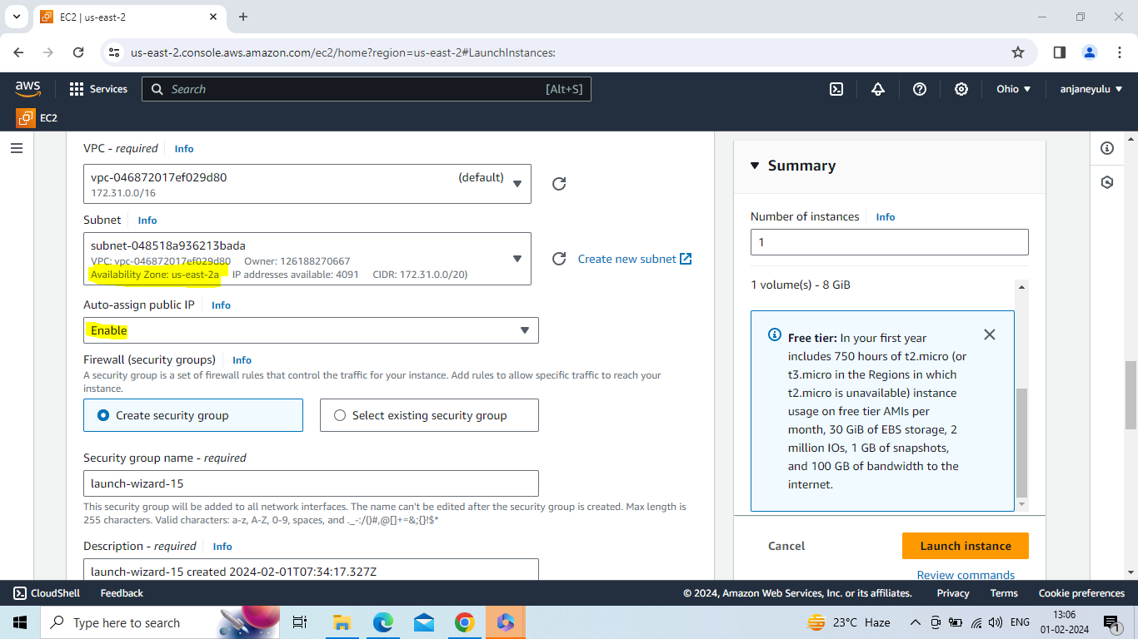

Attach volume to instance 1

Click on attach volume

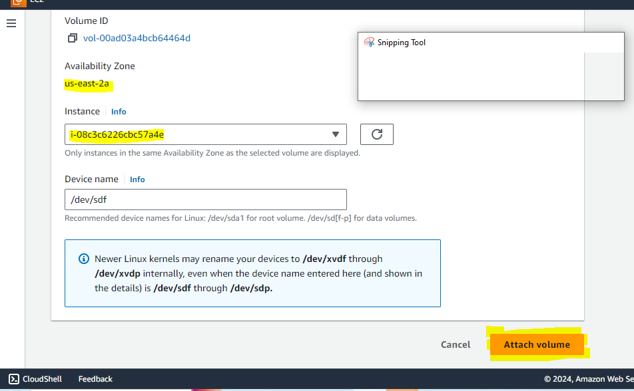

Connect to ubuntu server with instance

Sudo –i (convert to root user)

Df –h

Lsbl (list all block devices in linux machine)

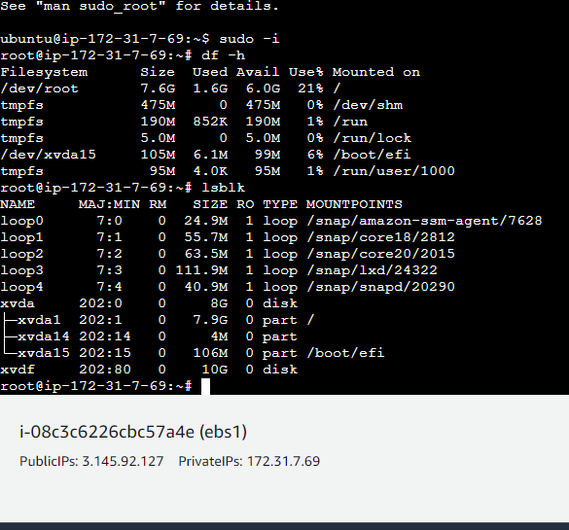

File –s /dev/xvdf (check is there any file system on this device)

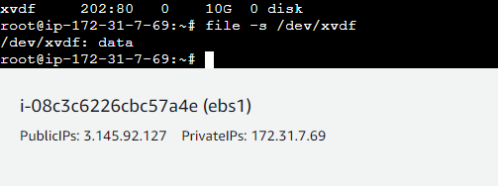

Mkfs –t xfs /dev/xvdf (create a file system)

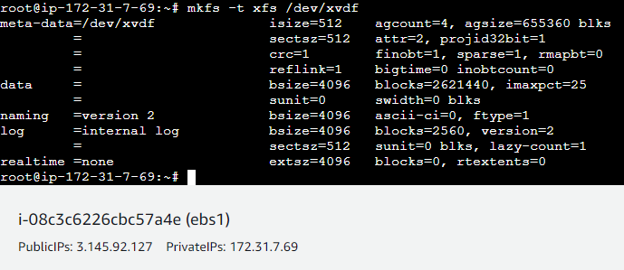

File –s /dev/xvdf (now we have a file system - check is there any file system on this device)

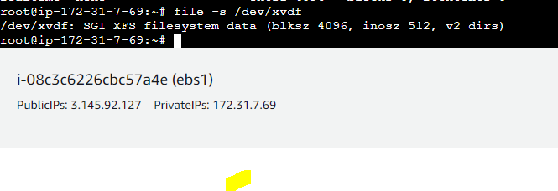

Mkdir d1 (create one directory)

Mount /dev/xvdf d1

Cd d1(go to d1 directory)

Vi file1 -->insert data in file1 (creation of file)

Vi file2 -->insert data in file2 (creation of file)

Mkdir file3

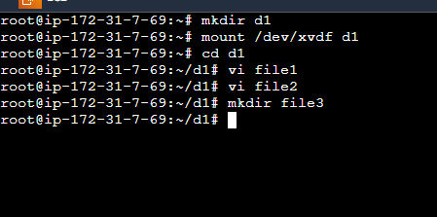

Detach the volume from instance

Create and launch instance 2 with availability zone : us-east-2a

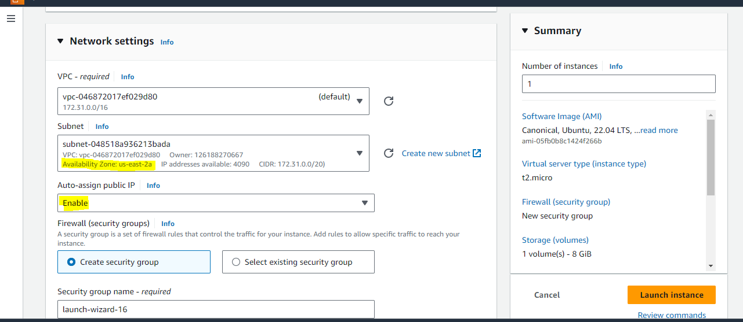

Attach the volume with instance 2

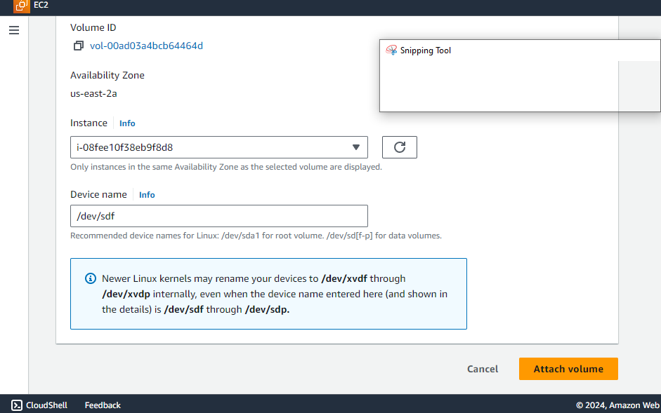

Connect to ubuntu server with instance 2

Sudo –i (convert to root user)

Mkdir d2 (create one directory)

Mount /dev/xvdf d2

Cd d2 (go to d2 directory)

Ls

Automatically files and directories come from instance 1 to instance 2

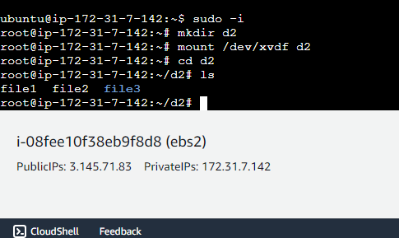

Create volume

Create and launch instance 1

Attach the volume to instance 1

Connect to ubuntu server

Df –h

Lsblk (list all block devices in linux machine)

File –s /dev/xvdf (check is there any file system on this device)

Mkfs –t xfs /dev/xvdf (create a file system)

File –s /dev/xvdf (now we have a file system - check is there any file system on this device)

Mkdir d1 (create directory)

Mount /dev/xvdf d1

Cd d1(change to d1 directory)

Create files and directories whatever you want

Detach volume from instance 1

Create and launch instance 2

Connect to server

Attach volume to instance 2

Sudo –i (convert to root user)

Mkdir d2 (create a directory)

Mount /dev/xvdf d2

Cd d2 (change to d2 directory)

Ls

After ls command using we will see whatever you create files in instance 1

Note:

1. you must be create instances(1,2) and volume in same region and same availibility zone

2.first we create one directory and mount that directory and after mount we have change into that directory and create files and directories what ever we want