BORG CALENDAR _ M4(Individual)

**Manouchehr Azizi (523228)**

# Observer (listener) pattern

**Introduction**

In this document I tried to avoid explaining clear things which is explained in comments of selected code here. And I just briefly explain 3 key points (Publisher, Listener (subscriber), notify) of observer pattern which is implemented in Borg Calendar. After introduction you will see in sequence: publisher, notify, Listener members (observer members), Sequence diagram and Partial class diagram section. For extract class “Aid UML diagram” is used. Following is reference to observer: <http://www.vogella.com/articles/DesignPatternObserver/article.html>, <http://java.dzone.com/articles/design-patterns-uncovered>.

**Publisher**

In “net.sf.borg.common.profs “ class, Listener class is implemented which is responsible to keep list of listeners and Notify listeners of a pref change (following notifyListeners method).the point is that prefsChanged method is going to be override in all subscriber that we will explain it in subscriber section.

**Remark:** prefsChanged method is going to be override to do proper action for each of listener member in case of preference changes.

/**

* Interface for classes that want to be notified of preference changes

*/

**public** **interface** Listener {

/**called when preferences changed.

*/

**public** **abstract** **void** prefsChanged();

}

/** list of listeners */

**static** **private** ArrayList<Listener> *listeners* = **new** ArrayList<Listener>();

/**

* add a listener

*

* **@param** listener the listener

*/

**static** **public** **void** addListener(Listener listener) {

*listeners*.add(listener);

}

/**

* Notify listeners of a pref change.

*/

**static** **public** **void** notifyListeners() {

**for** (**int** i = 0; i < *listeners*.size(); i++) {

Listener v = *listeners*.get(i);

v.prefsChanged();

}

}

**Notify**

**“Prefs.*notifyListeners*();”** is used in two following class to apply proper action to Observer members:

1. net.sf.borg.model.Theme

/**

* sync with the db. called if the options table is changed by something other than the UI (such as import)

*/

**public** **static** **void** sync()

{

*loadThemes*();

// notify listeners that Prefs may have changed

**Prefs.*notifyListeners*();**

}

1. net.sf.borg.ui.options.OptionsView

/**

* save all preferences to the preference store based on the current UI

* values

*/

**private** **void** applyChanges() {

**for** (OptionsPanel panel : panels)

panel.applyChanges();

// notify all parts of borg that have registered to know about

// options changes

**Prefs.*notifyListeners*();**

**if** (SunTrayIconProxy.*hasTrayIcon*())

SunTrayIconProxy.*getReference*().updateImage();

}

**Subscriber**

Following class with “Prefs.*addListener*(**this**);”add themselves to Listener list:

* net.sf.borg.ui.calendar.DayPanel
* net.sf.borg.ui.calendar. MonthPanel
* net.sf.borg.ui.calendar. TodoView
* net.sf.borg.ui.calendar. WeekPanel
* net.sf.borg.ui.calendar. YearPanel
* net.sf.borg.ui.popup. ReminderManager
* net.sf.borg.ui.task. ProjectTreePanel
* net.sf.borg.ui. SunTrayIconProxy

**Remark**: in all of upcoming class, prefsChanged method is override to do proper action in case of performance change.

**Sequence diagram**

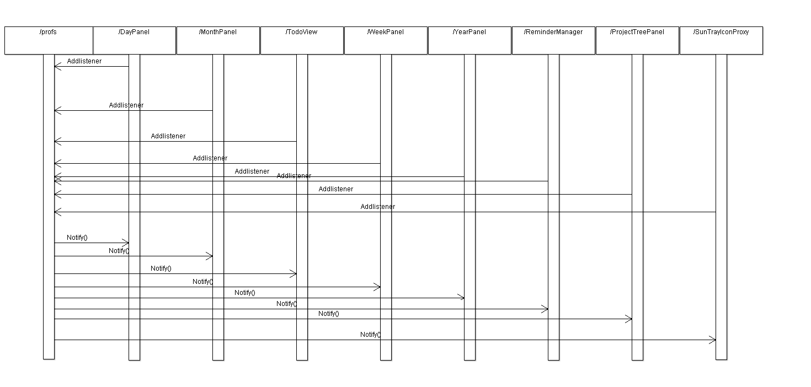

**Partial Class diagram**

