Data Bias in Artificially Generated Music: A Case Study in Adapting a Foundation Model to Generate Guzheng

Presented by Anjie Liu

in partial fulfillment of the requirements for completion of the
Evidence and Inquiry certificate and the
Polymathic Scholars honors program in the
College of Natural Sciences at
The University of Texas at Austin

Spring 2026

Thesis Supervisor:

Professor Shirley Cohen
Computer Science
The University of Texas at Austin

Second Thesis Supervisor:

Philipp Krähenbühl, Ph.D.
Computer Science
The University of Texas at Austin
Texas ScholarWorks Statement

I intend to submit a copy of this thesis to the Texas ScholarWorks (TSW) Repository. For more information on the TSW, please visit https://repositories.lib.utexas.edu/.

Data Bias in Artificially Generated Music: A Case Study in Adapting a Foundation Model to Generate Guzheng

_________________________________________ ____________________
Anjie Liu April 27th, 2026
Table of Contents
Acknowledgements v
Abstract vi
Introduction 1
Literature Review 3
How AI Models Generate Music 3
Representing Music for AI 5
The Cultural Bias Problem 6
Transfer Learning as a Solution 7
Background: The Guzheng 8
The Instrument 8
Pentatonic Tuning 9
Challenges for Digital Representation 9
Model and Transfer Learning 11
NotaGen Architecture 12
Transductive Transfer Learning 12
Baseline: Same Architecture, No Pre-training 13
Data Preparation 14
Curating the Dataset 14
From Jianpu to ABC 15
Dataset Characteristics 16
Experimental Methods 18
Generation Procedure 18
Rendering and Playing Techniques 18
Evaluation Metrics 19
Results 21
Fine-Tuned NotaGen vs. Baseline 21
Per-Metric Breakdown 24
Structural Recurrence 25
Rendered Audio 25
Novelty Analysis 26
Discussion 27
Why Pre-training Helps 27
Why the Baseline Fails 28
Implications for Inclusive Music AI 28
Limitations 29
Future Directions 30
Conclusion 30
References 32
Appendix A: Dataset Inventory 36
Appendix B: Model Architecture Details 38
Author Biography 40

Acknowledgements
I would like to thank my thesis supervisor, Professor Shirley Cohen, and Dr. Philipp Krähenbühl for their guidance and support throughout this project. Their feedback shaped the direction of this research and helped me navigate the challenges of working at the intersection of music and machine learning. I am grateful to my mentors, Dr. Stacia Rodenbusch and SeongGyeong Park, for their encouragement and advice throughout the Polymathic Scholars program. Finally, I thank my family for introducing me to the guzheng as a child, which inspired this thesis topic.

Abstract
Artificial intelligence (AI) music generators are trained primarily on Western music and cannot convincingly produce music for traditional instruments like the guzheng, a Chinese plucked zither tuned to a five-note pentatonic scale. This thesis asks how a music foundation model pre-trained on Western scores can be adapted to generate guzheng music, and whether that pre-training helps at all given the stylistic gulf between the two traditions. A corpus of 125 guzheng pieces (233 minutes total) was transcribed from jianpu numbered notation into staff notation, which is used to fine-tune NotaGen, a 244-million-parameter hierarchical patch-character Generative Pre-trained Transformer (GPT) pre-trained on 1.6 million Western scores. The fine-tuned NotaGen was compared with a baseline transformer of identical architecture trained from scratch on the same corpus. Across metrics of melodic coherence, rhythmic stability, and structural recurrence, the fine-tuned NotaGen substantially outperformed the baseline and produced output whose statistical profile was close to real guzheng music. A novelty analysis confirmed the output is original rather than memorized. A rule-based audio rendering layer reintroduces left-hand playing techniques (tremolo, glissando, vibrato, portamento) that standard symbolic notation cannot express, and the curated corpus, data preparation pipeline, and evaluation code are released as an open-source resource. The results demonstrate that transductive transfer learning from a Western-pretrained foundation model is a viable pathway toward broader cultural representation in AI music generation, achievable with limited non-Western data and modest computing resources — with the caveat that statistical fidelity is a necessary rather than sufficient condition for cultural authenticity, and Western pre-training likely leaves residual biases that aggregate metrics cannot detect.
Keywords: guzheng, music generation, foundation model, NotaGen, MIDI, deep learning

Introduction
Artificial intelligence can now compose convincing piano music on demand. It can produce mazurkas in the style of Chopin, fugues in the style of Bach, and mainstream pop tracks, all from a single text prompt. Ask the same systems for music from traditions outside the Western mainstream, however, and the illusion breaks. Consider the guzheng, a plucked Chinese zither with over two thousand years of history. Prompted to generate a guzheng piece, current systems return a Western melody played on a piano, with nothing recognizable about the instrument itself. They have never heard a guzheng, and no amount of prompting can teach them one.
Deep learning, the branch of artificial intelligence that powers modern music generators, requires large training corpora to learn musical patterns (Ma & Zheng, 2025). Systems such as MusicLM, MusicGen, Suno, and Udio can produce full tracks from a text description (Copet et al., 2023), but the data behind them is overwhelmingly Western.
Recent audits show that non-Western music makes up under 6 percent of AI training corpora (Mehta et al., 2025b), and the result is what researchers call representational bias: when asked to generate Chinese folk music, current models will likely produce something that sounds more like a Western film score with a pentatonic melody layered on top (Solak et al., 2025). The full distributional breakdown is reviewed in Section 2.3.
This thesis asks how non-Western genre representation in AI-generated music can be strengthened. One promising answer is transfer learning: rather than building a new model from scratch, we take a model that already understands general musical structure and adapt it using a small amount of data from the target tradition. The knowledge learned from a large source dataset transfers to a new target problem, especially when the target domain has limited labeled data (Pan & Yang, 2010). Applied to music, transfer learning reuses the broad musical competence the pre-trained model has already acquired, which helps sidestep the data scarcity and overfitting problems that plague any attempt to train from scratch on a small corpus.
The guzheng makes a natural case study. It is a 21-string plucked zither with a history spanning over two thousand years, and its standard tuning uses a five-note pentatonic scale that is fundamental to Chinese folk and classical music. Any AI model generating guzheng music must respect this constraint: nearly every note should belong to the pentatonic scale. Because success and failure are easy to hear and easy to measure, the guzheng is a clean test bed for culturally specific music generation.
To answer the central question, this thesis fine-tunes NotaGen, a 244-million-parameter music foundation model pre-trained on 1.6 million Western scores, using 125 guzheng Musical Instrument Digital Interface (MIDI) files (233 minutes total) that were transcribed from jianpu numbered notation and then rendered into ABC notation. The fine-tuned NotaGen is compared with a baseline transformer of identical architecture trained from scratch on the same guzheng corpus. The central finding is that pre-training on Western music, followed by targeted fine-tuning on the guzheng corpus, produces output that is more melodic, more rhythmically stable, and more structurally coherent than training the same architecture from scratch, even though essentially no guzheng appears in the pre-training data.
The guzheng is not the only instrument AI ignores. Qanuns, sitars, ouds, kotos, mbiras -- any instrument outside the Western mainstream faces the same problem: too little digital training data, a tuning system the models have never seen, and playing techniques that standard encodings cannot represent. If transfer learning works for the guzheng, the same approach should apply to these instruments too. That is the larger stake of this project.
The rest of this thesis is organized as follows. Section 2 reviews the state of AI music generation and the cultural bias problem. Section 3 introduces the guzheng and its musical characteristics. Section 4 describes NotaGen, the transfer learning approach, and the baseline. Section 5 details the data preparation pipeline from jianpu to staff. Section 6 explains the experimental methods and evaluation metrics. Section 7 presents results. Section 8 discusses the findings, limitations, and future directions. Section 9 concludes.

Literature Review

How AI Models Generate Music
Most AI music generators work by prediction. The model reads a sequence of musical events (notes, rests, chords) and guesses what comes next, much the way a language model predicts the next word in a sentence. Briot et al. (2017) survey early sequential approaches to music generation and document the difficulty Recurrent Neural Networks had maintaining coherent structure over long passages. The Transformer architecture changed the game. By attending to all parts of a sequence at once rather than processing it step by step, the Music Transformer generated piano compositions lasting over a minute with recognizable themes and repetition (Huang et al., 2018). Modern systems such as Suno, Udio, MusicLM, and MusicGen (Copet et al., 2023) build on these ideas and can now produce full tracks that approach human-composed Western pop and classical music in perceived quality. Maintaining structural coherence across very long sequences remains an active area of work; Cao et al. (2026) introduce an anchored cyclic generation framework that mitigates error accumulation in autoregressive symbolic music generation.
Different systems use different architectures. Some, like the Music Transformer, process the entire sequence with self-attention. Others, like NotaGen (used in this thesis), split the decoder into a patch-level component that reasons about long phrases and a character-level component that fills in individual notes, which reduces the cost of modeling long sequences. In every case, the models are trained by reading large collections of MIDI or score files and learning to predict the next event. The choice of architecture matters, but the choice of pre-training data matters at least as much: if the model has only seen Western music, no amount of architectural cleverness will teach it to produce convincing guzheng.
A small but growing body of work has specifically targeted Chinese traditional music generation. Chen et al. (2022) combined a Long Short-Term Memory network with reinforcement learning to generate guzheng melodies, producing musically coherent output but relying on a narrow training set. Li et al. (2022, 2023) introduced datasets and detection systems for guzheng playing techniques; the latter, Guzheng_Tech99, has since become a standard reference for Chinese plucked-string Music Information Retrieval (MIR) research. Most recently, Zheng et al. (2025) proposed a diffusion-transformer system that conditions guzheng audio generation on classical Chinese poetry, demonstrating active interest in culturally specific generation but operating in the audio domain rather than the symbolic one. These systems were built from scratch, which limits their ability to draw on the broad musical knowledge captured by large pre-trained models. NotaGen (Wang et al., 2025), the foundation model used in this thesis, takes the opposite approach: it is pre-trained on 1.6 million Western scores and adapted to new target domains by fine-tuning. MIDI-LLM (Wu, Kim, & Huang, 2025) similarly repurposes a pre-trained language model to generate MIDI, framing symbolic music as a natural interchange format between humans and AI. Wei et al. (2026) survey the broader landscape of foundation models for music and identify cultural representation as one of the central open problems.

Representing Music for AI
MIDI is the standard format for symbolic music. A MIDI file does not contain audio; instead, it stores a list of events such as "play middle C at time 2.5 seconds for 0.3 seconds." MIDI is editable in any digital audio workstation, which makes it the natural interchange format for human-AI collaboration (Wu, Kim, & Huang, 2025): composers can open the generated file, tweak individual notes, re-voice phrases, and re-render with any sampled instrument. For this reason, every stage of this thesis's pipeline stores music as MIDI or its text equivalent rather than as audio waveforms.
NotaGen does not consume MIDI directly. It operates on ABC notation, a compact text-based format originally designed for folk tune collections. In ABC, each note becomes an American Standard Code for Information Interchange (ASCII) character (for example, "C" for middle C, "D" for the next pitch up, and "/" to halve the duration), and bars are separated by the "|" character. Text-based notation makes it straightforward to tokenize music for a language-style model, and recent work has shown that large language models are particularly compatible with ABC because its alphabetic structure aligns with subword tokenization (Qu et al., 2024). The same observation has motivated contrastive language-music pre-training systems such as CLaMP (Wu, Yu, Tan, & Sun, 2023) and CLaMP 3 (Wu, Guo, et al., 2025), which align symbolic music with multilingual text in a shared representation space. NotaGen groups 16 consecutive ABC characters into a patch and feeds that patch through a hierarchical decoder, as described in Section 4. Figure 1 shows the same guzheng phrase in both forms side by side, making the correspondence between ABC characters and MIDI piano-roll events explicit.
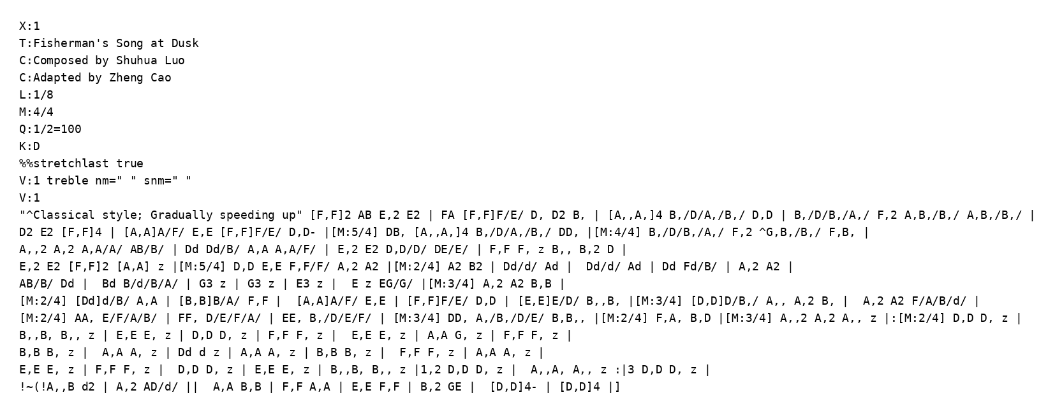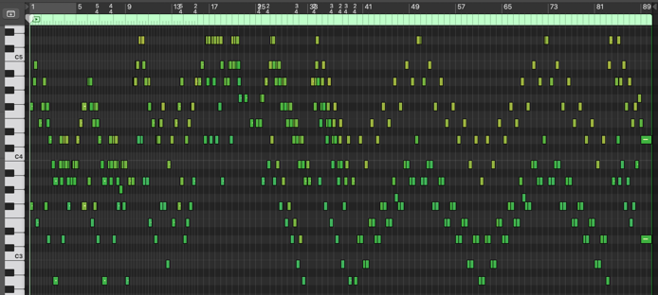
Figure 1. A complete guzheng piece in ABC notation (left) alongside its MIDI piano-roll rendering (right). Each pitch is a single ASCII character; duration, bar boundaries, and key are all expressed in text, which lets the model tokenize music the same way a language model tokenizes prose.

The Cultural Bias Problem
Most large music datasets reflect the dominance of Western music in digital archives. A 2025 audit of over one million hours of AI training audio found that only 5.7 percent is non-Western (Mehta et al., 2025b). Western pop, classical, and jazz together make up more than 94 percent of the data. Asian music accounts for 2.6 percent, Latin American 1.5 percent, and African music less than 1 percent. An earlier 2024 audit of commercial training corpora reached a similar conclusion, finding that non-Western content was "nearly entirely omitted" from the Global South (Mehta et al., 2024).
This imbalance produces measurable harm. The GlobalDISCO benchmark, which spans 147 languages and 79 countries, showed that commercial AI music generators produce output for non-Western genres that more closely resembles Western mainstream music than the intended style (Solak et al., 2025). When prompted to create music for the qanun, the sitar, or the guzheng, current models frequently default to Western major-minor tonality, standard 4/4 time signatures, and piano-like timbres, ignoring the modal systems, asymmetric rhythms, and distinctive instrument colors that define these traditions. The bias goes deeper than the training data alone. Even the evaluation tools are biased: audio analysis models like VGGish are trained on datasets where traditional instruments account for less than 3 percent of content, making them unreliable judges of non-Western music quality (Mehta et al., 2024). Chauhan and Pundhir (2026) further show that the mel-scale audio representations underlying many music systems — derived from 1940s Western psychoacoustic research — introduce systematic performance gaps of more than 15 percent between Western and non-Western music, suggesting that cultural bias in AI music is encoded all the way down to the feature representation.

Transfer Learning as a Solution
Transfer learning offers a practical way to adapt a pre-trained model to a new musical tradition without requiring millions of new training examples. The approach was formalized by Pan and Yang (2010): knowledge learned from a large source dataset can be transferred to a new target problem, especially when the target domain has limited labeled data. Applied to music, transfer learning takes a model that has already learned the fundamentals of melody, rhythm, and musical structure and steers it toward a new genre or instrument. Mehta, Chauhan, and Choudhury (2025a) extend this idea with parameter-efficient adapters, showing that mid-sized adapters (around 40 million parameters) can adapt MusicGen and Mustango to Hindustani Classical and Turkish Makam music while updating only a small fraction of the base model. Recent work has applied this approach to underrepresented genres such as Hindustani Classical and Turkish Makam with encouraging results (Mehta et al., 2025b).
This thesis uses a variant called transductive transfer learning. The source and target tasks are the same -- predicting the next musical event -- but the source and target domains differ: Western scores versus guzheng scores. Fine-tuning updates the model weights on the target data while preserving the general musical competence acquired during pre-training. A useful analogy is a pianist learning the guitar: they already understand melody, rhythm, and musical structure, so they only need to learn the new instrument's specifics rather than start from zero.

Background: The Guzheng

The Instrument
The guzheng (古筝) dates back over two thousand years to the Warring States period of Chinese history (475–221 Before the Common Era, or BCE) and remains one of the most widely played traditional Chinese instruments. The modern version has 21 strings stretched over a curved wooden soundboard. Each string rests on a movable bridge that the player repositions to change pitch. The strings span roughly three octaves, from the D two octaves below middle C to the D two octaves above it (Zheng & Knobloch, 1983). Figure 2 shows a schematic diagram.
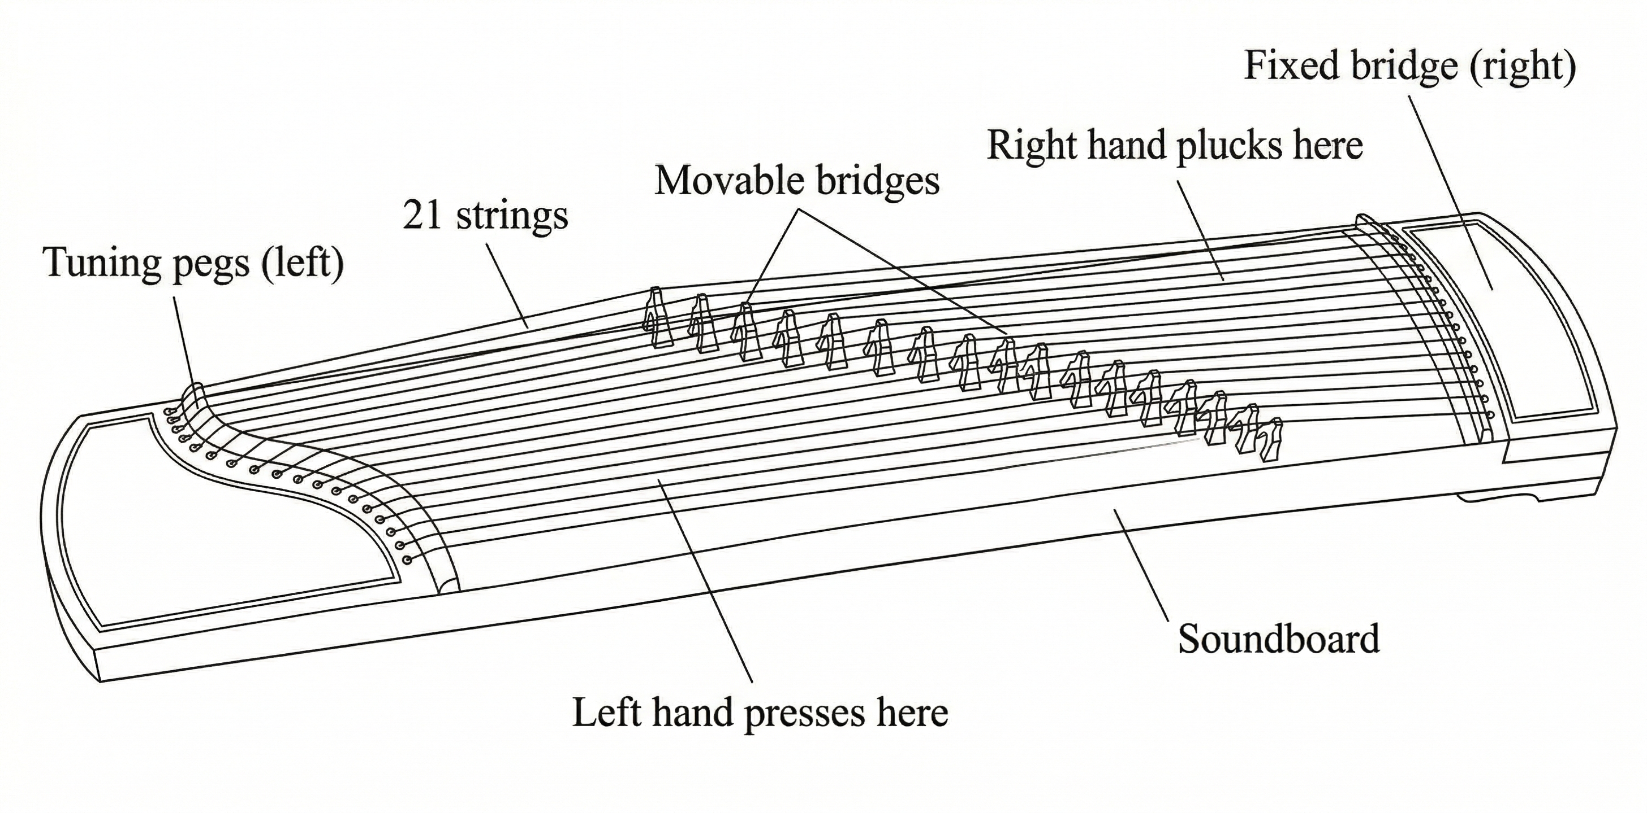
Figure 2. Schematic diagram of a guzheng. The right hand plucks the strings while the left hand presses behind the movable bridges to bend pitch, add vibrato, or create sliding effects.
Players use the right hand to pluck strings and the left hand to press strings behind the bridges. Pressing a string raises its pitch by one or two semitones, allowing the player to produce notes that are not part of the instrument's default tuning. Mingming (2017) identifies tremolo (rapid repetition of a single note), glissando (sweeping across multiple strings), vibrato (oscillating pitch variation), and portamento (sliding smoothly between two pitches) as the techniques that give the guzheng its distinctive expressive character.

Pentatonic Tuning
The guzheng's 21 strings are tuned to the Chinese major pentatonic scale, which uses five notes: C, D, E, G, and A. These correspond to the traditional Chinese scale degrees gong, shang, jue, zhi, and yu. The remaining two notes in the standard seven-note Western scale (F and B) are not available as open strings. Players produce them only by pressing a string with the left hand to raise its pitch.
This tuning system has a direct implication for AI music generation: valid guzheng output should consist almost entirely of notes from the pentatonic scale, with non-pentatonic notes appearing only occasionally and in ornamental contexts (Han, 2024; Mingming, 2017; Zheng & Knobloch, 1983). The five common keys used in guzheng repertoire are D, A, C, G, and F major pentatonic. Transposing a piece between these keys shifts which five pitch classes are used but preserves the melodic structure. This property is exploited for data augmentation, as described in Section 5.

Challenges for Digital Representation
Representing guzheng music in symbolic form involves several compromises.
First, MIDI has no standard sound for the guzheng; it is typically approximated by the koto (a Japanese relative) or generic plucked-string sounds. Listeners evaluating AI-generated guzheng music must therefore use a third-party sampled guzheng instrument to hear an accurate timbre.
Second, the left-hand techniques that define the guzheng's expressive character -- vibrato, sliding, and pitch bending -- require special MIDI messages (pitch bend, continuous controllers) that most AI tokenization schemes do not encode. As a result, the full expressive range of the instrument cannot be captured or reproduced by current symbolic models.
Third, guzheng texture is typically sparse. The training data used in this thesis is predominantly single-note or two-note passages, which differs markedly from the dense piano chords that dominate AI training datasets. A model trained on piano music expects thick harmonies and rapid chord changes; guzheng music instead features long melodic lines interspersed with occasional two- or three-note plucks.
Fourth, traditional guzheng notation uses a number-based system called jianpu rather than Western staff notation, which means that nearly every digital transcription used in this project had to be produced by hand, first from jianpu to staff, then from staff to MIDI. Figure 3 shows the same passage in both notations side by side.
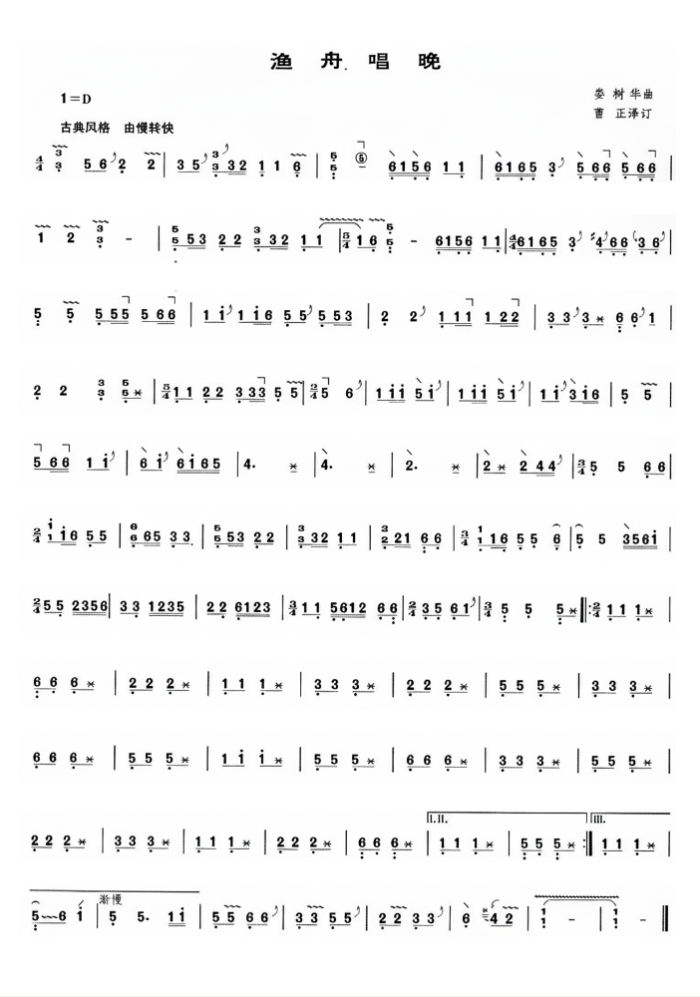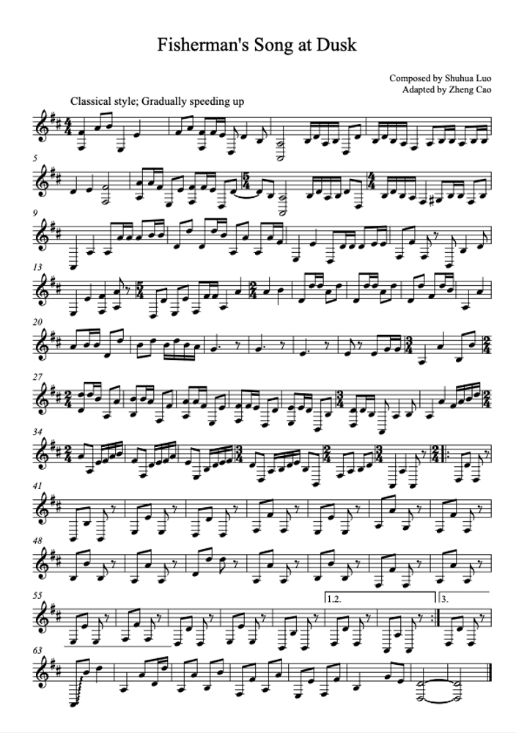
Figure 3. The opening of “Fisherman’s Song at Dusk” (渔舟唱晚) shown in jianpu numbered notation (left) and Western staff notation (right). Jianpu uses Arabic numerals 1–7 to denote scale degrees within a movable-do system, with rhythmic values indicated by underlines and dots; staff notation encodes the same pitch and rhythm content but in a form that standard digital tools and AI models can consume directly.

Model and Transfer Learning
A single pre-trained music model was selected for this study: NotaGen, a 244-million-parameter hierarchical patch-character GPT that operates on ABC notation. NotaGen was chosen because its architecture couples a patch-level view of musical phrases with a character-level view of individual notes, and because its pre-training corpus of 1.6 million Western scores is large enough to encode general musical patterns while still being amenable to fine-tuning on a single consumer Graphics Processing Unit (GPU). To isolate the contribution of pre-training, NotaGen was compared with a baseline transformer of identical architecture trained from scratch on the guzheng corpus alone.

NotaGen Architecture
NotaGen splits its decoder into two parts, each a GPT-2 Transformer. The patch-level decoder has 16 layers and about 180 million parameters. It reads the score 16 ABC characters at a time, treating each 16-character chunk as a single patch embedded in a 1024-dimensional vector, and reasons about long-range structure across the piece. The character-level decoder has 3 layers and about 64 million parameters. For each patch the patch-level decoder predicts, the character-level decoder fills in the 16 ASCII characters that make up that patch. The hierarchy lets the model handle a long piece without the quadratic cost that a flat character-level Transformer would incur. The full architectural specification is given by Wang et al. (2025).
NotaGen medium was pre-trained on 1.6 million Western music pieces spanning pop, classical, jazz, and folk, long enough for the model to learn how phrases repeat, how intervals resolve, and how rhythms interact with meter. None of these pieces are guzheng, but the underlying musical primitives the model has internalized transfer to any pitched instrument with a recognizable melodic contour. Table B1 in the appendix gives the full architectural specification, including layer counts, hidden dimension, patch size, and training hardware.

Transductive Transfer Learning
Adapting NotaGen to the guzheng uses transductive transfer learning (Pan & Yang, 2010). The source task (next-event prediction) is the same as the target task, but the source domain (Western scores) differs from the target domain (guzheng scores). The pre-trained weights are loaded as a starting point, and all parameters are updated on the target data via standard fine-tuning with a small learning rate. Every weight is allowed to move, but only a small number of epochs are used so the model does not drift far from its pre-trained knowledge.
Fine-tuning was performed on a single consumer GPU with a batch size of 1, a learning rate of 1e-5, and a constant-with-warmup schedule. The model was trained for 30 epochs on the guzheng ABC corpus described in Section 5. Training converged within a few hours; no distributed computing or specialized hardware was required. This accessibility matters: the method this thesis develops should be reproducible by anyone with a laptop and a modest corpus of transcriptions.

Baseline: Same Architecture, No Pre-training
To isolate the contribution of NotaGen's pre-training, a baseline model was built with the same hierarchical patch-character architecture but trained from scratch on the guzheng corpus alone. The baseline has the same hidden size, the same number of patch-level and character-level layers, and the same tokenization as NotaGen medium. The only difference is that its weights begin at random initialization rather than at NotaGen's pre-trained values. If NotaGen's pre-training on Western music is genuinely useful for guzheng generation, the fine-tuned NotaGen should outperform this baseline; otherwise, the pre-training is adding nothing.
Table 1 summarizes the two configurations. Architectural details are identical; only the initial weights and the training data differ.
Table 1. The two configurations compared in this study. Everything is identical except the initial weights.
Configuration | Architecture | Initial Weights | Training Data
Fine-tuned NotaGen | Patch 16L + Char 3L (244M) | NotaGen medium pre-trained (1.6M Western scores) | 125 guzheng pieces (233 min)
Baseline (from scratch) | Patch 16L + Char 3L (244M) | Random initialization | 125 guzheng pieces (233 min)

Data Preparation
Collecting training data was the primary challenge. Guzheng MIDI files are scarce because the instrument has no standard digital sound, guzheng music is traditionally written in a Chinese numbered notation called jianpu rather than Western staff notation, and most available guzheng content exists as audio recordings rather than symbolic transcriptions.

Curating the Dataset
The training corpus comprises 125 guzheng pieces totaling 233 minutes of music, drawn from two sources. Twenty-six pieces were hand-curated by the author: each was transcribed from a published jianpu sheet (primarily from guzheng.cn) into Western staff notation and then into MIDI, and every note was validated against the source score for pitch and rhythm accuracy. For these pieces, source-sheet URLs, tempo and time signatures, and English and Chinese titles are recorded in the dataset's metadata index. A further 99 pieces were taken from Guzheng_Tech99 (Li et al., 2023), a public frame-level guzheng playing-technique dataset released as part of an Institute of Electrical and Electronics Engineers (IEEE) International Conference on Acoustics, Speech and Signal Processing (ICASSP) paper. The pieces span a wide range of styles, from the slow meditative Chu Shui Lian ("Lotus Emerging from Water") to the fast virtuosic Zhan Tai Feng ("Battling the Typhoon"). Table A1 in the appendix lists the 20 hand-curated pieces whose metadata has been indexed, together with their keys, durations, and note counts.
Every file was human reviewed against its source sheet and normalized according to a fixed set of curation rules. All files were standardized to a single-track MIDI format that merges the left and right hand into one note stream; overlapping notes that resulted from this merge were handled case-by-case to produce a clean sequence. Every note was verified to belong to a pentatonic pitch class for its key; rare non-pentatonic ornaments were snapped to the nearest pentatonic pitch. Note durations were constrained to the range 10–10,240 ms, matching the envelope of the sampled guzheng instrument used for rendering. Notes that were slightly off-grid due to human transcription error were quantized. Pieces originally in B-flat major pentatonic were transposed to A major pentatonic to bring them into the guzheng's standard five-key family.

From Jianpu to ABC
The choice of which playing techniques to encode in MIDI matters for what the model can learn. Tremolos and glissandos are included: tremolos appear as rapid repeated notes on the same pitch, and glissandos as fast ascending or descending pentatonic runs. Acciaccaturas, vibratos, and pitch bends are not included, because the standard MIDI note-on/note-off representation cannot express them cleanly; they are reintroduced only at audio rendering time via rule-based keyswitch events. The corpus enters from two sources in different formats: the 26 hand-curated pieces are transcribed by the author from jianpu sheets into Western staff notation and exported as MIDI (a manual step that does not apply to the rest of the corpus), while the 99 Guzheng_Tech99 pieces enter directly as MIDI. The two streams are merged into a single normalized corpus and then run through an automated pipeline that quantizes onsets to a 32nd-note grid, tempo-normalizes so that the median inter-onset interval lands at a consistent grid position across the corpus, and renders the result into ABC notation. ABC is the text-based format that NotaGen consumes; each note becomes an ASCII character, and the entire piece becomes a sequence of 16-character patches ready for the patch-level decoder.
To multiply the training signal, NotaGen's preprocessing applies a 15-key symbolic transposition at the ABC level during training: each input piece is transposed into every playable key, which forces the model to learn melodic shapes rather than absolute pitches. Only one MIDI version of each piece is fed to NotaGen as its canonical input; the symbolic transposition happens inside NotaGen's preprocessing rather than as a separate MIDI-level step. Transposition is an approximation rather than a substitute for real musical diversity: a real G pentatonic guzheng piece sounds different from a D pentatonic piece transposed up a fifth, because idiomatic phrasing and characteristic ornaments depend on the physical layout of the strings, which changes with tuning. Transposition augments pitch diversity in the training data but does not capture these key-specific performance characteristics.

Dataset Characteristics
Table 2 summarizes the statistical profile of the 125-piece training corpus. Pieces range from 72–408 seconds in duration and from 246–1909 notes, reflecting the mix of slow lyrical passages and fast virtuosic runs. Most pieces are in D major pentatonic (the most common guzheng tuning), with smaller contingents in A, C, G, and F. Note density varies widely across the corpus, and over half the files are predominantly monophonic, consistent with the guzheng's typical solo texture.
All files use a constant velocity, meaning the models cannot learn dynamic variation -- a limitation discussed in Section 8. The hand-curated subset does carry velocity information in MIDI, but the merged corpus was standardized to constant velocity for consistency with Guzheng_Tech99. Left-hand ornamental techniques such as vibrato, bending, and pressing are not encoded in the symbolic data at all, so the corpus captures pitch and rhythm but not the full expressive surface of guzheng performance.
Table 2. Summary statistics for the 125-piece training corpus.
Metric | Value
Total pieces | 125
Hand-curated from jianpu (author) | 26 pieces (≈87 min)
Guzheng_Tech99 (Li et al., 2023) | 99 pieces (≈146 min)
Total duration | 233 minutes
Piece duration range | 72–408 seconds
Notes per piece (range) | 246–1909
Keys in source data | D (most), A, C, G, F major pentatonic
NotaGen training-time key augmentation | 15-key symbolic transposition at the ABC level
Pitch range (guzheng compass) | MIDI 37–86 (three octaves)
Pentatonic purity | 100% (rare non-pentatonic notes snapped)
Note duration range | 10–10,240 ms
Techniques included in MIDI | tremolo, glissando
Techniques excluded from MIDI | acciaccatura, vibrato, bend (added at render time)
Velocity (loudness) | Constant (standardized)
Predominantly monophonic files | over 50%

Experimental Methods

Generation Procedure
Each model generates music by predicting one patch at a time. A short ABC header (time signature 4/4, key C, note length 1/32, instrument name "Guzheng") is fed in as a prompt, and the patch-level decoder predicts the next 16-character patch conditional on everything seen so far. The character-level decoder then fills in the individual characters of that patch. The new patch is appended, and the process repeats until the model emits an end-of-sequence marker or the patch budget is exhausted.
Two sampling parameters control the randomness of predictions. Temperature scales the probability distribution: higher values produce more diverse output, while lower values make the model more conservative and repetitive. Top-p filtering, set to 0.9, restricts the model to choosing from the most likely tokens whose cumulative probability reaches 90 percent, discarding implausible options. Each sample runs for up to 128 patches (roughly 2048 ABC characters), and 10 samples were generated per model configuration. All generation was performed on a consumer GPU running on a standard desktop computer, demonstrating that expensive hardware is not required for this task.

Rendering and Playing Techniques
NotaGen outputs symbolic music; rendering it to audio requires a sound source. Each generated ABC file is first converted to MIDI via abc2midi, and then rendered through Ample China Zheng, a commercial sampled guzheng virtual instrument. Rendering through a sampled instrument means the generated pieces sound like real guzheng performances rather than the generic plucked-string timbre a default MIDI synthesizer would produce. Because timbre is recovered post-hoc from a library of guzheng samples, the pipeline keeps the instrument's authentic sound without requiring any audio in the training data.
A small amount of rule-based post-processing adds playing techniques that the symbolic model cannot itself represent. Key-switch MIDI events are inserted at appropriate locations to trigger tremolo, glissando, vibrato, and portamento samples in the virtual instrument. These techniques are central to the guzheng's expressive character (Mingming, 2017), and adding them post-hoc makes the generated music recognizable as guzheng rather than as a pentatonic melody on an anonymous plucked string.

Evaluation Metrics
Evaluating generated music is difficult because coherence and musicality are subjective. Kader and Karmaker (2025) survey the music-generation evaluation literature and identify three persistent challenges: poor correlation between objective metrics and human perception, cross-cultural bias in standard metrics, and a lack of standardization. The approach taken here side-steps the first two by anchoring every metric to the distribution of the training corpus itself rather than to a Western reference. This thesis compares the generated output against the training corpus along three dimensions: melodic quality, rhythmic quality, and structural quality. Each dimension contributes one or two metrics, all computed per sample and then averaged with a standard deviation. The target on every metric is not a specific number but the value observed on the training corpus itself: a good generator should match real guzheng, not exceed it on some arbitrary scale.
Melodic quality is measured by two statistics. Pitch autocorrelation at lag 1 captures how strongly consecutive notes are related: values near zero indicate random note choices, while values close to the training-data reference indicate melodic coherence. The inverse weighted interval penalty scores how "playable" the intervals are: small, singable intervals score higher than large, unnatural leaps. A genuinely melodic piece should have both an autocorrelation in the training-data range and a high interval score.
Rhythmic quality is summarized by the coefficient of variation of inter-onset intervals, denoted CV(IOI). A chaotic performance has a high CV because the times between successive note onsets vary wildly; a stable performance has a low CV. Structural quality is captured by two additional metrics. Interval 5-gram recurrence counts how often the same 5-note interval pattern reappears within a single sample, a stand-in for motif repetition. Lempel-Ziv (LZ) compression ratio on the interval sequence measures how compressible the piece is: highly structured music compresses well (low ratio), while random note sequences do not (high ratio).
A novelty check was also performed. Each generated sample was compared against the 125-file training corpus using n-gram overlap at varying lengths, to confirm that the model generates new melodic content rather than copying training pieces note for note.
Figure 4 shows the full production pipeline. The fine-tuned NotaGen generates ABC, the ABC is converted to MIDI, rule-based post-processing inserts playing technique keyswitches, and the Ample China Zheng sampler renders the final audio.
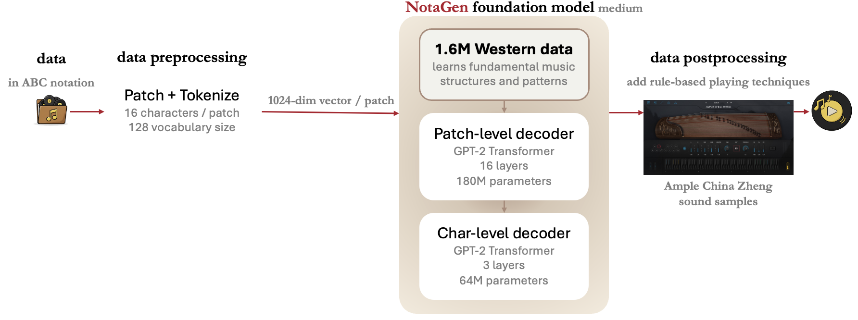
Figure 4. The full NotaGen production pipeline, end-to-end. ABC notation data is patch-tokenized (16 characters per patch, 1024-dimensional patch embeddings) and fed to the NotaGen foundation model — a hierarchical patch-level + character-level GPT pre-trained on 1.6 million Western scores. NotaGen's symbolic output is then post-processed with rule-based playing-technique keyswitches (tremolo, glissando, vibrato, portamento) and rendered through the Ample China Zheng sampler. Adapted from Wang et al. (2025).

Results
Ten samples were generated from each of the two models -- fine-tuned NotaGen and the baseline trained from scratch -- and compared against the 125-file training corpus along the metrics described in Section 6.3.

Fine-Tuned NotaGen vs. Baseline
Table 3 reports the five evaluation metrics for the training corpus, the baseline transformer, and the fine-tuned NotaGen. The fine-tuned NotaGen matches or approaches the training-data reference on every metric; the baseline does not.
On melodic quality, the baseline behaves nearly as a random note generator: its pitch autocorrelation is essentially zero (-0.001), and its inverse interval penalty of 0.316 reflects a preference for large, unnatural leaps that a guzheng player would never make. Fine-tuned NotaGen recovers most of the training data's melodic coherence: autocorrelation rises to 0.188, and the interval penalty climbs to 0.608, comfortably within the training corpus's standard deviation.
On rhythmic quality, the baseline's CV(IOI) of 1.648 describes erratic timing -- long silences followed by sudden flurries -- while NotaGen's 0.494 is close to the training corpus's 0.590. On structural quality, the baseline never repeats a 5-note interval motif (recurrence 0.001) and produces sequences that compress poorly (LZ ratio 0.853 -- near pure noise at 1.0). Fine-tuned NotaGen recovers structure on both fronts: it repeats motifs at a rate (0.418) slightly above the training data, and its sequences compress at a ratio (0.566) close to the training reference (0.607).
Figure 5 plots the three dimensions side by side. On every axis, the fine-tuned NotaGen closes most of the gap between the baseline and the training-data reference. Figure 6 shows a piano-roll comparison of one representative sample from each condition; the structural differences the metrics describe (motif recurrence, register stability, phrase shape) are visible directly in the piano roll.
Table 3. Evaluation metrics for the training data, the baseline, and fine-tuned NotaGen. The fine-tuned NotaGen matches or approaches the training-data reference on every metric; the baseline does not. Values are mean ± standard deviation across 10 generated samples.
Dimension | Metric | Training data | Baseline | Fine-tuned NotaGen
Melodic | Pitch autocorrelation (p1), higher → more coherent | 0.314 ± 0.241 | -0.001 ± 0.083 | 0.188 ± 0.409
Melodic | Inverse weighted interval penalty, higher → smoother | 0.628 ± 0.176 | 0.316 ± 0.048 | 0.608 ± 0.281
Rhythmic | CV(IOI), closer to training → more stable | 0.590 ± 0.192 | 1.648 ± 1.614 | 0.494 ± 0.274
Structural | Interval 5-gram recurrence, higher → more motifs | 0.369 ± 0.262 | 0.001 ± 0.005 | 0.418 ± 0.276
Structural | LZ compression ratio, lower → more structured | 0.607 ± 0.179 | 0.853 ± 0.025 | 0.566 ± 0.173
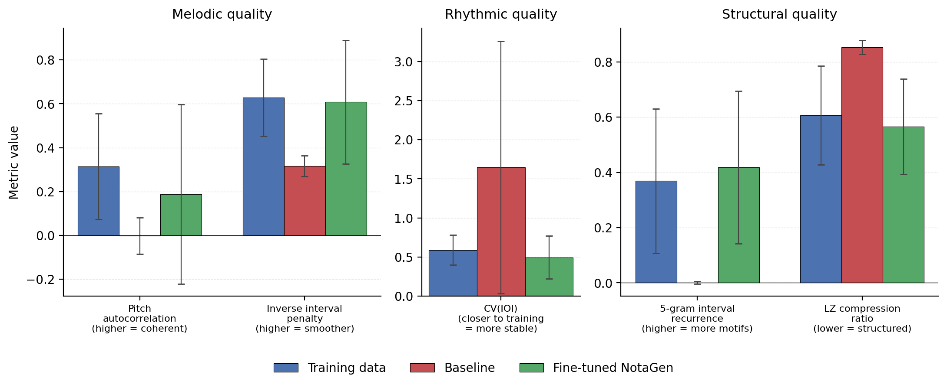
Figure 5. Melodic, rhythmic, and structural metrics for the training data, the baseline, and fine-tuned NotaGen. Bars are mean values and error bars are one standard deviation. On every dimension, the fine-tuned NotaGen lies close to the training-data reference, while the baseline lies far from it.
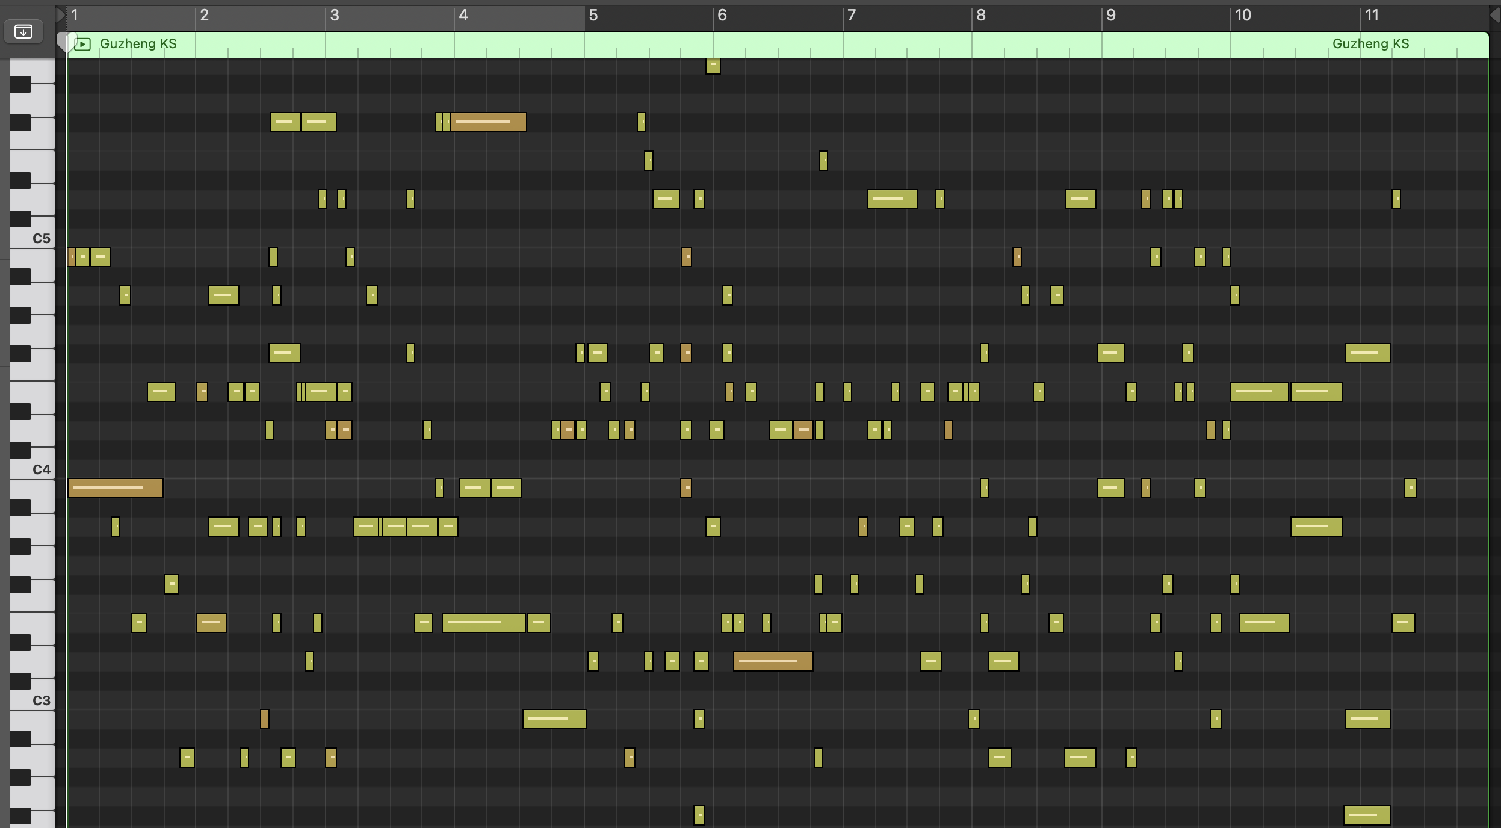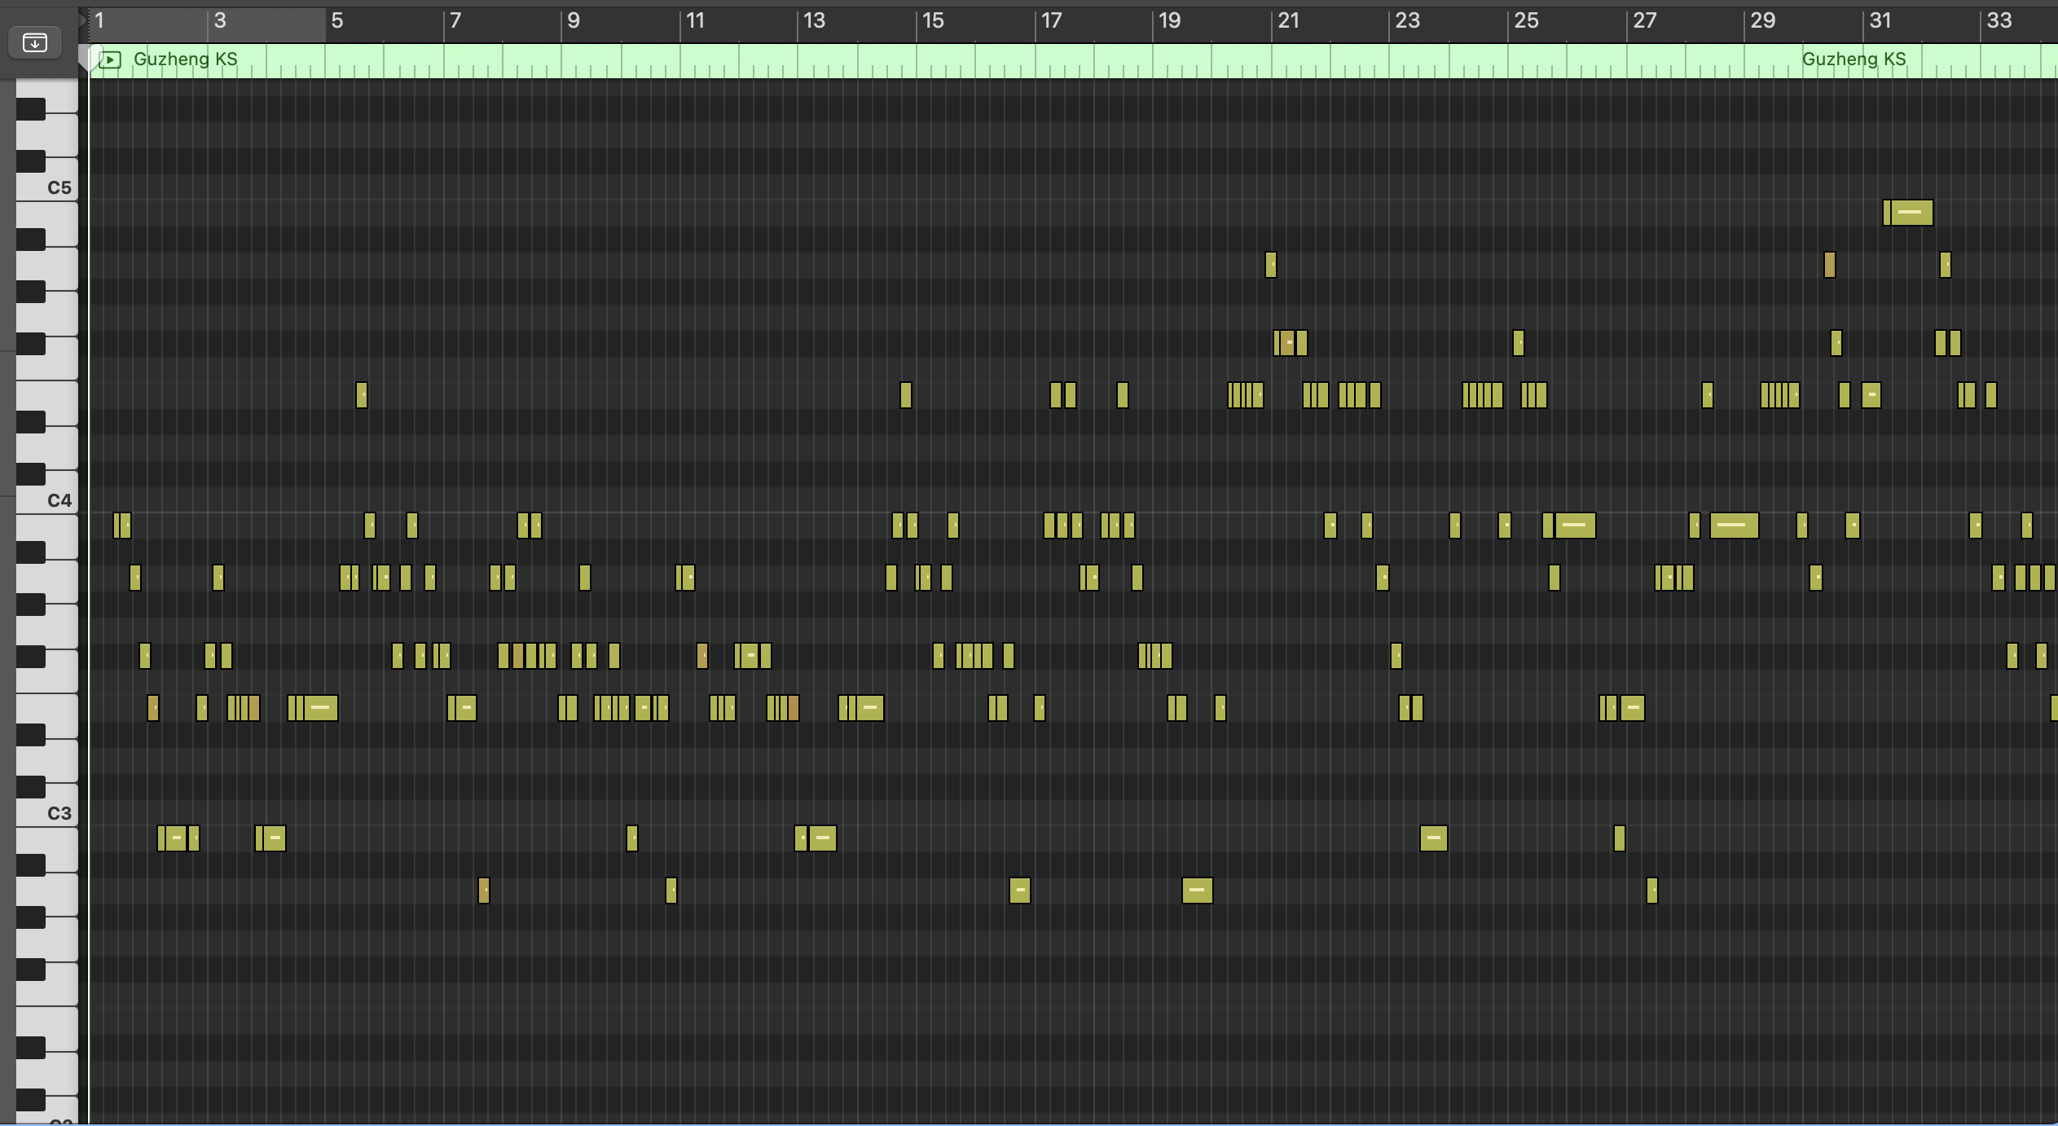
Figure 6. Piano-roll visualization of one representative sample from the baseline trained from scratch (left) and the fine-tuned NotaGen (right). The horizontal axis is time (numbered in bars) and the vertical axis is MIDI pitch. The baseline scatters notes across the full guzheng compass with no recurring phrase shape and collapses after about 21 seconds. The fine-tuned NotaGen stays in a tight mid-register tessitura, repeats clear arpeggio motifs, and uses a register shift to introduce a contrasting phrase.

Per-Metric Breakdown
Each metric tells a slightly different story about what went right and what went wrong. Pitch autocorrelation captures whether the model understands that consecutive notes should be related at all. The training data sits at 0.314 with substantial variance, reflecting the fact that some pieces are tightly stepwise and others move in larger intervals. Fine-tuned NotaGen reaches 0.188, slightly below the training mean but well above zero. The baseline sits indistinguishably from zero, confirming that without pre-training, the model has no notion of what makes one note follow another in a coherent way.
The inverse interval penalty asks whether the intervals the model chooses are ones a guzheng player would actually play. The baseline's value of 0.316 corresponds to frequent octave and ninth leaps that are physically and stylistically awkward on the instrument. Fine-tuned NotaGen's 0.608 is within one standard deviation of the training corpus (0.628), meaning the intervals it chooses are typical of the kinds that appear in real guzheng scores.
CV(IOI) measures rhythmic stability. The baseline's high value (1.648) means it cannot hold a pulse: a short flurry of notes is followed by a long silence is followed by another flurry. Fine-tuned NotaGen's 0.494 is slightly lower than the training corpus's 0.590, suggesting a marginal tendency toward rhythmic regularity -- possibly inherited from the metrical regularity of the Western pre-training data. This is a minor deviation and does not hurt the output musically.

Structural Recurrence
Interval 5-gram recurrence and LZ compression ratio both test whether the music is structured enough to compress. Random note sequences compress poorly and contain almost no repeated patterns. The baseline's recurrence of 0.001 and LZ ratio of 0.853 are diagnostic of this random regime. The training data sits at recurrence 0.369 and LZ 0.607; fine-tuned NotaGen is at recurrence 0.418 and LZ 0.566 -- slightly more structured than real guzheng, which is consistent with the observation that the model tends to repeat short motifs a bit more eagerly than a human composer would.
The combined picture is that the baseline fails on every front except the pure pitch-class constraint: its notes are technically within the pentatonic scale, but their arrangement is indistinguishable from noise. Pre-training on 1.6 million Western scores supplies exactly what the baseline lacks -- a working model of how notes should be related to each other, how intervals should be sized, and how motifs should recur.

Rendered Audio
Because NotaGen outputs symbolic music rather than audio, listening tests depend on how the symbolic output is rendered. In this thesis the output is rendered through the Ample China Zheng sampler, with rule-based keyswitches inserted to trigger tremolo, glissando, vibrato, and portamento samples at stylistically plausible moments (long sustained notes trigger tremolo; wide upward leaps trigger glissandos). This rendering layer is the bridge between the model's pentatonic note stream and audio that listeners recognize as guzheng, and it makes the difference between "a pentatonic melody on an anonymous plucked string" and "guzheng."
Author auditioning of the rendered samples is consistent with the pattern the metrics describe: the baseline samples, even rendered through Ample China Zheng, do not sound like guzheng music — they sound like random pentatonic fragments — while the NotaGen samples, rendered through the same sampler, sound like plausible short guzheng passages, not indistinguishable from master recordings but clearly within the idiom. These are unstructured impressions by a single listener and are reported as illustration rather than evidence; a formal listener evaluation is left to future work (see Section 8.4).

Novelty Analysis
A critical question is whether the fine-tuned NotaGen generates original music or simply copies training pieces. If the model memorizes its training data and plays it back, its output has no creative value. To test for this, the overlap between each generated sample and the 125-file training corpus was measured using n-grams, short consecutive note sequences of varying length. An n-gram of length 4 is a group of 4 consecutive notes; if such a group appears both in a generated sample and a training piece, it counts as an overlap.
Table 4 shows the results. At length 4, 15.4 percent of generated sequences also appear in the training data, an expected result since the pentatonic scale has only five notes and short shared motifs arise naturally in any pentatonic music. By length 8 overlap drops to 5.3 percent, and by length 20 it reaches 2.6 percent, negligible. Nine of ten samples contained no copied passage longer than 16 notes. These results confirm that the model is generating original melodic content, not regurgitating its training data.
Table 4. N-gram overlap between the 10 NotaGen samples and the full 125-file training set. Overlap drops rapidly with sequence length, confirming the model generates novel content.
N-gram length | Pitch overlap | Interval overlap
4 notes | 15.4% | 18.2%
8 notes | 5.3% | 10.9%
12 notes | 3.8% | 9.6%
20 notes | 2.6% | 8.3%

Discussion
The central result -- that a fine-tuned NotaGen produces guzheng-like output while a baseline of identical architecture fails -- invites two questions: why does pre-training on Western music help with a non-Western instrument, and what does this approach imply for other underrepresented musical traditions?

Why Pre-training Helps
NotaGen's pre-training corpus contains no guzheng, so the immediate puzzle is why pre-training improves the model at all for this task. The answer is that the fundamentals of music -- how pitches move through time, how phrases begin and end, how rhythms align with meter, how motifs repeat -- are largely shared across Western and Chinese traditions, even when surface features like scale, timbre, and ornamentation differ. Training from scratch on 125 guzheng pieces is not enough to learn these fundamentals; there is simply not enough data. Starting from a model that has already learned them on 1.6 million Western scores means the 125 guzheng pieces only need to teach the instrument-specific surface features -- pentatonic scale, sparse texture, characteristic rhythmic cells -- which is well within their reach.

Why the Baseline Fails
This explanation predicts a specific failure mode for training from scratch: not an inability to learn the pentatonic scale, which is simple, but an inability to produce coherent phrase structure. The baseline results match the prediction exactly. Its pitch class distribution is pentatonic, but its pitch autocorrelation is essentially zero, its interval recurrence is nil, and its LZ compression ratio is close to that of random noise. The baseline has learned which notes to play, but not how to put them together.
The failure is a scaling issue in disguise. A hierarchical patch-character GPT the size of NotaGen medium has 244 million parameters, far more capacity than a 125-piece corpus can constrain. Without the pre-training, the unused capacity becomes a liability: the model can fit arbitrary patterns in the training data but cannot generalize to coherent new sequences. Pre-training fills that capacity with transferable musical knowledge before the guzheng data is ever seen, so that fine-tuning only has to adjust a relatively small part of the model's behavior.

Implications for Inclusive Music AI
The method in this thesis is deliberately minimal. It uses off-the-shelf foundation model weights, standard fine-tuning, a small curated corpus, and rule-based post-processing. Each of these components is available to a single researcher with a consumer GPU. For communities that maintain traditional musical practices but lack access to cloud computing infrastructure, this matters. A qanun player in Cairo, a sitarist in Varanasi, or a koto teacher in Kyoto could apply the same pipeline to their own repertoire without relying on a data center or a million-file corpus.
The result also pushes back against the assumption that AI music generation is primarily a data problem that demands a data solution -- that is, collecting millions of hours of non-Western audio and retraining from scratch. Collecting a million hours of guzheng audio is not feasible. But fine-tuning a pre-trained model with 125 carefully curated pieces is, and produces usable output. The data-scarcity constraint does not preclude cultural representation; it just requires choosing adaptation over scratch training.
There are conditions under which this approach generalizes cleanly. The target tradition needs a digital representation (MIDI, ABC, MusicXML) that an existing foundation model can consume. Its music needs to share enough surface structure with the pre-training corpus that the model can recognize pitched events, phrase boundaries, and meter. For instruments whose music departs radically from these assumptions -- microtonal traditions, oral-only repertoire, timbre-centric music -- more work on tokenization and pre-training would be needed before fine-tuning can succeed.

Limitations
The most significant limitation is the evaluation itself. All metrics in this thesis are statistical: they measure whether the generated output matches the distributional profile of real guzheng music, but they cannot assess whether the music sounds convincing to a trained listener. A guzheng teacher hearing the output might notice awkward phrasing, unnatural note groupings, or missing expressive nuance that no histogram can capture. A formal listening study by trained musicians would address this gap, but it was beyond the scope of the present work.
The data also imposes hard constraints on what the model can learn. All files use constant velocity, so the model has no way to learn the loud-soft contrasts that define guzheng performance. Left-hand ornamental techniques central to the instrument's identity -- vibrato, pressing, sliding -- are not representable in standard MIDI and are reintroduced only through post-hoc keyswitches during rendering, which is a blunt approximation. The corpus of 125 pieces, though much larger than typical prior work on guzheng generation, is still small enough that individual training pieces can disproportionately influence the output. And because traditional notation practice is inconsistent across regions and teachers, even this carefully curated dataset reflects transcription choices made during jianpu-to-MIDI conversion rather than objective ground truth.

Future Directions
The most valuable next step is a formal listening evaluation in which trained guzheng musicians assess the generated samples for musical coherence, idiomatic phrasing, and aesthetic quality. Beyond evaluation, four directions extend naturally from the present work. First, scaling the corpus from 125 pieces to several hundred and introducing velocity variation would improve both diversity and expressiveness. Second, building standardized conventions for digitizing non-Western music — what counts as a "note" in traditions that use continuous pitch bending, for example — would lower the barrier to adapting this method to other instruments. Third, extending the method to multi-instrument ensemble generation (guzheng paired with erhu or pipa) would test whether transfer learning can capture the interactional structure of traditional Chinese ensembles, not just solo idiom. Fourth, an ablation that fine-tunes from a non-musical pre-trained model (e.g., natural language) would isolate how much of NotaGen's advantage comes specifically from musical pre-training rather than from pre-training of any kind.

Conclusion
This thesis demonstrated that transductive transfer learning from a music foundation model pre-trained on 1.6 million Western scores can generate guzheng music from a corpus of 125 pieces transcribed from jianpu. Fine-tuning NotaGen on this corpus produced output that closely matched the training data on melodic, rhythmic, and structural metrics, and consistently outperformed a baseline transformer of the same architecture trained from scratch. The baseline's failure -- random-sounding melodies, chaotic rhythms, and no structural recurrence -- shows that the knowledge encoded in NotaGen's pre-trained weights transfers meaningfully to a non-Western instrument, even though that instrument was essentially absent from pre-training.
Three practical contributions follow from this work. First, the 125-piece guzheng ABC corpus curated for this thesis, together with the data preparation pipeline, fine-tuning scripts, and evaluation code, is released as an open-source resource at https://github.com/anjieliu121/Guzheng to support future research on underrepresented instrument generation. Second, transductive transfer learning from a Western-pretrained foundation model is presented as a viable pipeline for adapting AI music generation to non-Western traditions, particularly when training data is scarce. Third, a rule-based rendering layer is proposed as a pragmatic way to reintroduce instrument-specific playing techniques (tremolo, glissando, vibrato, portamento) that standard symbolic notation cannot express.
These findings have implications beyond the guzheng. The method requires no instrument-specific architecture and should generalize to any tradition for which a small corpus of symbolic transcriptions can be assembled. Future work should validate these results through listening evaluations with trained musicians, expand the training corpus to improve diversity, and extend the approach to multi-instrument and expressive generation. The broader goal is a generation of AI music tools that can represent the full range of the world's musical traditions, rather than reproducing the statistical profile of Western pop indefinitely.

Code and Data Availability
The implementation, training data, evaluation code, and 20 paired generation samples supporting this thesis are released at https://github.com/anjieliu121/Guzheng and archived on Zenodo at https://doi.org/10.5281/zenodo.19868672 (release tag v1.0-thesis, commit 97dac1b).
Trained model checkpoints are hosted on the Hugging Face Hub: the fine-tuned NotaGen-medium at https://huggingface.co/anjieliu/notagen-guzheng, and the from-scratch baseline at https://huggingface.co/anjieliu/baseline-guzheng.
Code is released under the MIT License. Data and trained weights are released under the Creative Commons Attribution-ShareAlike 4.0 International license (CC-BY-SA 4.0). The 26 hand-curated guzheng pieces in raw_data/MIDI/ are derivative works of copyrighted compositions and are released for academic and research use only. BibTeX citation entries are provided in paper.bib at the repository root.

References
Briot, J.-P., Hadjeres, G., & Pachet, F.-D. (2017). Deep learning techniques for music generation — A survey. arXiv. https://doi.org/10.48550/arXiv.1709.01620
Cao, B., Qian, L., Li, D., Gu, H., Xu, M., & Liu, Q. (2026). Anchored cyclic generation: A novel paradigm for long-sequence symbolic music generation. Findings of the Association for Computational Linguistics: ACL 2026. https://doi.org/10.48550/arXiv.2604.05343
Chauhan, S., & Pundhir, A. (2026). Cross-cultural bias in mel-scale representations: Evidence and alternatives from speech and music. IEEE International Conference on Acoustics, Speech and Signal Processing (ICASSP). https://doi.org/10.48550/arXiv.2604.10503
Chen, S., Zhong, Y., & Du, R. (2022). Automatic composition of guzheng (Chinese zither) music using long short-term memory network (LSTM) and reinforcement learning (RL). Scientific Reports, 12(1), 15829. https://doi.org/10.1038/s41598-022-19786-1
Copet, J., Kreuk, F., Gat, I., Remez, T., Kant, D., Synnaeve, G., Adi, Y., & Defossez, A. (2023). Simple and controllable music generation. Advances in Neural Information Processing Systems, 36. https://doi.org/10.48550/arXiv.2306.05284
Han, M. (2024). Artificial intelligence-driven tone recognition of Guzheng: A linear prediction approach. Demonstratio Mathematica, 57(1), 20240009. https://doi.org/10.1515/dema-2024-0009
Huang, C.-Z. A., Vaswani, A., Uszkoreit, J., Shazeer, N., Simon, I., Hawthorne, C., Dai, A. M., Hoffman, M. D., Dinculescu, M., & Eck, D. (2018). Music Transformer: Generating music with long-term structure. arXiv. https://doi.org/10.48550/arXiv.1809.04281
Kader, F. B., & Karmaker, S. (2025). A survey on evaluation metrics for music generation. arXiv. https://doi.org/10.48550/arXiv.2509.00051
Li, D., Che, M., Meng, W., Wu, Y., Yu, Y., Xia, F., & Li, W. (2023). Frame-level multi-label playing technique detection using multi-scale network and self-attention mechanism. IEEE International Conference on Acoustics, Speech and Signal Processing (ICASSP).
Li, D., Wu, Y., Li, Q., Zhao, J., Yu, Y., Xia, F., & Li, W. (2022). Playing technique detection by fusing note onset information in guzheng performance. Proceedings of the 23rd International Society for Music Information Retrieval Conference (ISMIR). https://doi.org/10.48550/arXiv.2209.08774
Ma, W., & Zheng, Z. (2025). Applications of artificial intelligence in music: A review. International Journal of Crowd Science, 9(4), 221–238. https://doi.org/10.26599/IJCS.2025.9100011
Mehta, A., Chauhan, S., & Choudhury, M. (2024). Missing melodies: AI music generation and its "nearly" complete omission of the Global South. arXiv. https://doi.org/10.48550/arXiv.2412.04100
Mehta, A., Chauhan, S., & Choudhury, M. (2025a). Exploring adapter design tradeoffs for low resource music generation. arXiv. https://doi.org/10.48550/arXiv.2506.21298
Mehta, A., Chauhan, S., Djanibekov, A., Kulkarni, A., Xia, G., & Choudhury, M. (2025b). Music for all: Representational bias and cross-cultural adaptability of music generation models. Findings of the Association for Computational Linguistics: NAACL 2025, 4569–4585. https://doi.org/10.48550/arXiv.2502.07328
Mingming, Q. (2017). The development and innovation of Chinese guzheng playing techniques. Proceedings of the 4th International Conference on Literature, Linguistics and Arts.
Pan, S. J., & Yang, Q. (2010). A survey on transfer learning. IEEE Transactions on Knowledge and Data Engineering, 22(10), 1345–1359. https://doi.org/10.1109/TKDE.2009.191
Qu, X., Bai, Y., Ma, Y., Zhou, Z., Lo, K. M., Liu, J., Yuan, R., Min, L., Liu, X., Zhang, T., Du, X., Guo, S., Liang, Y., Li, Y., Wu, S., Zhou, J., Zheng, T., Ma, Z., Han, F., . . . Zhang, G. (2024). MuPT: A generative symbolic music pretrained transformer. arXiv. https://doi.org/10.48550/arXiv.2404.06393
Solak, A., Grotschla, F., Lanzendorfer, L. A., & Wattenhofer, R. (2025). Bias beyond borders: Global inequalities in AI-generated music. NeurIPS AI4Music Workshop. https://doi.org/10.48550/arXiv.2510.01963
Wang, Y., Wu, S., Hu, J., Du, X., Peng, Y., Huang, Y., Fan, S., Li, X., Yu, F., & Sun, M. (2025). NotaGen: Advancing musicality in symbolic music generation with large language model training paradigms. arXiv. https://doi.org/10.48550/arXiv.2502.18008
Wei, M., Modrzejewski, M., Sivaraman, A., & Herremans, D. (2026). Prevailing research areas for music AI in the era of foundation models. Proceedings of Machine Learning Research, 303, 1-23.
Wu, S., Guo, Z., Yuan, R., Jiang, J., Doh, S., Xia, G., Nam, J., Li, X., Yu, F., & Sun, M. (2025). CLaMP 3: Universal music information retrieval across unaligned modalities and unseen languages. Findings of the Association for Computational Linguistics: ACL 2025. https://doi.org/10.48550/arXiv.2502.10362
Wu, S., Yu, D., Tan, X., & Sun, M. (2023). CLaMP: Contrastive language-music pre-training for cross-modal symbolic music information retrieval. Proceedings of the 24th International Society for Music Information Retrieval Conference (ISMIR). https://doi.org/10.48550/arXiv.2304.11029
Wu, S.-L., Kim, Y., & Huang, C.-Z. A. (2025). MIDI-LLM: Adapting large language models for text-to-MIDI music generation. arXiv. https://doi.org/10.48550/arXiv.2511.03942
Zheng, C., & Knobloch, Y. (1983). A discussion of the history of the gu zheng. Asian Music, 14(2), 1. https://doi.org/10.2307/833935
Zheng, J., Cao, M., & Zhang, C. (2025). AI-driven generation of guzheng music from classical Chinese poetry: Toward a new paradigm of creative practice in Chinese traditional music. Multimedia Systems, 31, Article 437. https://doi.org/10.1007/s00530-025-02023-w

Appendix A: Dataset Inventory
Table A1. The 20 hand-curated guzheng pieces with full metadata (from metadata/MIDI.json). These pieces, together with six more hand-curated files awaiting metadata completion, make up the 26-piece hand-curated subset; the remaining 99 pieces in the 125-piece training corpus are drawn from Guzheng_Tech99 (Li et al., 2023).
English title | Chinese title | Key | Duration (s) | Note count | Density (notes/s)
Every Step is Higher | 步步高 | D | 72 | 321 | 4.46
High Mountains and Flowing Water | 高山流水 | D | 347 | 674 | 1.94
Thunder in Drought | 旱天雷 | D | 159 | 625 | 3.93
Thousand Buddha Chants | 千声佛 | D | 104 | 246 | 2.37
Fisherman's Song at Dusk | 渔舟唱晚 | D | 281 | 718 | 2.55
Going Upstairs | 上楼 | D | 109 | 369 | 3.36
Nan Zheng Palace | 南正宫 | D | 291 | 618 | 2.12
Lotus Emerging from Water | 出水莲 | D | 354 | 646 | 1.82
Osmanthus Blooming Everywhere in August | 八月桂花遍地开 | D | 87 | 502 | 5.77
Shooting the Wild Goose | 打雁 | G | 113 | 486 | 4.29
Joyful Spring (Hakka ver.) | 百家春（汉皋） | D | 199 | 406 | 2.03
Spring Has Arrived in Lhasa | 春到拉萨 | D | 263 | 1909 | 7.25
Moon over the River on a Spring Night | 春江花月夜 | A | 81 | 550 | 6.74
Lament of Lady Zhaojun | 昭君怨 | D | 326 | 519 | 1.59
Henan Eight Beats | 河南八板 | D | 88 | 340 | 3.85
Pink Butterflies Gathering Pollen | 粉蝶采花 | F | 307 | 1416 | 4.61
Much Sorrow | 虞美人 | D | 144 | 390 | 2.71
Busy Weaving | 纺织忙 | G | 147 | 809 | 5.50
New Song of Dongting Lake | 洞庭新歌 | D | 408 | 1122 | 2.75
Liuyang River | 浏阳河 | D | 120 | 790 | 6.58

Appendix B: Model Architecture Details
Table B1. Architecture comparison. The fine-tuned NotaGen and the baseline differ only in their initial weights.
Parameter | NotaGen (fine-tuned) | Baseline (from scratch)
Total parameters | 244M | 244M
Patch-level decoder | 16 layers GPT-2 (180M) | 16 layers GPT-2 (180M)
Character-level decoder | 3 layers GPT-2 (64M) | 3 layers GPT-2 (64M)
Hidden dimension | 1024 | 1024
Patch size (characters) | 16 | 16
Character vocabulary | 128 (ASCII) | 128 (ASCII)
Pre-training corpus | 1.6M Western scores | None
Fine-tuning hardware | 1× consumer GPU | 1× consumer GPU

Author Biography
Anjie Liu is an undergraduate student at The University of Texas at Austin, pursuing two degrees in the Department of Computer Science and Department of Statistics and Data Science in the College of Natural Sciences. As a Polymathic Scholar, Anjie has explored the intersection of artificial intelligence and creative expression, with a particular interest in music technology. Anjie first learned the guzheng as a child, set it aside for years, and returned to the instrument in middle school after a live performance rekindled a connection to it. When AI music generators became popular in 2023, Anjie was struck by their inability to produce convincing guzheng music -- an observation that motivated this thesis.

