Supply Chain Data Layer
Problem, solution and benefits · Worcester Bio Research Center · October 2026

One place to see where material is — from order, through receipt and release, to what is left in stock and what is shipping out.

Problem
There is no shared data layer underneath the site’s supply chain tools. Twenty-one applications sit between SAP and the people doing the work, each built in isolation to answer a request SAP did not cover, and none of them share keys. The consequence is structural: every new requirement produces another tool, because there is nothing underneath for it to be a view of.
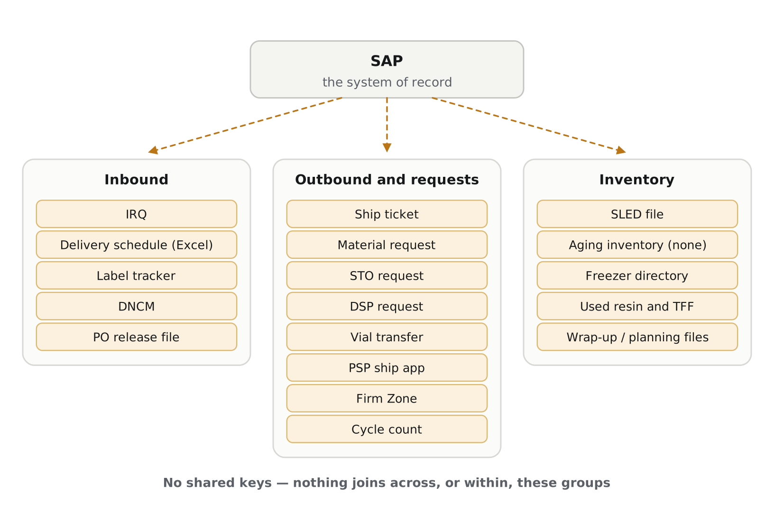
The current landscape. Dashed arrows are information entered by hand. There are no arrows between or within the groups because no such connections exist.
The same three failures repeat in every domain:
- Information is entered by hand from a system that already holds it. A planner reads a purchase order in SAP and types it into IRQ — 176 entries a month, about 10 minutes each. That list is copy-pasted into an Excel scheduler so it can be read in a planning layout. QC maintains a separate SharePoint list of the same items needing sampling. One shipment’s documentation is created across four systems and a local drive.
- Nothing reconciles afterwards. When a date or quantity changes in SAP, IRQ does not know, and the spreadsheet is a snapshot of whatever IRQ said on the day it was copied. There is currently no way to count how many open entries disagree with their purchase order.
- Nothing can be measured end to end. Booking-to-receipt and receipt-to-release cycle times, on-time performance, exception frequency and expiry exposure all require joining timestamps that sit in separate systems. Firm Zone records a root cause and impact score on every schedule break-in and nobody reports on it.
A fourth consequence follows: wherever a tool holds genuinely original content — a procurement comment, a root cause, a physical count — it is trapped in the tool that holds it.
Underneath all of it is a structural problem: orders are not delivered in one piece. A vendor splits a purchase order line across several deliveries; receiving splits those deliveries into separate batches, each with its own expiry date and its own label packet. Quantities do not reconcile one-to-one at any boundary.
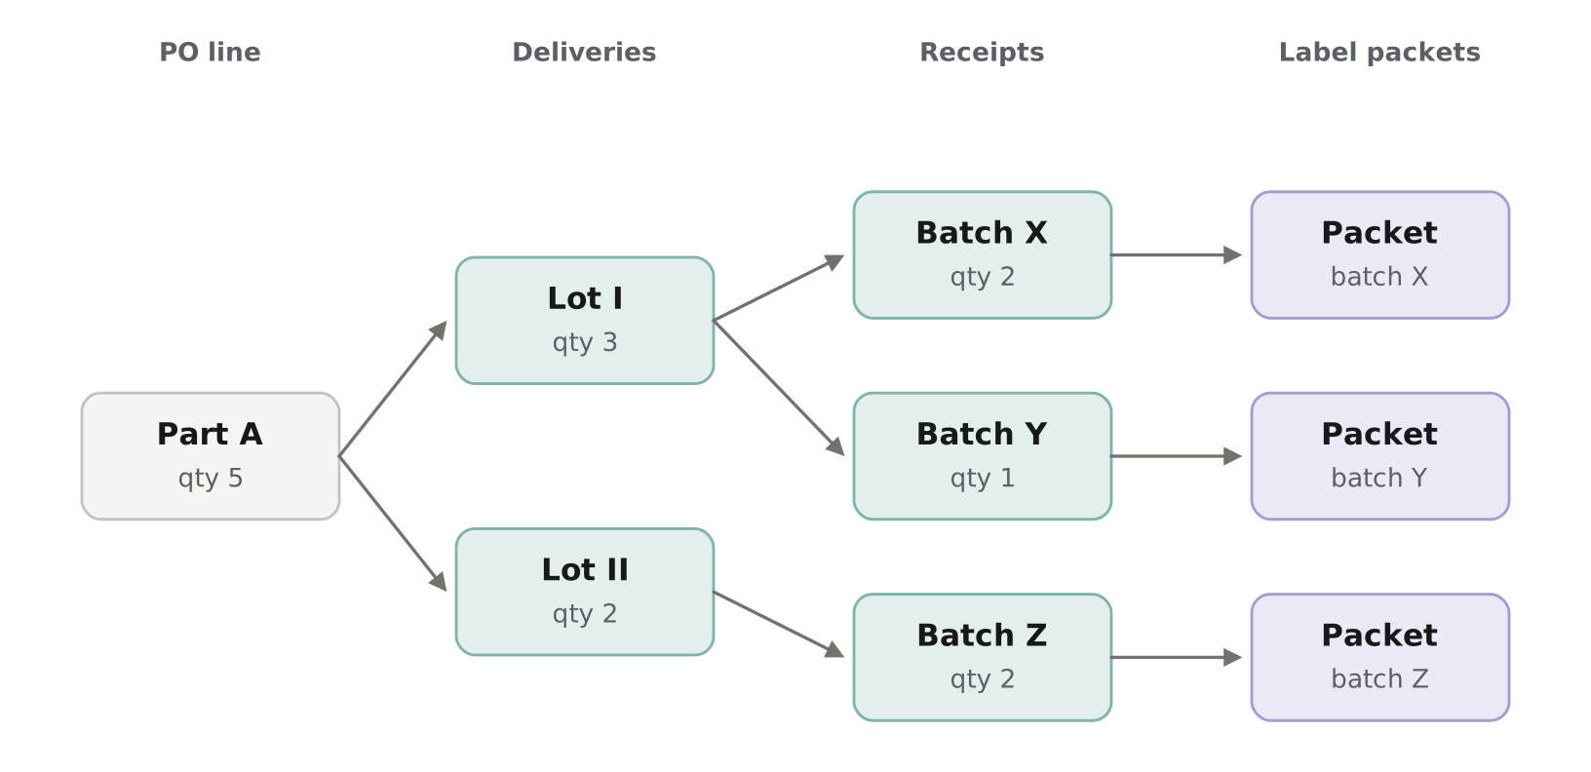
One order for five units arrives as two lots and is received as three batches, each with its own expiry date and label packet.
So "where is my order" has no single answer. Part may be received and released, part in transit, part not yet shipped — and what remains outstanding against an open purchase order is tracked by whoever remembers. Partial deliveries are also where the hand-typed copies drift fastest, because each new arrival changes a record somebody has to go and update in three places.
This is why the layer has to model deliveries and receipts as distinct levels, each carrying its own quantity, rather than assuming a straight chain from order to stock. It also makes quantity reconciliation between levels a derived check rather than a manual one.
The business has documented this twice, independently. The supply chain data structure review records that IRQ’s information is duplicated from the delivery schedule and SAP, asks whether incoming purchase orders could feed IRQ directly, and notes that no receipt or sampling on-time metrics exist. Separately, the logistics core responsibilities workbook catalogues 178 tasks with a column for Count per week that is blank for much of the sheet and a column headed Data source that is empty — logistics cannot size its own team because nobody can say how often its work occurs.

Solution
One read-only data layer that joins the existing systems on enterprise-standard keys and serves every view from it. Source systems continue to operate unchanged; what changes is that their data can be read together, and that information already held in SAP stops being retyped.
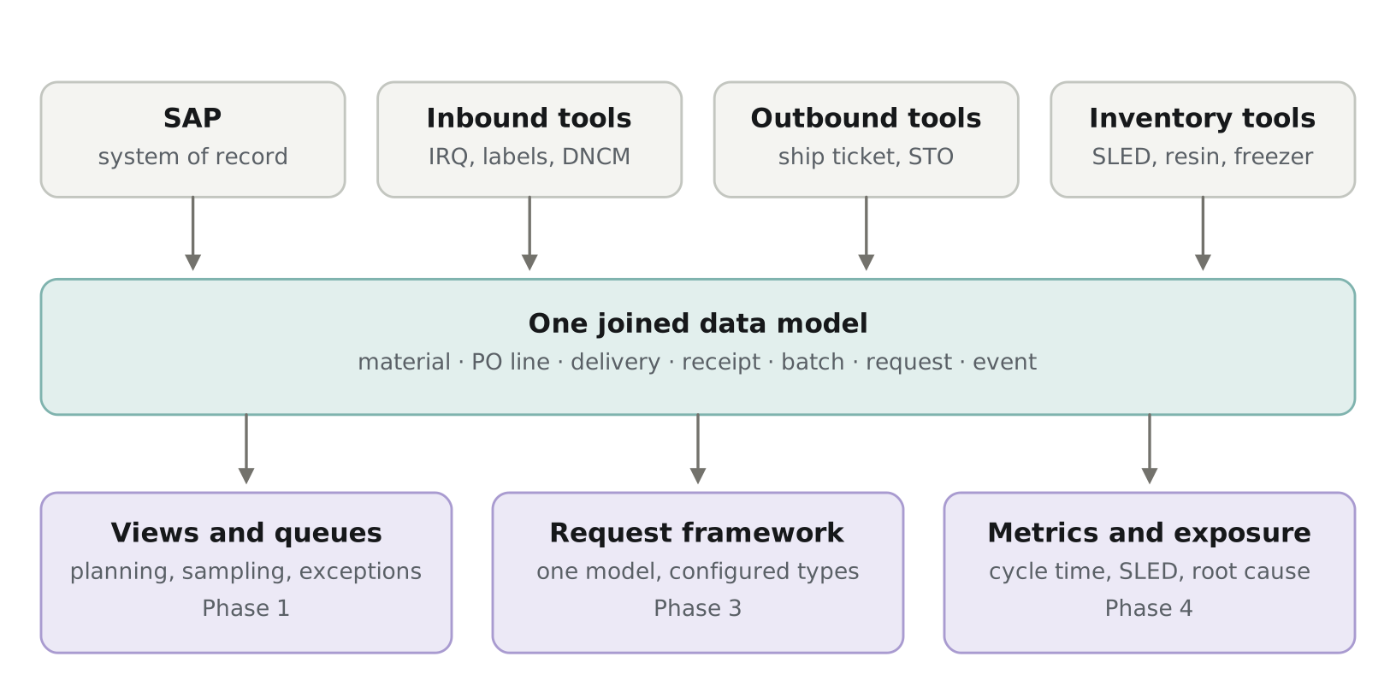
One model underneath; views, request types and metrics served from it. Phase labels show when each layer arrives.
Today | After | Effect
Planner types an IRQ entry from SAP, ~10 min | Draft arrives pre-filled; planner sets window, pallets and carrier, then confirms | Entry time falls to roughly 3 minutes
Excel scheduler copy-pasted; comments in a cell | Live planning view; comments stored against the PO line | Spreadsheet retired, commentary retained with history
QC keeps a separate SharePoint sampling list | QC reads the sampling queue from joined data | List retired; one source for the queue
Reports and KPI updates assembled by hand | Views that refresh themselves | Hours returned across logistics roles
No inbound timings or exception reporting | Cycle times and exception counts derived from events | Metrics exist for the first time

The layer reads; it does not write back. SAP remains the system of record and no validated system is modified. The one exception is procurement commentary, stored in the layer’s own table against the purchase order line — necessary because that comment column is the reason the spreadsheet exists, and a read-only view alone would not displace it.

Where AI could be used
Most of this programme is not AI. Joining records, deriving cycle times and reconciling quantities are database work, and reaching for a model where a query would do is slower, less reliable and harder to defend. There are four places where AI could genuinely help, all of them where the data is unstructured or the match is ambiguous. None is a commitment here; each would be assessed when its phase is scoped, and each would work without it.
- Reading booking emails (Phase 2). Carrier, reference, appointment date and time, pallet count and locations could be read from the shared mailbox into a draft entry the planner confirms. Booking is the only step in the process with no structured source at all, which makes this the strongest candidate. Replies that revise a date could be read the same way, so a change reaches the record instead of staying in somebody’s thread.
- Matching records that carry no key (Phase 1). Some records reference a shipment only in prose — a label packet row, a free-text discrepancy note. Where no key can be found or derived, a model could propose a match with a confidence score, with anything below threshold going to a review queue rather than being matched silently. Each confirmation would become a permanent crosswalk entry, so the manual residue shrinks rather than repeating. Without this, those records are matched by hand.
- Plain-language query, once the layer exists. "What is arriving this week that still needs sampling" could be answered from the data rather than by asking three people. This is only possible because the records are joined first — which is the shape of the whole thing: the plumbing is what would make the AI useful, not the reverse.
- Finding patterns in free text (Phase 4). DNCM and Firm Zone hold written descriptions of what went wrong. Searching those by meaning rather than keyword could group recurring problems by vendor, material or cause in ways the fixed categories do not capture.
Not proposed in any phase. Predicting late deliveries or temperature excursions needs twelve or more months of joined history that does not yet exist; it is a possible outcome of the earlier phases rather than a commitment in any of them. No model would write to a system of record, and no quality decision would be made or recommended by one.

Benefits
The logistics core responsibilities workbook catalogues 178 tasks across warehouse, shipping and leadership. Read alongside the supply chain data structure review, it describes most of the benefit below in the site’s own words.
- Avoided inventory write-off. One logistics task reads "trend data available related to eMDO’s and coordinate regular cross functional reviews to minimize future obsolescence." Performing it means assembling obsolescence data spread across SAP, the eMDO records and the SLED file — which exists, in the review’s own words, so finance can understand potential at-risk exposure for distressed inventory, and which is refreshed by hand each month. Material is genuinely at risk when it is close to expiry and unallocated: expiry sits on the batch in SAP, allocation sits elsewhere, so the question is answered late or not at all. Joined, it answers itself continuously.
- Capacity returned to logistics. Roughly 350 hours a year goes into creating IRQ entries alone — 176 a month at about 10 minutes each, most of it looking information up in SAP and retyping it. Beyond that, around twenty recurring tasks in the workbook involve assembling data by hand: completing the "not received" report and the monthly 3PL inventory reconciliation for finance; reporting unreceived materials at month end; reviewing the open order report to create a delivery report and a sampling forecast; monitoring BDS/BDI data to maintain under 80% capacity; tracking freezer health and material movements in the freezer directory; reporting real-time ship ticket status; and updating L4 KPI metrics, assigned separately to four roles.
These do not all recover the same way. For some — the "not received" report, unreceived materials at month end, the capacity threshold — the task becomes a view and the work disappears. For others the gathering disappears and the judgement remains: creating a delivery report or a sampling forecast still needs a planner once the data is in front of them. A few are barely affected at all. Logistics is best placed to split that list, and the hours figure below should reflect only the portion they confirm as recoverable.
- Decisions that would be better with data behind them. Four tasks across different roles call for allocating staffing resources against a delivery forecast or a set of transfer requests. Others call for measuring delivery booking performance and issuing actionable feedback, forecasting warehouse capacity from delivery and issuance projections, and confirming that dock capacity and personnel are not overcommitted. Those judgements are made today from experience and whatever can be pieced together by hand, because the numbers behind them sit across systems that do not join. The same gap sits underneath the workbook itself: its Count per week column is blank for much of the sheet and its Data source column is empty, so how often logistics work actually occurs cannot be established from the systems that record it. That frequency is precisely what joined transaction records supply.
- Less time spent chasing errors. "Oversee timely reconciliation of errors preventing GRs" appears twice in the task list. Alongside it sit "troubleshoot inventory discrepancies as needed," "end of lot reconciliation / material adjustments," and "reconcile damaged / non-conforming inventory in database and SAP." Separately, roughly 2,100 hand-typed IRQ entries a year is 2,100 chances for a date, quantity or vendor to be wrong or go stale, and nothing today compares the copy against the original. After Phase 1 that count is a single query.
- Fewer transcription errors in data feeding GxP decisions. One task reads "create shipping documentation in OZ, SAP, Jet and STO tracker databases, store electronically in local drive" — four systems and a shared drive for one shipment. Another enters a sample collection into LIMS and sends it to the QC bin in SAP. Sampling flags, discrepancy records and label reconciliation all inform GxP decisions even though the tools themselves are not GxP, and every re-key is an opportunity to transpose a batch number.
- Lower maintenance burden. Digital Systems maintains twenty-one applications today. Each retirement removes a maintained surface permanently, and each new request answered as a view avoids adding one. This is the only benefit here that compounds.
Five groups benefit directly: planning, procurement, logistics and the dock, QC, and finance.
Figures
Figure | Value | Source
IRQ entries per month | 176 | IRQ — September 2026
Minutes to create one entry | 10 | Timed with a planner
Annual hours on IRQ entry alone | ~350 | Derived from the two rows above
Logistics tasks documented | 178 | Core responsibilities workbook
Of those, tasks involving hand assembly of data | ~20 | Same workbook — to be confirmed with logistics
Of those, confirmed recoverable | ________ | Logistics review of the task list
Tasks with no frequency data today | ________ | Workbook — Count per week blank
Estimated hours per year on the recoverable tasks | ________ | Logistics estimates — see note
Loaded hourly rate | $________ | Finance
Inventory written off to expiry, last 12 months | $________ | Finance
Inventory within 90 days of expiry, unallocated | $________ | SLED file plus allocation
Expedite freight attributable to late inbound | $________ | Procurement / logistics

Note on the logistics figures. The core responsibilities workbook states that its internal timing templates contained no completed observations, so its distributions are labelled estimates to be validated by direct time study before staffing decisions. They are used here to size an opportunity, not to support a staffing decision. The data layer supplies the frequency half of that calculation; duration still requires observation.

Phasing
Each phase delivers something usable on its own and produces the evidence that justifies the next. Only Phase 1 is being requested.
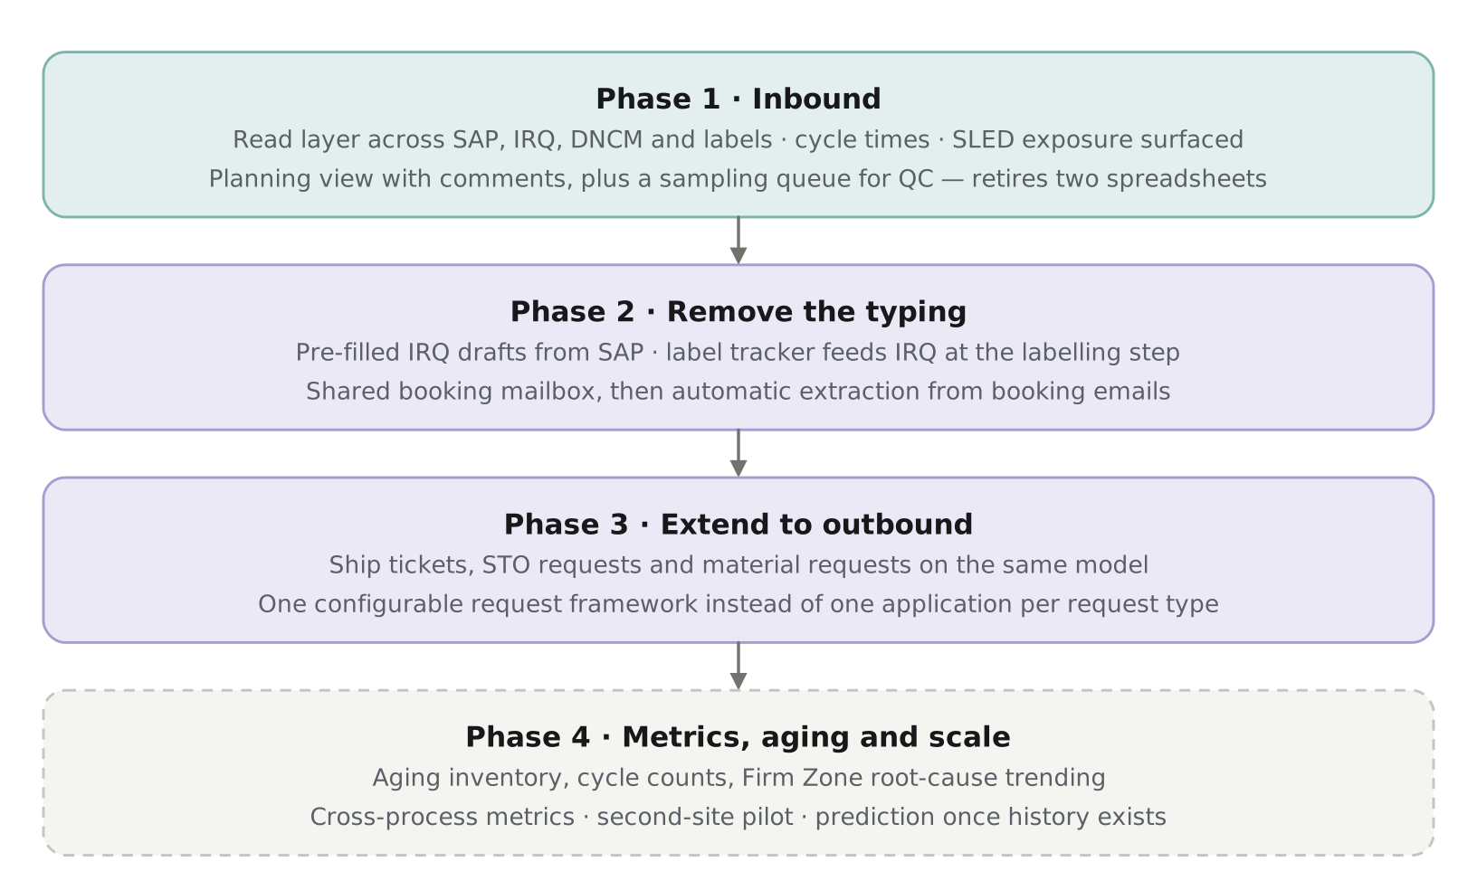
Phase 4 is dashed because it depends on history accumulated by the earlier phases.
Why inbound first. It is the smallest domain, the one where the duplication has already been measured, and the three-level split from order to delivery to batch exercises the hardest part of the model. If the join works on inbound it will work elsewhere; if it does not, that is better discovered on the narrowest scope rather than the widest. The SLED exposure snapshot needs no accumulated history and is pulled forward into Phase 1.

The end state
One interface. A person searches a material number, a purchase order, a batch or a shipment, and sees its whole life in one place.
Material view | Every order placed against it, every batch received, current stock by location and status, what is allocated and what is not, expiry exposure, and what is shipping out against it
Purchase order view | Promised, confirmed, scheduled, delivered, received, sampled, released — with the quantity split across deliveries and batches visible at each step
Shipment view | Inbound and outbound, with carrier and appointment detail, documents, labelling status, and any exception raised against it

Today that answer takes six systems: SAP for the order and the receipt, IRQ for the inbound schedule and status, the label tracker for labelling, LIMS for sampling, the SLED file for expiry, and the ship ticket and STO tracker for outbound. Nobody holds all six, so the answer is assembled by asking people — which is what the standing meetings and the email threads are for.
This is possible at the end and not at the start because of the join. Material number, purchase order line and batch are keys every one of those systems already carries. Once records are joined on them, "show me everything about this material" becomes a query rather than a project.
What makes this a single interface rather than a portal of links is that the model underneath is one model. A page of links to twenty-one applications is what the site has today; it does not answer a question, it tells you where to go and ask it again. The difference is not the front end, it is the fact that every record is joined on the same keys before anyone looks at it.

Application disposition
Every application identified in the supply chain data structure review, and how this programme treats it. Source means the layer reads from it and it continues unchanged. Revamp means it stays in use with its data entry reduced. Retire means it is replaced by a view.
Application | Platform | Phase | Disposition
IRQ | PowerApp / SharePoint | 1 and 2 | Revamp — remains the inbound coordination system; entry pre-filled from SAP
Delivery schedule / Excel scheduler | Excel | 1 | Retire — replaced by the planning view, comments carried over
QC sampling list | SharePoint | 1 | Retire — replaced by the sampling queue
DNCM | PowerApp / SQL | 1 | Source — exception and discrepancy data
Label tracker | Smartsheet | 1 and 2 | Source, then feeds IRQ at the labelling step
Firm Zone | PowerApp / SharePoint | 1 and 4 | Source — two inbound flags now, root-cause trending later
PO release file | Excel / SAP | 1 | Source — retirement candidate once the planning view covers it
SLED file | Excel / SAP | 1 and 4 | Source for the exposure snapshot; automated in Phase 4
Ship ticket | PowerApp / SharePoint | 3 | Revamp — becomes a configured request type
Material request | PowerApp / SharePoint | 3 | Revamp — auto-approval against live inventory becomes possible
STO request | React / SQL | 3 | Source — read only
Calibration scheduling tool | Smartsheet | 3 | Retirement candidate — duplication with ship ticket already flagged
DSP request | PowerApp / SharePoint | 3 | Revamp — distinct purpose; pre-filled from OneTrack and SAP
Vial transfer database | PowerApp / SharePoint | 3 | Retire — function already absorbed by ship ticket
PSP ship app | PowerApp | 3 | Retire — already an aggregation of other systems; becomes a view
Cycle count / kitting requests | Smartsheet | 3 and 4 | Keep submission — add the variance and reconciliation metrics it lacks
Used resin and TFF membranes | PowerApp | 4 | Keep — SAP structurally cannot hold this; add aging visibility
Freezer directory | SharePoint | 4 | Source — storage location context
Aging inventory | No tool today | 4 | New capability — nothing to retire
eMDO | — | 4 | Source — obsolescence trending
Wrap-up and project planning files | Excel | 4 | Later — assess once metrics exist

Two artifacts retired in Phase 1 and four more identified across Phases 3 and 4; four applications revamped; the remainder read as sources. Most of these are Digital Systems applications — all of the PowerApps and the spreadsheets maintained alongside them — so disposition is a usage decision with the supply chain owner rather than a negotiation across many system owners. The Smartsheet tools, owned by the teams that use them, are the exception. No application is retired without its owner’s agreement, and nothing is retired before its replacement is in use.

