Inbound Supply Chain Data Layer
Problem, Proposed Solution, Benefits and Phased Plan
Draft for review · Worcester Bio Research Center · October 2026
Note on figures: values shown as ________ are being confirmed with the supply chain team and will be filled in before circulation. Highlighted cells mark those gaps.

1. Vision
Worcester’s supply chain runs on SAP plus roughly twenty helper applications that the site built, one at a time, to cover what SAP does not. Each was the right answer to the request in front of us. Together they have produced a landscape where the same information is typed three or four times, nothing reconciles, and no end-to-end measurement is possible.
The target is one shared data layer underneath those tools: a single joined model of material, purchase order, delivery, receipt, batch and request, read from the systems that already own that data. Every view, queue, alert and metric is served from it.
What that makes possible, in order of maturity:
- See it. One place that shows where any inbound delivery stands, across SAP, IRQ, the label tracker and the exception systems.
- Stop retyping it. Information that already exists in SAP is never entered again by hand; people enter only what they decide.
- Measure it. Cycle times, on-time performance, exception frequency and root-cause trends become derivable because the events finally sit in one timeline.
- Stop the sprawl. The next request becomes a view or a configured request type on the shared model rather than application number twenty-two.
- Reuse it. Because the model joins on enterprise-standard SAP keys and treats site as a configuration dimension, another site adopts the model and writes its own adapters rather than starting over.
This document proposes Phase 1 only — inbound. Later phases are described so the direction is clear, but each is gated on the evidence the one before it produces.

2. Summary and the ask
Item | Detail
Scope of this ask | Phase 1, inbound only: purchase order through goods receipt and the sampling handoff
Effort | Existing engineering time, scoped to inbound only
Cost | Existing engineering time. No new licences, no new platform
Classification | Non-GxP. Read-only against all source systems. SAP remains the system of record
Primary deliverables | Joined inbound data layer; live planning view carrying procurement comments; sampling queue for QC; exception view; first inbound cycle-time and SLED exposure figures
Retired in Phase 1 | The Excel delivery scheduler and the QC SharePoint sampling list
Needed from the business | A daily automated SAP export (emailed by logistics, confirmed workable at a 24-hour cadence) for the inbound data set — purchase orders, goods receipts, material and batch master — plus a named supply chain owner, subject-matter time, QA/CSV classification review, and a shared booking mailbox
Who builds it | Digital Systems, which already builds and maintains most of the applications in scope

Measured so far: IRQ receives approximately 176 new entries per month, each taking about 10 minutes to create, and that time is spent looking information up in SAP and retyping it — roughly 350 hours per year on entry alone for one application, before the status updates that follow. The remaining value figures are being confirmed with the supply chain team and appear in section 6.

3. Problem statement
There is no shared data layer underneath the site’s supply chain tools — inbound, outbound or inventory. Each was built in isolation to answer a request SAP did not cover, and none share keys, so the information they hold cannot be joined. The consequence is structural rather than behavioural: every new requirement produces another tool, because there is nothing underneath for it to be a view of. The sections below set out the pattern once, then what it looks like in each domain.

3.1 The landscape
Twenty-one applications sit between SAP and the people doing the work, across three domains. Every one of them is populated by hand from SAP or from another of the twenty, and none of them share keys with each other. The groupings below are conceptual — the systems themselves have no awareness of one another.
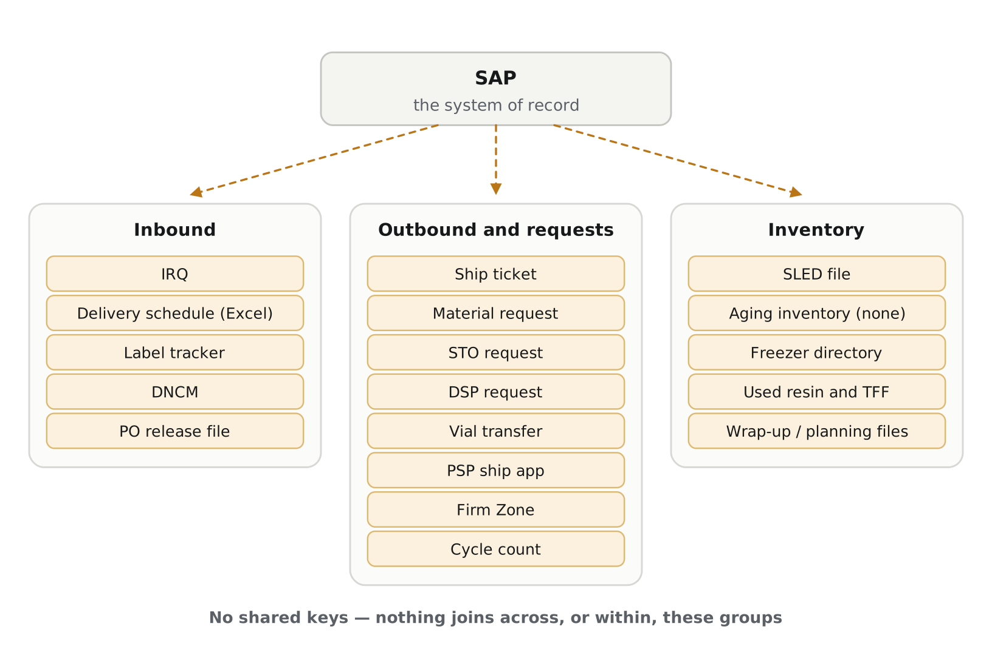
Figure 1 — The current landscape. Dashed arrows are information entered by hand. There are no arrows between or within the groups because no such connections exist.

3.2 The same three failures, repeated in every domain
The specific symptoms differ by area, but the underlying pattern does not. In each domain, information is entered by hand from a system that already holds it; nothing reconciles the copy against the original afterwards; and because the timestamps sit in separate systems, nothing can be measured end to end. A fourth consequence follows from the first three: wherever a tool holds genuinely original content — a comment, a root cause, a physical count — that content is trapped in the tool that holds it.

3.3 Inbound — the specific failures
- The same facts are typed three times. A planner reads a purchase order in SAP and types it into IRQ. That list is copy-pasted into an Excel scheduler so it can be read in a planning layout. QC maintains a separate SharePoint list of items needing sampling. Three keyboards, one set of facts.
- Nothing reconciles after the fact. When a date or quantity changes in SAP, IRQ does not know, and the spreadsheet is a snapshot of whatever IRQ said on the day it was copied. There is currently no way to count how many open IRQ entries disagree with their purchase order line.
- Procurement commentary has no home. The only genuinely original content in the Excel scheduler is the comment column, where procurement records why a delivery moved. It is the reason people keep the spreadsheet open, and it is lost or retyped on each refresh — so the reasoning behind schedule changes is not retained.
- Booking happens entirely by email. Carrier, appointment window, pallet count, source and delivery location are agreed in individual inboxes, then retyped into IRQ. If the person holding the thread is away, the information is effectively unavailable, and a revised date in a reply often never reaches IRQ at all.
- Arrival is not measured against anything. A shipment promised for the 27th may arrive on the 20th. Early arrival is as disruptive as late — no dock slot, no staged space, cold-chain material with nowhere to go — but neither direction is currently recorded as a deviation.
- No inbound metrics exist. Nobody can state booking-to-receipt or receipt-to-release cycle time, on-time receipt performance, or exception frequency, because the timestamps live in separate systems that cannot be joined.
- Exception and root-cause data is collected but unused. DNCM records damage and discrepancies. Firm Zone records every schedule break-in with a root cause, an error category, an impact score and an approval outcome. Neither is reported on, so the site cannot say why its schedule breaks.
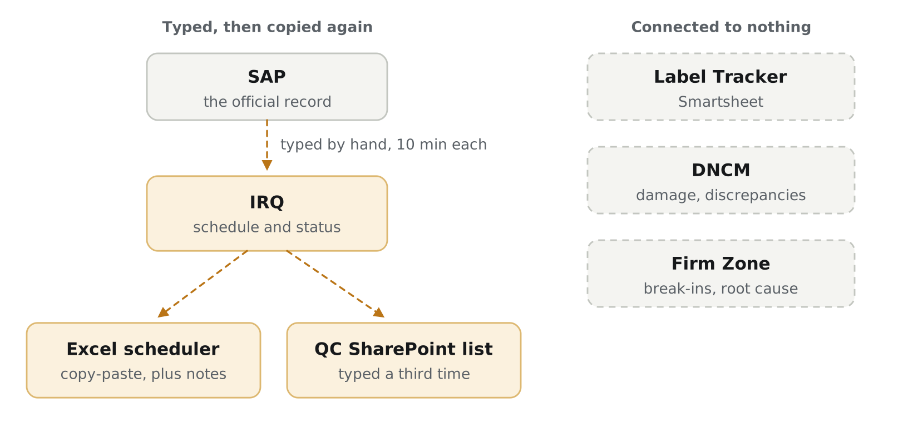
Figure 2 — Inbound in detail. One set of facts, three keyboards, and three systems holding information nothing else can read.

3.4 Outbound and requests — the specific failures
Eight applications handle requests for material, shipment and movement. They share one shape — a requester, a material or batch, an approval chain, a status — but each was built separately, so that shape is implemented eight times.
- Overlapping scope between applications. The review records that the calibration scheduling request is approved and then manually re-entered as a miscellaneous work task in the ship ticket database so a technician can be assigned. The vial transfer database is described as already part of ship ticket because the shipping team executes the work. The PSP ship app assembles its view from a Smartsheet datashuttle and an Infor batch summary. Three applications, one underlying shipment request.
- Approvals that live outside the tool. Vial transfer requires a separate form completed and signed by supply chain management and QA. Used resin approvals are form-based and, the review notes, not always uploaded. The system of record for the decision is a document, not the application.
- Known usability problems with no underlying fix available. Material request is described in the review as clunky and buggy, with a stated wish to move it to React to enable auto-approval based on inventory on hand. That auto-approval is impossible today because the application cannot see inventory — it is a data problem presented as a rebuild.
- Shipment performance is not measured. The review notes that shipping index flags are captured as booleans, that comparison of scheduled against actual ship date is wanted but not automated, and that fulfilled date is set automatically so it measures tool usage rather than actual fulfilment.
- Schedule disruption is recorded but never analysed. Firm Zone captures a root cause, an error category, an impact score and an approval outcome on every break-in request. Nobody reports on it, so the site cannot say whether disruption is driven by equipment, human error, vendor performance or planning.

3.5 Inventory — the specific failures
This is where the financial exposure sits, and it is the least instrumented of the three domains.
- Aging inventory has no tool at all. The review describes the need plainly: anything in inventory for five years or more with no plan for use or allocation, a better approval path to discard, and some way to visualise it. Nothing exists to retire here — this is a missing capability.
- Expiry exposure is assembled by hand. SLED generation is semi-automated in Excel, refreshed monthly. Its stated purpose is allocating material to projects and letting finance understand potential at-risk exposure for distressed inventory — which makes it the most financially significant artifact in the landscape and the one most dependent on a manual refresh.
- "At risk" is a join nobody can perform. Material is genuinely at risk when it is close to expiry and unallocated. Expiry sits on the batch in SAP; allocation sits elsewhere. Neither system alone can answer the question, so it is answered late or not at all.
- Some inventory is invisible to SAP by design. Resins and cassettes stop being tracked in SAP once cycles are depleted, and the review records that adding cycles to SAP was rejected on monetary grounds. A separate application holds that inventory. This is not duplication — it is a structural gap, and the data has nowhere else to live.
- Reported tooling failures go unaddressed. The review states that the freezer and capacity dashboard is broken and that aging flags in the used resin application do not work today. Both are requests for visibility that no single application can satisfy on its own.

3.6 Why this is not a tooling failure
The applications work. Planners, QC and the dock use them daily and they do their jobs. The problem is that each one solved a request in isolation, so the site accumulated twenty-one front ends over a foundation that was never built. Framed correctly, these tools are evidence of sustained demand for supply chain automation — and evidence that point solutions have reached their ceiling.
Most of these applications were built and are maintained by Digital Systems. Every one of the PowerApps in the landscape — IRQ, ship ticket, material request, DNCM, Firm Zone, DSP, vial transfer, PSP ship, used resin — came to the team as an individual request and was delivered as an individual application, because there was no shared model to build a view on instead. This proposal is therefore not a critique of another group’s systems; it is the team that built them proposing the foundation that should have existed underneath, now that the pattern is visible in a way it could not have been at request number two.
That ownership has three practical consequences for this proposal. Retirement decisions for most of the landscape sit inside the team and with the supply chain owner, rather than requiring negotiation across many system owners. The team already carries the maintenance cost of all twenty-one tools, so consolidation reduces an existing burden rather than adding a new one. And the team knows which fields in each application are actually used, which is the knowledge that makes a credible retirement plan possible at all.
The corollary is a commitment. If requests continue to be answered with new standalone applications while this is being built, the pattern simply continues alongside the fix. The governance rule in section 9 — that a new request is evaluated against the shared model before a new application is built — is something Digital Systems applies to its own intake, not a constraint imposed on anyone else.

3.7 The site has already identified this
The supply chain data structure review carried out by the business records the same conclusions independently of this proposal:
- The IRQ entry notes its information is duplicated from the delivery schedule and SAP, asks for milestone tracking on inbound shipments, and records that no receipt or sampling on-time metrics exist today.
- The delivery schedule entry asks whether incoming purchase order information could feed IRQ directly, including the commentary carried over from previous meetings.
- The label tracker entry asks for it to be connected to or feed into IRQ, so received entries are marked as labelled and then moved into the sampling phase.
- The calibration scheduling entry asks whether the scheduler could go directly into the ship ticket request rather than duplicating the work.
This proposal executes a direction the business has already articulated.

4. The process this covers
Phase 1 covers inbound: from a purchase order line released to a vendor, through to goods receipt and the handoff to sampling. Quality disposition, outbound movement and inventory management are later phases.

4.1 Why the data is hard to join
A single purchase order line does not produce a single delivery or a single batch. The vendor splits the order across shipments; receiving splits those shipments across batches; each batch generates its own label packet and its own expiry date. Quantities do not reconcile one-to-one at any boundary.
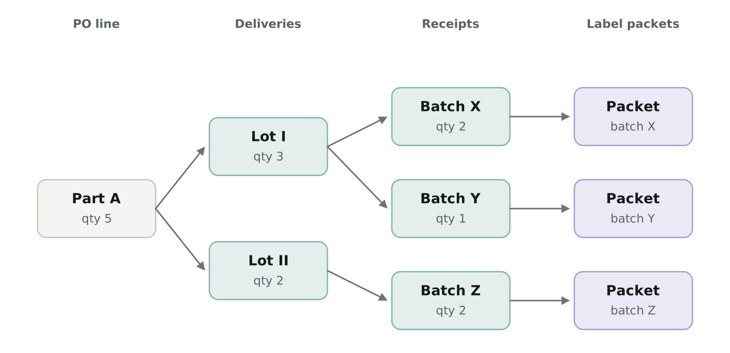
Figure 3 — One order for five units arrives as two lots and is received as three batches, each with its own expiry date and label packet. Any model that assumes a straight chain will be wrong.
This is why "where is my order" has no single answer today, and why the data layer must model delivery lines and receipt lines as distinct levels, each carrying its own quantity. It also makes quantity reconciliation between levels a derived check rather than a manual one.

4.2 The timestamps that matter
Almost every metric the site wants is the difference between two of the following. Three are reliably captured today; two are not.
Event | Where it lives today | Reliable?
PO promised date | SAP purchase order line, plus vendor confirmation | Yes, subject to confirmation practice
Scheduled arrival window | IRQ, typed by a planner | Yes, but drifts from SAP
Booking confirmed | Individual email inboxes | No — not systematically captured
Goods receipt posted | SAP material document | Yes — the strongest anchor
Sampling started and completed | IRQ flag, LIMS, QC SharePoint list | Partially — split across systems

5. Proposed solution
Build one read-only data layer that joins the existing systems on enterprise-standard keys — purchase order line, material and batch — and serve every view from it. Source systems continue to operate unchanged. What changes is that their data can be read together, and that information already held in SAP stops being retyped.
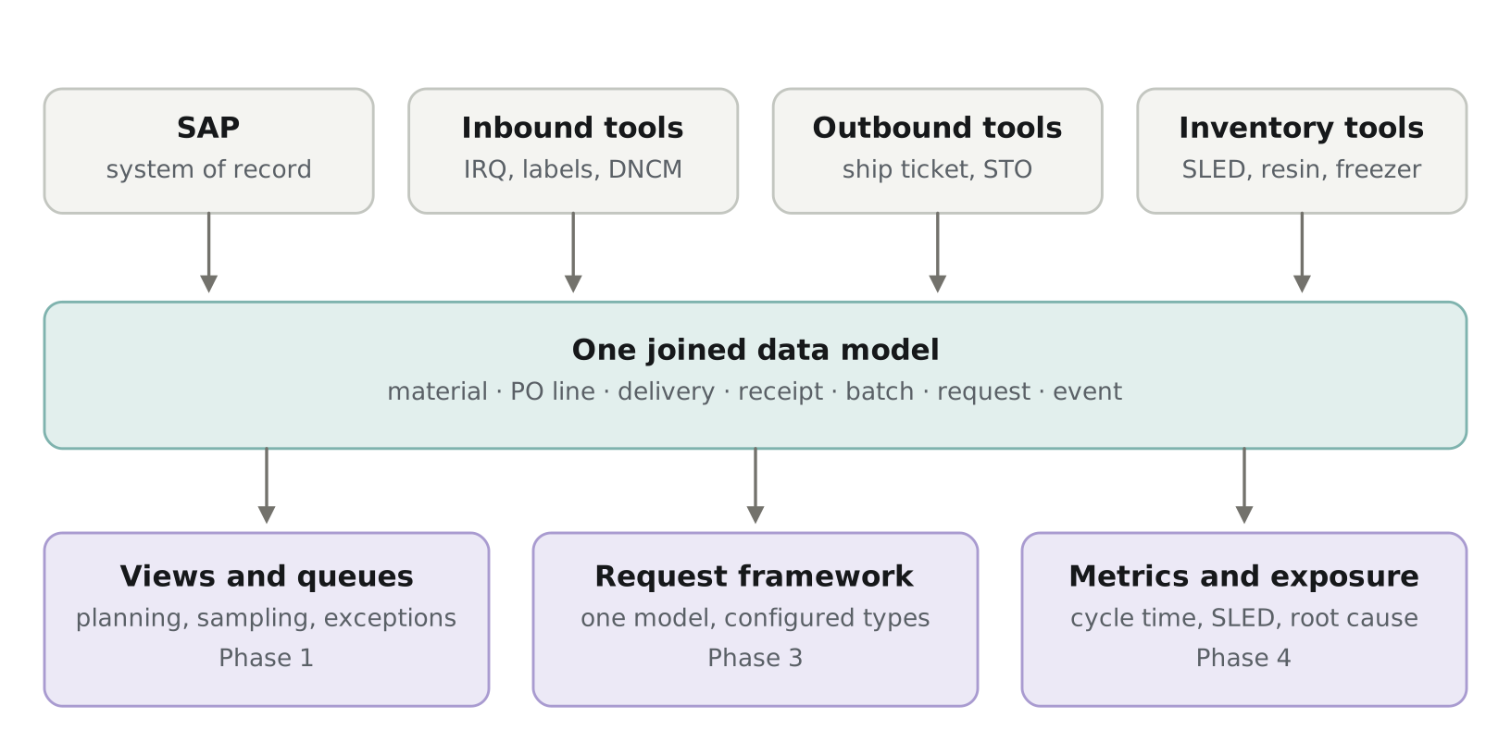
Figure 4 — Target state across all three domains. One model underneath; views, request types and metrics served from it. The phase labels show when each layer arrives.
The same structure answers all three domains, which is the point. Inbound needs views and queues. Outbound needs a request framework, because its eight applications are the same shape implemented eight times. Inventory needs metrics and exposure, because its gap is measurement rather than workflow. All three are served from one model, so a question that crosses domains — what is arriving for a project whose existing material expires next quarter — becomes answerable for the first time.

5.1 Architecture
- Raw landing. Each source is pulled on a schedule and stored exactly as received, immutable and timestamped. For SAP specifically, this is a daily automated export emailed by the logistics team and loaded into the layer every 24 hours — confirmed workable with logistics, and the only source handled this way. This gives replay after a transform error and an audit trail when a number is disputed.
- Canonical model. One adapter per source maps into a shared model: material, PO line, delivery line, receipt line, batch, label packet, request, event. When a source changes shape, one adapter changes.
- Event table. Append-only record of every state transition with its timestamp. Every cycle time is derived from it rather than stored, so a new metric is a query, not a schema change.
- Serving views and a read API. Denormalised views, one per question. The planning view, any reporting and any future service read through the API, never the database directly.
- Loads are incremental and idempotent. Re-running a window produces identical results, which matters because supply chain data arrives late, out of order and corrected.
Volumes are small — on the order of 2,100 IRQ entries a year and a few hundred thousand rows across all entities. No specialised infrastructure is required.

5.2 Identity resolution
Joining the systems is the one genuinely hard technical problem, because not every record carries a purchase order number. Three tiers are used, and the match rate is reported from day one rather than hidden:
- Exact key match where a PO line, material or batch number is present.
- Deterministic rules where a key can be derived — vendor plus material plus date window.
- A reviewed crosswalk table for the remainder, with an unmatched queue a person clears.
Reporting the match rate turns poor source data into a visible, fixable number rather than a silent defect in the layer.

5.3 Scope boundary and classification
The system is architected to stay outside GxP scope. This is a deliberate design constraint and it is what makes a lean Phase 1 credible.
In scope: read-only consumption of SAP, IRQ, DNCM and the label tracker; a joined model and derived views; status visualisation, exception views and reporting; a shared booking mailbox; procurement commentary stored in the layer’s own table.
Out of scope: any write-back to SAP or a validated system; approval routing or electronic signatures; records-retention claims; replacing any existing application; holding the authoritative version of any quality decision.
The one write: procurement comments are stored in the layer, against the PO line. This is not a GxP record and does not displace any system of record, but it is named explicitly here so it is not read later as scope drift. It is also what allows the Excel scheduler to be retired — a read-only view alone would not displace it, because the comment column is the reason the spreadsheet exists.
Required before build: a one-page classification assessment reviewed by QA and CSV. Several source tools inform GxP decisions even though they are not themselves GxP, so the classification is confirmed in writing rather than assumed. Adding write-back or approval routing in any later phase requires that assessment to be revisited.

5.4 Where AI is used, and where it is not
Phase 2 — booking email extraction. Carrier, reference, appointment date and time, pallet count and locations read from the shared mailbox into a draft IRQ entry, with a confidence threshold below which the record is held for review. This is the strongest AI case in the project because booking is the only step with no structured source at all. The planner confirms every draft; nothing is written automatically.
Phase 4 — semantic search over exception text. DNCM and Firm Zone free-text descriptions searched by meaning rather than keyword, to group recurring problems by vendor or material.
Not promised: late-delivery or excursion-risk prediction. That needs a substantial amount of joined history which does not yet exist. It is an outcome of the earlier phases, not a commitment in any of them.

6. Value
Ordered by financial weight. One figure is measured; the remainder are being confirmed with the supply chain team and are marked for completion.

6.1 Benefit areas
1. Avoided inventory write-off. Material reaching its shelf-life expiration date without being allocated is money already spent and discarded. SLED exposure is generated semi-automatically in Excel today and aging inventory has no tool at all, so exposure is not continuously visible. "At risk" requires joining expiry from the batch master with allocation held elsewhere — a join nobody can perform today and the layer performs by default.
2. Capacity returned to planners. Roughly 350 hours per year is spent creating IRQ entries, most of it SAP lookup and retyping. Conservatively around 250 hours is recoverable; the remainder is genuine scheduling judgement that stays with the planner. This is capacity to absorb volume.
3. Fewer silent discrepancies. Roughly 2,100 hand-typed entries a year is 2,100 chances for a date, quantity or vendor to be wrong or to go stale, and no mechanism exists to detect it. After Phase 1 the count of open IRQ entries disagreeing with SAP is a single query.
4. Earlier escalation on at-risk deliveries. Escalation currently happens at the standing purchasing meeting or when someone notices. Comparing promised, scheduled and actual dates daily moves that to same-shift, reducing production delay and expedited freight.
5. Fewer transcription errors in data feeding GxP decisions. Sampling flags, discrepancy records and label reconciliation all inform GxP decisions even though the tools are not GxP. Each removed re-key removes an opportunity to transpose a batch number or miss an excursion.
6. The site can finally answer why. Firm Zone already captures root cause, error category and impact score on every schedule break-in. Reporting on it costs a query and tells the site whether disruption is driven by equipment, human error, vendor performance or planning.
7. Lower maintenance burden on Digital Systems. The team currently maintains twenty-one applications: change requests, broken links, Excel refreshes, and a freezer dashboard the review records as broken. Each retirement removes a maintained surface permanently, and each new request answered as a view rather than an application avoids adding one. This is the only benefit in the list that compounds — it gets larger with every phase.
8. Shorter reconciliation. Much of the standing purchasing meeting is participants reading status to each other because no shared view exists.

6.2 Who benefits
Group | What changes for them
Planning | Entry time per IRQ falls from ~10 minutes to ~3; schedule drift against SAP becomes visible
Procurement | Commentary persists against the PO line with history, instead of being retyped each refresh
Logistics and dock | One view of what is arriving, in what window, with what exceptions
QC | A live sampling queue instead of a separately maintained list; forward view of sampling volume
Finance | SLED and at-risk exposure surfaced continuously rather than assembled in Excel
Site leadership | Inbound cycle time, on-time performance and break-in root causes for the first time
Data engineering | New requests become views on a shared model rather than new applications to maintain

6.3 Value figures to confirm
These are the numbers worth having before this goes to approval. Highlighted cells are to be completed with the supply chain team.
Figure | Value | Where it comes from
IRQ entries per month | 176 | IRQ — September 2026, main record
Minutes to create one entry | 10 | Timed with a planner
Annual hours on IRQ entry | ~350 | Derived from the two rows above
Minutes per entry on status updates, after creation | ________ | Planner — across the entry lifecycle
Hours per week maintaining the Excel scheduler | ________ | Whoever refreshes it for the purchasing meeting
Hours per week maintaining the QC sampling list | ________ | QC
Team hours per month maintaining the ~20 tools | ________ | Ticket history — available internally
Loaded hourly rate used to convert hours | $________ | Finance — needed to express hours in money
Inventory value written off to expiry, last 12 months | $________ | Finance — the strongest single figure
Inventory value within 90 days of SLED, unallocated | $________ | SLED file plus allocation — one-time snapshot
Expedite freight spend attributable to late inbound | $________ | Procurement / logistics
Booking-to-receipt, average days | ________ | Not measured today — Phase 1 output
Receipt-to-release, sampled vs certificate-released | ________ | Not measured today — later phase
Deliveries arriving outside the scheduled window | ________ % | Not measured today — Phase 1 output
Open IRQ entries that disagree with SAP | ________ | Not measurable today — Phase 1 output
DNCM entries per month arising at receiving | ________ | DNCM
Firm Zone break-ins per month, share inbound-related | ________ | Firm Zone
Label packets outstanding at any time | ________ | Label tracker — currently unanswerable

The two rows that matter most are the write-off figure and the loaded hourly rate. Hours saved only becomes a business case once it can be expressed in money, and avoided write-off is the only benefit here denominated in a currency finance already tracks.

7. Phased plan
Phases are ordered so that each one delivers something usable on its own and produces the evidence that justifies the next. Only Phase 1 is being requested now.
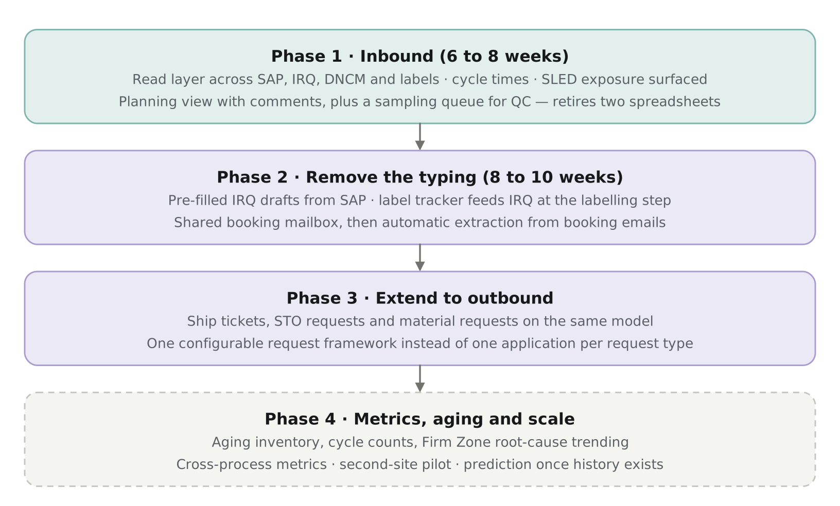
Figure 5 — Four phases. Phase 4 is dashed because it depends on history accumulated by the earlier phases.
Why inbound first. It is the smallest domain, it is the one where the duplication has already been measured, and the three-level fan-out from order to batch exercises the hardest part of the model. If the join works on inbound it will work elsewhere; if it does not, that is better discovered early. Outbound is deferred because its eight applications carry approval logic and are better rebuilt against a model that has been proven. Inventory is last because its value is measurement, and measurement needs the history the earlier phases generate — with one exception, the SLED exposure snapshot, which needs no history and is pulled forward into Phase 1.

7.1 Phase 1 — Inbound
Scope: purchase order line released, through vendor confirmation, booking, scheduled arrival, physical receipt and the handoff to sampling.
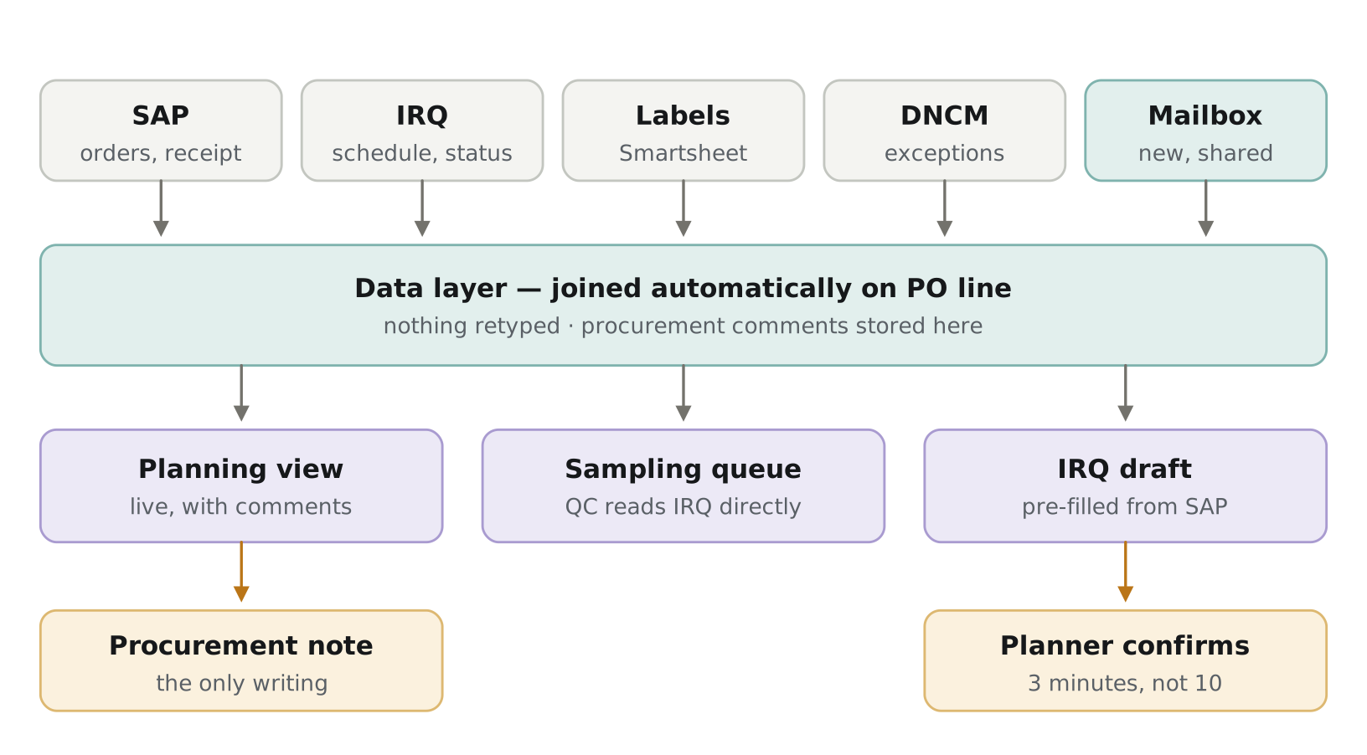
Figure 6 — Phase 1 in detail. Grey arrows are automatic. The two amber boxes are the only places a person still types, and both are judgement rather than transcription.
Deliverables:
- Read layer across SAP, IRQ, DNCM and the label tracker, joined on PO line, material and batch, with the match rate reported.
- Live planning view carrying procurement comments against the PO line — replaces and retires the Excel delivery scheduler.
- Sampling queue for QC, served from the IRQ flag and SAP receipt — replaces and retires the QC SharePoint list.
- Exception view: deliveries outside their scheduled window in either direction, bookings unconfirmed within 24 hours, receiving discrepancies from DNCM.
- Three-date comparison per delivery — PO promised, IRQ scheduled, actual receipt — separating vendor movement from carrier performance.
- First inbound cycle-time figures and a count of open IRQ entries disagreeing with SAP.
- One-time SLED exposure snapshot: inventory value within 90 days of expiry with no allocation.
- Shared team mailbox established for booking correspondence, so a corpus accumulates ahead of Phase 2.
Approach: built vertically, not horizontally. One real shipment is traced end to end through SAP, IRQ and the label tracker, only the entities it touches are modelled, and it is put on a screen. Then the second case, then the third. Building the full model before anything renders is the main way projects of this kind fail.
Gate to Phase 2: match rate high enough to trust, planning view adopted in place of the spreadsheet, and the value figures in section 6.3 completed.

7.2 Phase 2 — Remove the typing
- Pre-filled IRQ drafts: material, quantity, vendor and dates arrive from SAP; the planner sets the appointment window, pallets and carrier and confirms. Entry time falls from roughly 10 minutes to 3.
- Booking email extraction from the shared mailbox into draft entries, with a confidence threshold and a review queue. Handles revisions in a thread, not only the first message.
- Label tracker feeds IRQ at the labelling step, so a received entry is marked labelled and moves into sampling without a second system being consulted.
Gate to Phase 3: demonstrated reduction in entry time, extraction accuracy acceptable to planners, and confirmed ownership of whichever artifact is retired next.

7.3 Phase 3 — Extend to outbound
- Ship tickets, STO requests and material requests brought onto the same model. These share one shape — a requester, a material or batch, an approval chain, a status — so they become configured request types rather than separate applications.
- The duplication the business already flagged between the calibration scheduling tool and the ship ticket request is resolved in this phase.
Why third: outbound is a larger surface with more approval logic, and it benefits from a model proven on inbound first.

7.4 Phase 4 — Metrics, aging and scale
- Aging inventory — currently with no tool at all — and automated SLED exposure replacing the semi-automated Excel process.
- Cycle count variance and reconciliation speed into SAP.
- Firm Zone root-cause trending by category, vendor and material, with semantic search over exception free text.
- Cross-process metrics, second-site pilot, and an assessment of whether prediction is supportable once sufficient joined history exists.

7.5 Portability
Portability is a Phase 1 design decision, not a Phase 4 activity. Three choices made at the start determine whether another site can adopt this: joins use enterprise-standard SAP keys rather than Worcester identifiers; site is a configuration dimension present in the first schema; and source adapters are declarative mappings rather than bespoke code, so a second site writes configuration instead of commissioning development. What ports is the model, the SAP ingestion and everything above the canonical layer. What does not port is each site’s own helper-tool adapters — cheap individually, but written by someone who knows that site.

8. Risks and dependencies
Risk | Impact | Mitigation
SAP export cadence turns out too slow for a use case | Reduced usefulness for same-day escalation only | Mitigated: logistics has confirmed a daily automated email export works for Phase 1 scope. No SAP read-access approval required. Revisit cadence if a later phase needs tighter escalation timing
Users keep working in the spreadsheets they know | Adoption failure despite working software | Build with planning, dock and QC users in the room from the start; carry existing comments over so day one is not empty
IRQ holds only current status, not timestamped transitions | No historical baseline; metrics start from zero | Confirm before scoping. If confirmed, Phase 1 reports forward-looking metrics only and the cycle-time claim is adjusted
Label tracker sits in Smartsheet with separate access | One source unavailable at first | Confirm API access early; Phase 1 degrades gracefully without it
Identity match rate lower than expected on free-text records | Incomplete picture, reduced trust | Match rate reported from day one; reviewed crosswalk with an unmatched queue
Comment field attracts scope creep toward workflow | Read layer becomes a workflow tool | Comments only in Phase 1; anything structured is evaluated against whether IRQ should hold it instead
Retirement blocked for tools outside the team | A small number of artifacts persist | Most of the landscape is Digital Systems owned; the Smartsheet and corporate-owned items are the exceptions and are confirmed individually
New requests continue to be built as standalone apps | The pattern continues alongside the fix | Governance rule applied to Digital Systems intake: no new application without identifying which entity it extends
Single-person sustainment within the team | Unsupportable in two years | Standard platform, SQL in version control, documented; named secondary owner inside Digital Systems before Phase 2

What this will not do. It will not fix data quality at the point of entry — the match rate and drift count make existing quality visible rather than repair it. It will not retire any application unless an owner decides to. It will not predict anything in year one. And it does not replace SAP, LIMS or any validated system in any phase.

9. The ask
Approval of Phase 1 only. No new licences, no new platform. The cost is existing engineering time.

Needed from the business
- A daily automated SAP export for the inbound data set — purchase orders, goods receipts, material and batch master — emailed by the logistics team and loaded on a 24-hour cadence; confirmed workable with logistics
- A named business owner in supply chain who co-owns the problem and co-presents this
- Subject-matter time from planning, the dock and QC
- QA and CSV review of the one-page non-GxP classification assessment
- A shared team mailbox for carrier booking correspondence
- Business agreement to retire the two Phase 1 artifacts once their replacements are in use — both are maintained by Digital Systems, so this is a usage decision rather than a system-ownership negotiation
- Endorsement of the governance rule: new supply chain requests are evaluated against the shared model before a new application is built

Delivered in return
- A working inbound planning view carrying procurement comments, replacing the Excel scheduler
- A sampling queue for QC, replacing the separately maintained SharePoint list
- An exception view covering schedule deviation, unconfirmed bookings and receiving discrepancies
- The first inbound cycle-time figures and SLED exposure snapshot the site has had
- A documented recommendation on whether Phase 2 is worth funding
If the figures come back small, Phase 2 should not proceed, and the cost of establishing that is existing engineering time.

9.1 Open questions for the approval discussion
- Who is the named business owner, and will they co-present?
- Does IRQ timestamp each status transition, or hold only the current status? This determines whether Phase 1 can report historical cycle times or only forward-looking ones.
- Are vendor confirmations maintained in SAP, or is the PO line delivery date the only promised date available?
- Do receiving discrepancies reach DNCM, or only material-quality problems?
- Who can authorise retirement of a redundant tracking artifact?
- What is the expected sustainment path beyond the initial build?

Appendix A — Application disposition
Every application identified in the supply chain data structure review, and how this programme treats it. "Source" means the layer reads from it and it continues unchanged. "Revamp" means it remains in use with its data entry reduced. "Retire" means it is replaced by a view.
Most of these are Digital Systems applications — all of the PowerApps, and the spreadsheets maintained alongside them. The exceptions are the Smartsheet tools, which are owned by the teams that use them, and the corporate STO request, which is owned outside the site. Those three are the only entries where disposition requires agreement beyond Digital Systems and the supply chain owner.
Application | Platform | Phase | Disposition
IRQ | PowerApp / SharePoint | 1 and 2 | Revamp — remains the inbound coordination system; entry pre-filled from SAP
Delivery schedule / Excel scheduler | Excel | 1 | Retire — replaced by the planning view, comments carried over
QC sampling list | SharePoint | 1 | Retire — replaced by the sampling queue
DNCM | PowerApp / SQL | 1 | Source — exception and discrepancy data
Label tracker | Smartsheet | 1 and 2 | Source, then feeds IRQ at the labelling step
Firm Zone | PowerApp / SharePoint | 1 and 4 | Source — two inbound flags now, root-cause trending later
PO release file | Excel / SAP | 1 | Source — retirement candidate once the planning view covers it
SLED file | Excel / SAP | 1 and 4 | Source for the exposure snapshot; automated in Phase 4
Ship ticket | PowerApp / SharePoint | 3 | Revamp — becomes a configured request type
Material request | PowerApp / SharePoint | 3 | Revamp — becomes a configured request type
STO request (corporate) | React / SQL | 3 | Source — corporate owned, read only
Calibration scheduling tool | Smartsheet | 3 | Retirement candidate — duplication with ship ticket already flagged
DSP request | PowerApp / SharePoint | 3 | Revamp — distinct purpose; pre-filled from OneTrack and SAP, scope extended
Vial transfer database | PowerApp / SharePoint | 3 | Retire — function already absorbed by ship ticket
PSP ship app | PowerApp | 3 | Retire — already an aggregation of other systems; becomes a view
Cycle count / kitting requests | Smartsheet | 3 and 4 | Keep submission — add the variance and reconciliation metrics it lacks
Used resin and TFF membranes | PowerApp | 4 | Keep — SAP structurally cannot hold this; add aging visibility
Freezer directory | SharePoint | 4 | Source — storage location context
Aging inventory | No tool today | 4 | New capability — nothing to retire
eMDO | — | 4 | Source — assess in the inventory phase
Wrap-up and project planning files | Excel | 4 | Later — assess once metrics exist

Counts: two artifacts retired in Phase 1 and four more identified across Phases 3 and 4; three applications revamped; the remainder read as sources. No application is retired without its owner’s agreement, and nothing is retired before the replacement is in use.

A.1 Reasoning on the outbound and inventory applications
Several applications look similar from the outside but are not equivalent. Separating genuine duplication from systems that exist for a structural reason matters, because retiring the second kind would lose data that has nowhere else to live.

Retire — the function has already moved
Vial transfer database. The review records that this is part of ship ticket now, because the shipping team executes the work and wants to allocate their time against it. Its approvals run through a separately completed and signed form, so the application is not carrying the control. It is a leftover holding cell-bank issuance requests, and it folds into ship ticket in Phase 3 once the shipping team confirms nothing unique remains in it.
PSP ship app. Its purpose is planning and organising shipments against planned release times for manufactured projects, and it is already assembled from a Smartsheet datashuttle and the One Batch summary from Infor. It is an aggregation of other systems, which is what the data layer does natively — so it becomes a planned-release shipment view rather than an application. Note that Infor is a source this programme has not otherwise accounted for and would need to be scoped in Phase 3.

Revamp — distinct purpose, reduced entry
DSP request. New material set-up and onboarding, with a genuine approval chain across planning, QA and finance. Nothing else at the site does this, so it stays. The review notes its data can be sourced from OneTrack and SAP, that user feedback is mixed, and that users want material updates and extensions added to its scope. It becomes a configured request type with part number and sourcing information pre-filled, its scope extended to updates and extensions, and the dashboard the review says needs refreshing.
Cycle count and kitting requests. The submission itself needs a person — somebody physically counts — so it stays as a configured request type. What is missing is measurement, and the review states exactly what: variance by suite over time, and how quickly inventory is rectified in SAP. Both become derivable once counts and SAP movements sit in one model. This application is more valuable to the programme as a metrics source than as a workflow to rebuild.

Keep — structurally necessary
Used resin and TFF membranes. This is a shadow inventory repository, and it exists for a structural reason: resins and cassettes stop being tracked in SAP once cycles are depleted, and the review records that adding cycles to SAP was rejected on monetary grounds. SAP will not hold this data, so the application is the only record and must not be retired. What the programme can do is answer its stated request directly — the review asks whether aging materials can be flagged, notes that this does not work today, and asks for better visual tracking by age. The Phase 4 aging work satisfies that by reading from the application rather than replacing it.

