EEL-203 PROJECT: Elevator Controller System
Project Name: Elevator Controller System
1. Anu Yadav (B24EE007)
2. Bhumi Tapdiya (B24EE011)
3. Anjil Gupta (B24EE004)

Objective
To design and implement a Verilog code for a 4-floor elevator controller that manages internal floor requests and external call buttons, implementing a standard elevator movement protocol (continuing in the current direction until all requests in that direction are fulfilled).
Working Principle
The elevator controller operates on a 4-floor model (Floor 0 to Floor 3). Its behaviour is dictated by the current floor, the current direction of travel, and all pending requests.
- Request Consolidation: The system receives internal requests (inside the car) and external call buttons (up/down calls from each floor) and combines them into a single set of pending requests for each floor.
- Stopping Condition: When a request is present for the current_floor, the elevator stops, and the door opens (door_open = 1).
- Movement Logic (The Look-Ahead Strategy):
  - If the elevator is moving up (direction_up = 1): It will continue moving up to the next floor (current_floor + 1) as long as there are any requests above it (requests_above = 1).
  - If there are no more requests above it, the direction is reversed (direction_up = 0), and if requests exist below it, the elevator starts moving down (direction_down = 1).
  - If the elevator is moving down (direction_down = 1): It will continue moving down to the next floor (current_floor - 1) as long as there are any requests below it (requests_below = 1).
  - If there are no more requests below it, the direction is reversed (direction_down = 0), and if requests exist above it, the elevator starts moving up (direction_up = 1).
- Idle State: If the elevator is stopped and there are no current requests, it remains idle (direction_up = 0, direction_down = 0). As soon as a request (internal or external) is made, the elevator starts moving towards the nearest requested floor (preferring to move up if requests exist above and below).

Flow Chart
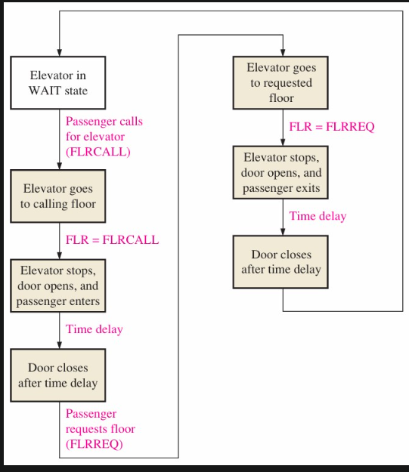

Understanding the Verilog Code
1. Inputs are received from users
The elevator takes 3 types of requests:
- Cab Requests (cab_req[3:0])
Buttons inside the elevator.
- Up Hall Calls (call_up[2:0])
Up buttons on floors 0–2.
- Down Hall Calls (call_down[3:0])
Down buttons on floors 1–3.
2. All requests are stored in pending_requests
- The controller stores all active requests in a 4-bit register:
- If any button is pressed, that bit becomes 1.
- Requests stay ON until the elevator reaches that floor and clears it.
3. Reset initializes the elevator
When reset = 0:
- Elevator goes to floor 0
- Door starts open
- Direction is set to UP
- Elevator is not moving
This is the starting state of your 4-floor elevator.
4. Controller checks if there are any requests
If no requests exist.
- Elevator remains idle
- Door remains open
- No movement
This saves power and mimics real lift behaviour.
5. If requests exist, system decides the target floor
A simple priority logic is used:
• The system checks floors 0 → 3
• The first floor with a pending request becomes the target floor
• This is stored in target_floor
Example: pending_requests = 0101
→ Target floor = 0 (lowest requested floor)
6. Compare current floor with target floor
Elevator now compares:
• current_floor
• target_floor
Three conditions determine movement:
7. If elevator is BELOW target → Move UP
Condition: current_floor < target_floor
Actions:
• Set direction = UP
• Close door
• Set moving = 1
• Increase floor number by +1 each clock cycle
8. If elevator is ABOVE target → Move DOWN
Condition: current_floor > target_floor
Actions:
• Set direction = DOWN
• Close door
• Set moving = 1
• Decrease floor number by -1 each clock cycle
9. If elevator REACHES target floor → Stop
Condition: current_floor == target_floor
Actions:
• moving = 0
• door_open = 1
• clear pending_requests[current_floor] = 0
So the request is served.
10. After serving, elevator checks for next request
Once a request is cleared:
• Controller looks again for any pending request
• If found → repeats movement
• If none → keeps door open and stays idle
11. The elevator continues this cycle forever
This controller keeps:
• Checking requests
• Moving the car
• Opening/closing doors
• Clearing floors
• Updating direction
until simulation ends or power is turned off.
Timing Diagram: 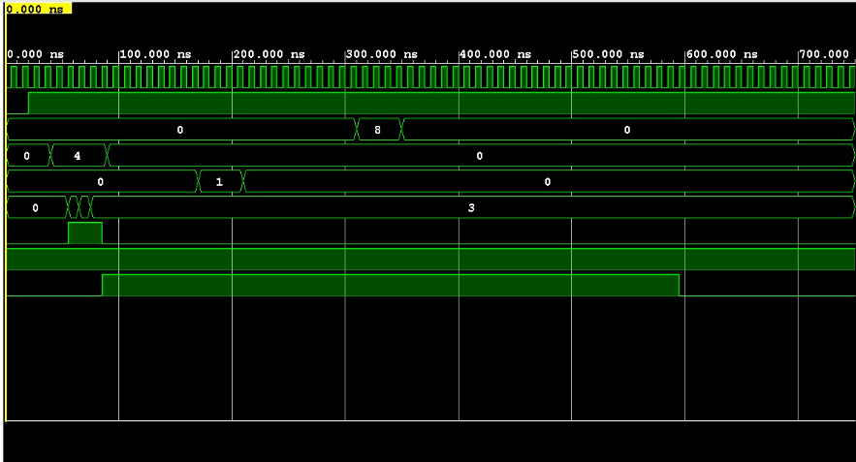
Applications
- Smart Buildings and Homes: Integrating with building management systems for automated and efficient floor access.
- Industrial Automation: Conveyor systems or vertical transport in warehouses and factories.
- Security Systems: As a component of access control in multi-story facilities.

Conclusion
We have successfully designed and implemented a synthesizable Verilog module for a 4-floor elevator controller. The design adheres to the standard elevator protocol of servicing requests in the current direction of travel before reversing, demonstrating a practical application of sequential and combinational digital logic design.

