Project Proposal
On
Flight Ticket Booking System



Submitted By:
Anjila Subedi
NCC ID: 00175854
Batch: '23' L5DC
Softwarica College of IT and E-Commerce

Submitted To:
Sudeep Lal Bajimaya

Table of Figures

Figure 1: Waterfall model 6
Figure 2: MVC pattern 7
Figure 3: 3-tier architecture 8
Figure 4: WBS 9
Figure 5: Gantt chart 12
Figure 6: Project local directory 15
Figure 7: GitHub directory 16

Table of Contents
Table of Figures 2
Chapter 1: Introduction 4
1.1 Introduction 4
1.2 Background of the project 4
1.2.1 Problem Statement 4
1.3 Justification of the project 4
1.4 Overview of the project 4
Chapter 2: Scope 5
2.1 Aims 5
2.2 Objectives 5
2.3 Features 5
2.4 Overview 5
Chapter 3: Development Methodology 6
3.1 Methodology to be used 6
3.2 Design Pattern 7
3.3 System Architecture 7
Chapter 4: Scheduling 9
4.1 Work Breakdown Structure (WBS) 9
4.2 Milestone 10
4.3 Scheduling/Gantt Chart 11
Chapter 5: Other Project Activities 13
5.1 Risk Management 13
5.2 Configuration Management 15
Conclusion 17
References 18

Chapter 1: Introduction

1.1 Introduction
A flight ticket booking system is a simple online booking system that handles all the information of customer as well as the flight information. This system is developed to provide customer satisfaction with great user interface. It will help to manage the flight system and also minimize the number vacant seat.

1.2 Background of the project
Flight ticket booking system is a digital system used by the customers for online booking. In past, due to lack of technology customer used to wait in line to book the ticket and it was offline desktop based system. But today the world is changing and with change this system is developed to provide the facility of online booking through any place at any time. Customer can view all the flight details and they can select their destination according to their interest. Online payment system is also available. They will also be able to update or delete the booking through the system.

1.2.1 Problem Statement
Today, the flight ticket booking system is not online based system. The system can faced lots of problem like unmanaged data etc. Thus, this system will help to manage the data properly and helps to minimize all the problem that may arise in the future.

1.3 Justification of the project
Thus, the project will help the staff to manage the customer information in an organized and secure way. It is user friendly system designed to provide easy way of reserving the ticket for customer destination. It helps to main a good-friendly relation between the system and the customer.

1.4 Overview of the project
The whole system is made using php core. This system will easily be available and used at any devices like PC's, Laptops, smartphone, tabs etc. This system is made for the easiness of the people in the office or outside the office. Also, this system can be used from anywhere but needed to be connected the internet.

Chapter 2: Scope

2.1 Aims
The aims of developing this project are as follows:-
- To design and implement which help the staffs of the airlines system to issue reservation tickets for various flights.
- It is develop to maintain or minimize the number of vacant seats on the flight.
- It helps to maintain the passenger's information in case of emergency.

2.2 Objectives
- User should be able to Login or register to enter to the system
- User should be able to view the flight details
- User must book the flight by providing their personal details for security check.
- User can pay online.
- User should be able to update and delete their details.
- User must be able to check the history.
- Admin should be able to insert, update and delete the flight details.

2.3 Features
Some of the features included in the system are as follows:-
- Admin
- Login/register in the system using Username and password
- Add/update/delete customer records
- Add/update/delete flight records
- Logout

- Passengers
- Login/Register using username and password
- Insert and update their details
- View flights details
- Pay online
- Compare flight fairs
- Logout
- Frequently asked questions

2.4 Overview
Flight ticket booking system is web based application design through core php. Anyone connecting to the internet can view this system and can book the ticket checking the flight details of their choice.

Chapter 3: Development Methodology

3.1 Methodology to be used
For the project I have chosen Waterfall Method for the development of this software. It is traditional System Development Life Cycle (SDLC) or waterfall approach. This method involves a complete set of steps that a team follows. This divide the development process into a series of phases or stages, each of which finishes before next one starts.
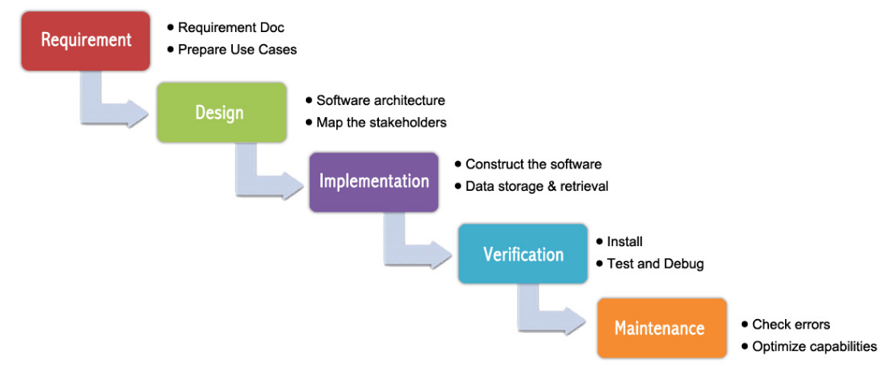
Figure 1: Waterfall model
- Advantage of waterfall model system
- It allows for departmentalization and control.
- It progresses through easily understandable and explainable phases and it is easy to use and understand.
- Easy to arrange task.

- Disadvantage of waterfall model system
- It is difficult to estimate time and cost for each phase of the development process
- It is not a good model for complex and object-oriented projects.
- It is difficult to measure progress within stages.
- Adjusting scope during the life cycle can end a project.

3.2 Design Pattern
Design pattern are a solution to a common problem in the software which are faced by the software developers. For this project I've decided to choose MVC deign patterns. Model View Controller (MVC) pattern is software pattern used for developing application. (Raji, 2017) It helps to manage the data, logic and rules of the application.
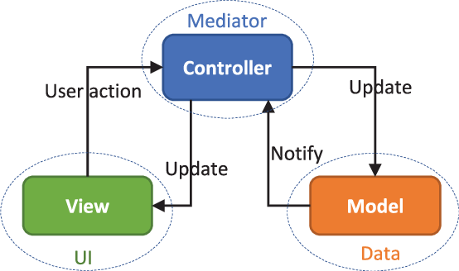

Figure 2: MVC pattern

3.3 System Architecture
System architecture defines the structure and behavior of the system. I have chosen 3-tier architecture for this project. It is a client server architecture with 3 tiers- presentation tier, application tier and data tier. (Rouse, 2007)
- Presentation tier:-A graphical user interface (GUI) built with HTML, CSS and JavaScript.
- Application tier:-It is written in Java language which handles logic and supports applications core functions.
- Data tier:-Also known as storage tier. It consists database and program for managing read and write access to database.
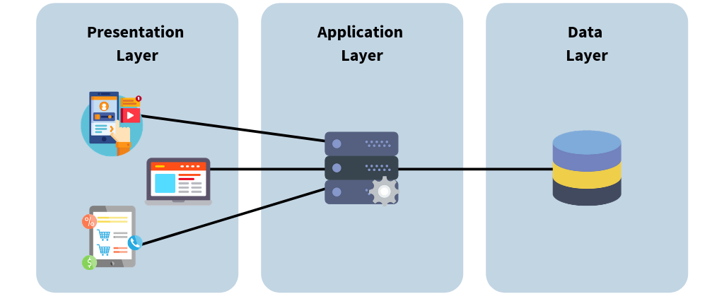

Figure 3: 3-tier architecture

Chapter 4: Scheduling

4.1 Work Breakdown Structure (WBS)
Work breakdown structure is a method that breaks the project into hierarchy of tasks and subtasks that will help in the completion of task in organized way. (Harned, 2019) It helps to provide detailed information regarding the project schedule for development and control. It helps to understand the task properly and task can be completed in the estimated date and time.
Figure 4: WBS

4.2 Milestone

S.NO | Task Description | Task Deadline
1. | Proposal | 1st July
2. | Analysis | 29th July
a) | Planning | 5th July
b) | Requirements Gathering | 15th July
c) | Feasibility Study | 19th July
d) | System Requirement Specification(SRS) | 25th July
e) | Use Case diagram | 29th July
3. | Design | 29th August
a) | Structural Diagram | 5th August
b) | Behavioral diagram | 8th August
c) | UI design | 22th August
d) | Database design | 29th August
4. | Coding | 20th September
a) | Frontend | 10th September
b) | Backend | 20th September
5. | Testing | 30th September
a) | Unit testing | 25th September
b) | Black box testing | 30th September
6. | Documentation | 12th October
a) | Final documentation | 8th October
b) | User Manual | 12th October
 | Final Submission | 12th October

As shown in above table, I will complete the project in 12th October. I will also finish the tasks and subtasks within their respective deadlines and submit my progress.
Description of the Milestones:
- Proposal (5 days)
- Analysis (20 days)
- Planning (4 days)
- Requirements Gathering (6 days)
- Feasibility Study (4 days)
- System Requirement Specification (4 days)
- Use case diagram(2 days)
- Design (23 days)
- Structural design (5 days)
- Behavioral design (3 days)
- UI design (10days)
- Database design (5 days)

- Coding (16 days)
- Frontend (8 days)
- Backend (8 days)
- Testing (6 days)
- Unit testing (3 days)
- Black box testing (3 days)
- Documentation (9 days)
- Final documentation (6 days)
- User manual (3 days)

4.3 Scheduling/Gantt Chart
Scheduling is the effective way of planning, allocating and arranging time for tasks and sub-tasks to be completed within the determined time frame. It helps us to complete the task in estimated time range. For scheduling I have used Project Libre to produce a Gantt chart for my project.
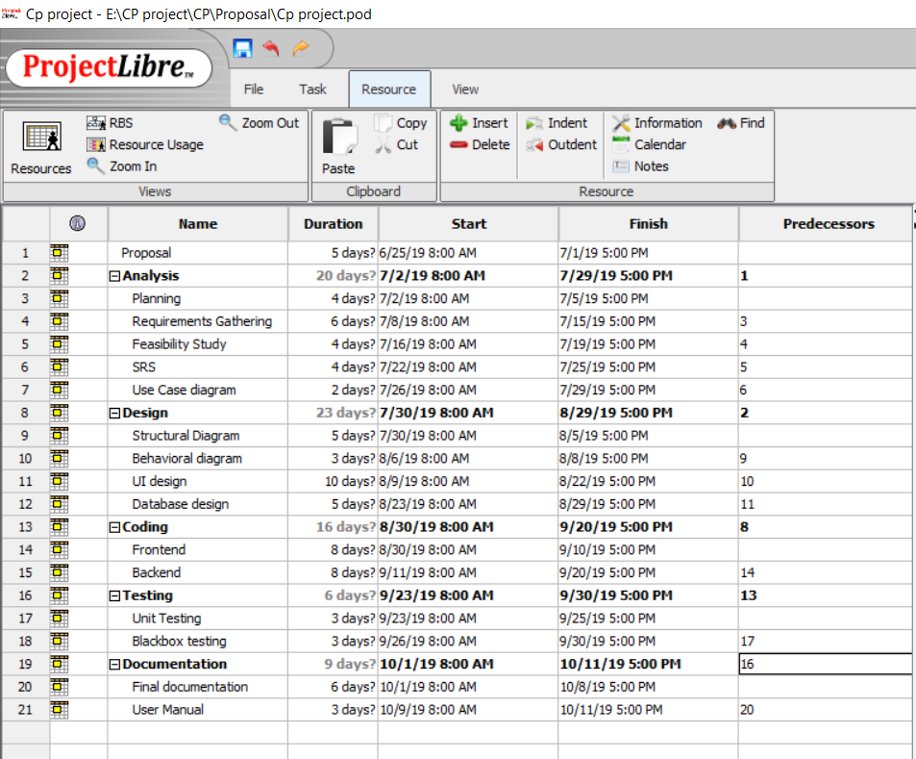
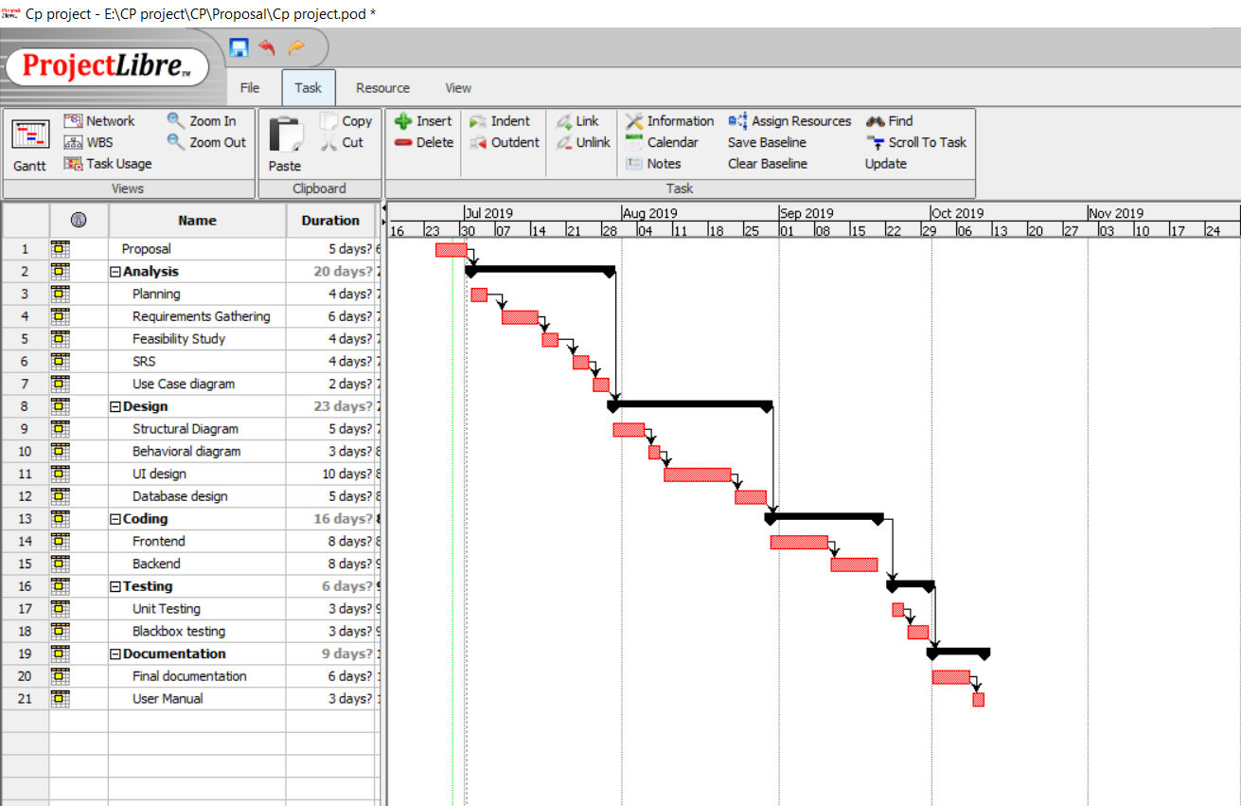
Figure 5: Gantt chart

Chapter 5: Other Project Activities

5.1 Risk Management
Risk management is the process of identifying, assessing and controlling threats to an organization's before the deployment of a system. Risk can cause huge impact on the system and it can also affect the data and financial information. So risk should be managed properly no matter how much they impact on the system. Risk management is done by providing useful precautions to the minimize risk which may harm the whole system.
For calculating process we will use two tables,
- Likelihood table
Likelihood | Value
Low | 1
Medium | 2
High | 3

- Consequences table
Consequences | Value
Very Low | 1
Low | 2
Medium | 3
High | 4
Very High | 5

Impact of risk is calculate by multiplying likelihood to consequences as shown below:-
Impact = Likelihood * Consequence

SN | Risks | Likelihood | Consequences | Impact | Actions
 | Virus | 2 | 5 | 10 | Antivirus software should be used to prevent Pc's from virus.
 | Hard drive Crash | 1 | 5 | 5 | Backup of the project must be kept.
 | Bugs | 1 | 5 | 5 | Testing should be done properly before deployment.
 | Limited Functionality | 1 | 4 | 4 | Requirements must be fulfilled properly.
 | Expensive than estimated budget. | 2 | 3 | 6 | Must go with the estimated budget or consult with the senior regarding the budget.
 | Time consuming | 2 | 3 | 6 | Must make schedules for tasks and follow the schedule.

The impacts which has score more than 6 and their precautions are as follows:-
- Virus: It is a type of malicious software which is the common risk that may occur in the system. It may corrupt the whole system by deleting the information and files stored in the Pc's. Some of the preventive measures are:-
- Blocking harmful sites.
- Antivirus software must be used.
- Backup of every data should be kept.
- Unusual link shared in email must not be opened.

- Time consuming: Time is an important factor that plays a vital role in the completion of the task. A proper planning and scheduling is very necessary to complete the project in time. Measures to be followed are:
- Managing time properly
- Following the schedule strictly

5.2 Configuration Management
A configuration management is the system used for tracking the hardware and software related information. It helps to handles the changes made in the system in such a way that it maintains integrity over time. It also helps to manage and organize the changes made in the files, codes etc. during the entire project lifecycle. (Anon., n.d.)
For this project, I have created multiple folder and their subfolder which can be used as backup files. I will also be using GitHub with account name "anjia12345" for online backup of all the files which will be updated in every 3-4 days after task completion. Backup is created to reuse the files in case of data loss or corrupt. Tree structure for my project is as given below:-
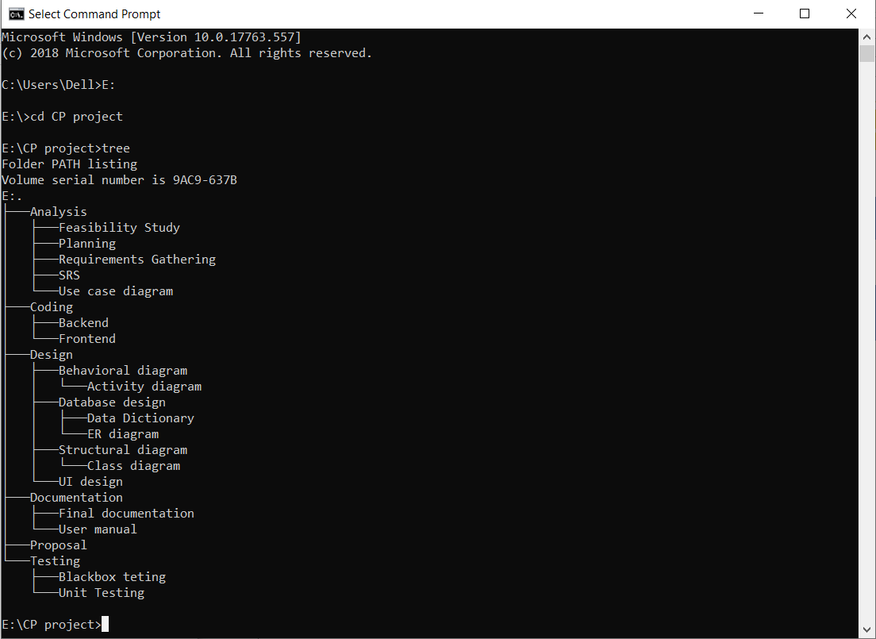
Figure 6: Project local directory

Below is the GitHub backup for my project:-
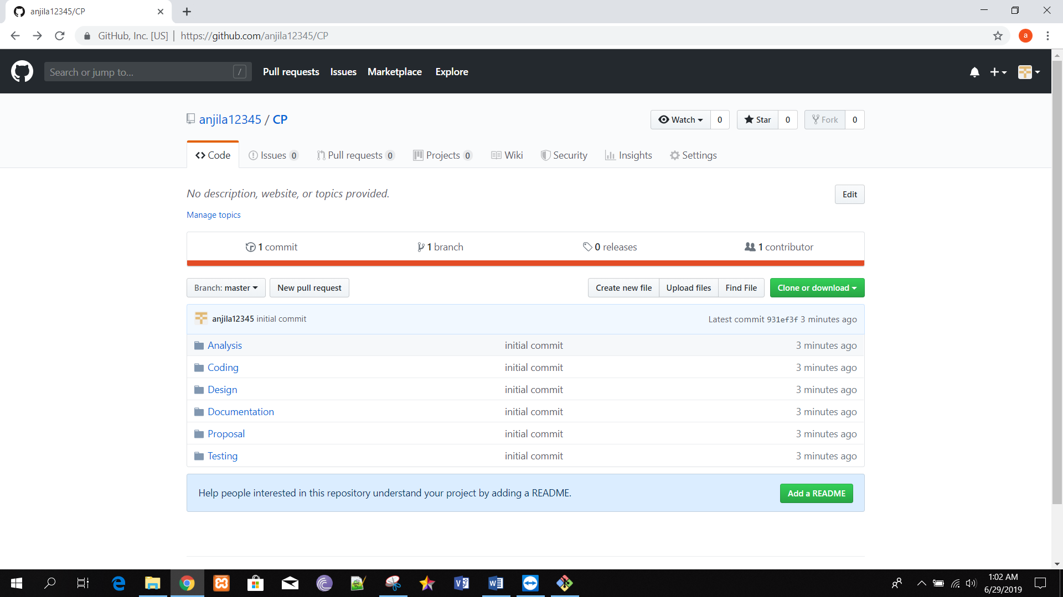
Figure 7: GitHub directory

Conclusion

Thus, the proposal is completed. This whole project is about flight ticket booking system which helps the customer to book the ticket online and helps to keep the record of data in secure way. WBS structure is created to break the task in different order which can be useful to complete the task in the exact time. Waterfall model and MVC design pattern will be in used while developing the system. This system will be easy to use and user friendly.

References
Anon., n.d. techopedia. [Online]
Available at: https://www.techopedia.com/definition/24822/configuration-controlconfiguration-management-cm
[Accessed 29 June 2019].
Harned, B., 2019. teamgantt. [Online]
Available at: https://www.teamgantt.com/blog/how-to-estimate-projects-accurately-using-a-work-breakdown-structure
[Accessed 29 June 2019].
Raji, S., 2017. Medium Corporation. [Online]
Available at: https://medium.com/@ormrepo/what-is-the-model-view-controller-design-pattern-e951816217d9
[Accessed 29 June 2019].
Rouse, M., 2007. TechTarget. [Online]
Available at: https://searchsoftwarequality.techtarget.com/definition/3-tier-application
[Accessed 29 June 2019].

