Testing

Testing is the process of finding out how well the work is done. It is also used to check whether it satisfy the requirements or not. An application must be well tested before lunching it. Software testing is done to identify error, gaps etc. in the requirements. There are various ways of testing the software like: - unit testing, black box testing, grey box testing etc. For this project I have chosen, black box testing.
Black box testing is also known as behavioral testing which is the software testing method. This testing is totally based on the software specification and requirements rather than focusing on the internal code. I have chosen this method because the tests are done from the user's point of view and it can also be done as soon as the requirements of the software is completed. Also the tester does not have to know how the code is implemented in the system for testing.
Black Box testing 1: Registration and validation
Test Case | Description | Task | Expected Result | Actual Result | Conclusion
1 | Register in the system. | Add all the necessary details. | New account created for the user. | User account created successfully. | Pass
2 | Validation of form. | Leave the form blank or email address not enter properly. | Give error message to the user. | Give error message to user. | Pass

Output:
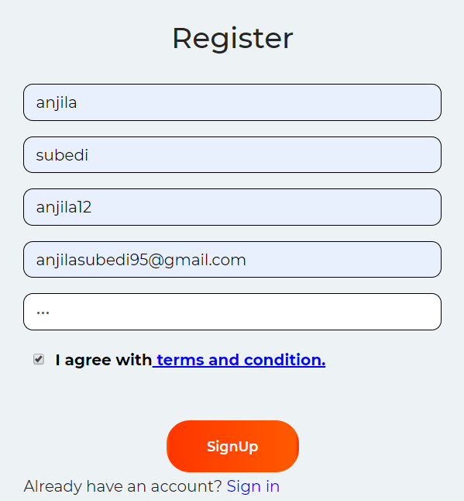
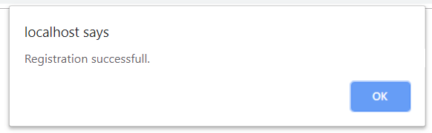
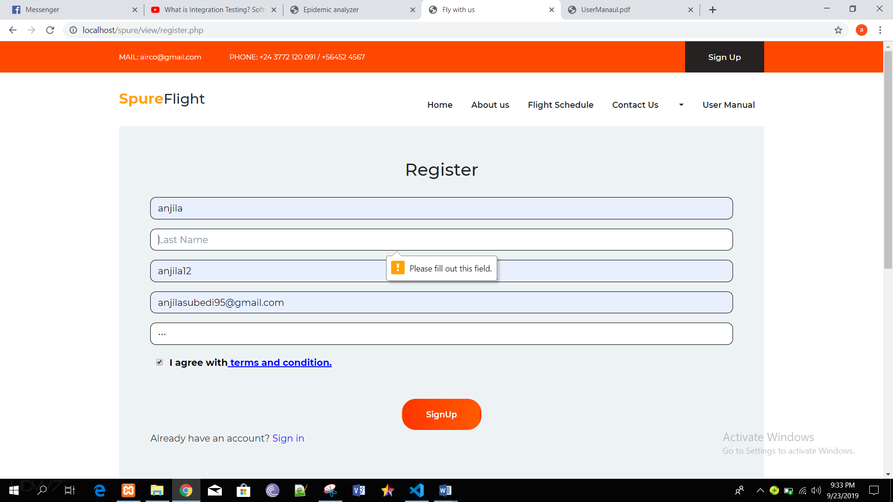
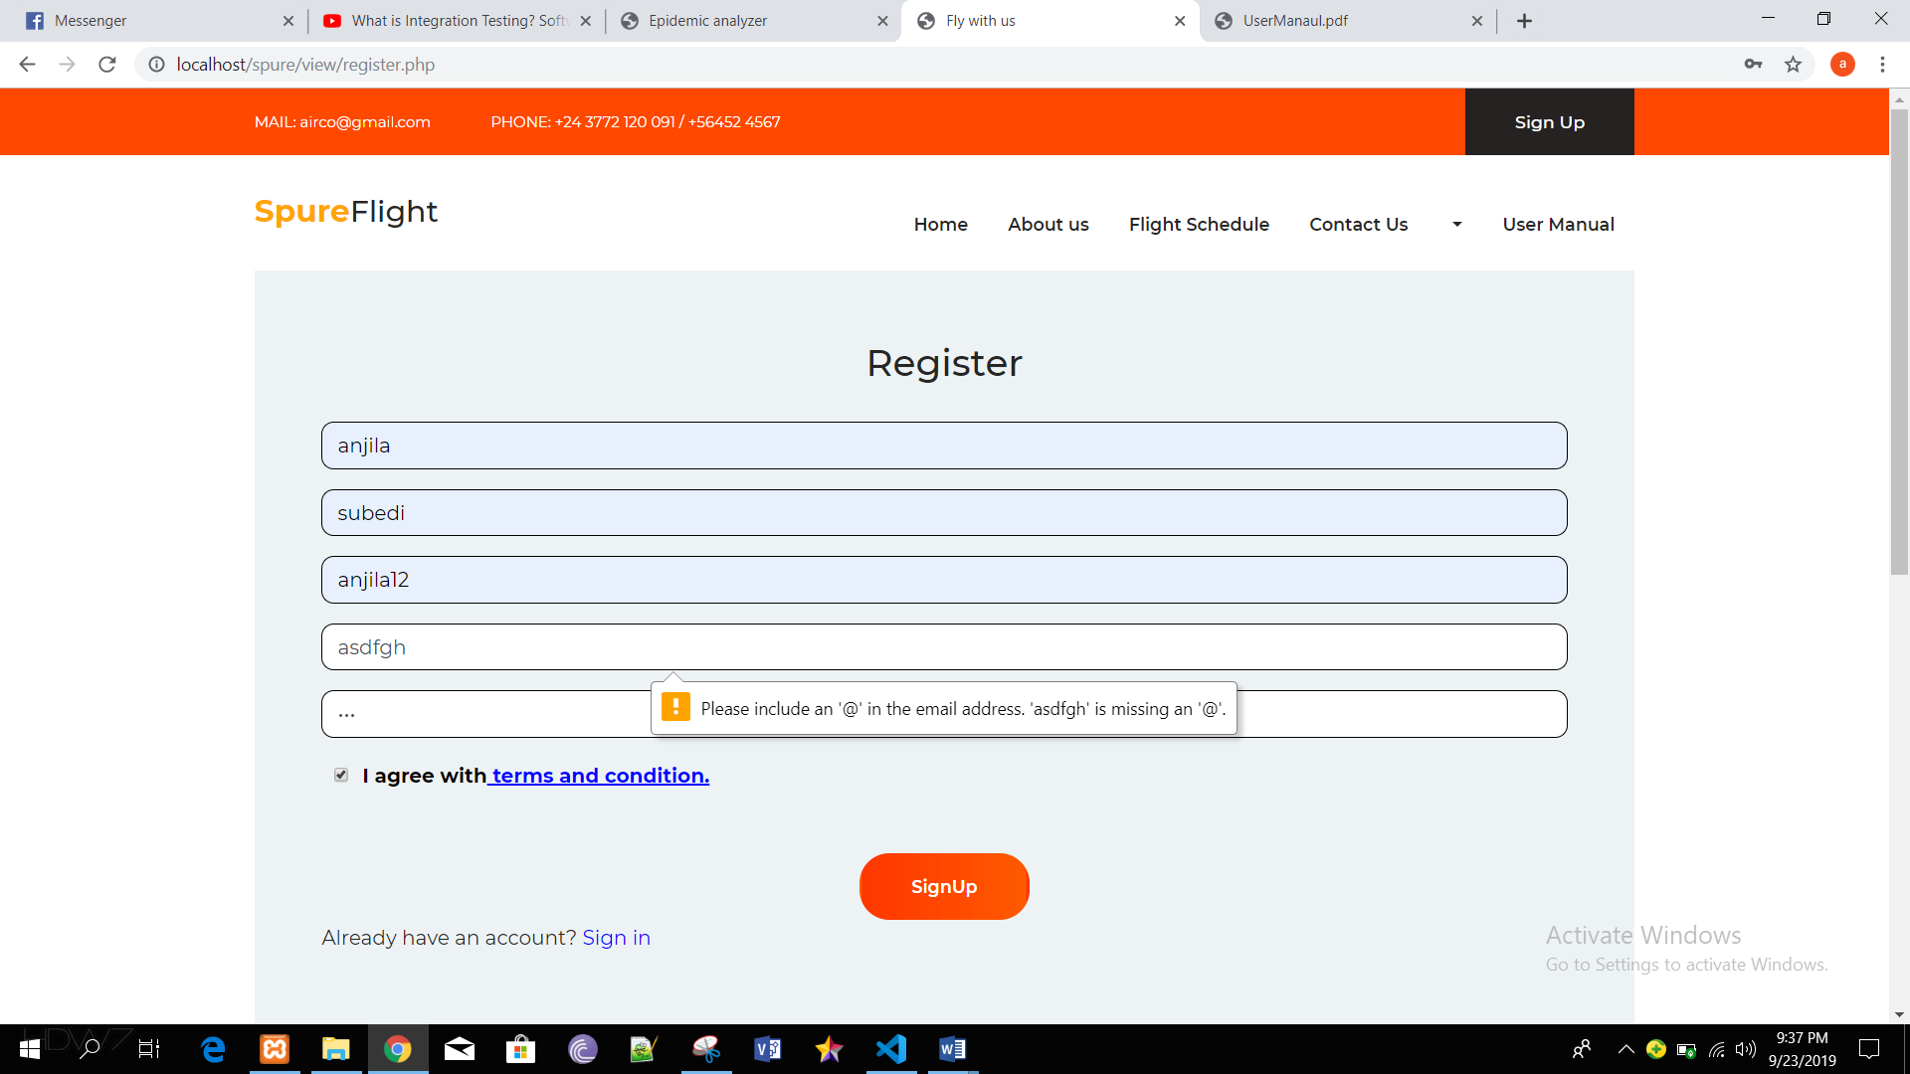

Black box test 2: Login
Test Case | Description | Task | Expected Result | Actual Result | Conclusion
1 | Login in the system. | Add username and password. | Login successful. | User is logged in to the system successfully. | Pass
2 | Invalid Login | Add invalid username and password. | User blocked for 60 sec after 3rd attempt. | User blocked for 60 sec after 3rd attempt. | Fail
3 | Validation of form | Leave any attribute blank | Error message must be displayed. | Error message is displayed. | Fail

Output:
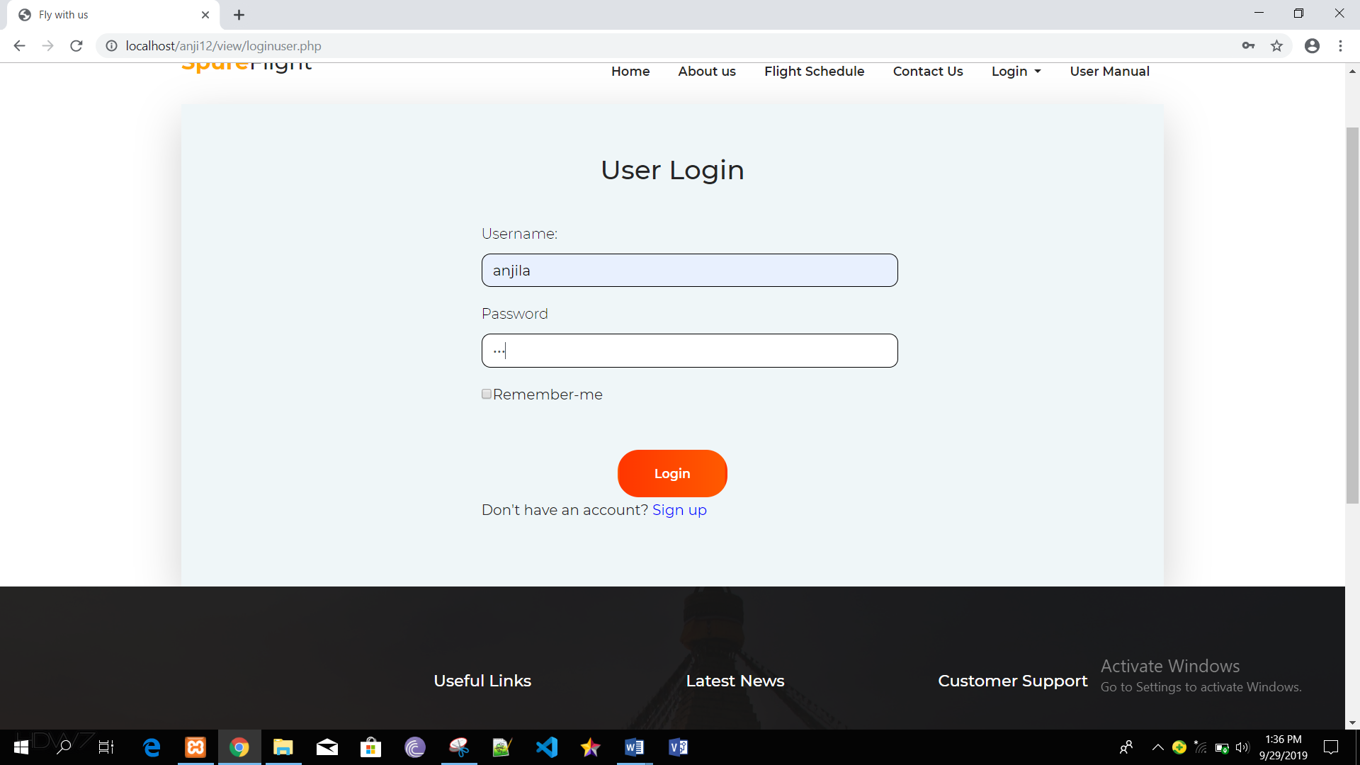
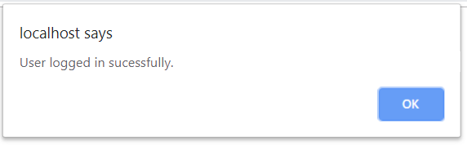
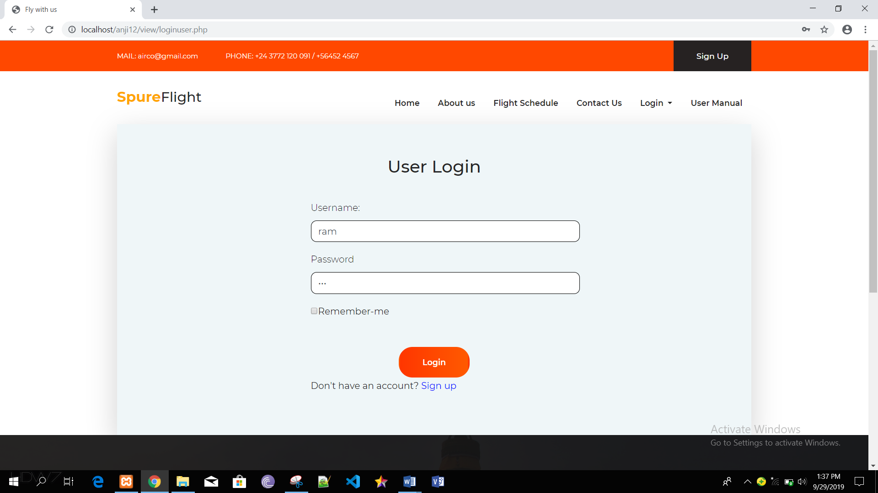
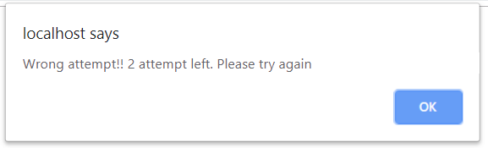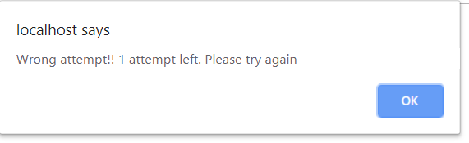
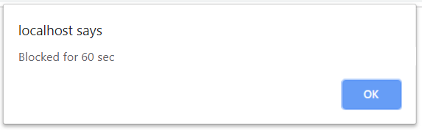
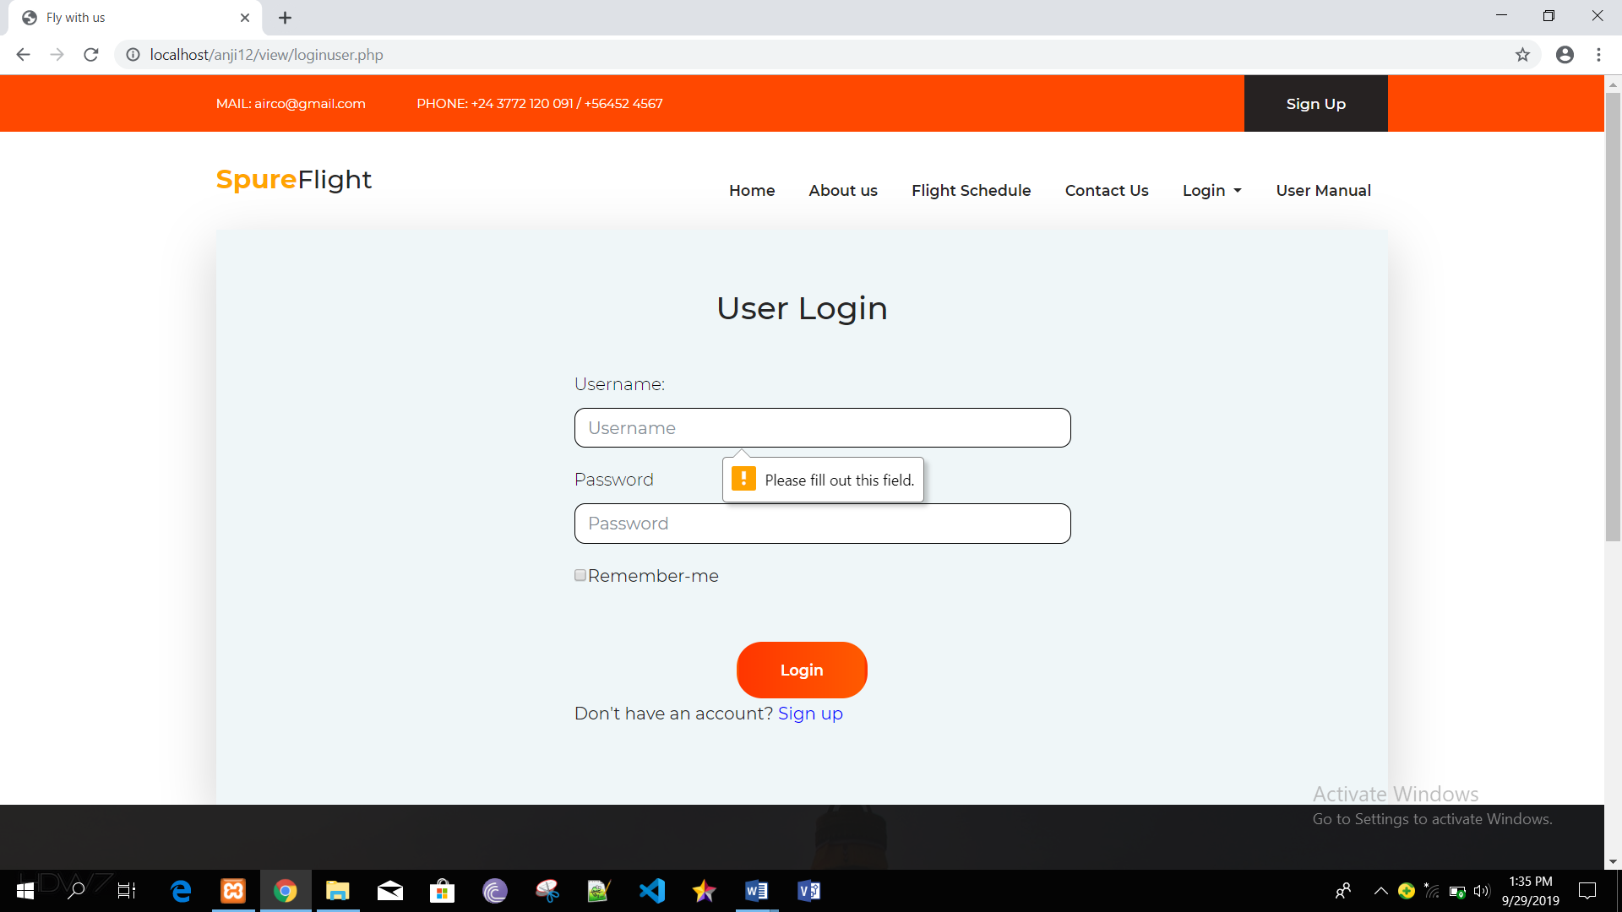

Black box testing 3: Add passenger details
Test Case | Description | Task | Expected Result | Actual Result | Conclusion
1 | Add passenger details. | Fill all the given attributes. | Data added successfully. | Data added successfully. | Pass
2 | Form validation | Leave all given attributes blank. | Error message must be displayed. | Error message was displayed. | Fail.

Output:
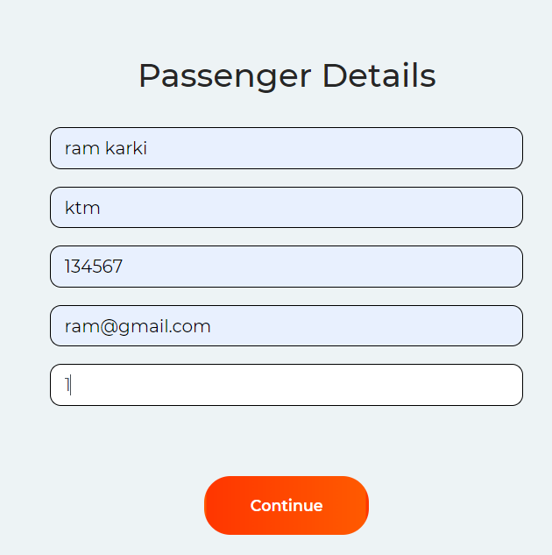
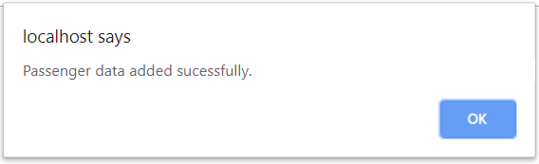
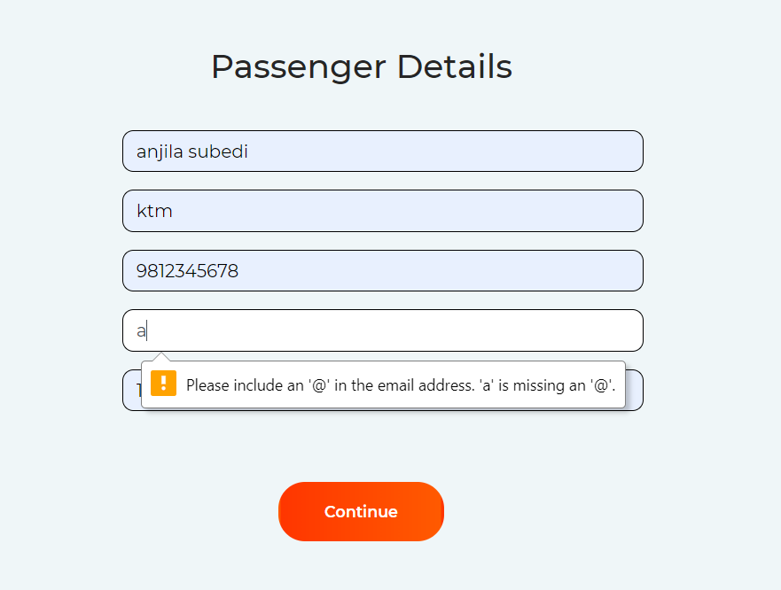

Black box testing 4: Add payment
Test Case | Description | Task | Expected Result | Actual Result | Conclusion
1 | Add payment details. | Fill all the given attributes. | Payment made successfully. | Payment made successfully. | Pass
2 | Form validation | Leave all attributes empty. | Error message must be displayed. | Message is displayed to user. | Fail

Output:
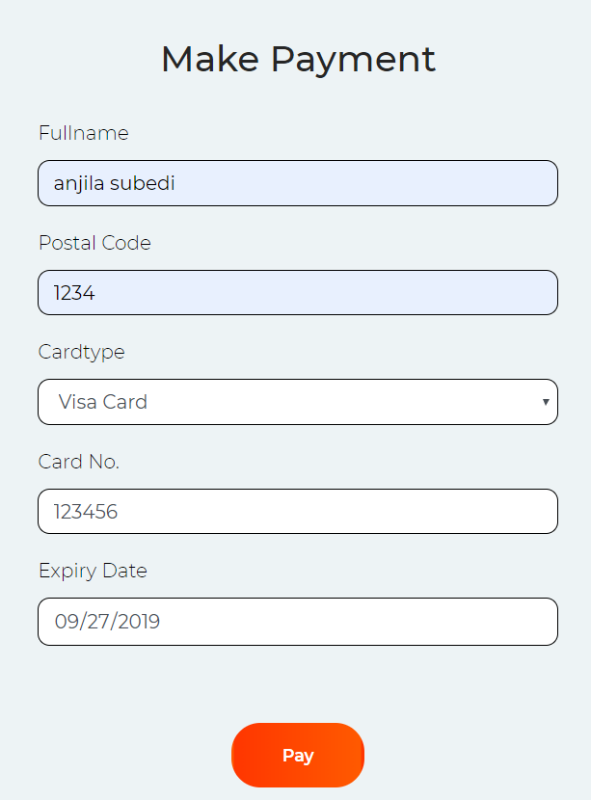
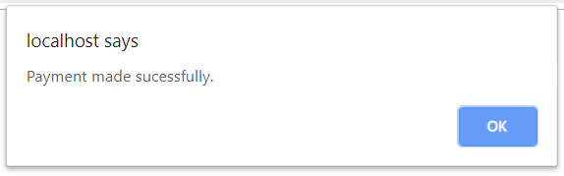
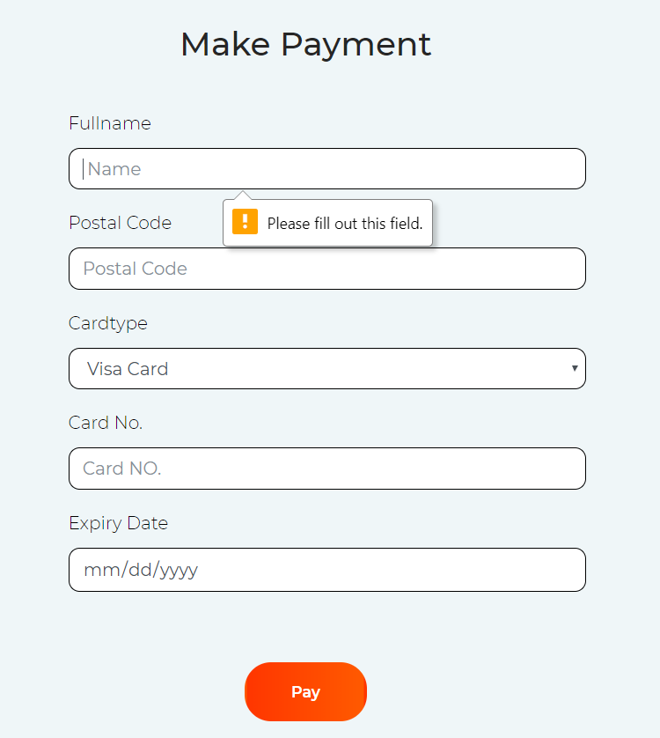

Black box testing 5: Add feedback
Test Case | Description | Task | Expected Result | Actual Result | Conclusion
1 | Add feedback | Fill the given details. | Feedback must be added successfully. | Feedback added successfully. | Pass
2 | Form validation | Leave any value blank. | Error message must be displayed to the user. | Error message displayed. | Fail

Output:
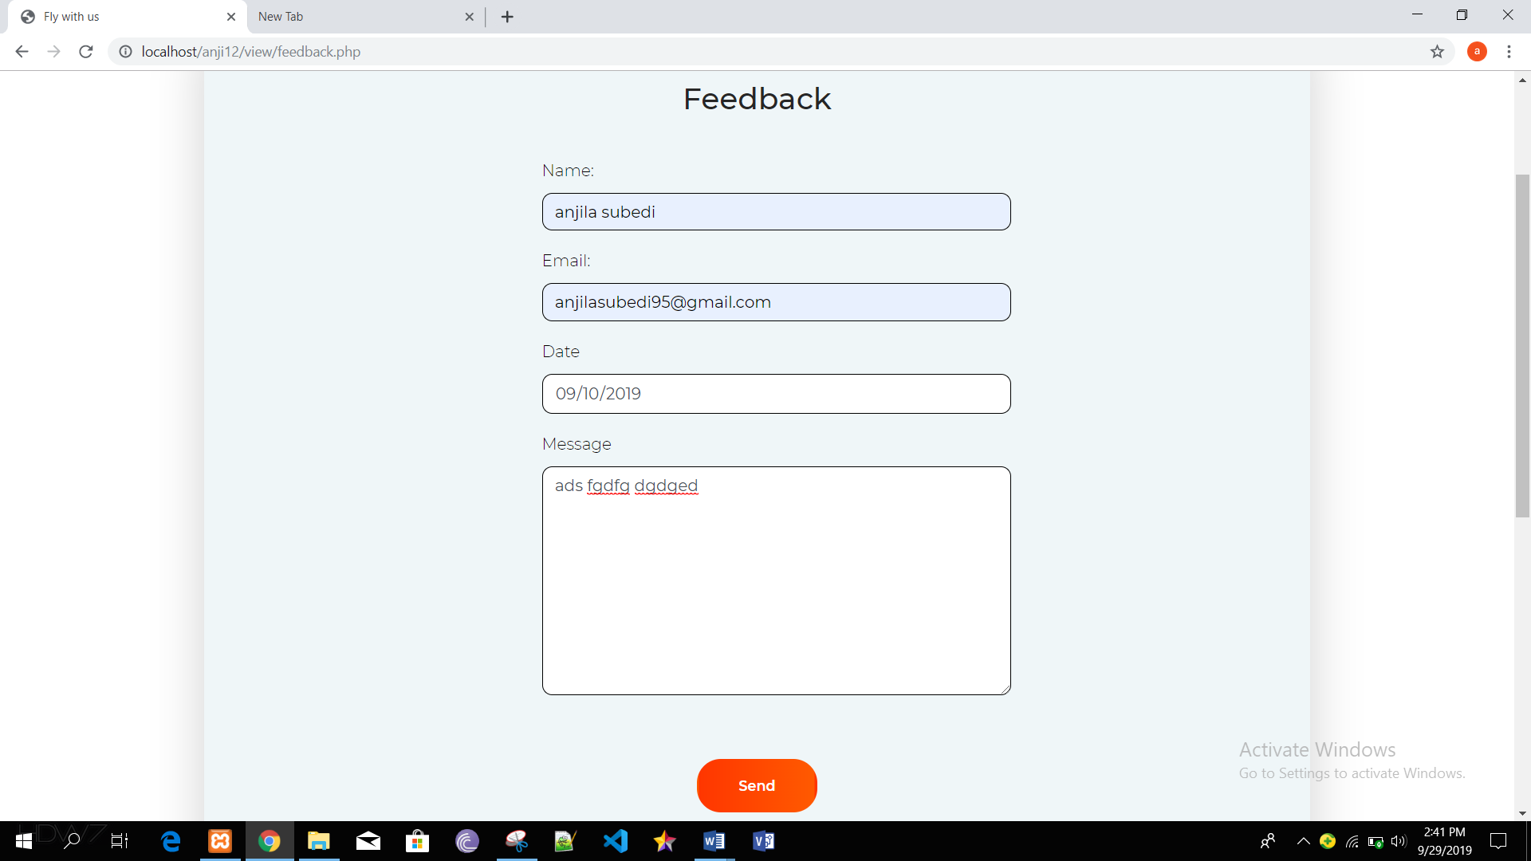
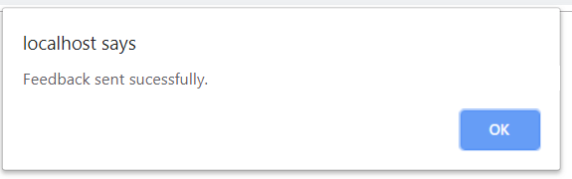
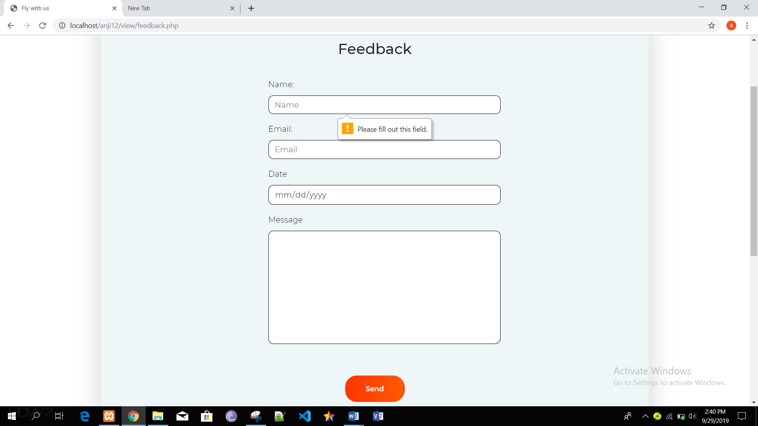

Black box testing 6: Cancel ticket
Test Case | Description | Task | Expected Result | Actual Result | Conclusion
1 | Cancel the booked ticket. | User can cancel the tickets. | Ticket must be canceled successfully. | Ticket cancelled successfully. | Pass

Output:
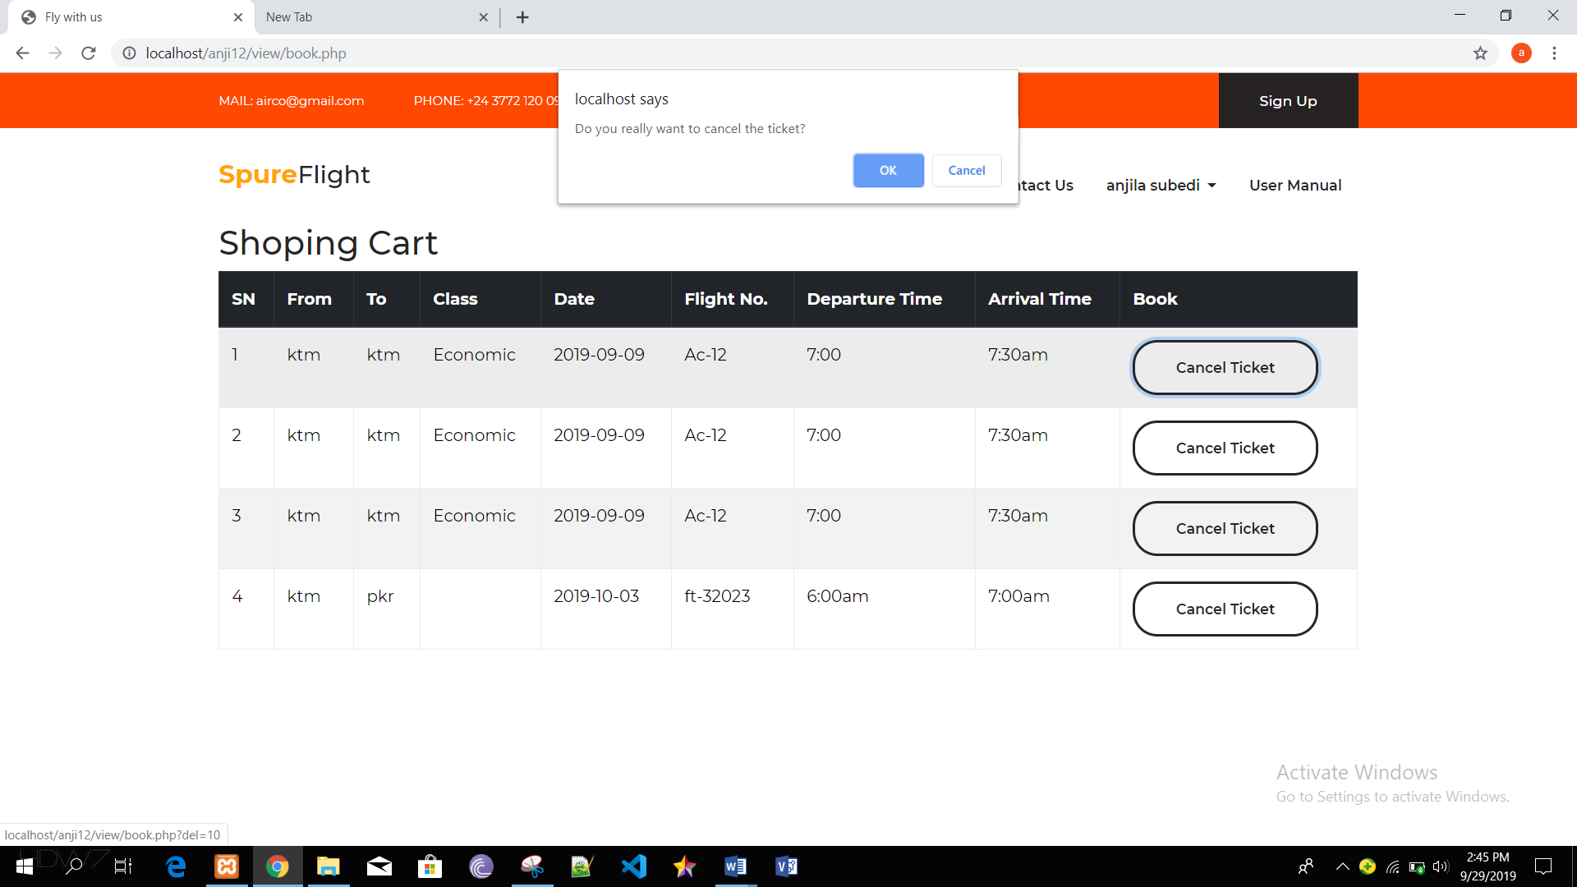
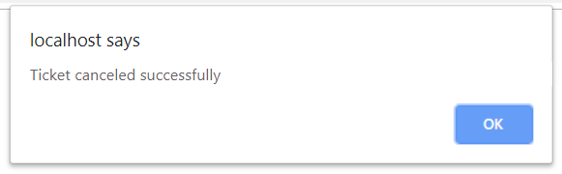

Black box testing 7: Admin Login
Test Case | Description | Task | Expected Result | Actual Result | Conclusion
1 | Login in the system. | Add username and password. | Login successful. | User is logged in to the system successfully. | Pass
2 | Invalid Login | Add invalid account details. | User and password did not match. | Login unsuccessful. | Fail
3 | Form validation | Leave any value empty. | Error message must be displayed. | Message was displayed. | Fail.

Output:
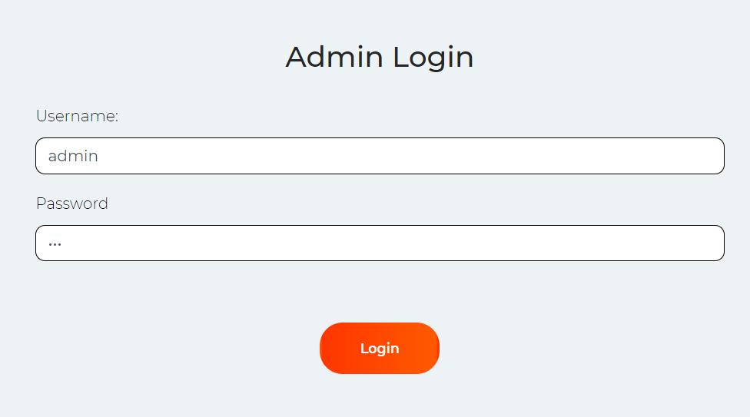
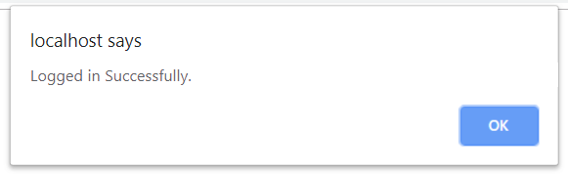
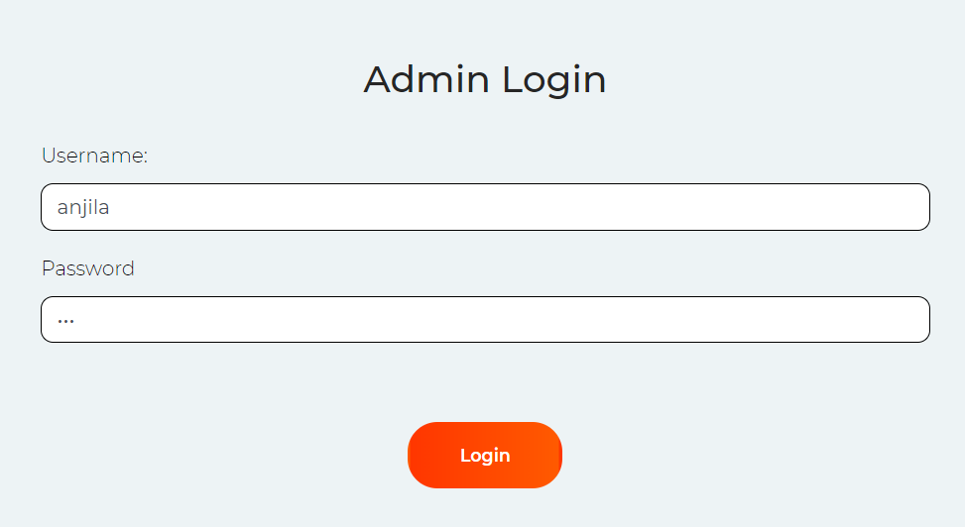
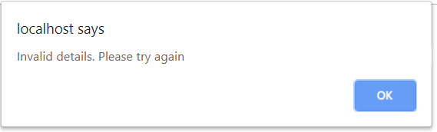
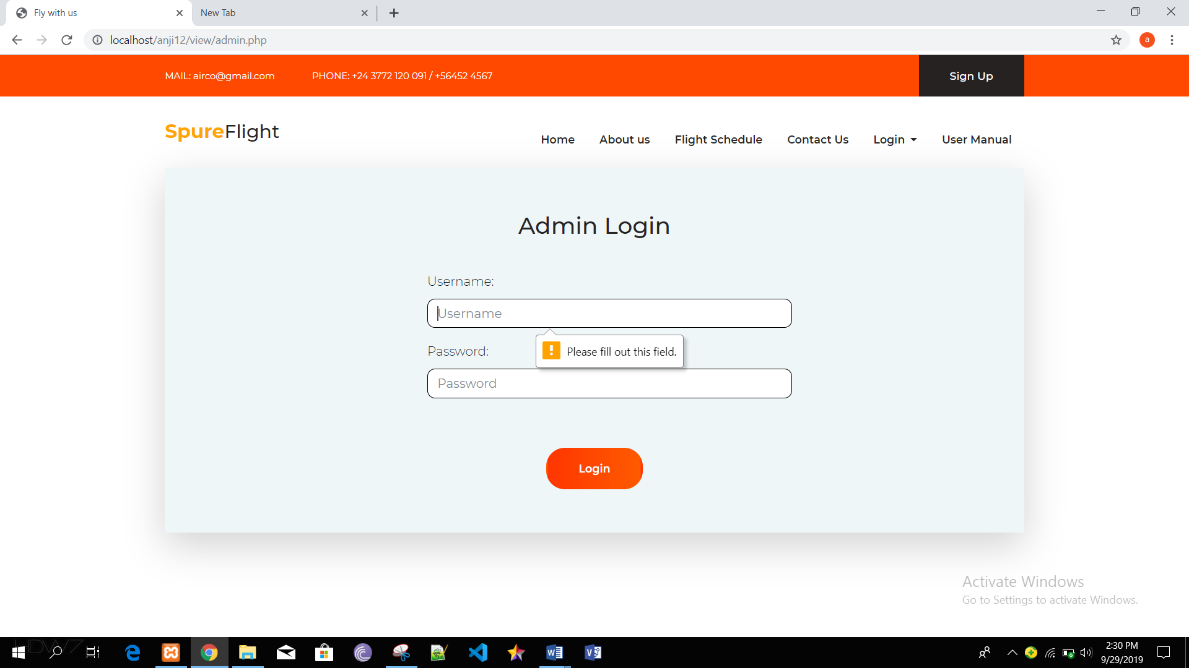

Black box testing 8: Add flight details
Test Case | Description | Task | Expected Result | Actual Result | Conclusion
1 | Add flight details | Fill all the attributes given. | Data inserted successfully. | Flight details added successfully. | Pass
2 | Validation of form | Leave all the attributes blank. | Admin will get an error message of validation. | Admin get an error message. | Pass

Output:
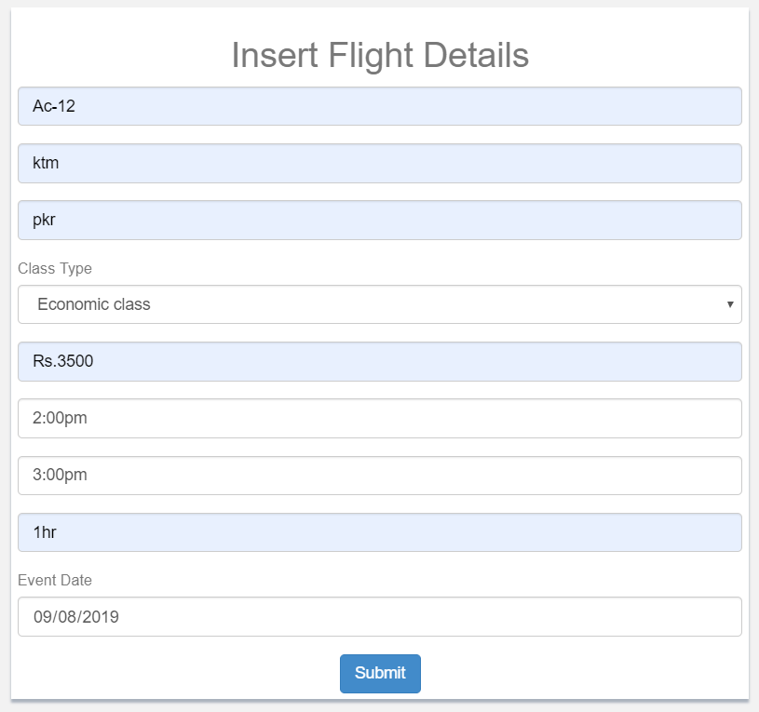
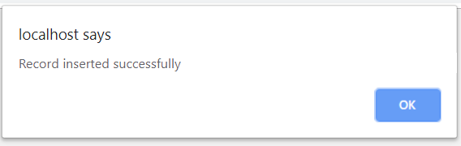
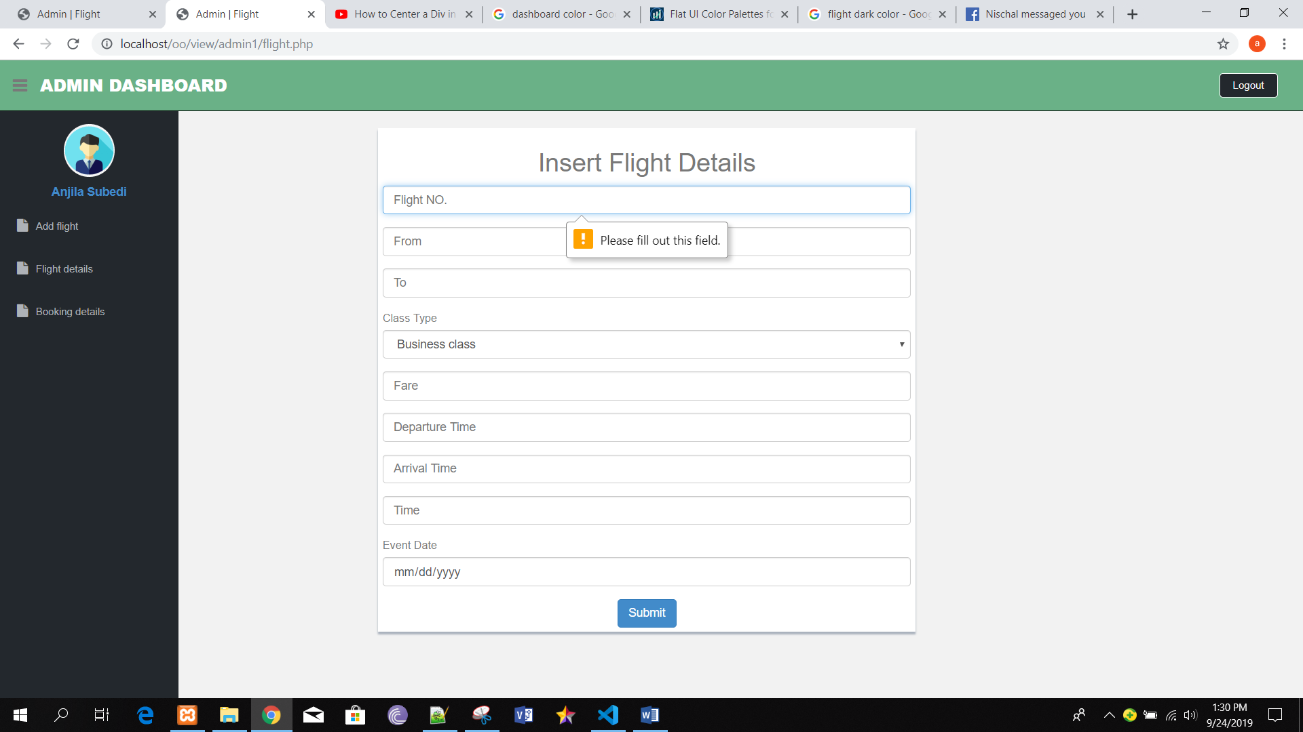

Black box testing 9: Update flight details
Test Case | Description | Task | Expected Result | Actual Result | Conclusion
1 | Update flight details | Flight data must be fetch from flight details form. | Flight details must be updated successfully. | Flight details updated successfully. | Pass

Output:
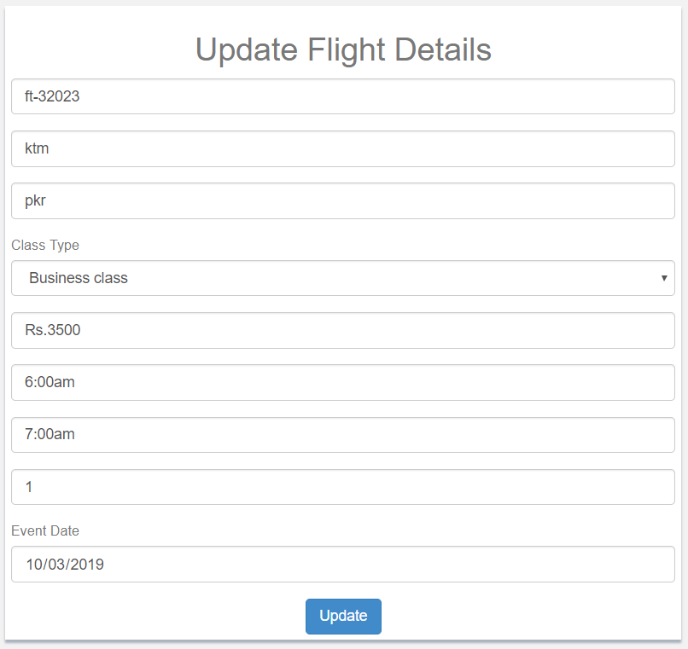
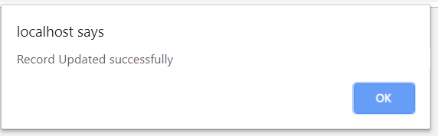

Black box testing 10: Delete flight details
Test Case | Description | Task | Expected Result | Actual Result | Conclusion
1 | Delete flight details | Admin can select the data from table and delete it. | Flight details must be delete. | Record deleted successfully. | Pass

Output:
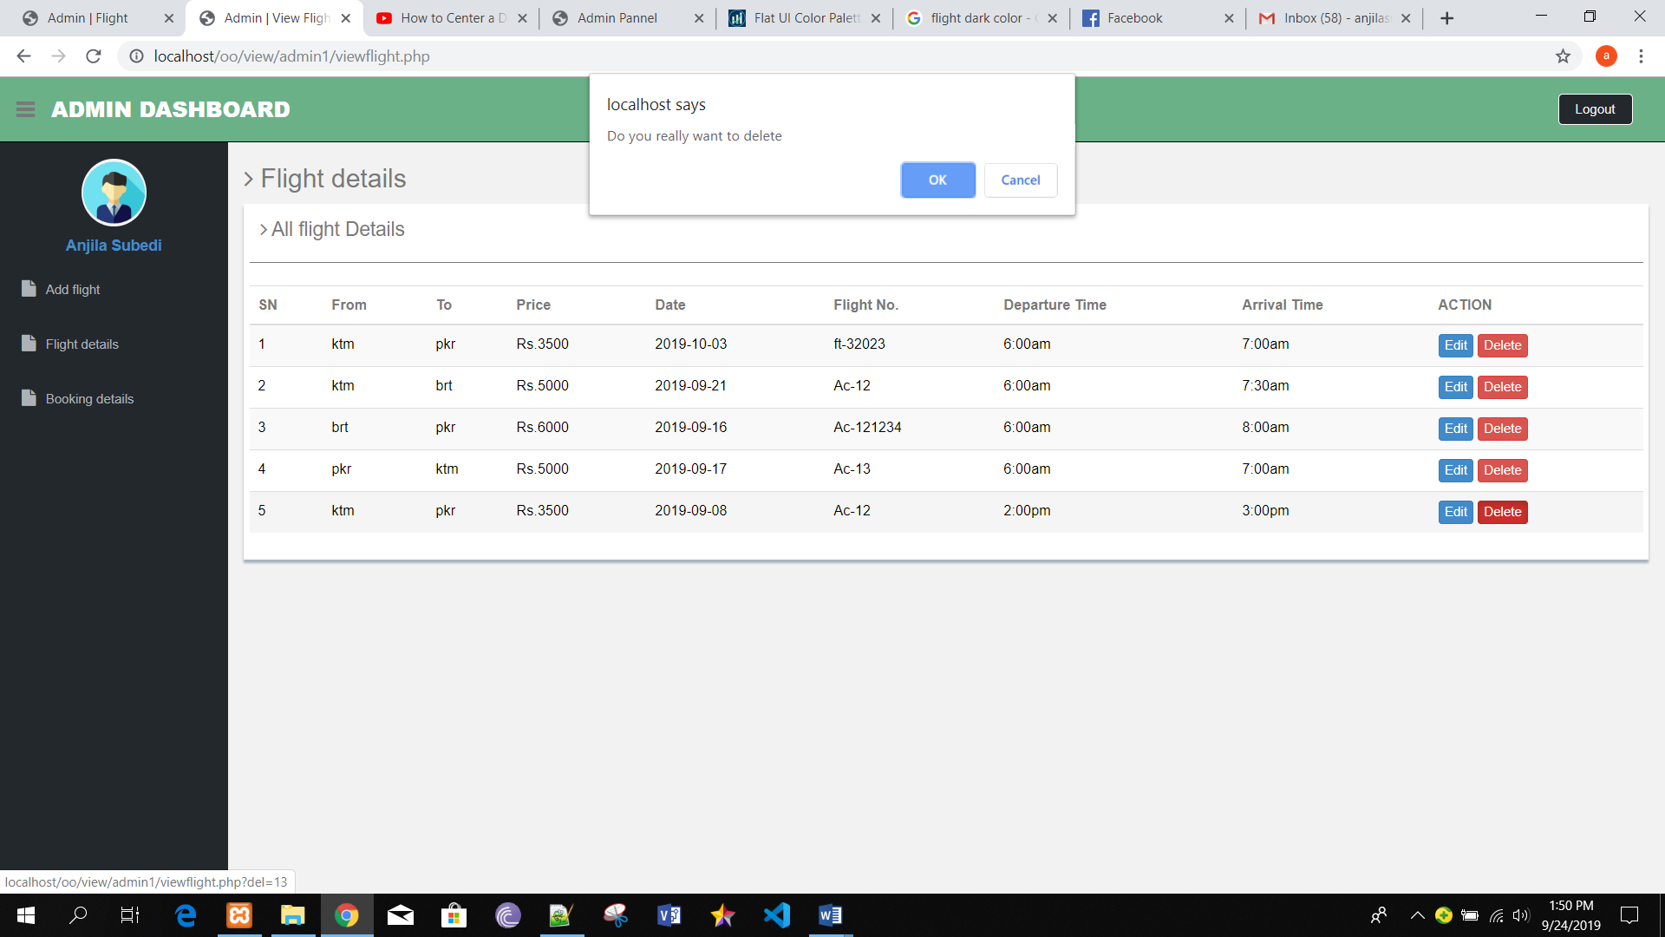
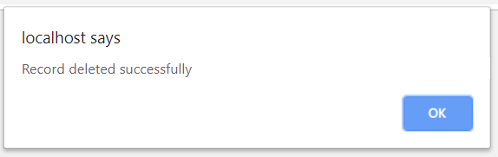

Black box testing 11: Delete booking details
Test Case | Description | Task | Expected Result | Actual Result | Conclusion
1 | Delete flight booking. | Admin can select the data from table and delete it. | Booked tickets must be delete. | Record deleted successfully. | Pass

Output:

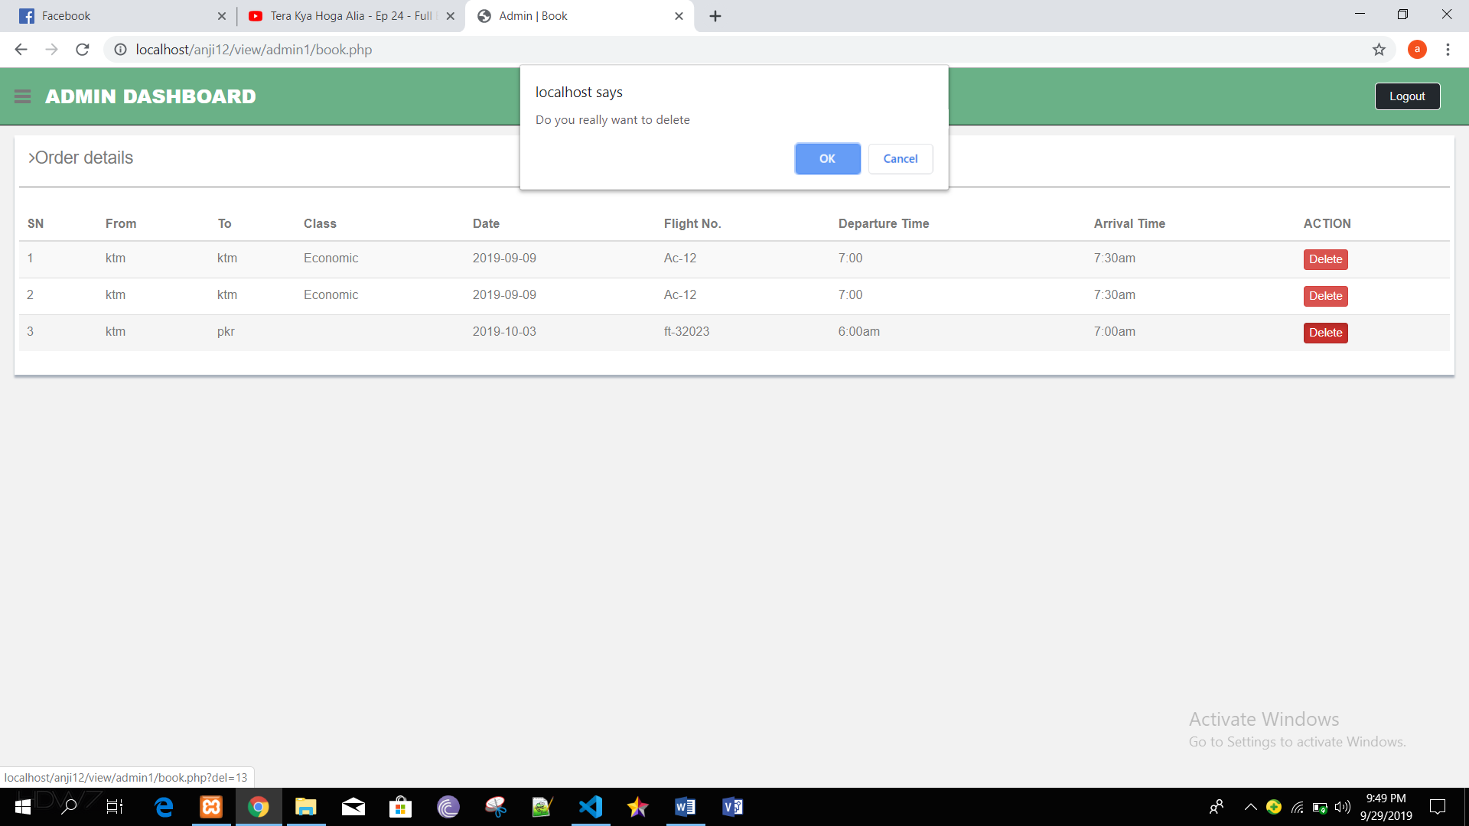
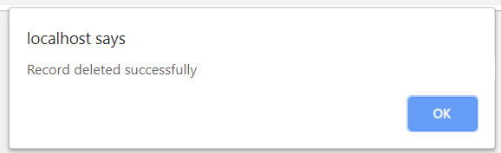

Black box testing 12: Delete feedback details
Test Case | Description | Task | Expected Result | Actual Result | Conclusion
1 | Delete feedback details. | Admin can select the data from table and delete it. | Feedback must be delete. | Record deleted successfully. | Pass

Output:
