ME 639 – Introduction to Robotics
Lab 3 – HEAL Robot Pick-and-Place
Using Three Inverse Kinematics Methods
Name: Anjil Shah
Roll No.: 26310010
Program: Ph.D. Mechanical
Assignment: Lab 3
Repository: github.com/anjilshah/lab3_heal_pick_and_place

1. Introduction and objectives
Objective. This work simulates a six-axis HEAL manipulator with a Robotiq 2F-85 gripper performing cube pick-and-place in MuJoCo. It compares custom damped least-squares (DLS), Mink differential inverse kinematics, and quadratic-programming (QP) IK on matched tasks; samples task and yaw-dependent workspace reachability; and evaluates a limited collision-aware segment check. The evidence is simulation-only and does not establish hardware performance or safety.

2. Methods

Environment and task.
The active model is robot_descriptions/arm_gripper.xml, with the right_center site as the TCP. The cube is 0.04 m on each side and starts at [0.35, 0.00, 0.165] m; the placement center is [0.35, 0.18, 0.165] m. The table is centered at [0.36, 0.05, 0.12] m with full dimensions [0.56, 0.64, 0.04] m and top at z=0.14 m. The same eight phases—approach, descend, close, lift, transfer, lower, release, retreat—use the existing torque-tracking controller and contact-simulated gripper.

IK methods and matched evaluation.
DLS uses a damped Jacobian pseudoinverse (damping 0.08; update clipping 0.035 rad). Mink supplies a differential FrameTask solver with DAQP, damping 10−4, joint configuration constraints, and a 1.2 rad/s per-joint velocity limit. The custom QP minimizes weighted task-velocity error with a 10−4 regularizer and hard next-step joint-position and 1.2 rad/s velocity bounds. The velocity limit is an evaluation setting, not a HEAL hardware rating. Each method uses the same targets, reset conditions, gripper logic, task phases, and torque tracker.
Stage 3 uses 25 shared seeds (20261011–20261035), giving 75 episodes. Per seed, cube x/y vary by ±0.01 m, cube yaw by ±0.10 rad, and target x/y by ±0.01 m; each episode starts from reset with matched conditions across methods. Success requires lifting the cube by more than 0.05 m, final x/y within 0.07 m of the target, final z in (0.13, 0.22) m, and no unexpected actual contact. The 70 mm horizontal tolerance is broad task acceptance, not precision placement. “IK time” is solver-call wall time summed within an episode; “episode time” is the full wall-clock run including physics and collision measurements.

2. Methods (continued)

Workspace and table design.
The deterministic endpoint sampler uses true MuJoCo joint ranges on Cartesian grids: x=0.08–0.64 m, y=−0.27–0.37 m, and TCP z={0.295, 0.415, 0.475} m. DLS samples pass at position residual <25 mm and orientation residual <0.05 rad (damping 0.08; up to 180 iterations). Dexterous poses test seven world-yaw orientations from −90° to +90°; a position is dexterous only if all seven pass.
Sampling is deterministic (recorded seed 7; no random draws). The 50 mm edge-buffered table-center grid spans x=0.13–0.59 m and y=−0.22–0.32 m. Measured reachability. The sampler classified 248/249 task samples and 1,735/1,743 dexterous pose samples. At TCP z=0.295 m, all 81 regular buffered grid points were reachable; the dexterous summary classified 82/83 contact-height positions as feasible at all yaws. The XY plot shows only the 81 regular grid points (80/81); two exact task samples account for the summary’s different denominator. These are sampled endpoint results, not continuous workspace or path guarantees. They support retaining the current 0.56×0.64 m footprint for the sampled targets, not structural or load-capacity design.
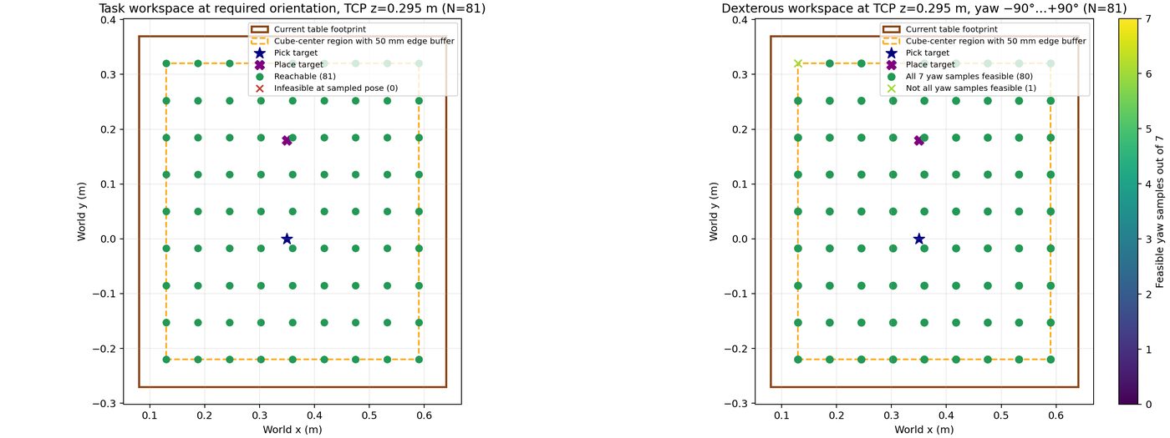
Figure 1. Sampled task workspace at the required orientation (left) and dexterous workspace across seven yaw samples (right). The table/task region is plotted against feasible and infeasible sampled positions; unsampled points are unknown.

Collision evidence.
Stage 2’s results_stage2/nominal_collision_smoke.json is passive contact and signed-distance monitoring; it observes but does not alter the controller. Stage 4 adds a 25-sample joint-interpolation segment precheck plus a runtime clearance/contact abort guard. Selected expected grasp/support contacts are excluded as documented in the saved audit. This rejects some unsafe proposed segments but does not perform obstacle detours or collision-constrained IK. The model contains no tray geometry.

3. Results

Matched Stage 3 comparison.
All three methods completed 25/25 tested episodes. Table 1 values were recomputed from the 75 JSONL records and checked against the saved summary. Means and medians are shown; clearance is the episode minimum over monitored unexpected geom pairs. The 95% Wilson success interval is 86.7%–100.0% for each 25/25 sample. Raw and aggregate records are results_stage3/batch/episodes.jsonl and summary.json; the fixed seed/task protocol is in manifest.json.
Method | Success  (n=25) | Mean IK  (ms) | Median IK  (ms) | Mean episode  wall (s) | Mean min. unexpected  clearance (mm)
DLS | 25/25 | 70.4 | 63.8 | 4.268 | 1.834
Mink | 25/25 | 102.2 | 98.1 | 4.309 | 1.774
QP | 25/25 | 101.5 | 93.7 | 4.315 | 1.788
Uncertainty. 95% bootstrap CIs for mean IK time: DLS 64.1–77.9 ms, Mink 97.6–107.9 ms, QP 93.5–111.2 ms. For mean episode time: 4.243–4.291 s, 4.287–4.332 s, and 4.292–4.341 s, respectively. Intervals overlap; these samples do not establish a universal best method. DLS had the lowest measured mean IK time. Full episode time is distinct from solver time.
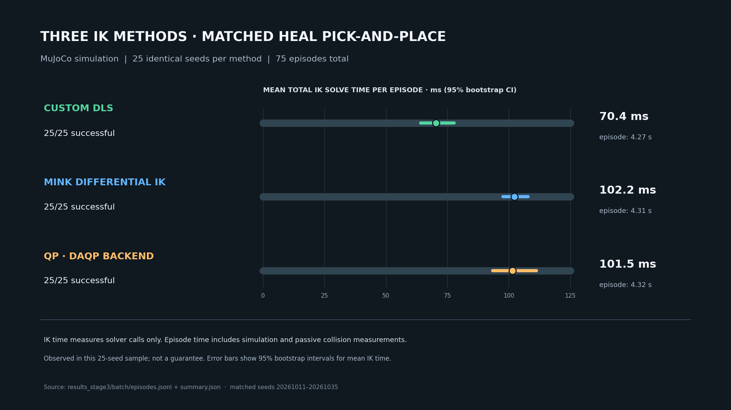
Figure 2. Stage 3 comparison card generated from matched raw episodes. It visualizes success and mean IK time with uncertainty; the table above additionally reports medians, episode time, and clearance.
No unexpected actual-contact or penetration observations occurred in the 75 episodes; measured joint-position limit excursions were zero. Mink and QP enforce the configured velocity bound; DLS has no time-based cap, so its velocity-limit metric is unavailable, not zero. Solver backend iteration counts are unavailable. Outer update counts are method-specific. Across 200 waypoint calls per method, max_iterations occurred 56 times for DLS and 55 times each for Mink and QP. These waypoints were executed because residuals met the controller’s looser 0.06 m / 0.25 rad execution thresholds.

4. Failure analysis and collision limitations

Stage 4 nominal and obstructed cases.
The saved Stage 4 record (results_stage4/collision_aware_smoke.json) shows the nominal run succeeded through all eight phases. Its minimum sampled planned-segment clearance was 0.793 mm against a 0.75 mm threshold (only 0.043 mm above the configured margin). Minimum unexpected-pair clearance measured during execution was 1.517 mm. The final cube x coordinate was 0.33192 m versus the 0.35000 m target, approximately an 18 mm x offset, while still inside the permissive task tolerance.
The deliberately low-pick descent was rejected before executing the unsafe segment. In the six-step Cartesian refinement, the last tested subsegment reached −5.612 mm minimum signed clearance and was rejected. The full direct proposed joint segment had a deeper minimum of −31.598 mm; its first sampled threshold crossing was −0.051 mm. These are different checks of the same attempted descent. The executed prefix had no unexpected actual contacts. Figure 3 depicts the saved clearance checks; the rejected candidate’s precise values are reported here because the plot summarizes the executed/refined subsegments.
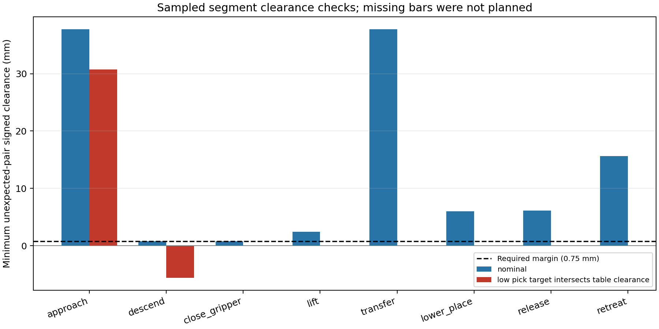
Figure 3. Stage 4 sampled segment clearances. The nominal descent passed narrowly; the obstructed descent was refused during refinement. Finite path samples can miss collisions between sample points.

Evidence scope and failure interpretation.
The original DLS baseline regression remains successful: the cube lifted and settled at [0.35214, 0.17795, 0.15994] m after 15.2 s simulated time, matching results/episodes.json. Stage 2 passive monitoring, Stage 4 active segment rejection, and endpoint workspace sampling are distinct evidence types. Neither a successful episode nor contact logging proves a generally collision-free path. The 0.793 mm nominal margin is model- and sampling-dependent, not a hardware safety margin. No tray avoidance is evaluated because no tray is modeled.

5. Discussion and conclusion
The saved evidence demonstrates task-level pick-and-place success for the baseline and 25 matched simulation episodes per IK method. In this sample, DLS has the lowest mean solver-call time; Mink and QP include explicit time-based velocity bounds. Their similar success and episode times, overlapping uncertainty ranges, and method-dependent update counts do not justify a broad ranking. All methods had zero measured joint-position excursions; only Mink/QP have an enforced velocity metric.
The workspace results support sampled endpoint reachability across the task grid and most sampled yaw poses, and support retaining the present table footprint for these sampled targets. Stage 4 shows that a limited sampled segment validator can reject one deliberately unsafe descent while completing one nominal run. It does not provide continuous collision checking, general detour planning, collision-constrained IK, tray handling, or certified safety. Placement tolerance is broad, and the Stage 4 nominal cube’s approximately 18 mm x offset should be kept in view.
Conclusion. The project provides a reproducible, matched comparison of three IK methods on a shared HEAL–Robotiq MuJoCo task, sampled workspace evidence, and a small collision-rejection demonstration. Stronger claims require finer or continuous collision checks, an explicit tray model, tighter placement criteria, and further randomized and hardware validation. Success in the reported episodes is not guaranteed future performance.

AI Use
I used AI to help debug three to four obstacle-avoidance challenges and brainstorm four scenarios: low descent near the table, limited pick-approach clearance, a transfer-corridor obstacle, and limited placement clearance. Only the low-pick descent has a saved run; the other three are ideas, not measured experiments. I reviewed the evidence and take responsibility.

