

Academic Skills and Team Based Learning
(4CI018)

Report Writing
Individual report

Student ID: 2330781
Student name: Anjina Shahi
Group: L4CG5
Module leader: Manish Deuja
Lecturer: Dipesh Shrestha
Tutor: Ishwor Luitel
Word Count: 1507
Submitted on: 2023/01/04
Abstract
The purpose of writing this report is to specify why the graduates of Herald College are suitable for the graduate scheme of Verisk Nepal. This report contains information about Herald College, the University of Wolverhampton, and the modules that are taught at Herald College. The key differences between Nepalese universities and foreign universities. How both Herald College and Verisk Nepal could get benefits out of this relationship.

Table of Contents
Introduction: 1
Verisk Nepal 1
University of Wolverhampton 1
Herald College 1
About 1
Verisk Nepal 1
University of Wolverhampton 2
Herald College 4
Circular structure: 4
Nepali universities 5
Foreign universities. 6
Relationship 6
Conclusion 7
References 7

Figure 1 Projects that Verisk Nepal works on 2
Figure 2 First year module 3
Figure 3 Second year module 4
Figure 4 Second year module 4
Figure 5 Third year module 4
Figure 6 Third year module 5
Figure 7 First and second year module of Herald College 6
Figure 8 Third year module of Herald College 6

Introduction:

Verisk Nepal

Verisk Nepal is an IT company that was established in 2009 and is based in Hattisar, Kathmandu. It is a software development company for risk analysis that operates a subsidiary of IOS. This company is a service support center for Verisk analytics. It is a software research and development center. Verisk Analytics is an American company for data analytics and risk assessment based in New Jersey. It works with a team of more than 300 professionals. It works in the design field, development of software, application development, testing, and maintenance of applications for customers. The company is looking for an IT professional who focuses on software projects and business processes. The company is listed on the NASDAQ stock exchange as VRSK. They use standard software development technology (verisk, 2022).

University of Wolverhampton

The University of Wolverhampton is a public university that was established in 1827 A.D. The university is located in the United Kingdom. It is ranked 601 in the world university ranking by Times Higher Education. According to the reviews of students in the study portal, the university has an overall score of 4.3 (study portals, 2022).

Herald College

Herald college is an IT and business college. It is located in Naxal, Kathmandu. The college was established in 2016 A.D. The college provides a UK university education. It is affiliated with the University of Wolverhampton. The college offers a bachelor’s degree BSc (Hons) in computer science and a bachelor’s in international business management (herald college, 2022).

About

Verisk Nepal

Verisk Nepal is a software research and development company providing its services since 2009 in software development and product delivery. The company is an expert in handling and managing big data. The company is more focused on software projects and business operations. They have also collaborated with Verisk business to go through all the stages of a project, from start to end of the final product. They are also providing risk assessment services and software solutions. As the company manages big data, to efficiently store and process the data they work with Hadoop and also with Vertica, and Green plum They also pursue text mining and are involved in designing, developing, testing, and maintaining software applications.
They work on projects like:
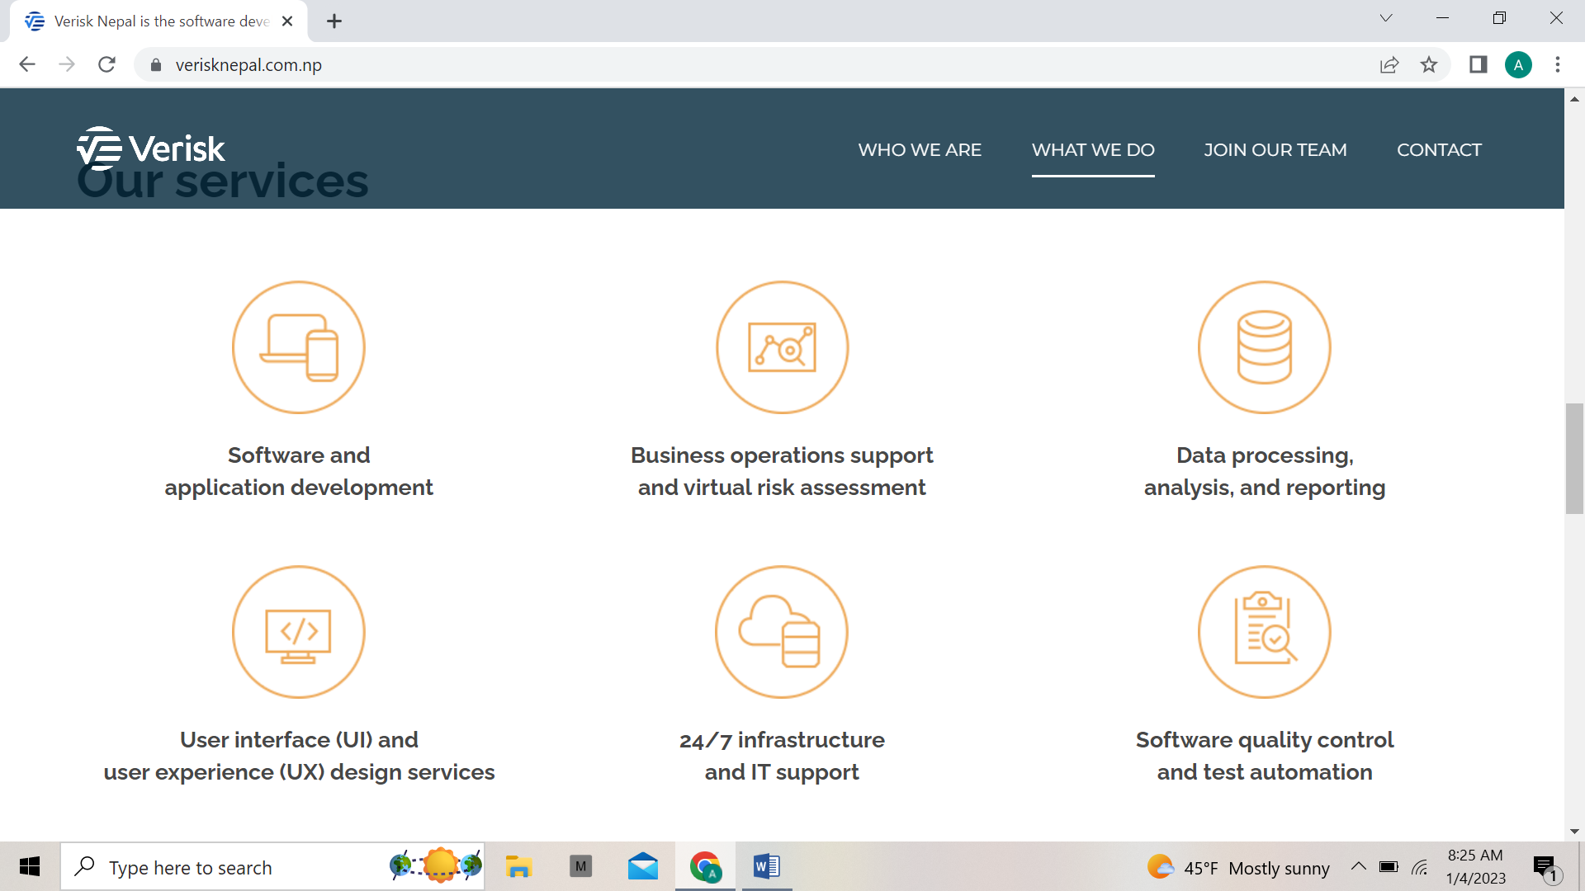
Figure 1 Projects that Verisk Nepal works on
The hiring ratio of the company is approximately seventy five employees per year.
Since the establishment of the company, it has been providing software development and product delivery services to the subsidiary companies of Verisk Analytics. Some of the facilities that are provided by the company after being an employee are free transportation to those who do not have private transportation, a central location, a spacious building, in house clinic available in the office for emergencies, and robust security (verisk, 2022).
List of human resource requirements:
- UI-UX designer
- Software developer
- Database analysis
- IT manager

University of Wolverhampton

The University of Wolverhampton is a UK based university that is located on four campuses across West Midlands, Shropshire, and Staffordshire in England. It has been providing its education services for over one hundred ninety years. The university has over 500 courses, bachelor in computer science is one of them. Over the course duration, the students are exposed to a wide range of computer related subjects. The students will have the chance to broaden their programming skills starting from the base to cutting edge expertise (university of wolverhampton, 2022).
The course module of the first year:

Figure 2 First year module
The course module of second year:
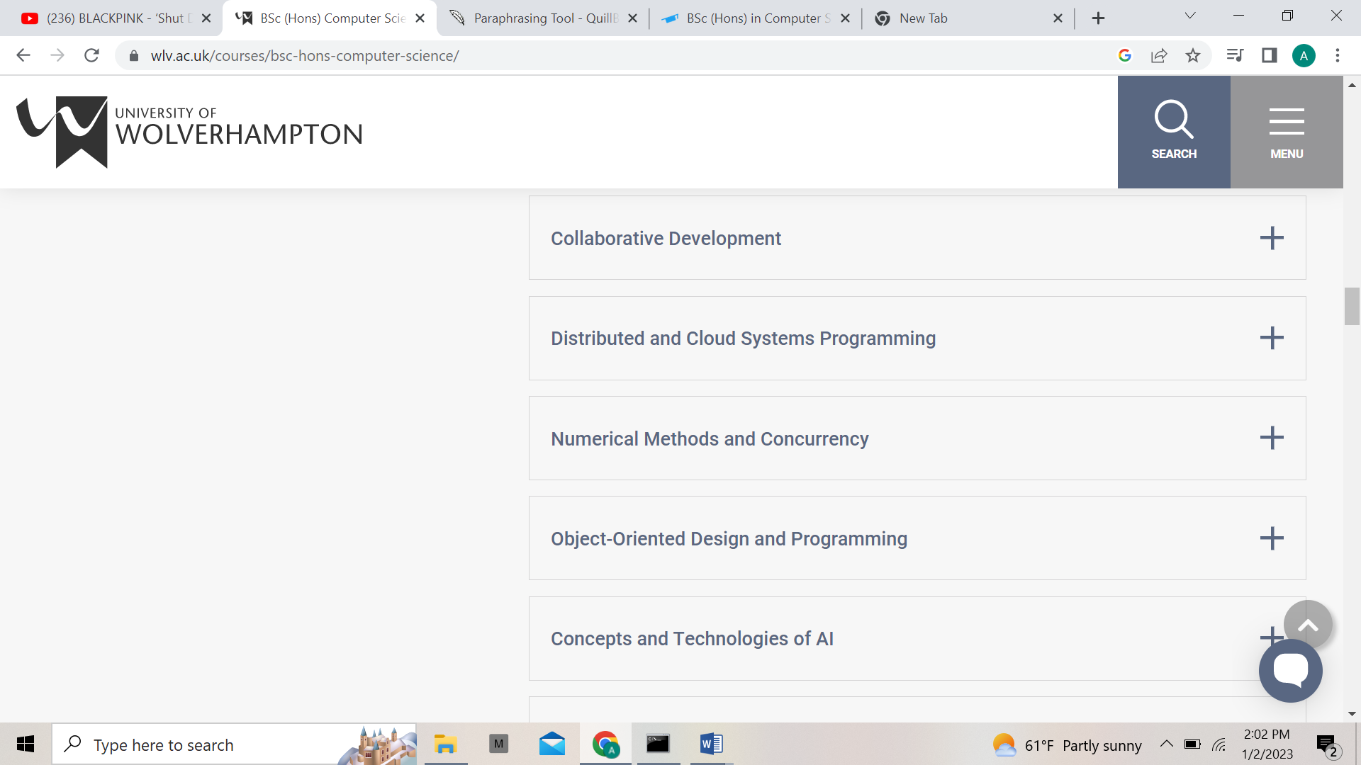
Figure 3 Second year module
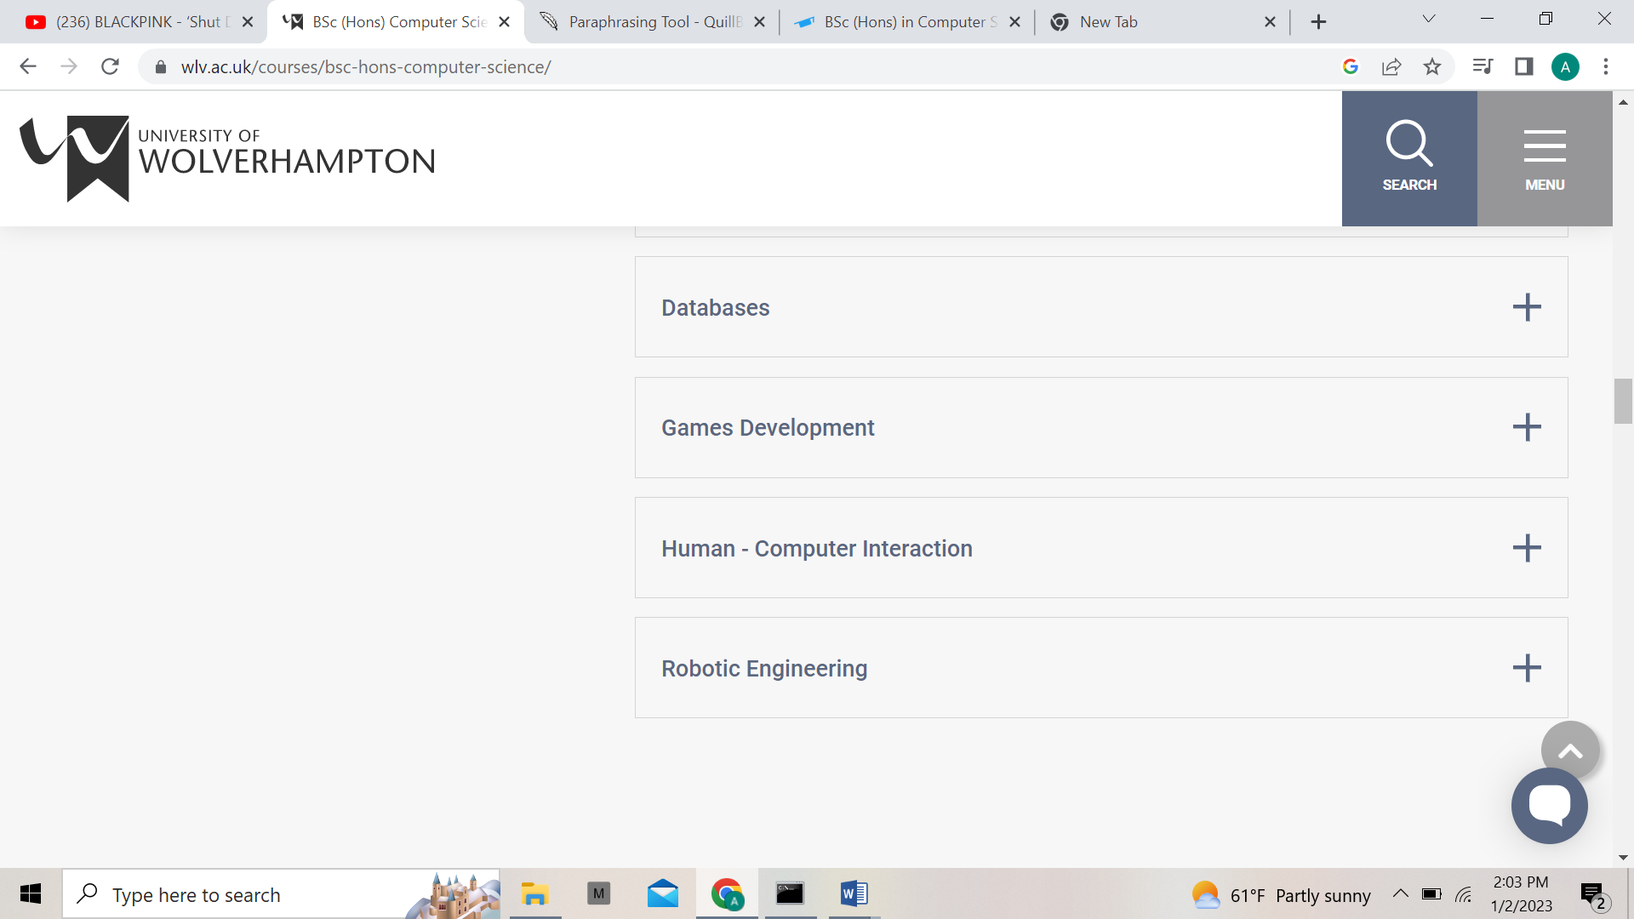
Figure 4 Second year module
The course module of the third year
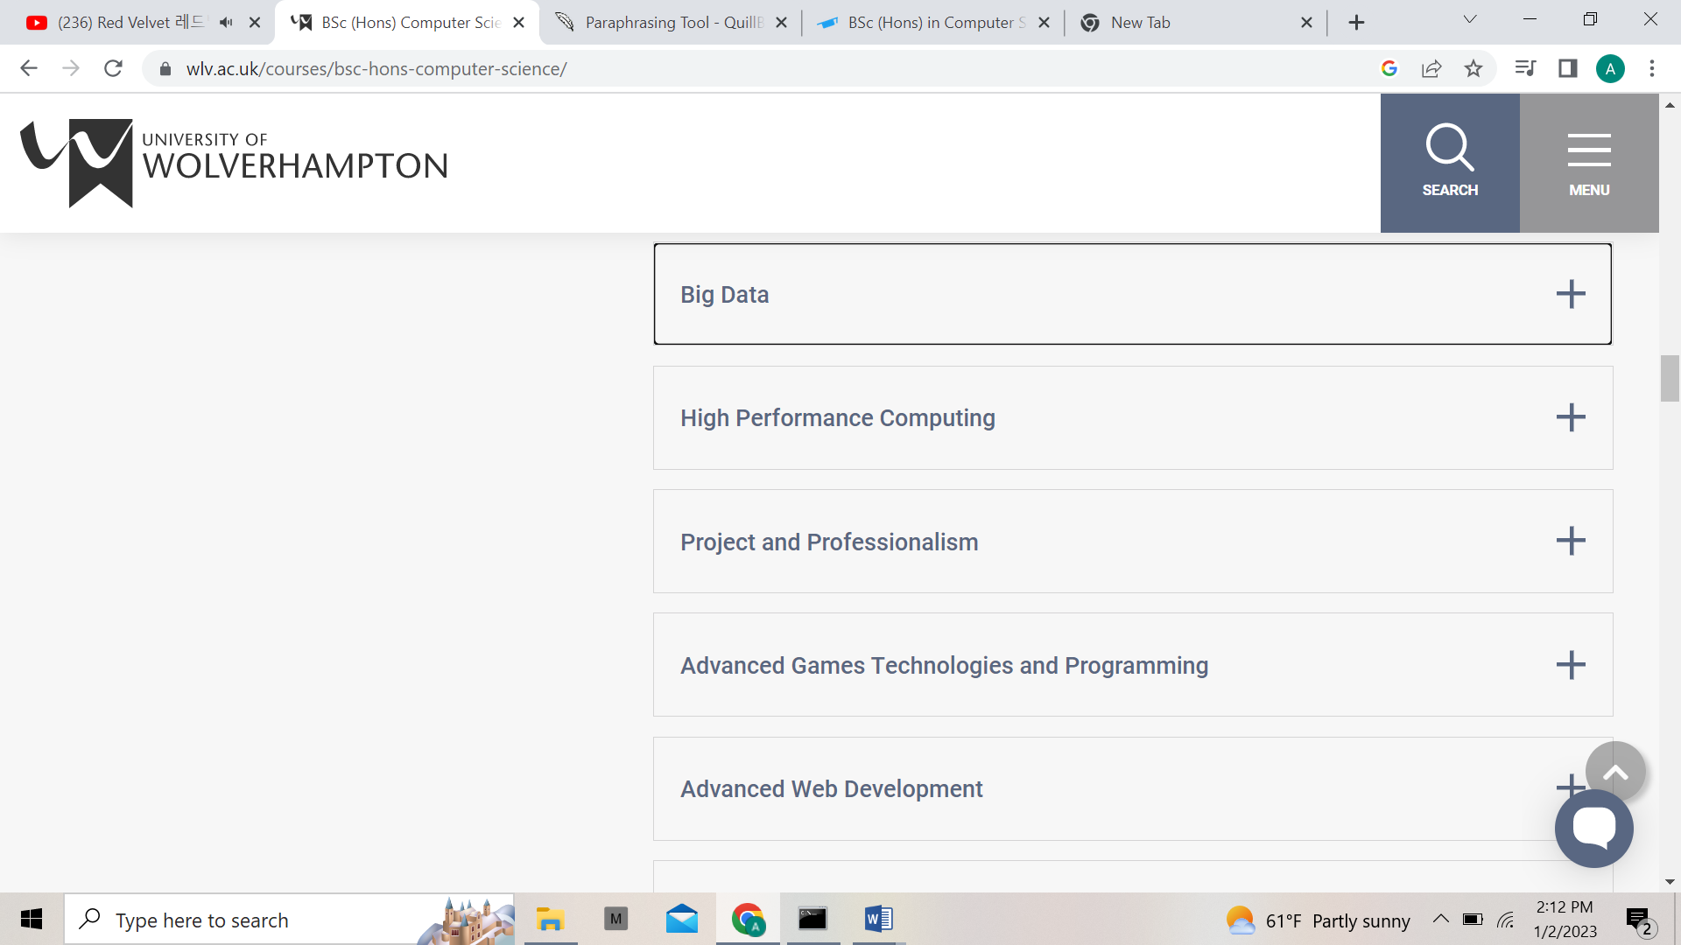
Figure 5 Third year module

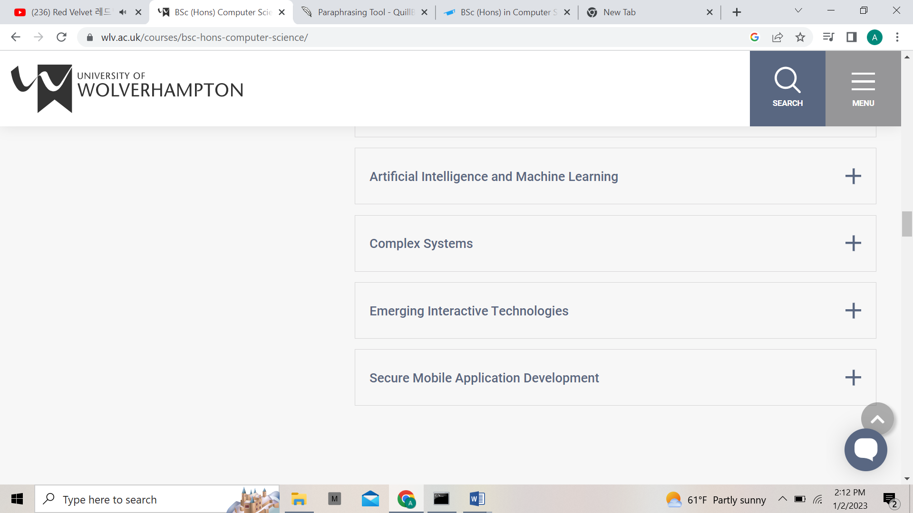
Figure 6 Third year module

Herald College

Herald College Kathmandu is the sole college in Nepal that teaches AI. The college is under the ING group. The college aims to nurture the skills of the students and make them industry ready.

Circular structure:

The bachelor’s program in computer science is divided into three years. The total credit hour is three hundred and sixty hours. The first year carries 120 credits. And second year and third year carry 180 credits each (Education sanjal, 2022).
Course module in Herald College Kathmandu
First year and second year
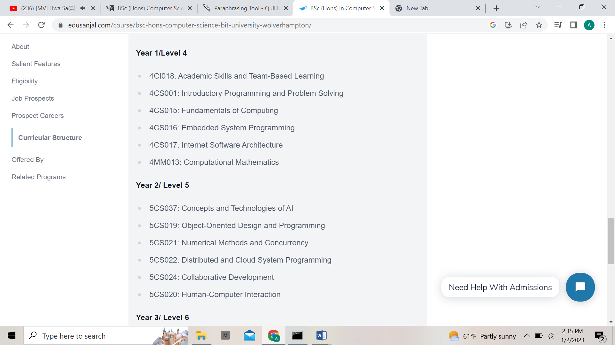
Figure 7 First and second year module of Herald College
Third year
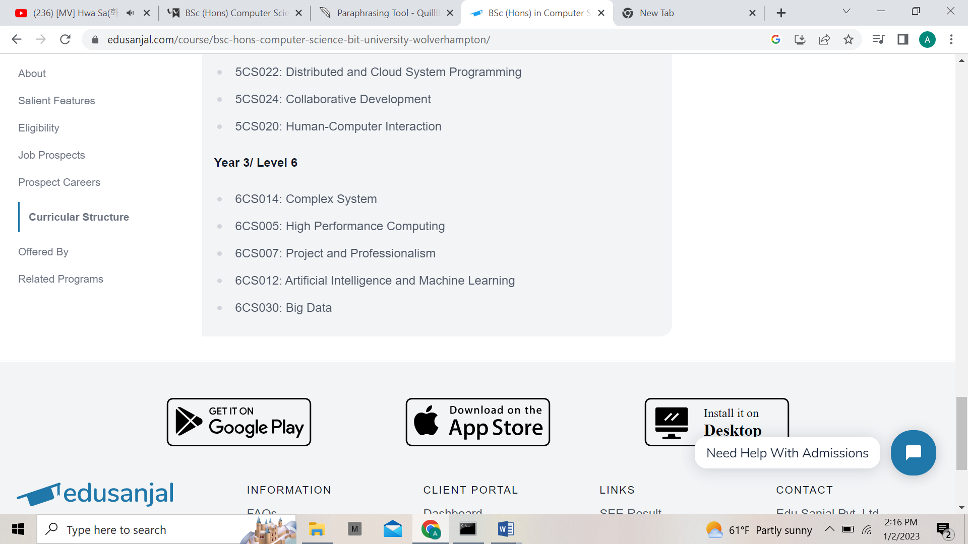
Figure 8 Third year module of Herald College
Herald College is affiliated with the University of Wolverhampton but there is some difference in the modules. In the first year, we have academic skills and team based learning instead of introduction to games technology for serious application. And the first year module includes a third year module on web development. It is a noncredit module. In the second year module, the Herald College module does not include database, game development, and robotic engineering as the course is focused on artificial intelligence, big data, and cloud computing.

Nepali universities

The top three most notable Nepali university is the Tribhuwan University, Kathmandu University, and Pokhara University. They continue the traditional way of teaching. And they possess more theoretical knowledge than applied knowledge. Padlock protests and student strikes are visibly seen in these universities. The problems are not being addressed by the concerned authorities who are responsible to manage the education system. Also, there is the involvement of politics.
The colleges neither have efficient staffs and teachers nor are well equipped with the infrastructure. The courses are also not up to date (Education sanjal, 2022).

Foreign universities

There are almost more than ten colleges that are affiliated with a foreign university and Herald College Kathmandu is one of them. The colleges have well equipped infrastructures with efficient staff. The curriculum and teaching techniques vary vastly from Nepali Universities. They follow the LTW (Lecture, Tutorial, Workshop) method of teaching. They put more emphasis on independent study and research than knowledge based instructions. One of the reasons why the foreign university is better is that they are more subject and industry oriented. They prioritize practical knowledge over theoretical knowledge so the students have hand on experience and are industry ready when they graduate (Education sanjal, 2022).

Critical analysis

As mentioned above Verisk Nepal is looking for candidates who have knowledge and skills in software development, and programming. The aim of Herald College is to produce industry ready software engineers and developers. To become a developer one needs to be skillful in programming. At Herald College, programming is taught from the start of the semester. There are two modules for programming one is introductory programming and problem solving in the first year. This module helps the students to be well prepared to learn to write programs in different languages. Second is object oriented design and programming in the second year. The goal of this module is to introduce students to the field of object oriented programming. The academic skills and team based learning module help the students to prepare for graduate employment selection.
One of the projects Verisk Nepal is UX design. And as Herald College has web development modules the graduates are skilled in web designing. The students of Herald have created a community of UI/UX visuals, where they can learn about UI/UX designing. This community also helps the students to develop their soft skills like communication, and leadership. Despite being IT professionals, the herald graduates also have management skills. The collaborative development modules in the second year help the student to learn teamwork and develop their managing skills.
Unlike other universities, the courses at Herald College are revised annually. This ensures that students are keeping up with the new changes. The web development course was introduced this year only. They are proficient in managing big data, as in the third year they are taught how the distributed system works and the latest advanced techniques in managing a large database.

Future relationship

This relationship benefits both of the industry. More students will be attracted to Herald College for higher education as it would be advertised, Herald College in relation with Verisk Nepal is providing internships for graduates. As the courses are updated annually the graduates are up to date with the new technologies so they have the skills they are necessary to compete in this field.

Conclusion

Verisk Nepal is one the leading IT companies in Nepal, a subsidiary of Verisk Analytics an American based company. They are in search of fresh graduates who are highly motivated, talented, and applicable for their graduate scheme. Herald College Kathmandu which is affiliated with the University of Wolverhampton provides one of the best computer science courses in Nepal. Every year herald college produces industry oriented graduates. The way of perceiving knowledge and skills in this college is different as the teaching methodology is similar to the British way of teaching. They give emphasis on practical knowledge which comes in handy in industry. So the herald graduates are better fitted for the scheme than any other graduates.

References

Education sanjal, 2022. bsc-hons-computer-science-bit-university-wolverhampton/. [Online]
Available at: https://edusanjal.com/course/bsc-hons-computer-science-bit-university-wolverhampton/
[Accessed 02 01 2023].
Education sanjal, 2022. reasons-foreign-degrees-popularity-nepal/. [Online]
Available at: https://edusanjal.com/blog/reasons-foreign-degrees-popularity-nepal/
[Accessed 02 01 2023].
Education sanjal, 2022. universities-of-nepal-getting-poor-grades/. [Online]
Available at: https://edusanjal.com/news/universities-of-nepal-getting-poor-grades/
[Accessed 02 01 2023].
herald college, 2022. heraldcollege.edu.np. [Online]
Available at: https://heraldcollege.edu.np/
[Accessed 20 12 2022].
study portals, 2022. university-of-wolverhampton.html#:~:text=University%20of%20Wolverhampton%20is%20ranked,from%20all%20over%20the%20world.. [Online]
Available at: https://www.mastersportal.com/rankings-reviews/1180/university-of-wolverhampton.html#:~:text=University%20of%20Wolverhampton%20is%20ranked,from%20all%20over%20the%20world.
[Accessed 20 12 2022].
university of wolverhampton, 2022. bsc-hons-computer-science/. [Online]
Available at: https://www.wlv.ac.uk/courses/bsc-hons-computer-science/
[Accessed 02 01 2023].
verisk, 2022. verisknepal.com.np. [Online]
Available at: https://verisknepal.com.np/
[Accessed 20 12 2022].

