**FISH NUTRI CART- A BOON TO FISHERS AS A BETTER INCOME GENERATION THROUGH FISH VALUE ADDED PRODUCTS IN VISAKHAPATNAM DISTRICT.**

Visakhapatnam district is endowed with a long coastline of 132 Kms with 63 coastal villages and 43 fish landing centres. About 1.16 coastal fishers are eking out their livelihood through coastal fishing and allied activities in the District. The fishing fleet consisting of 708 mechanised bots, 3478 motorised boats and 956 traditional boats totally 5142 number of boats involved in fishing activity, The major fishing harbour at Visakhapatnam is providing livelihood for about 10,000 families. The total fish and prawn catches of 0.43 lakh MT during the year 2006-07 has been enhanced to 1.55 lakh MT during the year 2017-18 with average annual growth rate of about 10%. Since fishing sector is one of the important sectors in the district, the fishers are supported with several welfare activities with State and Central Government assistance to promote their quality and standards of life. Visakhapatnam city is blessed with attractive nature, lengthy sand beach and offering immense scope of eco-tourism. Tourists from various parts of the country and other countries are visiting Visakhapatnam to enjoy the beauty of the beach city. There is great demand for fish value added products at tourist spots in the city and no facilities are available to meet the nutritional demand the tourists. In view of increasing consciousness among the tourists and visitors on nutritional value of fishery products and its impact on health, two mobile vending units of fish value added products are provided to fishers on pilot basis to examine their economical feasibility and scale up the activity basing on the feedback. Both the mobile vending units are operating very successfully with lucrative margins, providing employment to poor fishers and promoting fish consumption among the public and tourists.

1. **Mobile fishery products vending unit (FISH NUTRI CART) provided to Farmer Producer Organisation, Mangamarimeta, Bheemili mandal, Visakhapatnam District**:

70 Fisherwomen of Mangamaripeta village, Bheemunipatnam mandal have been organised into Farmer Producer Organisation (FPO) namely “Small Scale Fishers Producer Company Ltd” under Companies Act 2013 with the support of M/S fisher folk foundation. All 70 fisherwomen were trained at NIPHATT and SIFT, Kakinada on hygienic handling and preparation of various delicious items of fish and prawn value added products This FPO is supported with financial assistance under Fisheries Development Scheme of Normal State Plan through State Fisheries Department.

* Project Cost : Rs. 15.50 lakhs
* Government support : Rs. 10.00 lakhs
* Producer Company Share (Loan) : Rs. 05.50 lakhs
* Mobile vending unit supplied on : 1-04-2017
* Area of operation : Beach Road at YMCA
* No. of fisherwomen operating : 3 fisherwomen
* Types of Value added products
* Grilled fish
* Fish cutlets, Fish bowls
* Fish Biryani
* Fish , Prawn fry and curry
* Fish samosha
* Average sales per day : Rs. 8000/-
* Margin for per day (Profit) : Rs. 3000/-
* Wages for 3 fisherwomen/day : Rs. 1200/- @ Rs. 400/- each
* Loan repayment /day : Rs. 1800/- till clearing loan
* Billing & POS machine : For cash less transactions.

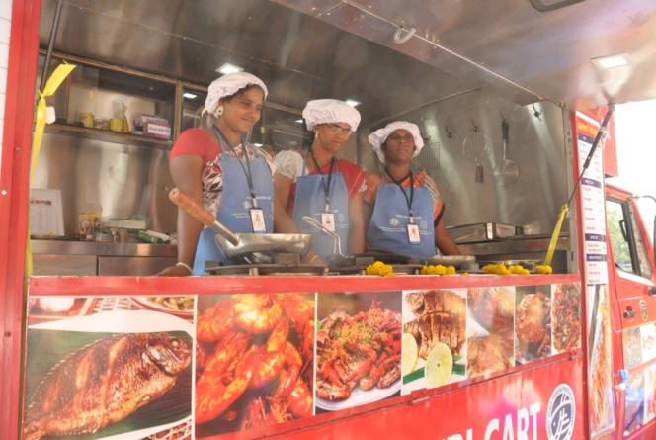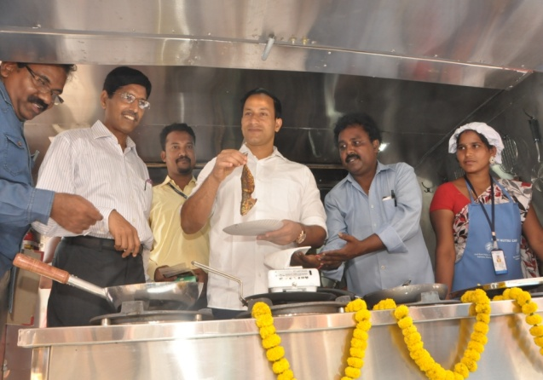 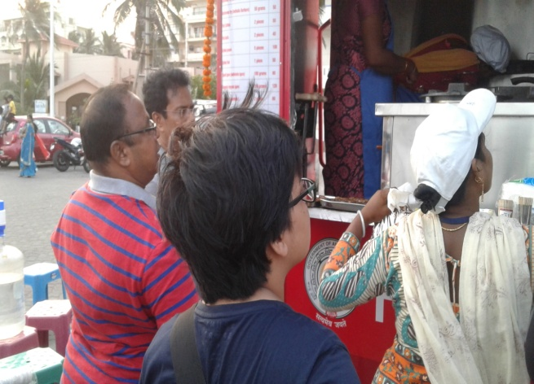 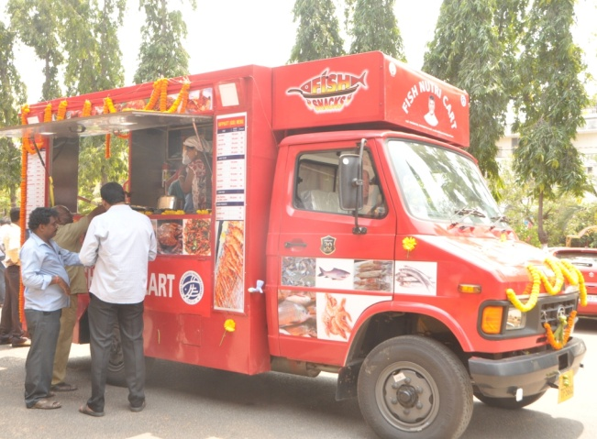

The fisherwomen are getting income of Rs. 500/- per day depending on the quantum of sales and they supplying very delicious, nutritious and healthy dishes of fishery products to visitors at affordable cost ranging from Rs. 30/- to 150/-. This vending unit operates from 4 pm to 9 pm i.e. for 5 hours per day only at beach road near YMCA, Visakhapatnam. These items are also very much popularised in beach road and became inspiration to many fisherwomen to venture into this field and approaching the Department for supply of similar units to operate in various areas in the City.

1. **Mobile Fishery products vending unit supplied to individual under Blue Revolution Scheme 2016-17.**

Mobile Fishery products vending unit is provided to Sri.K.Venkateswara Rao, Member in Small scale Fish Traders Society, RTC Complex, Visakhapatnam under Blue Revolution Scheme of Government of India. The beneficiary was trained at NIPHATT, Visakhapatnam on hygienic handling and preparation of fish value added products.

* Project Cost : Rs. 10.00 lakhs
* Government support : Rs. 05.00 lakhs
* Individual Share through Bank loan : Rs. 05.00 lakhs
* Mobile vending unit supplied on : May -2017
* Area of operation : Thenneti Park, Beach Road
* No. of fisherwomen operating : 1fisherwomen ,2 Fishermen
* Types of Value added products
* Grilled fish
* Fish cutlets
* Fish , Prawn fry and curry
* Crab fry
* Prawn Pakoda
* Average sales per day : Rs. 7500/-
* Margin per day (Profit) : Rs. 2500/-
* Net Profit to each member per day : Rs. 600/- excluding bank loan.
* Loan repayment : Rs. 700/- per day on average

The fishers are getting income of Rs. 600/- each per day depending on the quantum of sales. The outlet is permitted to operate at Public Park at beach road where very huge public gathers and preferring to take very delicious items of fish valued products. As a result the vendors are getting good profits. The vendors are well trained on hygienic maintenance and preparation of various items of fish value added products. They are supplying the value added products to visitors at affordable cost ranging from Rs. 20/- to 100/-. As such even poor people also prefers to take these items ultimately the business circulation for this unit is more. During holidays the sales will goes even to Rs. 12,000/- to 15,000/- per day.

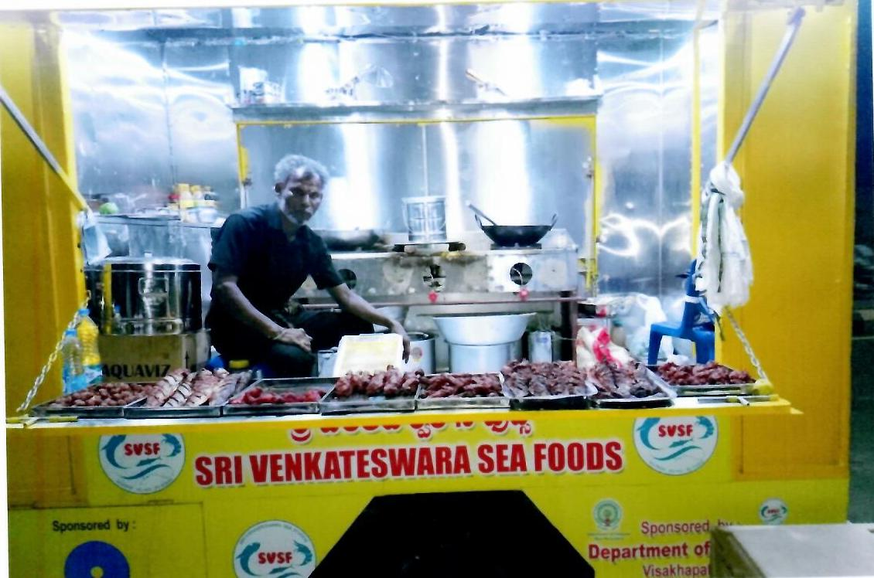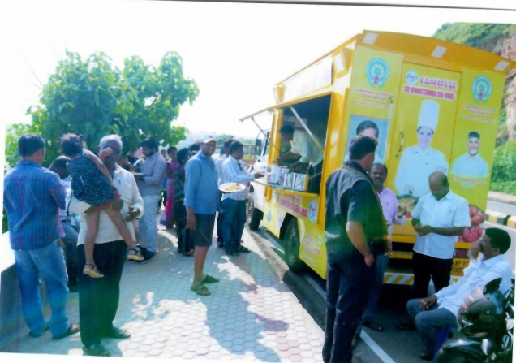

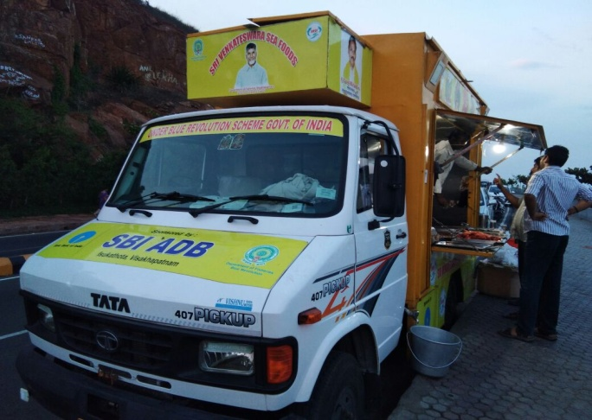 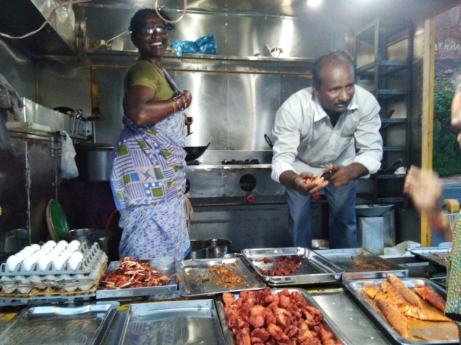

Since these 2 mobile vending units are operating successfully, because of low operational cost, low risk factor, public high choice for tasting the products and lucrative profits out of sales, several fishermen and fisherwomen are approaching the Department for supporting them with Government subsidy, bank loan component and necessary permission from Municipal Corporation authorities to take up the activity at beach road and tourism areas. Hence it is need of hour to promote similar units to operate at various locations of urban and semi urban areas in the City for multifarious benefits such as better income generation to fishers, creates employment opportunities for unemployed youth, promotes per capita consumption, enhance the domestic market opportunities and finally results good public health with consumption of very nutritious fishery products.

<<<>>>