Government of Andhra Pradesh

Department of Fisheries- Bhimavaram Fisheries Division, West Godavari District

**CHANDRANNA AQUA RAITU KSHETRALU - A SUCCESS STORY ( CARK)**

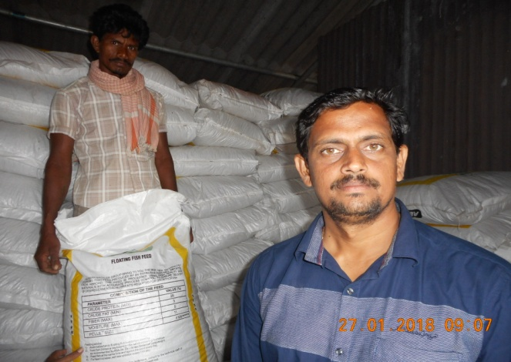

1. Name of the Aquafarmer : Sri Marella Rama Krishna

S/o Sri Nageswara rao

**I. Bhimavaram Village, Akiveedu mandal, West Godavari District**

AADHAR No.: 893415641105

Contact No. 7661040444

1. Total Culture Are ( EWSA ) (H) : 15.75 Acs ( 6.3 Hac.)
2. FW Aqua Regn.No : FRN 011500002559
3. Geo-Tagging : Lat. : 16.55638 ; Long. : 81.38170
4. Species Cultured : Indian Major Carps : Catla & Rohu
5. Total Stocking Density : 47,000 fish seed ; Catla : 2500 & Rohu 44,500
6. Stocking Density per Ac. : 2984 nos
7. Average Body Wt. of stocked : 400 gms
8. Date of Stocking : 18.07.2017
9. Manuring : SSP; DAP; Catlle Manure
10. Water Depth Maintained : 4 feet
11. **Feed : Supplementary Feed ; Floating Pellet : Cost @ Rs 30,000 per Ton**
12. Crude protein : 28 %
13. Crude Fibre : 05 %
14. Fat : 03 %
15. Moisture : 11 %
16. Ground Nut cake : 10 tons ( Cost @ Rs 31,000 per Ton ) : Crude Protein : 40 % ( During early period of the culture )
17. Culture Period : 7 Months & 27 Days ( Date of Harvest : 15.3.2018 )
18. Total harvest : 75 Tons
19. Feed Consumed : Floating Pellet : 120 Tons & GOC 10 Tons : Total 130 Tons
20. FCR : 130 : 75 Tons = 1:1.73
21. Management of the Pond :
22. **Regular Water Ananalysis carried out @ fortnight Intervals through the Department of Fisheries assistance through Filed Level Inspection & Govt. Aqua Lab Services at Akiveedu & Bhimavaram**
23. **Probiotics used to maintain water quality**
24. **Natural Plankton was maintained**
25. Only once Argulus was infected the fish and it is controlled effectively
26. **Regular sampling of the fish was done .The growth and health have been examined**
27. **Feed Regulations were made based on the weather and Growth of the animal.**
28. Water Exchange was very minimal during the culture
29. Fisheries Departmental Officials were visiting the CARK on regular basis @ fortnight basis & offered suitable suggestions
30. Total Expenditure :
31. Seed Cost @

Rs 30 per piece : Rs 18,80,000

1. Watch & Ward : Rs 1,50,000
2. Feed Cost : Rs 39,10,000
3. Labour : Rs 50,000
4. Electricity : Rs 70,000
5. Manure: :Rs 50,000
6. Probiotics : Rs 30,000
7. Sanitizer & Liming : Rs 30,000
8. Harvesting Charges : Rs 1,00,000
9. Miscellaneous : Rs 30,000
10. Interest on Rs 40 L : Rs 2,10,000

Total : Rs 65,10,000

20 Total Income on sale of Fish

@ Rs 1.00 Lakh per Ton :Rs 75,00,000

1. Total profit ( 20-19 ) :Rs 9,90,000
2. Profit per per Ac : Rs 62,000
3. Productivity per Hac : about 12 .00 Tons per crop

Remarks :

* The above project reveals that if the stocking size is > 400 gms , the production & productivity will be enhanced and there by the profits .
* It is proposed to propagate this technology to achieve 2 crops of IMC per year by reducing the stocking density to 2000-2300 per ac.
* Due introduction of CARK Field level Demonstration with the involvement of the Framers, the results are very fruitful .
* Under Cluster management also such technologies will be propagated to achieve the targeted production, productivity & GVA Without disease problems .