AP FISHERIES DEPARTMENT
GOVT AQUA LAB
REPORT

LAB DETAILS : XXXX
------------------------------------------------------------------------------------------------------------------------------------------

Test ID No. 00011
Name of Farmer : Name
Date generated on
Address of Farmer : XXXX
Contact No : YYYYY
Registration ID of Farm: ID 00021

Result Date :
Time :

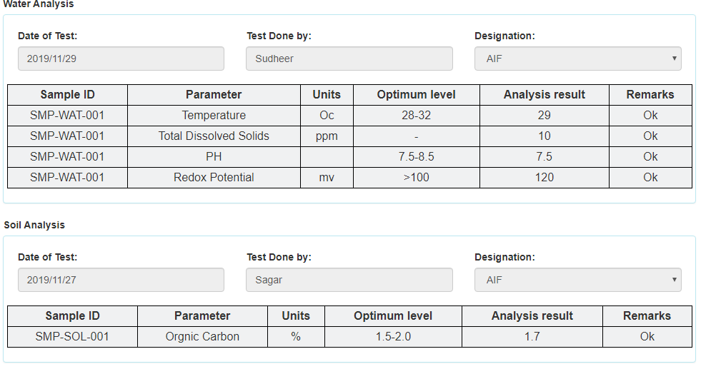

Paymennt details:
Cost : Rupees six hundred and ten only(in Words)
Payment mode : Online(CFMS)
Transation ID :
Other Details:

Receipt Generated by : Name
Designation
Seal

