A project report

On

**ROBO CAR AND PROJECT SIMULATION**

Submitted in partial fulfillment of the requirement of

Project-II [BIT179CO]

Of

Bachelor of Information Technology

**Submitted to**

PURBHANCHAL UNIVERSITY

BIRATNAGAR, NEPAL

**Submitted By:**

CHANDA SHRESTHA (323995)

ANJIT PARIYAR

ANUBHAV KHADKA

**KANTIPUR CITY COLLEGE**

Putalisadak, Kathmandu

September 17, 2019

A project report

On

**ROBO CAR AND PROJECT SIMULATION**

Submitted in partial fulfillment of the requirement of

Project-II [BIT179CO]

Of

Bachelor of Information Technology

**Submitted to**

PURBHANCHAL UNIVERSITY

BIRATNAGAR, NEPAL

**Submitted By:**

CHANDA SHRESTHA (323995)

ANJIT PARIYAR (

ANUBHAV KHADKA (

**Project Supervisor**

Mr. Subash Raj Karnikar

Mr. Kiran Khanal

**KANTIPUR CITY COLLEGE**

Putalisadak, Kathmandu

# TOPIC APPROVAL SHEET

It is here by informed that the topic selected by Chanda Shrestha, Anjit Pariyar and Anubhav Khadka of BIT II semester for their semester project has been found suitable and as per the credit assigned by Purbanchal University (PU), Biratnagar, Nepal. The Project Committee has approved the following topic and supervisor for the above mentioned students.

Topic Approved: Robo Car and Project Simulation

_ _ _ _ _ _ _ _

Bhawana Bam

Lecturer

Department of IT

_ _ _ _ _ _ _ _

Ashim K.C

Asst. Lecturer

Department of IT

_ _ _ _ _ _ _ _

Bikash Neupane

Asst. p

Department of IT

# CERTIFICATE

This is to certify that the project entitled “Robo Car and Project Simulation” submitted by Chanda Shrestha, Anjit Pariyar and Anubhav Khadka to the Department of Information Technology at Kantipur City College, Kathmandu, Nepal towards the requirement for BITII (179CO) Project-II of is an original work carried out by them under my supervision and guidance.

Signature: signature:

**SUBASH RAJ KARNIKAR KIRAN KHANAL**

Department of Information Technology Department of Information Technology

Kantipur City College Kantipur City College

(Project Supervisor) (Project Supervisor)

**Place**: Kantipur City College, Putalisadak, Kathmandu.

**Date**: November 13, 2019

# ACKNOWLEDGEMENT

We would like to express our deepest appreciation to our supervisor, Mr. Subash Raj Karnikar and Mr. Kiran Khanal for providing proper guidance during the completion of our project.

We would like to express our gratitude towards our supervisor Mr. Subash Raj Karnikar and Mr. Kiran Khanal for supervising, motivating and being co-operative throughout this project work. Without his guidance and help this project would not have been possible. We are grateful to all the teachers who had helped us directly and indirectly throughout the project. Finally, we are indebted to the lab incharge for providing the facilities of lab during our project. We would also like to thanks classmates, who are extensively helpful in the documentation and coding during our project period.

# ABSTRACT

This project is about the robo car and project simulation, which is complete using the C++ programming language with Arduino IDE. Which is also known as automatic car. It mainly focus on automatics simpler to drive, it can also allow us to focus on road position whether it is straight or not. It is a systematic way to drive a car. It always follow black line and move on it. We can easily know at what distance obstacle is. If the obstacle is at stationery car is stopped if the obstacle is a moving body then car also move. It detects an obstacles when any object (i.e humans, cars, animals) came in front of it. The lights of car turn on when maximum light is not present and light of car turn off when maximum light is appeared to turn off the lights. Its works when we supply the power and it stop when it detects an object as obstacle. It mainly focus to reduce accidents by detecting obstacles for example if any person came in front of car it takes that person as an obstacle and car stopped.

**Table of Contents**

TOPIC APPROVAL SHEET v

CERTIFICATE iv

ACKNOWLEDGEMENT v

ABSTRACT vi

CHAPTER 1: INTRODUCTION 1

1.1 Background 1

1.2 Project Introduction 1

1.3 Problem Statement 2

1.4 Objective of the project 2

1.5 Significance of the project 2

1.6 Feature of the project 2

1.7 Description of software 3

1.8 Description of hardware component 4

1.9 Assignment of roles and responsibilities 13

1.9 Documentation Organization of the project 13

CHAPTER 2: SYSTEM ANALYSIS 14

2.1 Requirement gathering process 14

2.2 Feasibility Study 15

2.3 Project Scheduling 16

CHAPTER 3: SYSTEM DESIGN 17

3.1Functional Analysis 17

3.2 Algorithm 19

3.3 Flowchart 20

3.4 Block diagram 22

CHAPTER 4: SYSTEM DEVELOPMENT AND IMPLEMENTATION 23

4.1 Programming platform 23

4.2Test Plan 23

4.3Implementation and result analysis 24

CHAPTER 5: CONCLUSION AND FUTURE ENHANCEMENT 25

5.1 Conclusion 25

5.2 Limitation 25

5.3 Future Enhancement 26

**List of figure**

|  |  |  |
| --- | --- | --- |
| **S.N** | **Name of figures** | **Page no** |
| 1. | Gantt Chart |  |
| 2. | Flow Chart |  |
| 3. | Block Diagram |  |
| 4. | Cost Schedule Preparation |  |

**List of Table**

|  |  |  |
| --- | --- | --- |
| **Table No.** | **Table Name** | **Reflection(page no)** |
| 1. | Documentation organization |  |
| 2. | Team structure |  |
| 3. | Function analysis |  |
| 4. | Testing |  |

# CHAPTER 1: INTRODUCTION

## 1.1 Background

# The concept of this project came in our mind when we project members are crossing the road of Putali sadak. We saw a car accident where two person are died on the spot after being hit by car. For the reduce of an accident, we the members decided to build a project which help to decrease an accident.The "ROBO CAR AND PROJECT SIMULATION" is developed in Arduino IDE. Our team members worked hard to make this project successful within the given deadline.

## 1.2 Project Introduction

This is “Robo Car and Project Simulation” using Arduino IDE. Arduino is an electronics device where we can write a C++ code. Arduino boards are able to read inputs (Light sensor, DC motors, Ultrasonic sensor) and turn it into output (activating a motor, turning on a LED, detects obstacle). Name of this project is “Robo Car and Project Simulation”. Which is also known as automatic car. It mainly focus on automatics simpler to drive, it can also allow us to focus on road position whether it is straight or not. It is a systematic way to drive a car. It always follow black line and move on it. We can easily know at what distance obstacle is. If the obstacle is at stationery car is stopped if the obstacle is a moving body then car also move. It detects an obstacles when any object (i.e humans, cars, animals) came in front of it. The lights of car turn on when maximum light is not present and light of car turn off when maximum light is appeared to turn off the lights. Its works when we supply the power and it stop when it detects an object as obstacle. It mainly focus to reduce accidents by detecting obstacles for example if any person came in front of car it takes that person as an obstacle and car stopped.

## 1.3 Problem Statement

Those car which we control through our hands that type of car are called human dependent car. While driving this type of car we may get unconscious sometime and accidents happened. But this auto car is a automatic car so it never get unconsious as human beings. And it helps us to reduce an accidents and it automatically turn on and turn off the lights. It also follow the traffic rule to reduce the accidents. Its also measure the distance of an oject and it send us a message by blinking the lights.

## 1.4 Objective of the project

* To make car not to cross white line marked on the road.
* To make car stop after detecting obstacle.

## 1.5 Significance of the project

* Less prone to accident.

## 1.6 Feature of the project

* It mainly reduce accidents.
* Car stop when it detect obstacle and move on when obstacle move.
* It’s automatically turn off and turn on the lights.

## 1.7 Description of software

**1.7.1 Arduino**

Arduino is an open source. Arduino is an open-source electronics platform based on easy to use hardware and software. [Arduino boards](https://www.arduino.cc/en/Main/Products) are able to read inputs i.e light on a sensor, turn it into an output activating a motor, measure the distance of obstacle. We can tell our board what to do by sending a set of instructions to the microcontroller on the board.  Arduino has been used in thousands of different projects and applications. It is used to build low cost scientific instruments.

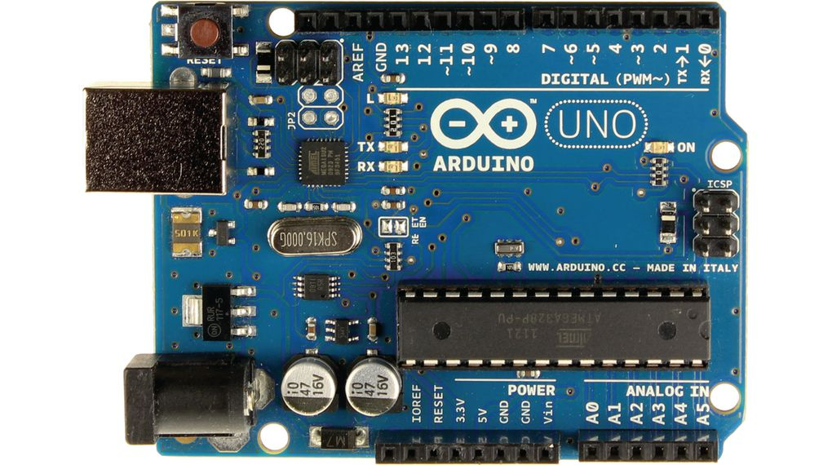

Figure 1.7.1 Arduino Uno

**1.7.2 Arduino IDE**

Arduino IDE is an open source software that is mainly used for writing and compiling the code into the Arduino Module. It is mainly developed in Arduino Software. There are mainly two types of Arduino functions they are:

void setup() :a function run once at the beginning of a program that may initialize the settings.

void loop() :a function referred to as repeatedly till the board powers off programming.

## Description of hardware component

**1.8.1 Resistor**

It is a part of electrical circuit which exist the flow of current. The main purpose of using resistor is control the current and voltage to convert one to another. In this project we used 2 resistor one is 10 kilo ohm and 100 kilo ohm. Its cost is low compared to other resistor. It operate at higher temperature, produce low noise, small in size and high stability.

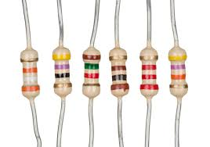

Figure 1.8.1 Resistor

* + 1. **LED**

A light emitting diode (LED) is a semiconductor device that emits visible light when an electric current passes through it.  A light-emitting diode is a two-lead semiconductor light source. It is a p–n junction diode that emits light when activated. When a suitable voltage is applied to the leads, electrons are able to recombine with electron holes within the device, releasing energy in the form of photon.

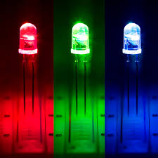

Figure 1.8.2 Light Emitting Diode (LED)

* + 1. **Servo Motor**

This is nothing but a simple electric motor controlled with the help of servomotor mechanism. If the motor as a controlled device associated with servomechanism is DC motor then it is commonly known as DC servomotor. The main reason behind using a servo motor is that it provides angular precision. When we apply power to it, and the rotation continues until we switch off the power. We cannot control the rotational progress of electrical motor, but we can only control the speed of rotation and can turn it on and off.

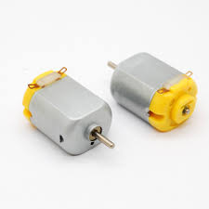

Figure 1.8.3 Servo Motor

* + 1. **Ultra Sonic Sensor**

An Ultrasonic sensor is a device that can measure the distance to an object by using sound waves. It measures distance by sending out a sound wave at a specific frequency and listening for that sound wave to bounce back. By recording the elapsed time between the sound wave being generated and the sound wave bouncing back. It is important to understand that some objects might not be detected by ultrasonic sensors. This is because some objects are shaped or positioned in such a way that the sound wave bounces off the object, but are deflected away from the Ultrasonic sensor. It is also possible for the object to be too small to reflect enough of the sound wave back to the sensor to be detected. Other objects can absorb the sound wave all together (cloth, carpeting, etc). Which means that there is no way for the sensor to detect them accurately.

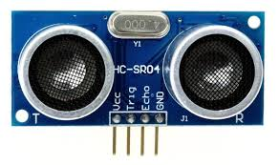

Figure 1.8.4 Ultrasonic Sensor

* + 1. **Motor Drive Control**

A motor controller is a device or group of devices that serves to govern in some predetermined manner the performance of an [electric motor](https://en.wikipedia.org/wiki/Electric_motor). A motor controller might include a manual or automatic means for starting and stopping the motor, selecting forward or reverse rotation. Motor driver act as an interface between the motors and the control circuits. Motor require high amount of current whereas the controller circuit works on low current signals. So the function of motor drivers is to take a low-current signal and then turn it into a higher current signal that can drive a motor.

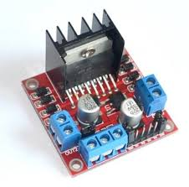

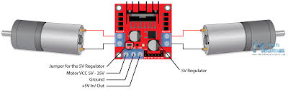

Figure 1.8.7 Motor Drive Control

**1.8.6 Line Following Sensor**

Line sensor are used for sensing white line on black surface. This sensor gives 0.18 volts on bright surface and gives 2.2 v. Its output is analog in nature. When car is placed on the fixed path, it follows the path by detecting the line. The car direction of motion depends on the two sensors outputs. When the two sensors are on the line of path, car moves forward.

**1.8.7Battery**

Batteries have three parts, an anode (-), a cathode (+), and the electrolyte. The cathode and anode (the positive and negative sides at either end of a traditional battery) are hooked up to an electrical circuit. In this project we used total 12 batteries have 1.5v. Its life time is one day.

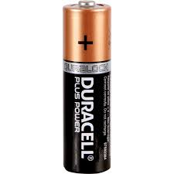

Figure 1.8.7 Battery

**1.8.8 Battery holder**

A battery holder is one or more chambers for holding a battery. For dry cells the holder must also make electrical contact with battery terminals. In this project we used total 3 battery holder and the connection is connected in series combination. Where current remains same and voltage is increased.

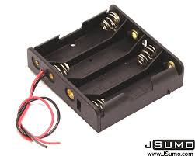

Figure 1.8.8 Battery holder

**1.8.9 Chassis**

The underpart of a motor vehicle, on which the body is mounted is known as chassis. In this project we used two chassis. Its length is 25.5cm and width is 15cm.

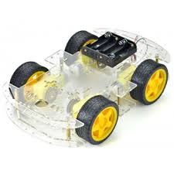

Figure 1.8.6 Chassis

**1.8.10Jumper Wire**

A jump wire is an electrical wire, or group of them in a cable, with a connector or pin at each end, which is normally used to interconnect the components of a breadboard. By placing the jumper wire on the circuit, it becomes possible to control the electricity, stop the operation of the circuit, and operate a circuit that does not operate with ordinary wiring.

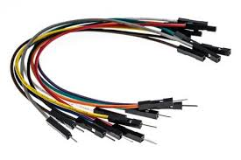

Figure 1.8.10 Jumper Wire

* + 1. **Light Dependent Resistor (LDR)**

A LDR is a light-controlled variable resistor. The resistance of a LDR decreases with increasing incident light intensity; in other words. A LDR can be applied in light-sensitive detector circuits, and light-activated and dark-activated switching circuits. The working principle of an LDR is photo conductivity that is nothing but an optical phenomenon. When the light is absorbed by the material then the conductivity of the material reduces. When the light falls on the LDR, then the electrons in the valence band of the material are eager to the conduction band.

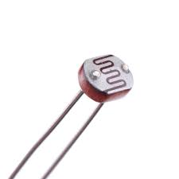

Figure 1.8.11 Light Dependent Resistor

## 1.9 Assignment of roles and responsibilities

|  |  |  |
| --- | --- | --- |
| **Member Name** | **Symbol Number** | **Task Performed** |
| Chanda Shrestha | 323995 | Documentation and coding |
| Anjit pariyar |  | Documentation and coding |
| Anubhav Khadka |  | Documentation, Presentation and coding |

Figure 1.8 Assignment of role and responsibilities

## 1.9 Documentation Organization of the project

|  |  |
| --- | --- |
| **Chapter** | **Heading** |
| Chapter 1 | Introduction |
| Chapter 2 | System Analysis |
| Chapter 3 | System Design |
| Chapter 4 | System Development and Implementation |
| Chapter 5 | Conclusion and Future Enhancement |

Figure 1.9Documentation Organization of the project

# CHAPTER 2: SYSTEM ANALYSIS

Systems analysis is a problem-solving method that involves looking at the wider system, breaking apart the parts, and figuring out how it works in order to achieve a particular goal.

## 2.1 Requirement gathering process

|  |  |  |  |
| --- | --- | --- | --- |
| **Requirement No.** | **Requirement Name** | **Requirement description** | **Process of gathering** |
| 1. | Arduino Uno | Its read input and generate output. | Available in college. |
| 2. | Ultrasonic Sensor | Its detect distance of object. | Available in college. |
| 3. | Line following Sensor | It’s used for sensing white line on black surface. | Available in college. |
| 4. | Light Dependent Resistor | When the lights fall on LDR its value increase rapidly. | Available in college. |
| 5. | Motor Drive Control | It is used to control the motors. | Available in college. |

Figure 2.1Requirement gathering process

## 2.2 Feasibility Study

The feasibility of the project is analyzed in this phase and business proposal is put forth with a very general plan for the project and some cost estimates. It is carried out to access whether project is technically and economically viable. During the system analysis the feasibility study of the proposed system is carried out. For feasibility analysis, some understanding of the major requirement for the system is essential like time and cost.

**2.2.1 Financial Feasibility**

**2.2.2 Technical Feasibility**

**2.2.3 Management Feasibility**

## 2.3 Project Scheduling

Project scheduling is achieved through the Gantt Chart. The work breakdown and time (in weeks), required to complete the specific tasks, are shown as in the Gantt Chart below:

|  |  |  |  |  |  |  |  |  |  |  |  |  |  |
| --- | --- | --- | --- | --- | --- | --- | --- | --- | --- | --- | --- | --- | --- |
| **S.N** | **Task** | **Duration** | **1** | **2** | **3** | **4** | **5** | **6** | **7** | **8** | **9** | **10** | **11** |
| 1 | System study | 1 week |  |  |  |  |  |  |  |  |  |  |  |
| 2 | System Analysis | 2 weeks |  |  |  |  |  |  |  |  |  |  |  |
| 3 | Hardware Design | 4 weeks |  |  |  |  |  |  |  |  |  |  |  |
| 4 | Software Design | 4 weeks |  |  |  |  |  |  |  |  |  |  |  |
| 4 | System Implementation | 3 weeks |  |  |  |  |  |  |  |  |  |  |  |
| 5 | Documentation | 8 weeks |  |  |  |  |  |  |  |  |  |  |  |

Figure 2.3 Project Scheduling

# CHAPTER 3: SYSTEM DESIGN

## 3.1Functional Analysis

**3.1.1 Library Functions**

|  |  |  |
| --- | --- | --- |
| **Function No.** | **Function Name** | **Function Description** |
| **1.** | Setup() | Used to function run once at the beginning of a program that may initialize the settings. |
| **2.** | Loop() | Used to function referred to as repeatedly till the board powers off programming. |

Figure 3.1.1 library function

**3.1.2 User-defined Functions**

|  |  |  |
| --- | --- | --- |
| **Function No.** | **Function Name** | **Function Description** |
| 1. | void forward() | To move the car forward |
| 2. | void back() | To move the car backward |
| 3. | void stop() | To stop the car |
| 4. | void blink() | To blink the lights of car |
| 5. | int ldr() | To turn on and off the lights. |

Figure 3.1.2 User defined function

## 3.2 Algorithm

Step1: start

Step2:initialize trigPin=6, echoPin=13, LS=2, RS=3, motorAIn1=9, motorAIn2=10, motorBIn1=11, motorBIn2=12, ledPin=5, ldrValue, ultraValue

Setp3: setup all variable to Arduino board

Setp4: while

if(LS&&RS==1)

car stop and blink the lights

if(LS==0&&RS==1)

car stop and light blink

if(LS==0&&RS==0)

if(ultraValue==1)

car move forward

else

car stop and light blink

else

car stop and light blink

if (ldrValue==1)

turn on light

else

turn off light

## 3.3 Flowchart

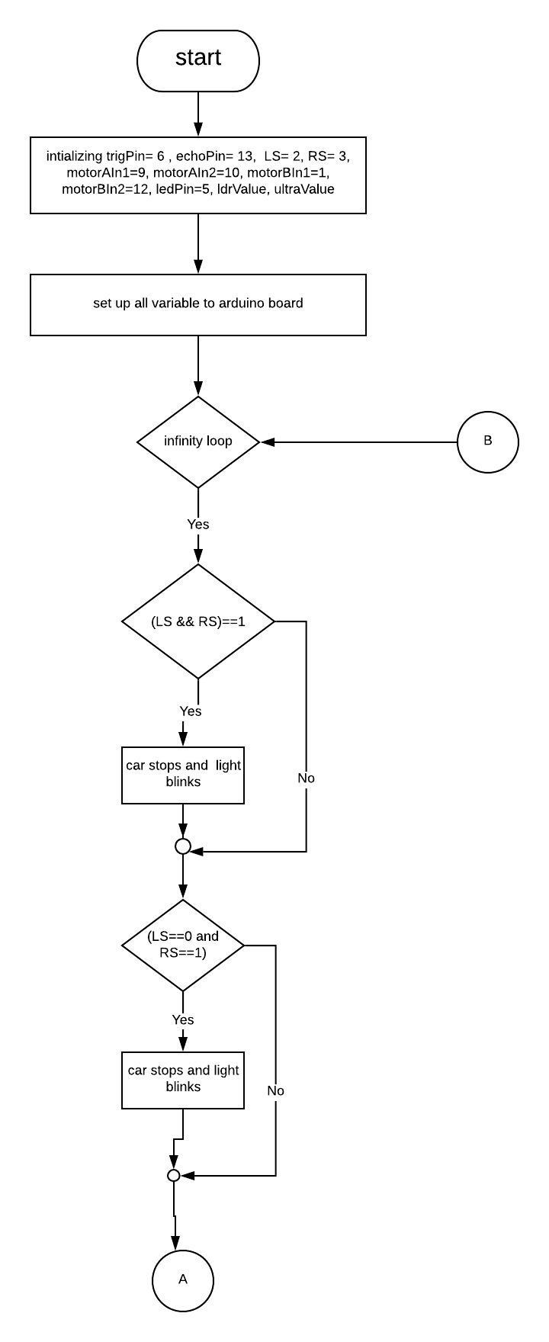

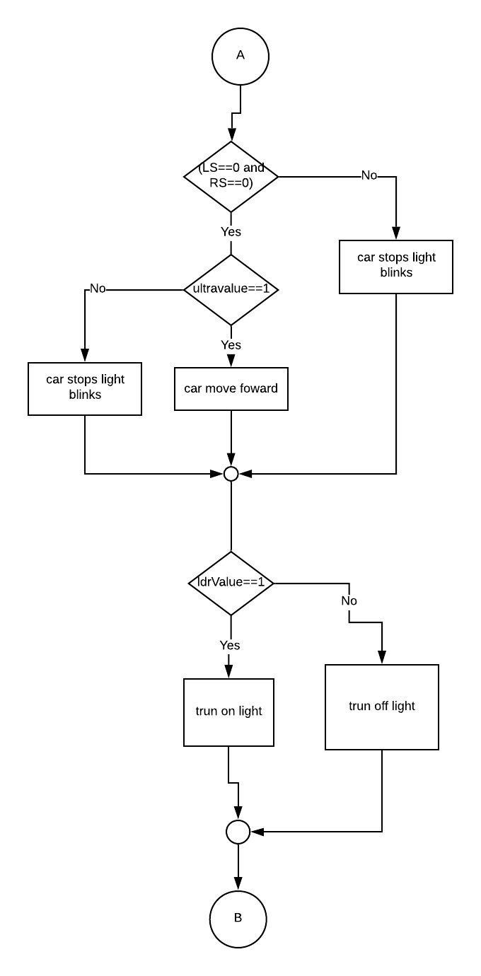

## 3.4 Block diagram

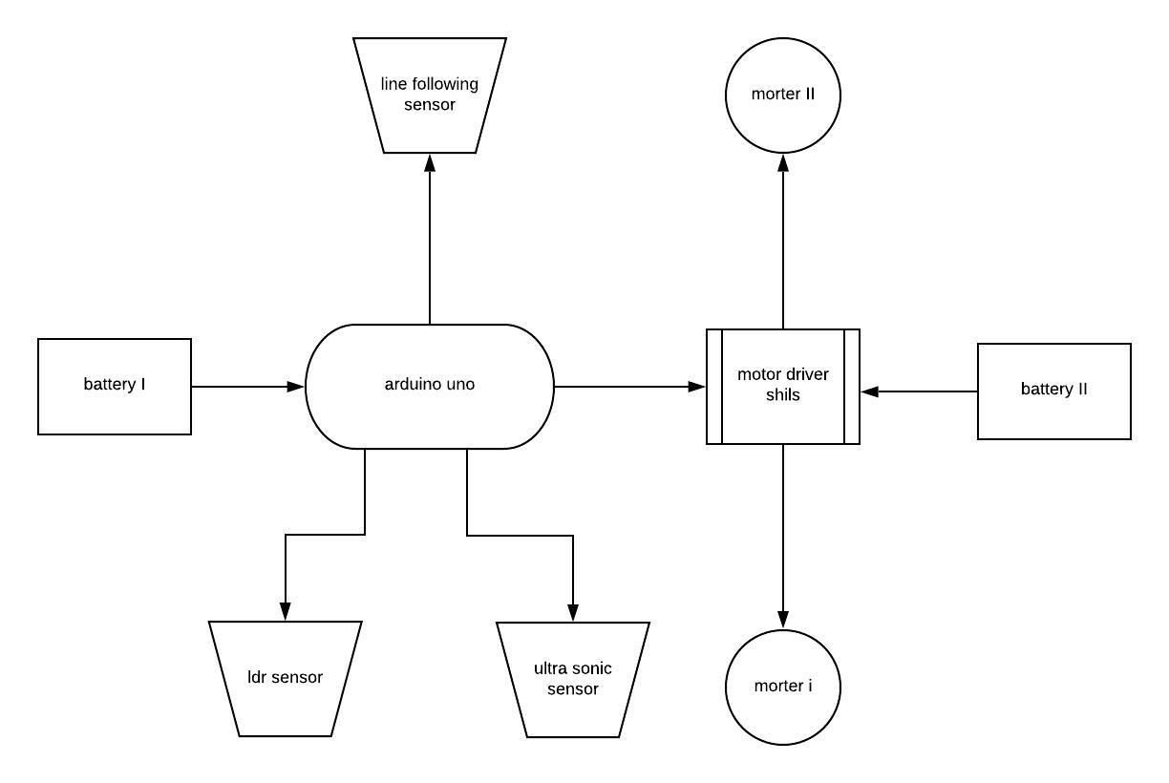

Figure 3.4 Block diagram

# CHAPTER 4: SYSTEM DEVELOPMENT AND IMPLEMENTATION

## 4.1 Programming platform

This project has been created using an Arduino IDE with C++. The Arduino Integrated Development Environment is a cross-platform application that is written in C++ programming language. It is used to write and upload programs to arduino compatible boards. In fact many of the libraries are written in **C**++.

## 4.2Test Plan

|  |  |  |  |
| --- | --- | --- | --- |
| **Input** | **Expected Output** | **Actual Output** | **Status** |
| To stop the car if it detect object | Car stopped if it detect any object or obstacle | Car stopped | True |
| To move the car if object is moved | Car moved forward if object or obstacle is moved | Car moved | True |
| Turn off and on the lights | Automatically turn on and turn off the lights | Car’s lights automatically turn on and off | True |
| Give message if it detect obstacle by blinking lights | If it detect any obstacle it gives message by blinking lights two time | Lights blink | True |

## 4.3Implementation and result analysis

* + 1. **Programming platform**

This project is developed in Arduino IDE.

* + 1. **Hardware Recommended**

This project requires the following hardware requirements:

1. Battery
2. Chassis
3. LED
4. Resistor
5. Servomotor
6. Arduino Uno
7. Line sensor
8. Motor drive control
9. Ultrasonic sensor
10. Jumper wire
11. DC motor
12. LDR
13. Battery holder

**4.3.3Software Requirements**

This project requires the Arduino IDE software and C++.

# CHAPTER 5: CONCLUSION AND FUTURE ENHANCEMENT

## 5.1 Conclusion

The project entitled “Robo Car and Project Simulation” is successfully developed using Arduino IDE. A robo car, also known as an self-driving car, connected and autonomous vehicle, driverless car, robo-car, or robotic car, is a vehicle that is capable of sensing its environment and moving safely with little or no human input.. Which is also known as automatic car. It mainly focus on automatics simpler to drive, it can also allow us to focus on road position whether it is straight or not. It is a systematic way to drive a car. It always follow black line and move on it. We can easily know at what distance obstacle is. If the obstacle is at stationery car is stopped if the obstacle is a moving body then car also move. It detects an obstacles when any object (i.e humans, cars, animals) came in front of it. The lights of car turn on when maximum light is not present and light of car turn off when maximum light is appeared to turn off the lights. Its works when we supply the power and it stop when it detects an object as obstacle. It mainly focus to reduce accidents by detecting obstacles for example if any person came in front of car it takes that person as an obstacle and car stopped.

## 5.2 Limitation

* Car always goes with constant speed
* Car doesn’t slow down while stopping.
* Car doesn’t run in slope.
* Car doesn’t move right, left and back

## 5.3 Future Enhancement

This project will be modified if any requirements occur from robo car in future.

We will include the following features in future they are as follows:

* Car will have ability move left and right
* It will fully follow traffic rules
* Connect to network, store information

**COST SCHEDULE PREPARATION**

|  |  |  |  |
| --- | --- | --- | --- |
| **S.N** | **Hardware** | **Quantity** | **Price** |
| 1. | Battery | 12 | 120 |
| 2. | Chassis | 2 | 140 |
| 3. | LED | 2 | 3 |
| 4. | Resistor | 2 | 2 |
| 6. | Arduino Uno | 1 | 850 |
| 7. | Line Sensor | 1 | 200 |
| 8. | Motor Drive control | 1 | 400 |
| 9. | Ultrasonic Sensor | 1 | 400 |
| 10. | Jumper Wire | 8 | 40 |
| 11. | DC motor | 4 | 40 |
| 12. | LDR | 1 | 10 |
| 13. | Battery holder | 3 | 12 |
| 14. | Switch | 1 | 10 |
| 15. | Wire | 12 | 30 |

Total cost = Rs.2,257

Figure: Cost schedule preparation

**REFRENCE**

**Appendix**