alter table Book Add Publisher varchar(10);



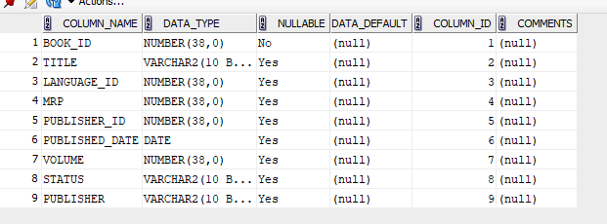

alter table Member modify Branch_Code int;



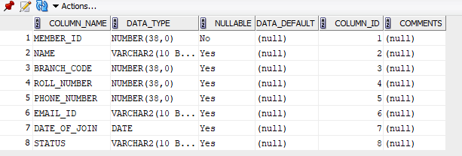

rename LATE_FEE_RULE to FINE_TABLE;



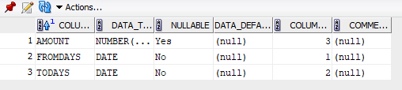

select constraint_name from user_constraints where table_name='BOOK' and constraint_type='R';

