PROBLEM 1: X_normalized  
  
/Users/pioloanjoemarbajaperez/Desktop/Screen Shot 2019-11-19 at 6.23.57 PM.png

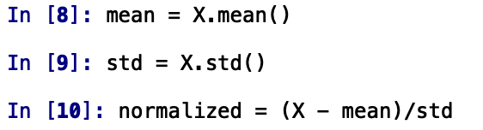

random 5 x 5 ndarray:

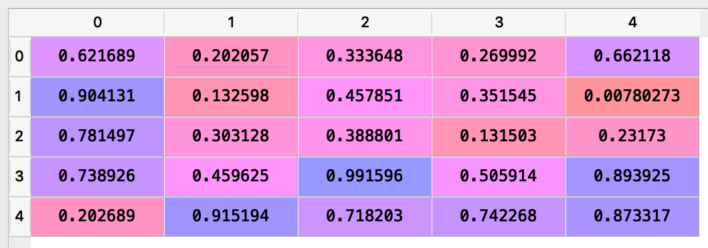

mean:

/Users/pioloanjoemarbajaperez/Desktop/Screen Shot 2019-11-19 at 6.28.20 PM.png

standard deviation:

/Users/pioloanjoemarbajaperez/Desktop/Screen Shot 2019-11-19 at 6.28.24 PM.png

normalized vector using the given formula, (X – mean)/std: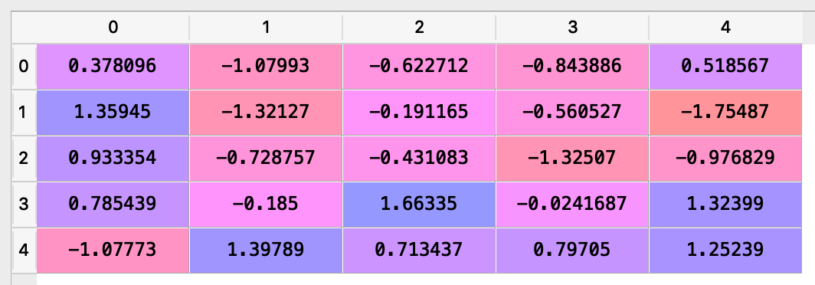

PROBLEM 2: div_by_3

