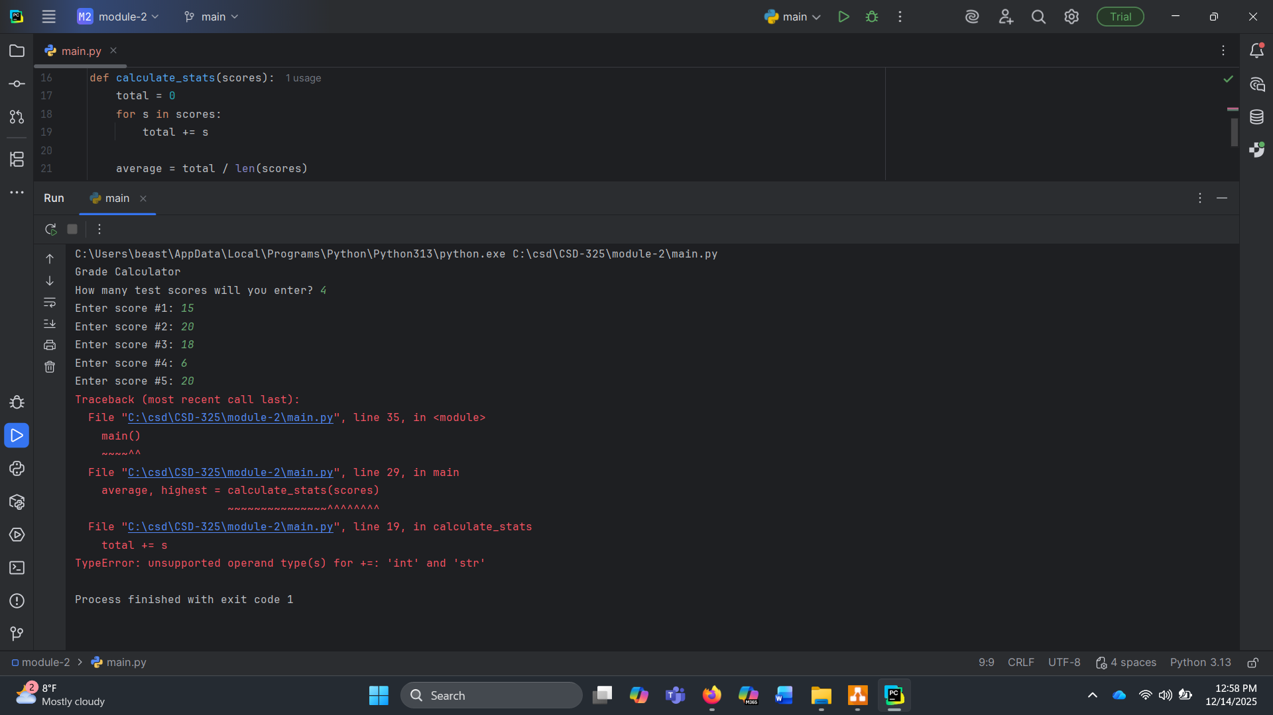
AI was used to produce code with intentional bugs. All of my personal projects are simple and work, a personal goal was to find a bug in unfamiliar code. The program intends to calculate the sum, average, and highest score of x number of scores and their numeric value, both requiring user input. When running the program, the user is prompted to input how many scores they plan to enter. The program then asks for the value of these scores. One immediate issue with the program is the request for an extra numeric value of a score after the expected number of entries. After completing this extra entry, the program exits with an error.

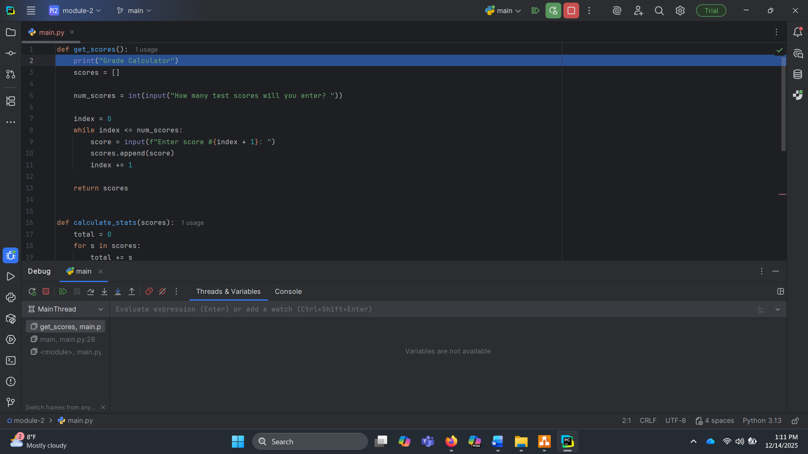
I set a breakpoint at “scores = get_scores()” and began debugging.
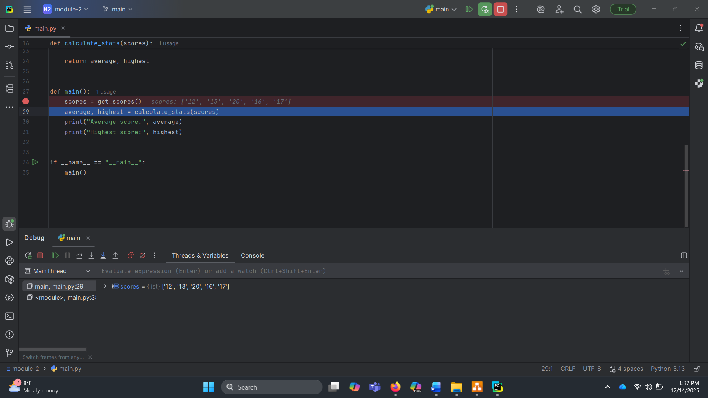
I stepped through the function until it was time to input values. After entering the number 4, I was prompted for 5 inputs. After a few reruns, I noticed the code says while the index is less than or equal to the user input, loop. This causes an extra loop because of the index starting at 0. For example, if the input was 2, and the index starts at 0, 0 is <=2, 1 is <= 2, and 2 is <= 2. This would call for three inputs instead of the expected 2.
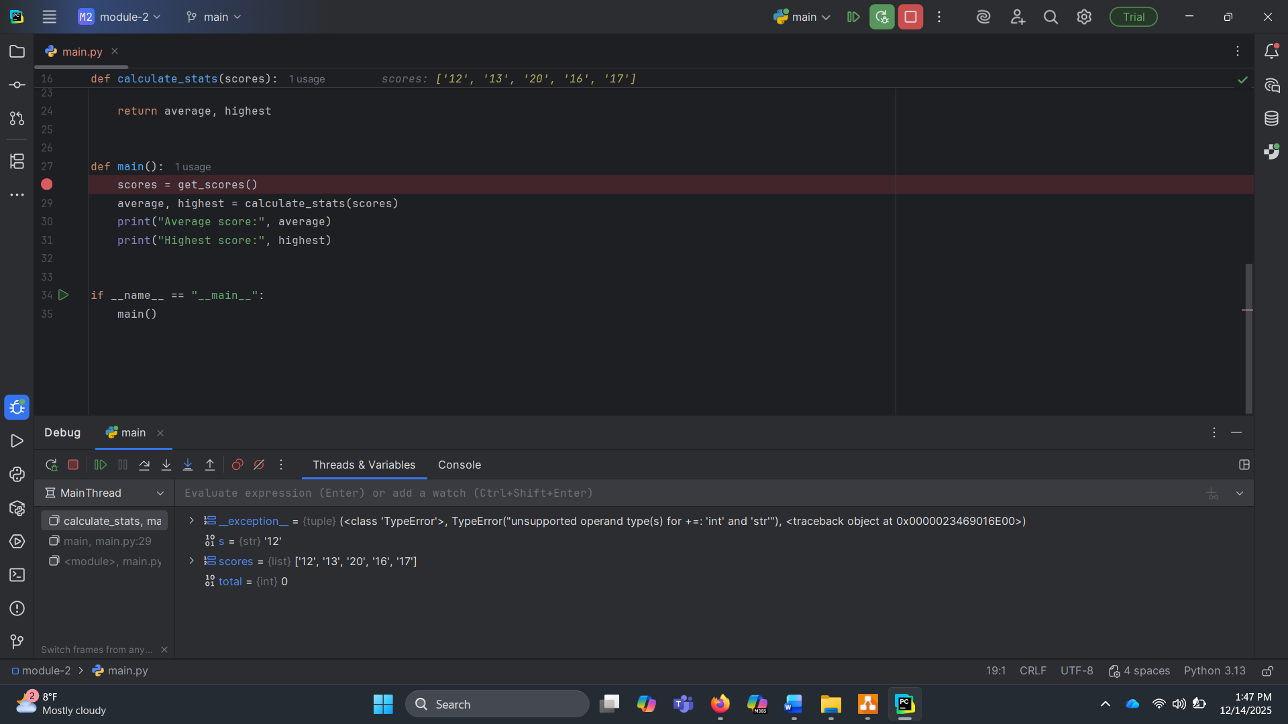
Once I stepped into calculate_stats(), the error presented itself. The error was a TypeError. Examining the threads & variables, the values entered are strings instead of integer. The function attempts to add those strings together, which returns an error.
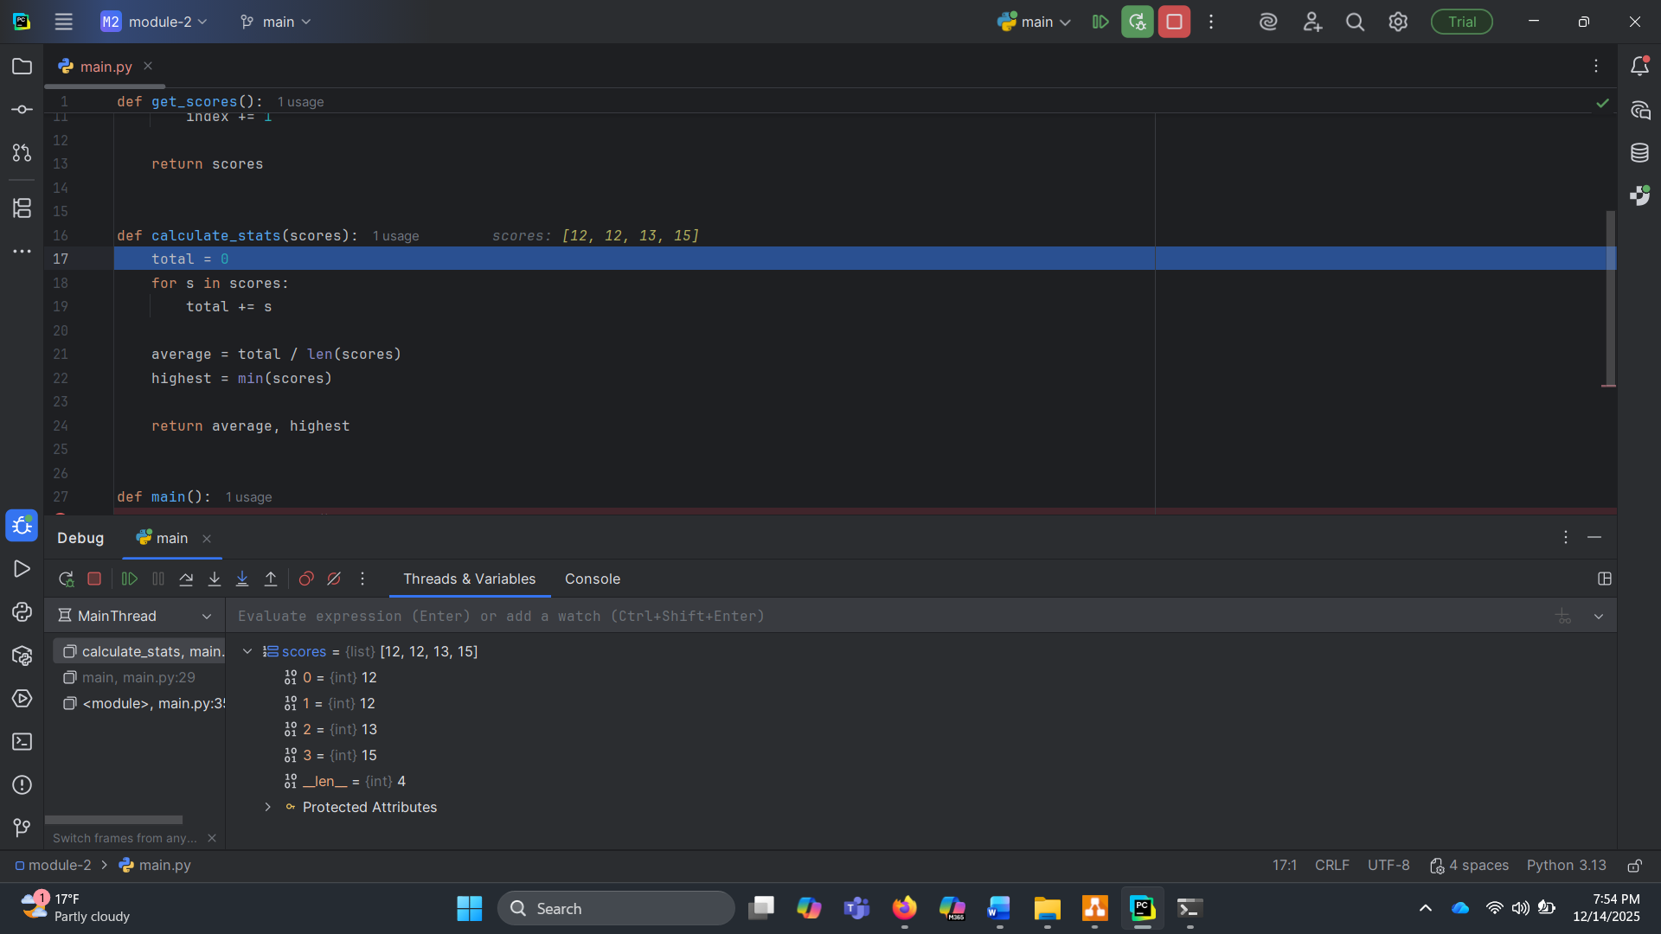
I rewrote the code and the results returned were expected. The issue lay in the line append(score), which correctly appends to a list, but leaves the input as a string. I fixed this to with append(int(score)) which converts it to an integer. This did remind me of the index issue which will need corrected.
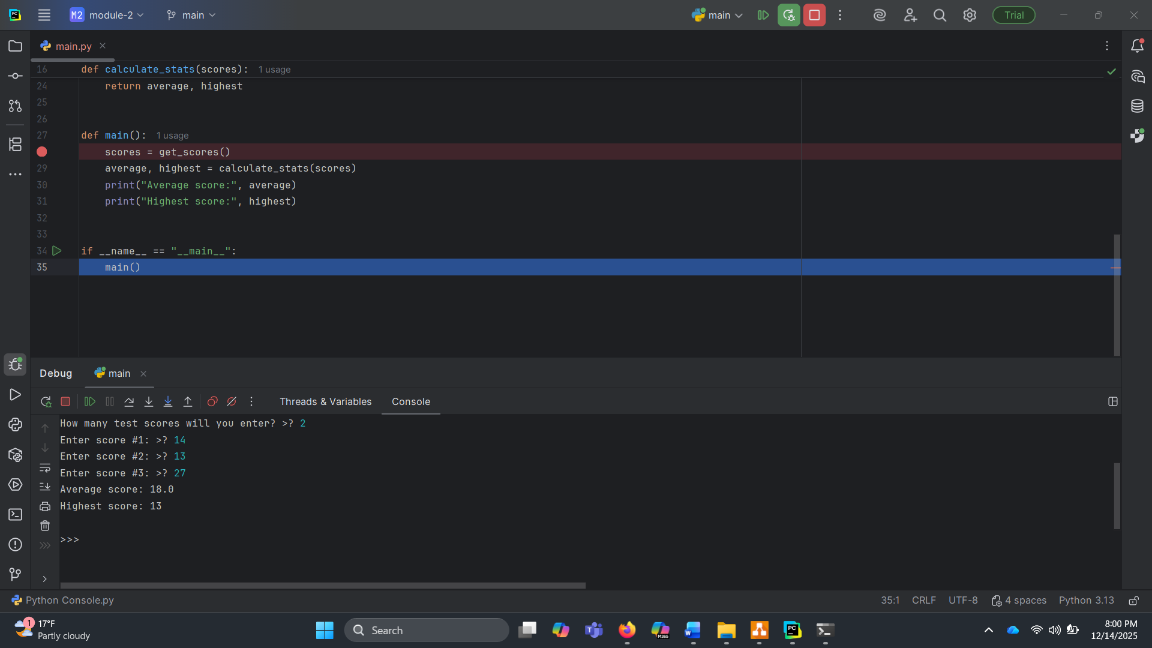
Rerunning the program, the error went away another issue presented. The highest score was not the expected result.
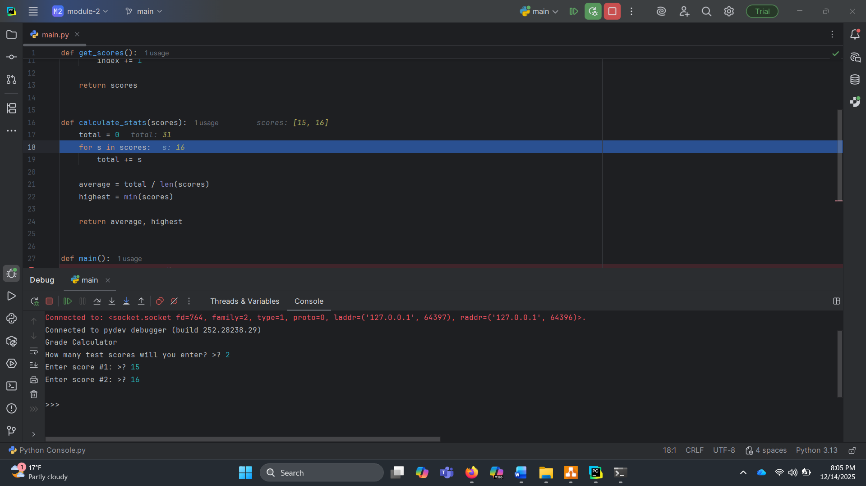
I fixed the index issue (it got annoying) and re-ran the program. This time I stepped into the code calculate_stats(), stepping into it a couple times returned correct values which is shown above.
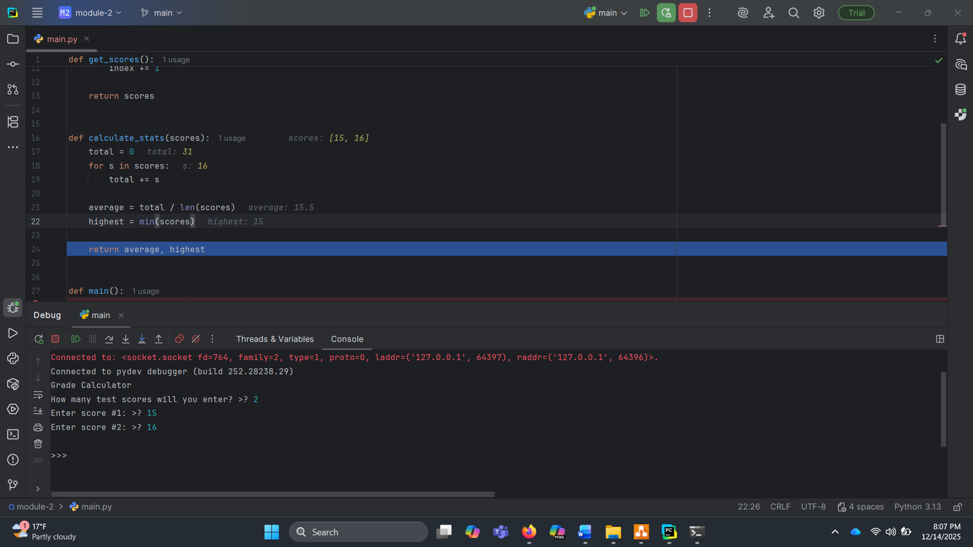
I kept going until I got to the line highest = min(score), and it was apparent what the bug. Min() will return the smallest number instead of the highest number. Inversely, max() will return the highest number.
This was swapped with max(scores) and rerun.
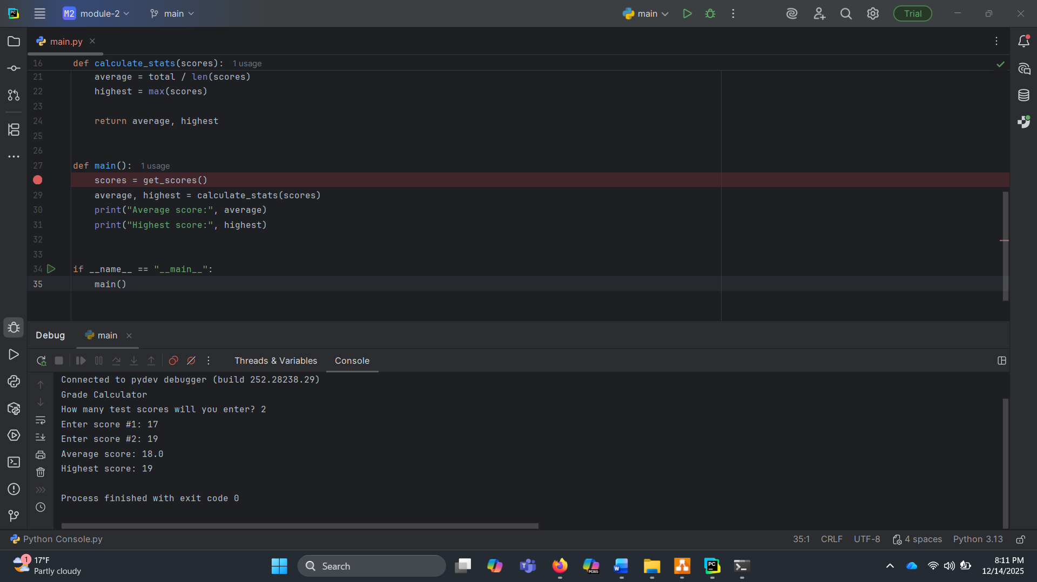
These changes led to the expected results of running the program and finishing with no errors.

