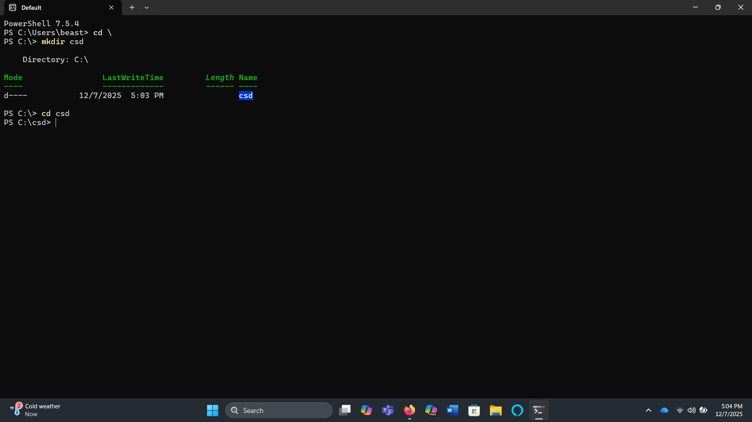
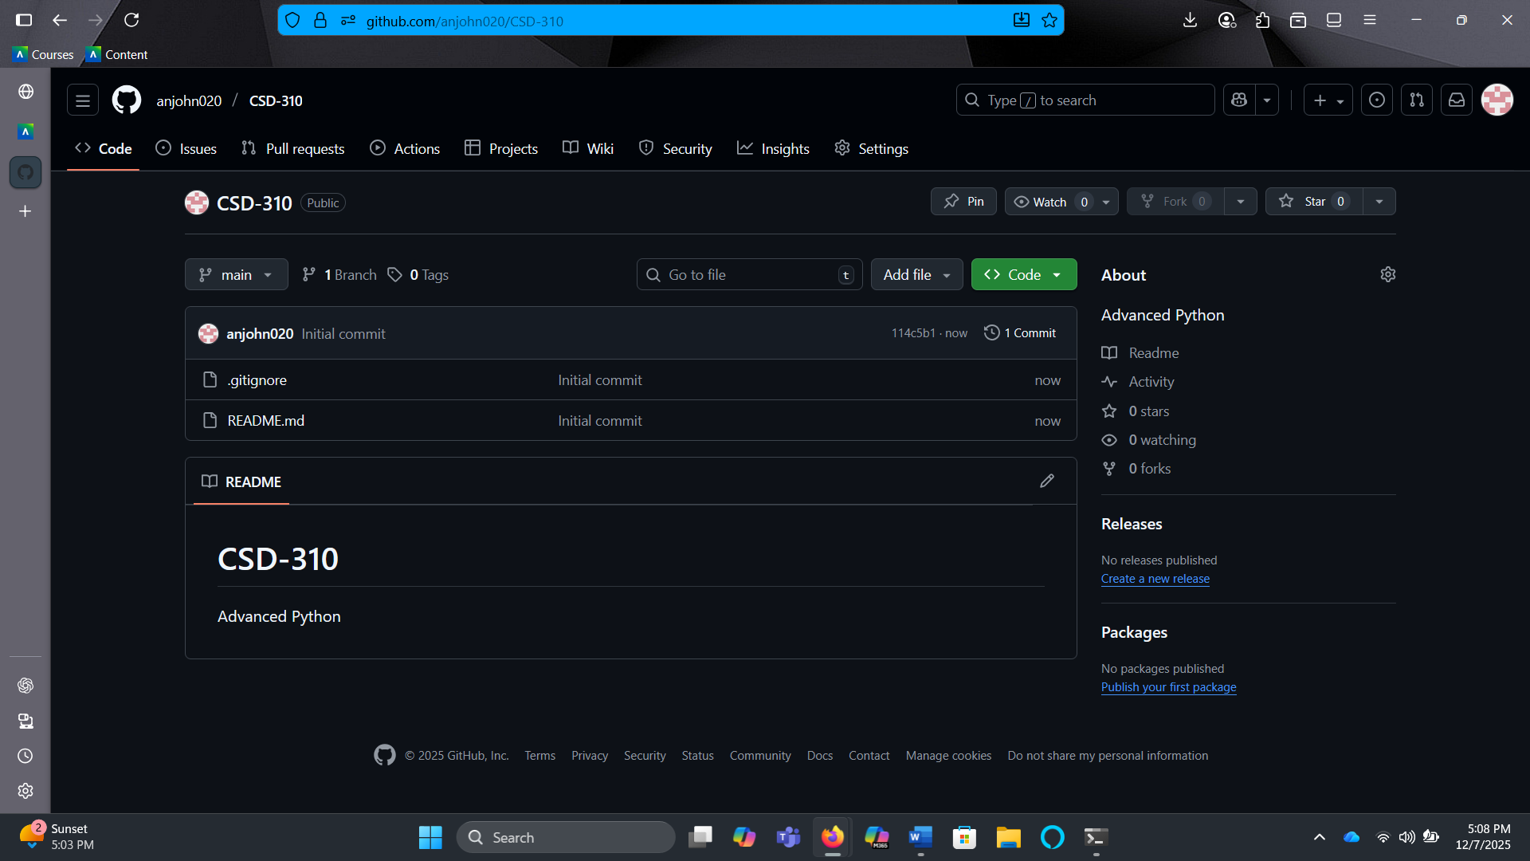
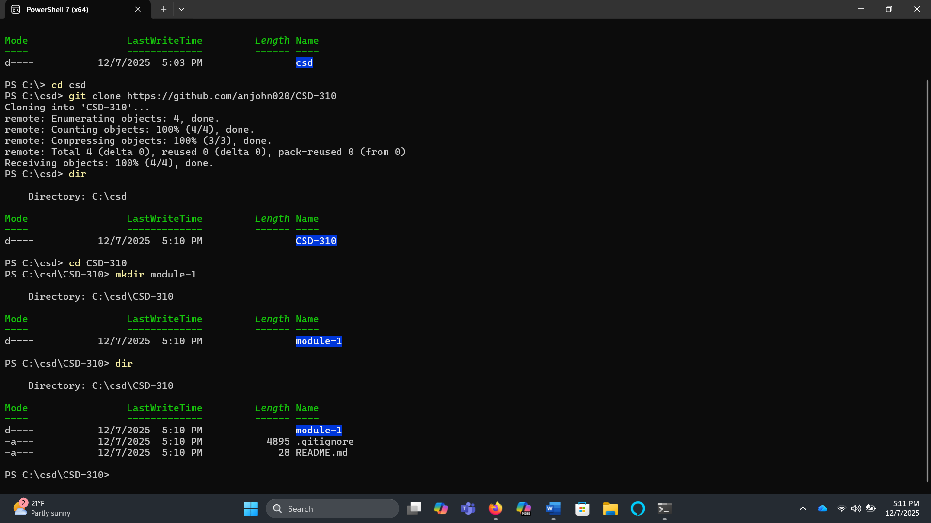
I had to rename a couple things which will be shown in the next screen shot. I updated my original name of the repository to “CSD-325”, then I updated the read-me file. Finally, I updated my origin in PowerShell and synced the changes I made.
