DAIL and the AI Stack Architecture / DAIL 與 AI 系統架構層

1. Introduction / 簡介
EN:
Modern AI systems are typically built as layered architectures. Application logic sits at the top, while foundation models sit at the bottom. Between them are agent frameworks and runtime systems that coordinate reasoning and tool use.
DAIL introduces a missing layer: a formal language for defining AI tasks and constraints.
CN:
現代 AI 系統通常採用分層架構。最上層是應用邏輯，最底層是基礎模型。中間則包含 Agent Framework 與 LLM Runtime，用來協調推理與工具調用。
DAIL 補上了一個長期缺失的層：用於正式定義 AI 任務與限制的語言層。

2. The AI Stack / AI 技術棧
EN:
A simplified AI stack can be described as:
Application → Agent Framework → DAIL → LLM Runtime → Model
CN:
簡化的 AI 技術棧可以表示為：
Application → Agent Framework → DAIL → LLM Runtime → Model
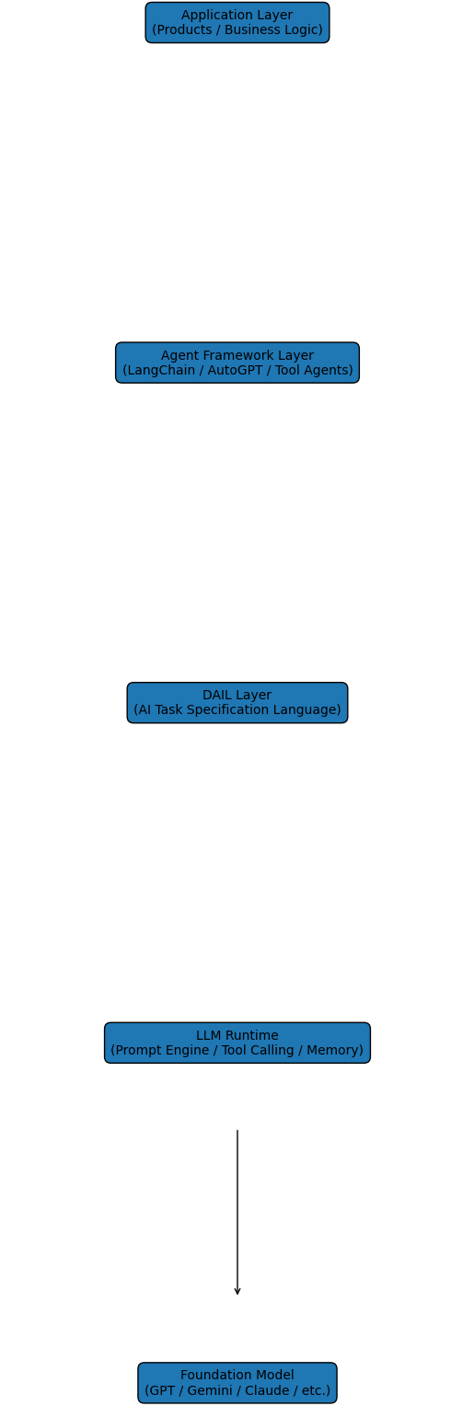

3. Layer Responsibilities / 各層責任
EN:
Application Layer: Business logic and product functionality.
Agent Framework: Executes workflows, planning, and tool orchestration.
DAIL Layer: Defines task goals, constraints, and validation rules.
LLM Runtime: Handles prompt execution, tool calls, and reasoning loops.
Foundation Model: Generates tokens based on learned patterns.
CN:
Application 層：業務邏輯與產品功能。
Agent Framework：負責工作流程、規劃與工具調度。
DAIL 層：定義任務目標、限制條件與驗證規則。
LLM Runtime：處理 prompt、工具呼叫與推理循環。
Foundation Model：根據訓練生成輸出。

4. Why the DAIL Layer Matters / 為什麼需要 DAIL 層
EN:
Without a task specification layer, AI systems rely on informal prompts to define tasks. This makes systems difficult to test, validate, and maintain.
DAIL introduces structured task definitions that allow AI behavior to be constrained and reasoned about systematically.
CN:
如果沒有任務規格層，AI 系統只能依賴非正式的 Prompt 來定義任務。這會使系統難以測試、驗證與維護。
DAIL 提供結構化任務定義，使 AI 行為可以被限制並可被系統化分析。

5. One‑Sentence Summary / 一句話總結
EN:
Agent frameworks execute tasks. DAIL defines tasks.
CN:
Agent Framework 負責執行任務；DAIL 負責定義任務。

