SAC Protocol v1.0 – Visual Supplement

1. Attractor Landscape Concept
Illustrates a conceptual attractor landscape where system states move between basins.
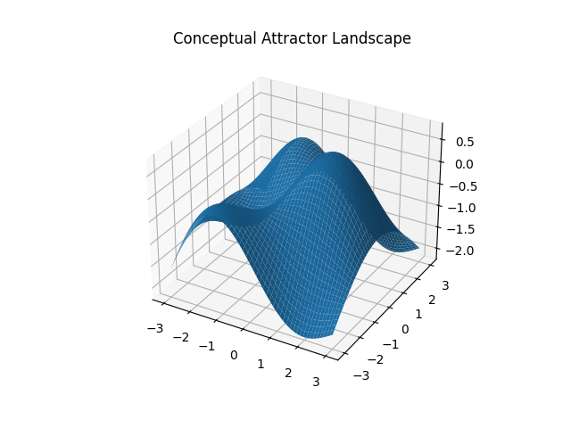

2. Tension Gradient
Example of tension variation during exploration phases.
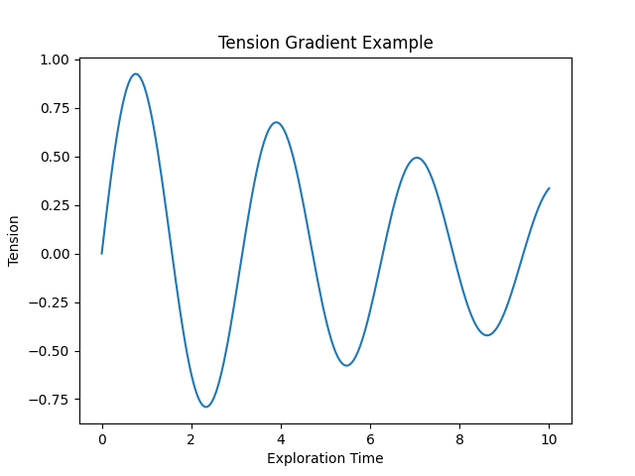

3. SAC Architecture Flow
Simplified conceptual architecture showing relationship between reactive substrate, SAC protocol, and language layer.
