# sass

# Created on November 02 2019

# Table of Contents

1.0. Initial Page

2.0. Details

# 1.0. Initial Page

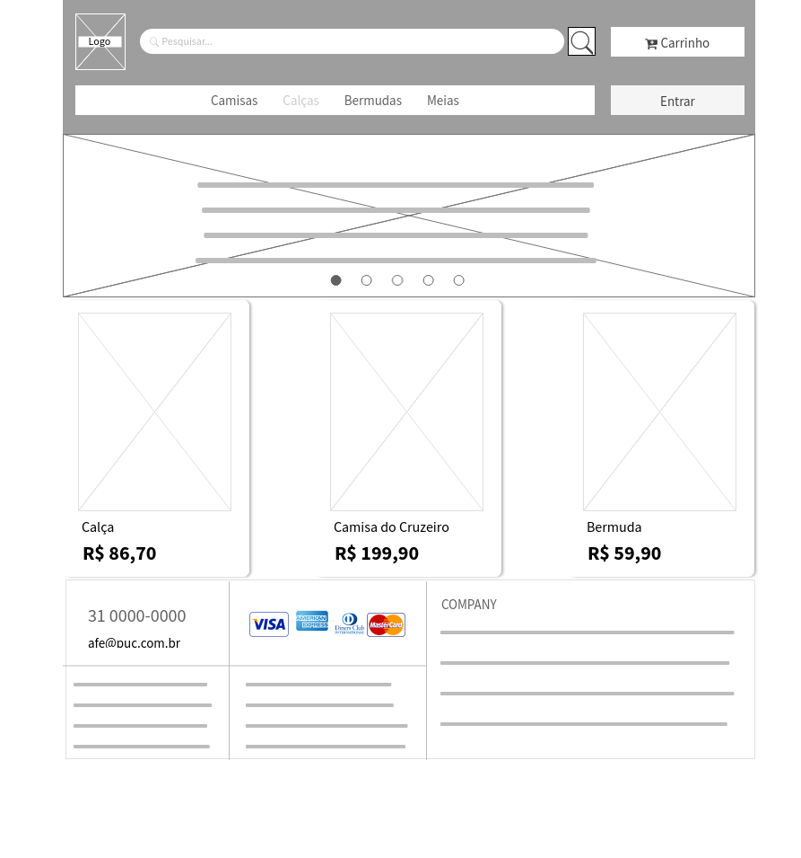

# 2.0. Details

