Week 15 Assessment

Step 1: Create Solution & Projects
Create Solution: NorthwindCatalog
Add 3 projects:
- NorthwindCatalog.Web → MVC
- NorthwindCatalog.Services → Class Library
- NorthwindCatalog.Tests → xUnit Test Project
Step 2: Add Project Reference

In Web: → Add reference to:
- Services

In Tests: → Add reference to:
- Services
Step 3: Install Required Packages
Install-Package Microsoft.EntityFrameworkCore.SqlServer
Install-Package Microsoft.EntityFrameworkCore.Tools
Install-Package AutoMapper
Step 4: DB First
Set Default Project : NorthwindCatalog.Services
In appsettings.json
Write your connection string
"ConnectionStrings": {
"DefaultConnection": "Server=.\\sqlexpress;Database=NorthWind;Trusted_Connection=True;TrustServerCertificate=True;"
}
- Run this command in Package Manager Console
Scaffold-DbContext "Server=.\SQLEXPRESS;Database=NorthWind;Trusted_Connection=True;TrustServerCertificate=True" Microsoft.EntityFrameworkCore.SqlServer -OutputDir Models -Tables Categories,Products
- You will see
Model-> Categories
Model->Products
And NorthWindContext.cs
Add this in program.cs
builder.Services.AddDbContext<NorthWindContext>();
STEP 5: DTOs + AutoMapper
STEP 5.1: Create DTO Folder
STEP 5.2: Create DTO Classes
- CategoryDto.cs
public class CategoryDto
{
public int CategoryId { get; set; }
public string CategoryName { get; set; }
public string ImageUrl { get; set; }
}
- ProductDto.cs
public class ProductDto
{
public string ProductName { get; set; }
public decimal UnitPrice { get; set; }
public short UnitsInStock { get; set; }

public decimal InventoryValue => UnitPrice * UnitsInStock;
}
- CategorySummaryDto.cs
public class CategorySummaryDto
{
public string CategoryName { get; set; }
public int ProductCount { get; set; }
public decimal AvgPrice { get; set; }
public string MostExpensiveProduct { get; set; }
}
STEP 5.3: Add AutoMapper
Create Folder- Mapping
Create File MappingProfile.cs
public class MappingProfile:Profile
{
public MappingProfile()
{
CreateMap<Category, CategoryDto>()
.ForMember(dest => dest.ImageUrl,
opt => opt.MapFrom(src => "/images/" + src.CategoryId + ".jpeg"));

CreateMap<Product, ProductDto>();
}
}
STEP 5.4: Register AutoMapper

builder.Services.AddAutoMapper(typeof(MappingProfile));

STEP 6: Repository Pattern

STEP 6.1: Create Folder

In Services Project -> Repositories

STEP 6.2: Create Interfaces

- ICategoryRepository.cs

public interface ICategoryRepository
{
Task<IEnumerable<Category>> GetAllAsync();
}

- IProductRepository.cs

public interface IProductRepository
{
Task<IEnumerable<Product>> GetByCategoryIdAsync(int categoryId);
Task<IEnumerable<CategorySummaryDto>> GetCategorySummariesAsync();
}

STEP 6.3: Implement Repositories

- CategoryRepository.cs

public class CategoryRepository:ICategoryRepository
{
private readonly NorthWindContext _context;

public CategoryRepository(NorthWindContext context)
{
_context = context;
}

public async Task<IEnumerable<Category>> GetAllAsync()
{
return await _context.Categories.ToListAsync();
}
}

- ProductRepository.cs

public class ProductRepository : IProductRepository
{
private readonly NorthWindContext _context;

public ProductRepository(NorthWindContext context)
{
_context = context;
}

public async Task<IEnumerable<Product>> GetByCategoryIdAsync(int categoryId)
{
return await _context.Products
.Where(p => p.CategoryId == categoryId)
.ToListAsync();
}

public async Task<IEnumerable<CategorySummaryDto>> GetCategorySummariesAsync()
{
return await _context.Categories
.Select(c => new CategorySummaryDto
{
CategoryName = c.CategoryName,
ProductCount = c.Products.Count(),

AvgPrice = c.Products.Any()
? c.Products.Average(p => p.UnitPrice ?? 0)
: 0,

MostExpensiveProduct = c.Products
.OrderByDescending(p => p.UnitPrice ?? 0)
.Select(p => p.ProductName)
.FirstOrDefault()
})
.ToListAsync();
}
}

STEP 6.4: Register Repositories

In Program.cs -> Add

builder.Services.AddScoped<ICategoryRepository, CategoryRepository>();
builder.Services.AddScoped<IProductRepository, ProductRepository>();

STEP 7: API CONTROLLERS

- Inside Services -> Controllers

Create Controllers

- CategoriesApiController

[Route("api/categories")]
[ApiController]public class CategoriesApiController : ControllerBase
{
private readonly ICategoryRepository _repo;
private readonly IMapper _mapper;

public CategoriesApiController(ICategoryRepository repo, IMapper mapper)
{
_repo = repo;
_mapper = mapper;
}

[HttpGet]
public async Task<IActionResult> Get()
{
var categories = await _repo.GetAllAsync();
var result = _mapper.Map<IEnumerable<CategoryDto>>(categories);
return Ok(result);
}
}

- ProductsApiController

[Route("api/products")]
[ApiController]public class ProductsApiController : ControllerBase
{
private readonly IProductRepository _repo;
private readonly IMapper _mapper;

public ProductsApiController(IProductRepository repo, IMapper mapper)
{
_repo = repo;
_mapper = mapper;
}

// 🔹 Get products by category
[HttpGet("by-category/{categoryId}")]
public async Task<IActionResult> GetByCategory(int categoryId)
{
var products = await _repo.GetByCategoryIdAsync(categoryId);
var result = _mapper.Map<IEnumerable<ProductDto>>(products);
return Ok(result);
}

// 🔹 Get summary
[HttpGet("summary")]
public async Task<IActionResult> GetSummary()
{
var data = await _repo.GetCategorySummariesAsync();
return Ok(data);
}
}

Run & Test

Run Service Project

Test Apis in Postman

- Categories API
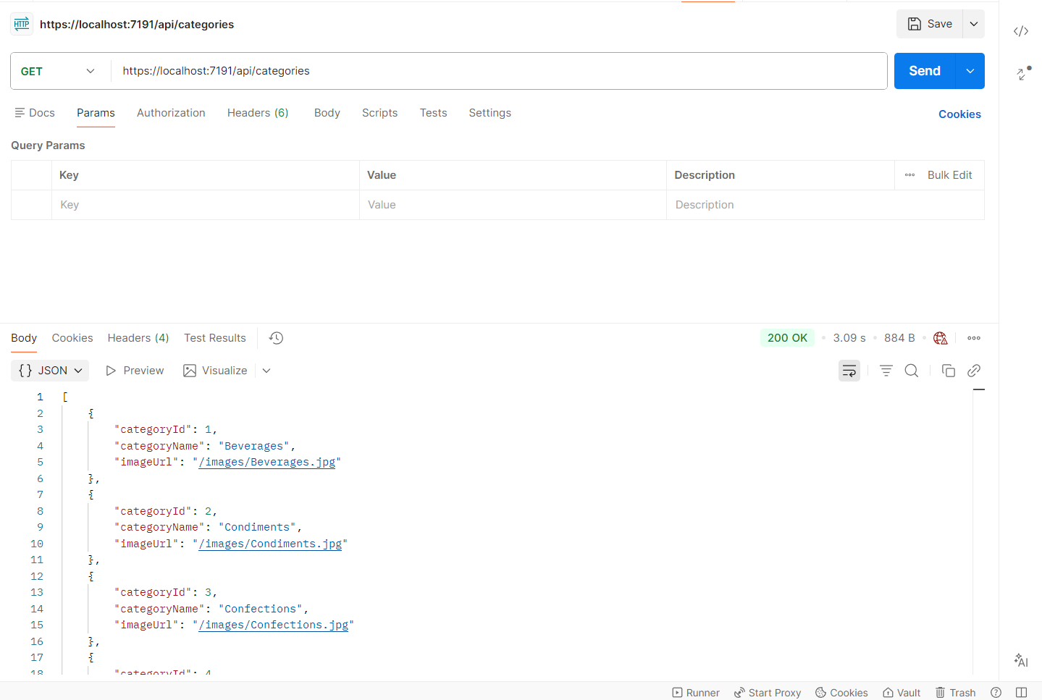
- Products by Category

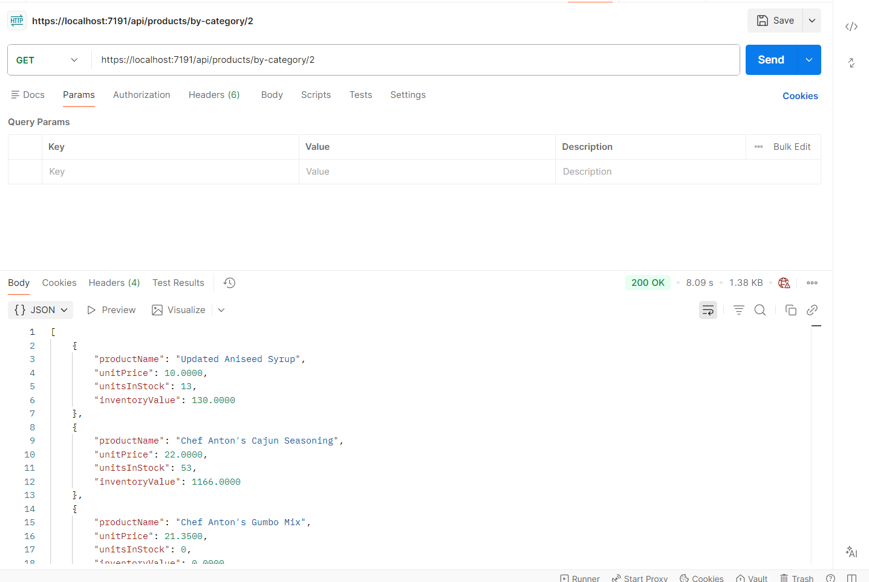

- Summary API

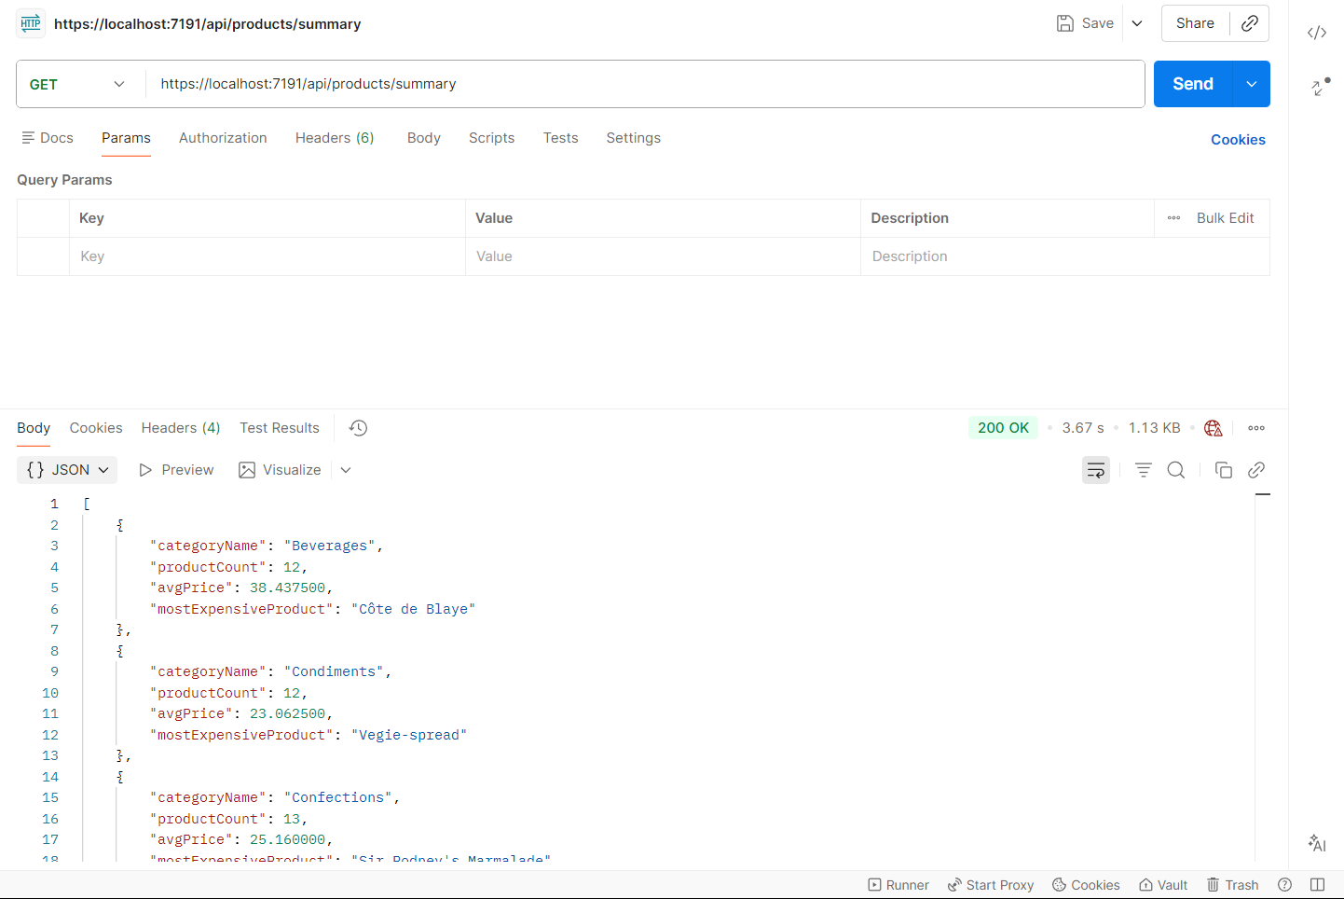

STEP 8: MVC (Frontend)
We’ll build 3 pages:
- Categories (cards)
- Products (cards)
- Summary (table)

STEP 8.1: Configure HttpClient
Open:
NorthWindCatalog.Web → Program.cs

Add:

builder.Services.AddHttpClient("api", client =>
{
client.BaseAddress = new Uri("https://localhost:7191/");
});

Step 8.2 Create Controllers

- CategoriesController.cs

public class CategoriesController : Controller
{
private readonly IHttpClientFactory _factory;

public CategoriesController(IHttpClientFactory factory)
{
_factory = factory;
}

public async Task<IActionResult> Index()
{
var client = _factory.CreateClient("api");

var data = await client.GetFromJsonAsync<List<CategoryDto>>("api/categories");

return View(data);
}
}

- ProductsController.cs

public class ProductsController : Controller
{
private readonly IHttpClientFactory _factory;

public ProductsController(IHttpClientFactory factory)
{
_factory = factory;
}

public async Task<IActionResult> ByCategory(int id)
{
var client = _factory.CreateClient("api");

var data = await client.GetFromJsonAsync<List<ProductDto>>($"api/products/by-category/{id}");

return View(data);
}
}

- SummaryController.cs

public class SummaryController : Controller
{
private readonly IHttpClientFactory _factory;

public SummaryController(IHttpClientFactory factory)
{
_factory = factory;
}

public async Task<IActionResult> Index()
{
var client = _factory.CreateClient("api");

var data = await client.GetFromJsonAsync<List<CategorySummaryDto>>("api/products/summary");

return View(data);
}
}
Step 8.3: Create Views
Create Views for all 3 controllers

Step 8.4 Run Project
Set Services and MVC as startup

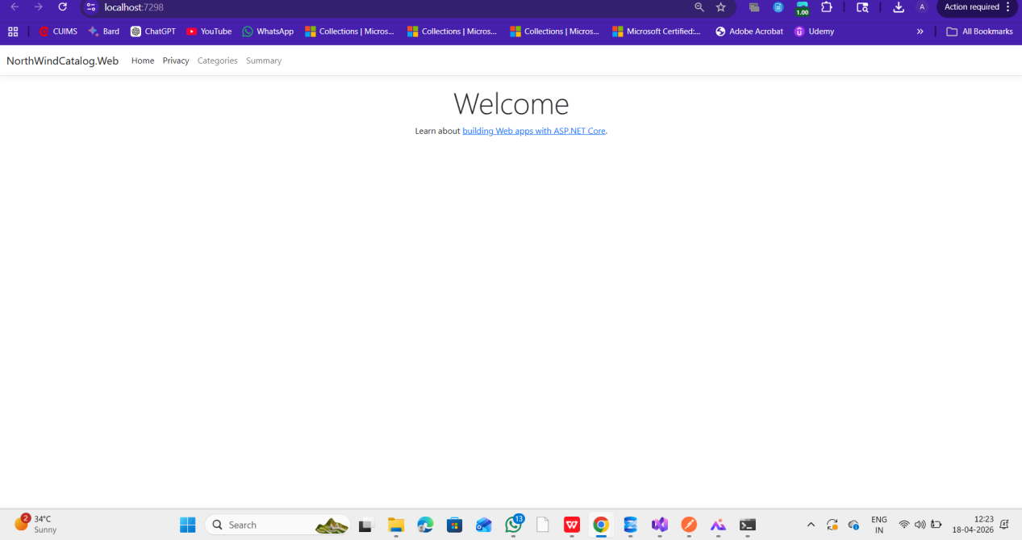
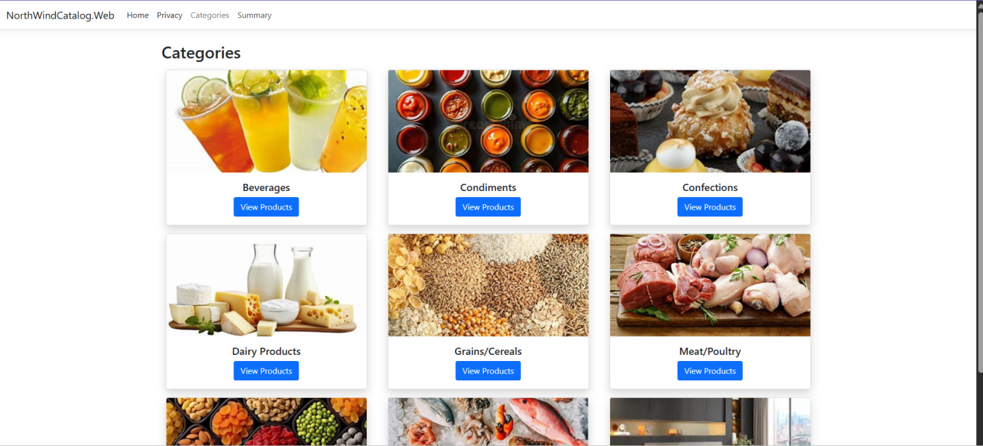

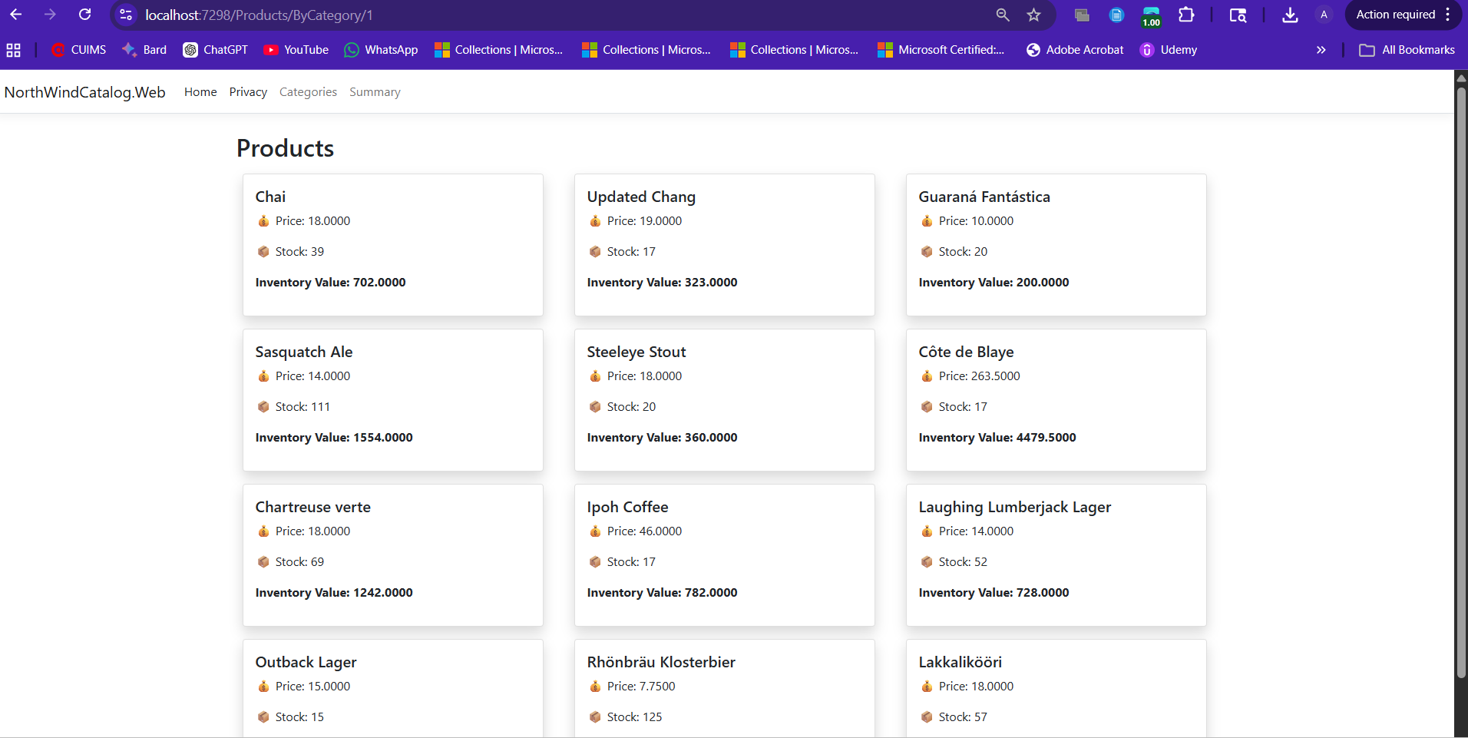

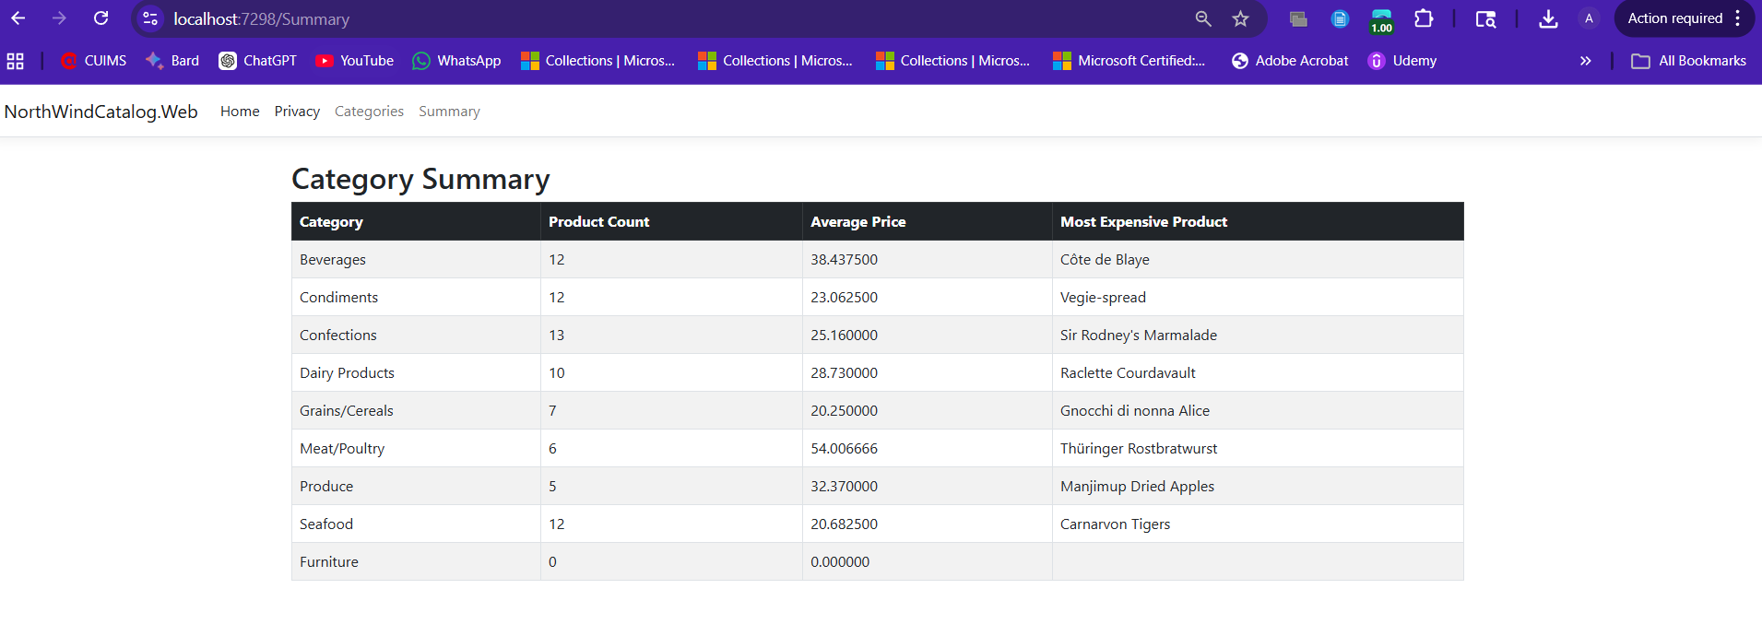

Step 9: NorthWindCatalog.Tests

- Select XUnit for Test
- Add reference-> Services
- Create Test class
- Run Test
- Go to Test -> Test Explorer
- Run All Tests
