Evaluating E-Learning within Automotive Small-Medium Suppliers (1)

(1) Developing an Evaluation Tool Kit

Professor Jean-Jacques CHANARON
Research Director with CNRS
Chief Scientific Adviser with Grenoble Ecole de Management

Abstract:

The two articles deal with the complex issue of evaluating e-learning and benchmarking with traditional face-to-face training. It is based on the implementation of an experimental e-learning platform dedicated to SMEs within the automotive supply chain. The first paper presents the evaluation tool kit that has been specifically designed from an extensive literature survey. The second part presents the results from the evaluation of the experimental e-learning platform and courses by trainees, tutors, managers and directors who have been involved in the trial sessions.

Key Words

Automotive, Suppliers, e-learning, evaluation

Biographical Notes

Professor J.J. Chanaron is currently Research Director within the French National Center for Scientific Research ‘CNRS) and professor in Technology Management and Economics at the Grenoble Graduate School of Business where he is also the Chief Scientific Advisor.

He has published extensively via books, articles in refereed journals and conference papers in Industrial Economics, Economics of Innovation and Technology Management since 1973 when he received his PhD at the University of Grenoble. He also holds a HDR in Economics. He is Associated Professor and Researcher with Henley Management College, Manchester University and Newcastle University in the UK. He is a well-recognized expert in the automotive industry. He is consultant to International Organizations (EU, OECD, ILO, UNIDO), professional organizations (CCFA, FIEV, JAMA, CLEPA), OEMs (PSA, Renault, Toyota, Nissan, DaimlerChrysler) and component manufacturers. He is a member of the French Society of Automotive Engineers (SIA) and the GERPISA International Network of Researchers on the Auto Industry.

Evaluating E-Learning within Automotive Small-Medium Suppliers (1)

(1) Building up an Evaluation Tool Kit

Introduction

This article presents the theoretical background and the evaluation tool kit as developed within a European-funded project, namely ELSA E-Learning Solution for Automotive SMEs, that has been carried out by a consortium of European SMEs, universities and professional organisations in 2002 and 2003. The outcome of the project has been the creation an e-learning platform (see http://elsa.clepa.com/) that has been tested and evaluated by three SMEs (two in Italy, one in the United Kingdom) all of them supplying European OEMs.

The document, as a first step, explores the ideas about evaluation of e-learning derived from an extensive literature survey and a synthesis of appropriate tools that are presented to form the ELSA-project specific evaluation plan. It presents the definition of the evaluation goals and methodology that has been made taking into account the outcomes of the users’ requirements analysis (Chanaron, 2002) and the functional design specifications of the ELSA portal.

1. Evaluating e-Training Efficiency

When corporations and SMEs are engaged in restructuring their organization and re-engineering their business, there are new demands on training. The two main changes are:

- Shifting from training the individual to satisfying the objectives of the organization;

- Serving well the customers, i.e. the trainees and their organizations in the context of increased competition and expanding globalisation.

Therefore, there is a renewed and intense need to justify the cost of training based on a demonstrated return on investment (ROI) and positive organizational impacts. Evaluating the impacts and benefits of training has always been a challenge for organizations. Most academic literature is very cautious about such evaluation since there is no consensus on the key issues that should be addressed:

- What should be evaluated?
- How it might be assessed?
- When it should be carried out?
- Who should be involved?

Expanding the need for evaluation to e-training is further complicating the questions. The only consensus is regarding

- The extreme complexity of any effort to evaluate training;
- The importance of being clear about the purposes of and the audiences for any such evaluation;
- The major differences between traditional classroom training and Internet-based training.

What should be evaluated? This is one of the main questions. Basically, there are many different aspects to be evaluated. According to press cuttings, when classified by the frequency of use by the business community, the two most popular methods for training evaluation are:

- Training participants immediately complete written surveys on training content (62%);
- Training participants immediately complete written surveys on trainer performance (60%).

These methods are trying to address trainee, i.e. customer satisfaction with the content and the trainer. But other methods should be pointed out such as getting ongoing feedback, e.g., from the learners, trainers and learner's supervisors, to improve the quality of the training and identify if the learner achieved the goals of the training and evaluating the benefits of training after a period during which the trainees are supposed to have used what they have learnt.

Again, as ranked according to a decreasing frequency of use by businesses, there are several other evaluation methods such as supervisors providing informal, verbal evaluations of employee performance changes after training; supervisors completing written evaluations of participants' performance after training; training participants completing written evaluations of training after designated time post-training; training participants completing pre- and post-training tests of job performance; measuring improved customer service; measuring improved organizational efficiency, effectiveness and/or performance is measured; and, finally, calculating cost savings after training.

This is worth pinpointing that the last but not the least by importance, i.e. measurement of cost savings, is to be used by a very small percentage of companies.

1.1. Basis from Literature

There is a very abundant literature on what should be evaluated as far as learning or training are concerned. Most papers are referring to the Donald Kirkpatrick's well-known framework for evaluating training, often referred as the four Kirkpatrick’s levels:

- Reaction: What does the learner feel about the training?
- Learning: What facts, knowledge, etc., did the learner gain?
- Behaviours: What skills did the learner develop? Or what new information is the learner using on the job?
- Results or effectiveness: What results occurred? In other words, did the learner apply the new skills to the necessary tasks in the organization and, if so, what results were achieved?

Very recently, a fifth level, i.e. level 5, Return On Investment (ROI) has been added to the Kirkpatrick’s scale since more attention has been paid to cost effectiveness.

It is important to recognise that the farther down the list, the more valid should be the evaluation. Although level 4, evaluating results and effectiveness, is the most desirable and desired result from training by the organization, it is usually far the most difficult to accomplish. Evaluating effectiveness often involves the use of key performance measurements such as faster and more reliable output from the machine after the operator has been trained, higher ratings on employees' job satisfaction questionnaires from the trainee’s supervisor, etc.

Nickols (2000) clearly points out the structure of the Kirkpatrick’s levels within the organization:

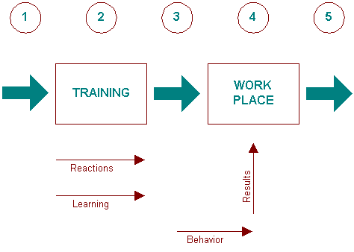
Source : Nickols, (2000).

According to Nickols (2000), there are five basic points at which evaluation takes place:

- Before training;
- During training;
- After training or before entry (or re-entry);
- In the workplace;
- Upon exiting the workplace.

One of the main problems when dealing with training is that evaluations are often a mixture of measurements, assessments, and judgments. Therefore, the exercise might loose its credibility.

As it might be expected from a professional trainer, Eisler (2000) suggests that assessment of e-training should concentrate on learning, i.e. Kirkpatrick’s level two.

Lockee (2001) pinpoints the variables that differentiates traditional classroom training and Internet-based training:

- Cognitive styles;
- Learning styles
- Instructional strategies,
- Teaching methodologies;
- Training domains

May (2000) suggests that the lack of face-to-face interaction in e-learning makes ongoing and on-line evaluation even more essential. Smith & Hardaker (2000) developed an interesting model to incorporate all cognitive aspects of Internet-based learning. Four inter-related dimensions are defined:

- Individual learning;
- Collaborative learning;
- Exploratory learning;
- Interactive learning.

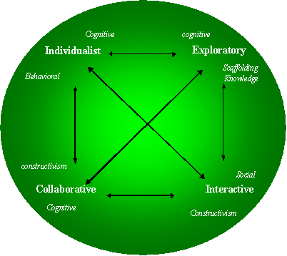

Such philosophy of e-learning would justify a multi-criteria approach to evaluation in order to encompass such diversity of learning styles. Penson (2001) suggests that the openness to various cognitive style is precisely a key strength of web-based training.

When dealing with Internet-based training, Gorski (1999) suggested seven criteria to evaluate such activities:

- Relevance and appropriateness: is there a need or a sense to use e-training instead of traditional training? What are the contextual strengths of e-training? Is e-training, its content and target audience appropriate?

- Credibility: are the author’s authority and the trustworthiness of the content proven?

- Bias identification: is the site inclusive or exclusive? Is it authored and sponsored? Is it commercial?

- Accuracy and completeness: are information, data and knowledge accurate and comprehensive?

- Accessibility: are all information accessible to anybody (no coding, total technological compatibility, all web links, etc.)?

- Navigability: is the site easy to navigate?

- “Multi-culturality”: is the site reflecting multicultural teaching and learning principles?

Evaluating the content might concentrate on different issues.

- Materials, i.e. the quality of the text, graphics, audio and video;

- Additional features and tools, i.e. the availability of proactive functions such as chat, e-mail, discussion groups, on-line assessment board, trainee individual account, file saving, tracking, Internet links, login security, import/export capabilities, upgrading, on-line help, progress tracking, self assessment, user interface, etc.;

- Co-lateral requirements, i.e. the quality and cost of required books and CD-Rom;

- Complementary modules or courses, i.e. the quality and compatibility of inter-linked multi-media courses.

Hazari (1998) proposed a comprehensive checklist. Graham, Cagiltay, Lim, Craner, Duffy, (2000), from the Indiana University Centre for Research on Learning and Technology (CRLT) elaborated seven principles that could help to evaluate on-line training:

- Interaction between instructors and students and trainees: policies for the types of communication such as individual or forum discussions, standards for instructors’ timelines for responding;

- Cooperation among participants: discussion assignments;

- Active learning by participants: projects, tasks, peer exchanges, etc.;

- Feedback: information/evaluation feedback and acknowledgment feedback;

- Timing of tasks for instructors and participants: scheduling and deadlines,

- Expectations: assignments, examples and models, case studies, etc.

- Respect of diversity of talents and ways of learning: choice by participants,

In April 2000, the Institute for Higher Education Policy (2000) proposed 45 different benchmarks for success in Internet-based distance learning grouped in seven categories: Institutional support; Course development; Teaching/learning; Course structure; Student support; Faculty support; Evaluation and Assessment.

As far as this last category is concerned, they suggested five key benchmarks:

- Diversity of evaluation methods of the programme effectiveness;

- Availability of an evaluation process to improve teaching/learning process;

- Definition of specific standards to compare and improve learning outcomes;

- Availability of data on enrolment, costs and effectiveness of new technologies;

- Regular evaluation of intended learning outcomes.

Finally, the Return On Investment (ROI) issue is obviously a very complicated question since it needs accurate and bias-free measurement. Some large corporations such as Cisco which has moved quite massively towards e-learning (Hall & Le Cavalier, 1999) reports increased productivity resulting from e-learning, including:

- Reduction in support costs;

- Improved efficiencies while using business tools;

- Increased workloads while requiring fewer people;

- Quicker implementation of tools to a broader scope of employees.

The evaluation of training costs is difficult. Anderson (2000), estimates that the total cost for 1,000 students would be US$ 1.5 million with e-learning and 1.3 million for a classroom system. For 2,000 students, the advantage will be to e-learning with US$ 2 million and 2.6 million for classroom.

Basically, most evaluation frameworks reviewed in the literature are either partial, i.e. covering part only of an overall process which appears to be quite complex; or highly challengeable due to weak theoretical foundations or performances measurement methods and tools. There is a need to build up a comprehensive model.

1.2. Towards a comprehensive model

The goal of setting up a comprehensive model might be achieved by constructing from existing basic frameworks that have limited weaknesses. The framework developed by Khan (2001) is very fruitful in contributing to the design of a comprehensive model for evaluation. Eight dimensions might be defined which all refer to several sub-dimensions that characterise e-training, in particular .

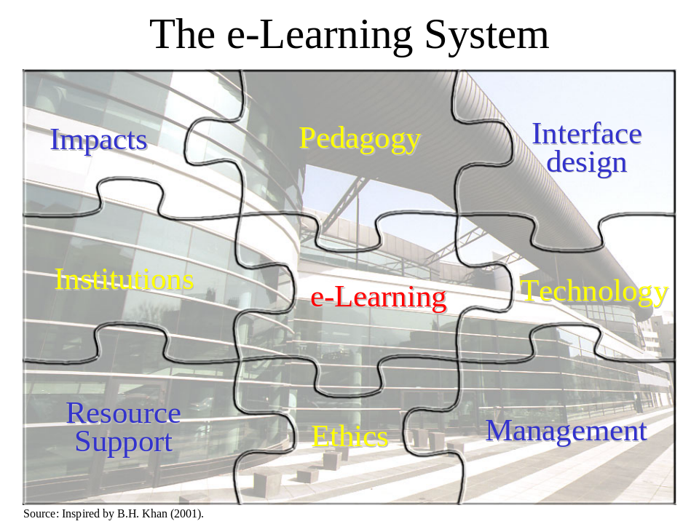

- Pedagogy: this issue covers the content, the knowledge transfer methods and strategy, the design, the organization, and also the objectives of the course;

- Technology: this aspect deals with the technology (hardware), the software, and the technical organization of the training;

- Ethics: this dimension has to check the fit with diversity in culture, geography and learning style, and the related legal issues, in order to assess the potential bias;

- Institution: this issue is related to corporate culture, human resource strategy, income policy, and personnel development and promotion strategy;

- Interface design: this dimension is associated with Internet site design and content, navigation capability, usability, etc.;

- Management: this issue is linked to maintenance, day-to-day management, technical support, distribution of information;

- Resource support: this dimension has to deal with communication tools, on-line support, contacts with tutors and other trainees;

- Impacts: this key issue evaluates several variables such as individual learning progress, return on investment, tutors capabilities, efficiency.

1.3. When, How and Who to evaluate

During the whole process of designing and delivering a training course or programme, there are at least two stages during which such evaluation effort should be deployed:

- The validation of the pilot module in order to test the accuracy and the quality of the training tools;

- The evaluation itself at the end of the delivering process in order to measure the impacts and review for further dissemination.

Another key question for the organization is to decide who is going to be questioned about the effectiveness of a training module or programme. Nickols (2001) is suggesting a stakeholder approach:

- Trainees
- Their managers
- The funding managers
- Training developers
- Instructors
- Training managers
- Training vendors

Obviously several methods and techniques are available for evaluating training. The most popular one is the end-of-training questionnaire. But, as stated by the Intelligent Machines Branch of the Georgia Tech Research Institute, many alternative options have advantages depending on what is to be measured and what are the desired information. They proposed the following data collection tools in order to evaluate interactive multi-media (IMM) training courses:

- Questionnaires filled up by users, instructors and managers;
- Interviews with users, tutors and managers;
- Expert reviews;
- Anonymous tests;
- Anecdotal records;
- Focus group protocol.

Then, a comprehensive and synthetic report should be produced, computing and interpreting the data generated by the different tools.

According to Wilson & Rosenfeld (1997), the evaluation of training should look at four different levels:

- Society
- Organization
- Group
- Individual

According to Rees (2002), the first factor in evaluation of training is to firstly consider organisational goals, then consider what each group, department or team can contribute, then the contribution of each individual. Once this is clear, then training needs for each of these levels can be considered. One of the key issues with efficiency is the alignment of these four dimensions.

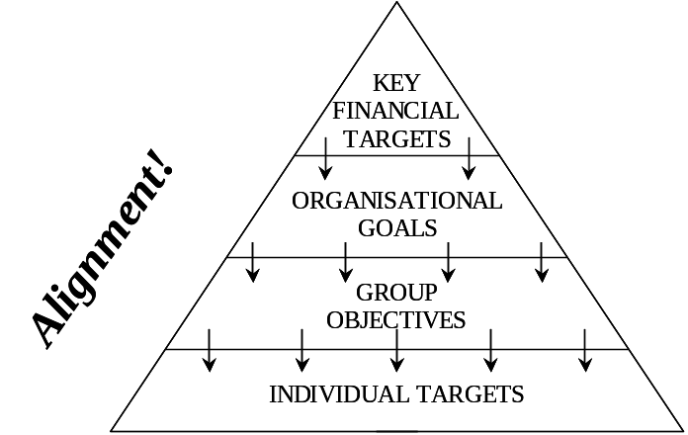

Rees (2002) suggested the following steps in setting up a training evaluation process dedicated to SMEs:

- Identify what the objectives for the organisation are: Are they to improve profitability, grow sales, attack a new market, or implement an environmental system?

- Decide how groups and individuals should contribute to such objectives;

- Review the existing skills within the organisation and identify any areas where improvements are required in order to achieve the objectives;

- Identify the impact that the training offered should have on each of these levels, using then four level framework: The effectiveness of the training is measured by relating back to its expected outcome, were the objectives achieved in full, partially, not at all, or possibly even having a better than expected result.

- Evaluate the efficiency of training for each of the above areas: how much the training cost, how much of peoples time it took, how easy it was for people to follow etc.

The end result of this might be a table that shows each group, together with information about effectiveness and efficiency.

2. Towards a Specific Evaluation Model for the ELSA project

According to the literature review, it is obvious that there is no one-best-way in evaluating e-learning, in fact in evaluating learning in general. Facing such a diversity in the issues to be evaluated and the extreme complexity of the assessment exercise, and taking into account the specificity of each situation, i.e. of each learning project, the only option available would be to design a specific set of tools using the most accurate and efficient methods proposed by experts.

2.1. The overall picture

The system with eight dimensions, i.e. pedagogy, technology, interface, institution, resource support, ethics, management and impacts, or in other words, the what to evaluate or measure, looks the most appropriate to take into account the very complexity and to cover the multidimensional characteristic of the process.

Then the first question is to measure at what stage of the learning process, such dimensions should be evaluated. From best practices comes the following suggestion:

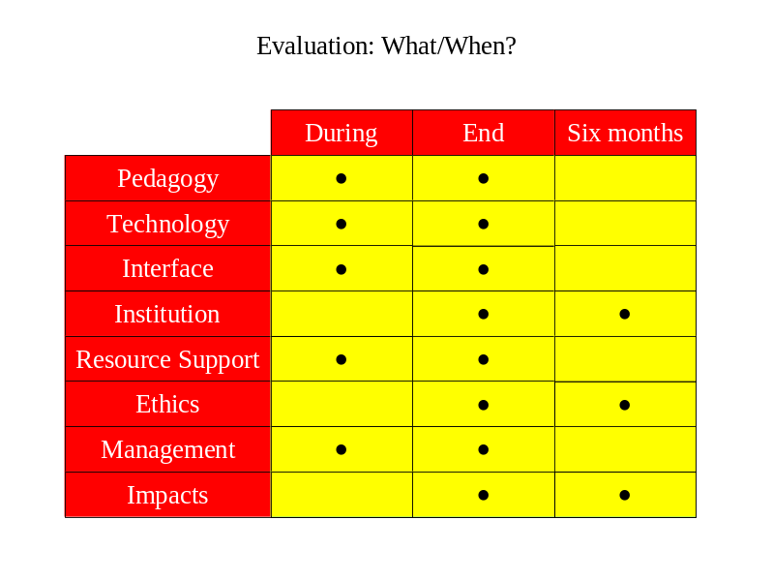

Then, the second level would be select who should evaluate those eight dimensions. It seems reasonable to involve the following persons:
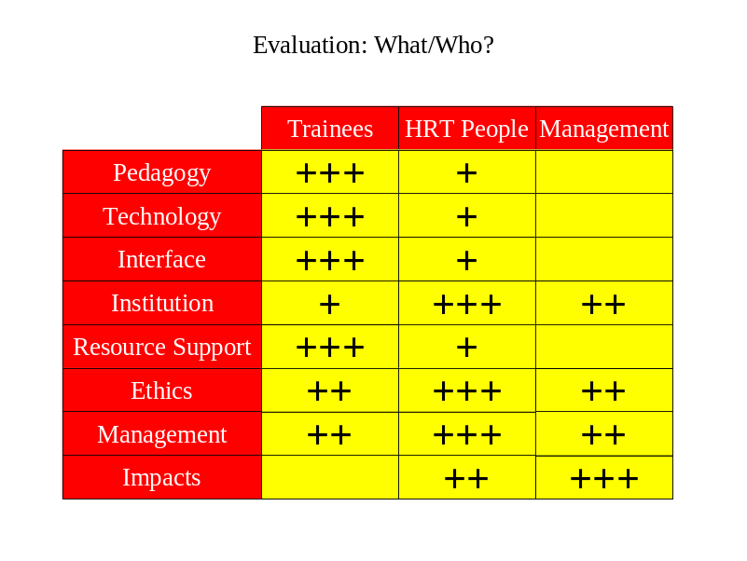
As suggested by the Georgia Tech Research Institute, the choice of the methods or tools has to be made by the e-learning evaluating body for each specific case.

2.2. The ELSA evaluation tool kit

The ELSA evaluation tool kit has been adapted from existing methods taking into account the above-mentioned literature background and the specific need of the project. It is a mix of different methodological options, depending on the evaluation actors and the information desired by the project members. The selection of tools has been heavily shaped the fact that the ELSA project was an experimental one due to its application in the context of automobile SMEs.

It has been designed in order to meet the SME-specific needs and requirements, in particular the lack of time and commitment. It is made of the following tools:

- The Anecdotal Record Form (ARF) that would be filled in by trainees and trainers during the course for each significant incident;

- The Evaluation Interview Protocol (EIP) which should be realised with training managers and SME executive managers with focus on impacts of training;

- The Evaluation Questionnaire (EQ) that should be answered by trainees and tutors or instructors;

- The User Interface Rating Form (UIRF) that should also be answered by trainees but also by tutors and instructors.

1. The Anecdotal Record Form

Participants in an interactive multimedia training project are asked to observe incidents and then to report of such incidents that relate to the development and impact of the program. The ARF should contain only factual, non-inferential description of the observed or reported incident and should be written as soon as possible after witnessing or hearing about the incident. It should include a separate section describing the interpretation of or feelings about the anecdote.

This tool has obvious advantages in particular when applied during an experimental learning situation. It allows identifying technical and pedagogic defects at a very early stage of the implementation process such as bugs, content-related mistakes, etc.

2. The Evaluation Interview Protocol

Interviews could be used to collect information about global reactions to an interactive multimedia program and more detailed information that could only be identified through face to face discussion. Such interviews would indeed lead to valuable qualitative comments that could not emerge from quantitative questionnaires. If carried out in advance with managers and human resources experts, such interviews might be used to identify the most important evaluation issues that will be included in a questionnaire disseminated to a larger population, in particular to trainees.

The quality of the interview guide is indeed the key issue and should be adapted to each particular learning situation. In the ELSA project, it was taking into account its experimental characteristic and was indeed adapted in complexity and length to SMEs employees and managers.

In a second step, i.e. after completion of the training phase, an open interview with managers and CEOs has been added specifically targeted at two key issues:

- Efficiency of the learning process;
- Return on investment.

All responses were purely qualitative and simply recorded as statements.

3. The Evaluation Questionnaire
The questionnaire, obviously a very traditional tool in evaluation procedure, is vital when looking for quantitative evaluations. It could approach a variety of dimensions and learning issues and be correlated to many variables such as job position, age, gender, location, job history, etc.

There are many options for rating the various aspects of a course. In the ELSA tool kit, the choice was put on a 1 to 5 scale where 1 equals "strongly disagree" and 5 equals "strongly agree." 1 represents the lowest and most negative impression on the scale, 3 represents an adequate impression, and 5 represents the highest and most positive impression. Finally, the option N/A was offered if the item is not appropriate or not applicable to the course.

4. The User Interface Rating Form

This is another tool designed to collect quantitative data. It is indeed a method specifically adapted to technology-based training methods.

The User Interface Rating Form should be used by experienced interactive multimedia designers or users to rate the interface of a new program or one under development. A one-to-ten scale has been adopted, ranging from difficult to easy for the ten following dimensions:

  - Ease of Use: It is concerned with the perceived facility with which a user interacts with an interactive multimedia program.
  - Navigation: It is concerned with the perceived ability to move through the contents of an interactive program in an intentional manner.
  - Cognitive Load: Using an interactive program requiring different mental efforts than performing tasks via print or other media, users must cope with and integrate at least three cognitive loads or demands, i.e., the content of the program, its structure, and the response options available. To use interactive programs, users must perceive options, conceptualise a choice, and make some physical action, all while mentally coordinating the demands of these three cognitive loads. The user interface is the vehicle that allows perceptual, conceptual, and physical contacts with the interactive program. In terms of "cognitive load," the user interface can seem unmanageable (i.e., confusing) at one end of the continuum and easily manageable (i.e., intuitive) at the other end.
  - Mapping: It refers to the program's ability to track and graphically represent to the user his or her path through the program.
  - Screen Design: It is a particularly complex dimension of interactive programs that can easily be broken down into many sub-dimensions related to text, icons, graphics, colour, and other visual aspects of interactive programs.
  - Knowledge Space Compatibility: It refers to the network of concepts and relationships that compose the mental schema a user possesses about a given phenomena, topic or process.
  - Information Presentation: It is concerned with whether the information contained in the knowledge space of an interactive program is presented in an understandable form.
  - Media Integration: The most important aspect of this dimension refers to how well an interactive program combines different media to produce an effective whole.
  - Aesthetics It refers to the artistic aspects of interactive programs in the sense of possessing beauty or elegance.
  - Overall Functionality: It is an aspect of interactive multimedia programs related to the perceived utility of the program.

2.3. The ELSA evaluation protocol: Towards an on-line evaluation

In order to provide the basis for a comprehensive evaluation of ELSA modules, it has been suggested the following mix of the four tools, evaluators and periods:

 | TYPE | EVALUATORS | SCHEDULE
1 | Anecdotal Report | TRAINEES | During training
2 | Evaluation questionnaire | TRAINEES | End-of-module
2bis | Evaluation questionnaire | TRAINEES | Eight weeks later
3 | Rating | TRAINEES | End-of-module
3bis | Rating | TRAINEES | Eight weeks later
4 | Evaluation Questionnaire | TUTORS | End-of-module
4bis | Evaluation Questionnaire | TUTORS | Eight weeks later
5 | Interview | TRAINEES | End-of-module
6 | Interview | MANAGERS | End-of-module
6bis | Interview | MANAGERS | Six month later
7 | Interview | CEO/DIRECTOR | End-of-module
7bis | Interview | CEO/DIRECTOR | Six month later

The Anecdotal Report, Evaluation Questionnaire and the Rating Tool are generic and therefore do not need to be adapted to each training module. Only the Interview Protocol has been adapted to each module.

The ELSA evaluation kit for the pilot sessions have been implemented according to the following plan:

- The Anecdotal Report Form, the Evaluation Questionnaire and the Rating Tool were made available on line attached to each module (http://elsa.clepa.com) as Microsoft Word® documents. They had to be downloaded and filled in by trainees, trainers and/or managers to their best convenience following the instructions. They werel then be e-mailed to the SME’s tutors and then transferred to the chief evaluator;

- The Interviews of trainees, tutors, managers, directors and CEOs have been carried out in due course by the chief evaluator when attending pilot sessions and during consortium meetings;

- The results have been computed on a Microsoft Excel® sheet and made available on-line to trainees, tutors, managers, directors and CEOs belonging to the three SMEs involved in the pilot sessions.

The evaluation plan aims at evaluating during the pilot sessions all courses made available on the ELSA e-learning platform. Three courses have been evaluated in late 2002 and early 2003.

Number | Course Titles
1 | FMEA (Failure Mode and Effects Analysis)
2 | Quality Management in the Automotive Industry (Introduction to ISO/TS 16949 standard
3 | Capable Process

According to the status of the ELSA platform, only two modules, namely Quality Management and Capable Process, were offered on-line derived from the existing VLE Automotive platform. The first module, FMEA, is a Grifo Multimedia property which is made available on courtesy by the consortium partner in the ELSA catalogue.

In order to prepare the validation phase a questionnaire has been circulated among SMEs to better set up organisational issues and identify the number and the level of personnel involved in the trials.

The following procedure has been set up for the pilot training programme of the ELSA project:

Date Type Activities

TUTOR LAUNCHING
WORKSHOP
SAN VALERIANO
TORINO - ITALY
06/06/2002 Coaching SMEs tutors
Introducing the modules
Evaluation tools

AWARENESS
CAMPAIGN
IN SMEs

FIRST
SME SITE
TRAINING
FACE-TO-FACE
WORKSHOP
E-training on selected module(s)
17-25/06/2002 Evaluation
Interview trainees, managers
ON GOING
E-LEARNING

On-line technical services
Consulting
OTHER
SME SITE
TRAINING
FACE-TO-FACE

WORKSHOPS
Forums
Chats
Once A Month Communication (e-mails)
Tests

06/12/2002 END OF PILOT TEST PHASE

06/02/2003 EIGHT WEEKS AFTER END OF MODULE
EVALUATION QUESTIONNAIRE

06/03/2003 FINAL EVALUATION REPORT

In order to track the short and the medium-term efficiency of e-training, the evaluation forms by trainees and tutors, i.e. evaluation questionnaire and rating forms, have to be filled twice:

- At the end of each module;
- Eight weeks after the end of each module.

The chief evaluator did indeed monitor tutors to the use of the various evaluation tools during the tutor launching workshop. Tutors then monitored the trainees in order to fill the various forms on-line in due time. Then direct interviews were carried out by the chief evaluator in order to get qualitative comments and feedbacks on the learning process as well as on the impact and efficiency of the e-learning solutions.

Conclusion

Evaluating the efficiency of e-training methods and outcomes with an obvious benchmark with traditional face-to-face training is a complicated task. The literature dealing with the evaluation of learning has not provided a general consensus on the issues to be evaluated and the best methods to be used. It is worth pinpointing that the relative novelty of e-learning is not a particular reason for such absence of consensus since it is also observed for traditional training situations.

From the practical implementation in real conditions of the selected tools, it has been learnt that:

- All stakeholders in the learning process – trainees, tutors, HR and training managers, executive managers, external experts – should be involved;

- Several evaluations should be carried out at different moments during and after the sessions;

- Evaluation tools should be as simple as possible, easy to understand and to fill in and workable in a limited period of time;

- Feedback on results, including comments on the tools, should be widely disseminated to trainees and their managers.

It is obvious that further reflection should be carried out on the tools as well as on their efficiency. One of the key areas for further research, as expressed by most interviewed executives, is indeed the assessment of e-training efficiency and of the return-on-investment.

REFERENCES

Abramson, T. (2000). From the desk of the Executive Editor: E-Learning Becomes Respectable, Journal of Instruction Delivery Systems, 14(3), retrieved on 19/09/2001 from http://scis.nova.edu/~abramson/jids143.htm.

Anderson, M., (2001), How Do You Choose the Right IBT Program?, retrieved on 14/09/2001 from http://www.traininguniversity.com/magazine/articles/ibt.asp, see also http://www.vcampus.com.

Brown, S.M., Changing times and changing methods of evaluating training, Lesley College, retrieved on 09/09/2001 from http://www.ktic.com/TOPIC7/14_BROWN.HTM.

Chanaron, J.J., (2002), SMEs’ Requirements and Needs for E-Learning: a Survey in the European Automotive Industry, The International Journal of Automobile Technology & Management, Vol. 2, n°3-4, pp. 319-334.

Eisler, A.W., (2000), eLearning: Designing For Success, Reisman Consulting Group, retrieved on 14/09/2001 from http://www.reisman-consulting.com/pages/a-eLearning.html.

Georgia Tech Research Institute, (2000), An Interactive Multimedia Evaluation Tool Kit, GTRI Intelligent Machines Branch, retrieved on 05/09/2001 from http://mime1.marc.gatech.edu/MM_Tools/evaluation.html.

Gorski, P., (1999), Toward a Multicultural Approach for Evaluating Educational Web Sites, Multicultural Perspectives, Vol. 2, n°3, retrieved on 12/09/2001 from http://curry.edschool.virginia.edu/go/multicultural/net/comps/eval.html.

Graham, C., Cagiltay, K., Lim, B.L., Craner, J., Duffy, T.M., (2000), Seven Principles of Effective Teaching: A Practical Lens for Evaluating Online Courses, Indiana University Center for Research on Learning and Technology (CRLT), retrieved on 12/09/2001 from http://crlt.indiana.edu/publications/crlt-13.pdf.

Hall, B., Le Cavalier, J., (1999), E-Learning Across the Enterprise: The Benchmarking Study of Best Practices, executive summary retrieved on 09/09/2001from http://www.brandon-hall.com/elacenbentsu.html.

Hazari, S. I. (1998). Evaluation and Selection of Web Course Management Tools, retrieved on 12/09/2001 from http://sunil.umd.edu/webct.

Institute for Higher Education Policy (2000), Quality on the Line, Benchmarks for success in internet-based distance education, April, http://www.ihep.com.

Khan, B.H., ed., (2001), Web Based Training, Englewood Cliffs, New Jersey, Educational Technology Publications.

Kirkpatrick, D.L., (1998), Evaluating Training Programs, 2nd Edition, Berret-Koehler, San Francisco.

Lockee, B.B., (2001), What Matters in Judging Distance Learning? Not How Much It’s Like Classroom Course, The Chronicle of Higher Education, February 2001, retrieved on 09/09/2001 from http://chronicle.com/distance.

May, K., (2000), e-learning: Improving Quality Through Assessment and Evaluation, retrieved on 14/09/2001 from http://eduport.com/community/kisok/20004/eval.htm.

Nathan, D.M., Moving on to effective e-learning, retrieved on 18/09/2001 from http://adtimes.nstp.com.my/jobstory/aug19e.htm.

Nickols, F., (2000), Evaluating Training, There is no ”Cookbook” Approach, retrieved on 09/09/2001 from http://home.att.net/~nickols/evaluate.htm.

Nickols, F., (2001), A Stakeholder Approach to Evaluating Training, retrieved on 09/09/2001 from http://home.att.net/~nickols/evaluate.htm.

Penson, J., (2001), E-learning: have we missed half the story?, Training Journal, July, retrieved on 18/09/2001 from http://www.words-work.co.uk.

Rees, C.D., (2002), Evaluating of Training, A Note to the ELSA Project Team, January.

Smith, D., Hardaker, G., (2000), e-Learning Innovation through the Implementation of an Internet Supported Learning Environment, Huddersfield University Business School.

Wilson, D., Calaghan, T., Honore, Sue, (2000, e-Learning: The Future of Learning, retrieved on 18/09/2001 from http://learning.thinq.com/press/wp_thefuture.htm.

Wilson, D.C., Rosenfeld, R.H., (1997), Managing organisations, text, readings and cases, McGraw Hill.

Appendix 1. An Example of the Evaluation Interview Protocol

Instructions For Use

1. Using an interview protocol is a type of survey activity. Conducting a survey should be done systematically. The overall steps in the survey process are:

- Organize the survey team.
- Determine the survey goal.
- Select a representative sample.
- Generate the questions.
- Construct the instrument (questionnaire, interview protocol, or focus group protocol).
- Test the instrument.
- Administer the instrument.
- Analyse the data.
- Share and use the results.

2. Consider collecting evaluation data with more than one method if time and resources allow. For example, a questionnaire can be used to collect information about global reactions to an interactive multimedia program. Then, interviews can be used to collect more detailed information. Alternatively, interviews might be used to identify the most important evaluation issues that will be included in a questionnaire sent to many people.

Example
Name: ________________ Interviewer: _______________ Date: __________
1. What is your specialty?
2. How many years and months in present position? _____years _____months
3. How many years experience with this company? _____years _____months
4. Please describe your use of the TQM since the “TQM On-line” Course.
5. Please describe your first reactions to “TQM On-line” Course.
6. Please describe your present opinions of “TQM On-line” Course.
7. Do you need additional training for the “TQM On-line” Course?
8. To what degree did you accomplish the performance objectives established for the “TQM On-line” Course?
9. What would you tell another person about to take the “TQM On-line” Course for the first time?
10. What kinds of successes have you experienced with the “TQM” since the training?
11. What kinds of problems have you experienced with the “TQM” since the training?
12. Please describe the areas in which you feel most competent concerning use of the “TQM”.
13. Please describe the areas in which you feel least competent concerning use of the “TQM”.
14. What improvements would you recommend for the “TQM On-line” Course overall?
15. What improvements would you recommend for the “TQM On-line” Course training site?
16. What is your opinion of the interactive multimedia system used to deliver this course?

Appendix 2. An Example of Questionnaire

ID

Course Name:
Training Location:
Participant Name (optional):
Date:
Job Title:
Years in present position:

Instructions

Please circle your response to the items. Rate aspects of the course on a 1 to 5 scale 1 equals "strongly disagree" and 5 equals "strongly agree." 1 represents the lowest and most negative impression on the scale, 3 represents an adequate impression, and 5 represents the highest and most positive impression. Choose N/A if the item is not appropriate or not applicable to this course. Your feedback is sincerely appreciated.
NA=Not applicable, 1=Strongly disagree, 2=Disagree, 3=Neither agree/nor disagree, 4=Agree, 5=Strongly agree

Questionnaire

COURSE CONTENT (Circle your response to each item.)
1. I was aware of the prerequisites for this course. | N/A | 1 | 2 | 3 | 4 | 5
2. I had the prerequisite knowledge and skills for this course. | N/A | 1 | 2 | 3 | 4 | 5
3. I was well informed about the objectives of this course. | N/A | 1 | 2 | 3 | 4 | 5
4. This course lived up to my expectations. | N/A | 1 | 2 | 3 | 4 | 5
5. The content is relevant to my job. | N/A | 1 | 2 | 3 | 4 | 5
COURSE DESIGN (Circle your response to each item.)
6. The course objectives are clear to me. | N/A | 1 | 2 | 3 | 4 | 5
7. The course activities stimulated my learning. | N/A | 1 | 2 | 3 | 4 | 5
8. Interactive multimedia was essential in the course. | N/A | 1 | 2 | 3 | 4 | 5
9. Activities gave me sufficient practice and feedback. | N/A | 1 | 2 | 3 | 4 | 5
10. The test(s) in this course were accurate and fair. | N/A | 1 | 2 | 3 | 4 | 5
11. The difficulty level of this course is appropriate. | N/A | 1 | 2 | 3 | 4 | 5
12. The pace of this course is appropriate. | N/A | 1 | 2 | 3 | 4 | 5
COURSE INSTRUCTOR (FACILITATOR) (Circle your response to each item.)
13. The instructor was well prepared. | N/A | 1 | 2 | 3 | 4 | 5
14. The instructor was helpful. | N/A | 1 | 2 | 3 | 4 | 5
COURSE ENVIRONMENT (Circle your response to each item.)
15. The training facility at this site was comfortable. | N/A | 1 | 2 | 3 | 4 | 5
16. Training facility provided everything I needed to learn. | N/A | 1 | 2 | 3 | 4 | 5
COURSE RESULTS (Circle your response to each item.)
17. I accomplished the objectives of this course. | N/A | 1 | 2 | 3 | 4 | 5
18. I will be able to use what I learned in this course. | N/A | 1 | 2 | 3 | 4 | 5
SELF-PACED DELIVERY (Circle your response to each item.)
19. IMM was a good way for me to learn this content. | N/A | 1 | 2 | 3 | 4 | 5
20. Video is an important aspect of the course. | N/A | 1 | 2 | 3 | 4 | 5
21. How would you improve this course? (Check with a + all that apply.)
___Provide better information before course.
___Clarify the course objectives.
___Reduce content covered in course.
___Increase content covered in course.
___Update content covered in course.
___Improve the instructional methods.
___Make course activities more stimulating.
___Improve course organization.
___Make the course less difficult.
___Make the course more difficult.
___Slow down the pace of the course.
___Speed up the pace of the course.
___Allot more time for the course.
___Shorten the time for the course.
___Improve the tests used in the course.
___Add more video to the course.
22.What other improvements would you recommend in this course?
23. What is least valuable about this course?
24. What is most valuable about this course?
25. Have you been trained before to an equivalent course using traditional training (face-to-face)?
26. If yes, would you consider the new one:
____More efficient? (Learning better)
____More rapid? (Learning quicker)
____More interesting? (Learning with more fun)
____More easy? (Learning more in a shorter time)

Donald Kirkpatrick presented his four-level approach to the evaluation of training in a series of articles appearing in the journal of the American Society of Training Directors. The first of these four seminal articles was published in November of 1959. The remaining three articles were published in the succeeding three months, with the fourth and final article appearing in February of 1960. These articles can be found in Evaluating Training Programs, a collection of articles compiled by Kirkpatrick from the pages of the ASTD Journal and published by ASTD in 1975.
It should be pinpointed that in the Hall & LeCavalier’s survey only 4 out of 10 corporations or organizations (Air Canada, Cisco, Dell Computer, Ernst & Young, GTE, IBM, Internal Revenue Service, Rockwell Collins, Shell, Unipart, US navy) did carry out ROI training evaluation while all of them collected formal perception data.
See http://mime1.marc.gatech.edu/MM_Tools/evaluation.html.

